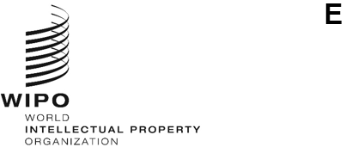
WO/CC/83/inf/2
ORIGINAL: English
DATE: APRIL 11, 2024
WIPO Coordination Committee
Eighty-Third (55th Ordinary) Session
Geneva, July 9 to 17, 2024
Annual Report by the Ethics Office
prepared by the Secretariat

Introduction
- This report is submitted to the WIPO General Assembly, through the Director General, in accordance with Office Instruction No. 16/2020 entitled “WIPO Ethics Office”. It describes the key activities undertaken by the Ethics Office in 2023.
- The Ethics Office was established in 2010 to support the Director General in ensuring that all WIPO personnel maintain the highest standards of ethics and integrity as required by the WIPO Convention, the Standards of Conduct for the International Civil Service, the Staff Regulations and Rules, the WIPO Code of Ethics, and relevant policies and procedures.
- The objective of the Ethics Office is to promote an organizational culture of ethics based on shared values of independence, loyalty, impartiality, integrity, accountability, and respect for human rights. The Ethics Office fulfills this mission by providing services to WIPO’s international workforce, including senior management, in the following broad areas of responsibility:

  - Confidential advice and guidance;
  - Ethics training, awareness raising and outreach;
  - Standard setting and policy advocacy;
  - Administration of the protection against retaliation policy; and
  - Administration of the financial disclosure and declaration of interest (FDDI) policy.
- The Office is headed by a Chief Ethics Officer, who is functionally and operationally independent from WIPO management. In 2023, the Office staff also included an intern, a consultant (as needed), an external reviewer (FDDI/IPSAS) and an agency worker for administrative support.

II. REPORT ON 2023 ACTIVITIES
- In 2023, the Ethics Office saw an increase in requests for its services. Despite challenges in managing the workload, the Office operated effectively and delivered results.
- The Chief Ethics Officer met regularly with the Director General to discuss issues of general concern. The Chief Ethics Officer also kept the Director General and the Independent Audit and Oversight Committee (IAOC) apprised of the performance of the ethics function.

A. CONFIDENTIAL ADVICE AND GUIDANCE
- The Ethics Office plays a key role in supporting WIPO’s ethical values by providing confidential ethics advice to all WIPO personnel. This includes managing potential conflicts of interest and advising on complex ethical issues before they escalate, thereby avoiding operational and reputational damage. In this way, the Ethics Office also plays a fundamental role in risk management, promoting awareness of and compliance with applicable rules, policies, and standards of conduct. Serving as a trusted consultative resource for all personnel, the Ethics Office also provides a confidential space to raise concerns and seek guidance.
- In 2023, the Ethics Office responded to 168 individual requests for ethics advice, through in-person and virtual meetings or in writing. Figure 1 summarizes the requests from 2019 to 2023.
- A comparison of the number of requests received in 2023 to those received in 2022 shows a continuous increase. This reflects strengthened staff and management engagement with the Ethics Office and indicates a high level of trust in the Ethics Office as a resource for advice and a “safe space” for practical guidance and support. The higher number is also attributable to the Ethics Office’s proactive approach to outreach and training activities. The Ethics Office received a very high number of requests from the Human Resources Management Division (HRMD) to assess potential conflicts of interest related to the engagement of personnel in outside activities and employment, and this significantly increased the workload.

Figure 1. Comparison of requests per reporting year, 2019 to 2023

- Requests for advice and guidance covered a broad range of categories (see Figure 2). The majority concerned participation in outside activities and employment (68, or 40 per cent) such as speaking engagements, teaching assignments and publishing, often on the topic of intellectual property (IP). Most of these requests (43) did not come directly to the Ethics Office, but rather through HRMD. In these cases, the Ethics Office provided advice to the Director, HRMD on potential conflicts of interest, although not having a dedicated role in the review of these cases under the current policy on outside activities. In other situations (25), individuals asked the Ethics Office whether an activity was appropriate (serving on a board of directors, providing third-party services, using WIPO information in written and research assignments, etc.), and the Ethics Office directly advised the individuals concerned.
- The other major categories of requests related to other conflicts of interest (18, or 11 per cent), standards of conduct (21, or 12 per cent) and other ethics advice (15, or 9 per cent) related to the fair and transparent application of policies and procedures, the reporting of misconduct including harassment and sexual harassment, and other workplace concerns.
- The Ethics Office also recorded requests in the following categories: gifts (21, or 12 per cent), financial disclosure (13, or 8 per cent), family and close relationships (1, or 1 per cent) and retaliation (11, or 7 per cent) (see Section D).

Figure 2. Breakdown of advice by category

- As shown in Figure 3, the majority of requests were made by WIPO personnel (168). Within this category, 114 came from staff members, 1 from non-staff personnel. The Ethics Office also received departmental requests from HRMD on outside activities (43), and management requests, meaning queries from WIPO managers in the performance of their official managerial function (7). There were four requests from former members of WIPO personnel.

Figure 3. Origin of requests

- A total of 152 requests (90 per cent) out of 168 were substantively handled solely by the Ethics Office. In a small number of cases (16, or 10 per cent), the Ethics Office directed staff and non-staff personnel to seek external support for matters related to grievances, dispute settlements and for reporting alleged wrongdoing. Referrals were made to HRMD, the Office of the Ombudsperson (OMB), the Internal Oversight Division (IOD), and to management (see Figure 4).
Figure 4. External referrals

B. AWARENESS RAISING AND TRAINING
- The awareness-raising and training activities of the Ethics Office aim to reinforce the core values and principles of WIPO, increase knowledge of and compliance with ethics-related policies, and encourage personnel and management to maintain high ethical standards.
- In 2023, the Ethics Office continued its training and awareness-raising activities.
- The Ethics Office delivered four induction training sessions on ethics at WIPO in March, July, October, and December, reaching 109 newly recruited personnel, including managers and staff at senior levels.
- Sixty-six participants attended the FDDI information session delivered by the Chief Ethics Officer in preparation of the new internal FDDI program launch (June 2023).

Figure 5. Outreach initiatives by the Ethics Office
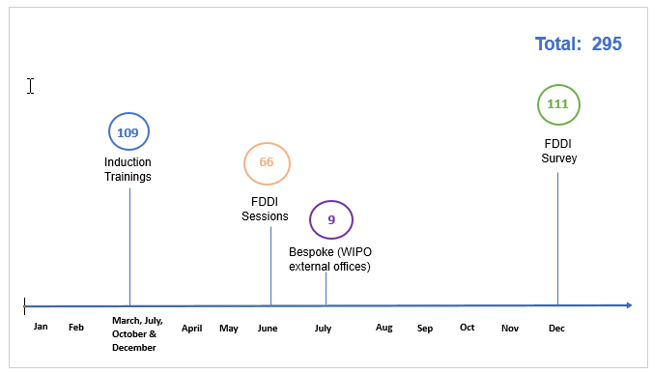

Mandatory Ethics Training
- The Ethics Office with the support of the WIPO Academy, sent regular reminders to all personnel working in WIPO after their first thirty days within the Organization. All new recruits since the launch of the new ethics and integrity training in 2022 have been required to complete the training. In total, for 2023, 1495 out of 1576 participants successfully completed the e-learning course, with a 95 per cent completion rate).
- The training gives an overview of ethics resources available, and includes a message from the Director General on the importance of ethics at WIPO and a closing quiz, developed infographics, interactive exercises and videos to convey important ethical concepts in an engaging way, such as what ethics means at WIPO, ethical risks personnel may face, the expectation for managers and supervisors to act as ethical role models, the role of the Ethics Office, and protection against retaliation. The training pass remains valid for three years and new recruits are required to complete it within 30 days of joining WIPO.

C. STANDARD SETTING AND POLICY ADVOCACY
- The Ethics Office is mandated to provide standard-setting and policy support for the development and interpretation of ethics-related policies, and input to management to ensure that policies, procedures, and practices reflect, reinforce, and promote ethical standards and integrity within WIPO.

D. protection against retaliation policy
- The Ethics Office is charged with administering the protection against retaliation policy, which sets out the prohibition against retaliation, the procedures for lodging a complaint and the steps WIPO may take to address retaliation. Upon receipt of a formal complaint, the Ethics Office undertakes a preliminary review of the request, and if a prima facie case of retaliation is established, the matter is referred to IOD for investigation. Following completion of the investigation, the Ethics Office reviews the IOD report, seeks clarification as needed and then determines whether retaliation occurred.

Requests for Protection Against Retaliation
- In 2023, the Ethics Office received seven retaliation-related requests for advice and, further, four formal requests for protection against retaliation. Figure 6 shows the number of formal requests each year since 2019.
Figure 6. Number of requests for protection against retaliation received from 2019 to 2023

- The four complaints arose in the context of alleged misconduct (harassment and abuse of authority). In all four cases, the Chief Ethics Officer found a complete or partial prima facie case of retaliation, and therefore referred the cases to IOD for investigation. Figure 7 shows that the four requests received in 2023 are now pending with IOD.
Figure 7. Resolution of four requests for protection against retaliation in 2023

Advice
- The Ethics Office responded to seven separate retaliation-related inquiries, where colleagues sought advice or reassurance about protection either before going on to report misconduct or when feeling exposed, having engaged in a protected activity. These inquiries did not escalate into formal requests.

Preventive Action
- WIPO’s policy on protection against retaliation provides that IOD will inform the Ethics Office of any report of wrongdoing received that IOD identifies as posing a retaliation risk. The Ethics Office then consults with the individual concerned about possible preventive action. Through this provision, the Ethics Office can be proactive in offering advice to a complainant rather than waiting to see if retaliation will materialize.
- In 2023, the Ethics Office received one report of wrongdoing that IOD identified as posing a risk of retaliation.

Policy Review
- To reflect observations of the IAOC regarding time limits, and to replace the United Nations Office for Project Services with the United Nations Ethics Office as the second-tier reviewer of determinations of no prima facie case of retaliation, the protection against retaliation policy was amended on December 22, 2023, following consultation with the IAOC.

E. FINANCIAL DISCLOSURE AND DECLARATION OF INTERESTS (FDDI)
- The FDDI program administered by the Ethics Office helps to promote transparency and accountability, thus enhancing public trust in the integrity of WIPO and its staff. The program is primarily a tool for identifying and assessing conflict-of-interest risks arising from the financial investments and outside activities of staff and their immediate family.
- In April 2023, the contract with KPMG as an external reviewer of the FDDI process came to an end. The Chief Ethics Officer proposed that WIPO should have its own FDDI software, and that KPMG should be replaced as the external reviewer, and management has approved these recommendations. The launch of the new WIPO FDDI/IPSAS platform was developed in time for the 2023 exercise. This new approach made the process more effective and efficient, yielding significant annual savings for WIPO. The Ethics Office has led the project with the support of the Information and Communication Technology Department and the Information Security Section to develop a secure and dependable system that the Office will manage confidentially.
- In 2023, a total of 111 staff members – at the level of D1 and above, as well as other staff working in specifically designated categories – participated in the annual FDDI program, which covered the 2022 calendar year.
Figure 8. FDDI participants, 2019 to 2023
- Hudson Ethics 2 LLC, the newly contracted external reviewer, sought advice from the Ethics Office on potential or perceived conflict of interest for three participants. The Ethics Office reviewed these three cases with the staff members concerned and determined that there was no actual conflict of interest.
- Following the closure of the exercise, approximately 10 per cent (10) of the participants were randomly selected to participate in the verification process prescribed by the rules. This verification process allows the Ethics Office to ensure that staff are completing their financial disclosure statements diligently and accurately. Four participants selected were compliant and provided the necessary third-party documentation or confirmation. Six participants had not disclosed any assets or liabilities on their FDDI statements. These six were requested to sign and submit a clarification document confirming (1) that they did not hold or acquire any reportable financial instruments, assets and/or non-WIPO sources of income at any time during the reporting period and (2) that they did not hold any reportable financial liability during the reporting period. All six complied. At the end of the process, Hudson Ethics 2 provided an anonymized report to the Director General. The program closed successfully with 100 per cent compliance.

International Public Sector Accounting Standards (IPSAS) disclosure
- Consistent with its mandate, the Ethics Office administered and managed the annual IPSAS disclosure exercise for 2023. All staff members at the D2 level and above were required to disclose transactions with close family members. All participants responded to the request and the exercise closed successfully with 100 per cent compliance.

Policy Review
- The Ethics Office also initiated the revision of the FDDI policy to reflect changes that had been made to the FDDI program, including the use of in-house FDDI software to manage the program. The policy was finalized for publication ahead of the launch of the 2023 FDDI exercise.

III. OTHER ACTIVITIES OF THE ETHICS OFFICE
- Throughout 2023, the Ethics Office continued to engage with the IAOC and submitted timely updates and reports, in particular on the implementation of the Office’s workplan. The committee members engaged in constructive discussions with, and provided useful guidance to, the Chief Ethics Officer, drawing on their extensive and varied organizational experience.
- The Ethics Office, as with all program units within the Organization, also contributed to WIPO’s annual and biennial planning and risk-management processes.

IV. COLLABORATION ON ETHICS-RELATED ISSUES WITHIN THE UN SYSTEM

Ethics Network of Multilateral Organizations (ENMO)
- The Ethics Office continued its active engagement with the ENMO, which serves as a broad forum of ethics functions from UN system entities, affiliated international organizations, and international financial institutions, and aims to promote system-wide collaboration on ethics-related issues for participating bodies.
- In May 2023, the Chief Ethics Officer brought together the heads of ethics offices of ENMO members in Geneva. The group has since met three times and continues to exchange regularly on matters of common concern.

V. OBSERVATIONS AND Looking Forward
- The increase in advisory cases is an area the Ethics Office will continue to monitor carefully into 2024. The Ethics Office has already improved its case-tracking and reporting capabilities, but still plans to move to an automated case-tracking and data-recording system that will further help with monitoring cases and analytics to better inform its strategy and help it report more efficiently and consistently on ethical maturity within WIPO.

- Based on the large number and the nature of requests received in the category of outside activities and employment, the Ethics Office considers that it would be in the best interests of WIPO to enhance the existing regulatory frameworks for the engagement of personnel in outside activities, particularly related to IP. It would also be helpful to include clearer guidance for personnel on the approval process and the role of the Ethics Office in the review of cases. The Ethics Office and HRMD have agreed to form a working group to consider possible changes to the current outside activity approval process.
- Considering the results of the mandatory ethics and integrity training, the Ethics Office is confident that a strong foundation has been laid to increase trust among WIPO staff and managers, and in the Organization itself. It has also promoted accountability in decision-making and strengthened ethical leadership at all levels of the Organization. As the Ethics Office, and other concerned stakeholders, continue to reinforce the expectation for personnel to align their conduct with UN values, and WIPO values in particular, they will in turn naturally expect procedural fairness from the Organization. Therefore, it is important that policies and guidelines are not only explicitly aligned with those values, with clear roles and responsibilities, but also clearly communicated to personnel, and implemented with integrity and fairness.
- The Ethics Office’s mandate includes supporting management in the review of policies that raise implicit or explicit ethical considerations. The Office encourages management to draw on its expertise in future discussions regarding WIPO’s policies, particularly concerning the ongoing culture change initiative in order to make sure that ethical considerations and considerations related to the Standards of Conduct for the International Civil Service are always incorporated into organizational policies and guidelines, as appropriate.

- In 2023, the Ethics Office initiated four policy reviews in relation to FDDI/IPSAS, PaR, consensual intimate relations between staff, and outside activities.
- The new internal platform (FDDI) was successfully launched in June 2023, followed by the development of IPSAS, ahead of the launch in January 2024.
- As per 2023 Staff Resources Report, the Ethics Office is comprised of one staff position, the Chief Ethics Officer. The Chief Ethics Officer is supported by one administrative agency worker (part-time), and contractors as needed, in particular during the financial disclosure process. Following the departure of Ms. Jovanie Philogène, WIPO’s Chief Ethics Officer, on October 16, 2023, Mr. David Mitchels has taken up his duties as interim Chief Ethics Officer until a new Chief Ethics Officer is appointed.
- Finally, the Ethics Office appreciates the support received from management and other offices for the implementation of its mandate. The Ethics Office plans to increase the frequency of briefings to WIPO Senior Leadership, as this is an opportunity to raise awareness of ethical issues while respecting the Office’s independence and obligations of confidentiality. In addition, the Office has appreciated the availability of temporary staffing which has helped its delivery capacity in 2023. With more sustained and durable resources, the Ethics Office looks forward to obtaining additional staff headcounts to respond to the increasing number of cases, impact the workforce more significantly and carry out new and strategic initiatives.

vI. CONCLUSION
- In 2023, the Ethics Office made significant efforts to provide consistent expert ethics advice, high-quality training, and meaningful outreach to strengthen capacity and further increased awareness, understanding and compliance with WIPO’s guiding principles and standards of conduct. The Office is encouraged by its increased interactions with personnel on ethics issues and looks forward to continuing this work in the next year.
- Following positive feedback, the Ethics Office plans to issue an illustrated summary report to all WIPO personnel. This report will provide an overview of the work of the Office. A one-page snapshot of this report is available in the Annex.
[Annex follows]
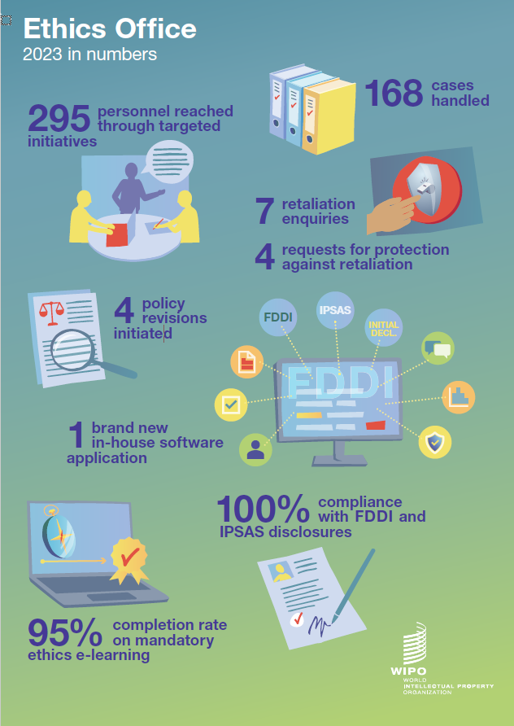
[End of Annex and of document]

This includes all WIPO staff and non-staff personnel based in WIPO headquarters and outside Geneva. The Ethics Office also provides services to staff of the International Union for the Protection of New Varieties of Plants.
The Office relied on the support of a consultant (on an hourly basis as needed), an external reviewer (FDDI/IPSAS), an intern (8 months) and a part-time (80 per cent) agency worker for administrative support (9 months).
The Ethics Office counts as a request any individual request for confidential advice and guidance by one member of staff or non-staff personnel, in relation to a set of facts. One request may require multiple communications by email and/or conversations, or it may require only a single exchange.
Outside activities. This category covers questions concerning external employment, occupations and other outside activities that might interfere with the ability of WIPO personnel to serve the Organization.
Currently, WIPO’s Policy on Outside Activity does not provide for the advisory role of the Ethics Office in each request to engage in an outside activity. The Office agreed to support HRMD, consistent with best practice in the UN system, to screen requests for outside activities to prevent any potential conflict of interest. Pursuant to Office Instruction No. 16/2020 on the WIPO Ethics Office, “[p]roviding confidential advice and guidance to staff and other personnel on ethical issues” falls within its main responsibilities. Conflicts of interest are, by their very nature, an ethical issue.
Conflict of interest. This category covers questions about independence and impartiality, such as personal financial conflicts of interest, use of WIPO’s assets, and post-employment restrictions.
Standards of conduct. This category covers questions related to the Standards of Conduct for the International Civil Service and allegations or queries about workplace conduct, including possible misconduct, fraud and corruption, harassment, abuse of authority, discrimination and fair application of policies.
Other ethics matters include employment-related inquiries related to ethics, and questions from personnel about how to speak up and the fair application of WIPO policies and practices.
Gifts, awards, honors and hospitality. This category includes advice given to WIPO personnel on how to conduct themselves when offered gifts, favors, remuneration, honors, awards, or hospitality by external sources in the course of their official duties or in relation to their WIPO status, while also clarifying if the gift was under the CHF 200 threshold, as indicated in WIPO’s Gifts and Honors Policy.
This category includes agency workers, contractors, and other external providers.
See the HRMD publication on the WIPO Workforce 2023.
The timeline for completion of the previous mandatory ethics training was one year, and there was no timeline set for the training validity.
One-hundred and eleven staff members were invited to participate at the start of the program.

