E
WIPO/INN/MCT/04/1
ORIGINAL: English
DATE: April 2004
   |  | 
SULTANATE OF OMAN | SULTAN QABOOS UNIVERSITY | WORLD INTELLECTUAL  PROPERTY ORGANIZATION
wipo national workshop on INNOVATION SUPPORT
SERVICES AND THEIR MANAGEMENT
organized by
the World Intellectual Property Organization (WIPO)
in cooperation with
the Ministry of Commerce and Industry
and
the Sultan Qaboos University (SQU)
Muscat, April 20, 2004
INTELLECTUAL PROPERTY: Its impact on RESEARCH AND DEVELOPMENT and strategy for Protecting Inventions and Research Results
Document prepared by by Professor Prabuddha Ganguli, Advisor,
Vision-IPR, Mumbai, India

Unraveling nature’s secrets and transforming the understanding into technology for societal use have been the hallmarks of human R&D ability, creativity and vision. In recent times this quest has taken unforeseen trajectories due to the creation of convergence technologies leading to non-linear and quantum leaps in knowledge and its applications resulting in metamorphosis of our lifestyles, working and methods of doing business.

Research and development activities result in innovations that are creations of the mind. Their protection using the tools of IPR converts them to intellectual property thereby transforming them to intellectual assets that have a potential and realizable value. It should be appreciated that that the realizable value of IP to the potential value of IP increases as the innovation moves up the value chain. The various features of such a value chain as mind goes to market are illustrated in the figure 1.

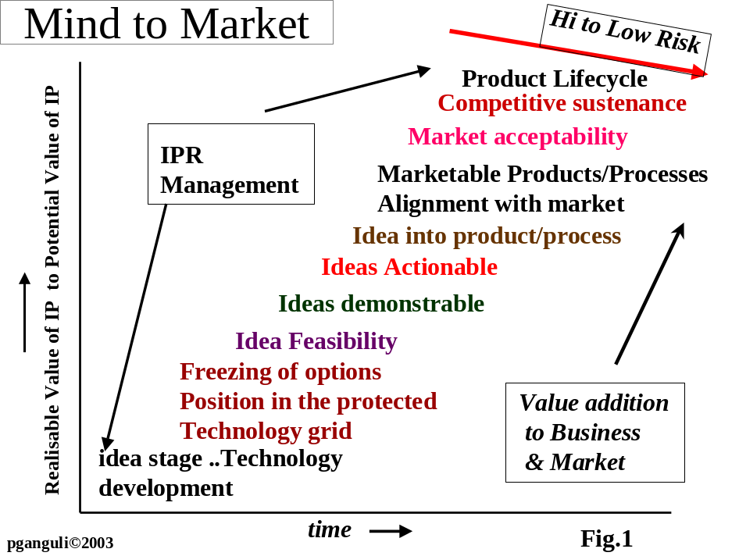

The challenge is to design and operate institutional R&D processes that preserve intellectual excellence and at the same time amicably fit into a disciplined formal IPR management system.

The R&D process pathway gets initiated with the germination of concepts that mature through thought and experimentation with some finally finding their way to markets. To sustain competitive position in the market place it is essential to protect the innovations exploiting the tools of IPR. This directly impacts the way R&D is to be managed as it calls for systematic mapping of knowledge ownership girds, planning strategic technology options for research projects and identification of business opportunities, negotiating contracts with prospective funding agencies and beneficiaries, followed by a set of cascading decision making events such as research reviews, IPR filings, exploring early transfer of technology, licensing, marketing tie ups progressing projects through possible joint developments, etc. Aspects such as product life cycles, fit of the acquired IPR into existing IPR portfolio, expenditure on maintenance of IPR portfolio, policing, enforcement etc. play equally important role.
Integration of IPR with R&D creates a new paradigm in project management as depicted in Fig. 2. The process is being described with patents as one of the forms of IPR as it gets integrated with the innovation and R &D process.

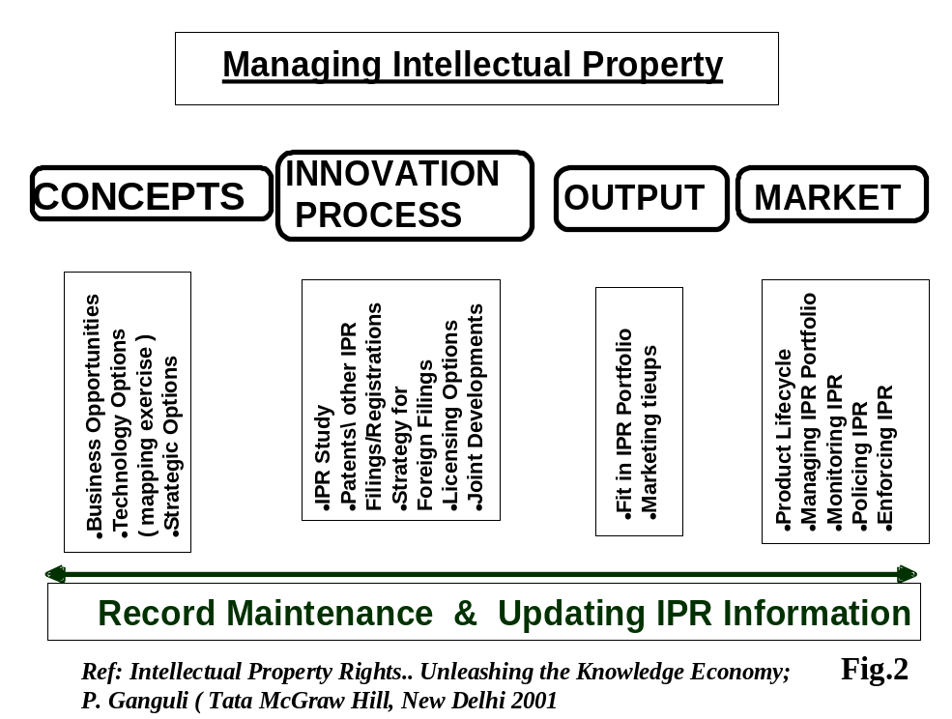

As the mind starts its journey to the market, one has to sift through the existing debris of proprietary and non-proprietary knowledge domain (prior art) to identify the technology gaps in prior art, develop non-obvious approaches to solving problems with respect to prior art and also assess their usefulness at a very early stage so that strategic research options are worked out. Such an approach would ensure that the research work being undertaken does not infringe any existing patents with the future possibility of patenting the fruits of the planned research. It is always recommended that a thorough patents search be conducted at the beginning or early stage of the project to avoid any possible duplication of existing knowledge in patents and other IPR databases.

Fig. 3 illustrates the power of information that is available in patents. If used judiciously, they serve as a gold mine of technical and legal information. It should be appreciated that patents get filed in different parts of the world continuously and hence the patent information database must be searched from time to time to keep oneself abreast with the happenings in their fields of research and development.

Fig.3 Patent Information and its use in R&D
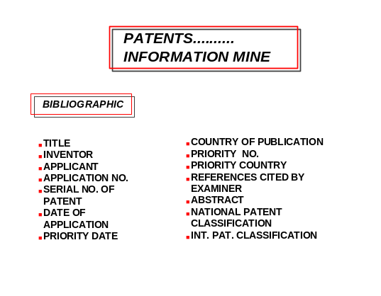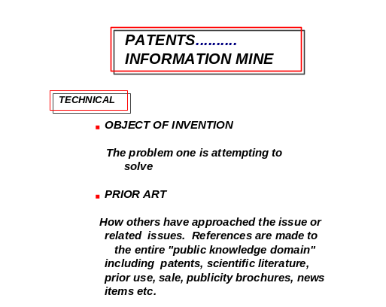
Ref: Intellectual Property Rights… Unleashing the Knowledge Economy
Prabuddha Ganguli; Tata McGraw Hill (New Delhi) , India (2001); ISBN 0-07-463860-2

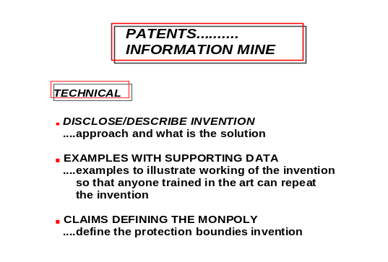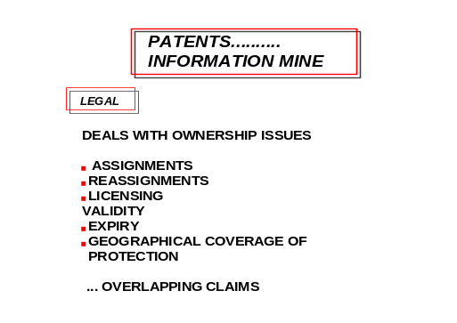

It may be noted that under certain conditions the information in patents can be used freely by anyone without paying any royalties or compensation to the patent applicant or patent holder. It is well established that less than 10% of the granted patents are commercialized around the world. Similarly several patent applications are not taken to the granting stage after they are published in the gazettes. More than 50% of the patents granted in various patent offices around the world are not kept live till the end of their term, as the patentees do not pay the annual renewal fees. The rights to such patents lapse and they become open to the public for free use without any obligation of licenses, royalty etc. R&D workers and businesses should be able to effectively exploit this rich technical information source for their product / process, business development and a strategic business planning tool. As patent rights are territorial, the businesses can find out the countries in which the patents have been granted with respect to a product or process and plan their business to avoid those countries for marketing to exploit markets where the patents on these products/processes are not granted. The concept of International Patens Classification (IPC) and the US Patents Classification as subject descriptor codes are of immense significance in the field of patent information and structured searching. For example as per IPC the area of Human Necessities is classified under "A". In this Agriculture is classified under " A01", Food Stuff under " A21-A23", Tobacco under "A24", etc. Subjects within these areas are further classed under sub-classifications. The databases have the patents classified and indexed with respect to these codes so that searches can be conducted using the IPC codes or the US classification codes. The classification system adds classes to its list from time to accommodate newer areas of technology as they evolve.

Systematic, structured and authenticated documentation of the research project objectives, dates when experiments are performed, who performs the experiments, the tools, the equipments used, the results obtained, the conclusions from the experiments etc must be maintained as they become a legal necessary to establish the inventors, when an idea was conceived, when the idea was reduced to practice, etc.

As indicated in fig. 2 the concept stage is followed by the innovation phase in which the R &D work progresses to achieve the set objectives. The results should be reviewed by a group of professionals and decisions on the protection of these through patents and/ or designs and/or copyright should be taken and implemented. Strategy for foreign filings also needs to be taken as these are bound by international conventions and the timings have to be planned. It is possible that there is an opportunity to license the results at a very early stage for a certain value and a strategic decision to do so is taken by the review committee. Joint developments through strategic collaborations may also be planned and implemented. There are occasions when the IPR by way of patents, design registrations and copyright do not fit into the existing IPR portfolio of the organization. Under such circumstances in the output stage itself, strategic selling off the IPR is initiated. Alternatively, the renewal fees for such IPR is not paid and the rights are allowed to lapse. Such decisions on the management of the IPR portfolio is also taken based on the product / technology lifecycle.

The next set of management decisions in the protection of research results lies in the monitoring of the licenses, the earnings from the royalty, policing of IPR in the market place to identify infringement, the approaches to be taken for their enforcement and strategies for litigation. These are fairly involved activities and need professional inputs to maximize benefits.

Management of IPR therefore involves integrated innovation and IPR capability development with the creation and implementation of organisational IPR Policies through targeted IPR servicing cells within the organisation. Such a servicing cell has a comprehensive and coordinating role and is represented in figure 4.

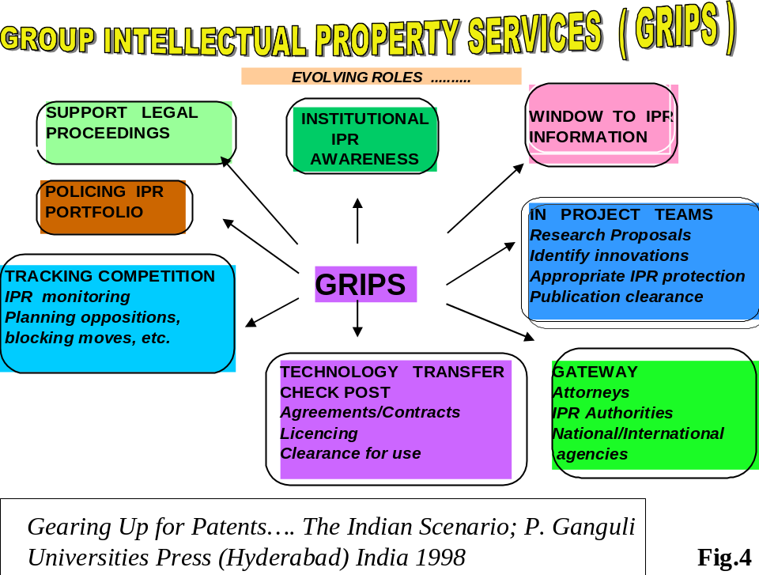

One of the major challenges is to develop and train techno-legal manpower to manage such servicing cells and this should be a priority thrust area for Governments, Human Resource Development Orgnaisations, Technology, Business Management and Law Schools especially in developing and least developing counties.

[End of document]

