 |  | E
A/50/4
ORIGINAL: ENGLISH
DATE: AUGUST 1, 2012

Assemblies of the Member States of WIPO

Fiftieth Series of Meetings
Geneva, October 1 to 9, 2012

PROGRAM PERFORMANCE REPORT FOR 2010/11

presented by the Director General

- The present document contains the Program Performance Report for 2010/11 (document WO/PBC/19/2), which is being submitted to the WIPO Program and Budget Committee (PBC) at its nineteenth session (September 10 to 14, 2012).

- The recommendation of the PBC in respect of this document will be included in the “Summary of Recommendations Made by the Program and Budget Committee at its Nineteenth Session held from September 10 to 14, 2012” (document A/50/14).

3. The Assemblies of the Member States of WIPO and of the Unions administered by it, each as far as it is concerned, are invited to approve the recommendation made by the Program and Budget Committee in respect of document WO/PBC/19/2, as recorded in document A/50/14.

[Document WO/PBC/19/2 follows]

E

wo/pbc/19/2
OriGINAL: ENGLISH
DATE : JUNE 20, 2012
Program and Budget Committee
Nineteenth Session
Geneva, September 10 to 14, 2012
Program Performance Report for 2010/11
presented by the Director General
1. The Program Performance Report (PPR) for 2010/11 has been prepared in accordance with WIPO’s results-based framework. The present report is based on the performance criteria established in the proposed Program and Budget for the 2010/11 biennium, as approved by the forty-seventh Assemblies of the WIPO Member States in December 2009 (publication No. 360E/PB1011). The Report provides an assessment of results achieved in the 2010/11 biennium.

2. The Program and Budget Committee is invited to recommend the approval of the present document to the Assemblies of the Member States of WIPO.

[Program Performance Report for 2010/11 follows]

PROGRAM PERFORMANCE REPORT FOR 2010/11

TABLE OF CONTENTS

Page
I. INTRODUCTION 1
II. SUMMARY OF ACHIEVEMENTS IN 2010/11 2
III. PROGRAM PERFORMANCE 2010/11 9
PROGRAM 1 PATENTS 9
PROGRAM 2 TRADEMARKS, INDUSTRIAL DESIGNS AND GEOGRAPHICAL INDICATIONS 12
PROGRAM 3 COPYRIGHT AND RELATED RIGHTS 15
PROGRAM 4 TRADITIONAL KNOWLEDGE, TRADITIONAL CULTURAL EXPRESSIONS AND GENETIC RESOURCES 21
PROGRAM 5 THE PCT SYSTEM 24
PROGRAM 6 MADRID, HAGUE AND LISBON SYSTEM 36
PROGRAM 7 ARBITRATION, MEDIATION AND DOMAIN NAMES 42
PROGRAM 8 DEVELOPMENT AGENDA COORDINATION 45
PROGRAM 9 AFRICA, ARAB, ASIA AND THE PACIFIC, LATIN AMERICA AND THE CARIBBEAN COUNTRIES, LEAST DEVELOPED COUNTRIES 48
PROGRAM 30 SMALL AND MEDIUM-SIZED ENTERPRISES 57
Program 10 Cooperation with Certain Countries in Europe and Asia 61
PROGRAM 11 THE WIPO ACADEMY 65
Program 12 International Classifications and WIPO Standards 69
PROGRAM 14 GLOBAL IP INFORMATION SERVICES 72
PROGRAM 15 IP OFFICE MODERNIZATION 76
PROGRAM 16 ECONOMIC STUDIES, STATISTICS AND ANALYSIS 80
PROGRAM 17 BUILDING RESPECT FOR IP 83
PROGRAM 18 IP AND GLOBAL CHALLENGES 86
PROGRAM 19 COMMUNICATIONS 92
PROGRAM 20 EXTERNAL OFFICES AND RELATIONS 96
PROGRAM 21 EXECUTIVE MANAGEMENT 101
PROGRAM 22 FINANCE, BUDGET AND PROGRAM MANAGEMENT 106
PROGRAM 23 HUMAN RESOURCES MANAGEMENT AND DEVELOPMENT 110
PROGRAM 24 ADMINISTRATIVE SUPPORT SERVICES 114
PROGRAM 25 INFORMATION AND COMMUNICATION TECHNOLOGY 121
PROGRAM 26 INTERNAL AUDIT AND OVERSIGHT 125
PROGRAM 27 CONFERENCE AND LANGUAGE SERVICES 128
PROGRAM 28 SECURITY 131
PROGRAM 29 NEW CONSTRUCTION 133

APPENDIX I Report on Expenditures Related to Development Activities 136
APPENDIX II Implementation of Funds-in-Trust 2011 139
APPENDIX III Acronyms used in the present document 162

INTRODUCTION

The Program Performance Report (PPR) is the principal accountability tool for reporting on organizational performance to Member States and an integral part of WIPO’s results based management (RBM) framework. The Report also serves as an important learning tool ensuring that lessons from past performance are learned and duly incorporated into the future implementation of WIPO’s activities. The PPR is based on a self-assessment by Program Managers. To strengthen the validity of the information in the PPR, the Internal Audit and Oversight Division (IAOD) carries out a validation of the performance data on a biennial basis. The validation of the PPR 2010/11 can be found in document WO/PBC/19/3.

The PPR 2010/11 is an end of biennium report and assesses achievement of the Expected Results, measured by the Performance Indicators and with the resources approved in the Program and Budget 2010/11.

The performance assessments for individual Programs in the PPR 2010/11 comprise:

Section I: Achievements in the 2010/11 biennium

An analytical summary presenting results achieved in the biennium 2010/11 by the Program concerned and any challenges encountered during the period under review.

Section II: Implementation of the WIPO Development Agenda

This section reports on a Program’s role and contribution to the implementation of the Development Agenda. In line with the Budgetary Process for Projects Proposed by the Committee on Development and Intellectual Property (CDIP) for the Implementation of the DA Recommendations, approved by the WIPO Assemblies in 2010, the reporting on the DA has been considerably strengthened compared to 2008/09, with detailed reporting on both the implementation of DA projects and DA recommendations under each Program.

Section III: Performance Data

The table in this section recapitulates the Expected Results for the Program and the Performance Indicators as approved by Member States in the Program and Budget 2010/11. Baselines have been updated, as appropriate, to reflect status at the end of 2009. The performance data for 2010/11 in relation to each indicator is provided in the 3rd column. The 4th column provides an assessment of performance using the “traffic light system”. The following criteria have been used for the PPR 2010/11:

Key to Traffic Light System (TLS)
“Fully Achieved” is applied when the 2010/11 performance data suggest 80 per cent or greater achievement of the performance indicator.
“Partially Achieved” is applied when achievement is assessed between 30-80 per cent of the performance indicator.
“Not Achieved” is applied when achievement is assessed at less than 30 per cent.
“Discontinued” is applied when performance data is not available for 2010/11 or when the indicator has been deemed no longer relevant for measuring performance.

Of a total of 298 performance indicators in the Program and Budget 2010/11, 223 indicators have been assessed as “Fully Achieved”, or 75 per cent. Performance on a total of 57 indicators, or 20 per cent, was assessed to be “Partially Achieved” and 6 indicators, or 2 per cent, were “Not Achieved”. 12 indicators, or 4 per cent, were discontinued.

Section IV: Budget Utilization 2010/11

The final section provides information, by Program, on the approved budget 2010/11, the final budget after transfer 2010/11, and actual expenditure in 2010/11 (both personnel and non-personnel resources) and an indication of the budget utilization rate. Explanations are provided for the differences between the approved budget and final budget after transfer as well as budget utilization. Taking due account of comments received by Member States, the Budget Utilization Section has been considerably refined compared to previous biennia.

Appendix I of this Program Performance Report contains a report on development expenditure by Program in 2010/11.

Appendix II contains, for the first time, a comprehensive overview of the implementation of the Funds- in-Trust in 2011 as an integral part of the Program Performance Report. This overview is part of efforts to enhance the integration of all activities under the results-based management framework of the Organization, irrespective of the source of funds.

SUMMARY OF ACHIEVEMENTS IN 2010/11

The biennium 2010/11 constitutes the first biennium of implementation of the Medium Term Strategic Plan (MTSP) 2010-2015. Highlights of progress in the biennium towards the nine Strategic Goals are summarized below.

The Strategic Realignment Program (SRP)

The Strategic Realignment Program (SRP) delivered tangible benefits to the Organization during the biennium, through improved business processes and better alignment of Programs, structure and resources to the nine Strategic Goals. The SRP delivered value at two levels: firstly it initiated a culture change at WIPO, embedding the Organization’s aspirational four Core Values in daily work, namely: Service orientation; Working as one; Accountability for results; and Environmental, social and governance responsibility.

Cultural change is difficult to measure and therefore a comprehensive Core Values staff survey was developed, which baselined staff’s perception of the uptake of the Core Values in December 2010, to measure progress against that baseline in December 2011. The result was a marked improvement in some areas, such as staff’s perception of our ability to “Work as one”, accountability for results and the importance of the role WIPO plays in society. The survey also identified areas for sharper focus, for example the need to improve internal communications. As a result, in 2011, over 130 staff members engaged to develop a portfolio of projects and initiatives. One such initiative was “what’s new” – a colleague-led monthly information seminar that has been extremely well received by a wide cross-section of staff.

On a second level, the SRP designed 19 concrete initiatives to implement or strengthen business processes, systems and policies. With a robust governance structure put in place and collective ownership by SMT, nearly all of the 19 initiatives developed early concepts into solid plans already in 2010. Staff engaged actively to contribute very positively to the change process. Tangible progress from initiatives focusing on performance, risk and financial management were observed, such as standardized risk registers, a better understanding of links between the financial and economic forecasts, improved uptake of the staff performance management system (PMSDS) and the first results-based budget. For initiatives contributing to the environmental, social and governance responsibility value, concrete deliverables were visible through the establishment of an Ethics Office and the endorsement of a Code of Ethics for WIPO. A number of environmentally conscious efforts were undertaken including a bike-to-work program and reducing the dependency on bottled water. WIPO continued its efforts to improve Service orientation. The results included improved customer service delivered through a consolidated Customer Service Center, a 5 per cent increase in the availability of WIPO core publications in all official languages, raising the total to 65 per cent and the development of a comprehensive draft business continuity management plan. WIPO increased its capacity to Work as one through a series of initiatives; benefits include a revised contractual framework for staff contracts which, together with an upgrade to the existing ERP system provided an important foundation for ensuring the integration of human resource management and business intelligence that would ensure greater transparency and information access for stakeholders, management and staff. Improvements to the ICT framework included the development of information security and confidentiality policies, designed to protect WIPO’s valuable information assets and the interests of stakeholders.

Quarterly progress reports to the Independent Advisory Oversight Committee and various communications documents can be found on the WIPO internet. The SRP is on track to conclude at the end of 2012, at which point the Organization will enter a period of continuous improvement where the outcomes of each initiative will be mainstreamed into the operations of WIPO’s Programs to ensure that the improvements introduced are sustained over the medium to long-term.

Strategic Goal I: Balanced Evolution of the International Normative Framework for IP

The biennium 2010/11 saw constructive deliberations and forward movement in almost all aspects of the Organization’s work under this Strategic Goal. The WIPO General Assembly in 2011 decided to convene a Diplomatic Conference on the Protection of Audiovisual Performances. Progress was achieved in the SCCR towards agreement on the content of an international instrument on limitations and exceptions with respect to visually impaired persons/persons with print disabilities, as well as on a work plan on the protection of broadcasting organizations.

Working under its new mandate established in late 2009, the WIPO Intergovernmental Committee on Intellectual Property and Genetic Resources, Traditional Knowledge and Folklore (the IGC) made considerable progress in the negotiations. By the end of 2011, the IGC had developed single negotiating texts on traditional knowledge (TK) and traditional cultural expressions (TCEs). Progress was also made on genetic resources (GRs) on the basis of several documents and proposals. The WIPO General Assembly in September 2011 recognized the progress made by the IGC in 2010 and 2011 and decided to renew its mandate for the 2012/13 biennium.

The Standing Committee on the Law of Trademarks, Industrial Designs and Geographical Indications (SCT) made progress on a number of specific topics in the areas of trademark and industrial design law. In particular, the SCT published two reference documents in the area of Grounds for Refusal of all Types of Marks (WIPO/STrad/INF/5) and concerning Technical and Procedural Aspects Relating to the Registration of Certification and Collective Marks (WIPO/STrad/INF/6). Furthermore, the SCT advanced work on industrial design law and practice and agreed that, as a possible path to move ahead, a diplomatic conference for the adoption of a design law treaty could be convened once sufficient progress has been made and the time was ripe for recommending the holding of such a diplomatic conference.

The Standing Committee on the Law of Patents (SCP) held four sessions during the biennium. Following an unanimous agreement at its 15th session, since May 2011, the SCP has been focusing on the following issues: (i) exceptions and limitations to the rights; (ii) quality of patents, including opposition systems; (iii) patents and health; (iv) confidentiality of communications between patent advisors and their clients; and (v) transfer of technology.

Strategic Goal II: Provision of Premier Global IP Services

In spite of the global financial crises, the 2010/11 biennium saw considerable growth in the international registration systems. The Organization successfully managed to deliver quality services and enhance the customer experience on the one hand while improving productivity through well designed ICT initiatives on the other hand.

International patent filings under the Patent Cooperation Treaty (PCT) set a new record in 2011 with 181,900 applications - a growth of 11 percent on 2010 and the fastest growth since 2005. Attesting further to the rapid growth of the PCT system, 2011 also saw the filing of the two millionth PCT application.

Further development of the PCT system remained an important focus of Member States and the International Bureau during the 2010/11 biennium. The PCT Working Group at its June 2010 session endorsed a series of recommendations covering a variety of actions which should be undertaken by the International Bureau, applicants, Contracting States and national Offices to make the PCT system more effective both for processing patent applications and for supporting dissemination of technical information, technology transfer and technical assistance for developing countries. Efforts focusing on improving the quality of international search and preliminary examination reports have resulted in the agreement by Member States on the establishment of a third party observations system and of a quality feedback system for national Offices, both of which will become operational in 2012.

Following a significant decrease of almost 17 per cent in 2009, as a result of the global financial crisis, the international trademark activity recovered in 2010 with WIPO receiving 39,687 and 42,270 applications in 2010 and 2011 respectively, 2011 thus constituting a record year in terms of international applications received. Also in the biennium, Israel, Kazakhstan, Sudan and Tajikistan acceded to the Madrid Protocol, increasing the number of members of the Protocol to 84, and the total number of members of the Madrid Union to 85. With the accession of Tajikistan to the Madrid Protocol in 2011, only one country remains in the Agreement (Algeria).

International registrations under the Hague system increased by 41 per cent compared to 2008/09. However, the number of new registrations remained far below that envisaged for the biennium.

The Membership of the Lisbon Agreement increased to 27, following the accession of the former Yugoslav Republic of Macedonia. With a view to facilitating a further increase of the Membership, the Working Group on the Development of the Lisbon System engaged in a review of the Lisbon system, aimed to make the system more attractive for users and prospective new Members, while preserving its principles and objectives.

The WIPO Arbitration and Mediation Center (Center) continued to work to optimize the potential of its procedures to meet the needs of IP right holders and users in the efficient resolution of disputes in relation to those rights. In the area of domain names, the Center developed a paperless filing mechanism and other case tools which enabled it to handle a 23 per cent increase over its 2008/09 caseload based on the Uniform Domain Name Dispute Resolution Policy (UDRP).

Strategic Goal III: Facilitating the Use of IP for Development

Facilitating the use of IP for development continued to be a priority and the biennium 2010/11 saw the mainstreaming of development take further root. While the demand for WIPO development-related assistance continued to exceed the Organization’s capacity to deliver, the biennium has seen the adoption of a more strategic approach to its development assistance, aiming at ensuring sustainable results at the national level. The mainstreaming of development in all specialized Strategic Goals has necessitated a better coordination between the Regional Bureaus and other organizational entities involved in the delivery of development-related assistance. Progress continued to be made in this respect including through the enhanced workplanning exercises.

The enhanced strategic approach also included the development of national IP strategy frameworks. The process of national IP strategy formulation was initiated in 29 countries during the biennium 2010/11 (13 countries in Africa, two in the Arab region, four in Asia and the Pacific, seven in Latin America and the Caribbean, and three in LDCs). In 16 other countries, national IP strategies/plans were adopted and/or are under implementation, namely nine countries in Africa, two in Arab, two in Asia and the Pacific and three in the Latin America and Caribbean region.

Enhancing national and regional capacities for the effective use of IP for development involved the launch by the WIPO Academy of new face-to-face and distance learning courses. In the biennium, WIPO’s distance learning program registered a total of 83,800 participants - the highest so far in any biennium - from 190 countries. A significant number of these courses were offered to Technology Information Support Centers (TISCs), Start-Up Academies and Universities.

In order to demonstrate how IP works in practice to promote innovation, the IP Advantage database was also launched during the biennium, featuring case studies from both developed and developing countries.

The CDIP met in four sessions during the biennium. The Committee approved nine new Development Agenda projects addressing 19 Recommendations bringing the total number of projects under implementation in the biennium to 23. It also agreed on the Coordination Mechanisms and Monitoring, Assessing and Reporting and considered Reports on WIPO’s Contribution to the United Nations Millennium Development Goals (MDGs) as well as multiple studies undertaken under the DA projects on IP and Public Domain, IP and Competition Policy and on Open Collaborative Projects and IP-Based Models.

Strategic Goal IV: Coordination and Development of Global IP Infrastructure

The 2010/11 biennium saw the consolidation of the Organization’s efforts under this relatively new Strategic Goal with significant progress in enhancing the global IP infrastructure to help meet the growing global demand on the IP system and facilitating the participation of developing countries and LDCs in the system. This included important achievements in the areas of global IP databases, classifications, IP office modernization, and Technology and Innovation Support Centers (TISCs).

The PATENTSCOPE portal moved to an entirely new high-performance system in late 2011, enhancing search functions and user experience and resulting in a significant increase in the number of visitors (an increase of 38 per cent in 2011 compared to 2010). The number of national and regional collections held in the system increased from eight to 28. Multi-linguistic functions were introduced to launch user interfaces in nine languages. In addition, two new global databases were launched: Global Brand Database containing the Madrid, 6ter and Lisbon collections, and the UPOV Plant Variety Database (PLUTO) in 2011.

A simplified structure of the IPC entered into force in 2011 together with a new publication platform. The Nice electronic forum was implemented allowing a better preparation and more efficient progress of the work of the Committee of Experts. The duration of its regular sessions was shortened from eight to five working days. As a result of the these initiatives, the average time between a revision request and its publication fell from 32 months in 2009 to 23 months in 2011. The decision to publish annual versions of the Nice Classification as from 2013 will further reduce the time lag between a revision request and its publication for certain types of amendments.

The agreement between the USPTO and the EPO to develop and use the Cooperative Patent Classification, which is based on the IPC, and to integrate their separate internal Classifications, was a major breakthrough during the biennium contributing to a wider acceptance and more effective use of International Classifications and WIPO Standards. The implementation of the Goods and Service manager, developed under the Madrid System, also contributed to a more correct use of the Nice Classification.

Modernization services were provided to IP Offices from more than 90 countries, across all regions, as well as two regional IP institutions in Africa, ARIPO and OAPI, including new modernization projects in 14 Offices and modernization projects already in progress but in different stages of implementation (44 Offices). The biennium also saw new releases of the WIPO Industrial Property Automation System (IPAS) with additional functionalities and enhanced efficiency, the development of the new Electronic Data Management System (EDMS) module, which is now being tested in several Offices, and the completion of WIPO’s digitization software, WIPOScan.

Work continued on the development of the WIPO CASE (Centralized Access to Search and Examination) platform, which to date count as users the Vancouver Group offices (Australia, Canada and the United Kingdom). A group of nine Latin American countries (the PROSUR group) requested assistance with the development of a similar system, and a pilot project was tested by the Offices during 2011.

The extension of the WIPO Priority Document Access Service (DAS) to new types of IP rights, including trademarks, industrial designs and utility models, was approved during the third session of the DAS Working Group in July 2011. The Working Group also approved simplifications to the service to make it more attractive for applicants to use and easier for Offices of all sizes to participate.

The “Technology and Innovation Support Centers”(TISCs) project attracted a total of 38 countries in the biennium, of which 20 countries established their TISCs networks. Regional cooperation was also facilitated through the creation of a regional platform for the exchange of experiences among countries in establishing and managing TISCs.

Strategic Goal V: World Reference Source for IP Information and Analysis

In 2011, WIPO launched for the first time an economics-focused analytical report – the World IP Report 2011: The Changing Face of Innovation. This Report fostered WIPO’s role in promoting evidence-based policymaking and generated a large number of news reports and interest from policymakers and academia.

A three-year economic studies project under the CDIP that promises to generate new evidence on the development linkages of IP policy was launched. During the 2010/11 biennium, this project made significant progress in creating the data infrastructure on the basis of which new evidence will be generated. The project is scheduled to be completed in 2013.

WIPO also assumed the role of Knowledge Partner in the INSEAD-led Global Innovation Index consortium, enabling the Organization to make a contribution in the field of innovation measurement and to foster a high quality discourse on innovation policy.

The WIPO Lex on-line collection of national IP laws and treaties was launched and subsequently expanded. WIPO Lex now covers nearly 200 countries and entities, and the availability of these legal instruments in some 70 languages has resulted in enhanced access to and use of IP-related legal information.

Strategic Goal VI: International Cooperation on Building Respect for IP

The 2010/11 biennium was marked by steady progress towards creating an enabling environment that promotes respect for IP in a sustainable manner. WIPO chaired the 6th Global Congress on Combating Counterfeiting and Piracy in Paris in February 2011, in partnership with INTERPOL, the World Customs Organization (WCO) and private sector groups, and in cooperation with the French Institut national de la propriété industrielle. Inspired by the policy dialogue in the framework of the ACE, the strategic realignment of the Global Congress initiative, hosted under the banner “Building Respect for IP: Sustainable Solutions to a Global Problem,” resulted in an unprecedented success as the refreshed program attracted 870 participants from 105 countries, almost 50 per cent representing Member States.

Strategic Goal VII: Addressing IP in Relation to Global IP Policy Issues

The IP and Global Challenges Program completed implementation of its first full biennium in 2010/11 providing support for strong, empirically well-founded policy dialogue between governments, international organizations, civil society actors and the private sector on current and emerging global issues touching on IP.

A determining achievement in the biennium was the establishment of WIPO Re:Search, a new Consortium of a broad range of private and public sector institutions from developed and developing countries providing royalty-free access to IP assets to stimulate new R&D for neglected tropical diseases, tuberculosis, and malaria. Members of WIPO Re:Search contribute assets such as for pharmaceutical compounds, technologies, know-how and data to qualified users that will use this information for product development.

The first pilot phase of the database component of wipo green – the sustainable technology marketplace for green technologies project was also completed during the biennium.

Strategic Goal VIII: A Responsive Communications Interface between WIPO, its Member States and All Stakeholders

WIPO became more visible during the biennium through a number of well planned communication initiatives.

The launch of the new WIPO logo reflected the strategic repositioning of the Organization to meet the IP challenges of the 21st century.

The WIPO GOLD web portal enhanced the visibility and accessibility of WIPO’s previously dispersed IP data collections, and helped raise the Organization’s profile as a world reference source of valuable IP information.

Media coverage of WIPO’s work continued to increase, boosted further by the involvement of celebrities, such as Stevie Wonder at the 2010 Assemblies. Use of social media, including the establishment of a WIPO video channel on YouTube and the first World IP Day Facebook campaign, reached new, younger audiences, triggering an exponential increase in viewing figures.

The first WIPO Open Day strengthened engagement with the local community in Geneva, giving an estimated 3,500 visitors an opportunity to learn about WIPO’s activities, IP and its contribution to daily life.

Strategic Goal IX: Efficient Administrative and Financial Support Structure to enable WIPO to Deliver its Programs

The Administration and Management, through its Programs, enabled the Organization in delivering the results expected by Member States and stakeholders, on the one hand, while navigating through the continuing financial crisis and serious uncertainties in the economic environment, on the other hand.
Despite these uncertainties, WIPO closed the biennium with a positive actual operational result of 3.9 million Swiss francs against the approved budget for 2010/11, as a result of prudent financial management measures implemented throughout the biennium.

WIPO also became one of the few UN system organizations to achieve compliance with International Public Sector Accounting Standards (IPSAS) within the original timeframe. The WIPO 2010 Financial Statements were thus prepared in accordance with IPSAS and received an unqualified audit opinion.

The New Construction Project was completed with all moves to the New Building finalized by June 2011. At the end of 2011, all preparatory steps for the execution phase of the New Conference Hall Project were equally on track.

WIPO conference services were considerably enhanced through the improvements made to the on-line registration system. The upgraded on-line registration tool, made available for the 2011 General Assemblies, was used by approximately 75 per cent of the participants resulting in minimal waiting time for delegates to collect badges or register on the spot. Based on a review of the Assemblies’ experience, further enhancements were made to the system, paving the way for its progressive deployment in other main meetings. The WIPO Assemblies were broadcast live over the Internet (webcasting), for the first time in 2010, and again in 2011, and a system for the digital recording of meetings was deployed at the end of 2011.

Two phases of the proposed WIPO Language Policy, approved by the 2010 and 2011 Assemblies, respectively, provided for the extension of full six language coverage for the documentation of the Intergovernmental Committee on Intellectual Property and Genetic Resources, Traditional Knowledge and Folklore (IGC) in 2010 and two additional committees, the Standing Committee on Copyright and Related Rights (SCCR) and Standing Committee on Trademarks, Industrial Designs and Geographical Indications (SCT) in 2011.

The ERP portfolio of projects, approved in the 2010 Assemblies as part of the Administrative and Management Sector modernization, has made good progress during 2011. The ERP Project Management Office (EPMO) was established, key resources were recruited and the governance structures and processes established. Through a number of projects the foundations for future solutions have been established based on a clear blueprint, developed through the vision project. Other foundational projects included introducing and moving the existing systems to new hardware, hosted at the UNICC, upgrading the underlying tools which support the ERP to the latest version and initiation of the project to upgrade the ERP software, PeopleSoft, to fully utilize the new tools. In addition, a project developed and introduced some new tools towards the end of 2011 to facilitate the 2012 work planning process. The portfolio of projects has adopted an approach of leveraging the work and learning of other UN agencies, en example being the use of the UNHCR HR solution as a starting point for WIPO’s design.

Efforts continued during the biennium to embed the core value Accountability for Results in the organizational culture, including through the SRP initiative “Strengthening Results-Based Management (RBM)” where significant progress was made. Notable achievements pertained to the strengthening of results-based planning as evidenced in the Program and Budget for 2012/13 which included the following enhancements: (i) a strategic organizational results framework (consolidation of Expected Results under the nine Strategic Goals); (ii) for the first time, a results-based budget; (iii) strengthened measurement frameworks, including through better indicators and the systematic introduction of baselines and targets; (iv) an indication of the development share of resources for each result (in line with the Organization’s focused efforts to improve its planning, tracking and reporting on development expenditure); (v) mainstreaming of development in all substantive Strategic Goals; (vi) integration of DA projects in line with the Budgetary Process for DA projects approved by the WIPO Assemblies in 2010; and (vii) integration of Funds-in-Trust.

PROGRAM PERFORMANCE 2010/11

PROGRAM 1 PATENTS

Program Manager Mr. J. Pooley

ACHIEVEMENTS IN THE 2010/11 BIENNIUM

The 2010/11 biennium was marked by a number of accomplishments which facilitated a better understanding of the role, principles and practices of patent law and an improved international cooperation in the area of developing the international patent system.

Four sessions of the Standing Committee on the Law of Patents (SCP) were held in the biennium. At its 14th and 15th sessions in January and October 2010, respectively, the SCP examined a number of issues relating to legal principles and practices relating to the patent system based on preliminary studies prepared by the Secretariat and a study on exclusions, exceptions and limitations prepared by a group of academic experts. The examined issues are: (i) dissemination of patent information; (ii) exclusions from patentable subject matter and exceptions and limitations to the rights; (iii) patents and standards; (iv) client-patent advisor privilege; (v) opposition systems; and (vi) transfer of technology. Following a unanimous agreement at its 15th session, since May 2011, the SCP has been focusing on the following issues: (i) exceptions and limitations to the rights; (ii) quality of patents, including opposition systems; (iii) patents and health; (iv) confidentiality of communications between patent advisors and their clients; and (v) transfer of technology.

The approach of conducting substantive studies has allowed the SCP to review the current international patent system from a holistic perspective, taking into account the different needs and interests of all Member States. It has also supported the discussions of the SCP as a participatory process that takes into consideration the viewpoints of all stakeholders. This is illustrated by the fact that a number of delegations have put their proposals forward and have actively engaged in the discussions. While the priorities of Member States vary, such a step-by-step process adopted by the SCP has resulted in gradually concretizing the Committee’s activities on the basis of consensus.

In 2010 and 2011, a number of countries acceded to, or ratified, WIPO administered treaties in the field of patents. Albania, Kazakhstan, Lithuania, Latvia, Montenegro, the Netherlands, Serbia and the former Yugoslav Republic of Macedonia joined the Patent Law Treaty (PLT), which made the total number of accessions or ratifications to the PLT reach 30 States at the end of 2011. Three countries (Chile, Luxembourg and Morocco) joined the Budapest Treaty and one country (Brunei Darussalam) became party to the Paris Convention in the biennium.

In cooperation with other relevant Sectors, the Program provided, upon request, legislative assistance and policy advice to Member States in the drafting and implementation of their national and/or regional patent / utility model / undisclosed information / integrated circuit laws and regulations, consistent with their bilateral/regional/multilateral treaties and obligations. This contributed to a greater awareness of the patent system and related policies, including the way flexibilities embedded in the patent system allow Member States to better work towards national development goals. Furthermore, the Program contributed to the discussions in other WIPO fora, such as the Committee on Development and Intellectual Property (CDIP).

In addition, greater awareness of the legal principles and practices of the patent system was facilitated by the Secretariat through provision of assistance and information to intergovernmental organizations, United Nations bodies and other parties on issues relating to patent law and protection of trade secrets.

IMPLEMENTATION OF THE DEVELOPMENT AGENDA

The Program was engaged in the implementation and preparation of two DA projects:

- Under the Project DA_16_20_01 on Intellectual Property and the Public Domain, a study on Patents and the Public Domain was commissioned to external experts from different regions. This study was finalized and presented during the eighth session of the CDIP and contributed to an enhanced understanding and further clarification of the relationship between the patent system and the public domain.

- Project on Patents and the Public Domain was prepared and presented to the sixth session of the CDIP. The Committee approved a revised version of the project during its eighth session held in November 2011.

In addition, the Program prepared two documents on “Patent Related Flexibilities in the Multilateral Legal Framework and their Legislative Implementation at the National and Regional Levels”. Document CDIP/5/4 was noted by the Committee and subsequently revised at the sixth session to include comments made by Member States. Document CDIP/7/3 will be discussed at the ninth session jointly with comments made by Members States, as agreed at the eight session.

The design, planning and implementation of activities undertaken by Program 1 were informed by the relevant DA Recommendations.

PERFORMANCE DATA

Expected Result: Enhanced cooperation among Member States in the area of developing the international patent system
Performance Indicators | Baselines | Performance Data | TLS
Agreement on, and start of implementation of, an SCP work program and advancement on issues of common interest | The SCP has not yet been able, but is on its way, to identify issues of common interest to be included in its work program | The SCP has been focusing its discussions on the following issues: (i) exceptions and limitations to patent rights (preparation of a draft questionnaire); (ii) quality of patents, including opposition systems; (iii) patents and health; (iv) confidentiality of communications between patent advisors and their clients; and (v) transfer of technology | Fully Achieved
Greater number of Contracting Parties to the patent-related WIPO administered treaties | End 2009:  173 (Paris Convention)  72 (Budapest Treaty)  22 (Patent Law Treaty) | End 2011:  174 (Paris Convention)  75 (Budapest Treaty)  30 (Patent Law Treaty) | Fully Achieved
Expected Result: Greater awareness of the legal principles and practices of the patent system, including the flexibilities existing in the system, and enhanced understanding and further clarification of current and emerging issues that arise in relation to patent-related matters
Performance Indicators  Increased number of debates on, and use of, the legal principles and practices of the patent system | Baselines  Decision by Member States to discuss a number of patent-related issues in the SCP (open-ended list) as well as patent-related flexibilities in the CDIP | Performance Data  Through neutral and balanced legal and policy advice, Members States (Bangladesh, Bosnia and Herzegovina, Bhutan, Colombia, Cook Islands, Ecuador, Egypt, Iraq, Jamaica, Lithuania, Lebanon, Maldives, Mauritius, Nigeria, Sudan, United Arab Emirates, and Sierra Leone), one Regional Group (COMESA) and one Regional Office (GCC), have been assisted to be able to better determine the patent/utility model/undisclosed information/ integrated circuits legal framework that fits their needs  Two documents on patent-related flexibilities were discussed by the CDIP; the first one of a series of regional seminars aiming to promote the interchange of experiences in the implementation of patent-related flexibilities, was held in the Asian region  Consultations on a number of patent laws and policies held in capitals (Beirut, Bogotá, Alger, Quito, GCC Office in Riyadh, COMESA in Lusaka, Dhaka) and Geneva based meetings (with delegations of Colombia, Oman, Cook Islands, Mauritius, Tunisia, COMESA and Bangladesh) allowed for a better understanding of the patent system and patent law. As well as the participation in national/regional seminars/workshops on patent law and policy that were organized jointly with IP authorities from the following Members States: Colombia, Costa Rica, Ecuador, Guatemala, Kenya, Lebanon, Panamá, Samoa, Syria and Uruguay  Guidance and input was provided through 12 written answers to queries or policy papers submitted for  comments (IP Strategies and/or Plans)  Discussions on a number of patent-related issues in the SCP by Member States which actively participated in the debates through the submission of inter-sessional comments and of proposals during the SCP sessions  A questionnaire on Exceptions and Limitations to Patent Rights received responses from more than 70 Member States and regional Patent Offices  A study on patents and the public domain was discussed by the CDIP and a Project on Patents and the Public Domain was adopted for its implementation | TLS  Fully Achieved
Expected Result: Increased number of ratifications or accessions to the Patent Law Treaty
Performance Indicators | Baselines | Performance Data | TLS
At least six ratifications or accessions to the Patent Law Treaty | 22 ratifications or accessions - end 2009 | 30 ratifications or accessions – end 2011 | Fully Achieved

BUDGET AND ACTUAL EXPENDITURE

Actual Expenditures (personnel and non-personnel) vs. Budget after Transfers 2010/11
(in thousands of Swiss francs)
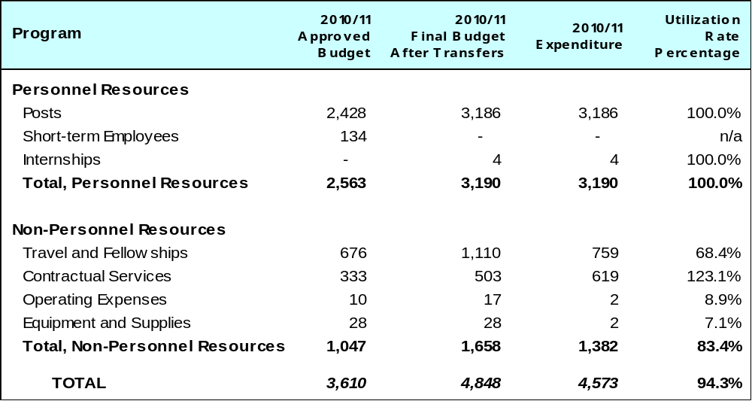

A. Budget after Transfers 2010/11

Additional activities on legislative and policy advice on patents and utility models were assigned to this Program during 2010, and resource allocations for the Program were adjusted accordingly. The Program was also assigned incremental resources of approximately 0.2 million Swiss francs for two DA projects: “IP and Competition Policy” and “IP and the Public Domain”.

B. Budget Utilization 2010/11

Budget utilization in respect of non-personnel resources amounted to 83.4 percent of the 2010/11 final budget after transfers. The underspend is attributable to the postponement of a regional meeting on patent-related flexibilities, initially planned to be held in the second half of 2011, as well as to cost-containment measures introduced across the Organization in the course of the biennium, in particular in relation to travel.

PROGRAM 2 TRADEMARKS, INDUSTRIAL DESIGNS AND GEOGRAPHICAL INDICATIONS

Program Manager Ms Binying Wang

ACHIEVEMENTS IN THE 2010/11 BIENNIUM

The Standing Committee on the Law of Trademarks, Industrial Designs and Geographical Indications (SCT) held four sessions and made progress on a number of specific topics in the areas of trademark and industrial design law. In particular, the SCT published two reference documents in the area of Grounds for Refusal of all Types of Marks (WIPO/STrad/INF/5) and concerning Technical and Procedural Aspects Relating to the Registration of Certification and Collective Marks (WIPO/STrad/INF/6). The SCT undertook work in the area of the protection of names of States against registration or use as trademarks, for which it could compile 71 returns from WIPO Members to a questionnaire and present them in the form of a draft reference paper, which forms a basis for further work on that topic (document SCT/25/4). The role and responsibility of Internet intermediaries in the field of trademarks was discussed by the SCT, which decided at its twenty-sixth session the modalities for an information meeting on that topic to take place back to back with the twenty-seventh session of the SCT. Furthermore, the SCT advanced work on industrial design law and practice and agreed that, as a possible path to move ahead, a diplomatic conference for the adoption of a design law treaty could be convened once sufficient progress has been made and the time was ripe for recommending the holding of such a diplomatic conference (see document SCT/25/6, paragraph 14).

The Working Group for the Review of Rule 3(4) to (6) of the Regulations under the Singapore Treaty on the Law of Trademarks met in one session on June 28 and 29, 2010 and agreed on a number of rule changes concerning the representation of non-traditional marks. Those changes were adopted by the STLT Assembly at its second session (see document STLT/A/2/2).

In the course of the biennium, nine States became party to the Singapore Treaty on the Law of Trademarks, bringing the overall number of ratifications by the end of 2011 to 25, of which 23 are effective. This result shows that the Singapore Treaty continues to be regularly implemented by Member States.

In cooperation with the National Institute for the Defense of Competition and the Protection of Intellectual Property (INDECOPI) of Peru, the Secretariat organized a Worldwide Symposium on Geographical Indications, which took place in Lima from June 22 to 24, 2011. The Symposium was attended by more than 400 participants and addressed the topic of geographical indications from an interdisciplinary point of view, including its legal, economic and administrative dimensions. Feedback from participants indicated that the approach chosen, namely to address the topic beyond the traditional legal and trade-oriented boundaries, was much welcomed as it enabled an informed exchange of views between panelists and participants.

Throughout the biennium, the Secretariat continued to administer Article 6ter Paris Convention communication procedures by way of four periodical electronic publications (at the end of the months of March and September, respectively), by which an overall 33 States and 19 international IGOs requested the communication of a total of 411 individual signs under Article 6ter(3). This periodical electronic communication replaces individual communications of paper copies to States party to the Paris Convention and members of the WTO not party to that Convention. Moreover, the Secretariat developed an internal database for the storage and retrieval of all Article 6ter relevant communications, which also serves as a paperless backup of all historic and current Article 6ter files.

IMPLEMENTATION OF THE DEVELOPMENT AGENDA

The Program devised the trademark component of the DA project DA_16_20_01 on “Intellectual Property and the Public Domain”. In this context a Study on Misappropriation of Signs were finalized and presented to the ninth session of the CDIP. The Program also provided advice to the project on IP and Product Branding for Business Development in Developing Countries and LDCs. The design, planning and implementation of activities undertaken by Program 2 were undertaken in accordance with the relevant DA Recommendations.

PERFORMANCE DATA

Expected Result: Progress achieved in the development of a balanced multilateral legal framework for trademarks, industrial designs and geographical indications
Performance Indicators | Baselines | Performance Data | TLS
Areas of convergence in Member States’ industrial design laws and practice; and trademark laws concerning grounds for refusal of all types of marks, and concerning technical and procedural aspects relating to the registration of certification and collective marks; better understanding of the use and effects of letters of consent to trademark registrations | Revised working documents in the area of the baseline description. No working document on protection of country names. First version of Regulations under the Singapore Treaty | Agreement by SCT on the possible holding of a diplomatic conference in the area of industrial design law and practice, subject to sufficient progress made  Agreement by SCT on reference documents in the area of Grounds for Refusal of all Types of Marks (WIPO/STrad/INF/5) and concerning Technical and Procedural Aspects Relating to the Registration of Certification and Collective Marks (WIPO/STrad/INF/6)  Draft reference paper on the protection of country names (SCT/25/4)  Revised Rule 3(4) to (10) adopted by the STLT Assembly | Fully Achieved
Expected Result: Increased number of ratifications of or accessions to the Singapore Treaty on the Law of Trademarks
Performance Indicators | Baselines | Performance Data | TLS
At least 10 ratifications of or accessions to the Singapore Treaty on the Law of Trademarks | 17 ratifications or accessions out of which 15 were effective | During the period under review, the following nine States became party to the Singapore Treaty: Croatia, Italy, Lichtenstein, Mongolia, Serbia, Slovakia, Sweden, the former Yugoslav Republic of Macedonia and Ukraine | Fully Achieved
Expected Result: Evaluation of the progress of the assistance related to efforts for the implementation of the Singapore Treaty and of the benefits resulting from such implementation has been finalized
Performance Indicators | Baselines | Performance Data | TLS
Issues limiting implementation of the Singapore Treaty and the benefits resulting from such implementation have been identified | No previous evaluations | Report on the assistance related to implementation efforts and the benefits resulting from such implementation (paragraph 8 of the Resolution Supplementary to the Singapore Treaty) presented to the third (second ordinary) session of the Singapore Treaty Assembly (STLT/A/3/1) and noted by that Assembly | Fully Achieved
Expected Result: The efficient administration of Article 6ter of the Paris Convention is ensured
Performance Indicators | Baselines | Performance Data | TLS
Savings in staff and non-staff resources due to: (a) the replacement of paper-based communications by electronic publication; and (b) the development of a database for the management of Article 6ter records, permitting the retrieval of data for electronic publication | (a) March 31, 2009; and  (b) no database available | (a) 52 requests for communication (made by 33 Member States and 19 IGOs) covering a total of 411 signs were communicated through electronic publication  (b) Internal database developed and fully operational | Fully Achieved
Expected Result: Better understanding among Member States of different existing approaches to the protection and use of geographical indications and the legal, administrative, socio-cultural and economic issues underlying to the implementation of such approaches
Performance Indicators | Baselines | Performance Data | TLS
Member States feedback on the issues paper on geographical indications to be presented for discussion at the SCT | No current work on geographical indications by the SCT | No current work on GIs in the SCT due to disagreement among Members on this topic, although item remained on SCT agenda  GIs remained under discussion within WIPO through holding of a worldwide symposium on GIs in June 2011 in Lima | Partially Achieved
BUDGET AND ACTUAL EXPENDITURE

Actual Expenditures (personnel and non-personnel) vs. Budget after Transfers 2010/11
(in thousands of Swiss francs)
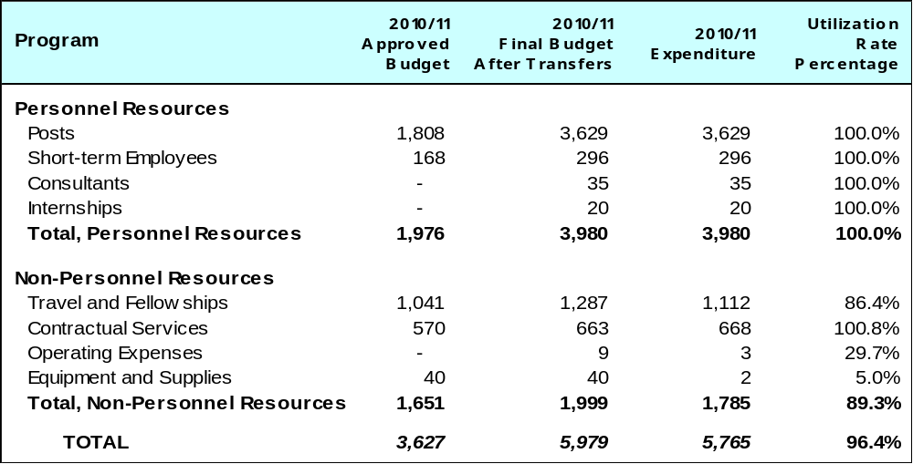

A. Budget after Transfers 2010/11

Additional responsibilities for legislative and policy advice on trademarks were assigned to this Program during 2010. Resource allocations for the Program were adjusted accordingly. The Program was also assigned incremental resources of approximately 0.13 million Swiss francs for two DA projects: “IP and Competition Policy” and “IP and the Public Domain”.

B. Budget Utilization 2010/11

Lower than expected utilization of resources in the 2010/11 biennium was primarily due to lower than expected expenditure on third-party travel in connection with the SCT. In addition, expenditure was lower than expected for DA project related activities.

PROGRAM 3 COPYRIGHT AND RELATED RIGHTS

Program Manager Mr. T. Clarke

ACHIEVEMENTS IN THE 2010/11 BIENNIUM

The work of this Program focused on four main areas: advancing the normative work in the Standing Committee on Copyright and Related Rights (SCCR), advancing WIPO’s role in addressing the challenges copyright is facing in the digital environment, strengthening copyright infrastructure and building confidence in developing countries while encouraging the pursuit of the economic advantages available through the copyright system.

As regards normative work, a recommendation to convene a Diplomatic Conference on the Protection of Audiovisual Performances was made by the WIPO Assemblies in 2011. In addition, progress was achieved in the SCCR towards agreement on the content of an international instrument on limitations and exceptions with respect to visually impaired persons/persons with print disabilities, as well as on a work plan on the protection of broadcasting organizations.

Legislative assistance on copyright matters was provided to various requesting Member States enabling them to upgrade and modernize their legal and regulatory framework.

As a result of the new complexities in the digital world, the Digital Future project has been embracing the interests of Governments and private stakeholders to assess the challenges faced by the copyright system. The project developed a series of effective platforms for dialogue among private and public stakeholders in areas where a need has been identified to find common ground for the diffusion of creativity in the on-line environment, such as identification of rights, licensing, contracts and the role of Internet Intermediaries in the field of copyright.

Under the International Music Registry (IMR), WIPO is facilitating a multi-stakeholder dialogue on the best approach to enable a reliable source of information on the different rights in different territories to help right owners to market their creations and help users to rapidly locate and pay for the content they wish to use. The recent release of a Study on the Role and Functions of the IMR, and the subsequent discussions among IMR stakeholders have greatly helped to clarify the possible functions of the IMR. The current IMR proposal, based on standard-setting, interconnecting infrastructure and making WIPO’s alternative dispute resolution expertise available, has been largely welcomed by representatives from industry. The scope of the IMR functionalities is now being narrowed down before assessing a possible transition to the implementation stage.

A Survey on Copyright Registration and Legal Deposit Systems was prepared in cooperation with 80 Member States of WIPO. The Member States’ responses illustrate the actual state of the registration and deposit systems around the world.

Concerning IGO licensing, WIPO has been partnering with several IGOs, including the ILO, UNESCO, FAO, OECD, UN, World Bank and WHO in 2010/11 in the pursuit of a more open approach to licensing and sharing of their copyright protected materials. A first draft is currently under discussion. Two approaches are being followed simultaneously. Firstly, the development of a Creative Commons license adapted to IGOs, and secondly, a new draft of a sui generis Open IGO license. This represents an important step towards the creation of a climate promoting creative and innovative activities while enabling the public to obtain easy access to data and research funded by IGOs.

Well-drafted contracts are key factors for an effective and balanced exercise of rights, ensuring both their exploitation and the equitable remuneration of creators. A Working Group was established with representatives from performers and producers, resulting in the publication of a WIPO Review of Contractual Considerations, which represents a balanced and comprehensive tool to promote the exercise of rights in the audiovisual sector, especially in developing countries.

Digital distribution of creative content is characterized by a multiplicity of new roles for Internet intermediaries such as search engines and ISPs, which may challenge traditional concepts of indirect responsibility for use and misuse of copyright material. In 2010/11, WIPO published two studies, attempting to find commonalities in the way that the responsibility of Internet Intermediaries is addressed in different jurisdictions. WIPO also organized a series of meetings in cooperation with the Internet Society (ISOC) to present and discuss this work.

A number of copyright initiatives were launched during the biennium. These initiatives included the T.A.G. of Quality (excellence in Transparency, Accountability and Governance), which aims to forge a partnership with key players in the creative community. The objective is that such partnership will agree a new international quality assurance standard in the collective management field which will (a) establish internationally-accepted norms of transparency, accountability and good governance; and (b) consolidate the best practices and procedures.

The WIPOCOS system for building collective management infrastructure continued to grow with a total of 19 installations in collective management organizations (CMOs) at the end of biennium. The system was fully upgraded into a five-modules-application, in cooperation with the Societies Council for the Collective Management of Performers’ Rights (SCAPR), to better cater to the needs of the collective management industry. In addition, the system was supplemented with the development of an automated data capture and matching application to facilitate and enhance royalties’ distribution by the societies.

The Gestion del Derecho de Autor (GDA) system, currently used by 10 Member States to automate voluntary records of copyright protected material, has been expanded beyond Latin America and is now also in service in Ghana and being evaluated in Jamaica and Kenya. The software application has been improved and new features added, such as for example an English interface.

Significant progress was made on the Stakeholders’ Platform of the WIPO-led Visually Impaired Persons (VIP) initiative with the launch of the Enabling Technologies Framework (ETF) and the Trusted Intermediary Global Accessible Resources (TIGAR) projects with participation from the private sector and from NGOs representing the interests of the visually impaired.

Eleven trusted intermediaries (TIs) serving the VIP community in both developing and developed countries and 20 right holders including major publishing houses have participated in the TIGAR project. Exchange of copyright protected books in accessible formats among participating TIs commenced in October 2011.

Working closely with Member States, over 70 training and other capacity building programs at national, sub-regional, regional and interregional levels were organized with the participation of more than 3,800 Government officials, managers, experts and other related professionals from 118 developing countries and LDCs. These activities contributed to the improvement of the awareness of the cultural and economic relevance and importance of copyright and related rights among different stakeholders as well as the enhancement of the institutional and human capacity of national copyright offices and other related institutions of these countries. The copyright development work has, in particular, been focused on encouraging adoption of appropriate IP policies, strengthening the legal framework, establishing progressive copyright institutions while pursuing the commercial exploitation of the local culture.

As regards creative industries, the geographical coverage of national studies providing evidence to policy makers and creative industries stakeholders on the economic contribution of copyright was expanded to an additional 13 Member States. Ten of these studies were published in the Creative Industries series. The demand for new studies continued to grow. The results of the studies have been used in developing policies for promoting the creative industries, enhancing awareness of the economic potential of the creative sector and capacity-building activities in 19 countries (Algeria, Azerbaijan, Bulgaria, Brazil, China, Colombia, Croatia, Indonesia, Jamaica, Jordan, Lesotho, Lithuania, Malawi, Philippines, Saint Lucia, Swaziland, Thailand, Viet Nam and Zimbabwe). A detailed analysis of the results of WIPO studies in this area was also prepared and made available to Member States. The increased use of the WIPO Guide on assessing the economic contribution of copyright-based industries in national economies has confirmed the applicability and acceptability of WIPO methodology for measuring the economic contribution of copyright-based industries and its adoption as one of the main instruments for producing evidence for policy making in this area.

Broader use was also made of creative industries training material in capacity-building activities which were undertaken in Antigua and Barbuda (for Member states of OECS), Bulgaria, China, Croatia, Indonesia (for Member States of ASEAN/SAARC countries), Jamaica, Kenya, Philippines and Thailand, while seven high level conferences have made specific use and referred to WIPO materials on creative industries, including in Brazil, Colombia and Thailand.

All creative industries tools for creators were translated into French and Spanish and some tools were also translated in Arabic, Chinese and Russian, making the WIPO tools accessible to a broader audience. New tools on Managing Intellectual Property in the Advertising Industry and on Copyright Ownership and Distribution Issues in the Film Industries were published and used in capacity-building activities. Substantial progress has been made in the work on the preparation of a Guide on Assessing the Economic, Social and Cultural Impact of Copyright in the creative industries and in the development of a methodology for measuring copyright piracy.

IMPLEMENTATION OF THE DEVELOPMENT AGENDA

The Program was engaged in the implementation of four DA projects:

- Under Project DA_10_04 “Strengthening the Capacity of National IP Governmental and Stakeholder Institutions to Manage, Monitor and Promote Creative Industries, and to Enhance the Performance and Network of Copyright Collective Management Organizations” WIPO measurement tools for assessing the economic contribution of the creative industries, specialized training modules on collective management and collective management business rules and CMOs assessment were developed.

- Under Project DA_16_20_01 on “Intellectual Property and the Public Domain”, A Scoping Study on Copyright and Related Rights and the Public Domain was prepared by an external expert. This study was published on the WIPO website and presented to the CDIP in its sixth session. Discussions on this study have been ongoing since the sixth session. The Committee is still discussing the Study since its sixth session. In addition, the second survey on voluntary registration and deposit systems, including responses from 80 member States and a Survey on private copyright documentation systems and practices have been made available on the WIPO website.

- Under Project DA_7_23_32_01 on “IP and Competition Policy” a Global Meeting on Emerging Copyright Licensing Modalities was held. The global meeting provided an opportunity for the exchange of national and regional experiences and information on the interplay between copyright and competition policies, examining, among others, licensing practices flowing from different business and management models and the compatibility between traditional licenses and emerging forms of licensing in the new technological environment.

- Under Project DA_19_24_27_01 on “IP, Information and Communication Technologies (ICTs), the Digital Divide and Access to Knowledge” a Study on Using Copyright to Promote Access to Information and Creative Content was prepared by a group of external experts. This study was presented to the ninth session of the CDIP.

- A study has been completed on the Impact of Recession on the Performance of Creative Industries. This study fits into the spirit of the Development Agenda Recommendations 4, 34, 35 and 37.

The design, planning and implementation of activities undertaken by Program 3 were informed by the relevant DA Recommendations.

PERFORMANCE DATA

Expected Result: Contribution to the development of the international copyright and related right policy and legal framework and of a global copyright infrastructure
Performance Indicators |  | Baselines | Performance Data | TLS
Increased number of Member States that have benefited from legislative advice on various copyright and related rights issues |  | 14 Member States benefited (2008/09) | A total of 20 Member States benefited: Andorra, Antigua and Barbuda, Bahamas, Barbados, Cook Islands, Indonesia, Iran, Iraq, Jamaica, Bhutan, Kuwait, Liberia, Mauritius, Montenegro, Mozambique, Namibia, Saudi Arabia, Sierra Leone, Thailand, Trinidad and Tobago | Fully Achieved
Number of countries that have used their study on the economic impact of creative industries for their policy development |  | 10 countries used studies for policy development (end 2009) | 8 additional countries have used the studies as a basis for policy input (Azerbaijan, Bulgaria, Colombia, Indonesia, Jamaica, Kenya, Philippines, Thailand)  13 national studies were initiated in the biennium (Albania, Australia, Jordan, Lithuania, Bhutan, Brunei Darussalam, China, Indonesia, Thailand, Pakistan, Finland, Panama and Slovenia) of which 10 were finalized and published. Efforts were made to relaunch a national study in Morocco | Fully Achieved
Number of collective management organizations (CMOs) by which WIPOCOS have been deployed in an streamlining manner |  | WIPOCOS was installed and/or further upgraded in 10 CMOs in 2008/09 | WIPOCOS was deployed in 19 CMOs (15 in Africa and 4 in ASPAC). Africa: Botswana, Burundi, Cameroon, Chad, Côte d’Ivoire, Ethiopia, Ghana, Guinea, Kenya (in 2 CMOs KAMP and PRSK), Madagascar, Mali, Nigeria, Rwanda, Zanzibar. ASPAC: Nepal, Indonesia (2 CMOs: PRISINDO and GAPRINDO) and the Philippines  WIPOCOS 5-Module System Development and Enhancement fully completed (in cooperation with SCAPR, a performers NGO)  WIPOCOS Re-Engineering Project, to be built on modern technology platforms with international data connectivity and cloud computing system, was launched | Fully Achieved
Decisions and requests resulting from the SCCR |  | 30 decisions and requests (2008/09) | 20 decisions and requests for action resulted from the SCCR sessions and were addressed | Fully Achieved
Improved access to published works on the part of the visually impaired and other categories suffering from disabilities |  | 10 countries with policies on behalf of visually impaired people (2008/09) | 42 countries engaged in policy dialogue at national and/or international level with the objective of improving access of visually impaired persons to copyrighted works  11 trusted intermediaries (TIs) serving people with print disabilities from developing and developed countries have participated in the TIGAR project. The TIs are from Australia, Brazil, Canada, Denmark, France, New Zealand, Norway, South Africa, Sweden, Switzerland and the United States of America  Exchange of books in accessible formats among participating TIs commenced in October 2011 | Fully Achieved
Expected Result: Increased awareness and capacity of Member States in copyright and related rights
Performance Indicators |  | Baselines | Performance Data | TLS
Number of meetings/ conferences/seminars by organization and country where WIPO was invited to disseminate information related to copyright and related rights |  | 45 events in 23 countries (2008/09) | Over 70 events were organized in 52 countries by the Copyright Development Services  40 events in 25 countries (creative industries)  6 events for 15 countries by the Singapore Office | Fully Achieved
Number of requests received from governments and other stakeholders to help improve understanding of how technological developments impact on copyright |  | 95 requests in 2008/09 | Over 100 requests received in 2010/11 | Fully Achieved
Number of experts in the copyright and related rights area by country and organization participating in WIPO seminars and capacity building activities (in cooperation with TACB) |  | 3,700 participants in 2008/09 in creative industries related events | Over 3,800 officials, experts and other related professionals participated in the meetings, seminars and other capacity building activities in the field of copyright and related rights organized by WIPO | Partially Achieved
Expected Result: Clarification of current emerging issues on copyright and related rights to Member States, creative industries, right owners and users
Performance Indicators |  | Baselines | Performance Data | TLS
Number of citations by publication/ published studies |  | Baseline not available | Data not available | Dis-continued
User number of the studies, tools and guidance materials published on the WIPO web site by country and organization (Web site hits) |  | About 200,000 hits on the Sector's major web pages, and about 15 emails received on average daily on matters concerning copyrights and related matters | About 480,000 hits on the Sector’s major web pages (all languages combined), and about 1,650 emails received on matters concerning copyright and related matters | Fully Achieved
Number of co-authored papers (done jointly between WIPO and other organization/s) |  | Baseline not available | 2 joint reports on the Creative Economy among which the Creative Economy Report coordinated with UNDP and UNCTAD | Fully Achieved
Expected Result: Increased awareness and capacity of Member States in copyright and related rights, and enhanced knowledge in the management of IP-based assets by creative enterprises
Performance Indicators | Baselines |  | Performance Data | TLS
Number of countries that have requested and used WIPO tools on the management of copyright/IP in specific creative industries | 10 national/regional workshops based on WIPO tools for specific creative industries (end 2009) |  | 20 national/regional workshops based on WIPO tools for specific creative industries. The events were held in 17 countries (Algeria, Antigua and Barbuda, Azerbaijan, Bulgaria, Brazil, China, Colombia, Croatia, Indonesia, Jamaica, Kenya, Lesotho, Lithuania, Malawi, Philippines, Thailand and Viet Nam)  Awareness and capacity building activities on the use of copyright management tools for CMOs in 3 countries (Cambodia, Indonesia and the Philippines) by Singapore Office | Fully Achieved
Number of workshops/seminars held on specific creative industries (documents, publications distributed) | 25 conferences and workshops based on WIPO tools (end 2009) |  | WIPO tools (publications on managing IP in specific creative industries) were distributed to participants of the 20 national/regional workshops and used in 32 conference, workshops, etc. | Fully Achieved
Expected Result: Clarification of current emerging issues on copyright and related rights to Member States, creative industries, right owners and users
Performance Indicators | Baselines |  | Performance Data |  | TLS
Development of new guides/studies on the economic, social and cultural impact of copyright in the creative industries | One tool developed in previous period |  | One IMR stakeholder dialogue launched; publication of the Study The Role and Functionalities of the International Music Registry  One IGO Open License stakeholder dialogue launched. 2 Draft Licenses for IGOs prepared  Significant progress was made in the development of guidelines to measure the economic, social and cultural impact of copyright in the creative industries |  | Partially Achieved
Development of new tools providing practical information on licensing and financing in specific creative industries | Three WIPO publications and one joint publication WIPO/UNDP/UNCTAD/UNESCO  Two Regional Seminars dealing with Licensing in the digital environment (one on software, another on UGC) |  | 2 new tools completed and published (Managing Intellectual Property in the Advertising Industry, and Copyright Ownership and Distribution Issues in the Film Industry). The tool “How to Make a Living from Music” is being updated  The International Conference on Emerging Licensing Modalities provided important clarifications regarding the interface between copyright and open licensing  3 Seminars and 2 Studies on the Role and Responsibility of Internet Intermediaries initiated a balanced and comprehensive international debate on this key issue |  | Partially Achieved

BUDGET AND ACTUAL EXPENDITURE

Actual Expenditures (personnel and non-personnel) vs. Budget after Transfers 2010/11
(in thousands of Swiss francs)

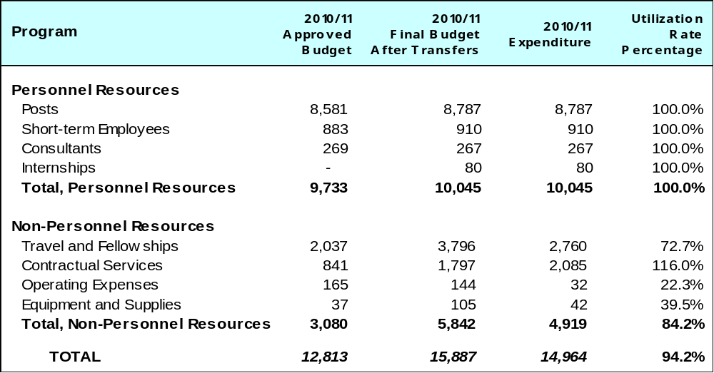

A. Budget after Transfers 2010/11

Copyright Development Activities were transferred to this Program with an associated resource allocation from Programs 9 and 15. In addition, the Program was assigned incremental resources of approximately 0.39 million Swiss francs for 2010/11, for three DA projects: “IP and Competition Policy”, “IP and the Public Domain” and “IP, Information and Communication Technologies (ICTs), the Digital Divide and Access to Knowledge”.

B. Budget Utilization 2010/11

Budget utilization in the biennium (non-personnel resources) amounted to 84.2 per cent, primarily due to the postponement of several workshops on the management of copyright in creative industries, and the rescheduling of the International Conference on IP and Creative Industries following the decision to make it a biennial event. Also, several national studies on the economic contribution of copyright industries were carried over to the next biennium in coordination with the respective Governments. The Seminar on Copyright in India was postponed from 2011 to 2012 at the request of the Government. The Regional Seminar on Copyright for Latin American countries, initially planned as a co-funding event, was fully funded by the WIPO Academy. Furthermore, the implementation of some activities related to the Copyright Information System (GDA) and the Visually Impaired Persons and other Persons with Print Disabilities (VIP) initiative was carried over to the next biennium. Cost savings were also achieved following the reduction of the number of staff missions.

PROGRAM 4 TRADITIONAL KNOWLEDGE, TRADITIONAL CULTURAL EXPRESSIONS AND GENETIC RESOURCES

Program Manager Mr. J. C. Wichard

ACHIEVEMENTS IN THE 2010/11 BIENNIUM

The 2010/11 biennium saw considerable progress in the negotiations of the WIPO Intergovernmental Committee on Intellectual Property and Genetic Resources, Traditional Knowledge and Folklore (the IGC). Under its new mandate for the biennium established in late 2009, the IGC, and its Intersessional Working Groups (IWGs), met seven times (IGCs 16, 17, 18 and 19, and IWGs 1, 2 and 3). Overall, a cooperative and focused working atmosphere characterized these sessions, and significant progress was made in the IGC’s “text-based negotiations”. By the end of the biennium, the IGC had developed single negotiating texts on traditional knowledge (TK) and traditional cultural expressions (TCEs). Progress was also made on genetic resources (GRs) on the basis of several documents and proposals. The WIPO General Assembly in September 2011 recognized the progress made by the IGC in 2010 and 2011 and decided to renew its mandate for the 2012/13 biennium. In addition to the Secretariat facilitating the IGC’s negotiations, a number of initiatives to increase participation in the IGC process and improve communications were undertaken. A fund-raising drive for the WIPO Voluntary Fund for Accredited Indigenous and Local Communities was launched and WIPO Indigenous IP Law Fellows were appointed for 2010 and 2011. The WIPO Traditional Knowledge Division’s website was restructured and regularly updated, electronic TK updates and newsletters were sent to several thousand subscribers and, as from 2010, the Secretariat began to offer Informal Information Sessions to Geneva-based delegates before each IGC and IWG session.

Capacity-building and other technical assistance activities undertaken in the biennium, upon request, served to increase understanding of the issues, the development of legislation and the forging of practical solutions at the regional, national and community levels, complementing the IGC’s normative work. Most notably, international meetings were organized in India, Oman and the Russian Federation, and a WIPO Creative Heritage training program on cultural documentation and IP management was held for communities in Jamaica. Assistance provided to ARIPO over several years culminated in the adoption by ARIPO Member States of a regional instrument on TK and TCEs. WIPO continued contributing as a technical partner to regional projects, such as a regional framework on TK, TCEs and GRs for the Caribbean, the TK Action Plan in the Pacific and a Global Environmental Facility-funded project in certain Latin American and Caribbean countries on the implementation of access to GRs and benefit-sharing regimes

Regarding developments in other fora, a significant event was the adoption of the Nagoya Protocol on Access to Genetic Resources and the Fair and Equitable Sharing of Benefits Arising from their Utilization to the Convention on Biological Diversity. WIPO followed the development of this Protocol closely, as well as developments in other key fora, mindful that the IGC’s mandate stipulates that the negotiations of the IGC should be without prejudice to the work pursued in other fora.

IMPLEMENTATION OF THE DEVELOPMENT AGENDA

The design, planning and implementation of activities by Program 4 were informed and guided by the relevant DA Recommendations. The Program’s norm-setting activities within the IGC continued to be inclusive and member-driven (Recommendation 15), duly considering the boundaries, role and contours of the “public domain” (Recommendations 16 and 20) and taking into account flexibilities in international IP agreements (Recommendation 17). The IGC’s negotiations were based upon open and balanced consultations (Recommendations 21 and 42) while being supportive of the UN development goals (Recommendation 22). The conclusion of the IGC’s negotiations is the subject of Development Agenda Recommendation 18, which urges the Committee “to accelerate the process on the protection of genetic resources, traditional knowledge and folklore, without prejudice to any outcome, including the possible development of an international instrument or instruments. (Recommendation 18)”. The Program’s technical assistance, capacity-building and legislative assistance activities were development-oriented, demand-driven and reported on in the normal course (Recommendations 1 and 13). The protection of TK, TCEs and GRs contributes to the mainstreaming of development considerations into WIPO’s work and the understanding and use of flexibilities (Recommendations 12 and 14). On participation, funding and other institutional matters, the IGC’s ad hoc NGO accreditation mechanism and the WIPO Voluntary Fund for Accredited Indigenous and Local Communities assisted in ensuring wide participation of civil society (Recommendation 42).

PERFORMANCE DATA

Expected Result: A stronger international legal and policy framework protecting TK and TCEs for the economic and cultural benefit of communities and other TK and TCE holders and their countries
Performance Indicators | Baselines | Performance Data | TLS
Adoption of an international instrument addressing IP and the protection of TK and TCEs | Comprehensive, substantive information base from which an instrument could be prepared, but diverse views among States as to the content and legal character and scope of any instrument | Draft texts on TK and TCEs prepared as a basis for ongoing negotiations  Mandate of the IGC renewed by the WIPO General Assembly for the 2012/13 biennium | Partially Achieved
Expected Result: Enhanced capacity at the regional, national and community levels to make use of IP principles and systems for the protection of TK and TCEs, and for management of the relationship between IP and genetic resources, for the economic and cultural benefit of communities and other TK and TCE holders and their countries
Performance Indicators | Baselines | Performance Data | TLS
Number of regional and national policy and legal processes using WIPO policy documents and legal materials. Target: Eight | 12 processes in 2008/09 | WIPO policy documents and legal materials were used in regional processes in Africa, the Pacific, Latin America, the Caribbean and Countries with Economies in Transition, and in national processes in 16 countries | Fully Achieved
Number of community, national or regional capacity-building activities that make actual use of WIPO materials and expertise. Target: 10 | 26 activities in 2008/09 | 39 distinct capacity-building activities | Fully Achieved
Expected Result: Greater cooperation and coordination between the work of WIPO and that of other international processes concerning TK, TCEs and genetic resources
Performance Indicators | Baselines | Performance Data | TLS
Number of processes of other international fora and agencies which explicitly recognize WIPO’s distinct technical IP expertise and input. Target: Four | 14 processes in 2008/09 | 9 processes during the 2010/11 biennium: WIPO was invited to participate in and provide IP-related information to meetings and activities of the CBD, WTO, FAO, OHCHR, WHO, the UN Permanent Forum on Indigenous Issues, the Expert Mechanism on the Rights of Indigenous Peoples, UNESCO and the Interagency Support Group on Indigenous Issues | Fully Achieved
Number of joint publications or activities between WIPO and other international agencies. Target: Three | Seven joint publications or activities in 2008/09 | 5 joint publications or activities during the 2010/11 biennium. WIPO contributed to publications by the WHO and WTO (a joint publication with WIPO) and UNCTAD, and continued to cooperate in multi-faceted projects with the Global Environmental Facility, the Pacific Islands Forum Secretariat and the Secretariat of the Pacific Community | Fully Achieved

BUDGET AND ACTUAL EXPENDITURE

Actual Expenditures (personnel and non-personnel) vs. Budget after Transfers 2010/11
(in thousands of Swiss francs)
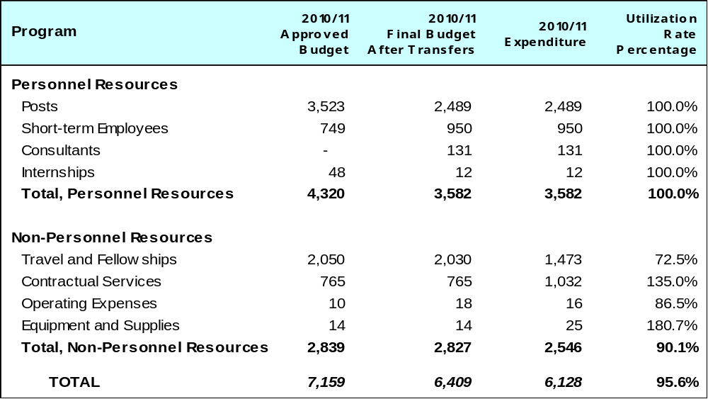

A. Budget after Transfers 2010/11

The budget after transfers 2010/11 compared to the approved budget 2010/11 reflects a decrease in personnel resources due to post vacancies as well as transfer of personnel from the Program during the course of 2010/11.

B. Budget Utilization 2010/11

The under-utilization of non-personnel resources was mainly due to savings realized through cost efficiencies related to travel and to the postponement of some activities. The over-spend under contractual services resulted from higher interpretation costs related to the organization of four IGCs and three IWGs in 2010 and 2011 versus the four IGCs planned for in the Program and Budget 2010/11.

PROGRAM 5 THE PCT SYSTEM

Program Manager Mr. J. Pooley

ACHIEVEMENTS IN THE 2010/11 BIENNIUM

The International Bureau received approximately 181,900 record copies in 2011, representing an increase of 11 percent compared to 2010. The share of fully electronic filing methods kept increasing in 2011 and now represents 82 per cent of total filings. While English remains by far the most important language of filing, its importance has diminished relative to Japanese, Chinese and Korean. The share of the PCT applications filed in Japanese, Chinese and Korean has increased from 29 per cent in 2010 to 33 per cent in 2011. The average cost of processing a published PCT application has decreased by nine per cent in 2011 compared to 2010, and reached 747 Swiss Francs. This decrease is explained by the fact that 7.7 per cent more PCT applications were published in 2011 than in 2010, while overall costs decreased slightly. Quality has improved markedly from 2007 until the first half of 2011. However, as of the second half of 2011 a regression in quality can be observed, explained by increased delays in the republication of PCT applications and in the transmission of the notification of receipt of a PCT application. Further information and details are contained in the Annex on Indicators for PCT Operations.

The further development of the PCT system remained an important focus of Member States and the International Bureau during the 2010/2011 biennium. Based on a study by the International Bureau entitled “The Need for Improving the Functioning of the PCT System”, the PCT Working Group, at its June 2010 session, endorsed a series of recommendations covering a variety of actions which should be undertaken by the International Bureau, applicants, Contracting States and national Offices (acting in both their national and international capacities) to make the PCT system more effective both for processing patent applications and for supporting dissemination of technical information, technology transfer and technical assistance for developing countries. Work towards implementing those recommendations continued throughout the biennium. Efforts focusing on improving the quality of international search and preliminary examination reports have resulted in the agreement by Member States on the establishment of a third party observations system and a quality feedback system for national Offices, both of which will become operational in 2012. Discussions continue on various other proposals aimed at improving the quality and the utility of PCT search and preliminary examination reports, such as, in particular, the development of “quality metrics” for international reports and ways to more directly measure the utility of those reports during the national phase of procedures.

Significant efforts were made to use technological tools for PCT information dissemination and outreach to PCT users. PCT recent development-themed webinars were offered free of charge in 10 languages, with almost 1,300 persons participating, and more than 7,400 persons from 142 countries took the basic PCT distance learning course. Important to the continued success of the PCT system, PCT staff continued to make sustained efforts to maintain close contact with and foster close relationships with PCT applicants.

The International Bureau continued making efforts in conducting various tailor-made cooperation activities with PCT Member States, Offices and International Authorities, as well as countries interested in joining the PCT. The activities covered, inter alia, staff training and technical, legal, operational and administrative issues for better implementing the PCT and promoting PCT use, both nationally and regionally. Training activities and seminars focused, in particular, on Offices in developing countries and LDCs, and universities, research institutions and interested circles in those countries. Technical cooperation activities focused on the electronic exchange of documents and data between the International Bureau and Offices, resulting in 86 per cent of the International Bureau’s incoming documents from Offices being received in electronic form in 2011. The International Bureau collects feedback systematically from PCT Member States, Offices and International Authorities to improve these cooperation activities.

IMPLEMENTATION OF THE DEVELOPMENT AGENDA

An important part of the work of the Program involves the promotion of the PCT system and technical cooperation and assistance to developing countries and LDCs. This work directly contributes to the implementation of DA Recommendations 10, 11 and 31. In addition, during 2010, a study entitled “The Need for Improving the Functioning of the PCT System” (PCT/WG/3/2) was prepared. Inter alia, this study looked into the issue of how well the PCT system was performing with regard to one of its main objectives, namely, to support technology transfer and technical assistance for developing countries, and in this context addressed the issue of how future development of the PCT could be matched with applicable DA recommendations, notably from Clusters A and C. Discussions on these issues continued in 2011 on the basis of further studies requested by Member States and presented to the fourth session of the PCT Working Group.

PERFORMANCE DATA

Expected Result: Containment of cost of receiving, processing and translating an international application
Performance Indicators | Baselines | Performance Data | TLS
Workload Indicators  (see annex) | Total record copies in 2009: 158,800 | See annex “Background”  Total record copies  2010: 162,000  2011: 181,900 | Fully Achieved
Productivity Indicators  (see annex) | Total unit cost in 2009:  821 Swiss francs | See annex “Unit cost of processing an application” and “Productivity of formality examination”  Total unit cost  2010: 756 Swiss francs  2011: 747 | Fully Achieved
Expected Result: Consistent, high quality services to PCT users
Performance Indicators | Baselines | Performance Data | TLS
PCT Quality indicator  (see annex) | Aggregate index Q4 2009: 90% | See annex “Aggregate quality of formality examination”, “Timeliness of formality examination”, “Timeliness of publication” and “Timeliness of republication”  Aggregate index Q4  2010: 95.3%  2011: 86.2% | Fully Achieved
Expected Result: Continued use of technological tools for PCT information dissemination and outreach to users of the PCT
Performance Indicators | Baselines | Performance Data | TLS
Annual number of users of webinars, video conferences, and distance learning courses, et al. | Data not available | PCT Webinar attendees (10 languages):  2010: 543  2011: 755  PCT Basic DL Course users (10 languages):  2010: 4,122  2011: 3,319  Videoconferences:  Although consistently offered for PCT user training and outreach, very little uptake has yet been achieved | Partially Achieved
Expected Result: Close relationships with PCT applicants worldwide
Performance Indicators | Baselines | Performance Data | TLS
Regular contacts with PCT applicants worldwide | Data not available | Regular attendance and PCT presentations at IP owner and agent association meetings in the United States of America, Europe, Asia and Latin America (AIPLA, IPO, ABA, APAA, EPI, ASIPI, AUTM, FICPI, ICC, LES, ACPC, NAPP, etc.) and frequent contacts with large PCT users | Fully Achieved
Expected Result: A single consolidated processing environment supporting the PCT procedure
Performance Indicators | Baselines | Performance Data | TLS
Reduction in the use of the COR system by offices | 25 offices | The IB announced that the COR system would be decommissioned end 2011. PADOS, a modernized web services based ordering system has replaced it. In 2010, the number of offices using COR decreased to 11  By the end of 2011, all but 2 offices had migrated away from COR. The system is expected to stop operating in Q2 of 2012. | Fully Achieved
99% systems availability for agreed operations times | 98% internal systems availability; 99% external | Systems availability as a percentage:  2010 2011  Internal systems  Edossier 99.7 98.9*  External systems  COR 100 100  email 98.1 100  ePCT Pilot NA 94**  *In 2011 a fire resulted in 2 days downtime. Internal systems operated at 99.6% if one excludes this incident  ** As the ePCT is in a pilot phase, 99% availability was not required | Fully Achieved
% of users rating the systems as satisfactory and above | Data not available | Percentage of users expressing satisfaction with the internal systems following surveys conducted in 2010 and 2011:  2010 2011  Satisfied 74 79.5  Not satisfied 10.5 12  Undecided 15.5 8.5 | Fully Achieved
Expected Result: Considerable progress made in the establishment of a fully electronic PCT procedure
Performance Indicators | Baselines | Performance Data | TLS
85% of incoming documents arrive electronically | 79% of documents | Using the same page count oriented algorithm as in the baseline, 80% of documents were received electronically in 2010, and 86% in 2011 | Fully Achieved
Expected Result: Availability to applicants and Offices of confidential data and transactions via secure mechanisms in the PCT Customer Service Centre
Performance Indicators | Baselines | Performance Data | TLS
At least 500 registered users classified by countries | Services not yet deployed | Until December 2011, service was in a restricted pilot with only around 50 users (this quickly increased following the opening up of the system to around 600 users from 50 countries by the start of March 2012) | Partially Achieved
Services are adopted by at least five large applicants | Services not yet deployed | Target was literally met, since a majority of the users in the pilot represented large applicants or agents handling significant numbers of international applications. However, the focus of the pilot was changed at an early stage to focus on deep testing of functions within a limited range of international applications. Consequently, the users did not systematically adopt ePCT as part of the workflow for all international applications, as had been envisaged by the original target | Dis-continued
At least three functions are deployed that use a common identity management service | Services not yet deployed | Functionality was deployed significantly faster than initially projected; 12 major and many minor functions were included by the end of the period. | Fully Achieved
Expected Result: Intensified cooperation with, and improved coordination of activities of, PCT Offices and Authorities covering, inter alia, operational, technical, procedural, legal and training issues
Performance Indicators | Baselines | Performance Data | TLS
Feedback from Member States on the successful implementation of cooperation activities carried out “on request” or under formal cooperative work programs (joint International Bureau/Office evaluation) | Feedback data is not yet collected systematically | 95% overall satisfaction for PCT cooperative activities (2011)  Survey result*  Satisfied and above: 58 respondents  Partially satisfied and below: 3 respondents  Not applicable: 7 respondents  * 68 out of 149 offices and international authorities responded | Fully Achieved
Expected Result: Submission of proposals as to how the PCT system as a whole might be improved so that it delivers results which meet the needs of applicants and designated Offices of all types and which assist Offices in ensuring rapid resolution of rights in the national phase
Performance Indicators | Baselines | Performance Data | TLS
Timeliness of submission of proposals | % of working documents posted on WIPO website within the 2 month time limit: 0% for PCT/WG/3 | % of working documents posted on WIPO website before meeting:  - PCT/WG/4 (2010): 33% 5 weeks before, 66% 4 weeks before, 100% 3 weeks before;  - PCT/A/41 (2010): 100% 8 weeks before;  - PCT/WG/5 (2011): 45% 7 weeks before, 65% 6 weeks before, 100% 3 weeks before;  - PCT/A/42 (2011): 100% | Partially Achieved
Feedback from Member States on the quality of the proposals | n/a | Delegations of Member States represented at the 2010 and 2011 sessions of the PCT Working Group expressed their appreciation for the preparatory work for the sessions by the Secretariat, including the informal briefing sessions held in the run-up to the meetings, and for the quality of the working documents submitted for the consideration of the Working Group (see the reports of the sessions, documents PCT/WG/3/14 Rev. and PCT/WG/4/17) | Fully Achieved
Adoption of proposals by the appropriate PCT bodies | PCT/A/40: 100% | Adoption of proposals for amendment of the PCT Regulations:  PCT/A/41: 100%  PCT/A/42: 100% | Fully Achieved
Expected Result: More accessible legal and technological information concerning better applications available to member States, applicants, research institutions and the public
Performance Indicators | Baselines | Performance Data | TLS
Timely publication of complete searchable public information concerning PCT applications | Fully searchable formats not yet available in certain non-Roman character languages | All Chinese XML filings were made available on PATENTSCOPE as of July 2010. All XML filings from all receiving Offices including EPO and the IB as Receiving Office were also made available on PATENTSCOPE as of July 2011 | Fully Achieved
BUDGET AND ACTUAL EXPENDITURE

Actual Expenditures (personnel and non-personnel) vs. Budget after Transfers 2010/11
(in thousands of Swiss francs)

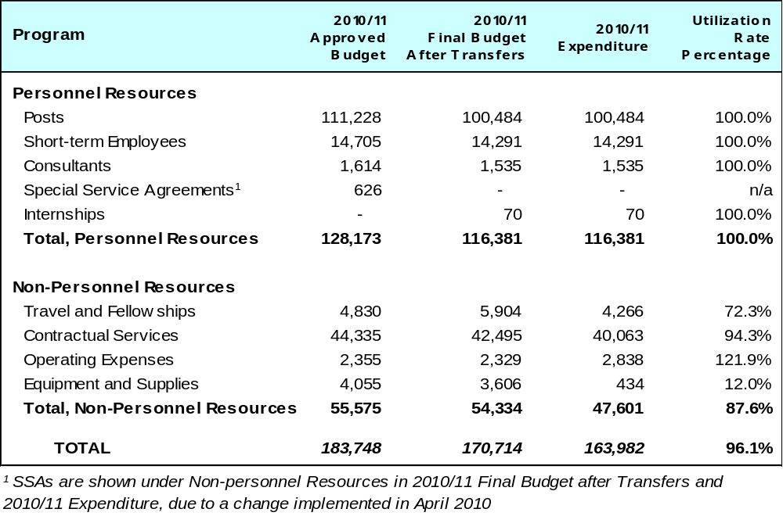

A. Budget after Transfers 2010/11

The budget after transfers 2010/11 compared to the approved budget 2010/11 reflects a decrease in personnel resources, primarily under PCT Operations, due to the departure of a number of staff under the Voluntary Separation Program (VSP).

B. Budget Utilization 2010/11

The under-utilization of non-personnel resources for the biennium is primarily due to lower than estimated costs for outsourced translations, a change in the financing strategy for the PCT operations disaster recovery infrastructure (leasing instead of purchase), and lower mailing costs due to wider acceptance of electronic communication of PCT forms to applicants.

[Annex on Indicators for PCT Operations follows]

Annex: Indicators for PCT Operations

Performance Indicators for the Expected Result
“Enhanced IB Operations”

Background

As background for the performance indicators for the expected result “Enhanced IB Operations”, it is useful to consider the evolution of:

- The PCT workloads;
- The language distribution of those workloads; and
- The number of staff assigned to process those workloads.

Workloads

The workloads are tracked on the basis of the yearly number of record copies received by the IB.

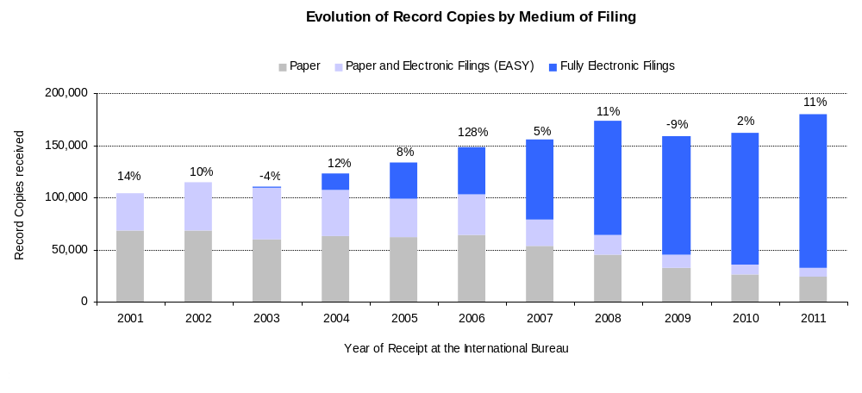

- The IB received approximately 181,900 record copies in 2011, representing an increase of 11% compared to 2010.

- The share of fully electronic filing methods kept increasing in 2011 and now represents 82% of total filings.

Language distribution

One fundamental development driving change in the IB is the increasing language diversity of filings, resulting, in particular, from increased usage of the PCT System in East Asian countries.

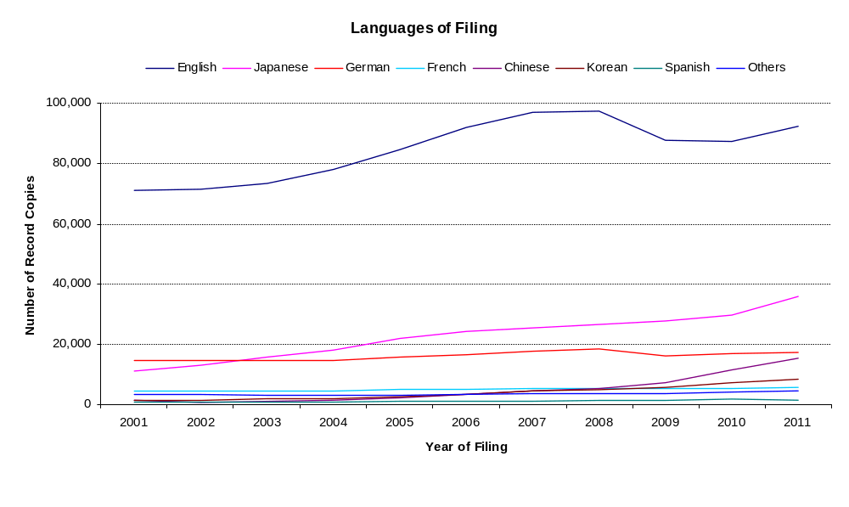
As can be observed, while English remains by far the most important language of filing, its importance has diminished relative to Japanese, Chinese and Korean. The share of the PCT applications filed in Japanese, Chinese and Korean has increased from 29% in 2010 to 33% in 2011. Zooming in on languages other than English provides the following picture:

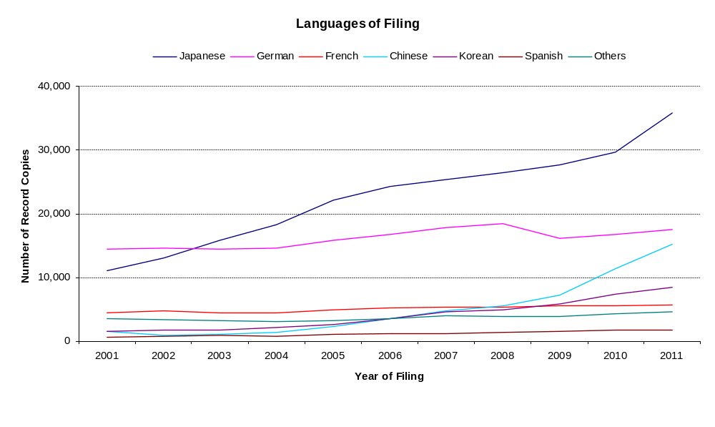
These evolutions put a considerable strain on the IB because it takes many years to adjust the language composition of the PCT Operations staff.

Staff
The chart below shows the number of PCT Operations staff since 2001, in Full Time Staff Equivalent (- FTSE - total number of full-time staff plus the full-time equivalent of the part-time staff).

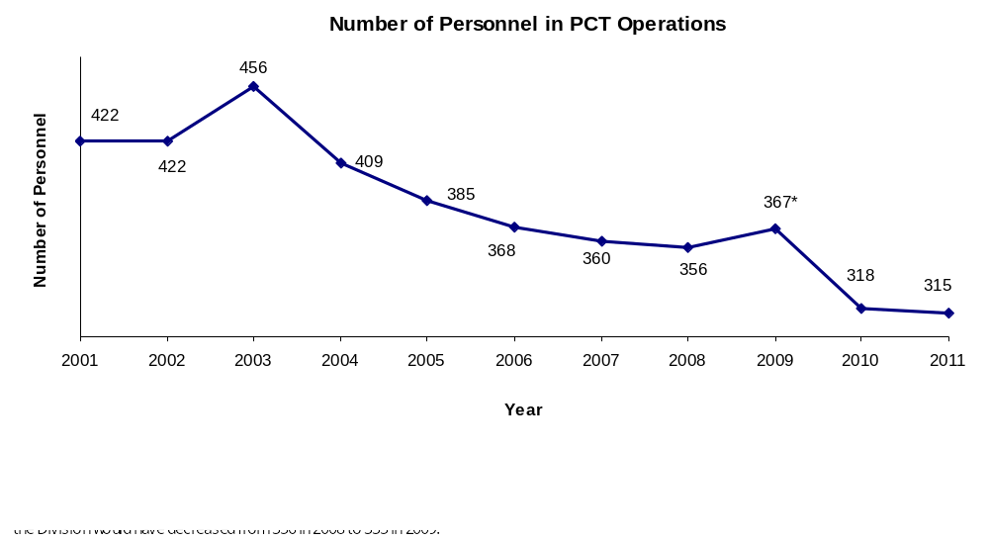

- The PCT Operations Division’s personnel was reduced by 1% in 2011 (3 staff less than in 2010).

Unit cost of processing an application

The IB’s productivity in processing PCT applications can be measured by unit cost of processing, defined as the average total cost of publishing a PCT application. Average total cost is determined by total PCT expenditure, plus a certain share of expenditure related to support and management activities. The unit cost thus includes the cost of all PCT activities – including translation, communication, management and others.

In computing unit cost, the production cost consists of two parts: direct and indirect costs. Direct costs correspond to the expenditure incurred by the IB (for administration of the PCT system and related programs). Indirect costs include expenditure for supporting units (e.g., buildings and information technology, among others). Indirect costs are weighted to take into account only the share attributable to the PCT system. The cost of storing published applications is added to unit cost since the PCT system must store them for 30 years.

Formally, unit cost is defined as:



Figure B.1.9 depicts the evolution of the unit cost of processing from 2004 to 2011, including a breakdown of the contribution of direct and indirect costs.

Figure B.1.9: Unit cost of processing a published PCT application
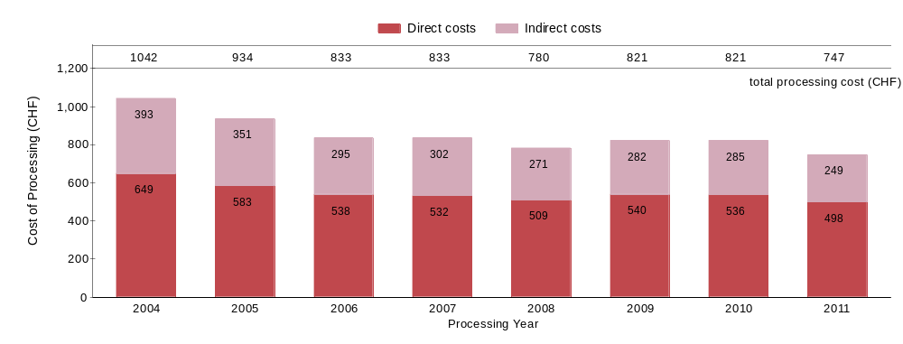
Note: The average cost of published PCT application is an estimation which is calculated by dividing the total processing cost by the number of published PCT applications. Historical data have been revised and may differ from previous reported data.

Source: WIPO Statistics Database, March 2012

- The average cost of processing a published PCT application has decreased by 9% in 2011 compared to 2010, and reached 747 Swiss Francs. This decrease is explained by the fact that 7.7% more PCT applications were published in 2011 than in 2010, while overall costs decreased slightly (in particular indirect costs).

Productivity of formality examination

The definition of staff productivity is output (i.e., number of PCT publications) divided by the number of available staff for formality examination.
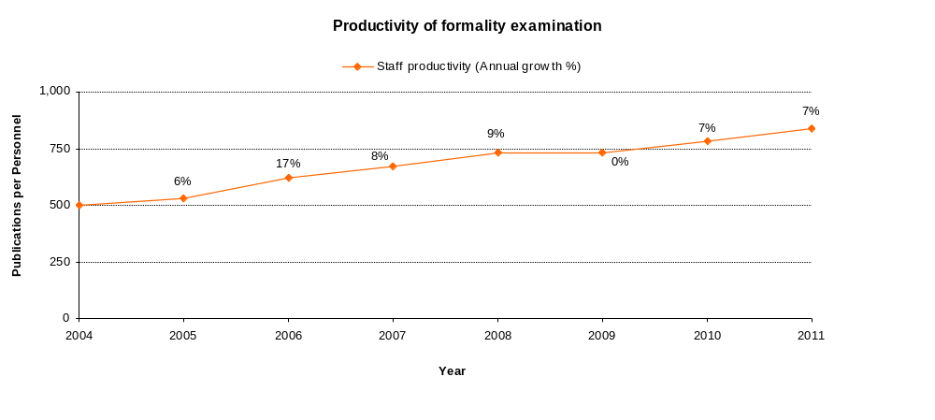

- Historically, productivity of formality examination has increased, mainly due to automation which has permitted the processing of much larger workloads with less staff.

Aggregate quality of formality examination

In order to capture quality in a simple and comprehensive way, a single aggregate quality indicator has been developed, constructed from a set of four lead quality indicators.

The quality indicator is the simple average of four lead indicators, three of which are based on the timeliness of key transactions in the PCT system – issuance of Form 301, publication and republication. The fourth indicator shows the number of quality defects resulting in republication code R5 (errors in bibliographical data, mostly due to manual data entry errors).

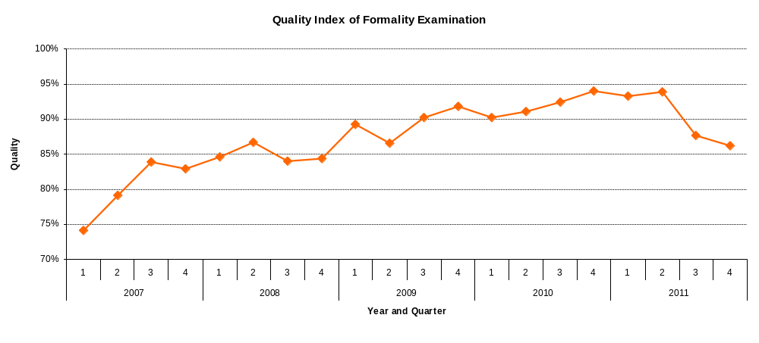

- Quality, as measured by the aggregate index, has improved markedly from 2007 until the first half of 2011. However, as of the second half of 2011, a regression in quality can be observed. Increased delays in the republication of PCT applications with their ISR are the main causes of this regression. In the second quarter of 2011, approximately 86% of applications were republished within 2 months, but only 59% in the last quarter of 2011. Increasing delays in the transmission of the notification of receipt of a PCT application is the second cause of the regression in quality, as 88% of notifications were transmitted within 5 weeks in the last quarter of 2011, which corresponds to a decrease of 9% compared to the result of the first quarter. Further details are provided in the charts below.

Timeliness of formality examination

This indicator reflects in more detail one of the components of the aggregate quality indicator, namely the time required by the IB to issue Form 301. This form is issued after the formality examination of the application has been completed. Applicants appreciate receiving this Form as soon as possible because it allows them to know whether their application has any formal defects.

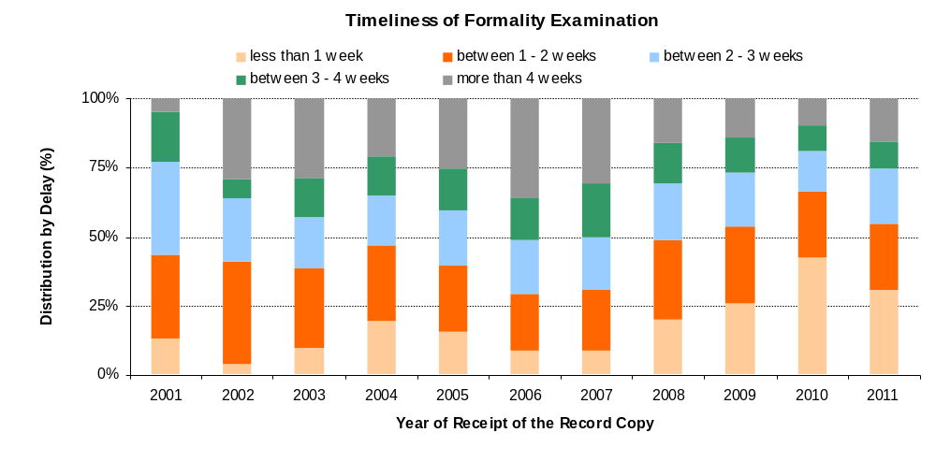

Timeliness of publication

This indicator reflects in more detail one of the components of the aggregate quality indicator, namely the time required by the IB to publish the application. Article 21 (2) (a) of the PCT states that the “… international publication of the international application shall be effected promptly after the expiration of 18 months from the priority date of that application.”

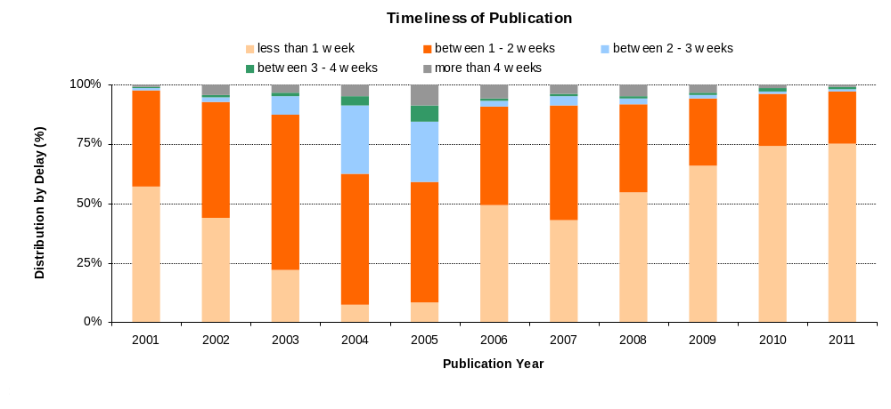

Timeliness of republication

This indicator reflects in more detail one of the components of the aggregate quality indicator, namely the time required by the IB to republish the application with the ISR. Due to delays in the communication of ISRs by ISAs, a number of international applications are published without the ISR. When the ISR becomes available, the international application needs to be republished with the ISR as soon as possible, so as to complete the international publication.

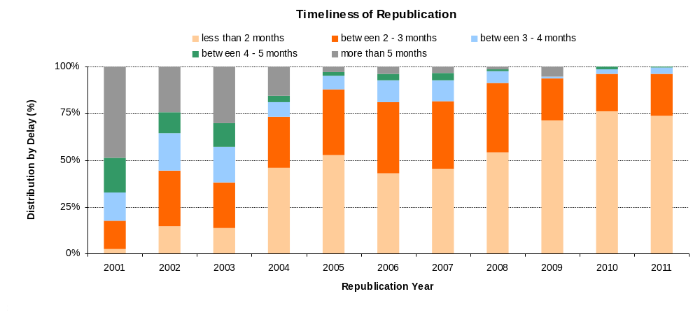

Quality of translation

Translations of abstracts and reports prepared under the responsibility of the IB are subjected to a quality control process based on a sample. The results are classified in two categories: translations that are deemed acceptable and those that are deemed not acceptable. This performance indicator tracks the quality of the translations as reflected in the samples.

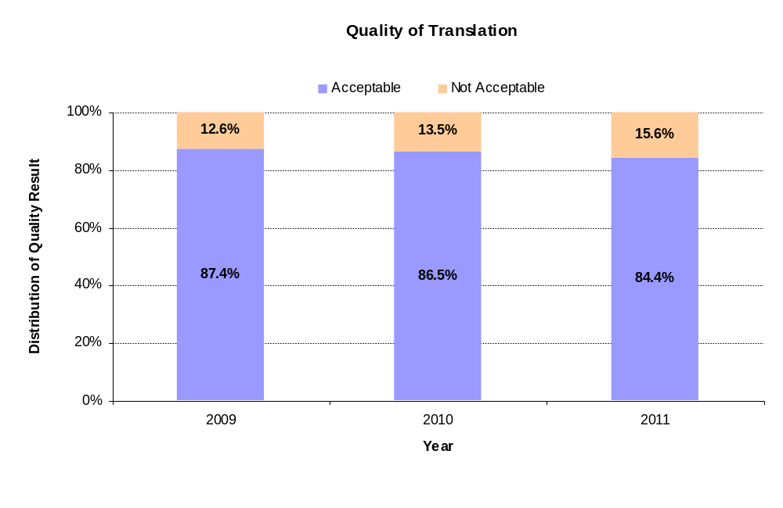

Filings at the IB as Receiving Office (RO/IB)

This table presents PCT filings by the top fifteen receiving offices over the past five years to 2011. In principle, a PCT application is filed at the national patent office of the applicant’s home country or at a regional patent office acting for the applicant’s home jurisdiction. The IB is a competent receiving office for applicants from all PCT contracting states. The evolution of the filings at the RO/IB, its ranking in terms of the number of filings among other receiving offices, as well as its market share can be observed in this table.

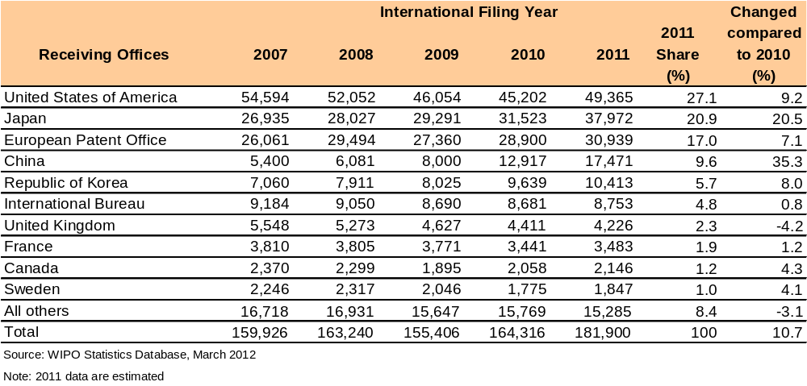

[End of Annex]

PROGRAM 6 MADRID, HAGUE AND LISBON SYSTEM

Program Manager Ms. Binying Wang

ACHIEVEMENTS IN THE 2010/11 BIENNIUM

The Madrid System

In 2010/11, Israel, Kazakhstan, Sudan and Tajikistan acceded to the Madrid Protocol, increasing the number of members of the Protocol to 84, and the total number of members of the Madrid Union to 85. With the accession of Tajikistan to the Madrid Protocol in 2011, only one country remains in the Agreement (Algeria). A high level of promotional activities to current as well as potential members was undertaken. One focus has been the promotion of a better use of the Madrid system, in particular in countries where an under-utilization can be observed.

In addition, the International Bureau assisted a number of States in their preparatory work towards a future accession to the Madrid Protocol, such as, in particular, Colombia, Costa Rica, Dominican Republic, India, Mexico, New Zealand, Philippines and Trinidad and Tobago. These potential future accessions will greatly enhance the geographical scope of the Madrid system and make the system more attractive to use, providing a simple, efficient and cost-effective option for trademark holders to obtain and maintain protection for their trademarks in an expanded geographical area.

After a significant decrease of almost 17 per cent in 2009 as a result of the global financial crisis, the international trademark activity recovered in 2010 with WIPO receiving 39,687 and 42,270 applications in 2010 and 2011 respectively. 2011 thus constituted a record year in terms of international applications received. Of the total applications received, 6.9 and 7.4 per cent came from developing countries and LDCs respectively in 2010 and 2011. The number of new registrations processed amounted to a total of 78,244 in the biennium with renewals reaching a total of 43,703. The figures for registrations and renewals were lower in the biennium than expected, primarily because the targets were devised in 2008 before the financial crisis.

The average processing time of all documents received (without irregularities) amounted to
3.5 – 4 weeks, with 88 per cent of documents being processed within 23 days. The average processing time for new applications was 32 calendar days in 2011 (33 in 2010). Irregularities regarding classification amounted to 19.9 and 23.8 per cent of applications in 2010 and 2011 respectively.

Decisions by Offices (including refusals and statements of grant of protection) rose by 27.6 per cent in 2011 (a total of 315,177), of which almost 50 per cent related to statements of grant of protection. Some 43 percent of these were received electronically.

Automation efforts in the biennium included further steps towards automatic processing of provisional refusals, final decisions and statements of grant of protection. This has resulted in efficiency gains of approximately 20 per cent per annum for these types of documents. At the end of 2011, some 12 Contracting States were sending provisional refusals and final decisions electronically, resulting in 64 per cent of all provisional refusals now being sent electronically. Eight Contracting States have successfully been automated, which accounts for 87 per cent of the files received electronically.

An automatic pre-translation tool was implemented in June 2010, resulting in a high number of standard indications of goods and services in new applications being processed automatically. The resulting efficiency gain for translation amounted to about 35 per cent by the end of 2011. The tool continues to be refined under the Goods & Services (G&S) Manager project.

Phase I of the IT Modernization Program reached its final stages, with only the Office pilot of the future technical architecture to be completed. It is expected that the Office pilot will be concluded during 2012, where some Offices shall exploit WIPO web services for the filing of international trademark applications.

Phase II of the IT Modernization Program involves the migration of all Madrid and Hague business functions from their legacy technology to a modern internet ready and eBusiness enabled, technical architecture. Contract negotiations with the selected external partner were concluded in December 2011, and work on Phase II is expected to commence in January 2012.
In the biennium, the International Bureau began a process of simplifying internal processes in order to enhance the efficiency, flexibility and user-friendliness of the Madrid system. This was supported by the discussions in the Working Group for the Legal Development of the Madrid system (introduction of division, clarification on the translation issue and amendment to Article 9sexies). In addition, the Madrid Legal Forum went live in the beginning of 2011 following a request from the Working Group to “take steps to establish an electronic forum concerning the issues of the requirement of a basic mark and of central attack.” It should be seen as a means to facilitate the free exchange of ideas concerning the present and the future of the Madrid system.

The Working Group established procedures for electronic adoption of a report of a Working Group meeting, which resulted in the adoption of the report only 3.5 months after the completion of the meeting compared to 6 months previously.

The entering into force of the mandatory requirement of Statement of Grant of Protection on January 1, 2011, ensured that trademark holders now receive positive information on the scope of the protection of their mark in a timely manner. With more than 162,000 such Statements received in 2011, this provision has proven to be widely appreciated by the trademark holders.

The Hague System

A number of initiatives undertaken in line with the Medium Term Strategic Plan (MTSP) 2010-15 started bearing results throughout the 2010/11 biennium, making the management of the Hague system well positioned for further improvement.

Some of these initiatives were undertaken with the members of the Hague Union and implemented with the approval of the Assembly, namely, the coming into force of new Common Regulations specific to the 1960 and 1999 Acts of the Agreement and the introduction of Spanish as a full working language. Other initiatives, often undertaken in cooperation with the Offices of the members of the Union, have led to an increase in the number of training or outreach activities and a general improvement in the quality of information provided on the Hague system. Finally, developments introduced with the cooperation of the Offices of the members of the Union, such as the shortening of the publication cycle of the International Designs Bulletin, and internal initiatives, such as the revamping of the electronic filing interface and the launching of an electronic-renewal interface, all have resulted in an increase in the quality of service as well as swifter and more cost-effective processing of requests.

The above results helped international registrations under the Hague system to increase by 41 per cent over the biennium, with more filings coming in particular from developing countries. Nevertheless, and in spite of being on track in terms of designs filed, renewals and other recordings, the number of new registrations remained far below that envisaged for each year of the biennium. This is explained by the fact that the results for 2009 were themselves much lower than what was anticipated at the time the forecast for the 2010/11 biennium was made. This was due to a combination of two external factors, namely the global economic crisis and the fact that the membership to the 1999 Act did not grow as expected. At the end of the 2010/11 biennium, even though there were seven new Contracting Parties, none of the countries whose accession would have had a significant positive impact on filings, were among those that acceded.

The Lisbon System

The Membership of the Lisbon Agreement increased to 27, following the accession of the former Yugoslav Republic of Macedonia. With a view to facilitating a further increase of the Membership, the Working Group on the Development of the Lisbon System, established by the Lisbon Union Assembly in 2008, is engaged in a review of the Lisbon system, aimed at making the system more attractive for users and prospective new Members, while preserving its principles and objectives. The Working Group is open to all WIPO members and observers. It met three times in the biennium to consider the results of the questionnaire survey initiated by the International Bureau in 2009 and a study prepared by the International Bureau on the relationship between regional systems for the protection of geographical indications and the Lisbon System and the conditions for the possible accession by IGOs to the Lisbon Agreement (August/September, 2010); draft provisions on a number of specific issues (May 2011); and a draft new instrument (DNI) containing the draft provisions referred to above, as revised on the basis of comments made during the session in May 2011, as well as further draft provisions, the inclusion of which, would be necessary for making the DNI as complete as possible, while leaving open the question as to the legal instrument by which it might be formalized (December 2011). As a result of the Working Group session in December 2011, the International Bureau is to prepare, for the next session of the Working Group, in June 2012, a revised version of the DNI as well as draft regulations (DR). On a longer term, the International Bureau has also been invited to prepare a study on the possibility of dispute settlement within the Lisbon system, as it might be useful to explore in which situations and in what form dispute settlement might be appropriate.

As from January 1, 2010, as a result of the amendments to the Regulations under the Lisbon Agreement adopted by the Lisbon Union Assembly in September 2009, an optional procedure is in place by which the competent authority of a contracting country can send a statement of grant of protection in respect of a given internationally registered appellation of origin. This procedure has meanwhile been used a number of times in cases in which a decision had been taken that no refusal declaration would be issued in respect of the appellation of origin. The procedure can also be used by a competent authority in case of a decision to withdraw a refusal declaration that it had issued in respect of the appellation of origin. Another amendment concerns the newly introduced possibility for the Director General to establish Administrative Instructions concerning details for the application of the application, notification and registration procedures under the Regulations. Administrative Instructions, as the Director General has meanwhile established under these provisions, are aimed to streamline the procedures and allow for the use of electronic means for the transmittal of communications between the International Bureau and the competent authorities of Member States. By the end of 2011, some 16 competent authorities had given their consent to the use of electronic means for this purpose. In October 2011, the Lisbon Union Assembly adopted further amendments to the Regulations under the Lisbon Agreement, which entered into force on January 1, 2012, concerning the optional contents of international applications and the mandatory requirements for notifications of invalidations.

In March 2010, some other IT-based developments took place. On-line editions were made available on the WIPO website of all issues of the official publication of the Lisbon system, the WIPO Bulletin “Appellations of Origin”. Further, the Lisbon Express database on the WIPO website went live with a new interface. In addition, in the second quarter of 2010, an Interactive World Map on the Lisbon system was introduced, showing the membership of the Lisbon System and facilitating access to information in the International Register of the Lisbon System per member state.

IMPLEMENTATION OF THE DEVELOPMENT AGENDA

In the context of the mainstreaming of the DA, the work undertaken by Program 6 took fully into consideration the DA Recommendations 1 and 6.

PERFORMANCE DATA

Expected Result: Increased use of the Madrid system
Performance Indicators | Baselines |  |  | Performance Data |  |  | TLS
2010 2011  New registrations 42,800 44,200  Renewals 22,700 21,900 | 2008/09:  82,485  39,172 |  |  | 2010 2011  37,533 40,711  21,949 21,754 |  |  | Partially Achieved
Expected Result: Increased use of the Hague system
Performance Indicators | Baselines |  |  |  |  | Performance Data | TLS
2010 2011  New registrations 3,100 4,000  Designs contained 12,000 14,000  Renewals 2,600 2,600  Other recordings 4,000 4,500 | 2008/2009:  3,283  17,920  5,869  7,794 |  |  |  |  | 2010 2011  2,216 2,363  11,238 11,077  2,793 2,822  4,247 4,326 | Partially Achieved
Expected Result: Swift and cost-effective processing of applications and registrations under the Madrid and Hague procedures
Performance Indicators |  |  | Baselines |  |  | Performance Data | TLS
Reduction of the overall processing time to 3.5 weeks with respect to all documents without irregularities under the Madrid procedures |  |  | 95% documents processed within 3 weeks |  |  | 88% documents processed within 23 days | Fully Achieved
Reduction of overall processing time to 3 weeks, provided no irregularities under the Hague procedures |  |  | Four weeks |  |  | Three weeks (Hague) | Fully Achieved
Expected Result: Increased quality of service and information in relation to Madrid, Hague and Lisbon
Performance Indicators |  |  | Baselines |  |  | Performance Data | TLS
% files that fulfill quality standards (consistency in classification, examination translation tasks and marginal level of errors) |  |  | 80% with no irregularity letters (Madrid)  Information as available on the WIPO website at the end of 2009 (Lisbon) |  |  | Madrid application with no irregularity regarding classification  2010 2011  80.1% 76.2%  Lisbon: new interface Lisbon Express; on-line editions of the official Bulletin of the Lisbon System made available on the WIPO website; Interactive World Map introduced on the WIPO website. | Fully Achieved
% of offices, applicants and holders that have exchanged paper communication/ notifications and filing for electronic ones under the Madrid, Hague and Lisbon |  | 34% of Madrid documents received electronically  50% of e-filings; 0% of e-renewals (Hague)  Provisions allowing for the use of electronic communication were only introduced on January 1, 2010 (Lisbon) |  |  |  | Madrid documents filed electronically:  2010 2011  46% 60%  Hague  Registrations: 80 % E-filing  Renewals: 60 % E-renewal  Lisbon: 16 competent authorities have given their consent to the use of electronic means | Fully Achieved
Expected Result: Improved procedures under the Madrid, Hague and Lisbon system
Performance Indicator |  |  | Baselines |  | Performance Data |  | TLS
Adoption of provisions laying down new procedures under the Madrid, Lisbon and Hague system |  |  | Procedures currently laid out under the applicable Regulations and Administrative Instructions  No current procedures have been optimized from an IT perspective |  | Automation of decisions by Offices (refusal, grant of protection, final decisions) allowed the processing of 193,054 transactions in a fully automated way, representing 54% of the total number of decisions for the Madrid system received by the IB in 2011  Hague: Streamlined Common Regulations entered into force in 2010. Further amendments to the Common Regulations introducing new procedures adopted by the Hague Assembly in 2011. Spanish introduced as full working language on April 1, 2010 (Hague)  Lisbon: new procedures introduced with effect from January 1, 2010; further new procedures adopted in 2011  Madrid: an amendment was introduced to the Common Regulations with effect from January 1, 2012. Other possible changes discussed at the Working Group meeting in 2011 have been postponed and will be discussed in the Working Group meeting of 2012 |  | Fully Achieved
Expected Result: Increased international coverage of the Madrid system
Performance Indicators |  |  | Baselines |  | Performance Data |  | TLS
Eight new Contracting Parties to the Madrid Protocol |  |  | 83 total |  | Four new Contracting Parties: Israel, Kazakhstan, Sudan and Tajikistan |  | Partially Achieved
Two new Contracting Parties to the Lisbon Agreement |  |  | 26 total |  | One accession: the former Yugoslav Republic of Macedonia |  | Partially Achieved
Eight new Contracting Parties to the Geneva Act |  |  | 36 contracting parties to the Geneva Act |  | Seven new Contracting Parties: Azerbaijan, Finland, Monaco, Montenegro, Norway, Rwanda, Tajikistan |  | Fully Achieved
Expected Result: Increased number of training, outreach and user relation initiatives offered by WIPO at both Headquarters and national levels for a larger and better use of the Madrid and Hague systems
Performance Indicators |  |  | Baselines |  | Performance Data |  | TLS
% of training participants using new acquired knowledge and skills on the job by office and country |  |  | Data not available |  | Data not available |  | Dis-continued
Number of professional and other key stakeholders participating in the various outreach activities by office and country |  |  | Data not available |  | A number of outreach activities were held in Asia (China and Japan), Europe (including in Bulgaria, Cyprus, France, Poland, Spain, Turkey) and the United States of America. In addition, there were two seminars on Madrid held in Geneva. These outreach activities – promoting better use – were reflected in the record number of received international applications and subsequent designations of 2011, in spite of the economic conditions and the fact that there were no new accessions to the Madrid system as such in 2011  15 outreach activities: four roving seminars in China with 400 participants; 2 Arab regional seminars with 70 participants; four in-house seminars with 120 participants; and 5 workshops with 200 participants (Hague) |  | Fully Achieved
Expected Result: Increased access to global markets for products and services from the developing world
Performance Indicator |  |  | Baseline |  | Performance Data |  | TLS
% of international applications from the developing world |  | 5.6% of total applications received in 2009 (Madrid)  One applicant (Hague)  End 2009, 55 international registrations in force (out of 817) were from developing countries (Lisbon) |  |  | 6.9% (2010) 7.4% (2011) (Madrid)  0.85% of total applications received in 2010/11 (Hague)  End 2011, 58 in force originating in developing countries (out of 795) (Lisbon) |  | Fully Achieved
Expected Result: Availability of expanding database of IP identifiers
Performance Indicator |  |  | Baseline |  | Performance Data |  | TLS
Single authentic database for all product information relating to registrations under the Madrid Protocol, the Hague System, the Lisbon Agreement and Article 6ter of the Paris Convention |  |  | Two separate databases |  | New version ROMARIN, including all Madrid Express functions, launched in February 2011  Madrid Express decommissioned in March 2011  Global Brands Database launched in 2011 |  | Fully Achieved

BUDGET AND ACTUAL EXPENDITURE

Actual Expenditures (personnel and non-personnel) vs. Budget after Transfers 2010/11
(in thousands of Swiss francs)

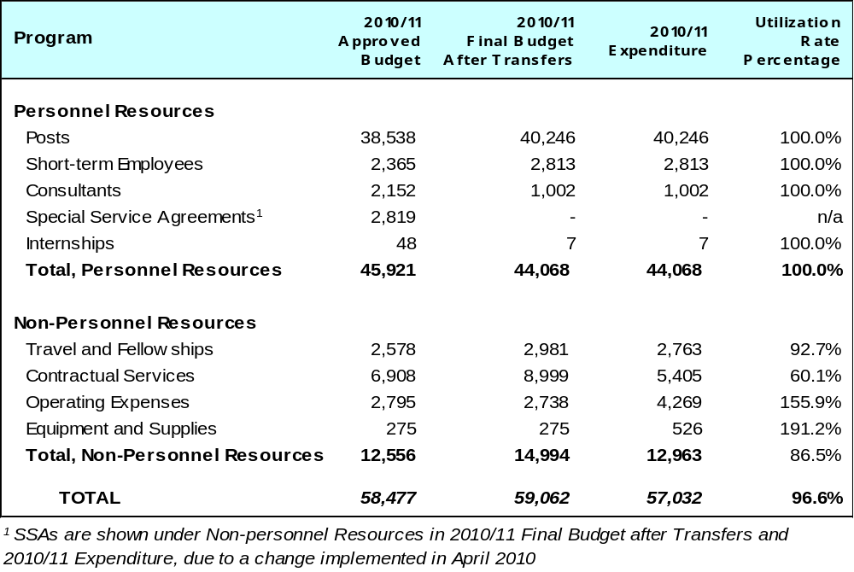

A. Budget after Transfers 2010/11

The budget after transfers 2010/11 compared to the approved budget 2010/11 reflects a decrease in personnel resources due to the departure of staff under the Voluntary Separation Program (VSP) in 2010.

B. Budget Utilization 2010/11

Lower than expected utilization of non-personnel resources in the 2010/11 biennium was due in part to efficiency gains regarding third party travel in relation to the Madrid Assemblies (e.g. early ticketing), the outsourcing of translations in Madrid Operations and an increase in the number of back-to-back missions. Under the Hague System, expenditures were lower than budgeted, in particular in Operations, as a result of lower than anticipated registration levels and as regards information and promotional activities (contractual services).

PROGRAM 7 ARBITRATION, MEDIATION AND DOMAIN NAMES

Program Manager Mr. J. C. Wichard

ACHIEVEMENTS IN THE 2010/2011 BIENNIUM

The WIPO Arbitration and Mediation Center (Center) has become the principal international resource for time and cost effective alternatives to court litigation of IP disputes, acting as a provider of legal and organizational expertise and as an administrator of cases. This includes the provision of services for Internet domain name disputes.

In 2010/11, the Center continued to work to optimize the potential of its procedures to meet the needs of IP right holders and users in the efficient resolution of disputes in relation to those rights. The principal component of this effort is quality management and resolution of cases conducted under those procedures, which entails training and appointing qualified arbitrators and mediators, maintaining up-to-date case administration infrastructure, and active management of WIPO cases, including support to appointed neutrals. An increasing number of parties in patent, trademark and software disputes under WIPO Rules used the WIPO Electronic Case Facility (ECAF). Undertaking research into user expectations and experience, in consultation with international experts, the Center developed and conducted a Survey of Dispute Resolution in International Technology Transactions with survey results expected in 2012. In the area of domain names, the Center developed a paperless filing mechanism and other case tools which enabled it to handle a 23 per cent increase over its 2008/09 caseload based on the Uniform Domain Name Dispute Resolution Policy (UDRP). The Center released a major update to the WIPO Overview of WIPO Panel Views on Selected UDRP Questions, a unique tool used by parties and stakeholders around the world to understand and apply WIPO cybersquatting jurisprudence.

The establishment of a Center presence at Maxwell Chambers in Singapore reflects the increased focus on IP dispute resolution in that region. In addition to offering guidance on dispute resolution clauses and administering WIPO procedures, this activity involved the organization of training programs.

The Center assisted IP stakeholders in establishing alternative dispute resolution (ADR) procedures adapted to the features of recurrent disputes in their areas of activity. In particular, the Center assisted the Spanish collecting society "Entidad de Gestión de Derechos de los Productores Audiovisuales" (EGEDA) on special arbitration rules; further to a memorandum of understanding (MoU) between WIPO and the International Council of Museums (ICOM), helped develop a mediation procedure for art and cultural heritage disputes; and met a request from the Food and Agriculture Organization (FAO) to help develop "Procedures for the Operation of the Third Party Beneficiary" and “Rules for Mediation of a Dispute in Relation to a Standard Material Transfer Agreement” in the context of the International Treaty on Plant Genetic Resources for Food and Agriculture.

The Center collaborated with the Intellectual Property Offices of the Philippines and Singapore in their establishment of optional ADR frameworks for disputes pending before them concerning applications and registrations.

In the area of science and technology collaboration, the Center administered a number of cases and furthered the use of ADR more generally. For example, the Development of a Simplified Consortium Agreement (DESCA) model agreement for European-funded international research incorporated a dispute clause providing for WIPO ADR.

The Center strives to provide leadership in the development of ADR solutions in relation to the unauthorized use of IP on the Internet. Focusing in particular on new Rights Protection Mechanisms adopted by the Internet Corporation for Assigned Names and Numbers (ICANN), WIPO engaged in significant policy activity in response to the envisaged introduction by ICANN of large numbers of new Top Level Domains. In this connection, the Center was appointed by ICANN as the provider of dispute resolution services under a Center-developed trademark-based “pre-delegation” Legal Rights Objections procedure.

The Center continued to liaise with the administrators of country code Top Level Domains (ccTLDs) in different regions in the creation of dispute resolution policies, for example for .BR (Brazil). Against the background of the global emergence of domain names in local language scripts, the Center initiated ADR services for .AE and امارات. (dotEmarat), and .QA and قطر. (dotQatar).

IMPLEMENTATION OF THE DEVELOPMENT AGENDA

The Center organized tailor-made arbitration and mediation programs for IP officials and practitioners, assisted IP Offices in establishing optional ADR frameworks for disputes pending before them, and further assisted national domain name authorities in the establishment of best registry practices and dispute resolution mechanisms, as relevant to developing countries and countries with economies in transition. These activities related to the DA Recommendations 1, 6 and 10.

PERFORMANCE DATA

Expected Result: International and domestic intellectual property disputes are increasingly prevented or resolved through mediation, arbitration and other alternative dispute resolution methods
Performance Indicators | Baselines | Performance Data | TLS
The Center supports the resolution of an increasing number of disputes through its alternative dispute resolution services and resources | 220 disputes (end 2009 updated figure) | As of December 2011, the Center had administered over 269 mediations and arbitrations. The Center received 49 mediation and arbitration cases in 2010/11 (21 in 2010 (updated figure) and 28 in 2011)  The Center regularly provides procedural guidance to parties in order to facilitate the submission of their dispute to mediation or arbitration. These "Good Offices" services involved parties based in developed and developing countries. The Center received 30 requests for Good Offices in 2010/11 | Fully Achieved
Expected Result: Effective intellectual property protection in the gTLDs and the ccTLDs
Performance Indicators | Baselines | Performance Data | TLS
3,000 gTLD UDRP cases administered | 16,770 TLD received and administered cases by the Center (end 2009) | 4,618 gTLD UDRP cases were filed with the Center in 2010/11. 4,068 of those cases were resolved during that period, with the remainder expected to be resolved in 2012 | Fully Achieved
300 ccTLD UDRP-based cases administered | 16,770 gTLD UDRP and ccTLD cases received and administered by the Center (end 2009) | 842 ccTLD UDRP-based were filed with the Center in 2010/11. 739 of those cases were resolved during that period, with the remainder expected to be resolved in 2012 | Fully Achieved
Implementation by ICANN and new gTLD registries of WIPO policy and process recommendations | UDRP (at the end of 2009, only the UDRP had been adopted, for a number of years already. Additional procedures are under discussion) | The Center was appointed by ICANN as the provider of dispute resolution services for the WIPO-developed trademark-based “pre-delegation” Legal Rights Objections under ICANN’s New gTLD Program | Fully Achieved
Four more ccTLD administrators with WIPO-assisted design or administration of intellectual property protection mechanisms in accordance with international standards | A total of 62 ccTLD administrators (end 2009) | Four additional ccTLDs administrators designated the Center to provide domain name dispute resolution services in 2010/11: .br (Brazil), .qa (Qatar) .so (Somalia) and .tj (Tajikistan). (One ccTLD administrator for which the Center provided services in 2009 adopted in 2010/11 a mechanism for which the Center does not provide services)  The total number of ccTLD administrators which designated the Center to provide domain name dispute resolution services rose to 65  In addition, the Center provides dispute resolution services for two new Internationalized Country Code Top-Level Domains (IDN):  امارات. (dotEmirat) for operation by the United Arab Emirates, and  قطر. (DotQatar) for operation by Qatar | Fully Achieved

BUDGET AND ACTUAL EXPENDITURE

Actual Expenditures (personnel and non-personnel) vs. Budget after Transfers 2010/11
(in thousands of Swiss francs)

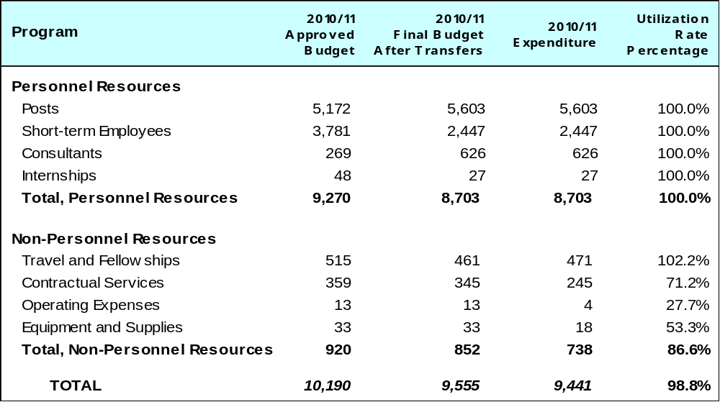

A. Budget after Transfers 2010/11

The final budget after transfers 2010/11 compared to the approved budget 2010/11 reflects, inter alia, a decrease in personnel resources, primarily due to the deferment of recruitment of several short term Case Managers and a decrease in non-personnel resources, due to the centralization of telecommunication and internship costs.

B. Budget Utilization 2010/11

The budget utilization of 86.6 per cent for non-personnel resources reflects the cancellation or delay of certain planned expenditures as a result of several unforeseeable events, Center logistics and travel disruptions, as well as efforts made by the Center to reduce expenditure. Such planned expenditures related primarily to the postponement of a conference, the cancellation of a workshop, and the deferment to 2012/13 of the printing of publications.

PROGRAM 8 DEVELOPMENT AGENDA COORDINATION

Program Manager Mr. G. Onyeama

ACHIEVEMENTS IN THE 2010/11 BIENNIUM

Program 8 was established in 2009 to strengthen the implementation of the WIPO Development Agenda. During the 2010/11 biennium, the Program continued to coordinate and facilitate the mainstreaming of the Development Agenda Recommendations and principles into the Organization’s work and to facilitate the work of the Committee on Development and Intellectual Property (CDIP). In addition, the Program undertook a number of activities to support Member States in deriving benefits from the Development Agenda Implementation.

During the 2010/11 biennium, the CDIP met in four sessions. The Committee approved nine new projects addressing 19 Recommendations; considered two Reports by the Director General on Implementation of the Development Agenda; and four Progress Reports on the Implementation of Recommendations for Immediate Implementation and Development Agenda Projects. The Committee agreed on the Coordination Mechanisms and Monitoring, Assessing and Reporting Modalities and discussed a document forwarded to it by the General Assembly on the Description of the Contribution of the Relevant WIPO Bodies on the Implementation of Respective Development Agenda Recommendations. The Committee also discussed Reports on WIPO’s Contribution to the United Nations Millennium Development Goals (MDGs). In addition, the Committee discussed two documents on Patent-Related Flexibilities in the Multilateral Legal Framework and Legislative Implementation at the National and Regional Levels and partially agreed on a Future Work Program on Flexibilities in the Intellectual Property System. The Committee also considered An External Review of WIPO’s Technical Assistance in the Area of Cooperation for Development prepared under the Project on Enhancement of WIPO's Results-Based Management (RBM) Framework to Support the Monitoring and Evaluation of Development Activities, and discussed the seven studies undertaken under the projects on IP and Public Domain, IP and Competition Policy and on Open Collaborative Projects and IP-Based Models. Some 55 observers participated in the work of the Committee during the biennium.

The Program continued to ensure that Development Agenda related activities and projects were properly implemented, monitored, evaluated and reported on. In this context, continued efforts focused on ensuring an effective implementation of the 19 Recommendations for Immediate Implementation. The Program also continued to coordinate the monitoring, evaluation and reporting on the implementation of the projects approved since the third session of the CDIP. Furthermore, the Program collaborated with Program 11 to make the WIPO Development Agenda an integral part of the Distance Learning Courses of WIPO. The Program also contributed to the work on IP related Flexibilities in the Multilateral Legal Framework and launched an initiative on a Framework for Designing National IP Strategies.

The Program worked very closely with Program 22 in mainstreaming the development dimension in the Program and Budget and Program Performance Reports (PPR). This involved, in particular, the development of a considerably strengthened and detailed reporting in the PPRs 2010 and 2010/11 on the contribution of various Programs to the implementation of the Development Agenda Recommendations and projects. In addition, the Program facilitated the incorporation of the 45 Development Agenda Recommendations and the principles contained therein into the Medium Term Strategic Plan (MTSP) and contributed to the elaboration of the Budgetary Process applied to the Projects proposed by the Committee on Development and Intellectual Property (CDIP) for the Implementation of the Development Agenda Recommendations, which was adopted by the WIPO Assembly in September 2010.

In order to increase awareness as regards the benefits arising from the implementation of the Development Agenda, a number of workshops, information meetings, consultations and briefings were organized and a brochure entitled “The WIPO DA - An overview” developed.

IMPLEMENTATION OF THE DEVELOPMENT AGENDA

Program 8 is responsible for the coordination of the implementation of the WIPO Development Agenda. In this endeavor, all its work remains guided by the spirit of the Development Agenda Recommendations.

PERFORMANCE DATA

Expected Result: DA (DA) principles further mainstreamed into the Organization’s programs and activities, including its normative work
Performance Indicators |  | Baselines |  | Performance Data |  | TLS
All WIPO activities are undertaken in line with the DA principles |  | Internal instructions have been issued in 2009 to apply the principles |  | 40 expected results out of 60 (under all 7 substantive Strategic Goals) in the Program and Budget 2012/13 have a development share  The 45 DA Recommendations were incorporated into the MTSP  PPR included a section for reporting on the implementation of the DA recommendations and projects |  | Fully Achieved
Expected Result: Effective implementation of the DA through concrete projects and activities
Performance Indicators |  | Baselines |  | Performance Data |  | TLS
Number of DA recommendations that are being successfully implemented through projects and activities |  | 19 recommendations being successfully implemented |  | 19 Recommendations continued to be successfully implemented:  - Nine projects on technical assistance (addressing Recommendations 2, 5, 8, 9 and 10)  - Five thematic projects addressing Recommendations 7, 16, 19, 20, 23, 24, 27, 30, 31, 32, 33, 38 and 41  - Nine thematic projects approved during the Biennium (addressing Recommendations 1, 4, 10, 11, 13, 16, 19, 20, 25, 26, 28, 30, 31, 34, 35, 36, 37, 39, and 40) |  | Fully Achieved
Expected Result: Effective monitoring, evaluation and reporting on recommendations
Performance Indicators |  | Baselines |  | Performance Data |  | TLS
Monitoring systems are being used by all projects and used for decision making |  | Mechanisms for evaluation under development by end 2009 |  | A robust monitoring system was used by project managers to monitor the implementation of the 23 projects under implementation  External evaluation of six completed projects was initiated |  | Fully Achieved
Recommendations resulting from monitoring and evaluation are successfully being implemented |  | Report submitted on 19 recommendations in April 2009 |  | Two Director General’s Report on the implementation of the DA submitted respectively to the fifth and seventh sessions of the CDIP  Four progress reports on Recommendations for Immediate Implementation and on DA projects under implementation were submitted to the sixth and eighth sessions of the CDIP. Each successive report benefited from the Member States’ guidance as regards substance and presentation |  | Fully Achieved
Number of self-evaluations and independent evaluations undertaken during the biennium |  | No self-evaluations or independent evaluations undertaken in 2008/09 |  | Self-evaluations of 19 DA projects were undertaken during the biennium |  | Fully Achieved
Expected Result: Support to Member States in deriving benefits from DA implementation
Performance Indicators | Baselines |  | Performance Data |  | TLS
Policy processes at national and inter-governmental level make reference to the DA and seek to derive benefits from DA recommendations | Implementation of DA recommendations started in October 2007. Member States are only beginning to factor DA into policy processes |  | Three Regional Seminars on the implementation of the WIPO DA were organized in Argentine, Cameroun and Kyrgyzstan  Two national seminars for policy-makers were organized in Lebanon and Oman |  | Fully Achieved
Expected Result: Enhanced understanding of the DA by Member States, IGOs, civil society and other stakeholders
Performance Indicators | Baselines |  | Performance Data |  | TLS
Communication and dissemination strategy designed and being implemented | Ad hoc communication strategy on the DA in 2009 |  | In the context of the DA Communication Strategy, a meeting with IGO’s on cooperation for DA implementation as well as two meetings for academics were organized in cooperation with Programs 20 and 11 and a brochure on the ”WIPO Development Agenda- An overview” developed |  | Fully Achieved

BUDGET AND ACTUAL EXPENDITURE

Actual Expenditures (personnel and non-personnel) vs. Budget after Transfers 2010/11
(in thousands of Swiss francs)

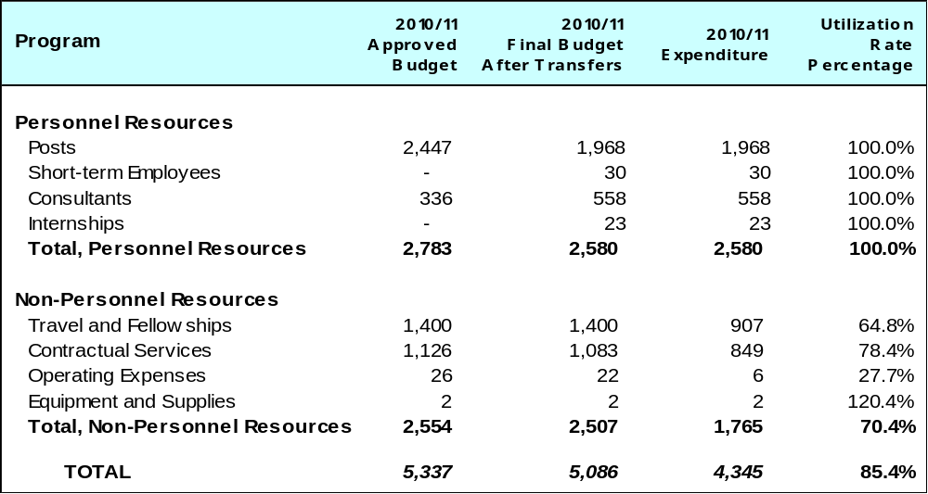

A. Budget after Transfers 2010/11

The 2010/11 budget after transfers primarily reflects a decrease in personnel resources as compared to the Approved Budget 2010/11, due to post vacancies during the biennium.

B. Budget Utilization 2010/11

The under-utilization of non-personnel resources was due primarily to a delay in the implementation of the national IP strategy framework initiative and the postponement of the International Conference on Integrating Development into IP Policy Making to the next biennium.

PROGRAM 9 AFRICA, ARAB, ASIA AND THE PACIFIC, LATIN AMERICA AND THE CARIBBEAN COUNTRIES, LEAST DEVELOPED COUNTRIES

Program Manager Mr. G. Onyeama

ACHIEVEMENTS IN THE 2010/11 BIENNIUM

At the core of WIPO’s development cooperation program is the goal of empowering developing countries and least developed countries (LDCs) to harness IP for enhancing national innovation potential and capacities as critical inputs to economic, social and cultural development. Implied in this is the ability to participate and reap the benefits that IP and innovation brings to a knowledge economy.

The realization of these goals is made possible through a combination of strategy, policy and legislative, institutional and human capacity-building interventions, which are embodied in the key Expected Results of Program 9. Regional specificities are taken into account by way of regional Performance Indicators while national circumstances are dealt with at the level of country projects and activities. A country-specific and tailored approach based on needs is a fundamental principle that governs program planning and delivery.

As the primary interface between the Member States and the Secretariat, the Program solidified that role by providing a methodological approach to deriving strategic directions for IP and IP-related initiatives in a country through the national IP strategy framework. This methodological approach has several advantages: i) it provides customizable tools for assessing the current status of the country’s IP system; b) through a national multi-sectoral consultation process, it provides a reliable definition of strategic IP targets and priority areas and crystallizes how these can contribute to national development objectives; and c) it enables the assessment of specific IP needs with a view to formulating a national IP strategy that is in line with national development priorities and objectives and in economic clusters where IP can clearly add value. The process of national IP strategy formulation was initiated in 29 countries during the biennium 2010/11 (13 countries in Africa, two in the Arab region, four in the Asia and the Pacific, seven in the Latin America and the Caribbean, and three for LDCs). In 16 other countries, national IP strategies/plans have been adopted and/or are under implementation, namely nine countries in Africa, two in Arab, two in Asia and the Pacific and three in the Latin America and Caribbean region.

Awareness and capacity building which provided opportunities for access to new information and knowledge, have touched a broad range and an increased audience, comprising policy-makers, administrators and officials, IP professionals and managers, researchers and academics, entrepreneurs and industrialists. Performance data for 2010/11 for Africa and Asia Pacific regions and LDCs show a total of some 7,000 trainees who have benefitted from this service. These activities have led to an increase in the number of IP specialists representing a broad range of institutions such as the academia, business promotion centers and incubators, research and development institutions, innovation agencies, IP offices, judiciary and law enforcement, who are now serving as knowledge resources for capacity-building in the regions. They have also provided platforms for regional discourse and reflection on the interface of IP with issues such as climate change and green growth, innovation and technology transfer, public health, food security, science and technology and trade and industry.

The interface and coordinating role of the Program was critical to ensuring coherence of policy and legislative, institutional and capacity-building support to countries, which are being delivered by various other Programs in the Organization. The biennium saw the increasing systematization of coordination between and among Programs that led to the realization of key expected results particularly in the areas of legislative assistance, IP modernization and technical infrastructure services. This coordination will be more clearly reflected with the move to the country planning approach.

As reported by Program 14, Technology Innovation and Support Centers (TISCs) have been established in a total of 18 countries comprising seven in Africa, of which four are LDCs, four in the Arab region, two in Asia and the Pacific and five in Latin America and the Caribbean, thus facilitating access to IP-related information by researchers, inventors and innovators in these countries. Initiatives for the modernization of IP administrations were carried out in cooperation with Program 15 and have produced significant results, among which are the successful deployment of the new version of IPAS to two countries in the Arab region while preparations have been made to deploy it in many other countries during the biennium; the installation of the WIPOScan software in ARIPO and five countries in Africa, four countries in the Arab region and three countries in the Latin America and Caribbean; and the implementation of modernization projects in medium-to-large IP offices in two countries in Asia and the Pacific and two in Latin America and the Caribbean, as well as regional cooperation initiatives, such as PROSUR and the Caribbean Regional Patent Administration. All these efforts are leading to greater efficiency in the administration and registration of IP rights by IP offices while enabling them to keep pace with the increasing and changing demands of the users of their services.

Several important tools were produced during the period. The on-line databases and their associated internet based platforms developed within the context of CDIP Recommendations 5, 6 and 9 have been completed and are now fully operational (please see further details below).

The IP Advantage is another on-line database of case studies which presents practical illustrations of how IP works and how new IP rights contribute to promoting innovation both in developed and developing countries.

Innovative projects that serve to concretize the benefits of IP to local communities were launched, such as a project for nurturing appropriate technologies in developing countries and assisting the commercialization of such technologies, a project to outline a possible IP-based strategy for the Iranian carpet industry to protect traditional Iranian handmade carpets against unfair competition in foreign markets, a project on sectoral IP and branding strategy for Zanzibar cloves and a project to enhance the use of innovative technology, branding and collective marks in Africa.

Two tailored programs for LDCs, the SIDA-WIPO Training Program for LDCs in the Global Economy and the WIPO Development Agenda project on the Transfer and Use of Appropriate Technology in LDCs have led to partnerships among governmental organizations, private sector and other development partners in Bangladesh, Nepal and Zambia. The Fourth United Nations Conference for LDCs held in Istanbul in May 2011, where WIPO was a major collaborator, produced The Istanbul Program of Action for LDCs 2010-2020, which includes seven WIPO Deliverables in the field of IP.

IMPLEMENTATION OF THE DEVELOPMENT AGENDA

Program 9 is one of the major implementers of the WIPO DA. A number of DA Recommendations relate to WIPO’s technical assistance and capacity building, in particular the Recommendations under Cluster A. These Recommendations shape goal and strategy setting, and the planning, design and implementation of activities under Program 9.

The Program was engaged in the implementation of the following DA projects:

- Under the Project DA_05_01 on Intellectual Property Technical Assistance Database (IP-TAD), a database was established (accessible at http://www.wipo.int/tad/en/). The Roster of Consultants presented at CDIP/3 was updated and integrated with this database (the roster is available at http://www.wipo.int/roc/en/).

- Under the Project DA_09_01 on IP Development Matchmaking Database (IP-DMD), the Database was completed with the launch of the online facility (www.wipo.int/dmd).

- Under the Project DA_10_05 on Improvement of National, Sub-regional and Regional IP Institutional and User Capacity, a methodology and a series of benchmarking tools were developed with a view to assisting officials involved in the development of national IP strategies in assessing the status of their national IP system, defining strategic targets and assessing specific IP needs. These tools were tested, refined and consolidated on the basis of feedback received from the six pilot countries which applied the proposed methodology in the development of the respective national IP strategies.
- Under the Project DA_4_10_01 on IP and Product Branding for Business Development in Developing and Least Developed Countries, a methodology has been developed to assist local communities in designing IP and branding strategies. This was tested on three handicraft products in Thailand, three agricultural products in Uganda, and a mix of agricultural and handicraft products in Panama.

- Under the Project DA_19_30_31_02 on Capacity-Building in the Use of Appropriate Technology-specific Technical and Scientific Information as a Solution for Identified Development Challenges, implementation started in three pilot Least Developed Countries (LDCs), namely: Bangladesh, Nepal and Zambia. Various steps have been completed, including the selection of international and national experts with the participation of officials from beneficiary countries, establishment of national expert groups, meetings of national expert groups with the participation of international experts, identification of the ‘development challenges’ for which appropriate technical and scientific solutions will be sought through landscaping of the global IP system. The search for the required technical and scientific information as a solution for the nationally identified problem areas has been completed with the cooperation of patent offices of a number of countries. A stage has been reached to select and implement the most appropriate technology as a solution for the development challenges identified in each of the countries.

The Program was also a main partner in DA_33_38_41_01 Project on Enhancement of WIPO's Results-Based Management (RBM) Framework to Support the Monitoring and Evaluation of Development Activities.

PERFORMANCE DATA

Expected Result: National IP policies/strategies and country action plans that are in line with national development plans and priorities (Africa)
Performance Indicators | Baselines |  | Performance Data | TLS
Up to five countries have launched the IP policy/strategy formulation process, four countries have adopted IP policies/strategies and 3 countries are implementing national IP plans | IP is not integrated in the majority of National Development or National Poverty Alleviation Strategies; four countries adopted policies and/or strategies at end 2009 |  | IP Policy/Strategy formulation process launched: Botswana, Burundi, Cameroun, Central African Republic, Congo, Democratic Republic of Congo, Ghana, Lesotho, Mali, Nigeria, Tanzania, Togo and Sierra Leone (13 countries)  IP Policy/Strategy adopted: Mauritius, Rwanda, Senegal, Seychelles (4 countries)  IP Policy/strategy under implementation: Liberia, Mauritius, Rwanda, Senegal, Seychelles, Zambia (6 countries) | Fully Achieved
Two action plans to support regional policies/strategies in the field of TK and TCEs at OAPI and ARIPO level | To be determined |  | Adoption of the ARIPO Protocol on TK and Expressions of Folklore and a work plan for implementation of the Protocol; implementation started in 2011 with the training of high level officials to facilitate enactment of national legislation | Partially Achieved
Expected Result: Enhanced capacity of IP professionals and creation of a critical mass of IP specialists/experts (Africa)
Performance Indicators | Baselines |  | Performance Data | TLS
Number of trainees per year and geographical distribution | Limited number of IP specialists across various IP related sectors (the Academia, Judiciary, Law enforcement, business promotion centers and incubators, research institutions, etc.) |  | Over 1,300 professionals (820 in 2010 and 500 in 2012) from R&D institutions, the judiciary, SMEs, agriculture and agro foods industries, policy making, trade, IP professionals (Trademark, Patent Examiners), IP Office officials, the academia from the following countries received training: Angola, Benin, Burundi, Botswana, Cape Verde, Cameroun, Côte d’Ivoire, Democratic Republic of Congo, Ethiopia, Kenya, Guinea Bissau, Liberia, Malawi, Mali, Mauritius, Mozambique, Namibia, Nigeria, Rwanda, Seychelles, Sierra Leone, South Africa, Tanzania, Uganda, Zambia and Zimbabwe | Fully Achieved
Number of institutions providing IP services | Limited number of IP specialists across various IP related sectors (the Academia, Judiciary, Law enforcement, business promotion centers and incubators, research institutions, etc.) |  | As a result of training and technical support, research institutions and institutions of higher learning are in a position to better extend IP advisory services, namely the Mauritius Research Council, COSTECH and SOKOINE University of Agriculture in Tanzania, University of Sierra Leone, and the Ecole Nationale d’Administration Publique of the Central African Republic | Fully Achieved
Expected Result: Modernized service-oriented IP administrations with strengthened infrastructure (Africa)
Performance Indicators | Baselines |  | Performance Data | TLS
Number of countries with modernized IP administration and extending value added IP services to the users | Limited capacity for reaching out to the user community by national or regional IP administrations |  | 8 countries namely Botswana, Ethiopia, Kenya, Madagascar, Mozambique, Tanzania, Uganda and Zambia with strengthened infrastructure through IPAS/WIPOscan | Fully Achieved
Number of IP administrations that have developed business tools and drafted rules | Limited capacity for reaching out to the user community by national or regional IP administrations |  | 7 TISC networks installed in the Democratic Republic of Congo, Kenya, Madagascar, Mozambique, Nigeria, Republic of Congo and Senegal | Fully Achieved
Number of newly created or strengthened copyright collective management organizations | To be determined |  | Copyright Society of Burundi and Copyright Society of Botswana established in 2011 | Fully Achieved
Number of countries that have formulated, developed and implemented plans for GIs (selected agro products) | Limited capacity for reaching out to the user community by national or regional IP administrations |  | In Zanzibar, formulation of a sectoral IP and branding strategy for Zanzibar cloves was initiated and in Mozambique, formulation of a project for setting up and managing a system for the use of GIs for selected agro based products | Fully Achieved
Expected Result: Broader perspective on IP at all levels, enabling Arab Countries to reap the full benefit of IP as a catalyst for economic development and wealth creation (Arab States)
Performance Indicators | Baselines |  | Performance Data | TLS
Some three programs implemented to strengthen understanding of IP as a tool for stimulating creativity and innovation and for economic and social development | Very few requests from countries for activities on the importance of IP as a catalyst for development and for wealth creation |  | Several programs on IP and development contributed to achieving the expected result, namely: Sub-regional Seminar on IP and its impact on economic development (Algeria); WIPO/KIPO/LAS Arab Regional Symposium on the Strategic  Use of IP in Business ( Egypt); Workshop on Integrating IP into Development Plans; The WIPO DA (Amman and Bahrain); Workshop on the Role of IP in Enhancing Business Competitiveness (Beirut); WIPO/IDB Workshop on Innovation, IP Asset Management and Successful Technology Licensing (Oman); WIPO/ISESCO Sub-regional Seminar on the Economic Importance of Copyright and Related Rights (Algeria); Joint Workshop between WIPO and Fes University on IP for Development and National seminar on IP as a tool for development (Morocco) |  | Fully Achieved
Expected Result: National IP and innovation strategies that are aligned with national development plans and priorities
(Arab States)
Performance Indicators | Baselines |  | Performance Data | TLS
Some three national IP strategies formulated and adopted based on a  multi-sectoral coordination and consultation | National IP strategy formulation at an early stage |  | IP/innovation strategy in different stages of implementation in Morocco and Tunisia including establishment of a cooperation agreement between WIPO and the Ministry of Industry and Technology of Tunisia as part of the strategy; National IP strategy formulation initiated in Algeria, Oman, Saudi Arabia and Sudan |  | Partially Achieved
Expected Result: Modernized IP administrations and institutions (including R&D institutions and collective management organizations) based on modern and service oriented objectives and making efficient use of information technology (Arab States)
Performance Indicators | Baselines |  | Performance Data | TLS
Some three IP administrations/ institutions with enhanced service delivery | Five IP administrations |  | 15 IP administrations have improved their IP Offices’ service delivery as a result of skills upgrading of officials in patent drafting, patent examination, electronic deposit, international classifications and collective administration of rights. (Algeria, Egypt, Jordan, Kuwait, Lebanon, Morocco, Oman, Palestine, Qatar, Syria, Tunisia, Saudi Arabia, Sudan, United Arab Emirates and GCC Patent Office) |  | Fully Achieved
Installation of IP automation/ information systems in three countries | 13 countries received assistance (2008/09) |  | TISCs established in Morocco, Tunisia, Egypt, Algeria and TISC preparatory missions undertaken in Jordan, Saudi Arabia, Oman. Development of the new version of IPAS in Algeria and Tunisia |  | Fully Achieved
Expected Result: Increased awareness and appreciation of the economic importance of IP including of cultural industries and support to efforts in protecting and exploiting TK, TCEs and public heritage (Arab States)
Performance Indicators | Baselines |  | Performance Data | TLS
Number of programs/ studies/tools applied to cultural industries/folklore/ traditional knowledge | One study completed in Lebanon, two ongoing in Morocco and Sudan in 2008/09 |  | Study on cultural industries initiated in Jordan; efforts were made to relaunch similar study in Morocco; program on IP and sustainable development, documentation and registration of traditional knowledge and traditional cultural expressions took place in Oman |  | Fully Achieved
Some three public awareness and outreach programs utilizing various media and tools for enhancing public awareness of IP” | Three agreements signed for outreach and public awareness in 2008/09 |  | In addition to the three programs in Jordan, Morocco and United Arab Emirates reported in 2010, awareness activities were also conducted in Algeria, Bahrain, Egypt, Jordan, Kuwait, Lebanon, Morocco, Saudi Arabia, Sudan, Tunisia, Oman and Yemen, in the areas of IP, including traditional handicraft, GIs, designs, etc. |  | Fully Achieved
Expected Result: National IP policies/strategies and country action plans that are in line with national development goals and priorities (Asia and the Pacific)
Performance Indicators | Baselines |  | Performance Data | TLS
Nine new countries have formulated and/or adopted national IP policies/strategies/plans | Five countries |  | IP policies/strategies adopted in Fiji and Papua New Guinea, and formulated for Bhutan, Mongolia and Viet Nam. An IP action plan formulated for Maldives |  | Partially Achieved
Expected Result: National IP legislation consistent with national development objectives as well as with international IP treaties and agreements, where applicable, while taking into account available flexibilities for public policy (Asia and the Pacific)
Performance Indicators | Baselines |  | Performance Data | TLS
Draft laws and/or comments to draft laws prepared and submitted to five countries upon request | Seven countries and one  sub-regional group in 2008/09 |  | Written legal advice and comments provided to 11 countries: Bangladesh, Bhutan, Cambodia, Cook Islands, Indonesia, Malaysia, Maldives, Mongolia, Pakistan, Thailand and Sri Lanka |  | Fully Achieved
Expected Result: Enhanced capacity and knowledge of policy makers, government officials, IP professionals and practitioners, IP owners and user community on effective use of IP for development (Asia and the Pacific)
Performance Indicators | Baselines |  | Performance Data | TLS
Number of trainees/participants per year | 4,300 persons provided with enhanced IP knowledge and skills in 2008/09 (average 2,150 per year) |  | Total of 4,489 persons provided with enhanced IP knowledge and skills |  | Fully Achieved
Number of country/region-specific IP outreach and awareness enhancing products | 10 IP outreach and awareness enhancing products |  | 16 countries: Customization and printing of selected IP information and outreach materials in the local language/context for Afghanistan, Bhutan, China, Indonesia, Iran, Mongolia, Lao PDR, Nepal, Thailand and Viet Nam, selected IP reference materials provided to Cambodia, Indonesia, Lao PDR, Myanmar, Sri Lanka and Thailand for IP education and awareness |  | Fully Achieved
Expected Result: Modernized IP institutions delivering efficient and user-friendly services and facilitating access to and effective use of the IP system (Asia and the Pacific)
Performance Indicators | Baselines |  | Performance Data | TLS
Number of IP administrations with modernized/automated office systems and streamlined work procedures | 13 countries assisted |  | Total of 15 countries assisted with modernization/automation initiatives, e.i. IPAS and IT equipment delivered to Samoa and Tonga; expert and advisory missions fielded to Bangladesh, Bhutan, Cambodia, Fiji, Indonesia, Lao PDR, Malaysia, Mongolia, Nepal, Papua New Guinea and Sri Lanka to review existing automation systems and advise on further upgrading of the system; comprehensive automation plan (IPAS and WIPO Scan digitization) developed for the Philippines and its implementation initiated |  | Fully Achieved
Number of institutions established and strengthened that facilitate technology transfer, access to IP information and provide value-added services | 2 patent information centers set up |  | TISCs established in the Philippines and Viet Nam with the signing of SLAs; in Mongolia, IP information center was strengthened |  | Fully Achieved
Number of collective management organizations (CMOs) strengthened and/or established  (responsibility for this indicator moved to Program 3) | 6 countries assisted to establish/ strengthen CMOs |  | 10 countries assisted to establish/strengthen CMOs: Brunei Darussalam, Cambodia, China, Fiji, Indonesia, Malaysia, Mongolia, Phillipines, Thailand and Viet Nam |  | Fully Achieved
Expected Result: New or strengthened sub-regional IP cooperation programs (Asia and the Pacific)
Performance Indicators | Baselines |  | Performance Data | TLS
Two new sub-regional cooperation initiatives in the form of joint projects or joint programs | 2 sub-regional cooperation programs initiated |  | A joint program between WIPO and ASEAN took place in Bangkok, Thailand, in October 2010 on effective cooperation in the area of patent examination, in the context of the ASEAN cooperation in patent search and examination. In addition, a program was initiated to build the capacity of the members of the ASEAN Working Group on IP Cooperation (AWGIPC) on the formulation of results-based IP development plans which included an intensive workshop in Indonesia in July 2011. This contributed to the strengthening of the ASEAN IPR Action Plan for 2011-2015  Advice provided on a proposed regional mechanism for administration of trademarks for the Pacific Island Forum States |  | Fully Achieved
Number of consultation mechanisms to promote/strengthen  sub-regional cooperation | 6 mechanisms conducted |  | Four annual consultations took place, WIPO with the ASEAN Geneva Committee and WIPO with the SAARC Group of Ambassadors to review existing cooperation programs and explore further cooperation; WIPO also participated in the ASEAN Working Group on IP Cooperation (AWGIPC) in 2010 and 2011, to review the on-going cooperation between WIPO and ASEAN |  | Fully Achieved
Expected Result: National IP strategies and development plans formulated and/or adopted
(Latin America and the Caribbean)
Performance Indicators | Baselines | Performance Data |  | TLS
Up to three new countries which have formulated and/or adopted national IP/policies, strategies and plans | 3 countries | National IP strategies formulated for the Dominican Republic (pending adoption), Costa Rica and Panama; IP strategy processes initiated for Ecuador, El Salvador, Honduras and Mexico (innovation and IP strategy); 3 countries implementing national IP plans (Argentina, Barbados and Uruguay) |  |  | Fully Achieved
Expected Result: National IP legal framework consistent with development goals and public policy, strengthened IP technical and administrative infrastructure (Latin America and the Caribbean)
Performance Indicators | Baselines | Performance Data |  | TLS
Up to five countries with modernized IP legal framework | 10 countries | Legal and technical advice to Colombia and the Dominican Republic have led to legislative initiatives for accession to the Madrid Protocol; legislative modernization also in progress as a result of technical and legal assistance to 6 Central American countries and to Colombia, Ecuador, Peru on the Trademark Law Treaty and to Dominican Republic, Honduras, Nicaragua, Panama on the modernization of legislation on trademarks and patents for compliance with trade agreements |  |  | Fully Achieved
Expected Result: Modernized service-oriented IP administrations with strengthened infrastructure
(Latin America and the Caribbean)
Performance Indicators | Baselines | Performance Data |  | TLS
Up to five countries with modernized IP administration and extending value added IP services to the users | 10 countries | As a result of capacity building in strategic planning and quality management systems introduced through 2 regional seminars, industrial property Offices of Argentina, Brazil, the Dominican Republic, Guatemala, Peru and Uruguay are in a better position to deliver services to users; support to 9 countries (Argentina, Belize, Brazil, Chile, Colombia, Ecuador, Paraguay, Peru, Uruguay) in the establishment of a common platform for regional cooperation titled “South American Cooperation on Industrial Property Administration and Information System (PROSUR)” is also expected to improve delivery of value-added services, as well as support to the establishment of a Regional Caribbean Patent Administration; capacity building for national IP Offices in 16 countries (Antigua and Barbuda, Barbados, Belize, Chile, Colombia, Costa Rica, Cuba, Dominica, the Dominican Republic, Ecuador, Grenada, Honduras, Nicaragua, Peru, St. Kitts and Nevis, St. Vincent and the Grenadines) to improve administrative management in the areas of trademark classifications (Nice, Vienna, Locarno), trademarks and industrial designs examination, patent examination and use of the IPC have led to better service delivery |  |  | Fully Achieved
Up to four IP offices using newly developed tools and mechanisms within the global IP infrastructure to actively access IP technological information | 10 countries | A number of IP offices in the region were able to improve access to technological information through enhanced IP infrastructure resulting from the LATIPAT initiative (Management of Patent Information of Industrial Property Offices of Latin America) involving 18 countries; establishment of TISCs in 5 countries (Cuba, Dominican Republic, Ecuador, Guatemala, Honduras); installation and use of IPAS in 4 countries (Barbados, Belize, Cuba and Jamaica); and provision of equipment and software to 3 countries (Belize, Chile, Nicaragua) |  |  | Fully Achieved
Expected Result: Enhanced institutional capacity of universities, R&D centers and other private sector stakeholders in order to effectively manage IP (Latin America and the Caribbean)
Performance Indicators | Baselines | Performance Data |  | TLS
Up to 12 institutions with functioning structures for the management of IP | 15 institutions | Universities and R&D centers in 8 countries (Argentina, Colombia, Costa Rica, Cuba, Mexico, Peru, Trinidad and Tobago and Uruguay) provided with institutional capacity building on patent drafting and successful technology transfer (STL); institutions in 9 countries (Brazil, Chile, Colombia, Costa Rica, Ecuador, Mexico, Panama, Trinidad and Tobago and Uruguay) with enhanced capacities in managing IP for universities and R&D centers; at a sub-regional level, conduct of an IP Audit at the University of the West Indies (UWI) which aims to address IP management in universities |  |  | Fully Achieved
Expected Result: National IP strategies and development plans formulated and/or adopted (LDCs)
Performance Indicators | Baselines | Performance Data |  | TLS
Number of LDCs that included IP considerations in the planning and work program of national institutions and organizations | Three LDCs - end 2009 (Ethiopia, Rwanda, Zambia) | Development cooperation activities with emphasis on ownership of the national IP policies and strategies by LDCs through establishment of national committees and involvement of national experts in the process. This was applied to IP policy and formulation processes in Bangladesh, Djibouti and Madagascar |  |  | Fully Achieved
IP Policy/strategies prepared in up to five LDCs during the biennium. | Three LDCs - end 2009 (Zambia, Rwanda, Ethiopia) | IP policies/strategy formulation processes initiated in Bangladesh, Djibouti and Madagascar |  |  | Partially Achieved
Expected Result: Enhance institutional capacity of senior officials and professionals on IP and the use of IP tools for technological, economic, social and cultural development (LDCs)
Performance Indicators | Baselines | Performance Data |  | TLS
Number of countries by which the needs for technical assistance and capacity building have been assessed. | No needs assessments - end 2009 | The specific needs of 45 LDCs were identified through policy dialogues and consultation processes with policy makers, senior government officials and other IP stakeholders and in a series of meetings, training programs and regional fora. The Fourth UN Conference for LDCs held in Istanbul in May 2011, resulted in seven WIPO deliverables in the field of IP to be implemented in LDCs within the Istanbul Program of Action (IPoA) for 2010-2020 |  |  | Fully Achieved
Number of trainees/participants per year and geographical distribution | 300 from 45 LDCs in 2008 and 330 from 45 LDCs - 2009 | 409 from 45 LDCs in 2010 and 1,012 from 45 LDCs in 2011 |  |  | Fully Achieved
Expected Result: New or strengthened cooperation mechanism, programs and partnerships (LDCs)
Performance Indicators | Baselines | Performance Data |  | TLS
Number of partnerships established in LDCs amongst governmental organizations, private sector and other development partners | No partnerships - end 2009 | Within the context of the SIDA - WIPO training program for LDCs in the global economy, participants have initiated projects with public / private sector components in 2010 and 2011  In the context of the WIPO DA project on the Transfer and use of Appropriate Technology in LDCs, national committees have been established in Bangladesh, Nepal and Zambia in 2011 which have public / private sector components |  |  | Fully Achieved
Number of IP programs implemented jointly with other UN organizations | One joint program - end 2009 (Office of UN High Representative for LDCs, Land Locked Developing Countries and Small Island | The Fourth United Nations Conference for Least Developed Countries, May 2011 in Istanbul.  The Istanbul Program of Action (IPoA) for Least Developed Countries for the 2010-2020 decade |  |  | Fully Achieved
Expected Result: Modernize service-oriented IP administrations with strengthened infrastructure (LDCs)
Performance Indicators | Baselines | Performance Data |  | TLS
Number of established technological information centers (TISCs) by country | Three Centers - end 2009 | Establishment of TISCs in 4 LDCs (Democratic Republic of Congo, Madagascar, Mozambique and Senegal) |  |  | Fully Achieved
Number of individuals, organizations, teaching institutes that received technological information and advisory services | IP research centers, universities and business organizations served by the Technological Information Centers in Tanzania and Ethiopia. Cambodia not yet fully functional (end 2009) | More LDCs providing technological information and advisory services to IP user communities with the establishment of TISCs in 4 additional LDCs |  |  | Fully Achieved

BUDGET AND ACTUAL EXPENDITURE

Actual Expenditures (personnel and non-personnel) vs. Budget after Transfers 2010/11
(in thousands of Swiss francs)

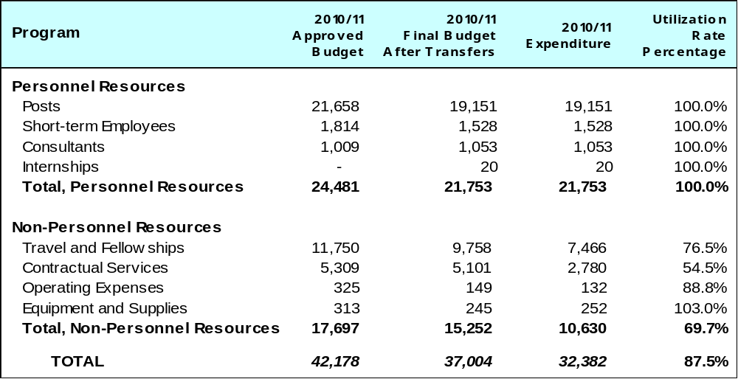

A. Budget after Transfers 2010/11

The budget after transfers 2010/11 compared to the approved budget 2010/11 reflects the reassignment of activities related to legislative policy advice on patents and trademarks to Programs 1 and 2, respectively, copyright development activities to Program 3 and activities of the external offices under Program 20.

The Program was assigned incremental resources in the order of 1 million Swiss francs for 2010/11, for three DA projects: “IP and Competition Policy”, “IP and Product Branding for Business Development in Developing Countries and Least-Developed Countries (LDCs)”, and “Capacity-Building in the Use of Appropriate Technology-Specific Technical and Scientific Information as a Solution for Identified Development Challenges”.

B. Budget Utilization 2010/11

Budget utilization for non-personnel resources in 2010/11 amounted to 69.7 per cent primarily due to unexpected political developments and disturbances in some regions, natural disasters, as well as requests from counterparts in some countries for the postponement or cancellation of some activities.

PROGRAM 30 SMALL AND MEDIUM-SIZED ENTERPRISES

Program Manager Mr. J. Pooley

ACHIEVEMENTS IN THE 2010/11 BIENNIUM

Support continued to be offered to national and regional IP Offices and other SME support institutions in assisting entrepreneurs and SMEs in using the IP system, primarily through the provision of support for translating and/or adapting content on IP for business to the local context and training of trainers programs.

Several projects in Member States for the translation and customization of publications, especially in the IP for Business series, were completed during the biennium. In addition, 28 Training of Trainers (TOTs) programs on effective IP asset management by SMEs were organized, aiming at creating a critical mass of trainers in a specific country with basic knowledge, skills and experience to provide preliminary assistance to SMEs on IP asset management.

Five new books on Strategic IP Asset Management, Use of Intangibles for Access to the Capital Market, IP Issues in the Agro Food Sector, IP Issues in Franchising and Trade Secrets for SMEs were in the process of being developed during the biennium. The IP Issues in Franchising publication is now in the layout and design stage. A new joint WIPO/ICC publication, Making IP Work for Business, was published in 2011. Furthermore, two guides in the IP for Business Series, namely on trademarks and on patents, were substantially updated.

WIPO continued to contribute to fostering appropriate policies and policy coherence on IP for SMEs at the national, sub-regional and regional levels. To this end, the annual OECD Forum was organized in 2010 and 2011 (the 8th and 9th such Forums) to discuss and exchange experiences on best practices in publicly funded IP support for SMEs. A sub-regional forum with the same objective was organized in Bratislava in addition to two national forums in India in 2010 and 2011. Substantive input was also provided to the OECD report on Intellectual Assets and Innovation: The SME Dimension.

In cooperation with the Regional Bureau for Africa, projects to improve the competitiveness of cluster-based micro, small and medium-sized enterprises (MSMEs) were initiated through the use of innovations in technology, branding and collective marks for added value in selected countries of Africa.

The Program also continued to develop other material for awareness creation and capacity building purposes. In this regard, the IP PANORAMATM multimedia toolkit, which was developed over a three-year period by WIPO, jointly with the Korean Intellectual Property Office (KIPO) and the Korea Invention Promotion Association (KIPA), has been increasingly used as an interactive e-learning tool in the field of IP asset management by a wide variety of SME stakeholders, including universities, business consultants, researchers and SMEs worldwide. A 13th module on IP Issues in Franchising reached the final stages of completion. An advanced international certificate course on IP asset management for business success based on the IP PANORAMATM Multimedia Toolkit, in English, was offered in cooperation with KIPO, KIPA and the Korea Advanced Institute of Science and Technology (KAIST). This course consisted of three components: an online course; an IP essay test; and an offline program. The six-week online course was offered three times during the biennium. Participants who completed the online course were to complete an essay test from which a small group was selected to attend a three-day advanced offline course organized by the same institutions in Seoul. A total of 603 students in 2010 and 921 in 2011 took the online courses. Some 13 students in 2010 and 19 in 2011, who successfully completed a session of the online course, and of the IP essay test, were given the opportunity to participate in the three-day offline program on advanced topics and issues related to IP asset management.

While national and regional IP Offices as well as a diverse range of SME support institutions remained the principle partners for the Program’s activities, efforts to reach out directly to SMEs continued via the SMEs website in the six UN languages and the monthly e-newsletter which was distributed to some 35,000 subscribers worldwide in 2010 and 43,513 in 2011, representing an increase of 24 per cent in 2011.
IMPLEMENTATION OF THE DEVELOPMENT AGENDA

The design, planning and implementation of activities undertaken by Program 30 were informed and guided by the relevant DA Recommendations. The Program was engaged in the implementation of the DA project DA_10_05 “Improvement of National, Sub-Regional and Regional IP Institutional and User Capacity”, within the framework of which a number of studies, training of trainers programs and translations and/or customization of IP for Business series publications and translation of IP PANORAMA multimedia tool kits were implemented. The primary objective was to enhance understanding of the use of the IP system by SMEs as well as the obstacles and challenges facing SMEs in trying to take advantage of the IP system.

PERFORMANCE DATA

Expected Result: Improved awareness of SMEs and SME support institutions on IP asset management and of policy makers on the importance of integrating IP into national strategies on enterprise competitiveness
Performance Indicators | Baselines | Performance Data | TLS
Increased number of SMEs and SMEs support institutions that rate the program’s website, new/previous publications, and the 12 modules of IP PANORAMA™ as useful for their work | 1,879,689 page views on SME website (2009) | 1,001,229 page views on the SMEs website in 2010, 1,062,211 page views in 2011  34,453 subscribers to the SMEs newsletter in 2010, and 43,513 subscribers in 2011, an increase of 24% in 2011 compared to 2010 | Fully Achieved
Increase in the number of countries requesting customization and/or translation of publications and modules of IP PANORAMA™ into their national language | 16 countries | 18 translation/customization agreements were signed with partner institutions/countries for 52 publications in 2010  Translation/customization of 24 publications in 8 countries (initiated in 2009) were completed  8 countries and one institution signed agreements for the translation and customization of 22 publications in 2011  14 countries and one institution completed the translation and/or customization of 40 publications in 2011  IP PANORAMA Multimedia Toolkit:  During the biennium, approximately 5,000 copies of CD-ROMs and 1,400 copies of learning point books of the English IP PANORAMA have been released to users, mainly on request  As local language versions of IP PANORAMA are concerned, the Hungarian, Swahili and Viet Namese versions were completed during the biennium as well as the Polish, Mozambiquan and Slovakian translations  As for the UN official language versions of IP PANORAMA, the Arabic version was successfully launched in 2010 and the French and Spanish versions were launched in 2011. The Russian version is at an advanced stage of completion  The 13th Module on IP Issues in Franchising is at an advanced stage | Fully Achieved
Number of national studies quoted as a source of reference in policy-making | No studies completed | Studies have been completed in Poland, Serbia and Tanzania. Studies are in progress in Brazil, India and Jordan | Partially Achieved
Number of quotations referring to the program publications and IP PANORAMA™ | Data not available | Data not available | Dis-continued
Increase in demand for the publication of more original content on IP for business | No new publications developed | 5 book projects were commissioned by WIPO in 2010 as well as 1 joint WIPO/International Chamber of Commerce (ICC) publication, which has been completed in 2011, namely Making IP Work for Business  One publication commissioned by WIPO is in the process of being completed (at the layout and design stages): IP Issues in Franchising  The four remaining books are currently in the review process | Fully Achieved
Expected Result: Enhanced capacity of SME support institutions, including universities and SME training institutions, to provide IP information, support and advisory services to their constituencies
Performance Indicators | Baselines | Performance Data | TLS
Increase in the number of SMEs support institutions providing services and information on IP | 45 SME Support Institutions | Data not available | Dis-continued
Number of SME support institutions, including universities, using WIPO material or material based on WIPO products in their awareness and capacity building services | Data not available | The WIPO-KIPO-KAIST-KIPA advanced international certificate course based on the English IP PANORAMA was organized yearly during the biennium  2 National Conferences in India one sub regional conference in Bratislava and two forums for OECD countries on Sharing of Best Practices on IP for MSMEs  3 Seminars held in Africa on Improving Competitiveness on Clusters-based MSMEs through the use of IP and Competitive Intelligence  Fact-finding Missions to Ethiopia, Tanzania and Uganda on Sectoral IP Development Strategies for Small scale producers in the agricultural sector  TOT Programs:  8 Training of Trainers Programs on Effective IP Asset Management by SMEs were carried out in 2010, and 20 such Training of Trainers Programs in 2011 | Fully Achieved
Rate of satisfaction of SMEs with the advisory services provided by SME support institutions | Data not available | Data not available | Dis-continued
Expected Result: Strengthened capacity of policy makers to formulate policies, develop and implement projects on IP asset management
Performance Indicators | Baselines | Performance Data | TLS
Increased reference to IP asset management in statements, speeches and directives of policy makers | Data not available | A number of national/regional studies and economic policy statements made by policy makers refer to the need for SMEs to better understand and manage IP assets for their competitiveness | Partially Achieved
Number of projects developed and implemented by national governments to promote IP based entrepreneurship | Data not available | Data not available | Dis-continued

BUDGET AND ACTUAL EXPENDITURE

Non-Personnel Expenditures - Allocation vs. Actuals 2010/11
(in thousands of Swiss francs)

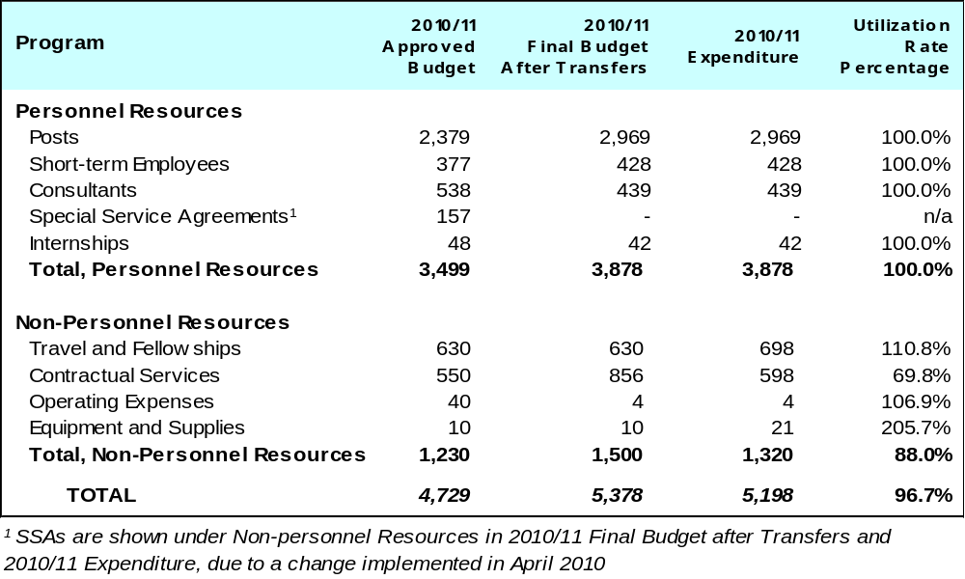

A. Budget after transfers 2010/11

The budget after transfers 2010/11 compared to the approved budget 2010/11 reflects an increase primarily due to the redeployment of staff to the Program.

B. Budget utilization 2010

Budget utilization of non-personnel resources reached 88 per cent primarily due to delays in implementation of planned activities during the second half of 2010 as a result of internal reorganization.

Program 10 Cooperation with Certain Countries in Europe and Asia

Program Manager Mr. J. C. Wichard

ACHIEVEMENTS IN THE 2010/11 BIENNIUM

In the biennium, focus continued to be on the elaboration and implementation of national IP strategies in countries in transition. Considering the specific needs of the countries in the region, guidance material on the Development of an Intellectual Property (IP) Strategy in Countries in Transition was published. This was complemented by a number of needs assessments and specific advice on the elaboration of national strategies. As a result of these activities, several countries adopted or revised their IP strategies (namely, Albania, Bulgaria, Croatia, Hungary, Romania, Kyrgyzstan, and Moldova) and some countries initiated the process (Armenia, Belarus, Bosnia and Herzegovina, Israel, Malta, Serbia, The former Yugoslav Republic of Macedonia, Ukraine and Turkey).

Development of new tools and guidelines was initiated to assist countries in the region to use IP for their economical, social and cultural development in a more focused manner. These tools benefitted from significant regional expert input.

The guidelines were instrumental, inter alia, in facilitating the revision of national legislation in the field of IP. Ten countries amended their national legislation in line with international IP treaties and national development plans, and further 14 countries announced their intention to assess the need for legislative amendments.

Throughout the biennium, WIPO also provided assistance to IP Offices for the modernization of procedures and automation systems, including: Azerbaijan, Albania, Belarus, Bosnia and Herzegovina, Bulgaria, Croatia, Israel, Malta, Montenegro, Poland, Russian Federation, Serbia, Slovakia, Slovenia and Ukraine.

WIPO expanded its cooperation with industry, SMEs and other relevant economic sectors to enhance the use of IP for economic development in the region and promoted the creation of partnerships between the public and private sectors (PPPs) in the area of IP. As a result, such partnerships were established in nine countries: Albania, Bosnia and Herzegovina, Croatia, Hungary, Poland, Slovakia, Slovenia, Russian Federation and Uzbekistan.

Support also continued to be provided to countries in building their national human resource capacities, and enhancing awareness and the knowledge base for an effective use of IP for economic, social and cultural development. More than 1,000 IP specialists and experts were trained in specialized IP programs relating to technology transfer, enforcement, copyright, teaching of IP, traditional knowledge, etc. In addition, WIPO Summer Schools were organized in Croatia, Russian Federation and Ukraine.

IMPLEMENTATION OF THE DEVELOPMENT AGENDA

Program 10 continued to play a key role in the implementation of the WIPO DA in relation to cooperation with certain countries in Europe and Asia. This was particularly the case for the DA Recommendations relating to WIPO’s technical assistance and capacity building activities - the recommendations under Cluster A which continued to shape the design and implementation of activities under Program 10.

PERFORMANCE DATA

Expected Result: National IP strategies and legislations have been aligned to national development strategies and plans as well as to international IP treaties and agreements
Performance Indicators | Baselines | Performance Data | TLS
Some 15 new countries with developed national IP capacity-building programs and IP strategies, dovetailed with national development plans | IP strategies developed in 11 countries: Bosnia and Herzegovina, Bulgaria, Croatia, Czech Republic, Hungary, Kazakhstan, Poland, Romania, Russian Federation, Slovakia, Slovenia | Adopted or revised IP strategies: Albania, Bulgaria, Croatia, Hungary, Romania, Kyrgyzstan and Moldova  (total 7)  IP strategies initiated: Armenia, Belarus, Bosnia and Herzegovina, Israel, Malta, Serbia, The former Yugoslav Republic of Macedonia, Ukraine and Turkey (total 9) | Fully Achieved
Some 21 new countries with updated national IP laws and regulations which are consistent with international IP treaties and agreements and conform to national development priorities | 22 countries amended or are planning to amend their national legislation to make them consistent with international IP treaties and national development plans: Armenia, Azerbaijan, Belarus, Bosnia and Herzegovina, Bulgaria, Croatia, Czech Republic, Georgia, Hungary, Kazakhstan, Lithuania, FYR Macedonia, Malta, Moldova, Poland, Romania, Serbia, Slovakia, Slovenia, Tajikistan, Turkmenistan and Ukraine | 10 countries amended their national legislation in line with international IP treaties and national development plans: Albania, Bosnia and Herzegovina, Bulgaria, Croatia, Israel, Malta, Romania, Slovakia, The former Yugoslav Republic of Macedonia and Uzbekistan  14 countries are planning to amend their legislation: Armenia, Belarus, Bulgaria, Georgia, Hungary, Kazakhstan, Lithuania, Moldova, Serbia, Slovenia, Tajikistan, Turkmenistan, Ukraine, Turkey | Fully Achieved
Expected Result: More effective and user-friendly services by national IP institutions
Performance Indicators | Baselines | Performance Data | TLS
Some 14 new countries with modernized IP infrastructure and upgraded management of IP services, including updated working methods and automated IP office operations | 17 countries improved the capacity of their IP centers: Albania, Belarus, Bulgaria, Croatia, Czech Republic, Estonia, Hungary, Kazakhstan, Latvia, Lithuania, Poland, Romania, Russian Federation, Serbia, Slovakia, Slovenia, and Ukraine | IP Offices were modernized in 15 countries: Azerbaijan, Albania, Belarus, Bosnia and Herzegovina, Bulgaria, Croatia, Israel, Malta, Montenegro, Poland, Russian Federation, Serbia, Slovakia, Slovenia and Ukraine | Fully Achieved
Some 15 new countries with well-functioning IP-related information and service centers | 17 countries improved the capacity of their IP centers: Albania, Belarus, Bulgaria, Croatia, Czech Republic, Estonia, Hungary, Kazakhstan, Latvia, Lithuania, Poland, Romania, Russian Federation, Serbia, Slovakia, Slovenia, and Ukraine | IP-related information and service centers were established in 9 countries: Azerbaijan, Bosnia and Herzegovina, Estonia, Georgia, Israel, The former Yugoslav Republic of Macedonia, Moldova, Montenegro and Turkey  TISC launched in Kyrgyzstan | Partially Achieved
Expected Result: Enhanced capacity of IP professionals
Performance Indicators | Baselines | Performance Data | TLS
IP training program for professionals was provided to some 16 countries and improved performance was noted in over 60% of participants | Training programs organized for IP professionals from 12 countries: Albania, Armenia, Belarus, Bulgaria, Czech Republic, Kazakhstan, Kyrgyzstan, Lithuania, Moldova, Russian Federation, Slovakia, Ukraine | Training programs, summer schools, study visits organized for IP professionals from 20 countries: Albania, Azerbaijan, Belarus, Bulgaria, Croatia, Cyprus, Israel, Kyrgyzstan, Latvia, Lithuania, Moldova, Montenegro, Poland, Romania, Russian Federation, Slovakia, Slovenia, Tajikistan, Turkey, Ukraine. According to the feedback received from IP Offices, the performance of the trained staff improved in almost 90 percent of the cases | Fully Achieved
Expected Result: Effective use of IP systems prompted by the establishment of domestic partnerships between the public and private sectors (PPPs) in the area of IP
Performance Indicators | Baselines | Performance Data | TLS
Some 10–12 new start up companies, spin off projects were initiated in various countries in partnerships among public and private sectors for IP development and use | Partnerships between public and private sectors established in 10 countries: Czech Republic, Georgia, Kazakhstan, Latvia, Poland, Romania, Russian Federation, Serbia, Slovakia and Ukraine | Partnerships between public and private sectors established in 9 countries: Albania, Bosnia and Herzegovina, Croatia, Hungary, Poland, Slovakia, Slovenia, Russian Federation and Uzbekistan  Partnerships between public and private sectors in the process of being established in 7 countries: Armenia, Azerbaijan, Belarus, Kyrgyzstan, Lithuania, Moldova and Turkey | Fully Achieved
Expected Result: Newly developed tools and guidance to promote the use of IPRs for economic development used by countries in transition
Performance Indicators | Baselines | Performance Data | TLS
Number of webpage/readers hits by new guidance material and country | Work started on special WIPO Tools to facilitate the exchange of experience and best practices, elaborated for the specific needs of the countries of the region | About 5,000 web pages refer to newly developed tools for countries in transition with approximately 40,000 readers. | Fully Achieved
Six new guidance materials will be produced by the end of 2011 | Three new Tools developed: 1. Management of Academic Intellectual Property and Early Stage Innovation  2. Special Features of the Copyright Systems  3. Recommendations on Strengthening the Role of Innovative SMEs in CIS countries | The following new guidance material was developed:  1. Model IP policy for universities and research institutions; 2. Case study on technology transfer in countries in transition; 3. Tool on the role of IP, in particular, trademarks and geographical indications, in creating, developing and strengthening of a nation brand; 4. Toolkit on enforcement of IPRs in countries in transition; 5. Teaching IP in countries in transition; 6. Revised guidance material on the Development of an Intellectual Property (IP) Strategy in Countries in Transition; 7. Practical handbook for countries in transition on the management of IP in digitization projects of intangible cultural heritage | Fully Achieved

BUDGET AND ACTUAL EXPENDITURE

Actual Expenditures (personnel and non-personnel) vs. Budget after Transfers 2010/11
(in thousands of Swiss francs)

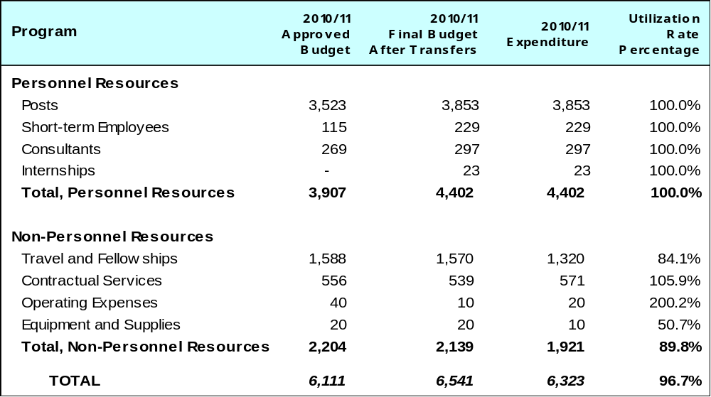

A. Budget after Transfers 2010/11

The 2010/11 final budget after transfers reflects an increase in personnel resources compared to the approved budget, primarily due to the redeployment of staff to the Program.

B. Budget Utilization 2010/11

The under-utilization of non-personnel resources was the result of lower costs incurred in respect of events organized in the region due to the implementation of general cost saving measures across the Organization, for example in relation to travel costs.

PROGRAM 11 THE WIPO ACADEMY

Program Manager Mr. G. Onyeama

ACHIEVEMENTS IN THE 2010/11 BIENNIUM

In 2010/11, the Academy continued to offer training courses in partnership with its long-standing cooperating institutions. To respond to the increasing quantitative and qualitative demands from Member States, the Academy launched both new face-to-face and distance learning courses. It also continued to strengthen the interdisciplinary methodology to IP teaching through its training programs. Furthermore, the Academy enterred into new partnerships and broadened cooperation to cover all regions.

Under the Professional Development Program – in partnership with 26 institutions in all regions – 42 training courses were organized on industrial property and copyright and related rights. A total of 396 participants from IP offices, including collective management organizations on copyright and related rights and relevant ministries participated in the courses. Feedback from participants indicated that the training had enhanced their knowledge and skills in the administration of IP rights and enabled the participants to provide better services to users of the IP system. Despite a slight increase in 2011, overall the biennium 2010/11 saw a decrease in the number of participants trained due to the transfer of responsibility for organizing two courses on copyright from the Academy to Program 3.

The demand for the Distance Learning (DL) courses remained high during the Biennium. The program registered a total of 83,800 participants (the highest so far in any biennium) from 190 countries in the 14 DL courses, comprising 161 sessions which were offered in Arabic, Chinese, English, French, Portuguese, Russian and Spanish. Of the 161 sessions, 53 were offered to Technology Information Support Centers (TISCs), Start-Up Academies and Universities in special sessions. The expected result, easy access to IP knowledge, was primarily achieved through: the deployment of a new IP eTeaching/eLearning platform; offering DL courses in conjunction with existing WIPO Master Programs on IP, Summer School Programs and the WIPO-University of South Africa Specialization on IP Certificate Program; reviewing the course content of five advanced DL courses; introducing a module on the WIPO Development Agenda (see further details below); and training of tutors from developing countries on Institutional Capacity Building in IP eTeaching/eLearning. The Academy collaborated closely with the IP Offices of Brazil, China, Mexico and Russia in this endeavor.

Arabic, Croatian, Russian and Vietnamese were added as additional languages during the biennium. The advanced courses on Copyright and Related Rights (DL-201), Trademarks, Industrial Designs and Geographical Indications (DL-302), IP and Biotechnology (DL-204), Basics on Patent Information Search (DL-318), and IP Management (DL-450) underwent phase one of two of content review. Some 48 tutors from the IP Offices of Colombia, Croatia, Dominican Republic and Viet Nam were trained on eTeaching and customizing the DL-101. Some 314 participants from the University Technology Transfer Offices (TTOs) of Dominican Republic, Egypt, Ethiopia, Honduras, Kyrgyzstan, Philippines and Viet Nam, and were trained in DL courses on Patents, Patent Drafting, and IP-Management, organized in cooperation with the WIPO DA project on Technology Information and Support Centers (TISCs).

To enhance the efficiency of IP education, continued training of trainers and other IP specialists in cooperation with universities were pursued under the Academic Institutions Program. A total of 249 students from 122 different countries, of which 124 were sponsored by WIPO, were enrolled in the Master Programs offered jointly with the Turin University in cooperation with the International Training Center of the International Labor Organization (ITC-ILO), Italy; the Africa University and ARIPO, Zimbabwe; Queensland University of Technology (QUT), Australia; and the OAPI and University of Yaoundé II in Cameroon. In order to enhance networking and efficiency of IP education and training worldwide, two Colloquia for Teachers of IP was organized jointly with the World Trade Organization (WTO) with a total of 44 teachers from 44 countries taking part in the program. In addition, 40 government officials from 40 countries were trained under the WIPO-WTO Advanced Course on IP. A total of 403 students, university lecturers, researchers and government officials participated in six regional and national symposia on IP education, training and research organized in Bulgaria, China, Fiji, Kazakhstan, Liberia and Malawi. To promote and improve IP teaching and training, 10 professors from developing countries and countries in transition were sponsored to participate in the ATRIP Congress in 2010 and 2011. Initiatives were also undertaken to assess the development of post-graduate programs in the Asian and Latin American regions.

The Executive Education Program was remodeled and reintroduced in the 2010/11 biennium. The first program on “Strategic Management of Intellectual Property” was held in Singapore in 2011 at the Business School of National University of Singapore (NUS) and targeted business managers and senior executives in the region, particularly in developing countries. The program featured two core professors, one from Harvard Business School and the other from Harvard Law School. They were complemented by experts from industry, WIPO and a regional expert from NUS. Twenty-three participants attended from 12 countries in the region namely, Australia, Brunei Darussalam, China, India, Indonesia, Malaysia, New Zealand, Philippines, Qatar, Singapore, Sri Lanka and Thailand.

The WIPO Summer School Program continued to grow with a total of 17 Summer Schools organized worldwide. A total of 640 senior students and young professionals from 84 countries benefited from the courses in 2010/11. The total number of languages increased to three (English, Russian and Spanish).

IMPLEMENTATION OF THE DEVELOPMENT AGENDA

Program 11 was engaged in the implementation of the DA projects DA_10_01 “A Pilot Project for the Establishment of “Start-Up” National IP Academies”. Under this project, four academies were launched in Colombia, Dominican Republic, Peru and Tunisia.

In addition, a process was initiated to better integrate the DA into the distance learning programs of the Academy. The so-called ‘learner-centered-approach’ was developed to give higher visibility to the teaching of IP and development. As a result, a specific module has been developed for the General Course on IP (DL-101), and specifics modules are being developed for Copyright and Related Rights (DL-201), Trademarks, Geographical Indications and Industrial Designs (DL-302) and Patents (DL-301) making the WIPO DA an integral part of these courses.

The design, planning and implementation of activities undertaken by Program 11 were informed by the relevant DA Recommendations on technical assistance and capacity building.

PERFORMANCE DATA

Expected Result: Upgraded and enhanced knowledge and skills of staff of IP offices and other stakeholders in developing countries
Performance Indicators | Baselines | Performance Data | TLS
% satisfaction rate for all Academy programs and the Masters of Law in IP | 95% for Professional Development Program, Academic Institutions and Distance Learning Program | 95% satisfaction rate for Professional Development Program, Academic Institutions and Distance Learning Program | Fully Achieved
% of students/trainees /participants using new knowledge and skills on the job by office and country | 90% in Professional Development Program | 91% rate in Professional Development Program | Fully Achieved
Number of IP professionals trained by institution and country | 246 professionals trained | 396 professionals trained in 2010/11 under the Professional Development Program and 640 participants from 84 countries under the Summer School Program | Fully Achieved
Number of graduates specialized in IP by country | Number of students enrolled: 33 LLM Turin from 15 countries; 26 MIP-Africa University from 15 countries | Number of students enrolled: 79 LLM Turin from 35 countries; 62 MIP- Africa University from 30 countries; 61 MIP-University of Yaoundé II from 29 countries and 47 MIP Law – Queensland University of Technology from 5 countries  (Of the above total of 249 students, 124 were sponsored by WIPO) | Fully Achieved
Expected Result: Strengthened infrastructure for IP education and introducing IP at different academic levels in Member States
Performance Indicators | Baselines | Performance Data | TLS
Six Start-up and National IP Academies will be established in developing countries and LDCs | DA project commenced in 2009 and no Start-up National IP Academies were established by end 2009 | According to the finalized project document approved in the third session of the CDIP, four national IP Academies were launched | Partially Achieved
At least one university or high learning institution in each region to introduce specialized IP courses or update existing IP courses | 5 universities/  institutions (India, FYR Macedonia, Malawi, Uganda and Zambia) | 10 universities/ institutions (Australia, Bangladesh, Cameroon, The Former Yugoslav Republic of Macedonia, Indonesia (2) (Univ of Indonesia and Universistas Padjadjaran), Malawi, Thailand, Turkey, and Zambia | Fully Achieved
Expected Result: Use of the on-line courses as a complement to IP training and education programs and to generate greater public awareness on IP
Performance Indicators | Baselines | Performance Data | TLS
% of students/trainees /participants using new knowledge and skills on the job by office and country | 90% utilization | 93% utilization | Fully Achieved
Increased/maintain the number of annual registration and completion rate of all on-line courses | 71,500 registrations; 69% completion rate (2008/09) | 83,000 registrations; 68% completion rate (2010/11) | Fully Achieved
Increased number of courses available in all six UN languages | 2 courses (DL-201 & DL-202) | 4 courses in additional UN languages DL-101, DL-201, DL-202 and DL-301 | Fully Achieved
Expected Result: Enhanced networks and efficiency of international cooperation for IP training and education among Member States
Performance Indicators | Baselines | Performance Data | TLS
Increased geographical representation of key cooperation partners at the Network | 21 partners | 24 partners (total) | Fully Achieved
Number of cooperation projects carried out within the framework of the Network among members | None | 12 projects | Fully Achieved

BUDGET AND ACTUAL EXPENDITURE

Actual Expenditures (personnel and non-personnel) vs. Budget after Transfers 2010/11
(in thousands of Swiss francs)
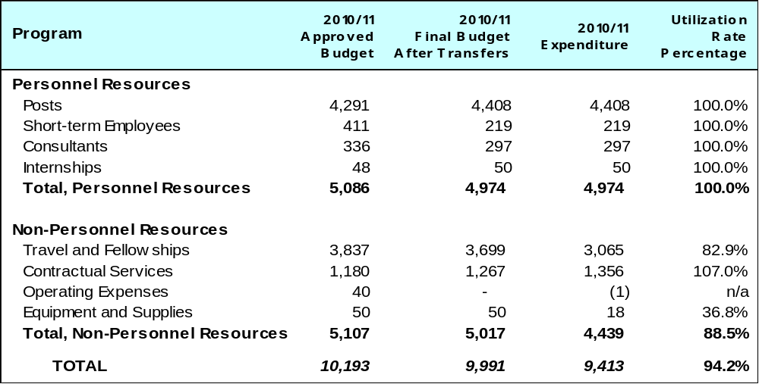

- Budget after Transfers 2010/11

The 2010/11 final budget after transfers reflects a decrease in personnel resources primarily due to a reduction in short-term employees.

B. Budget Utilization 2010/11

The budget utilization rate reflects the postponement of three courses under the Professional Development Program, as agreed with the partner institutions.

Program 12 International Classifications and WIPO Standards

Program Manager Mr. Y Takagi

ACHIEVEMENTS IN THE 2010/11 BIENNIUM

Significant progress was achieved during the 2010/11 biennium with respect to enhancing the efficiency of the revision of International Classifications and WIPO IP Standards.

To this end, a simplified structure of the IPC entered into force in 2011 together with a new publication platform. The administrative procedures were simplified, in particular as regards the preparation of paper documentation for the meetings which was replaced by the distribution of USB keys.

The Nice electronic forum was implemented and allowed a better preparation and more efficient progress of the work of the Committee of Experts. It was thus possible to shorten the duration of its regular session to five working days instead of eight in the past.

A new work flow was also implemented for the publication of the report of the sessions of the IPC Revision Working Group which allowed the shortening of the period used for publication of the report documents and update of the e-forum to three weeks instead of six.

As a result of the above initiatives, the average time between a revision request and its publication fell from 32 months in 2009 to 23 months in 2011. The decision to publish annual versions of the Nice Classification as from 2013 will reduce the time lag between a revision request and its publication for certain types of amendments.

Concerning the wider acceptance and more effective use of International Classifications and WIPO Standards, the agreement between the USPTO and the EPO to develop and use the Cooperative Patent Classification, which is based on the IPC, and to integrate their separate internal Classifications, was a major breakthrough during the biennium. The implementation of the Goods and Service manager, developed under the Madrid System, also contributed to a more correct use of the Nice Classification. A new tool included in WIPOSTAD for making surveys will be used in the future for assessing the use of Standards by offices.

The unification of the publication platforms has begun. It is expected that by the end of 2013, IPC, Nice and Vienna will be unified reducing the dependency on external resources for publication.

Finally, a new IPC reclassification platform was developed which is expected to be put into production at the beginning of 2012. This will allow WIPO to take a more active role in the reclassification process and also allow smaller Offices to participate in the reclassification exercise. In addition, administrative measures have been taken to allow active Offices to reclassify more documents than what was previously in their lists. By the end of 2012, the number of reclassified patent documents using the new platform is expected to significantly increase.

IMPLEMENTATION OF THE DEVELOPMENT AGENDA

The work of Program 12 supports the implementation of DA Recommendations 8, 30 and 31, by facilitating access for developing countries to publicly available patent information. In doing so, it also contributes to efforts related to the transfer of technologies.

PERFORMANCE DATA

Expected Result: Enhanced efficiency in the revision of International Classifications and WIPO Standards
Performance Indicators | Baselines | Performance Data | TLS
Full implementation of the IPC simplified structure by January 2011 | Two-tiered structure | The simplified structure of the IPC entered into force on January 1, 2011 as planned  In that respect a new publication platform for the IPC was put in production six months before | Fully Achieved
Full implementation of the Reform of the Nice Classification Revision Process to shorten the revision period from 5 to 1 year by 2011 | Five year revision period | The Nice Committee of Experts decided to shorten the revision period to one year for new versions of the Classification | Fully Achieved
The number of NIVILO classifications projects discussed on e-Forum | None | 18 classification projects were considered on the e-forum in 2010 and five additional in 2011 (total of 23 projects) | Fully Achieved
Decrease the time necessary between the submission of a request and its adoption and publication | 32 months average for IPC revision. | Average in 2010: 21 months  Average in 2011: 23 months | Fully Achieved
The amount of editorial work to be considerably reduced by new web-based database for SDWG and corresponding tools for the Classifications | The current workflow and publication need a considerable amount of formative editorial work | New workflow for publication of reports of the IPC Revision  Working Group has reduced the total duration of publication from six to three weeks  The WIPOSTAD database was put into production in July 2011 but was not fully operational by the end of the biennium  E-forum was used during the meetings instead of distribution of paper  The e-forum simplified the paper documentation distributed for NVL Classifications meetings | Fully Achieved
Expected Result: Wider acceptance and more effective use of International Classifications and WIPO Standards
Performance Indicators | Baselines | Performance Data | TLS
Increased number of contracting parties to corresponding Agreements | Information available on WIPO web site | IPC: two new members (Ukraine and Serbia)  Nice: one new member  Vienna: three new members (the former Yugoslav Republic of Macedonia; Montenegro; Republic of Korea  Locarno: one new member (Republic of Korea) | Fully Achieved
Increased consultation of the relevant WIPO web sites | Page views for 2009:  IPC home: 349,199  Nice home: 278,425  Locarno home: 20,311  Vienna home: 14,273  IPC publication  Not available (since March 2010)  WIPO Standards (Handbook): 116,031 | Page views for 2010 / 2011  (the consistency of page view figures is expected to improve with the new IPC reclassification service, hosted in WIPO, which recently went into production)  IPC home: 324,852 / 341,583  Nice home: 269,315 / 307,403  Locarno home: 17,637 / 21,481  Vienna home: 13,588 / 19,691  IPC publication  27,274 / 55,153 (since March 2010)  WIPO Standards (Handbook):  108,711 / 95,323 | Fully Achieved
Expected Result: Unify the publication procedures and relevant IT support of the International Classifications
Performance Indicators | Baselines | Performance Data | TLS
Minimize the use of external resources for publication of the Classifications | Heavily rely on external resources for publication in particular of the NIVILO Classifications | The new publication platform for Nice was developed and is expected to enter into production by the end of 2012. Vienna will follow in 2013. | Partially Achieved
Expected Result: Development and improvement of IT support tools to assist national offices in producing national versions of the International Classifications
Performance Indicators | Baselines | Performance Data | TLS
Number of offices using these tools: Target 8 | 4 offices (BR, ES, GR, PL) | 1 additional new Office (SK) has started publishing the IPC using the tools  1 additional Office expressed interest in 2011 (SER) and will implement the tools in 2012 | Partially Achieved
Expected Result: Systematic reclassification of patent documents following IPC revision using an XML web service
Performance Indicators | Baselines | Performance Data | TLS
Number of offices participating in the reclassification and number of patent documents reclassified | 12 offices participated in 2009 (EP, US, JP, ES, BR, SE, NO, HU, GB, BG, CN, MX).  73% average of documents reclassified | 15 Offices participated in 2010/11 (EP, US, SE, RU, NO, JP, HR, FI, CA, BR, ES, MX, IL, HU, CZ)  Average of reclassified documents:  2007: 91%  2008: 83%  2009: 59%  2010: 42%  2011: 25% | Fully Achieved

BUDGET AND ACTUAL EXPENDITURE

Actual Expenditures (personnel and non-personnel) vs. Budget after Transfers 2010/11
(in thousands of Swiss francs)

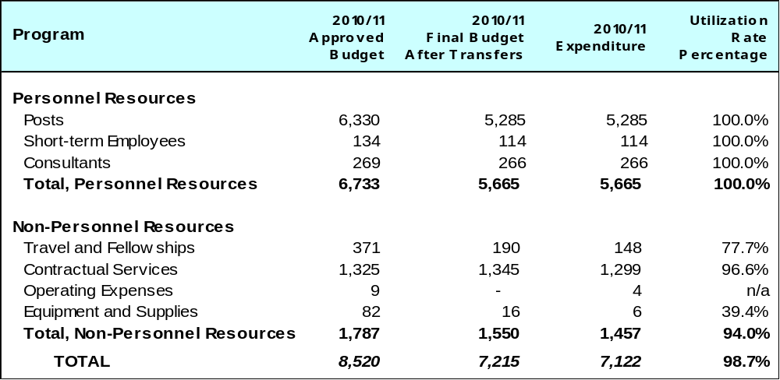

A. Budget after Transfers 2010/11

The 2010/11 final budget after transfers reflects a decrease due to the reassignment of patent information services to Program 14, and the transfer of funds to Program 20 in order to cover the cost for the relocation of the WIPO Japan Office.

B. Budget Utilization 2010/11

The slight underspend in non-personnel resources was due primarily to lower travel expenses as a result of cost efficiency measures.

PROGRAM 14 GLOBAL IP INFORMATION SERVICES

Program Manager Mr. Y. Takagi

ACHIEVEMENTS IN THE 2010/11 BIENNIUM

The PATENTSCOPE portal moved to an entirely new high-performance system in late 2011, enhancing search functions and user experience and resulting in a significant increase in the number of visitors (38 per cent in 2011 compared to 2010). The number of national and regional collections held in the system increased from eight to 28. Multi-linguistic functions were introduced to launch user interfaces in nine languages, Cross Lingual Information Retrieval (CLIR) query expansion and translation in nine languages, integration of Google translate, KIPO translate for Korean and Microsoft translate for search results and Translation Assistant for Patent Titles and Abstracts (TAPTA). In addition, two new global databases were launched: Global Brand Database containing the Madrid, 6ter and Lisbon collections, and the UPOV Plant Variety Database (PLUTO) in 2011.

The project “Access to Specialized Patent Information” (ASPI) was launched in 2010 leveraging experiences from the project “Access to Research for Development and Innovation” (ARDI), which started in 2009. In partnerships with commercial database vendors and other UN agencies, both projects made a number of commercial databases accessible for free, or at a preferential rate, in developing countries and LDCs. During the biennium, the projects managed to significantly increase the content accessible by beneficiary countries.

The “Technology and Innovation Support Centers”(TISCs) project attracted a total of 38 countries in the biennium. A total of 20 countries established their TISCs networks after needs assessment missions, planning, conclusion of Service Level Agreements (SLAs) and initial training of TISC staff members. To facilitate regional cooperation, four regional seminars on the TISC project were organized to allow countries to create a regional platform for the exchange of experiences among countries in establishing and managing TISCs.

Under the Development Agenda Project (“Developing Tools for Access to Patent Information”), WIPO prepared nine patent landscape reports (PLRs) in areas of particular interest to developing countries and LDCs. They were prepared in cooperation with the WHO, FAO, the Medicines Patent Pool (MPP), the International Renewable Energy Agency (IRENA) and the African Agricultural Technology Foundation (AATF). They were published on a website dedicated to PLRs, which also includes a compilation of existing PLRs by various public and private sector actors in various fields.

A feasibility study on the establishment of national patent register databases and linkages to PATENTSCOPE prepared for the eight session of the CDIP in 2011, provided guidance to the enhancement of WIPO Patent Search Support Services for IP Offices and also facilitated discussions on international cooperation for improved access to inventions in the public domain.

WIPO also assisted interested Member States in developing a concept for a system for transnational exchange of patent search and examination services to explore further international cooperation on patent examination.

In 2010 and 2011, WIPO organized the second and third Global Symposia of IP Authorities respectively, which provided heads of IP Offices, industry leaders and other stakeholders with an international forum to share ideas and experiences for improving services to be provided by IP authorities. Over 50 participants from developing countries and LDCs attended the Symposia, which contributed to furtherance of international cooperation on the coordination of developing a global infrastructure conducive to improved access to global IP information.

IMPLEMENTATION OF THE DEVELOPMENT AGENDA

A major part of the Program’s work during the period under review consisted of the implementation of the DA projects on Specialized Databases’ Access and Support and Developing Tools for Access to Patent Information as described above.

The design, planning and implementation of activities undertaken by Program 14 were informed by the relevant DA Recommendations.

PERFORMANCE DATA

Expected Result: Improved access to information resources generated by IP systems
Performance Indicators | Baselines | Performance Data | TLS
New PATENTSCOPE search services has contributed to an increased number of users | Data pre-2010 not available | Q1 2010 - 156,271 unique visitors  Q4 2011 - 216,290 unique visitors | Fully Achieved
Increased number of countries that have access to specialized databases and related support services in developing countries and LDCs | Access to scientific & technical journals through ARDI program for 105 developing countries and LDCs; access to commercial patent databases through ASPI program for 115 developing countries and LDCs | The ARDI program offers access to over 200 (4 times more than in 2010) scientific and technical journals to 77 developing countries for free and to 28 at a very low cost. ARDI opened the possibility of access to more journals by joining the Research4Life (R4L) partnership, which offers access to over 8,000 peer-reviewed journals in WHO’s HINARI program (biomedical and health journals), FAO’s AGORA program (agriculture based journals), and UNEP’s OARE program (environmental issues); ASPI offers access to 6 of the world’s major commercial patent databases to 49 LDCs for free and to 66 other developing countries at very low cost | Fully Achieved
Number of Technology and Innovation Support Centres (TISCs) beneficiaries that perceived the TISCs as a central point of expertise for patent and technology information by country | TISC networks established in 6 countries | TISC networks were established in 20 countries during this biennium: Algeria, Republic of Congo, Democratic Republic of Congo, Cuba, Dominican Republic, Ecuador, Egypt, Georgia, Guatemala, Honduras, Kenya, Kyrgyzstan, Madagascar, Morocco, Mozambique, Nigeria, Philippines, Senegal, Tunisia and Viet Nam | Fully Achieved
% of users of the global IP data bases and IP services data bases that consider that the data bases have facilitated the efficiency and effectiveness of their work | Data pre-2010 not available | See the “Technology and Innovation Support Centers (TISC) Progress and needs assessment questionnaire” - December 2011 - Survey Summary Report http://www.wipo.int/export/sites/www/patentscope/en/programs/tisc/doc/TISC_2011_2012_Survey_Summary_Report.pdf | Fully Achieved
Expected Result: Increased dissemination of digitized patent collections of national/regional offices of
WIPO member states
Performance Indicators | Baselines | Performance Data | TLS
Increased available number of new patent collections in online databases on the Internet. | End 2009 PATENTSCOPE contained eight collections | End 2011 contained 28 collections in addition to PCT | Fully Achieved
Expected Result: Enhancement of WIPO Patent Search Support Services for IP offices of member states
Performance Indicators | Baselines | Performance Data | TLS
Number of local inventors in developing countries and LDCs that have benefited from the capacity building program related to state-of-the-art searches | n/a | WPIS search services were not actively promoted any longer as before since they should partially be replaced by services offered by TISCs. Number of users has therefore decreased | Fully Achieved
Redesign of the ICSEI service to provide for further improvement within the PCT system and improved access to the PCT system for inventors from developing countries and LDCs | n/a | Redesign of ICSEI (now called ICE) was started and the scope of services were expanded to also deliver specialized training to patent examiners on the utilization of external examination results from other IP Offices. A first sub-regional workshop for ASPAC IP Offices was delivered in November 2011 in Kuala Lumpur. With Swiss IGE a new donor for pro-bono examination reports was recruited | Partially Achieved
Expected Result: Improved use of patent information through the development of patent landscapes
and related tools covering selected topics
Performance Indicators | Baselines | Performance Data | TLS
Number of users of the published patent landscapes on a set of agreed topics of interest to Member States | None - end 2009  (A first set of Patent Landscape reports will be produced in 2011) | PLR website (4,228 views on the website)  The year 2010 served for setting up the concept of the Landscape Reports, identifying cooperation partners and subjects to be addressed, along with the individual patent search methodology to be used and the public procurement procedure for the preparation of the reports  Nine patent landscape reports were produced in 2011 and are in the publication process: Ritonavir, Atazanavir, Solar Cooking, Solar Cooling, Vaccines (Global overview and Selected Diseases Part), Desalination and the Use of Alternative Energy for Desalination | Fully Achieved
% of participants of the online tutorial on patent information and patent landscaping and regional conferences on patent landscaping using the new knowledge and skills on the job by office and country | None - end 2009  (on-line tutorial will be made available only in 1Q of 2011) | The online tutorial is to be completed in mid-2012; 4 regional conferences were organized during the biennium in Africa, (Addis Ababa), ASPAC (Singapore), CCEAC (Moscow) and LAC (Buenos Aires); see also the “Technology and Innovation Support Centers (TISC) Progress and needs assessment questionnaire” Dec 2011 | Partially Achieved

BUDGET AND ACTUAL EXPENDITURE

Actual Expenditures (personnel and non-personnel) vs. Budget after Transfers 2010/11
(in thousands of Swiss francs)
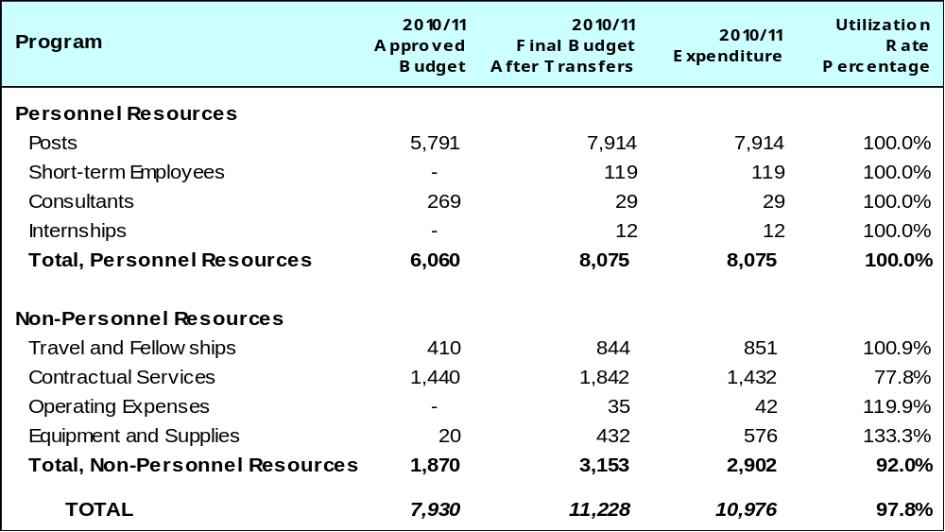

A. Budget after Transfers 2010/11

The budget after transfers 2010/11 reflects an increase compared to the approved budget 2010/11 due to the assignment of patent information services to this Program (from Program 12) and additional resources allocated for global databases related activities. The Program was also assigned incremental resources of approximately 1 million Swiss francs for two DA projects: “Developing Tools for Access to Patent Information” and “IP and the Public Domain”.

B. Budget Utilization 2010/11

The budget utilization rate for non-personnel resources was slightly lower than expected (92 per cent) mainly due to delays in ongoing procurements which could not be finalized before the end of the biennium.

PROGRAM 15 IP OFFICE MODERNIZATION

Program Manager Mr. Y. Takagi

ACHIEVEMENTS IN THE 2010/11 BIENNIUM

In 2010/11, modernization services were provided to IP Offices from more than 90 countries, across all regions, of which 16 were LDCs. In addition, two regional IP institutions in Africa, ARIPO and OAPI, received ongoing assistance in their modernization projects. National and/or regional Offices assisted included both those where new modernization projects were initiated (14 Offices), as well as those where modernization projects were already in progress but in different stages of implementation (44 Offices).

Work in the biennium also included the organization and/or participation in eight regional workshops focusing on key automation topics, training and sharing of national experiences and best practices.

In order to better address the challenges faced in assisting IP institutions at diverse levels of development, infrastructure, skills and resources, a comprehensive set of modernization services were offered including: technical advice and guidance; needs assessments; simplification of business processes; provision of standard automation components customized to specific national requirements; establishment of national IP databases; e-communication with the Madrid System; linkage with the WIPO PATENTSCOPE service; extensive training of IP institutions’ staff and knowledge transfer to their technical focal points; follow-up and monitoring and post-implementation progress review evaluations. Technical capacity building and knowledge transfer activities accounted for about 60 per cent of the Program’s work and were critical in achieving the desired results.

Achievements during the 2010/11 biennium also included new releases of the WIPO Industrial Property Automation System (IPAS) with additional functionalities and enhanced efficiency, the development of the new Electronic Data Management System (EDMS) module, which is now being tested in several Offices, and the completion of WIPO’s digitization software, WIPOScan.

The new version of IPAS was successfully deployed in Algeria, Malta, San Marino, Serbia and Tunisia and projects are underway to deploy it in other countries in 2012. As a result of progressively migrating users of the Arab IP Management System (AIPMS) to the new IPAS, the use of the AIPMS in the Arab region decreased during the biennium. This trend is expected to continue in the coming years. The WIPOScan software was installed in ARIPO, Argentina, Azerbaijan, Botswana, the Dominican Republic, Egypt, Kenya, Morocco, Namibia, Panama, South Africa, Tunisia, the United Arab Emirates and Zambia.

Significant progress was also made in the deployment of IPAS to medium-to-large IP offices that had requested assistance in Brazil, Chile, Indonesia and the Philippines. Interest was also expressed from Egypt, Mexico, Nigeria and South Africa, and assessments have been conducted for those offices.

Furthermore, the biennium saw the development of the WIPO CASE (Centralized Access to Search and Examination) platform, enabling participating offices to share information relating to the patent search and examination processes. To date, users of the WIPO CASE are the Vancouver Group offices (Australia, Canada and the United Kingdom). A group of nine Latin American countries (the PROSUR group, consisting of Argentina, Brazil, Chile, Colombia, Ecuador, Paraguay, Peru, Suriname and Uruguay) have requested assistance with the development of a similar system, and a pilot project was tested by the Offices during 2011.

The extension of the WIPO Priority Document Access Service (DAS) to new types of IP rights, including trademarks, industrial designs and utility models, was approved during the third session of the DAS Working Group in July 2011. The Working Group also approved simplifications to the service to make it more attractive for applicants to use and easier for Offices of all sizes to participate. Development of new improvements is in progress.

Collaboration and partnership with Offices was reinforced through the signature of 37 new Cooperation Agreements regarding the deployment of systems for the development of business services.
The chart below provides an indication of the level of usage of the WIPO business modernization systems by the end of 2011 as compared to 2009:

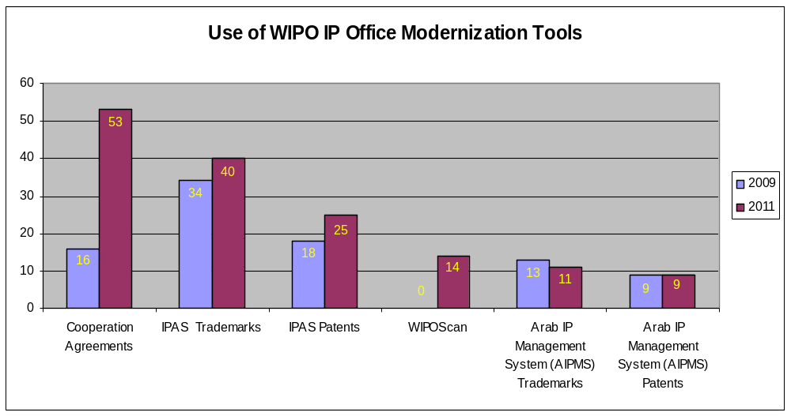

IMPLEMENTATION OF THE DEVELOPMENT AGENDA

The Program was engaged in the implementation of the DA project DA_10_02 on “Smart IP Institutions”.

Preparatory work was undertaken at the Organisation Africaine de la Propriété Intellectuelle (OAPI) for the deployment of the Industrial Property Automation System (IPAS), and equipment was purchased for the Office to support the modernization plan at OAPI and two Member States identified for the project, namely Gabon and Senegal. The system was configured to OAPI’s workflow for the Trade Names sub-project, the data was migrated and the users were trained on the use of the system.

In addition, an electronic data exchange system of notifications between the African Regional Intellectual Property Organization (ARIPO) and five of its Member State offices (Botswana, Ghana, Kenya, Namibia, and Uganda) was successfully installed and is being actively used.

Needs assessments were carried out in all three LDC Offices (Bhutan, Cambodia and Laos) to clearly define the nature and scope of assistance to be provided to help the Offices reach the defined project objectives, which were followed by training missions on the use of IPAS.

A workshop on building institutional capacity and in promoting collaboration among Offices was also held at ARIPO to support the Smart IP Institutions project.

Under the project DA_19_24_27_01 on “Information and Communication Technologies (ICTs), the Digital Divide and Access to Knowledge”, assistance was provided to thirteen Offices, namely ARIPO, Argentina, Azerbaijan, Botswana, Colombia, Dominican Republic, Ghana, Kenya, Namibia, South Africa, Viet Nam, United Arab Emirates and Zambia. Assistance ranged from the deployment of WIPOScan and/or the purchase of digitization equipment to the digitization of very large files of IP records.

The design, planning and implementation of activities undertaken by Program 15 were informed and guided by the relevant DA Recommendations.

PERFORMANCE DATA

Expected Result: Enhanced efficiency of IP institutions through automation of business processes
Performance Indicators | Baselines | Performance Data | TLS
Increased efficiency in 42 IP offices during the 2010/11 biennium. This will be achieved by providing the automation assistance package and training. Efficiency will be measured based on agreed efficiency criteria. |  | 91 IP Offices were visited during the biennium, sometimes more than once  Efficiency was increased in 58 IP Offices across regions through the delivery of WIPO’s modernization products and services | Fully Achieved
The 42 IP Offices assisted during this biennium will include 12 new IP Offices and 30 IP Offices that still require further ongoing assistance to achieve the desired results | 54 offices were assisted during all previous reporting periods | Out of the 58 IP Offices where modernization services were delivered, 14 were new projects and 44 will still need further ongoing assistance to fully achieve the desired results | Fully Achieved
Efficiency will be increased in 14 collective management organizations (CMOs) during the 2010/11 biennium. This will be achieved by providing the automation assistance package and training. Efficiency will be measured based on agreed efficiency criteria.  The 14 collective management organizations assisted during this biennium include six new CMOs and eight CMOs that still require further ongoing assistance to achieve the desired results |  | Please see Program 3 for further details | Dis-continued
Expected Result: IP institutions with capability to access and use global resources through use of standardized electronic data exchange systems
Performance Indicators | Baselines | Performance Data | TLS
20 Madrid member IP Offices will be able to electronically access and download Madrid international applications, designated for them, using the IPAS Madrid Module and training | 10 IP offices assisted | 12 IP Offices were assisted with electronic access and download facilities for Madrid international applications through the deployment of the WIPO Industrial Property Automation Madrid Module | Partially Achieved
13 PCT member IP offices will be able to exchange data with the WIPO PATENTSCOPE service and access its resources through the use of the IPAS ST.36 Module | Three IP offices assisted | A total of 28 Offices were assisted to exchange data with the WIPO PATENTSCOPE service. 5 of those Offices were assisted enabling them to exchange data with the WIPO PATENTSCOPE service through the use of the WIPO Industrial Property Automation System ST36 Module | Partially Achieved

BUDGET AND ACTUAL EXPENDITURE

Actual Expenditures (personnel and non-personnel) vs. Budget after Transfers 2010/11
(in thousands of Swiss francs)
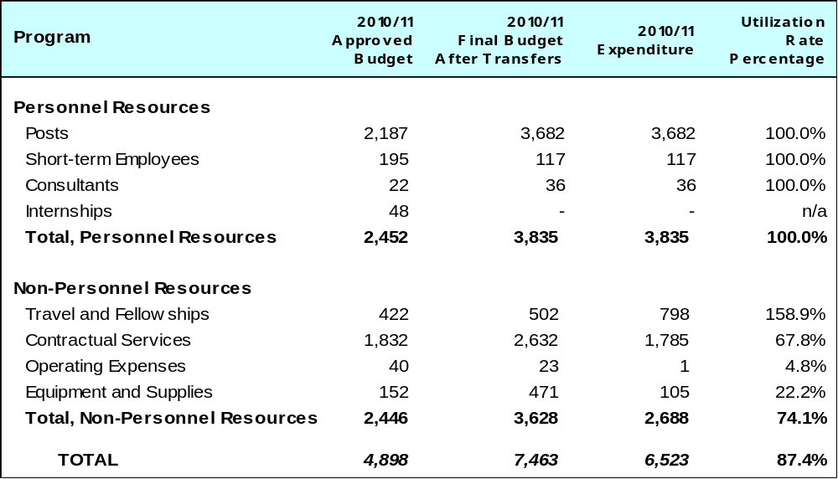

A. Budget after Transfers 2010/11

The budget after transfers 2010/11 compared to the approved budget 2010/11 reflects an increase due to the redeployment of staff and incremental resources assigned to the Program of approximately 1.2 million Swiss francs for 2010/11, for the DA project: “IP, Information and Communication Technologies (ICTs), the Digital Divide and Access to Knowledge”.

B. Budget Utilization 2010/11

By the end of the 2010/11 biennium, the utilization rate of non-Development Agenda project related non-personnel resources was 98.5 per cent.

The global resource utilization rate for the Program (non-personnel resources) amounted to 74.1 per cent primarily due to underspend on the Development Agenda project “Information and Communication Technologies (ICTs), the Digital Divide and Access to Knowledge”. While achieving its objectives, as set out in the project document, the project managed with less resources than expected mainly due to the use of local IP Office resources rather than international experts or external contractors.

PROGRAM 16 ECONOMIC STUDIES, STATISTICS AND ANALYSIS

Program Manager Director General

ACHIEVEMENTS IN THE 2010/11 BIENNIUM

The statistical work fully achieved its objective in providing high quality empirical input for policymaking. As in previous years, the Program conducted comprehensive annual surveys of national intellectual property (IP) Offices. Compared to the previous biennium, country coverage improved substantially, especially in 2011. The collected data were made available free of charge on WIPO’s statistical webpage and are used by researchers from around the world, as evidenced by data downloads, user requests, and citations in research articles. The World Intellectual Property Indicators 2010 and 2011 reports – offering summary data and statistical analysis on patents, trademarks, industrial designs, and utility models – were well-received around the world, generating a large number of news reports and numerous citations in policy publications and analytical reports. Two new products – Statistical Country Profiles and IP Facts and Figures – were launched, responding to a demand for easy-to-access key statistical information. During times of continued economic uncertainty, the Program provided timely performance reporting and forecasting to the PCT sector and WIPO’s Senior Management, enabling well-informed operational and financial decision-making.

The economic analysis work completed its first full biennium of operation. The work has shown important achievements. For the first time, WIPO in 2011 launched an economics-focused analytical report – the World IP Report 2011: The Changing Face of Innovation. This Report fostered WIPO’s role in promoting evidence-based policymaking; it generated a large number of news reports and interest from policymakers and academia. The launch of the Economics Seminar Series in 2010 attracted significant attention from core stakeholders. The Series promoted a focused discussion on the effects of IP policies on economic performance, drawing on the insights of some of the most prominent IP economists. Video recordings of economics seminars, posted on WIPO’s website, are viewed by policymakers and other stakeholders from around the world.

The Program also launched a three-year economic studies project under the CDIP that promises to generate new evidence on the development linkages of IP policy (see further details below). During the 2010/11 biennium, this project made significant progress in creating the data infrastructure on the basis of which new evidence will be generated. (The project is scheduled to be completed in 2013). The 2010/11 biennium also saw the adoption of two additional CDIP projects – on IP and brain drain and IP and the informal economy that will be implemented during the 2012/13 biennium.

Economic analysis provided by the Program – notably on IP activity during and after the financial crisis and for various WIPO Committees – helped mainstreaming economic analysis in IP policy discussions at WIPO. In 2010, WIPO helped launched an international network of IP Office economists, embarking on enhanced coordination and comparability of economic analysis conducted by national and regional IP Offices. Finally, WIPO assumed the role of Knowledge Partner in the INSEAD-led Global Innovation Index consortium, enabling the Organization to make a contribution in the field of innovation measurement and to foster a high quality discourse on innovation policy.

IMPLEMENTATION OF THE DEVELOPMENT AGENDA

The Program was engaged in the implementation of the DA project DA_35_37_01 on Intellectual Property and Economic and Social Development, under which three ongoing country studies on the relationship between IP protection and various aspects of economic performance are ongoing. For this purpose, significant progress was made in creating the data infrastructure on the basis of which new empirical insights will be sought.

The Program was also engaged in the preparation of two projects on IP and Brain Drain and IP and the Informal Economy.

The design, planning and implementation of activities undertaken by Program 16 were informed by the relevant DA Recommendations.
PERFORMANCE DATA

Expected Result: Improved information, analysis and statistics on the use of IP systems worldwide
Performance Indicators | Baselines | Performance Data | TLS
Number of IP publications | Two major publications (WIPI, PCT Yearly Review), plus monthly and quarterly PCT reports | All publications and reports were released in a timely manner  In addition to the “baseline publication”, a new World IP Report was launched in 2011 | Fully Achieved
Number of citations by publication | In 2009, there were 47,129 downloads/views of the main statistical publications in all languages (World Patent Report 2008, WIPI 2009, PCT Yearly Review 2008/09, PCT Quarterly and Monthly Reports).  As for the statistical data itself, there were 42,655 downloads of the various data spreadsheet during 2009. | Consistent download/view  statistics not available | Fully Achieved
Number of co-authored papers | A new activity | Publication of four working papers, a Survey Report published on WIPO’s website, and an economic literature review for the Advisory Committee on Enforcement | Fully Achieved
Expected Result: World reference resource of statistics, economic studies and research
Performance Indicators | Baselines | Performance Data | TLS
Creation of a portal providing access to studies and related resources by WIPO and other organizations | IP statistics portal already exists | IP statistics portal updated and enriched (especially through the inclusion of Country Profiles)  New IP economics portal created | Fully Achieved
Expected Result: Improved theoretical, empirical and practical understanding of the impact of IP systems on development
Performance Indicators | Baselines | Performance Data | TLS
Number of users by agency and country of published studies commissioned in response to demand by member states in relation to the total number of publications | A new activity | 3 country studies on IP and economic development themes were launched. As foreseen in project CDIP/5/7, these studies will only be completed in 2012/13 | Fully Achieved
Number of users by agency and country of published methodologies for analyzing the economic impact of IP worldwide | A new activity | 3 country studies on IP and economic development themes were launched. As foreseen in project CDIP/5/7, these studies will only be completed in 2012/13 | Fully Achieved

BUDGET AND ACTUAL EXPENDITURE

Actual Expenditures (personnel and non-personnel) vs. Budget after Transfers 2010/11
(in thousands of Swiss francs)
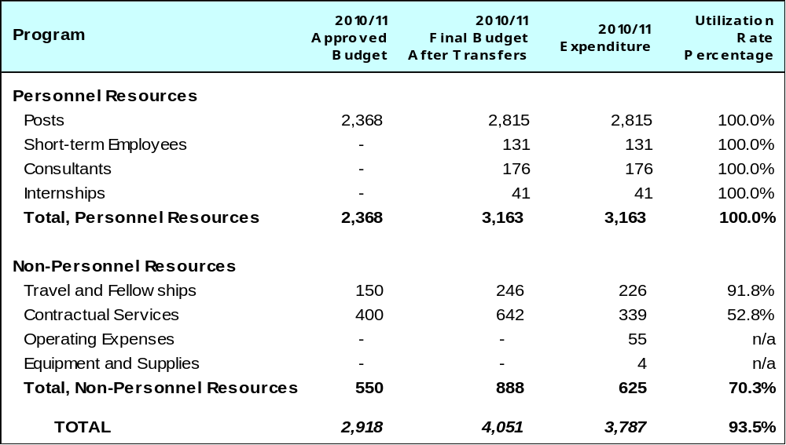

A. Budget after Transfers 2010/11

The budget after transfers 2010/11 compared to the approved budget 2010/11 reflects an increase primarily due to the redeployment of staff to this Program. In addition, the Program was assigned incremental resources of approximately 0.5 million Swiss francs for 2010/11, for two DA projects: “IP and Socio-Economic Development”, and “Open Collaborative Projects and IP-Based Models”.

B. Budget Utilization 2010/11

The underutilization in non-personnel resources is due primarily to delays in the implementation of the DA project on IP and Economic and Social Development caused by delays in hiring project personnel and longer than anticipated approval processes in Member States for initiating country studies.

PROGRAM 17 BUILDING RESPECT FOR IP

Program Manager Mr. J. C. Wichard

ACHIEVEMENTS IN THE 2010/11 BIENNIUM

The Program continued to facilitate a constructive and balanced policy dialogue in the context of the WIPO Advisory Committee on Enforcement (ACE). Both the sixth and seventh sessions of ACE were characterized by a spirit of outreach and cooperation, by Member States and Observers, in order to maximize the outcome of both sessions of the Committee, reviewing methodologies and gaps in existing studies to measure the impact of counterfeiting and piracy; analyzing reasons that fuel counterfeiting and piracy, including with a view to different levels of socio-economic development; and exploring alternate models to address counterfeiting and piracy. The agreement to continue the work program of the ACE in the 8th session underscored WIPO’s efforts, as well as the committment of Member States, to nurture an inclusive approach in WIPO’s activities relating to Building Respect for IP.

In the area of international cooperation, WIPO chaired the sixth Global Congress on Combating Counterfeiting and Piracy in Paris in February 2011, in partnership with INTERPOL, the World Customs Organization (WCO) and private sector groups, and in cooperation with the French Institut national de la propriété industrielle. Inspired by the policy dialogue in the framework of the ACE, the strategic realignment of the Global Congress initiative, hosted under the banner “Building Respect for IP: Sustainable Solutions to a Global Problem,” resulted in an unprecedented success as the refreshed and Strategic Goal VI-balanced program attracted 870 participants from 105 countries, almost 50 per cent representing Member States. The attractiveness of the event was further proved by the increase in the number of paying participants (38 per cent in comparison with 14 per cent at the fifth Global Congress).

Throughout the biennium the Program continued to respond to the requests from Member States for legislative assistance and enforcement-related capacity building activities. In all these activities, the Program ensured that socio-economic and development-oriented concerns, as well as the balance between private rights and the public interest, were adequately reflected and addressed. Simultaneously, flexibilities that are available to countries under international legal frameworks, as well as the value of strategic cooperation, were highlighted. In the interest of maximizing the efficient use of available resources and to ensure higher visibility, the majority of enforcement-related events were organized at sub-regional or regional levels.

Systematic cooperation and coordination with partner organizations continued in order to integrate development-oriented concerns in the work streams of such organizations. Moreover, the interests of both civil society and industry prompted the Program to pursue balance in its activities. This approach also inspired discussions conducted in Geneva with numerous visiting delegations from Member States; associations of right holders; academic institutions; and students.

IMPLEMENTATION OF THE DEVELOPMENT AGENDA

The design, planning and implementation of activities undertaken by the Program were informed and guided by the relevant DA Recommendations.

The Program’s technical assistance, capacity-building and legislative assistance activities were development-oriented, demand-driven and transparent (DA Recommendations 1 and 13). DA Recommendation 45 guided the work program agreed by the ACE for its sixth and seventh sessions.

PERFORMANCE DATA

Expected Result: Create an enabling environment that promotes respect for IP by initiating a constructive and balanced policy dialogue, taking into account DA Recommendation 45
Performance Indicators | Baselines | Performance Data | TLS
Number of studies and research conducted, within the framework of two sessions of the Advisory Committee on Enforcement (ACE), to identify elements that affect the respect for IP rights and to undertake an objective assessment of the cost of counterfeiting and piracy, as well as the socio-economic impact thereof | Eight papers in 2008/09 | Following the strategic re-orientation of the work program of the ACE, 14 Strategic Goal VI-based papers were presented during the 6th and 7th sessions of the ACE, prompting the Committee to continue its current work program in the 8th session of the ACE. The 7th session also resulted in significant savings due to reduced 3rd party travel costs | Fully Achieved
Expected Result: Strengthened legal frameworks and capacity building for law enforcement officials and the judiciary to deal with IP enforcement in a strategic and coordinated way with right holder cooperation
Performance Indicators | Baselines | Performance Data | TLS
Number of countries provided with technical assistance on new or updated legislative frameworks for effective enforcement, taking into account flexibilities in Part III of TRIPS | Four countries - end 2009 | Legislative assistance provided to 2 countries and to the Secretariat of a regional IGO for further consultation among its 5 member countries sharing both Common and Civil Law legal systems | Fully Achieved
Number of requests received and number of requests processed (by Member States and interested IGOs) on capacity building and technical assistance | 42 requests in 2008/09 | 35 capacity-building activities were conducted for Member States and IGOs, 24 of which were sub-regional or regional. These activities were guided by DA Recommendation 45. Several of these activities were co-funded under FIT/France, FIT/Japan and FIT/USEN, respectively | Fully Achieved
Number of requests received and number of requests processed (by Member States) to assist with the formulation of national and regional strategies to enhance effective enforcement actions | Three requests in 2008/09 | 3 regional events in Africa, Asia, and Certain Countries in Europe and Asia, respectively, as well as 3 national events (2 in Asia and 1 in Africa) focused on specific assistance on the formulation of regional and national enforcement strategies | Fully Achieved
Expected Result: International cooperation and the integration of IP issues in building respect for IP related activities of partner Organizations
Performance Indicators | Baselines | Performance Data | TLS
Number of activities related to building respect for IP of inter-and non-governmental organizations with common goals organized by key leading partner organizations and the private sector | 28 activities - end 2009 | The Program participated in 34 activities of partner organizations relating to building respect for IP in the framework of Strategic Goal VI | Fully Achieved
Expected Result: International cooperation in the framework of the Global Congress on Counterfeiting and Piracy with the WCO, Interpol and the private sector, and upon invitation civil society and other interested organizations
Performance Indicators | Baselines | Performance Data | TLS
WIPO hosted in cooperation with the WCO, INTERPOL and the private sector the Global Congress on Counterfeiting and Piracy in 2010 and partnering in the organization in 2011, inviting the civil society and other interested organizations | No applicable baseline | The 6th Global Congress was held in 2011 under the Chairmanship of WIPO. The ACE-inspired Agenda moved the Strategic Goal VI-required balance between private rights and the public interest, in the field of IP enforcement, to the global center stage for public/private policy dialogue | Fully Achieved

BUDGET AND ACTUAL EXPENDITURE

Actual Expenditures (personnel and non-personnel) vs. Budget after Transfers 2010/11
(in thousands of Swiss francs)

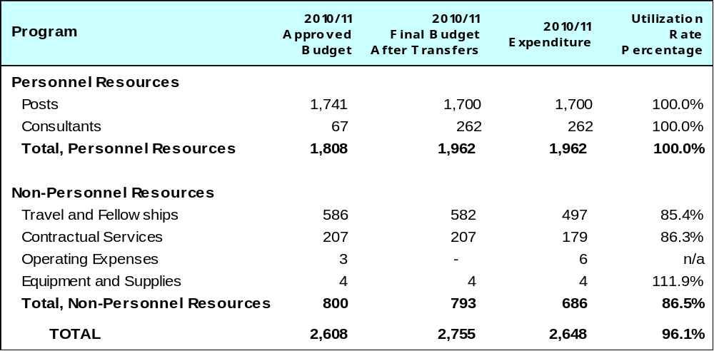

A. Budget after Transfers 2010/11

The budget after transfers 2010/11 compared to the approved budget 2010/11 reflects an increase due to the redeployment of a post and additional resources for consultancy under the Program. It is noted that a vacant post under the Program was only filled around end of 2011.

B. Budget Utilization 2010/11

The budget utilization rate (non-personnel) amounted to 86.5 per cent primarily due to savings in respect of the annual Advisory Committee on Enforcement; reduced travel costs for speakers; and implementation of cost-efficiency measures.

PROGRAM 18 IP AND GLOBAL CHALLENGES

Program Manager Mr. J. C. Wichard

ACHIEVEMENTS IN THE 2010/11 BIENNIUM

IP and Global Challenges

IP and Global challenges finalized implementation of its first full biennium in 2010/11 contributing to WIPO’s goals by providing support for strong, empirically well-founded policy dialogue between governments, international organizations, civil society actors and the private sector on current and emerging global issues touching on IP. The emphasis in the biennium has been on producing distinctive and practical information resources combining policy analysis with enhanced use of patent information for policy-makers and practical tools for open innovation and technology diffusion.

International policy dialogue has been successfully promoted through a number of WIPO organized events, such as the WIPO Conference on Innovation and Climate Change and the Symposia on IP and Global Health, including two major symposia organized trilaterally in cooperation with WHO and WTO. These events provided fora for a broad exchange of experiences and expertise, as well as balanced and engaged discussions among all relevant stakeholders. In addition, practical support was provided on IP and licensing issues to UNITAID and the Medicines Patent Pool Foundation and informative side events at UNFCCC meetings were organized in collaboration with various stakeholders. Cooperation was extended to WHO and WTO in the area of global health, and with the UNFCCC and other relevant UN agencies in climate change, particularly as it relates to innovation and technology transfer. This result was further supported by two new series of publications: Global Challenges Reports and Global Challenges Briefs.

A determining achievement in the biennium was the establishment of WIPO Re:Search, a new Consortium of a broad range of private and public sector institutions from developed and developing countries providing royalty-free access to IP assets to stimulate new R&D for neglected tropical diseases, tuberculosis, and malaria. Members of WIPO Re:Search contribute assets such as for pharmaceutical compounds and libraries, technologies, know-how and data to qualified users for research, product development and production.

The first pilot phase of the database component of wipo green – the sustainable technology marketplace for green technologies project was completed. A first stakeholders meeting for wipo green was held, where companies, UN organizations, universities and NGOs were represented. The pilot version of wipo green is available on the internet for users. Several companies and universities have uploaded technologies to the database.

Innovation Promotion and Technology Transfer

R&D institutions and universities are often the main research engines and local knowledge-producers in developing countries and countries with economies in transition. However, they are facing many challenges in utilizing the IP system for protecting their research results and for using IP rights as their assets. As a consequence, there are often limited economic return and social benefits based on their R&D investments in terms of locally developed, produced and distributed technologies and products. This may hinder both the public and private sector in these countries from re-investing in R&D. These obstacles for the efficient use of IP for development in WIPO Member States are defined as the Research Ownership-Exploitation (ROE) challenges. In order to address these challenges, WIPO focused, during 2010/11, on enhancing the capacity of Member States’ Governments, universities and public research organizations to develop the necessary IP management infrastructure and practical capacities to develop, protect, manage and exploit their local R&D and innovation results as assets protected by IP rights. This was mainly done through: (i) assisting Member States in the formulation of IP strategies at the national (macro) level and/or the institutional (micro) level in order for them to create the necessary infrastructure and effectively integrate the IP component into their national and institutional strategies; (ii) contributing to enhancement of their innovation and technology transfer support system as well as in strengthening professional practical skills in the field of IP asset management, including patent drafting and technology management, IP valuation, marketing, commercialization and licensing; (iii) making available for the use of Member States WIPO-developed practical tools, models and training materials in the above-mentioned areas; and (iv) supporting Member States in the design and implementation of projects that are in line with their particular strategic priorities and needs and encouraging universities and research institutions to use the WIPO “R&D Network & IP Hub” as a strategic model. In addition, a new Pilot Project for the Establishment of Technology Transfer Offices (TTOs) was launched in the Arab Region. This model, if successfully tested, could be replicated in other regions.

In addition, support to Member States was provided using the following strategies: (i) ensuring that the circumstances of each country and different sectors were duly taken into consideration when responding to the particular requests, for the elaboration and implementation of practical tools, training programs and provision of technical advice; (ii) prioritizing as much as possible the use of local IP professional expertise in developing countries, in particular regarding the development of training materials, the delivery of programs and the assessment of national IP needs in the framework of national IP strategy formulation; (iii) paying due attention to identification of target participants in view of using WIPO trainees as future focal points and trainers; and (iv) strategically developing and strengthening cooperation with other national, regional and international governmental organizations as well as NGOs, professional associations and UN commissions and specialized agencies. Examples of cooperation activities included regional patent drafting workshops in Zimbabwe jointly organized with ARIPO.

IMPLEMENTATION OF THE DEVELOPMENT AGENDA

The design, planning and implementation of activities undertaken by Program 18 were guided by the relevant DA Recommendations.

The Program contributed to the implementation of the Development Agenda through contributing to public policy patent landscaping initiatives concerning food security, health, and climate change.

The Program was also engaged in the implementation and preparation of the following DA projects:

- Project DA_10_03 on “Innovation and Technology Transfer Support Structure for National Institutions”. The first prototype of the ITTS Portal was lunched during the eighth session of the CDIP. Six technology transfer guides / manuals were commissioned and training tools were tested during various seminars and events.
- The “Project on Intellectual Property and Technology Transfer: Common Challenges - Building Solutions. A Project Paper on the project “Intellectual Property and Technology Transfer: Common Challenges ― Building Solutions”, was presented to the eighth session of the Committee.
- A project proposal on “Open Collaborative Projects and IP-Based Models”. A taxonomy-analytical study was prepared under this project and presented to the eighth session of the CDIP who requested the Secretariat to revise the Study taking into consideration comments made by Member States.
- Project DA_7_23_32_01 on “IP and Competition Policy”. The project was completed. The major achievement of this project was to bring together national agencies of a number of WIPO Member States involved with managing and enforcing IP and Competition statutes, thereby facilitating a dialogue aiming at coordinating and harmonizing those two branches of law. The Project also served as an instrument for the sharing of national experiences of a number of Member States on the interface between IP and competition policy.

PERFORMANCE DATA

Expected Result: Stronger, empirically well-founded policy dialogue between governments, international organizations, civil society actors and the private sector on current and emerging global issues touching on IP
Performance Indicators | Baselines |  | Performance Data | TLS
Extent and diversity of participation in policy forums convened by WIPO.  Target: one major policy forum and four issue-specific policy forums each year | A series of policy symposia on life sciences issues, policy analysis and studies responding to invitations from other fora (notably the FAO, the WHO and the UN Interagency Committee on Bioethics (UNIACB)), and pilot-level patent landscaping surveys on influenza, neglected diseases, and key food crops. WIPO’s Conference on IP and Global Challenges has further strengthened the substantive and institutional framework for more systematic WIPO engagement with global policy issues |  | WIPO conference on Innovation and Climate Change  Side events at UNFCCC meetings on issues of innovation and technology diffusion  In cooperation with WHO and WIPO:  - Joint Technical Symposium on Access to Medicines: Pricing and Procurement Practices  - Joint Technical Symposium on Access to Medicines, Patent Information and Freedom to Operate  - Workshop on Patent Searches and Freedom to Operate  In cooperation with UNITAID and the Medicines Patent Pool, Workshop on Licensing Terms and Conditions for Medicines Patent Pool staff  Launch of WIPO Re:Search on October 26, 2011  Symposium on the Evolution of the Regulatory Framework of Test Data - From the Property of the Intellect to the Intellect of Property at WIPO  Seminar on How the Private and the Public Sectors Use Intellectual Property to Enhance Agricultural Productivity  Session in the FAO International Conference on Agricultural Biotechnologies in Developing Countries, Mexico | Fully Achieved
Expanded WIPO participation in other policy forums, including more intensive engagement with existing and new partners.  Target: Policy dialogue expanded with six existing partners and initiated with six new partners | WIPO contributed policy materials and other inputs to WHO (the Intergovernmental Working Group on Public Health Innovation and Intellectual Property (IGWG), Global Strategy and Plan of Action (GSPOA), Pandemic Influenza Preparedness (PIP)), the UNITAID Medicine Patent Pool Initiative, the Human Rights Council (High Level Task Force on Implementation of the Right to Development), the UN Inter-Agency Committee on Bioethics (UNIACB), FAO, UNFCCC (Subsidiary Bodies and Conferences of the Parties (COP) in Poznan 2008 and Copenhagen 2009 with side events organized at the COPs), WTO (national and regional seminars on certain aspects of the WTO TRIPs Agreement), the World Trade Institute at the Berne University (on animal genetic resources) as well as to several national regional processes, including the  African Union Pharmaceutical Manufacturing Plan and the WHO TDR/ANDI project |  | Continued support (WHO) in the “Implementation of the Global Strategy and Plan of Action on Public Health Innovation and Intellectual Property” and the “Pandemic Influenza Preparedness Process”  Continued input to WTO workshops and Seminars on the TRIPS Agreement and public health and other related meetings  WHO, WIPO, WTO trilateral cooperation, regular coordination meetings and joint organization of two symposia (see above)  Participation in UNITAID Executive Board meetings and support in the endeavor to establish the Medicines Patent Pool Foundation (MPP)  Continued participation in UNFCCC meetings and cooperation with the UNFCCC Secretariat, UNIDO, UNEP, infodev, NGOs and industry on climate change-related IP issues. Contact with ESCAP was initiated  Continued participation in the UN Interagency Committee on Bioethics  Cooperation with the Graduate Institute of International and Development Studies for the preparation of the Graduate Institute’s Geneva 5th High-Level Symposium on Global Health Diplomacy (Doha +10), in close consultation with WHO, WIPO and WTO  Cooperation with 30 new partners in the context of WIPO Re:Search and 10 new partners in the context of wipo green (see below) | Fully Achieved
Feedback and reported impact from policy forums WIPO convenes. Target: positive reporting in external publications of each activity | Positive feedback on WIPO inputs was received from the WHO, the FAO, the UNIACB, TDR and the African Union as well as several civil society and industry NGOs and Member State representatives |  | Participants to the WIPO organized events noted with appreciation the comprehensive and balanced coverage of the topics addressed and the empirical fact based approach  The WIPO Re:Search launch was attended by 18 journalists and the event was reported by around 100 news agencies and newspapers  WHO Member States and WTO Members referred to WIPO’s activities in their respective meetings, such as the WHO EB, the WHA or the WTO TRIPS Council | Fully Achieved
Expected Result: Distinctive and practically useful information resources combining policy analysis with enhanced use of patent information for policy-makers and practical tools for open innovation
Performance Indicators | Baselines |  | Performance Data | TLS
Number and scope of new policy tools and studies, and patent information analyses and data tools  Target: four in-house and four externally commissioned policy studies; six patent landscapes; a functioning platform for open innovation and: 1, diffusion of green technology, and 2, R&D for Neglected Tropical Diseases | Patent landscapes established concerning influenza virus, neglected diseases, the rice genome and policy studies concluded on avian flu, technology transfer under Multilateral Environmental Agreements (MEAs), public interest IP management, bioethics |  | The new consortium WIPO Re:Search – Sharing Innovation in the Fight Against Neglected Tropical Diseases was launched in October 2011 (www.wiporesearch.org)  A pilot version of wipo green – The Sustainable Technology Marketplace is available online  Upon a request from WHO (December 2010), a WIPO Patent Search Report on Pandemic Influenza Preparedness (PIP) - Related Patents and Patent Applications was prepared and presented in the WHO Meeting of the Open-Ended Working Group of Member States on Pandemic Influenza Preparedness: Sharing of Influenza Viruses and Access to Vaccines and other Benefits (OEWG) in April 2011  The summary reports of the two joint WHO/WTO/WIPO Symposia, commonly prepared by WHO, WIPO and WTO were published  2 new publication series have been launched:  - First Global Challenges Brief: “When policy meets evidence: What’s next in the discussion on intellectual property, technology transfer & the environment?”  - First Global Challenges Report “The Role of IP Rights in the Transfer of Environmentally Sound Technologies”  Proceedings of Seminar on How the Private and the Public Sectors Use Intellectual Property to Enhance Agricultural Productivity have been published  9 patent landscape reports were produced (please refer to Program 14 for additional details) | Partially Achieved
Feedback from users and partners on the quality and relevance of tools developed. Target: positive external reporting on each new product | Pilot program established for a green technology platform and also a health platform |  | Feedback received from WIPO’s partners on further development of the green technology platform was very positive and constructive. The platform was reported on positively by the press  WIPO Re:Search: Positive feedback at launch on October 26, 2011. By the end of 2011 WIPO Re:Search counted 30 Members (Providers, Potential Users and Supporters), representing both developed and developing countries and the database included over 100 entries. 3,530 website visits amounted to a total of 12,904 page visits |  | Fully Achieved
Expected Result: Member States’ capacity and understanding of innovation and technology management and transfer has been enhanced
Performance Indicators |  | Baselines | Performance Data |  | TLS
Increased number of Member States that have identified needs and have formulated, implemented and evaluated national IP strategies for innovation promotion and IP asset management |  | In 2008/09, nine countries implemented or were on the way to implement national IP strategies for innovation promotion and IP asset management on the basis of the WIPO Audit tool (publication no 927) | In 2010/11, 7 countries (Algeria, Cameroon, Pakistan, Mauritius, Niger, Nigeria and Oman) implemented or were on the way to implement national IP strategies for innovation promotion and IP asset management as a result of advice given by WIPO on the basis of the WIPO Audit tool (publication no 927) |  | Fully Achieved
Increased number of R&D institutions, universities and other innovation system actors in Member States that have acquired and applied practical knowledge and skills in the area of IP asset development, management and transfer |  | By the end of 2009, more than 500 University IP Coordinators, technology managers, scientists, researchers and policy makers benefited from the WIPO University Initiative Program and more than 50 research institutions were assisted by WIPO during the process of establishing their IP management units and/or Technology Transfer Offices (TTOs) | In 2010/11, more than 1,080 University IP Coordinators, technology managers, scientists, researchers and policy makers benefited from the WIPO University Initiative Program and more than 31 research institutions were assisted by WIPO during the process of establishing their IP management units and/or TTOs. One TTO was established (Mauritius). |  | Fully Achieved
Increased number of users by target groups of WIPO-developed practical tools, models, materials and information on IP asset management related areas for government policy makers, R&D institutions and other innovation system actors |  | During the 2008/09 biennium, around 1,000 researchers, technology managers, scientists and lawyers acquired practical skills in the area of patent drafting, and more than 450 participants attended “Successful Technology Licensing (STL)” Training program | In 2010/11, around 800 researchers, technology managers, scientists and lawyers acquired practical skills in the area of patent drafting, and more than 520 participants attended “Successful Technology Licensing (STL)” Training program |  | Fully Achieved

BUDGET AND ACTUAL EXPENDITURE

Actual Expenditures (personnel and non-personnel) vs. Budget after Transfers 2010/11
(in thousands of Swiss francs)

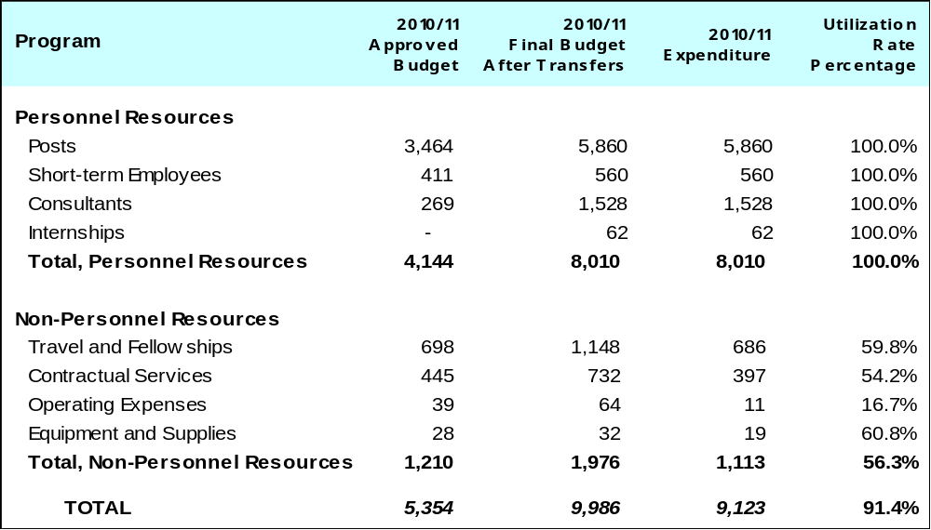

A. Budget after Transfers 2010/11

The budget after transfers 2010/11 compared to the approved budget 2010/11 reflects an increase due to the redeployment of staff to the Program, primarily for the strengthening of innovation promotion and technology transfer and IP and global challenges related activities. In addition, incremental resources were assigned of approximately 1 million Swiss francs for 2010/11, for two DA projects: “IP and Technology Transfer: Common Challenges - Building Solutions”, and “Open Collaborative Projects and IP-Based Models”.

B. Budget Utilization 2010/11

The 56.3 per cent budget utilization rate for non-personnel resources was primarily due to the delay in the implementation of the DA project on IP and Technology Transfer: Common Challenges - Building Solutions.

PROGRAM 19 COMMUNICATIONS

Program Manager Mr. J. C. Wichard

ACHIEVEMENTS IN THE 2010/11 BIENNIUM

In order to build broader understanding among policy makers and the general public about the role of IP and of WIPO, Program 19 continued to diversify its offerings and delivery channels to reach new audiences, while providing targeted communications to meet the needs of existing stakeholders.

WIPO’s visibility in the media was raised around the world throughout the biennium, with a 19 per cent increase in press articles reporting on the Organization’s work as compared to 2008/09. The participation of celebrity artists such as Stevie Wonder, Barbara Hendricks and Javier Bardem in WIPO events and the creation and dissemination of integrated video, web, press, editorial and photographic content on these events generated extensive international media coverage and brought new visitors to WIPO’s web and social media platforms. The accessible content produced served to highlight different aspects of WIPO’s work and to broaden understanding of certain normative issues.

Interaction with WIPO’s stakeholders was strengthened through expanded social media activity. The first World IP Day Facebook campaign in 2011 attracted 180,000 views and 2,500 “fans” in just 30 days and stimulated interest and engagement among a wide range of participants, from national IP Offices to individuals, including many in developing countries or LDCs. The establishment of the WIPO YouTube Channel resulted in an exponential increase in audience numbers for WIPO’s unique video content, with Channel views more than doubling in 2011 to almost 100,000, (compared to 5,000 per year on the former video web page). The Program worked in partnership with Member States and IGOs to triple production of WIPO’s video “documentaries” in order to meet the increased global demand for video-based communication.

Gaps in WIPO’s information products were filled with new publications for specific stakeholder needs, such as the “Guide to WIPO Services” and the “WIPO Users Guide” for delegates. The “core publications” initiative (launched end 2009) achieved a 10 per cent increase in the availability of WIPO core publications in all six official languages. The first WIPO manga (Japanese comic book) gained attention on hundreds of web and social media sites, and generated numerous requests from IP offices to translate the publication into non-UN languages. The WIPO Magazine was rated highly by surveyed readers, who described its value as a unique, authoritative, free information source to aid understanding of WIPO and IP in practice.

WIPO outreach tools and materials delivered to IP Offices and other stakeholders were used inter alia to develop public awareness campaigns in Gambia, Indonesia, Morocco, Pakistan, Papua New Guinea, the Philippines and Thailand. The IP Advantage database of IP success stories, a DA-related product, attracted 1,800 unique page views per week. WIPO Awards to 346 inventors and creators in 43 countries, the majority of which were developing countries and LDCs, generated positive publicity. The Innovative Solutions in Everyday Life competitions in Ethiopia and Malaysia promoted the use of patent information for innovation and resulted in the winner from Ethiopia being assisted to develop a prototype for his invention in Korea.

Outreach to the Geneva community included the first WIPO Open Day in 2010 (over 3,500 visitors); the WIPO visits program (1,758 participants in 2011); and the co-organization of cultural events in response to Member State requests (the Czech Republic, Ecuador, Italy, Jamaica, Morocco, Oman, Poland and South Africa).

Services to other Programs across the Organization, including editorial services, design, events, press, web communications, branding and strategic advice, helped enhance the presentational quality of WIPO’s offerings and heightened public and press attention for milestone projects/events, such as the PCT 2 Million, WIPO Re:Search, inauguration of the New Building, Vision IP, TIGAR, the Global Innovation Index, World IP Report and economic/statistical publications.

Contributing to WIPO’s strategic goal of being the World IP Reference Source, the WIPO GOLD web portal boosted visibility of WIPO’s previously dispersed data collections. User feedback attested to the value of the WIPO Library’s service to scholars, and the Library’s e-book collection from external publishers increased accessibility to reference material. The WIPO Depository Library program provided free sets of WIPO publications to a further 36 libraries in 26 developing countries and countries in transition.
Work continued to improve WIPO’s service orientation. The streamlining of the customer assistance structure across the Organization, the creation of a Customer Service Center and the roll-out of the WINS enquiry tracking system, resulted in a significant reduction in unanswered/lost inquiries, fewer complaints and increased responsiveness to customers. Lost telephone calls were reduced from one in three on average, to one in four. This figure is expected to further improve with the assignment of additional staff resources to individual customer service teams, additional tools to increase efficiency and the refinement of some inquiry management processes. Service-orientation skills were increased through tailored training of more than 90 customer-facing staff.

Brand development work centered on strengthening WIPO’s organizational identity. The 2010 launch of the new WIPO logo, reflecting the strategic reorientation of the Organization, was well received by stakeholders. A distinctive visual identity for the fee-generating services, implemented in 2011, helped strengthen recognition of these services as key WIPO “sub-brands.” Internal guidelines, templates and policies ensured that WIPO web pages, documents and correspondence were prepared in a consistent manner, so contributing to a professional and unified image of the Organization.

Internal communications, a key element for both a strong organizational identity and external communications, were also strengthened. The first phase of the Internal Communications Initiative achieved Organization-wide staff engagement, with one in ten staff actively contributing to practical recommendations to improve horizontal and vertical communications. The Initiative was cited by staff in the 2011 Core Values staff survey as a positive example of improved “working as one.”

IMPLEMENTATION OF THE DEVELOPMENT AGENDA

The design, planning and implementation of activities undertaken by Program 19 were informed by the relevant DA Recommendations. Specific activities were tailored to enhance awareness of the general public, including in developing countries and LDCs, on the importance of IP rights and the benefits of a greater use of the IP system. The Program continued to maintain and add to IP Advantage, a database of case studies and other materials (articles, videos, etc.), which was implemented as a joint project by WIPO and Japan, and endorsed by the CDIP, to illustrate instances of successful use of the IP system.

PERFORMANCE DATA

Expected Result: Broader understanding of the role of IP, and of WIPO and its activities, among policymakers and the general public
Performance Indicators | Baselines | Performance Data | TLS
Number people reached through the various documentaries and publications; number of respondents by countries (phoning, letters, comments on websites, etc.) | 5,000 clicks on "webcast" link on WIPO website in 2009  4.1 million WIPO Magazine website page views in 2008/09 (1.8 million in 2008; 2.3 million in 2009)  13,400 subscribers to the WIPO Magazine e-mail newsletter (in all three languages).  3,684 subscribers to the hard copy version of the WIPO Magazine (English version)  88% of surveyed readers rated the WIPO Magazine "good" (51%) or "very good" (37%)  47 new versions of WIPO publications authorized for translation (into non-UN languages) and reviewed prior to publication in 2008/09 (34 in 2008; 13 in 2009) | n/a - Webcast tool discontinued  Note: No reliable web statistics are available due to a change in measurement tools and algorithms. Urchin statistics give: 5.6 million in 2010 and 27.6 million in 2011. Google Analytics gives 431,000 in 2010 and 419,000 in 2011  15,903 subscribers (19% increase) to WIPO Magazine e-newsletter (3 language versions combined)  4,205 subscribers (14% increase) to WIPO Magazine hard copy (English version)  94% of readers surveyed rated WIPO Magazine “good” (46%) or “very good” (48%)  55 new versions of WIPO publications authorized for translation into non-UN languages and reviewed prior to publication (27 in 2010; 28 in 2011) | Fully Achieved
Approximate number of people reached through the activities by country for the World IP Day based on data supplied by organizations hosting World IP Day events | World IP Day events reported from 139 countries in 2008-2009 (60 countries in 2008; 79 countries in 2009)  500 World IP Day event summaries received in 2008-2009 (240 in 2008; 260 in 2009) | World IP Day events reported from 132 countries (58 countries in 2010; 74 countries in 2011)  397 World IP Day event summaries received (188 in 2010; 209 in 2011). Note: The focus has moved from compiling official reports to increasing overall public participation in IP Day through an annual Facebook campaign (3,500 “fans” in 2011) | Partially Achieved
5% increase in world press articles on WIPO’s work | 6,226 articles reporting on WIPO during 2008 and 2009 | 7,423 press articles reporting on WIPO in 2010/11 (19% increase as compared to 2008/09) | Fully Achieved
Use of WIPO IP educational materials for young people in national and international school systems | WIPO IP educational materials for young people used in ten Member States in 2008-2009 (2008: Morocco, United Arab Emirates; 2009: Cuba, Germany, Jordan, Lebanon, Luxembourg, Peru, Philippines, Qatar) | WIPO IP educational materials for young people used in 14 Member States: Antigua and Barbuda, Australia, Canada, Ecuador, Egypt, Ghana, Israel, Jamaica, Jordan, Malaysia, Morocco, Oman, Syria and United Arab Emirates | Fully Achieved
Number of new WIPO documentaries disseminated through various media on innovators and creators, themed spots on international networks, on national networks by country, and on social networking sites; number of viewers of WIPO films on such sites | Five documentaries (co-produced) and made available in 2008-2009 (two in 2008; three in 2009)  0 publicity spots produced/diffused in 2008-2009  75,500 WIPO videos viewed on social networking sites during 2008 and 2009 (25,500 in 2008; 50,000 in 2009) | 14 WIPO documentaries (co-produced)  (5 in 2010 and 9 in 2011)  4 publicity spots produced / diffused  WIPO videos viewed 139,393 times (85% increase) on WIPO YouTube Channel (39,873 in 2010 / 99,520 in 2011) | Fully Achieved
Expected Result: Improved customer focus and service quality
Performance Indicators | Baselines | Performance Data | TLS
% of customer satisfied with the quality of WIPO’s services and information | No data available for 2008/09 | No data available for 2010/11. A customer satisfaction survey will be conducted in March 2012 | Not Achieved
Expected Result: Improved efficiency of customer services
Performance Indicators | Baselines | Performance Data | TLS
Enquiries processing: No abandoned/lost calls | >33% unanswered calls in 2009 | 25.7% unanswered calls (32.4% in 2010 and 19% in 2011) | Not Achieved
Tracking of enquiries | No centralized tracking of enquiries at the end of 2009 | >10% of enquiries centralized and tracked at the end of 2010/11 | Fully Achieved
Reduced number of internal info lines and support teams | 10 formal and 20 informal support teams | 8 formal and 2 informal support teams | Fully Achieved
Expected Result: Strong and well-developed WIPO brand
Performance Indicators | Baselines | Performance Data | TLS
% of stakeholders that consider that the WIPO brand has improved and is well developed | No data available for 2008/09 | 44% of respondents are very likely to recommend WIPO to a third party; and an additional 28% are moderately likely to do so (WIPO Stakeholders Perceptions Survey, January 2012) | Fully Achieved
Positive feedback received (web surveys, reader surveys, etc.) to new WIPO brand and corporate image | No data available for 2008/09 | 65% of survey respondents perceived WIPO as the global leader in the protection and promotion of IP (WIPO Stakeholders Perceptions Survey, January 2012) | Fully Achieved
Successful development of IP portfolio (domain names, marks, etc.) | N/a: management of WIPO's IP portfolio and development of IP policy transferred to and centralized at the Office of Legal Counsel in Q1/2010 (Program 21) | n/a | Dis-continued
Expected Result: Enhanced use of the WIPO Library’s information resources
Performance Indicators | Baselines | Performance Data | TLS
Increased number of visitors to the Library premises and increased demand for the Service’s information resources | 11 visitors per week to Library in 2008/09 | 12 visitors per week in 2010;  25 per week since moving to the New Building in June 2011 | Fully Achieved
Number of requests being managed by the Library | 270 external and 1,500 internal information requests managed by the Library during 2008-2009 (120 external and 700 internal requests in 2008, and 150 external and 800 internal requests in 2009) | 514 external information requests (a 90% increase) and 804 internal information requests (a 46% decrease partially due to easier staff access in the new premises) were managed by the Library during 2010/11 | Partially Achieved

BUDGET AND ACTUAL EXPENDITURE

Actual Expenditures (personnel and non-personnel) vs. Budget after Transfers 2010/11
(in thousands of Swiss francs)

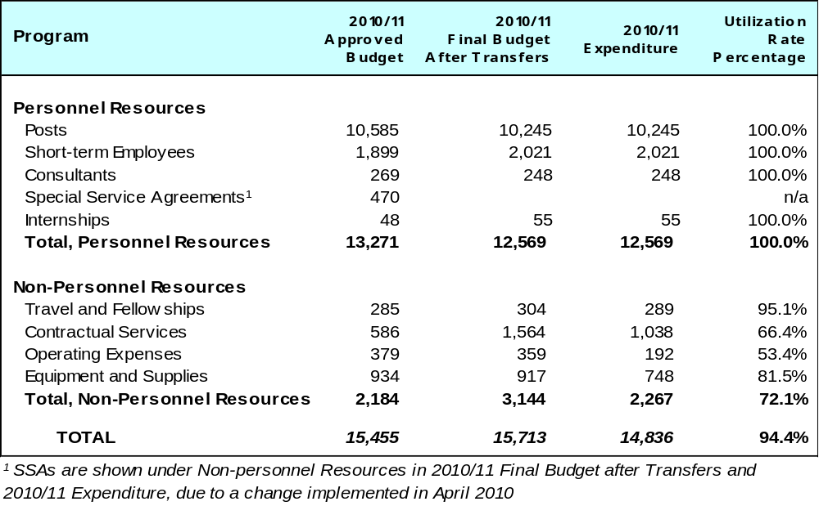

A. Budget after Transfers 2010/11

The budget after transfers 2010/11 compared to the approved budget 2010/11 reflects an increase in non-personnel resources for the implementation of a number of SRP initiatives.

- Budget Utilization 2010/11

The biennium saw some delays in the implementation of a number of communications initiatives due to delays in the filling of posts, which affected the utilization of non-personnel resources. In addition, lower than expected utilization of non-personnel resources was also due to cost efficiencies on travel and graphic design services, as well as reduced contractual fees in connection with the internal communications initiative.

PROGRAM 20 EXTERNAL OFFICES AND RELATIONS

Program Manager Mr. J. C. Wichard

ACHIEVEMENTS IN THE 2010/11 BIENNIUM

External Relations

Program 20 ensured WIPO’s strengthened engagement in a range of UN and other IGO-led processes and negotiations. This involved WIPO’s active participation in meetings, the submission of contributions to UN reports and the coordination and implementation of collaborative activities with other organizations. In response to requests from the UN and other IGOs, Program 20 coordinated 24 substantive submissions or contributions to UN reports and processes of which 20 were reflected in either UN Secretary General Reports and in other documents of UN agencies and inter-governmental processes. Program 20 also prepared responses to over 311 invitations to UN and IGO meetings and ensured / coordinated WIPO’s participation at the appropriate technical level in over 224 of these meetings. These activities helped ensure recognition of the valuable contribution WIPO can make and increased WIPO’s profile as the UN agency mandated to work on IP issues. It also helped support more informed and balanced consideration of IP in other fora. As a result, WIPO has seen an increase in demand for its participation and contribution to a range of UN and other IGO processes.

Program 20, in close coordination with Program 18, contributed to joint activities organized as part of WIPO’s trilateral cooperation with the WHO and WTO to support implementation of the Global Strategy and Plan of Action on Public Health, Innovation and Intellectual Property. Program 20 also coordinated WIPO’s contribution to the WHO-led inter-agency process on non-communicable diseases. The WIPO submissions to the TRIPS Council in October 2010 and 2011 demonstrated the significant technical assistance that WIPO provides to developing countries. WIPO also increased its effort to work more closely with the WTO in relation to the WTO LDC Needs Assessment process. During the WTO Third Global Review of Aid-for-Trade, WIPO partnered with the Government of Ethiopia to showcase the role that IP can play in generating increased revenues, job creation and economic growth through the use of IP.

WIPO has actively engaged in UN inter-agency processes both within the framework of the preparatory process for the UN Conference on Sustainable Development (UNCSD - Rio+20) and in providing support, upon request, to the UNFCCC Secretariat and to the UNFCCC Parties on the climate change negotiations. Within the UN Chief Executive Board’s (CEB) High Level Committee on Programmes (HLCP), WIPO is the lead convening agency on the issue of technology transfer within the HLCP Working Group on Climate Change. In that capacity, WIPO organized a number of inter-agency awareness raising events at COP16 in Cancun and at COP17 in Durban. On the Rio+20 Conference, WIPO was effectively represented at the Rio+20 Prepcoms and intersessional meetings and contributed to the compilation document prepared by the Rio+20 co-chairs. Program 20 also coordinated WIPO’s input to the UN Environment Management Group Report was also coordinated entitled “Working together towards a balanced and inclusive green economy: A UN system-wide perspective”.

A range of activities was coordinated related to the follow-up to the World Summit on the Information Society (WSIS). In 2010 and 2011, WIPO provided senior level speakers at the 6th and 7th High-Level Meeting of the UN Group of the Information Society (UNGIS). In 2011, WIPO organized a side event on the role and responsibility of Internet Intermediaries in the field of copyright in the WSIS Forum. In September 2011, WIPO also organized, in conjunction with the Internet Society (ISOC), a similar workshop at the Sixth Annual meeting of the Internet Governance Forum (IGF) in Nairobi. WIPO also participated as one of the five IGO members of the UN Commission on Science and Technology for Development (CSTD) Working Group on Improvements to the Internet Governance Forum (IGF). During the 2011 UN Economic and Social Council (ECOSOC) meeting which focused on education, WIPO co-organized with UNICEF a Ministerial breakfast Roundtable on "Increasing Access, Enhancing Quality and Promoting Equity in Education Through Innovation, Products and Partnerships". These activities have helped raise awareness of IP related issues in discussions aimed at addressing the digital divide. Program 20 has also led the coordination of WIPO’s consultations with the UN and other agencies to ensure that it can play a leading role in the discussions on the ECOSOC AMR theme for 2013 which will focus on “Science, Technology, Innovation, and the Potential of Culture for Promoting Sustainable Development and Achieving the MDGs”.

Ensuring civil society’s engagement and participation in WIPO’s work remains a critical objective (DA Recommendation 42). In the 2010/11 biennium, the WIPO Assemblies decided to grant observer status to 13 international NGOs and to 11 national NGOs. Moreover, representatives from NGOs have increasingly been invited to participate in a wide range of WIPO activities, including, in particular, activities relating to the WIPO Development Agenda and briefings on WIPO activities.

As regards WIPO’s resource mobilization activities, WIPO undertook a range of activities to implement the “Next Steps” identified at the Conference on Building Partnerships for Mobilizing Resources for Development (November, 2009) and reported to the CDIP. A more detailed assessment of this project and implementation of the “Next Steps” can be found in the independent evaluation of the CDIP project presented to the 9th Session of the CDIP in May 2012 (please refer to CDIP/9/3). In parallel with this work, draft guidelines for partnership with the private sector have been prepared. These will form the basis of consultations with Member States and their approval in line with the Program and Budget 2012/13.

External Offices

The WIPO New York Office plays an increasingly central role in ensuring that WIPO is the point of reference within the UN system on issues related to IP. It is able, with very limited resources, to deploy an extensive network of contacts within the New York based UN system and other organizations to support the achievement of WIPO’s expected results. The New York Office has played a particularly important role with respect to the preparatory process for the Rio+20 Conference, preparations for and participation in ECOSOC, the work of the Permanent Forum on Indigenous Issues, and a wide range of other relevant UN meetings taking place in New York. In addition, it has participated in and organized a series of IP awareness raising events in New York, which targets policy-makers, member of the UN Secretariat staff and delegates to UN meetings. This work has helped raise the knowledge and understanding of the complexity of issues related to IP and global public policy making.

In 2011, WIPO Japan Office (WJO) started to reinforce its services to users of WIPO global protection systems, based on achievements in 2010 in the area of technical assistance to developing countries and outreach programs in cooperation with the host government and the United Nations in Tokyo. A “Manga” competition was organized and a booklet published on the web site and in print on counterfeiting and piracy. The competition received an award from an advertising industry magazine. A new database IP Advantage was developed and launched in which some 140 cases of successful use of IP in developing countries are show cased. The database is accessible on the WIPO web site. As an initial step towards better service orientation, WJO improved its access to users by relocating to the IP-related business center. WJO also assisted in the implementation of a number of technical assistance activities to developing countries organized in Japan under FIT/Japan.

As regards the WIPO Singapore Office (WSO), the 2010/11 Workplan agreed under the MoU between WIPO and the Government of Singapore was completed. In addition, WSO participated in various national level events aimed at enhancing the capacity and knowledge of more than 450 policy makers, government officials, IP professionals and practitioners, IP owners and user communities on the strategic and effective use of IP for development. IP tools and innovation were also promoted in 19 events resulting in enhanced capacities of newly recruited patent examiners in using non-commercial databases (including PATENTSCOPE).

WSO also focused its efforts on establishing, strengthening and consolidating collective management in the region. In Cambodia, the first two phases of establishing a CMO were completed. In the Philippines, the awareness and managerial capabilities of an existing CMO in the field of visual arts, FILVADRO, were strengthened resulting in more members joining the society. In Indonesia, a project to consolidate several established CMOs to form a joint licensing scheme, implemented in cooperation with the Directorate General of IPR (DGIPR) of Indonesia resulted in avoiding confusion in the market whereby certain category of users would have been licensed by several CMOs multiple times.

A WIPO-ASEAN Study on the Strategic Use of Intellectual Property in Select Industries in ASEAN was completed and contributions provided to a study on the Economics of Intellectual Property in the Republic of Korea.

Finally, the WIPO Office in Singapore (WSO) co-organized and supported four joint activities with the World Trade Organization (WTO); Institute for Southeast Asian Studies (ISEAS) and Licensing Executive Society (LES). These activities resulted in strengthening the cooperation with WTO and LES and establishment of a new partnership with a highly reputable institute, ISEAS.

The WIPO Office in Brazil (WOB) implemented several activities aimed at promoting the use of WIPO services and strengthening national IP capacities. The Office also participated in various regional and national events aimed at promoting awareness of IP among government officials, IP professionals, IP owners and users and of the cooperation and international registration treaties administered by WIPO.
In this context, WOB organized, in cooperation with the National Institute of Industrial Property of Brazil (INPI), Seminars and Round Tables on the accession to the Madrid Protocol. As a result, the National Confederation of Industries (CNI) published a document outlining the relevance for national companies to be part of the Protocol, in a context where strong emphasis is placed on exports and larger presence in the global market.
The WOB negotiated with the Brazilian Government the establishment of a new Funds-in-Trust (FIT) focusing on promoting the use of the IP system and the development of competencies on IP protection and commercialization. The Agreement, which is managed from the WOB, was signed by WIPO and the Brazilian Government, on September 2011.

IMPLEMENTATION OF THE DEVELOPMENT AGENDA

The design of Program activities under Program 20 is aimed at implementing DA Recommendations 2, 9, 14, 22, 24, 30, 40, and 42. Following the CDIP Project to implement Development Agenda Recommendation 2, Program 20 has begun implementation of a number of follow up steps to the WIPO Conference on Building Partnerships for Mobilizing Resources for Development (November, 2009), this includes work to support implementation of the CDIP Project to implement Recommendation 9 and in the development of a Partnership and Resource Mobilization Strategy. With respect to Recommendation 14 on providing advice to developing countries and LDC’s, on the implementation and operation of the rights and obligations and the understanding and use of flexibilities contained in the TRIPS agreement, Program 20, in cooperation with the substantive WIPO sectors, ensured that activities undertaken with the WTO reflected this Recommendation. Program 20 also worked with the relevant sectors in WIPO to enhance their cooperation with other intergovernmental organizations and processes to contribute to work on the WSIS outcomes (Recommendation 24), and to provide advice to developing countries and LDC’s on how to gain access and make use of IP related information on technology (Recommendation 30).

The Program worked to improve information sharing and communication with UN organizations and other relevant IGOs to strengthen cooperation and maximize the different expertise of each organization.(Recommendation 40). It also worked to enhance participation by civil society in several WIPO meetings. In addition, the Program made available on the WIPO website information on its activities related to supporting the achievement of the MDGs (Recommendation 22).

PERFORMANCE DATA

Expected Result: Greater understanding among industry groups and civil society of WIPO’s work and the developmental benefits of IP; and enhanced participation of civil society in WIPO activities in accordance with criteria regarding NGO acceptance and accreditation (DA recommendation 42)
Performance Indicators | Baselines | Performance Data | TLS
Communications, reports and publications from governmental and NGOs reflect a more informed view on IP | Baseline not available | 24 (10 in 2010 and 14 in 2011) substantive submissions or contributions to UN reports and processes, of which 20 (9 in 2010 and 11 in 2011) were reflected in either UN Secretary General Reports or in other documents of UN agencies and inter-governmental processes  Coordination of responses to over 311 (121 in 2010 + 190 in 2011) invitations to UN and IGO meetings of WIPO’s participation at over 224 (105 in 2010 and 119 in 2011) of these meetings | Fully Achieved
Increased number of NGOs participate as observers at WIPO and engage in joint activities | 210 International and 51 national NGOs accredited to WIPO  Extent of joint activities with NGOs reported on under relevant Programs | 223 international (an increase of 13) and 62 national (an increase of 11)  Extent of joint activities with NGOs is reported on under relevant Programs | Fully Achieved
Increased number of joint activities with regional, sub-regional and national organizations | Extent of joint activities with regional or sub-regional IGOs reported on under relevant Programs | The full extent of joint activities with regional or sub-regional IGOs is reported on under relevant Programs | Dis-continued
Additional public and private sector partnerships | No guidelines  No formal public and private sector partnership agreements | Draft prepared and reviewed internally. Final draft to form the basis for consultations with Member States  3 partnerships (ARDI, wipo green and WIPO Re:Search) | Fully Achieved
Expected Result: Better understanding of the role and function of external offices and the advantages and disadvantages of centralized and decentralized service delivery
Performance Indicators | Baselines | Performance Data | TLS
Monitoring use and activities of external offices | n/a | n/a | Dis-continued
Study on policy of centralization and decentralization | n/a | n/a | Dis-continued
Expected Result: An increase in resources available to WIPO, either through direct contributions and managed as Funds-in-Trust, or through access to existing external funding modalities to support its technical assistance and capacity building work in developing countries
Performance Indicators | Baselines | Performance Data | TLS
An increase in funds available through Fund-in-Trust arrangements  Target: 20% increase by end 2010/11 | FIT income received in 2008/09: 13,239, 902 Swiss francs | FIT income received in 2010/11: 11,962,239  Contributions committed but not yet received: 2,827,053 Swiss francs  Contributions at advanced stage of discussion 2,4 million Swiss francs | Partially Achieved
WIPO projects funded through existing external funding modalities (e.g., Enhanced Integrated Framework (EIF), UN Multi-donor Trust Funds (UN MDTF))  Target: To be developed following the WIPO Mobilizing Resources for Development Conference | No WIPO projects funded through EIF, UN MDTF or other such existing mechanisms | No projects | Not Achieved
Increase in the number of donors to WIPO from all sources | Nine donors (EU, France, Italy, Finland, Japan, Korea, Portugal, Spain, United States of America) | 11 donors (Brazil, EU, France, Italy, Finland, Japan, Korea, Mexico, Portugal, Spain, United States of America) | Fully Achieved

BUDGET AND ACTUAL EXPENDITURE

Actual Expenditures (personnel and non-personnel) vs. Budget after Transfers 2010/11
(in thousands of Swiss francs)

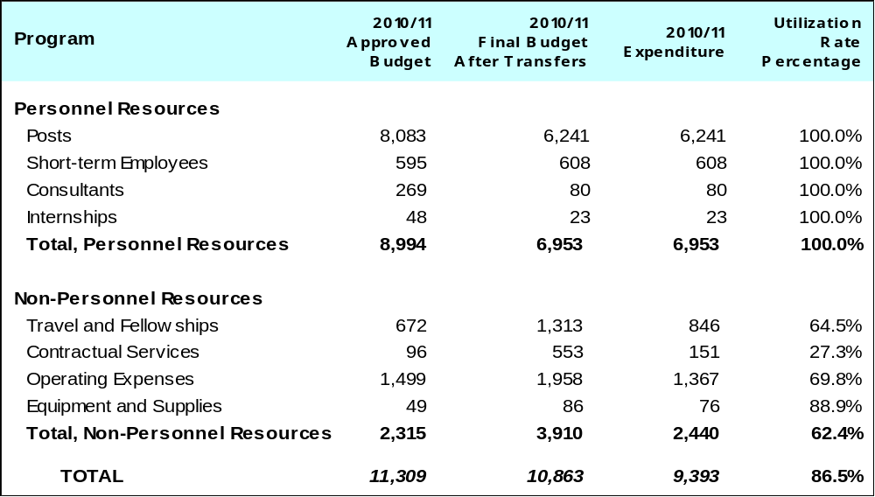

A. Budget after Transfers 2010/11

The budget after transfers 2010/11 compared to the approved budget 2010/11 reflects a decrease in personnel resources primarily due to the transfer of Sector support activities, within the Global Issues Sector, to Program 18.

Increases in non-personnel resources were primarily due to the reassignment of activities from Program 9 to the External Offices, and increase in rental costs for the WIPO Brazil Office and the Tokyo Office. Additional non-personnel resources were also allocated for increased outreach activities to NGOs and for extra-budgetary resource mobilization.

B. Budget Utilization 2010/11

Expenditure related to the implementation of NGO outreach activities was lower than expected pending appointment of the Head of the NGO and Industry Section. Planned regional resource mobilization events have been rescheduled to the 2012/13 biennium. Cost savings were realised following a reduction in office space for the WIPO New York Office.

PROGRAM 21 EXECUTIVE MANAGEMENT

Program Manager Director General

ACHIEVEMENTS IN THE 2010/11 BIENNIUM

Program 21 covers the Office of the Director General (ODG), the Office of the Legal Counsel (OLC), the Assemblies Affairs and Documentation Division (AADD), the Office of the Ombudsman, the Ethics Office and the Protocol Service.

The first half of the 2010/11 biennium focused on consolidating the Director General’s team and establishing the necessary institutional framework. The Senior Management Team (SMT) was integrated into the management of the Organization and new units were created – the Assemblies Affairs and Documentation Division (AADD) and the Ethics Office – to provide the foundation for the realization of the expected results.

In the second half of the biennium, the Program moved from planning to implementation. To enhance and promote internal coherence, the Director General instituted regular meetings of the SMT, of managers from across Sectors, and with staff both collectively and in small groups. These fora have proven invaluable in ensuring that clear and consistent messages are delivered at all levels of WIPO and have provided an important channel for receiving feedback. Externally, the Director General enhanced the Organization’s effective engagement with its Member States through regular and focused interactions. Briefings for Ambassadors were organized and meetings with Member States on topical issues were conducted. The advice and insights received have been valuable, including with respect to performance across programs.

The Director General continued to champion implementation of the Strategic Realignment Program (SRP). By the end of 2011, the SRP was mid-way through its two year implementation phase. In addition to the concrete achievements noted elsewhere in this report, the SRP has been instrumental in creating an atmosphere of change and risk management. The Director General launched the second Core Values Survey at the end of 2011, permitting comparison to the previous year. In many areas, improvements were observed towards the Organization’s aspirational Core Values, whilst the survey responses also enabled the SRP to focus efforts where needed most. The release of the substantive SRP results framework in the second quarter of 2011 enabled progress towards the Core Values to be quantified. In terms of its initiatives, the SRP is on target to complete and mainstream its improved processes by the end of 2012, with the strengthened Core Values embedded in the Organization’s culture for the years ahead.

Several innovations were introduced by Program 21 throughout the biennium to enhance the effectiveness of the Assemblies as the Organization’s governing organ. In 2010, the second High Level Segment was held, elevating the level of Member States’ participation and providing important perspectives on the theme of ”Innovation, Growth and Development” from the 64 Ministers which attended. The following year, further improvements and rationalizations were introduced such as: webcasting of debates; introduction of an electronic registration system for delegates; electronic transmission of documents including on USB keys; and new travel procedures which all contributed to WIPO’s greenest and most efficient Assemblies in 2011. Many of these innovations have subsequently been rolled out to other WIPO meetings.

The OLC continued to provide legal advice on constitutional affairs, general legal issues, contracts, administrative and human resource related matters, to the Director General, the Secretariat and Member States. The OLC ensured that the depository functions of WIPO-administered treaties and agreements continued to function efficiently and managed an increasing demand for its services while sustaining a high level of customer satisfaction. The OLC provided timely and effective legal advice to the new construction projects – the new building and the conference hall. The transfer of the management of responsibility for the Organization’s IP assets was completed and resulted in a more effective and coordinated projection of WIPO. At the same time, the WIPO Lex on-line collection of national IP laws and treaties was launched and subsequently expanded. WIPO Lex now covers nearly 200 countries and entities, and the availability of these legal instruments in some 70 languages has resulted in enhanced access to and use of IP-related legal information.

The appointment of WIPO’s first Chief Ethics Officer in June 2010 underscored the Director General’s commitment to ensuring the Organization establishes a comprehensive integrity system based on best practices. Substantial progress was achieved in several areas. A review of existing ethics policies and principles was undertaken. A 98 per cent compliance rate with the filing requirements of the Declarations of Interest Policy was achieved. A draft Whistleblower Protection Policy was also developed and consultations on it initiated. A WIPO Code of Ethics was finalized in consultation with the Staff Council. Finding such common ground provides a solid basis for further evolution of the ethics system at WIPO.

A new Ombudsman was appointed in September 2010, forming an integral part of WIPO’s accountability and integrity framework. Since then, the Ombudsman has established her office and its systems, undertaken outreach and offered coaching and mediation services to staff. The uptake of the Ombudsman’s services has indicated a broad acceptance by staff of informal conflict resolution as a key part of fostering a respectful workplace.

IMPLEMENTATION OF THE DEVELOPMENT AGENDA

All Programs related to Strategic Goal IX “Efficient administrative and financial support structure to enable WIPO to deliver its programs” provide support or other services to the Organization as a whole to achieve WIPO’s Expected Results. In this regard, Program 21, which includes the work of the Office of the Director General, plays a key role in providing the overall strategic guidance and oversight to facilitate the mainstreaming and implementation of the WIPO Development Agenda by all relevant Sectors within WIPO. In order to implement the DA Recommendation 6, a WIPO Ethics Office has been established under this Program with clear terms of reference. A Chief Ethics Officer has also been appointed, and a WIPO Code of Ethics developed.

PERFORMANCE DATA

Expected Result: The essential conditions – internal coherence, corporate regulation and alignment to strategic goals are in place for providing effective strategic direction, support to the member States and delivery of results
Performance Indicators | Baselines |  | Performance Data | TLS
The Organization has an effective governance structure comprising clear expected results linked to strategic goals | No Senior Management tier in place  No intermediate level established between the nine Strategic Goals of the Organization and the Expected Results in biennial Program and Budgets |  | Fully functioning Senior Management Team in place  Medium Term Strategic Plan 2010-2015 noted by Member States | Fully Achieved
Utility of the Organization’s Performance Framework (Organizational and individual staff performance) | Implementation of the SRP Strengthening RBM Initiative commenced in January 2010  Statistical information on the % of staff whose performance was evaluated against their individual work objectives was not available at the beginning of 2010 |  | The Strengthening RBM Initiative has resulted in the following achievements in 2010/11:  - An organizational set of Expected Results for 2012/13  - First results-based biennial budget  - Strengthened measurement frameworks  - Mainstreaming of development in all substantive Strategic Goals  - Strengthened capacities of managers for results-based planning  In 2010, 90% of the staff covered under PMSDS was evaluated using the system, of which about 70% were evaluated against individual objectives  In 2011, 95% of the staff covered under PMSDS was appraised using the system, of which about 92% were appraised against individual objectives | Fully Achieved
Integrity of the Organizational Management Structure that enables effective allocation of resources to priorities, alignment of programs to results and management of accountabilities showing leadership in results based management | Phase I of the SRP focused on realigning Programs, the organizational structure and resources to support the nine new Strategic Goals. Planning and Design of the SRP at the Program level not yet started |  | Planning has taken place for the SRP initiative “develop WIPO organizational design”, which will continue during 2012. Integration of organizational design into work planning has begun, and a focus on ensuring that all positions in the organization contribute to the Strategic Goals will continue | Partially Achieved
Introduction of financial declarations and disclosures | Declarations of Interest - 24 % of those staff members required to file had filed by December 31, 2009 |  | Compliance with initial filing requirements under the WIPO Declarations of Interest Policy is 98% | Fully Achieved
Implementation of plan to transform the Organization into a carbon-neutral entity | Main Working Group and Subsidiary Working Groups were established to address key areas. Participation in a number of worldwide or UN-wide initiatives. Mobility study started |  | Progress towards development of strategies in respect of greener official travel and commuting from home to work  Water fountains with city water supply were installed in the new building  The greenest electricity tariff has been implemented for the new building in 2011  New electronic communication system for official documents implemented (for the WIPO Assemblies and certain Committees) according to which printed material are no longer dispatched systematically but rather only upon explicit request  Ecological criteria included in several procurement processes for building and equipment supplies  Technical studies aimed at reducing electricity consumption undertaken with the aim to upgrade the equipment in at least one building in 2012  A variety of awareness campaigns and incentives launched within the Organization (replacement of plastic utensils by biodegradable items in the cafeterias, free public transport passes, free electrical bicycle trial, free advice on local transportation alternatives)  Participation in UN and local initiatives and events  (See further details reported also under Program 24) | Partially Achieved
Implementation of plan to make the Organization’s accessibility user-friendly to the disabled | No accurate data on the status of accessibility in the WIPO campus. |  | A preliminary internal study completed identifying some of the shortfalls of the current premises  A tender process launched for a professional physical audit of the premises  The website content policy continued to be implemented with a view to further improving access to the website content by people with disabilities | Partially Achieved
Expected Result: Enabling the environment in which the Organization operates by providing timely quality advice and assistance to the Member States, the Director General and WIPO’s internal sectors and divisions on a wide range of legal issues related to the work of the Organization including the use of new IT tools and the implementation of the Strategic Realignment Program
Performance Indicators | Baselines |  | Performance Data | TLS
% of complaints related to the appropriateness, timeliness and effectiveness of the total number of advice rendered | No complaints - end 2009 |  | Despite an increase in the number of requests for advice as well as in the fields covered by such advice, a very high level of satisfaction was maintained and almost no complaints were received by the end of 2011 | Fully Achieved
New effective internal procedures to deal with the required assistance including the use of new available IT tools | No applicable baseline |  | (Performance indicator discontinued due to reassessment of the need for a fully-fledged database to record claims) | Dis-continued
Expected Result: Enhanced effectiveness of the depository functions of WIPO-administered treaties and agreements, including maintenance and update of the treaties database
Performance Indicators | Baselines | Performance Data |  | TLS
% of notifications of adherence and other treaty-related actions that have been processed within three days | Three days per action - end 2010 - 100% of notifications of adherence and other treaty related actions processed within 3 days within OLC | 98% of notifications of adherence and other  treaty-related actions processed within three days |  | Partially Achieved
Expected Result: Promote and encourage The utilization of the IP treaties and laws database worldwide within the public and private sector, including the academic and professional sectors has been promoted and encouraged
Performance Indicators | Baselines | Performance Data |  | TLS
Increased number of countries whose IP laws are included in the Collection of Laws for Electronic Access (CLEA) database | Substantial coverage of some 126 countries at end of 2009 in the Collection of Laws for Electronic Access (CLEA) which was replaced by WIPO Lex in September 2010 | Complete coverage of 186 countries and four other entities and substantial coverage of eight countries |  | Fully Achieved
The number of laws and treaties increased by 10% | Approx. 2,563 full legislative texts covering 4,291 documents in various languages | Current total is approx. 10,500 legislative texts covering 17,894 documents in various languages |  | Fully Achieved
The number of legislative texts in French and Spanish increased by 3% | Of 2,563 full legislative texts, 2,013 are in English, 925 in French and 419 in Spanish. | Of the 17,894 documents, 8,378 are in English, 2,192 in French and 2,039 in Spanish |  | Fully Achieved
% of increased number of database users and hits or visitors to the web page | User's data in 2009: 379,181 visitors in some 200 countries; 1,000,293 page views; 2.64 pages/visit; 66.59% bounce rate; 1.58 minutes average time on the site. The sources of traffic to site were as follows: search engines - 81.5% referring sites - 10.29% and direct traffic - 8.2% | User’s data in 2010/11:  533,520 visitors in 225 countries and territories; 1,614,633 page views; 3.03 pages/visit; 57.08% bounce rate; 2.39 minutes average time on the site. Sources of traffic to site were: search engines – 82.61%; referring sites – 8.08%; and direct traffic – 9.31% |  | Fully Achieved

BUDGET AND ACTUAL EXPENDITURE

Non-Personnel Expenditures - Allocation vs. Actuals 2010/11
(in thousands of Swiss francs)

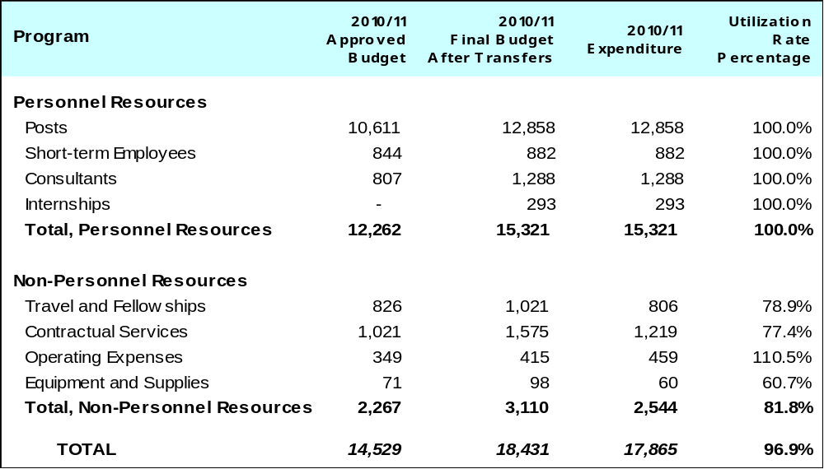

A. Budget after Transfers 2010/11

Incremental resources were allocated to this Program for the newly created Assemblies Affairs and Documentation Division, the Ethics Office and the WIPO Lex initiative. In addition, some SRP initiatives were provided for under the Program.

B. Budget Utilization 2010/11

The budget utilization rate for non-personnel resources reached 81.8 per cent, primarily due to the postponement of some SRP-related initiatives, namely those concerned with ethics and internal controls.

PROGRAM 22 FINANCE, BUDGET AND PROGRAM MANAGEMENT

Program Manager Mr. A. Sundaram

ACHIEVEMENTS IN THE 2010/11 BIENNIUM

The 2010/11 biennium saw the Secretariat making significant progress as regards program and financial management.

WIPO became one of the few UN system organizations to achieve compliance with International Public Sector Accounting Standards (IPSAS) within the original timeframe. The WIPO 2010 Financial Statements were thus prepared in accordance with IPSAS and received an unqualified audit opinion. The FRR-IPSAS project, which included the addition of the procurement and asset management modules to the automated finance system (AIMS), went "live" in January 2010, on time and within budget. This resulted in a number of new processes, procedures, and reports for resource utilization, which were essential for compliance both with the Financial Regulations and Rules (FRR) of WIPO and IPSAS. The introduction of the new modules, data structures and procedures also enabled continued enhancement of the financial management reports available to Program Managers and Member States.

Continued work on strengthening WIPO’s regulatory framework resulted in the consideration and/or adoption by Member States of a series of important policy papers, including (i) Budgetary Process Applied to Projects Proposed by the Committee on Development and Intellectual Property (CDIP) for the Implementation of the Development Agenda Recommendations; (ii) Policy on Reserves and Principles Applied in Respect of the Use of Reserves; (iii) Policy on Investments; and, (iii) WIPO’s Capital Planning and Management Framework.

The Program also successfully supported the selection processes of the new External Auditor for WIPO and members of the Independent Advisory Oversight Committee (IAOC). The former will take up duties at the beginning of 2012, while the new IAOC members took over in 2011.

Efforts continued during the biennium to embed the core value Accountability for Results in the organizational culture, including through the SRP initiative Strengthening Results-Based Management (RBM) where significant progress was made. Notable achievements pertained to the strengthening of results-based planning as evidenced in the Program and Budget for 2012/13 which included the following enhancements: (i) a strategic organizational results framework (consolidation of Expected Results under the nine Strategic Goals); (ii) for the first time, a results-based budget; (iii) strengthened measurement frameworks, including through better indicators and the systematic introduction of baselines and targets; (iv) an indication of the development share of resources for each result (in line with the Organization’s focused efforts to improve its planning, tracking and reporting on development expenditure); (v) mainstreaming of development in all substantive Strategic Goals; (vi) integration of DA projects in line with the Budgetary Process for DA projects approved by the WIPO Assemblies in 2010; and (vii) integration of Funds-in-Trust.

IMPLEMENTATION OF THE DEVELOPMENT AGENDA

The implementation of the Project on Enhancement of WIPO's Results-Based Management (RBM) Framework to Support the Monitoring and Evaluation of Development Activities (CDIP/4/8/Rev.) focused on strengthening the application of results-based planning principles across all Programs through a series of results-based management (RBM) workshops conducted in 2010 for all Sectors. The workshops aimed at strengthening the biennial results frameworks through clear linkages between the expected results and the Strategic Goals, more measurable and results-focused indicators and consistent use of baselines and targets. In addition, the workshops focused on mainstreaming development, including the DA, across Programs and enhancing WIPO’s ability to assess the outcomes and impact of its development-oriented activities.

In addition, the External Review of WIPO’s Technical Assistance in the Area of Cooperation for Development, conducted by two external consultants selected as per the Terms of Reference (TOR) for the review, was completed.
PERFORMANCE DATA

Expected Result: Continued efficiency of financial operations and budget management
Performance Indicators | Baselines | Performance Data | TLS
Total cost of the finance, budget and program management function as a percentage of the organizational running cost (expenditure) | Total expenditure for Program 22 amounted to 16.53 million Swiss francs i.e. 2.86% of total expenditure for the Organization in 2008/09 | Total expenditure for the Program amounted to 17.4 million Swiss francs i.e 2.96% of total expenditure for the Organization in 2010/11. This includes the expenditures incurred for the DA Project | Fully Achieved
Timely and relevant financial and management reporting to senior management, Program Managers and Member States | Submission of monthly and quarterly management reports within 10 working days of closure and receipt of data from relevant sectors | All reports were submitted within 10 working days of closure | Fully Achieved
Timely and relevant financial and management reporting to senior management, Program Managers and Member States | Online budget utilization and human resource management reports available in the appropriate structure to support budget management and management decision making processes | Reports were available online and up to date | Fully Achieved
Payments (including Madrid and Hague fees) to be made on time | Payments are made in accordance with treaty rules and supplier credit periods (where invoices are submitted to Finance in accordance with their payment terms) | All fees collected on behalf of members were transferred to them in due time  More than 14,500 supplier payments were processed in 2011. For the payment term most commonly used (net 30), 73% of the more than 6,400 payments were made on time based on the invoice date indicated by the supplier. In cases of late receipt, the payment was typically executed within 7 days of that later date (15%). The remaining 12% was paid later, due to, inter alia, invoices not being received or purchase orders not having been dispatched in a timely fashion  7,097 payments were made with the payment term “immediate”. 73% of these were completed within one week of the receipt date, with an additional 27% reflecting the workflow issues noted above  Remaining payment types constituted a total of 1,060 transactions including payment terms net 10 (550 total), net 15 (374), net 45 (40), net 60 (52) as well as net 30 less 2% (44) and reflected the timeliness ranges noted above | Fully Achieved
Return on invested funds is in line with benchmarks established by the Investment Advisory Committee | Internal benchmark set as rate of return obtained through deposits with the BNS (Central Bank of Switzerland) | All Swiss franc deposits made for WIPO achieved the benchmark | Fully Achieved
Expected Result: Coherent regulatory framework in place in respect of the use of financial resources and post management ensuring that all financial operations executed with probity
Performance Indicators | Baselines | Performance Data | TLS
Financial operations and budget management conform to the provisions of the applicable WIPO conventions and treaties, the WIPO FRR and appropriate applicable accounting standards | Documentation of policies, rules and procedures ready and available for use | A review of Office Instructions was performed to identify those requiring an update. The Office Instruction on Official Hospitality was updated accordingly. Updates to the FRR were submitted to the WIPO Assemblies to reflect changes (IAOD and IAOC). Policies approved and promulgated during the biennium included: Budgetary Process Applied to Projects Proposed by the Committee on Development and Intellectual Property (CDIP) for the Implementation of the Development Agenda Recommendations; Policy on Reserves and Principles Applied in Respect of the Use of Reserves; Policy on Investments; WIPO’s Capital Planning and Management Framework. The Program also contributed to the formulation of the Long-Serving Temporary employees: Regularization Strategy | Partially Achieved
Satisfactory financial report from the External Auditors confirms the conformity of accounting operations with applicable regulations, rules and standards | Financial statements for 2008-09 to be the final financial statements prepared in accordance with UN Accounting Standards | 2008-2009 financial statements were prepared in accordance with UN Accounting Standards and received an unqualified audit report | Fully Achieved
Smooth transition to International Public Sector Accounting Standards during the course of 2010 | NRB Financial statements for 2008/09 to be the final financial statements prepared in accordance with UN Accounting Standards | Financial statements for 2010 were prepared in accordance with International Public Sector Accounting Standards (IPSAS). These statements received an unqualified audit report | Fully Achieved
Expected Result: Coherent program management and performance practices and accountability are enhanced across the organization
Performance Indicators | Baselines | Performance Data | TLS
Coherent monitoring systems have been developed for all programs and are being implemented by all programs | Scattered systems only - end 2009 | Some sectors have introduced quarterly monitoring systems for the implementation of workplans in 2010 and 2011. A coherent organizational-wide approach is expected to be implemented for the 2012 workplans (supported and facilitated by the ERP) | Not Achieved
% of programs implementing newly developed management systems and tools | n/a | Workplans for the year 2011 were improved both in terms of process and content (link to expected results) | Partially Achieved
% of programs that have been provided with training and coaching on program management | n/a | A total of nine sectoral workshops (covering all Programs) were conducted to strengthen the results frameworks for the Program and Budget 2012/13 and mainstream development | Fully Achieved
% of programs that are implementing the newly acquired knowledge and skills provided with training and coaching on program management | n/a | Improvements have been made across all Programs to strengthen the results frameworks for the Program and Budget 2012/13, including organizational expected results with clear links to the Strategic Goals, enhanced measurability of the performance indicators and consistent approach to baselines and targets | Fully Achieved
% of program and performance reports by which an improvement on quality has been identified | Enhancing performance assessment is a continuous process with tangible improvements made in 2008/09 (enhanced focus on results and improved analytical assessments) | Better integration of reporting on the DA into the Program Performance Reports 2010 and 2010/11  The introduction of baselines in the Program and Budget 2010/11 provides a better basis for reporting on organizational performance in the 2010/11 biennium | Partially Achieved

BUDGET AND ACTUAL EXPENDITURE

Actual Expenditures (personnel and non-personnel) vs. Budget after Transfers 2010/11
(in thousands of Swiss francs)
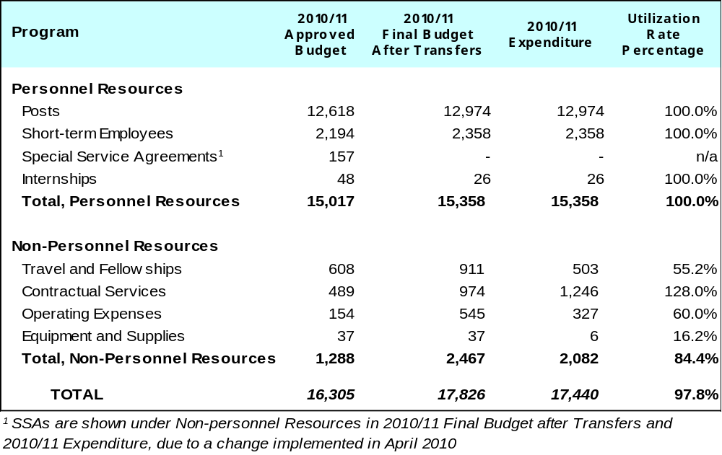

A. Budget after Transfers 2010/11

The budget after transfers 2010/11 compared to the approved budget 2010/11 reflects an increase due to the redeployment of staff to the Program primarily for resource planning, program management and performance and IPSAS related activities. The Program was also assigned incremental resources in the order of 0.6 million Swiss francs for 2010/11, for the DA project on the Enhancement of WIPO's Results-Based Management (RBM) Framework to Support the Monitoring and Evaluation of Development Activities.

B. Budget Utilization 2010/11

Following adjustments to the available resources to reflect the allocation of DA resources, the additional and unplanned Program and Budget Committee (PBC) in 2011, as well as the costs related to the selection process in respect of the IAOC, the budget after transfers reflects the envelope available to the Program for the delivery of its expected results. The higher than planned level of expenditures in respect of contractual services reflects the increased cost of interpretation due to the initially unplanned PBC meeting in January 2011 and the extended length of both the summer and fall PBC sessions which took place in 2011 (five days). Regarding the DA project Enhancement of WIPO's Results-Based Management (RBM) Framework to Support the Monitoring and Evaluation of Development Activities there was an underspend due the postponement of one project component to 2012/13.

PROGRAM 23 HUMAN RESOURCES MANAGEMENT AND DEVELOPMENT

Program Manager Mr. A. Sundaram

ACHIEVEMENTS IN THE 2010/11 BIENNIUM

During the 2010/11 biennium, a number of human resources inititatives were implemented as part of the Strategic Realignment Program (SRP). These initiatives aim at contributing to enhanced effectiveness and efficiency of the human resource management function.

In 2010, the Director General established a Consultative Group consisting both of administration and staff representatives, entrusted with the responsibility of conducting a comprehensive review of the Staff Regulations and Rules (SRRs). The review was initiated in December 2010. A limited set of amendments to the SRRs, relating to WIPO’s contractual framework and recruitment procedures were submitted to the Coordination Committee and approved in October 2011. These amendments will take effect in 2012 with an expected phased implementation of the benefits and allowance package that will be offered to both short-term Professional and General Service staff.

In 2010, the Member States approved, in principle, the creation of up to 156 posts under the regular budget over a period of five years, subject to the availability of budgetary funds, for the purpose of regularizing long-serving temporary employees performing continuing functions and with five or more years of continuous and satisfactory service on January 1, 2012. The resulting regularization process for the long-serving temporary employees will be initiated in 2012.

The Performance Management and Staff Development System (PMSDS) became operational across all WIPO Sectors. Its implementation was supported by a comprehensive training program. Overall, the PMSDS has resulted in a continuous and enhanced performance dialog between supervisors and supervisees in WIPO, a more systematic and cost-effective way of identifying staff development and learning opportunities, and increased awareness of WIPO staff of the Expected Results to which their work contribute. In 2011, a refinement of the PMSDS was undertaken to ensure that the system continues to develop in line with the evolving needs of the Organization.

An e-Recruitment system was successfully introduced and has been consolidated with the development of several components (matrix, online tests, statistics, etc). In addition, actions were taken to address the significant recruitment needs following the Voluntary Separation Program (VSP) initiative. Special procedures were proposed to group multiple vacancies under a single Board. This resulted in the finalization of a total of 140 recruitments during the biennium.

In 2010, and as part of the re-organization of the Department, a merge of the former Social Security and Staff Administration Sections took place aimed at rationalizing processes and improving the quality and efficiency of service delivery to internal stakeholders. A significant change in job profiles and an intensive on-the-job and change management training followed as a consequence of this reorganization At the same time, several process automation projects involving internal and external partners, such as the Swiss Permanent Mission and the United Nations Joint Staff Pension Fund have been initiated, with a view to streamlining processes and increasing efficiency and effectiveness in preparation for the implementation of the human resource components of the Enterprise Resource Planning (ERP) System.

IMPLEMENTATION OF THE DEVELOPMENT AGENDA

All Programs related to Strategic Goal IX “An efficient administrative and financial support structure to enable WIPO to deliver its programs” provide support or other services to the Organization as a whole in delivering on WIPO’s Expected Results. In this regard, Program 23 facilitates, from a human resource management perspective, the implementation of the WIPO Development Agenda. During the biennium, the Standards of Conduct for the International Civil Service were incorporated in all WIPO contracts, including Special Service Agreements (SSA) and the Roster of Consultants was updated and integrated with the project on Intellectual Property Technical Assistance Database (IP-TAD) (DA-05-01). In addition, a WIPO Code of Ethics was developed.

PERFORMANCE DATA

Expected Result: Improved overall effectiveness and efficiency of HR function
Performance Indicators | Baselines | Performance Data | TLS
Cost of the HR services (Organizational Design, Workforce Planning and Resourcing Section, Performance Management, Training & Development Section, Policy and Development and Administrative Law Coordination Section and HR Operations Service) as a percentage of organizational running cost (expenditure) | Total expenditure for Program 23 amounted to 17.1 million Swiss francs in 2008/09 i.e. 2.96% of total expenditure for the Organization in 2008/09 | Total expenditure for Program 23 was 20.2 million Swiss francs in the biennium 2010/11, i.e 3.4% of the total expenditure for the Organization | Partially Achieved
Ratio of employees (full time equivalents) to HR staff | One HR employee for 31 Organization employees | The average ratio of employees (full time equivalents) to full time HR staff for the biennium 2010/11 was 29.3. (It should be noted that in 2009 the total HR headcount included people with Special Service Agreeements (SSAs) and interns, which are no longer included in the total headcount as from 2010. If SSAs and interns are excluded in the total headcount of 2009, the ratio of employees (full time equivalents) to full time HR staff would be 28.7 for 2009) | Fully Achieved
Staff feedback rating the HR services as satisfactory and above in terms of effectiveness and efficiency | Based on exit questionnaire: Highly satisfied: 31.8%, Satisfied: 45.5%, Dissatisfied: 18.2%, Highly dissatisfied: 4.5% | For details on feedback based on exit questionnaire, please see below  The Core Values Survey Report for 2011 reflected improvement in internal service orientation and specifically mentioned improvement in HR operations based on comments provided by staff members | Fully Achieved
Number of new management practices that have been put in place by the organization out of the total agreed during the 2008-2009 biennium | n/a | HR reorganization conducted to improve the HR function, in particular service delivery:  - e-Recruitment launched November 2010  - Additional measures and enhanced management focus on filling the high number of vacancies, including for posts vacated as a result of the Voluntary Separation Program (VSP)  - Guidelines for WIPO Internship Program prepared  - Introduction of new tools to support the Appointment and Promotion Boards (i.e. matrix, selection report, electronic equipment, briefing sessions for Board members)  - Refinement of PMSDS undertaken and Guidelines modified accordingly | Partially Achieved
Expected Result: Enhanced performance-orientated culture
Performance Indicators | Baselines | Performance Data | TLS
Percentage of staff that have been appraised using the corporate Performance Management and Staff Development Systems (PMSDS) against individual objectives cascaded from program | n/a | In 2010, 90% of the staff covered under PMSDS was evaluated using the system, of which about 70% were evaluated against individual objectives  In 2011, 95% of the staff covered under PMSDS was appraised using the system, of which about 92% were appraised against individual objectives | Fully Achieved
Percentage of exit questionnaires at termination of employment rated adequate and above for HR services | Based on exit questionnaire: Highly satisfied: 31.8%, Satisfied: 45.5%, Dissatisfied: 18.2%, Highly dissatisfied: 4.5% | Based on the exit questionnaire completed by 50 staff members during the biennium 77.3% rated HR services adequate (satisfactory and above):  Highly satisfied: 30.1%  Satisfied: 47.2%  Dissatisfied: 19.4%  Highly dissatisfied: 3.3%  The % of questionnaires that rated adequate and above for HR services remained at the same level (77.3%) | Fully Achieved
Expected Result: Improved recruitment and training processes supported by automation and adequate resources
Performance Indicators | Baselines | Performance Data | TLS
Number of staff trained in key organizational priority areas | 768 | 2010: 1,182  2011: 811  Average for the biennium: 996 per year  The number of staff trained increased mainly due to the Organization-wide training provided on PMSDS. In addition, training on Customer Service Orientation was arranged under the SRP initiative  Individual training needs identified through PMSDS could not be fully met due to resource constraints | Fully Achieved
Percentage of income invested in staff development | Percentage of income invested in staff development in 2009 was 0.37% of mass salary. | Percentage achieved:  2010: 0.44%  2011: 0.46% | Partially Achieved
Average days per full-time employee per year invested in learning and development | 5,183 days/staff i.e. four days per employee | Total number of training days in 2010/11 amounted to 12,646. The average number of days invested in learning and development per full time employee was 5.3 days per year | Fully Achieved
Expected Result: Improved policies to promote work/life balance and guidelines on management of presence have resulted in higher efficiency and reduction of absenteeism
Performance Indicators | Baselines | Performance Data | TLS
Distribution of staff according to years of tenure | n/a | n/a | Dis-continued
Leavers in the last year as a percentage of the average total staff | 56 staff members left in 2009 representing 4.3% | Including VSP, a total of 130 employees left the Organization in 2010/11 (97 in 2010 and 33 in 2011) representing 10.4% of the total headcount at the beginning of 2010 | Fully Achieved
Average number of working days lost to sickness per employee | Average number of sick leave days in 2009 per employee: 9.3 days | Average number of sick leave days per employee in  2010: 10.2 days  2011: 11.3 days | Not Achieved
Expected Result: Improved geographical and gender balance in staff
Performance Indicators | Baselines | Performance Data | TLS
Number of professional staff recruited from under-represented regions | East-EUR and Central Asia 5 (2009) | East-EUR and Central Asia 3 (2010)  3 (2011) | Partially Achieved
% of female staff in the middle and senior management | Women at grades P5 and above: 21.7% | Women at grades P5 and above:  24.6% (2010)  25.4% (2011) | Fully Achieved
BUDGET AND ACTUAL EXPENDITURE

Actual Expenditures (personnel and non-personnel) vs. Budget after Transfers 2010/11
(in thousands of Swiss francs)
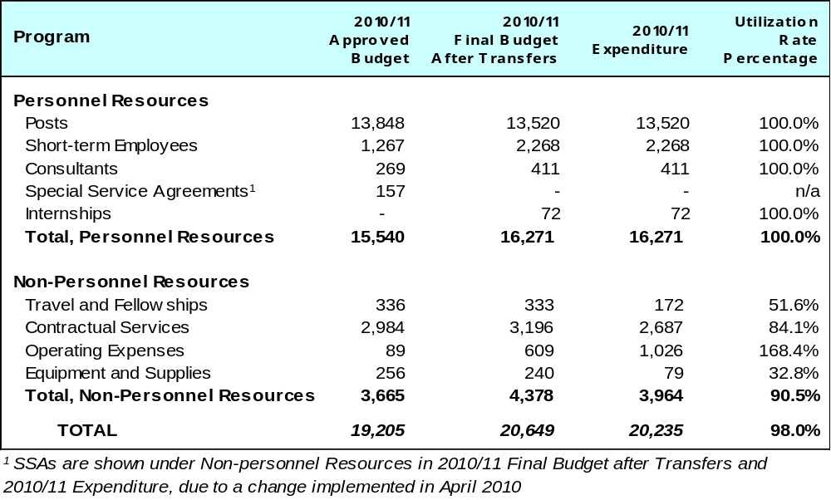

A. Budget after Transfers 2010/11

The budget after transfers increased by 1.44 million Swiss francs primarily due to:

- An increase in personnel resources of 0.73 million Swiss francs reflecting the centralization of the budget for professional accident insurance and interns under Program 23, provisions for ILO Administrative Tribunal related payments, and use of additional short-term personnel resources while relevant posts were under competitive process.

- An increase in non-personnel resources of 0.71 million Swiss francs for the introduction of the e-recruitment system, HR policy/manual development, assessment centers, PMSDS as part of SRP and ePMSDS reporting project.

B. Budget Utilization 2010/11

The budget utilization rate of 90.5 per cent for non-personnel resources was due to less expenditure on assessment centers than originally anticipated; project for HR policy/manual development (e-manual) not pursued due to on-going discussions on the revision of SRRs; and decrease in cost of third party travel due to increased use of webex and video-conferencing.

PROGRAM 24 ADMINISTRATIVE SUPPORT SERVICES

Program Manager Mr. A. Sundaram

ACHIEVEMENTS IN THE 2010/11 BIENNIUM

In the biennium, procurement and travel reached a satisfactory level of achievement of its expected results as illustrated by the performance data in the table below.

The most significant event impacting the work in this area was the successful launch in early 2010 of the AIMS Procure to Pay module within the FRR/IPSAS project. As a result of the new ERP module, which provides an on-line system for all purchase requisitions, the cost effectiveness of the global procurement process has improved and more than 95 per cent of WIPO spend (non-personnel resources) is now handled through this controlled process. Travel and Event requests are also pre-encumbered in our budget thanks to AIMS.

In parallel, the necessary actions in terms of Request for Quotation (RFQ), Invitation to Bid (ITB), and Request for Proposals (RFP) were undertaken to ensure competitive bidding processes. Among these were important projects such as the tender for the New Conference Hall. Initiatives were also undertaken to ensure WIPO’s participation in common procurement activities in order to leverage WIPO’s spend with other international organizations in Geneva. A total of 1,747,000 Swiss francs was saved through different operations of common procurement.

Although WIPO travel expenses have increased (increase in the number of trips), it should be noted that the average air ticket price has decreased from 2,452 Swiss francs in 2009 to 2,183 Swiss francs in 2011 (representing a decrease of 11 per cent). This decrease was achieved due to systematically exploring lowest available fares and increasing the use of economy class. Substantial savings (1.9 million Swiss francs in the biennium) continued to be yielded through the Joint Airlines Negotiations working group of International Organizations based in Geneva. In addition to this amount, additional savings were generated by the Travel Management Company through creative ticketing.

The visa processing activities also saw a sharp increase (29 per cent compared to 2008/09). The new arrangement of processing staff visas through the Travel Management Company, introduced in 2009, enabled internal staff to cope with the increased volume.

As regards premises management, at the end of 2011, a total of 1,579 workplaces were available in all buildings combined (WIPO-owned and rented premises), i.e. an increase of 122 additional workplaces as compared to 2010 (1,457 workplaces), and an increase of 179 workplaces as compared to 2009 (1,400 workplaces).

Of the 1,579 available workplaces, 87 per cent were occupied in 2011, compared to 92 and 94 per cent at the end of 2010 and 2009 respectively. The increase in empty workplaces resulted from several initiatives. Firstly, a stricter office space allocation policy was issued in December 2010 and fully implemented in the New Building and gradually in other buildings. Secondly, the New Building provided around 550 workplaces, i.e. an additional 145 workplaces as compared to the number of workplaces previously offered by the largest rented premises (the P&G Building). Thirdly, a more efficient and cost-effective use of the premises was implemented in particular through conversion of certain spaces into workplaces.

However, the available workplaces are not evenly distributed between the various buildings. In particular, the PCT Building has stricter access rules than other buildings, therefore reducing the flexibility for allocating available workplaces to employees of other administrative units. In addition, safety regulations require that certain large IT equipment, filing cabinets and paper supplies be located in closed areas which can be isolated in case of fire or other incidents, and no longer in corridors. As a consequence, spaces which could have been allocated as workplaces need to be converted into dedicated IT and local storage spaces, thereby reducing the total number of available workplaces. Finally, given the increasing demand for meeting rooms, a number of former office spaces had to be emptied in the AB Building for the creation of several meeting rooms and in the GBI Building for the creation of the control center under the UN H-MOSS upgrade project).

Due to the efficiency measures mentioned above, the Secretariat was able to manage the increased demand in workplaces and thereby avoided the need to rent additional space off-site during 2010 and the first half of 2011, pending the full availability of the New Building. In addition, a certain volume of stored documents were disposed off, thereby contributing to a more efficient and cost-effective use of storage areas on- and off-site, which is expected to lead to termination of the rental of at least one off-site storage area in 2012. The new office space allocation policy not only provides for more workplaces, but it is also expected to reduce the need to modify office floor layouts.

While the lease for the P&G Building was terminated with effect from August 31, 2011, as planned, the Secretariat decided not to terminate the lease of the CAM Building in December 2010 (with effect from January 2012), in anticipation of the need for, in particular, training facilities related to ERP implementation and other internal training programs. Furthermore, the existing lease arrangement provides much more favorable conditions than other commercial rentals in the vicinity.

In respect of technical installations, regular maintenance was undertaken and all premises continued to function adequately, with two significant exceptions: the PCT Building which will require the replacement of the cooling system and a renovation of the facades. This will constitute one of the major renovation projects in the existing buildings to be undertaken as from 2012. In addition, the cooling system for the GBII Building unexpectedly broke down in mid-2011 and will require replacement in 2012.

Measures aimed at reducing electricity consumption were examined for implementation in 2011 in at least one building (implementation postponed to 2012). These measures, involving replacement of original installations and equipment by new technological solutions, are expected to result in an overall reduction of consumption costs as well as an improvement of the carbon footprint.

In respect of asset management, the Property Survey Board continued its review aimed at establishing simpler and more consistent inventory procedures, in particular the tracking and disposal of articles and a better interface with the financial aspects of assets management. By the end of 2011, the Board had completed its work to recommend, similarly to other UN Organizations, that the threshold for tracking items be increased from 100 Swiss francs to 1,000 Swiss francs, and the threshold for capitalization of items be increased from 1,000 Swiss francs to 5,000 Swiss francs. A number of consequential procedural changes will be put in place as from 2012.

The WIPO Accessibility Project was launched at the end of 2009. The first initiatives consisted of internal assessments and reviews. In the course of 2010, the Project was fully integrated into the Strategic Realignment Program (SRP), as part of the “Environmental, Social and Governance Responsibility” Core Value. During the biennium, preliminary steps were taken aimed at identifying basic shortfalls in the existing premises and launching a tender for engaging the services of specialized architects to conduct a professional physical audit of the premises, which is expected to start in 2012.

The initial phases of the Carbon Neutrality Project were carried out in 2009 addressing a range of topics including: raising environmental awareness, premises-related issues (electricity and water consumption), IT-related issues, mobility issues (commuting from home to work) and official travel. More than 60 initiatives were launched throughout the 2010/11 biennium including: mobility days to raise awareness on alternatives to the use of individual cars to commute from home to work (public transport, car-sharing, biking), introducing environmental clauses in tender documents for office supplies and other goods, increasing the number of documents for WIPO meetings which are printed and mailed only on express demand of Member States, replacing cafeteria plastic articles by biodegradable articles, increasing the recycling of products, drafting the first draft of a sustainable travel policy, selecting for the New Building the electricity tariff with the highest percentage of contribution to renewable electricity production in the Canton of Geneva, full deployment of a cooling system for the New Building using the Geneva Lake deep water supply, water fountains in office floors of the New Building with City drinking water supply instead of plastic bottles. In addition, WIPO participated in a number of initiatives within the UN-Interagency context, mainly through UNEP and Sustainable UN (“SUN”), such as participation in the annual collection of data for the Greenhouse Gas (GHG) Calculator, the World Environment Day, the peer review exercise with UN Agencies (in particular the WTO and the UPU). The Project was fully integrated into the SRP in 2010.

PERFORMANCE DATA

Expected Result: Increased efficiency and effectiveness of the administrative support services
Performance Indicators |  | Baselines |  |  | Performance Data | TLS
Reduction on the number of complaints related to the administrative support services |  | 35 complaints received regarding messenger and driver services |  |  | 24 complaints received regarding messenger and driver services | Fully Achieved
Cost of the administrative support services as a percentage of organizational running costs (expenditure) classified by procurement, travel, premises management and messenger-driver services |  | Total expenditure for Program 24 amounted to 54.1 million Swiss francs i.e. 9.38% of total expenditure for the Organization in 2008/09 |  |  | Total expenditure for Program 24 amounted to 51.1 million Swiss francs, i.e. 8.7% of total expenditure for the Organization in 2010/11 | Fully Achieved
Expected Result: Enhanced cost-effectiveness of the procurement process
Performance Indicators |  | Baselines |  |  | Performance Data | TLS
Proportion of purchases based on market competition relative to total annual value of procurement maintained at the same level or increased |  | Proportion better than 85 % (baseline as of end of 2007). |  |  | >98% | Fully Achieved
Increased percentage of corporate spends transacted through the ERP process and the electronic tendering system relative to previous year |  | Not available |  |  | >98% | Fully Achieved
Expected Result: Overall reduction in the costs of goods and services acquired through the procurement process
Performance Indicators |  | Baselines |  |  | Performance Data | TLS
Total savings achieved in annual procurement expenditure. This will include economies from common procurement cooperation with other UN organizations and the Development Agenda |  | Annual savings of at least 500,000 Swiss francs |  |  | 1,747,000 Swiss francs | Fully Achieved
Expected Result: Greater cost-efficiency of the travel services
Performance Indicators |  | Baselines |  |  | Performance Data | TLS
Cost savings have been maintained or further increased by 20-25% for departure from Geneva |  | 20-25% cost savings on average by the end of 2009 |  |  | 28% | Fully Achieved
Cost savings have been maintained or further increased by 15% for departure from abroad and for third party travelers |  | 15% cost savings |  |  | 12% | Partially Achieved
Cost savings have been maintained or further increased by increased use of low cost airlines by 3-5% |  | 3-5 % more (baseline end of 2009 |  |  | 12% increase | Fully Achieved
Reduced processing time for travel authorization to maximum one day thanks to E-TA |  | Three days by the end of 2008 |  |  | 3 hours to one day | Fully Achieved
Expected Result: More efficient visa processing
Performance Indicators | Baselines |  |  | Performance Data |  | TLS
% of complaints due to delays in visa processing in relation to the total amount of visas processed on an annual basis | % of complaints due to delays in visa processing in relation to the total amount of visas processed on an annual basis by the end of 2010 |  |  | Not relevant. To be replaced by reduced % of staff visas processed as a matter of emergency, i.e. 20% in 2010 versus 14% in 2009 |  | Dis-continued  (as of 2011)
Expected Result: Optimal use and occupation of premises (including new building)
Performance Indicators | Baselines |  |  | Performance Data |  | TLS
Allocation of office spaces within existing (owned and rented) premises without any additional rental of premises | Occupancy rate of available office spaces was 94% (end 2009) as follows:  -1,400 workplaces available in all owned buildings (AB, GBI, GBII, PCT) and rented buildings (P&G, CAM);  -1,320 persons were allocated workplaces (including staff on post, G short-termers, T translators revisers, consultants and SLCs, interns, SSAs, and employees of external companies).  The 6% empty workplace rate is close to the lower bracket of the minimum business standard of 5-10% |  |  | Occupancy rate of available office spaces was 92% (end 2010) and 87% (end 2011) as follows:  -1,457 workplaces were available in 2010 following the conversion of certain spaces and 1,579 in 2011 due to the opening of the New Building and the implementation of a stricter office space allocation policy  -in 2010, 1,346 and in 2011, 1,374 persons were allocated workplaces (including staff on post, G short-termers, T translators revisers, consultants and SLCs, interns, SSAs, and employees of external companies)  Empty workplace rate: 8% in 2010 and 13% in 2011, i.e. a further improvement securing the necessary flexibility for the medium-term |  | Fully Achieved
Total office space (square meter) per headcount | Average number of square meters per person of available workplaces (i.e., occupied or not) was 14.7 square meters (end 2009):  -1,400 available workplaces  -a total of 20,636 square meters for available workplaces (i.e., occupied or not) in all owned and rented buildings. |  |  | Average number of square meters per person of available workplaces (i.e. occupied or not) was 14.2 square meters (end 2010) a decrease of 0.5 square meters or 3.4% compared to 2009, and 13.7 square meters or a further decrease of 0.5 square meter or 3.4 % compared to 2010:  -at the end of 2010, a total of 20,636 square meters, and at the end of 2011, a total of 21,685 square meters, of available workplaces (i.e., occupied or not) in all owned and rented buildings (the new building is counted only in 2011) |  | Fully Achieved
Total property costs (occupancy, operational and management) per square meter | The total property cost per square meter was 173 Swiss francs (end 2009):  -total property costs amounted to 19.6 million Swiss francs, including staff and non-staff costs related to premises management;  -a total of 113,644 square meters for all spaces in all owned and rented premises (including offices, meeting rooms, common areas, technical rooms, public areas, land surrounding buildings, etc.). |  |  | The total property cost per square meter was 172 Swiss francs (end 2010) and 147 Swiss francs (end 2011):  -in 2010, total property costs amounted to 19.5 million Swiss francs, and, 24 million Swiss francs in 2011, including staff and non-staff costs related to premises management;  -in 2010, a total of 113,644 square meters and 163,420 square meters in 2011 for all spaces in all owned and rented premises as at the end of each year (including offices, meeting rooms, common areas, technical rooms, public areas, land surrounding buildings, etc.) with the New Building in 2011 and the P&G Building until August 2011, date of termination of lease |  | Fully Achieved
Expected Result: Adequate functioning of installations in all WIPO buildings
Performance Indicators | Baselines |  | Performance Data |  |  | TLS
Total properties maintenance backlog as a percentage of average annual maintenance spend for the last three years | Baseline could not be established in view of lack of adequate and validated data. |  | Nearly all critical technical installations functioned adequately during the biennium, except: 1) the heating and cooling installations and systems in the PCT Building (substantial renovation planned as from 2012); 2) the cooling installation of the GBII Building (replacement planned in 2012 by an extension of the “Geneva Lake Water” system) |  |  | Partially Achieved
Minimum standards criteria for the adequate functioning of installations identified | Baseline could not be established in view of lack of adequate and validated data. |  | The selection of preferred systems or supplies has been confirmed in 2011 for:  - cooling system (including for data centers) using the “Geneva Lake Water” system;  - heating using natural gas (State monopoly);  - water (State monopoly) with additional specific treatment for sanitary installations and kitchens, as well as for certain installations, demineralization  Minimum standards for other installations and in other areas are still in the process of being identified |  |  | Partially Achieved
% of reduction in cost of energy and supplies in a sustainable framework (medium- or long-term, rather than short-term cheaper prices and services) | Baseline could not be established in view of lack of adequate and validated data. |  | Energy tariffs for electricity decreased during the biennium with the result that the increased consumption due to the New Building (twice the volume of the P&G Building) did not cause an increased overall cost (remaining stable at around 1.4 million Swiss francs compared to 2010 and slightly less compared to 2009). A marginal increase (135,000 Swiss francs) was due to the choice of the greenest tariff (subsidizing 100% renewable electricity provision in the Canton of Geneva) for the equivalent of the consumption of the New Building  Technical studies to reduce electricity consumption have been undertaken, and electrical equipment in at least one WIPO building will be upgraded in 2012  No decrease in cost was made in respect of natural gas and water since the prices of these utilities increased in 2011 compared to 2010 and since the consumption in 2011 was significantly greater due to the fact that both the New Building and the P&G Building had to be serviced concurrently for 8 months in 2011 |  |  | Partially Achieved
Expected Result: Vacating rented premises at minimum cost
Performance Indicators | Baselines |  | Performance Data |  |  | TLS
Cost for vacating rented premises kept to a minimum and possibly at a cost lower than originally budgeted | Depending on compliance with delivery date of new building and with contractual conditions as fixed in the various rental contracts |  | The P&G Building was vacated at the end of August 2011, at a cost (about 50,000 Swiss francs) much lower than expected (250,000 Swiss francs) due to the decision of the owner to renovate that building rather than leasing it immediately to another tenant  As noted by the PBC and the Assemblies in September 2011, the CAM Building was not vacated at the end of 2011 due to the Secretariat decision to keep an adequate flexibility in the balance between occupied and non-occupied workplaces and to secure a medium term solution to space management at a price significantly lower than market prices in the vicinity |  |  | Fully Achieved
Expected Result: Formalization of inventory, management procedure and processes
Performance Indicators | Baselines |  | Performance Data |  |  | TLS
% new implemented procedures | To be developed once implementation starts |  | All preparatory work for the implementation of new inventory procedures through an Office Instruction was completed by end-2011 after numerous reviews by the Property Survey Board; these procedures are expected to be implemented in the first quarter of 2012  New procedures were implemented through the Property Survey Board to deal with the recycling and disposal of obsolete items, to improve the reconciliation between the physical and financial aspects of asset management and to improve the tracking of certain categories of items (IT items and works of art)  Decision was taken to align the thresholds for capitalizing assets and for tracking items to those applicable in other UN Agencies (to 5,000 and 1,000 Swiss francs, respectively, instead of 1,000 and 100 Swiss francs previously) |  |  | Partially Achieved
Expected Result: Reflecting WIPO’s commitment in reducing the impact on the environment of carbon emissions across the various programs
Performance Indicators | Baselines |  | Performance Data |  |  | TLS
Green indicators will be reflected in some programs | List of indicators will be provided to all programs by the end of 2011 |  | Several initiatives have been ongoing since 2010, in particular:  - Implementation of a new electronic communication system for official documents for delegates during WIPO Assemblies and certain Committees, where printed material is dispatched only upon request (all Programs servicing WIPO meetings affected)  - Water fountains with city water supply installed in the New Building instead of plastic bottles (Programs 24 and 29 affected)  - Greenest electricity tariff implemented in the New Building in 2011 (Program 24 affected)  - Ecological criteria included in several procurement processes for building and equipment supplies (Program 24 affected)  - Technical studies aimed at reducing electricity consumption undertaken with the aim to upgrade the equipment in at least one building in 2012 (Program 24 affected)  - A variety of awareness campaigns and incentives launched within the Organization (replacement of plastic utensils by biodegradable items in the cafeterias, free public transport passes, free electrical bicycle trials, advice on local transportation alternatives)  - Participation in UN and local initiatives and events  It has not been possible to provide environmental indicators to all Programs in 2010/11. Efforts will therefore continue in 2012/13 |  |  | Partially Achieved

BUDGET AND ACTUAL EXPENDITURE

Actual Expenditures (personnel and non-personnel) vs. Budget after Transfers 2010/11
(in thousands of Swiss francs)

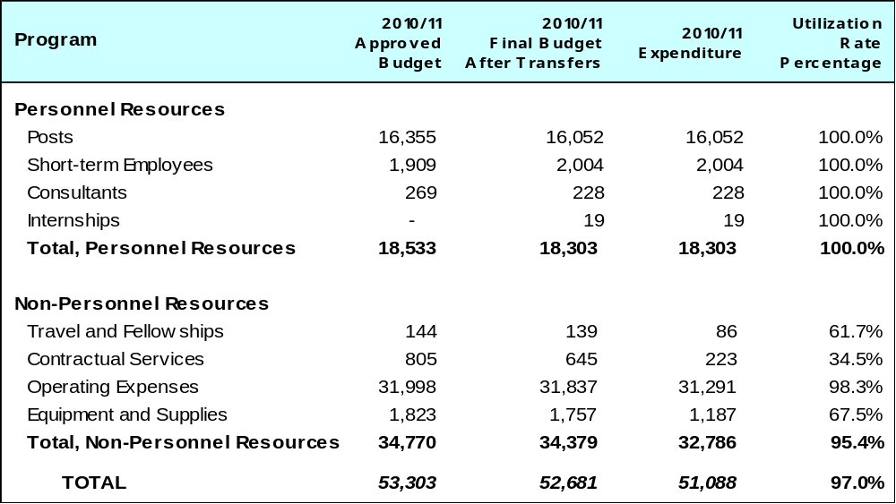

A. Budget after Transfers 2010/11

The budget after transfers 2010/11 compared to the approved budget 2010/11 reflects a decrease primarily due to the transfer of responsibilities for security-related maintenance contracts to Program 28 and a reduction in the number of short term staff.

B. Budget Utilization 2010/11

The budget utilization (non-personnel resources) amounted to 95.4 per cent for the Program, primarily due to the postponement of some procurement related training activities; and a number of upgrades to installations and renovation of facilities. In addition, a number of carbon neutrality related initiatives could not be fully implemented as foreseen due to the lack of adequate personnel resources.

PROGRAM 25 INFORMATION AND COMMUNICATION TECHNOLOGY

Program Manager Mr. A. Sundaram

ACHIEVEMENTS IN THE 2010/11 BIENNIUM

Coherence and efficiency in WIPO’s IT infrastructure management was achieved by realigning the structure and staffing of the Program, developing a comprehensive ICT Strategy for the Organization, strengthening the ICT Security Plan and enhancing cooperation with the business applications management teams throughout the Organization.

2010 saw the establishment of the ICT Board - an important enhancement in strengthening the ICT governance framework. The ICT Board endorsed the ICT Strategy, which called for the establishment of ten enabling ICT capabilities in response to evolving business needs in the coming years.

The following technical highlights are indicators of good progress in the biennium in the field of Infrastructure Services, Business Solution Services (including Internet Services), IT Service Management Services and Information Security Services:

- During the reporting period, all of the Organization’s mission-critical Oracle database systems have been consolidated and migrated to modern cluster-based server platforms in order to reinforce their reliability and availability, while increasing performance and reducing operational costs.

- In order to enhance communications with the Organization’s stakeholders, for the first time in 2010, and again in 2011, the WIPO Assemblies was broadcast live over the Internet (via webcasting). The recorded video sessions were also made accessible through the WIPO Web site in the form of “video-on-demand”. Based on this positive experience, Member States approved in October 2011 the webcasting of all major WIPO meetings as of 2012.

- The internal data network architecture has been redesigned and fully validated in 2010 in order to reinforce network security controls and to effectively handle multimedia (voice, video and data) traffic, including the new IP-based telephone system. This new architecture was successfully deployed during the first half of 2011 to over 550 work places in the new WIPO Building. Based on the positive results of the pilot, the same solution will be implemented in all other WIPO buildings during the course of 2012.

- A new 220 m² Computer Center has been established in the new WIPO Building in order to securely house WIPO’s mission critical ICT Systems. In line with WIPO’s Carbon Neutrality project, energy efficiency has been a significant design consideration leading to solutions such as the use of the Geneva Lake Water (GLN Project) for the cooling of the Computer Center.

- Extensive new ICT infrastructure has been deployed during the reporting period, including a new Identity Management System, for facilitating access to the Organization’s external Business Systems such as ePCT, PATENTSCOPE, Global Brand Database, Madrid Email alerts (MEA) and Madrid Portfolio Manager (MPM).

- The FRR/IPSAS Project started implementation in January 2010. Procurement and Asset Management modules have been introduced together with streamlined business processes from requisition to invoicing. WIPO obtained IPSAS compliance in 2011, as one of the first UN organizations. The outsourcing of the related infrastructure hosting has resulted in high availability at affordable costs during the reporting period.

A number of externally available information systems were also launched:

- WIPO Gold, an Internet portal which provides easy access to WIPO’s major applications;

- IP Advantage, which aims to promote a better understanding of how to create and protect intellectual property and reap the benefits provided by the IP system;

- WIPO Lex, a one-stop search facility for national laws and treaties on IP of WIPO, WTO and UN Members was published. It also features related information which elaborates, analyzes and interprets these laws and treaties. It provides streamlined access to reference material of key importance for optimal information on the global IP System;

- PCT E-Payment Service permits applicants to pay PCT fees by credit card via an online secure e-payment facility;

- UPOV’s website was re-designed and re-architectured in 2011;

- wipo green and WIPO Re:Search databases focusing on transfer of sustainable technologies and know-how and data available on research and development information on neglected tropical diseases;

- Major refresh of the conference registration system and the WIPO e-Learning systems.

In addition, Web accessibility workshop was organized for staff of the United Nations system and other International Organizations to promote awareness on accessibility and encourage webmasters to adopt specific techniques in making their websites more accessible.

The first Organization-wide Information Risk Assessment was conducted, providing insight into the types of information deemed important by the various business units which will be used to better focus information security efforts going forwards. The security protection of the PCT IB database was also increased through the deployment of new and advanced tools, which allow monitoring and alerting for suspicious activity on WIPO’s business critical data.
A formal self-assessment was run based on the industry best practices, which resulted in the improvement of Service Desk services, implementation of follow-up of ticket aging as a performance indicator and formal change management.

The standardization of PRINCE2 project management methodology was extended and an online Organization-wide Project Registry established.

PERFORMANCE DATA

Expected Result: Enhanced service delivery and cost-effectiveness of high quality external IT service provisioning
Performance Indicators | Baselines | Performance Data | TLS
Cost of the ICT services (spend on the ICT program including staff and associate overheads) as a percentage of the organizational running cost (expenditure) | Total expenditure for Program 25 amounted to 45.2 million Swiss francs (2008/09) i.e. 7.83% of total expenditure for the Organization in 2008/09 | Total expenditure for Program 25 amounted to 42.7 million Swiss francs i.e. 7.25 % of total expenditure for the Organization in 2010/11 | Fully Achieved
ICT competence of users  source: online statistics of CustomGuide | Post-assessment tutorials success rate: 93% (total number of tests: 1,679), end of 2009 | Post assessment tutorials success rate: 97% (total number of tests: 5,000) | Fully Achieved
Organizational ICT spend (investment in ICT infrastructure and hardware across the organization) as a percentage of the organizational running costs (expenditure) and per user  (The ICT spend per user has been discontinued as it is not considered a meaningful performance measure) | 24.6 million Swiss francs (non-personnel resources) / 180 million Swiss francs (non-personnel resources) = 13.7% for 2008/09 | 22.8 million Swiss francs (non-personnel resources) / 192.5 million Swiss francs (non-personnel resources) = 11.8 % 2010/11 | Fully Achieved
Number of new management practices that have been put in place by the organization out of the total agreed during the 2008-2009 biennium | None implemented in 2009 | Management practices were outlined in the IT Strategy and in Service Management practices | Dis-continued
Users and requisitioners feedback rating the ICT services as satisfactory and above in terms of effectiveness and efficiency | Not available | User satisfaction is above 80% for all dimensions of the service (survey in 2010) | Fully Achieved
Average number of support calls per user | 2008 January: 50-60 service requests per working day | Number of support requests totaled 90-120 service requests per working day (December 2011). The number of requests is independent from the size of the user base | Fully Achieved
Percentage of users who are able to access the network and systems remotely | 200 users with VPN access in 2008/09 | 300 users with VPN access in 2011 December | Fully Achieved
Number of external  SLAs (4) | (2) MAPS/DMAPS, PeopleSoft in 2008/09 | MAPS/DMAPS (Adabas hosting); AIMS (PeopleSoft hosting); IP telephony; IRPI/SOA hosting | Fully Achieved
Expected Result: Continued high system availability of mission critical systems (statistics to be provided from system monitoring tools)
Performance Indicators | Baselines | Performance Data | TLS
Availability of business systems: 99.8% | 99.8% | 99.8% | Fully Achieved
Availability of critical network services: 99.7% | 99.7% | 99.7% | Fully Achieved
Internal Service Level Agreements (SLAs) (5) SLAs for the Service Desk supported services (25) | 0 | 0 | Not Achieved
Percentage of procedures related to basic IT services being implemented by the end of 2009  (The % of procedures has been replaced by number of procedures, the latter being considered a more meaningful performance measure) | 12 service related procedures were computerized | 14 services computerized, handled by the service desk, integrated to Service Desk Express (SDE) | Fully Achieved
Expected Result: Implementation of ITIL processes
Performance Indicators | Baselines | Performance Data | TLS
Number of formally implemented ITIL processes (6) | Service Desk, Incident Management in 2009 (2) | Service Desk, Incident Management, Change Management (3) | Partially Achieved
Expected Result: Security of the system operations has been increased/ maintained
Performance Indicators | Baselines | Performance Data | TLS
Percentage of incidents resolved within agreed service levels/timescale from the total number of reported incidents | Not available | Ticket aging was stabilized at a 2% level (tickets not resolved in 1 week or 1 month) | Partially Achieved

BUDGET AND ACTUAL EXPENDITURE

Actual Expenditures (personnel and non-personnel) vs. Budget after Transfers 2010/11
(in thousands of Swiss francs)
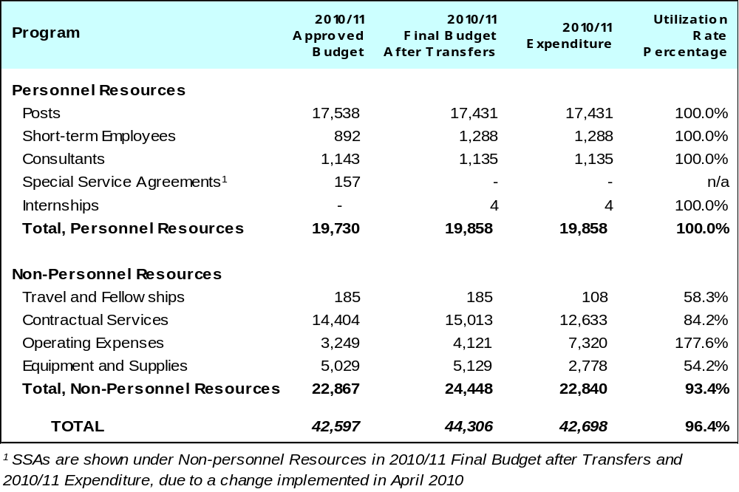

A. Budget after Transfers 2010/11

The budget after transfers 2010/11 compared to the approved budget 2010/11 reflects an increase primarily due to the transfer of non-personnel resources from PCT for IT technical services, centralization of the communication related services under the Program as well as additional resources provided under the SRP-related initiatives.

B. Budget Utilization 2010/11

The biennium 2010/11 saw an under-utilization of non-personnel resources of approximately 1.6 million Swiss francs primarily due to slower than expected progress on a number of projects initiated in cooperation with the UN International Computing Center in particular the migration of the WIPO Computer Center to the new computer room managed by UNICC (ICT infrastructure management, migration project), and the second and third phase of the IP telephony project.

PROGRAM 26 INTERNAL AUDIT AND OVERSIGHT

Program Manager Mr. T. Rajaobelina

ACHIEVEMENTS IN THE 2010/11 BIENNIUM

The Internal Audit and Oversight Division (IAOD) consolidated its policies, manuals and guidelines for Internal Audit, Evaluation, Investigation, Document Retention and Training. This consolidation improved the Program’s operational effectiveness and efficiency in serving the Organization.

All audits addressed operational areas of high risk and audit reports provided reasonable assurance to the Director General and Member States on the adequacy and effectiveness of internal controls system and risk management at WIPO. Audit recommendations were instrumental in facilitating the mitigation of risks and in further strengthening governance, the system of internal controls and risk management in general and, in particular, in the areas of development cooperation, WIPO construction projects, the FlexiTime system, the WIPO Arbitration and Mediation Center, Procurement and the WIPO Academy.

In line with the Evaluation Strategy 2010-2015, IAOD began its first evaluations towards the end of the biennium. In collaboration with Program 9, the first Country Portfolio Evaluation identified some of the improvements that can be made by having a more strategic and systematic approach to strengthening and supporting IP systems in recipient countries.

The validation of the Program Performance Report for the 2008/09 biennium highlighted the need for more systematic reporting, a reduction of the number, as well as an increase in the quality, of objectives, indicators and targets for the following biennium. It also pointed to the need for identifying assumptions and risks more explicitly and recording those alongside the monitoring of achievement of objectives.

In 2011, two additional evaluations of Development Agenda projects (Technology and Innovation Support Centers (TISCs) and National Start-up Academies) were launched for the ninth session of the CDIP in 2012.

In order to strike the balance between the two evaluation functions of learning and accountability and with the aim of promoting an organizational evaluation culture, a Seminar on Learning from Existing Evaluation Practices on the Impacts and Effects of Intellectual Property on Development was organized. A large majority of the 80 participants expressed interest in pursuing this initiative in the future.

Although the investigation function suffered from a shortage of staff during the reporting period, 35 investigation cases were completed. However, an important backlog of 18 cases remained at the end of 2011. The publication and implementation of the Investigation Procedure Manual provided for a full set of rules for the investigations guaranteeing a fair process. In addition, the preparation of a “whistle blower” protection policy, along with the preparatory work for the implementation of a hotline, should lead to improved risk mitigation within the Organization.

IAOD effectively monitored outstanding oversight recommendations and reported on progress to the Director General and the Independent Advisory Oversight Committee (IAOC) on a bi-annual basis.

PERFORMANCE DATA

Expected Result: An effective and professional internal audit is in place covering all high risk work areas
Performance Indicators | Baselines | Performance Data | TLS
Internal Audit recommendations accepted by the Director General are implemented by management within 12 months | Of the current 228 accepted Internal Audit recommendation made since December 2007, 51 have been fully implemented by the Director General  In 2009, IAOD made 74 recommendations. Of these, 24 (31%) remain not fully implemented | In the 2010/11 biennium, IAOD made 162 internal audit recommendations. While 160 were accepted, 90 were implemented (55.6%) and 72 recommendations were outstanding (44.4%) | Partially Achieved
Key and high risk areas are audited | Over four person years of internal audit were estimated to be required in 2008 to cover all high risk work areas | All internal audit assignments undertaken in 2010/11 were in high and key risk areas as defined in the Annual Audit Plans. Audit coverage of high risk areas was about 80%, excluding medium and low risk areas | Partially Achieved
Expected Result: An effective and professional internal audit is in place covering all high risk work areas
Performance Indicators | Baselines | Performance Data | TLS
At least 10 audits completed during the biennium. | Four audits were completed in 2008.  Five audit reports were issued in 2009 | 14 audits (six audits in 2010 and eight audits in 2011) were completed | Fully Achieved
The professional standards, code of ethics, and practice advisories of the Institute of Internal Auditors (IIA) are applied | The Internal Audit Charter refers to the application of the IIA standards, code of ethics and practice advisories | All audit assignments were undertaken in line with the IIA standards, practice advisory and code of ethics. This has been assessed on an ongoing basis, including by the External Auditors | Fully Achieved
Expected Result: Investigation reports provide a timely and sound basis for decision-making by the Director General
Performance Indicators | Baselines | Performance Data | TLS
Investigation activity is carried out in accordance with the Internal Audit Charter, the Investigation Policy and the Investigation Procedure Manual | Currently, the Investigation Section applies the Internal Audit Charter and the Uniform Guidelines for Investigation adopted by the Conference of International Investigators and the UN | The Investigation Procedure Manual which provides a complete set of rules governing the investigation has been in effect since August 2010 | Fully Achieved
 | An Investigation Policy and an Investigation Procedure Manual are being prepared based on professional standards and UN good practices | The Investigations Procedure Manual was published in August 2010. Investigation Policy is pending | Partially Achieved
 | The Investigation Section currently has 22 open cases; three cases were completed in 2008 | 18 open cases as of December 31, 2011. 35 cases were closed during the biennium | Partially Achieved
 | Whistle blowing procedures required by the Internal Audit Charter will be formalized in 2010 | IAOD contributed to a whistleblower protection policy which is now in draft and under consultation | Partially Achieved
Expected Result: Evidence-based evaluative information is available to senior management, program managers and Member States for decision making
Performance Indicators | Baselines | Performance Data | TLS
The Evaluation Policy and evaluation manuals and guidance are implemented | In 2009 draft manuals and procedures will be prepared for independent and self-evaluations | Draft Evaluation Policy prepared in May 2010 (approved by the Director General in March 2011). WIPO Independent Evaluation Guidelines were developed in 2010 and have been implemented during the biennium | Fully Achieved
 | The Evaluation Policy will be progressively implemented through 2010 | Implementation of the revised Evaluation Policy and the Evaluation Strategy for 2010-2015, based on this Policy, began in 2011 with the design of the Kenya Country Portfolio Evaluation and two Development Agenda Project Evaluations (TISCs and National Startup Academies) | Partially Achieved
At least 6 evaluations completed in the biennium, and made appropriately available to relevant stakeholders | Two Evaluation Section reports were completed in 2008. | The validation of the Program Performance Report 2008/09 was completed  Evaluation of the Kenya Country Portfolio was close to completion by the end of 2011 (draft report received) | Partially Achieved
Most self-evaluations undertaken by programs meet basic evaluation quality standards | Currently self-evaluations are not routinely carried out and do not reflect basic quality standards, e.g. regarding: baselines, definition of objective, sampling, accuracy of analysis… | Ad-hoc advice was provided on carrying out self-evaluations at the request of internal clients.  However, not all programs and projects do foresee evaluations as part of their planning cycles | Partially Achieved

BUDGET AND ACTUAL EXPENDITURE

Actual Expenditures (personnel and non-personnel) vs. Budget after Transfers 2010/11
(in thousands of Swiss francs)

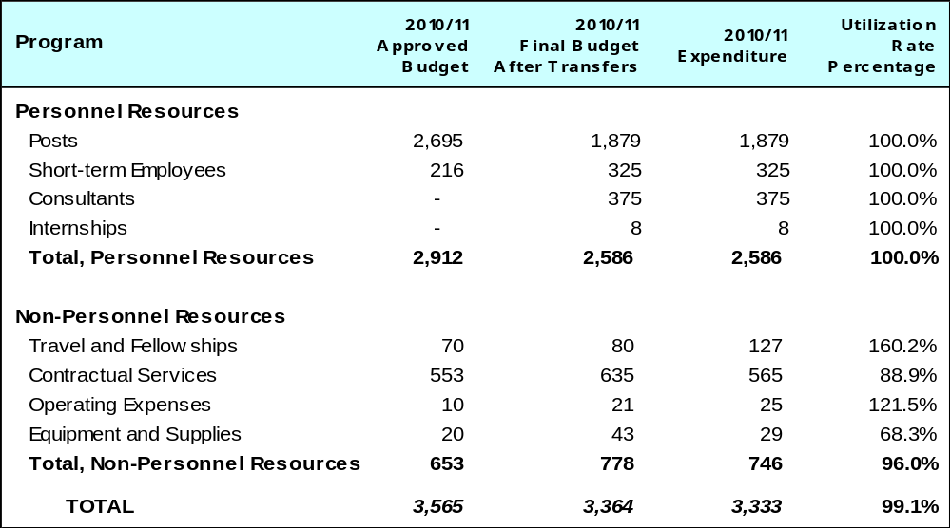

A. Budget after Transfers 2010/11

The budget after transfers 2010/11 compared to the approved budget 2010/11 reflects a small decrease primarily due to post vacancies within the Program during the biennium.

B. Budget Utilization 2010/11

The key vacancy in the investigation and evaluation area meant that certain activities, which required close oversight and management of outsourced contractual services, could not be fully performed and completed as initially planned. This has resulted in some under-expenditure in non-personnel resources, specifically under Contractual Services.

PROGRAM 27 CONFERENCE AND LANGUAGE SERVICES

Program Manager Mr. A. Sundaram

ACHIEVEMENTS IN THE 2010/11 BIENNIUM

This Program, covering conference, language, printing, records management/archiving and mail expedition services, continued to expand, streamline and modernize its functions, in an efficient and timely manner, in response to the increasing demand for its services.

The project for the digital recording of meetings was initiated in 2010. System installation and testing was carried out, and relevant staff trained. The system was fully deployed by the end of 2011.

Substantial development work was undertaken in the area of on-line registration, to improve the existing electronic system. The upgraded on-line registration tool was made available for the 2011 General Assemblies, and was widely used by participants (approximately 75 percent of participants were registered through the electronic web-based system, including those who were registered “on the spot” by WIPO staff). The use of the web-based system, upgraded hardware, and a well-conceived infrastructure for registration during the Assemblies, resulted in minimal waiting time for delegates to collect badges or register on the spot. Based on a review of the Assemblies’ experience, further enhancements were made to the system, paving the way for its progressive deployment in other main meetings. Refinement of the online registration system will continue in the next biennium.

During the biennium, not only did WIPO see a rise in the number of meetings (250 compared to 221 in 2008/09), but also extended conference hours, within the framework of the sessions of principal committees.

The process for registration of incoming documents and digitalization of the archives continued. The total number of documents (paper, electronic, FAX) scanned in 2010/11 reached 98,000 as compared to 55,000 documents in 2008/09.

The electronic filing of e-mails in UPOV was implemented successfully, along with the electronic archiving of all WIPO publications created during the last 12 years (over 21,000 publications electronically archived).

During the biennium, mailing costs were reduced by 17.8 per cent, as a result of renegotiation of contracts with the mail suppliers and enhanced use of electronic means for dissemination of documentation to Member States, IGOs and NGOs.

Enhanced efficiency in printing and publications production services was achieved through the acquisition of more technically advanced equipment. The challenges of responding to the increasing demand for printing in very short time delays, the implementation of the new WIPO logo and the launch of WIPO’s first Open Day were successfully overcome.

As far as language services are concerned, the Secretariat continued to respond to requests from Member States for wider language coverage with regard to interpretation, documentation, publications or, in more recent years, databases and web sites.

An analytical study that took stock of the availability of documents for all WIPO Committees in the six official languages of the United Nations was carried out in 2010 and submitted to the 2010 Assemblies, together with a phased comprehensive language policy for WIPO, as identified by the Director General in the Medium Term Strategic Plan 2010-2015, taking into account the resource-intensive nature and quality considerations of translation activities (document A/48/11).

Two phases of the proposed WIPO Language Policy, approved by the 2010 and 2011 Assemblies, respectively, provided for the extension of full six language coverage for the documentation of the Intergovernmental Committee on Intellectual Property and Genetic Resources, Traditional Knowledge and Folklore (IGC) in 2010 and two additional committees, the Standing Committee on Copyright and Related Rights (SCCR) and the Standing Committee on Trademarks, Industrial Designs and Geographical Indications (SCT) in 2011.

The successful implementation of both phases within approved budget allocations, was ensured by the introduction of rationalization measures (such as reduction of document volume) approved by Member States and restructuring efforts aiming at embracing a new business model that increased reliance on outsourcing activities, while maintaining quality standards.

PERFORMANCE DATA

Expected Result: Increased efficiency of the conference, language, printing, records management/ archiving and mail expedition services for all requisitioners and users
Performance Indicators | Baselines | Performance Data | TLS
Cost of the services and coverage (conference, language, printing, records management/ archiving and mail expedition services) as a percentage of organizational running costs (expenditures) | Total expenditure for Program 27 amounted to 38.4 million Swiss francs (2008/09) i.e. 6.7% of total expenditure for the Organization in 2008/09.  A total of 121 meetings were held in Geneva, for a total duration of 310 days and attended by 7,808 participants in 2009 | Total expenditure for Program 27 amounted to 35.3 million Swiss francs, i.e. 6% of total expenditure for the Organization in 2010/11  A total number of 250 meetings were held in Geneva (221 in 2008/09 biennium) attended by 16,330 participants (15,900 in 2008/09)  The volume of documents scanned and recorded increased to 98,000, compared with 55,000 in 2008/2009, an increase of 78%. The number of requests for retrieval of old documents increased by 24%. The search time was brought down to less than one minute, with electronic delivery in all cases | Fully Achieved
Outcome of activities to maintain or improve productivity standards for in-house staff in the language service, and cost per page of translation | 2008/2009 productivity and cost levels | Productivity and cost levels were maintained, with the average translation cost per page at 213 Swiss francs  Translation of documentation for WIPO meetings, publications and other documents increased by 12.6% (from a total of 74,633 pages in 2008/09 to 84,087 pages in 2010/11) | Fully Achieved
Reduction of overall mailing costs by 15% | Overall mailing cost by the end of 2009: 2,887,753 Swiss francs | Overall mailing cost for 2010/11 was 5,1 million Swiss francs, compared to 6,2 million Swiss francs in 2008/09 - a reduction of 17.8% | Fully Achieved
Expected Result: Increased effectiveness of the conference, language, printing, records management/ archiving and mail expedition services for all requisitioners and users
Performance Indicators | Baselines | Performance Data | TLS
% of feedback from requisitioners and users of the services (conference, language, printing, records management/ archiving and mail expedition services) rating satisfactory or above | % of feedback from requisitioners and users of the services rating satisfactory or above by the end of 2010 | Although a formal survey was not undertaken due to the lack of human resources, the overall user feedback was positive. No complaints were received during the biennium  100% PCT Mediabatches delivered in paper and electronic format on time  Madrid Notifications, Bulletin and Romarin, documents for meetings were reproduced and delivered within the reproduction timeframe  A total of 40 million faceprints were printed (30 million black and white and 10 million color) | Partially Achieved
Development of an effective and comprehensive language policy and definition of related resource allocation needs to cover meetings, publications and the WIPO website | Current policy and resources do not meet needs expressed by Member States | The WIPO Language Policy was considered in the General Assemblies 2010 and 2011. Decision was taken in 2011 to extend six-language coverage to all Committees and Main Bodies of WIPO from 2012. Six-language coverage extended to SCCR and SCT in 2010/11. | Fully Achieved
Availability of documents for IGC/GRTKF meetings in all official languages | English, French and Spanish for the majority of meetings | Documents for the IGC/GRTKF meetings, and also for the three related inter-sessional working groups were made available in Arabic, Chinese and Russian in addition to English, French and Spanish | Fully Achieved

BUDGET AND ACTUAL EXPENDITURE

Actual Expenditures (personnel and non-personnel) vs. Budget after Transfers 2010/11
(in thousands of Swiss francs)
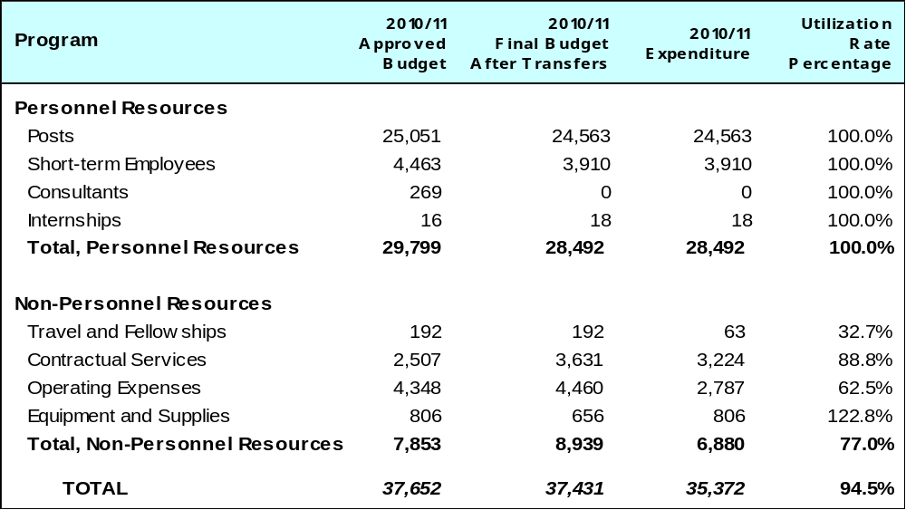

A. Budget after Transfers 2010/11

The budget after transfers 2010/11 compared to the approved budget 2010/11 reflects a small increase due to additional non-personnel resources allocated to the Program for the WIPO Assemblies, replacement of the Isiline system and outsourcing related to the implementation of the new Language Policy.

B. Budget Utilization 2010/11

The biennium saw an under-utilization of the non-personnel resources primarily due to: an overestimation of costs related to the General Assemblies; non-implementation of the CAT Tools project; a decrease in the volume and downward negotiation of mail prices and postponement of a database migration project.

PROGRAM 28 SECURITY

Program Manager Mr. A. Sundaram

ACHIEVEMENTS IN THE 2010/11 BIENNIUM

Costs related to safety and security services during 2010/11 continued to be consistent with previous years’ costs as a percentage of total organizational expenditure. During the biennium, Program 28 successfully assumed management responsibility for 100 per cent of all organization-wide safety and security systems and equipment installations, some of which were previously managed by Program 24. In addition, the New Building premises became operational in March 2011, resulting in the absorption by the Program of additional safety and security systems and equipment installations that had previously been under guarantee.

Several new policies in regards to safety and security for official staff travel and WIPO sponsored events outside of Geneva were implemented in 2010/11, in addition to standardization of badge layouts in accordance with the United Nations Security Management System (UNSMS), and introduction of improved biometric access controls to the New Building Datacenter.

The security upgrade project for the implementation of the UN Security Management Standards at WIPO has progressed through the pre-project phase to full implementation. Overall at the end of the biennium, implementation of approximately 60 per cent of the standards as per the audit report road map from 2008-09 had been completed. As regards the total number of reported incidents in 2010/11, less than two per cent pertained to staff injuries.

As a result of a new organizational policy promulgated in July 2010, Program 28 became increasingly involved in managing safety and security risks at WIPO sponsored events outside of Geneva during 2010/11. The annual quality assurance of the Security Risk Assessment (SRA) was completed for the WIPO HQ operations, as well as the annual assessment audits of the WIPO External Office premises. Moreover, the Program also participated extensively in the development of the Business Continuity Response Plan (BCRP) and the Business Continuity Management Strategy (BCMS) for WIPO operations. Finally in early 2011, the Program was involved extensively in evacuating staff and assisting in the remote running of the WIPO Japan Office after the earthquake and tsunami, which greatly aided in the ability to maintain business as usual and reduce the adverse impact of the disaster to WIPO staff, business operations, the Organization and other stakeholders.

PERFORMANCE DATA

Expected Result: Enhanced effectiveness and efficiency of WIPO's safety and security services
Performance Indicators | Baselines | Performance Data | TLS
Cost of the safety and security services as a percentage of organizational running costs (expenditures) | Total expenditure for Program 28 amounted to 9.4 million Swiss francs i.e. 1.64% of total expenditure for the Organization in 2008/09 | The total expenditure for Program 28 amounted to 9.983 million Swiss francs i.e. 1.70% of total expenditure for the Organization in 2010/11. These costs remain stable compared to the 2008/09 biennium. It should be noted that Program 28 now manages 100% of all the safety and security systems | Fully Achieved
Number of new management practices that have been put in place by the organization out of the total agreed during the 2008-2009 biennium | Number of recommendations for improvement that have been approved for implementation by the end of 2009 | There were a total of six new recommendations that were approved in the 2010/11 biennium | Fully Achieved
Expected Result: Improvement in overall safety and security including reported injury risk related incidents
Performance Indicators | Baselines | Performance Data | TLS
By the end of 2011 WIPO will meet 60% of the UN security management system standards | In 2008 WIPO met the UN security management system standards by about 20% as indicated in its audit  reports. By the end of 2009 the program met 30% of the UN security management system standards | Approximately 60% of the UN Security Management System standards were implemented during the biennium as the security upgrade project for the WIPO  existing premises progressed through the pre-project phase to the execution phase | Fully Achieved
Keep under 2% of staff injured from the total number of staff including the WIPO Coordination Bureaus | Less than 1% of staff injured from the total number of staff by the end of 2009 | Of the total of 531 reported incidents in 2010/11 of which 8 involved reported injuries, 1.5% pertained to staff injuries | Fully Achieved
Expected Result: Quality assurance : Satisfactory and improved safety and security at high-level WIPO hosted conferences and meetings, in Geneva and elsewhere as well as in the WIPO Coordination Bureaus
Performance Indicators | Baselines | Performance Data | TLS
% of the total risk assessments and audits carried out for HQ and coordination premises, conferences, meetings and various functions that meet UN security management system standards | Approximately 80% of the total risk assessments and audits carried out for HQ and coordination premises, conferences, meetings and various functions did meet UN security management system standards | In 2010/11 there were seven audits undertaken of External Office premises, and of two external events, managed directly by WIPO. In addition, three audits were undertaken of external conferences/ meetings where UN DSS in country assisted WIPO by coordinating the safety and security of the event | Fully Achieved

BUDGET AND ACTUAL EXPENDITURE

Actual Expenditures (personnel and non-personnel) vs. Budget after Transfers 2010/11
(in thousands of Swiss francs)

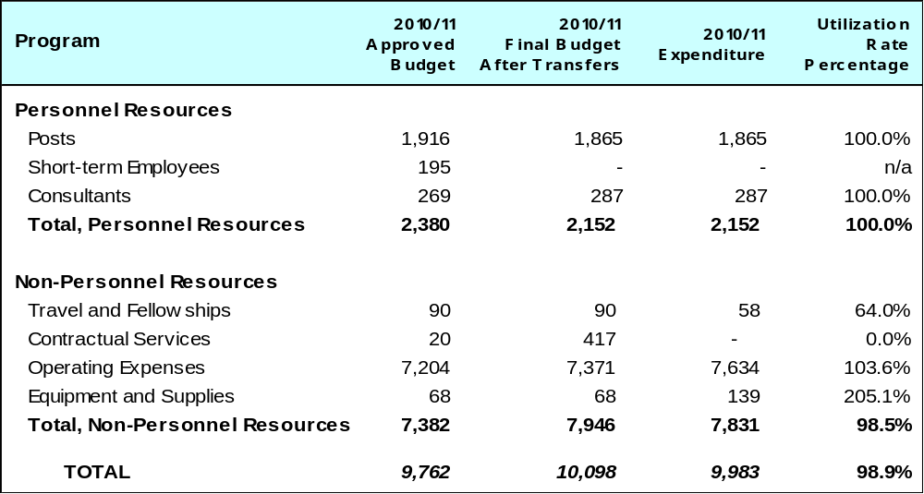

A. Budget after Transfers 2010/11

The budget after transfers 2010/11 compared to the approved budget 2010/11 reflects an increased budget of 564,000 Swiss francs due to the absorption of the overall responsibility for the management of all safety and security maintenance related contracts that were previously managed by Program 24. In addition, the Organization took occupancy of the New Building premises in March 2011, which required additional physical uniformed security posts and extended hours to temporarily cover the additional tasks associated with the move.

B. Budget Utilization 2010/11

Budget utilization of non-personnel resources amounted to 98.5 per cent, which included the additional funds transferred in 2011.

PROGRAM 29 NEW CONSTRUCTION

Program Manager Mr. A. Sundaram

ACHIEVEMENTS IN THE 2010/11 BIENNIUM

During the biennium, the New Construction Project progressed well towards completion despite the
non-delivery by the General Contractor in a number in areas by the contractual date of October 2010 and a subsequently agreed postponed delivery date of November 2010. Interior fittings, testing and validation of utilities, safety and security features were completed with delay at the beginning of 2011. As a consequence, the application for the occupation permit was only obtained in March 2011. Nevertheless, a number of preparations for moving employees from rented premises (P&G and CAM Buildings) to the New Building could start before the end of 2010 to ensure that the P&G Building would be vacated by the contractual termination date of August 2011 without additional cost to WIPO. All moves to the New Building took place between March and June 2011. The largest rented building, the P&G Building, was vacated and the lease terminated, as planned, at the end of August 2011.

The Construction Committee, the Internal Project Monitoring Team, the Pilot, the Architect and the WIPO-mandated agents synchronized their efforts towards the objective of ensuring that the New Building was completed within budget while not jeopardizing the quality of the works. As at the end of 2011, the Project was within the approved budget (comprising the consolidated basic budget and the Contingency Provisions for a total amount of approximately 162 million Swiss francs), noting that a number of payments would still have to be made in 2012. As a consequence, the closing of the accounts with respect to the New Construction Project could not be completed at the end of 2011.

In view of the delays in delivering certain areas in 2010, a financial compensation was obtained by WIPO from the General Contractor following negotiations carried out until mid-2011, for a total amount of 2,225,000 Swiss francs.

The approved budget was not fully utilized, leaving an uncommitted and unspent amount of about
2.4 million Swiss francs in the consolidated basic budget and another 2.1 million Swiss francs from the Provision for Miscellaneous and Unforeseen. The compliance with the required quality of works has been one of the causes of the postponed delivery of the new building since the Secretariat, together with the Architect and Pilot, refused to accept unsatisfactory deliveries merely to meet contractual deadlines. As a consequence, the project timeline has not been fully respected, but without serious negative impact on the occupation of the New Building and no impact on the termination of the lease of the largest rented premises (the P&G Building), which would otherwise have cost an extra year of rental of about 7 million Swiss francs.

In view of the fact that the General Contractor continued to experience delays in completing its work and attending to all required corrections, discussions were initiated by WIPO in May 2011, and have been ongoing since between WIPO and the General Contractor, in order to agree on a mechanism to move forward towards full completion of the Project and full delivery of the New Building by the Contractor.

During the biennium, all the preparatory steps for the execution phase of the New Conference Hall Project (including the new conference hall per se, modifications to three floors of the main AB Building and the new main access center to the WIPO campus) were completed. In 2010, the Selection Board composed of representatives of Member States pre-selected three companies, which were invited in June 2010 to submit a tender as general contractor for the Project. In October 2010, proposals were received from two companies. In December 2010, evaluations were presented to the Board by the WIPO Evaluation Team and the Pilot. The final selection was made by the Board in February 2011 on the basis of a joint recommendation by the WIPO Team and the Pilot and the contract was signed at the end of May 2011.

Since the price offered by the selected general contractor was higher than the estimated approved budget, the contract included options in order to secure unit prices whilst guaranteeing that the Client would be able to exercise one or more of the options only after submission to the PBC and the Assemblies of Member States, for their approval, of a proposal for an additional budget line to utilize funds which had been approved for the New Construction Project, but which would not be needed and therefore not spent for that Project (see above). The PBC recommended and the Assemblies approved the proposal at their respective sessions in September 2011, the result of which was that an additional amount of up to 4.5 million Swiss francs was authorized for the New Conference Hall Project.

The worksite opened mid-August 2011, and the excavation and main structural works, which represented the bulk of the work, were ongoing until end-2011.

PERFORMANCE DATA

Expected Result: Construction work on time and within the budgetary limits
Performance Indicators | Baselines | Performance Data | TLS
Monitor timeliness of construction work:  - New construction phase timetable for period January to October 2010 | n/a | New building was almost completed by mid-2011 through deliveries in installments since November 2010. Certain parts remained to be completed and delivered in 2012 | Fully Achieved
Monitor budgetary envelope for the new construction and as approved by the Member States | n/a | Expenditure was well within the budgetary limits at the end of 2011, leaving a total uncommitted and unspent amount of 4.5 million Swiss francs | Fully Achieved
Expected Result: Construction work in accordance with required quality levels and UN-H-MOSS standards
Performance Indicators | Baselines | Performance Data | TLS
Acceptance by the Pilot and the Construction Committee of the choice by the general contractor of construction materials and methods in accordance with the required quality levels and UN H-MOSS security standards selected by WIPO | n/a | Compliance with required quality standards was closely monitored by the Pilot and the Construction Committee, which in some cases caused delays  Compliance with UN H-MOSS security standards selected by WIPO was monitored and achieved for interior security measures  The peripheral measures were reviewed for implementation as from end 2011 in the context of a global review of peripheral measures for all WIPO buildings in cooperation with the Host Country and FIPOI | Fully Achieved

BUDGET AND ACTUAL EXPENDITURE

Actual Expenditures (personnel and non-personnel) vs. Budget after Transfers 2010/11
(in thousands of Swiss francs)
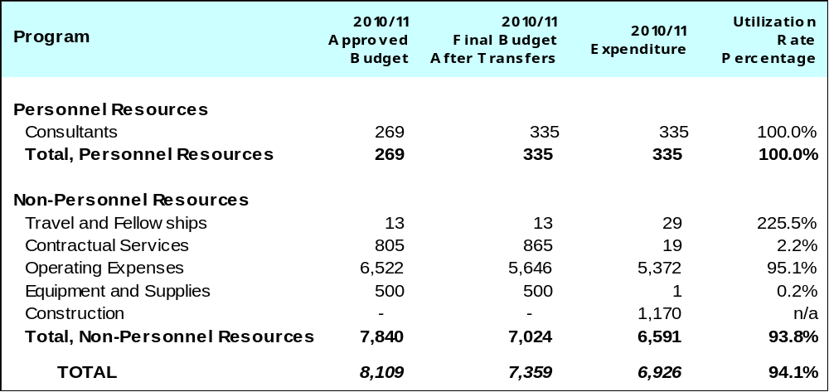

A. Budget after Transfers 2010/11

The budget after transfers 2010/11 compared to the approved budget 2010/11 reflects a decrease due to lower than anticipated loan interest payments related to the new building.

B. Budget Utilization 2010/11

The resource transfer out of the Program in year one of the biennium recognized the potential delay in the loan drawdowns for the New Construction Project. However, due to favorable interest rates towards the end of the second year of the biennium, the decision was taken to draw down funds against the available loan, but the overall volume of these remained below the levels initially foreseen for 2011, thereby requiring lower interest payments overall.

[Appendix I follows]

APPENDIX I

REPORT ON DEVELOPMENT EXPENDITURES 2010/11

The Program and Budget 2010/11 (Table 11) provided an estimate of the resources for development activities across the Organization in the biennium. The purpose of this Annex is to report on actual development expenditure by Program.

A comprehensive estimation of development expenditure was introduced for the first time in the revised Program and Budget 2008/09. During the past biennia, the Secretariat has continued to refine the development expenditure methodology and to work on establishing appropriate expenditure tracking mechanisms. The 2010/11 methodology was, as in 2008/09, based on high level estimations at the Program level, whereas the approach has been considerably refined in the Program and Budget 2012/13 based on a detailed bottom-up activity-level approach. This revised approach for 2012/13, complemented by the establishment of development expenditure tracking mechanisms through the ERP, is expected to lead to a more refined reporting on development expenditure in the upcoming biennia as compared to the high level estimations at the level of Programs applied in 2010/11.

The table below provides an overview of the estimated development expenditure by Program (columns 1 and 2) and actual expenditure (column 3). The table excludes the actual expenditure related to the implementation of Development Agenda (DA) projects which amounted to 3,030 million Swiss francs in the biennium 2010/11 (for DA projects financed under the regular budget). For further information on the development related results achieved and on budget utilization in the biennium, please refer to the individual Program performance assessments in this report.

Development Activities Resources in 2010/11¹
(in thousands of Swiss francs)

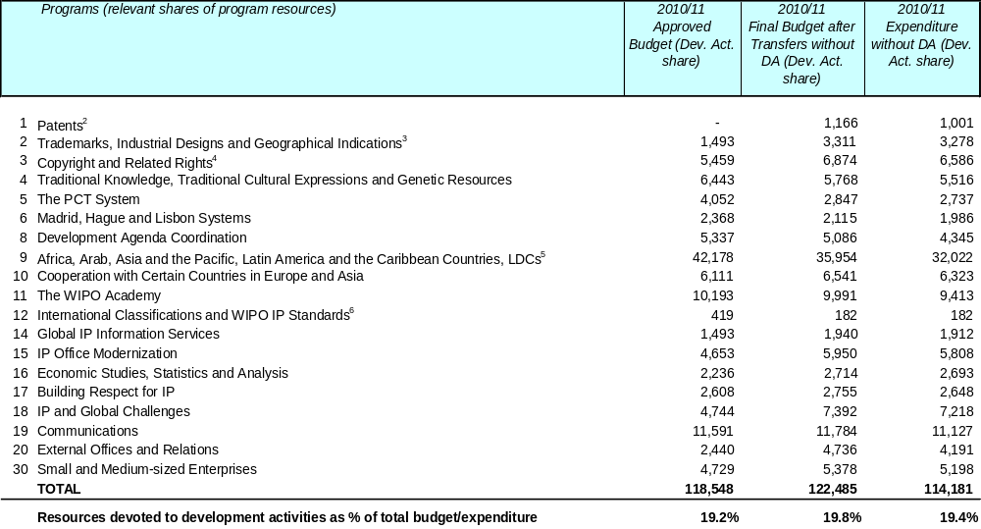

Notes:
¹ The amounts do not include funds earmarked for Development Agenda projects.
² Activities on Policy and Legislative Advice on Patents and Utility Models, originally budgeted under Program 9, were transferred to Program 1 during 2010/11. The 2010/11 Final Budget after Transfers and 2010/11 Expenditure reflect this transfer accordingly.
³ Activities on Legislative Policy Advice on Trademarks, originally budgeted under Program 9 were transferred to Program 2 during 2010/11. The 2010/11 Final Budget after Transfers and 2010/11 Expenditure reflect this transfer accordingly.
⁴Activities on Copyright Development Services, originally budgeted under Program 9 were transferred to Program 3 during 2010/11. The 2010/11 Final Budget after Transfers and 2010/11 Expenditure reflect this transfer accordingly.
⁵Activities on Legislative Policy Advice and Copyright Development Services, originally budgeted under Program 9, were transferred to Programs 1, 2 and 3 during 2010/11. The 2010/11 Final Budget after Transfers and 2010/11 Expenditure reflect these activities under the receiving programs.
⁶Activities on IP Information Services for Developing Countries, originally budgeted under Program 12, were transferred to Program 14 during 2010/11. The 2010/11 Final Budget after Transfers and 2010/11 Expenditure reflect this transfer accordingly.

In the case of certain Programs, the full amount of resources allocated was considered to be devoted to development activities (see below), while in the case of others, only a share of the Program’s resources were earmarked specifically for development.

The Programs fully dedicated to development comprise: Program 8 - Development Agenda Coordination; Program 9 - Africa, Arab, Asia and the Pacific, Latin America and the Caribbean Countries, LDCs; Program 10 - Cooperation with Certain Countries in Europe and Asia; Program 11 - WIPO Academy; Program 15 – IP Office Modernization; Program 17 - Building Respect for IP; and Program 30 – Small and medium-sized Enterprises.

The Programs partially dedicated to development comprise:

- Program 1 – Patents: Development activities undertaken by this Program included legislative and policy advice to developing countries regarding patents and utility models and support in relation to flexibilities which were assigned to the Program in 2010. It should be noted that in addition to the 2010/11 development expenditure indicated for Program 1, some 407.2 thousand Swiss francs were spent in support of the participation of developing country delegations in the meetings of the SCP.

- Program 2 - Trademarks, Industrial Designs and Geographical Indications: Development activities undertaken by Program 2 included support to developing country delegations to participate in meetings of the Standing Committee on the Law of Trademarks, Industrial Designs and Geographical Indications (SCT) and legislative and policy advice on trademarks, industrial designs and geographical indications which were assigned to this Program during 2010. It should be noted that in addition to the 2010/11 development expenditure indicated for Program 2, some 384.5 thousand Swiss francs were spent in support of the participation of developing country delegations in the meetings of the SCT.

- Program 3 - Copyright and Related Rights: Development activities undertaken by Program 3 included: support to developing countries in the use of copyright in the digital environment; collective management of copyright and related rights; and creative industries. Copyright-related development activities were assigned to this Program in 2010. In addition to the 2010/11 development expenditure indicated for Program 3, some 503.3 thousand Swiss francs were spent in support of the participation of developing country delegations in the meetings of the SCCR.

- Program 4 - Traditional Knowledge, Traditional Cultural Expressions and Genetic Resources: Development activities undertaken by Program 4 included: (i) support of participants from developing countries in member-driven norm-setting activities, in particular in relation to the acceleration of the IGC process on the protection of genetic resources, traditional knowledge and folklore; and (ii) specialist capacity building activities, taking into account the priorities and the special needs of developing countries.

- Program 5 - The PCT System: Development activities undertaken by Program 5 related to the activities of the PCT International Cooperation Division including training activities and seminars for Offices in developing countries and LDCs, as well as universities and research institutions. Technical cooperation activities focused on the electronic exchange of documents and data between the International Bureau and Offices.

- Program 6 - Madrid, Hague and Lisbon Systems: Development activities undertaken by Program 6 focused on legal assistance, training activities as well as information and promotional work, including: (i) provision of advice to governments of developing countries before or following accession to one of the registration treaties; (ii) enabling representatives of developing countries to participate in working groups; and (iii) pre- and post accession training activities.

- Program 12 - International Classification and WIPO Standards: Development activities undertaken by Program 12 included training activities in several developing countries in the use of International Classifications.

- Program 14 – Global Information Services: Development activities undertaken by Program 14 included activities related to the “Access to Specialized Patent Information” (ASPI) and “Access to Research for Development and Innovation” (ARDI) projects aimed at making a number of commercial databases accessible for free, or at a preferential rate, in developing countries and LDCs.

- Program 16 – Economic Studies, Statistics and Analysis: Approximately 75 per cent of the Program’s resources were estimated to be devoted to development activities including both statistical and economic analysis work.

- Program 18 - IP and Global Challenges: development activities undertaken by Program 18 included: (i) establishment of WIPO Re:Search providing royalty-free access to IP assets to stimulate new R&D for neglected tropical diseases, tuberculosis, and malaria, (ii) mainstreaming the health, bio-ethics, environmental, and food security aspects of development considerations into WIPO’s substantive and technical assistance activities and debates; and (iii) enhancing Member States’ innovation and technology transfer support systems as well as strengthening professional skills in the field of IP asset management, including patent drafting and technology management, IP valuation, marketing, commercialization and licensing.

- Program 19 - Communications: Development activities undertaken by Program 19 included: translation of various publications; WIPO outreach tools and materials delivered to IP Offices and other stakeholders used inter alia for the development of public awareness campaigns; the IP Advantage database of IP success stories; WIPO Awards to inventors and creators in developing countries and LDCs; The Innovative Solutions in Everyday Life competitions which promoted the use of patent information for innovation; publication of the Magazine which content, inter alia, promotes the use of IP for development; the production of films dealing with subjects in developing countries; the organization of the World IP Day, and the promotion of development activities on the WIPO website.

- Program 20 - External Office and Relations: Development activities undertaken by Program 20 included activities implemented by the WIPO Singapore and Rio Offices as well as activities related to NGOs and partnerships.

[Appendix II follows]

APPENDIX II

IMPLEMENTATION OF FUNDS-IN-TRUST 2011

As part of the efforts to enhance the integration of all activities under the results-based management framework of the Organization, irrespective of the source of funds, this Appendix provides, for the first time, an overview of activities implemented under the WIPO Funds-in-Trust (FIT/s). At the same time, this report responds to a request by donors for a more comprehensive report on all Funds-in-Trust, including both programmatic and financial information. In order to streamline reporting, the FIT report is an integral part of the Program Performance Report 2010/11, but covers activities implemented in 2011 only. The next annual FIT report will be included in the PPR for 2012. This annex reports on the FIT/s listed in the table below and excludes the FITs for Junior Professional Officers (JPOs).

FUND-IN-TRUST | IMPLEMENTING SECTOR
EU/Bangladesh | Development Sector
EU/Pakistan | Development Sector
Finland Copyright I | Culture and Creative Industries Sector
Finland Copyright III | Culture and Creative Industries Sector
France IP | Development Sector
Italy Intellectual Property | Development Sector
Japan Copyright | Culture and Creative Industries Sector
Japan IP | Development Sector
Japan IP/Africa | Development Sector
Portugal | Development Sector
Republic of Korea Copyright | Culture and Creative Industries Sector
Republic of Korea IP | Development Sector
Spain | Development Sector
US Copyright | Culture and Creative Industries Sector
US IP/Enforcement | Global Issues Sector
US SME | Global Issues Sector
EUROPEAN UNION (Bangladesh Project)

 | RESULT: Tailored and balanced IP legislative, regulatory and policy frameworks
 | Activity | Date | Host Country/  Recipients |  |  | Purpose(s)/Description(s)
 | National Study on the Use of IP as a Tool for Economic Development in Bangladesh  merged with a  National Study on IP for SMEs | April 2010 to June 2011 | Bangladesh |  |  | To avoid duplication of coverage these two studies were merged. The study focused on the protection and use of IPRs in Bangladesh, with special emphasis on economic sectors that mainly contribute to export earning and account for industrial development in the country. Specific objectives were: (i) awareness of SMEs of IP issues and how IPRs can add value to their businesses; (ii) how Bangladesh can transform its rich natural and human resources into value added national IP assets; and (iii) commercialization of IP.
 | RESULT: Enhanced human resources capacities able to deal with the broad range of requirements for the effective use of IP for development in developing countries, LDCs and countries with economies in transition
 | Activity | Date |  | Host Country/  Recipients | Purpose(s)/Description(s)
 | National Workshop on Copyright and Collective Management | June 19 and 20, 2011 |  | Bangladesh  36 participants from the entertainment and creative industries and 15 government officials | To: (i) creative awareness among stakeholders on the protection of copyright and related rights, and the collective management of these rights and (ii) provide update on CR to right holders and users, to facilitate introduction of collective management in Bangladesh.
 | Roundtable on a Structured Enforcement Approach in the Private Sector | April 18, 2011 |  | Bangladesh  15 industry representatives and 5 senior government officials | To build the foundations for effective cooperation within the private sector on the enforcement of IPRs. Discussions addressed the impact of counterfeiting and piracy on the respective industries; the costs to the right holders to address this phenomena; industry assistance to law enforcement agencies involved in the enforcement of IP rights; and the establishment of a body to represent the interests of the respective industries in a structured enforcement approach at the national level.
 | Roundtable on a Strategic Enforcement Approach at the National Level | April 18, 2011 |  | Bangladesh  20 representatives from private sector and senior officials from customs, police, public prosecution, judiciary, Bureau of standards and drug administration | To enhance: (i) cooperation and the sharing of information; (ii) capacity building, and (iii) public awareness. The need to establish a national enforcement strategy to combat counterfeiting and piracy, comprising elements comprising to both public and private sector, was identified and discussed.
 | RESULT: Enhanced technical and knowledge infrastructure for IP Offices and other IP institutions leading to better services (cheaper, faster, higher quality) to their stakeholders
 | Activity | Date | Host Country/  Recipients |  | Purpose(s)/Description(s)
 | Collection and digitization of IP data | From 2010 to 2011 | Bangladesh |  | Conversion of paper files to an electronic format was a requirement for the automation of the Department of Patents, Designs and Trademarks (DPDT). Patent and design files have been captured.
 | Initial Assistance to Conduct Teaching Sessions | May 22 to 26, 2011 | Bangladesh  Dhaka University students |  | After developing appropriate IP curriculum for law and engineering faculties in Bangladesh, lectures on IP issues were given at Dhaka University.
RESULT: Facilitating the use of IP for Development
Activity |  | Date | Host Country/  Recipients |  | Purpose(s)/Description(s)
Customization/ Translation/Printing of Selected WIPO Publications |  | November 2009 to April 2011 | Bangladesh |  | To: (i) improve capacity of national IP authorities to undertake awareness building activities; (ii) enhance public awareness of basic concepts of IP and (iii) to increase awareness of SMEs and SME support institutions on IP assets management

EUROPEAN UNION (Bangladesh Project) Donor Contributions and Expenditure in 2011¹

Balance as of December 31, 2010 | Income 2011 | Expenditure 2011 | Reimbursements | Balance as of December 31, 2011
508,834 | -13,867 | 150,295 | 0 | 344,673
¹ WIPO Financial Statements 2011 (Annex III)

EUROPEAN UNION (Pakistan Project)

RESULT: Tailored and balanced IP legislative, regulatory and policy frameworks
Activity | Date | Host Country/  Recipients | Purpose(s)/Description(s)
Participation (via video-conferencing) in a Public Private Dialogue (PPD) on Services Sector Export Development Strategy for Pakistan | October 27, 2011 | Pakistan  Over 115 participants from Pakistan's public and private sectors as well as from civil society | To: (i) assist in defining policy recommendations on domestic regulatory reform for the development of services trade in Pakistan; (ii) focus on the IP aspects of the PPD Session on “Computer and Related Services (CRS)”; (iii) offer an opportunity for participants to understand how IP policies, strategies, systems and enforcement mechanisms can be strengthened and exploited to help the CRS sector boost its exports, which is currently much below its potential
Training on Geographical Indications (GIs) | October 17 to 28, 2011 | Pakistan  4 IPO Pakistan officials | To: (i) build capacity of IPO Pakistan on GI registration; (ii) impart knowledge on existing practices in other countries; (iii) share country experiences; and (iv) identify challenges in implementing GI registration
Participation (via video-conferencing) in a Public Private Dialog (PPD) on Regional Trade with Economic Cooperation Organization (ECO) countries in textile made-ups and light engineering sectors | December 21, 2011 | Pakistan  Representatives from various government departments, Chambers of Commerce, Federal Government Ministries, provincial associations, individual firms, independent research organizations and academia | To: (i) define policy recommendations for trade policy and attendant domestic regulatory reform for the development of regional trade with ECO countries in textile made-ups and light engineering sectors; (ii) offer an opportunity to discuss reform issues that are cross-sectoral in nature, including IP issues
RESULT: Enhanced human resources capacities able to deal with the broad range of requirements for the effective use of IP for development
Activity | Date | Host Country/  Recipients | Purpose(s)/Description(s)
Training on International IP Classification systems | September 19 to 23, 2011 | Pakistan  4 IPO Pakistan officials | To: (i) enhance knowledge on the International Patent Classification (IPC) and its effective use; (ii) use of WIPO IPC tools; (iii) search international patent databases using IPC; (iv) enhance knowledge on the effective use and application of the Nice, Vienna and Locarno international classifications
Review of patents administrative procedures and training of patent examiners | October 10 to 18, 2011 | Pakistan  Over 14 participants including patent examiners and officials of the IPO Pakistan | To: (i) review and advise on patent administrative procedures against the respective national rules and regulations and against international best practices; (ii) provide customized training for IPO Pakistan, focusing on topics identified by the patent examiners and on the challenges faced by them in their work; (iii) improve patent examiners skills in examining national and international patent applications and in interpreting the international search and preliminary examination reports
Briefings for Journalists on IP issues (part of a series of briefings planned under FIT Pakistan) | November 30, 2011 | Pakistan  About 10 representatives from Pakistan print and electronic media | To: (i) raise awareness about the importance of IP for economic development and business competitiveness; (ii) increase understanding amongst the general public of the key role played by IP in modern economies and its linkages with trade and development
RESULT: Enhanced technical and knowledge infrastructure for IP Offices and other IP institutions leading to better services (cheaper, faster, higher quality) to their stakeholders
Activity | Date | Host Country/  Recipients | Purpose(s)/Description(s)
Advisory mission on IT Infrastructure (Part 1) | July 5 to 22, 2011 | Pakistan | To: (i) assess organization-wide technical infrastructure of IPO Pakistan and its capacity to support the upgraded IP systems and services that would be provided under the FIT Pakistan (IPO Pakistan offices are located in Karachi, Lahore and Islamabad); (ii) focus on aspects relating to: IT strategic plan, integration of operations of the three registries, inter-office connectivity, consolidated data centre, IT equipment, core IT team, upgraded technical skills and upgraded internet connectivity
Training on digitization of IP records | September 26 to 30, 2011 | Pakistan  4 IPO Pakistan officials | To: (i) impart knowledge on different aspects of digitization, including the relevant technical standards, formats, document management systems, scanning solutions, indexing and optical character recognition (OCR); (ii) present information on available WIPO tools and systems; (iii) provide specifications of the required IT infrastructure elements to support digitization; (iv) provide hands-on practical exercises and discussions on customized solutions for IPO; (v) provide guidelines and templates for preparation of Terms of Reference required for the tendering and procurement of local contractual services for the actual digitization of IP records at IPO Pakistan
Expert mission on the design and development of an IP web portal for IPO Pakistan | November 23 to December 2, 2011 | Pakistan | To: (i) assess existing features of the IPO Pakistan website including its design, functionality, content, frequency of updates and potential for online services; (ii) assist IPO Pakistan in identifying the elements and requirements for preparing Terms of Reference (TOR) for web portal development
First Training session on IPAS Java (via video-conferencing) | December 7, 2011 | Pakistan  4 IPO Pakistan officials | To: (i) impart knowledge on the basic configuration and installation of a test version of the new IPAS Java system; (ii) provide hands-on practical exercises; (iii) resolve problems encountered; (iv) review IP business procedures workflow diagrams

EUROPEAN UNION (Pakistan Project) Donor Contributions and Expenditure in 2011¹

Balance as of December 31, 2010 | Income 2011 | Expenditure 2011 | Reimbursements | Balance as of December 31, 2011
0 | 473,515 | 118,932 | 0 | 354,583
¹ WIPO Financial Statements 2011 (Annex III)

FINLAND/ COPYRIGHT I and III

RESULT: Evidence-based decision making on copyright issues
Activity | Date | Host Country/  Recipients | Purpose(s)/Description(s)
Development of methodologies to assess the broader impact of copyright on creative industries | January 2010 to December 2011 | All WIPO Member States | To provide guidelines on measurement procedures to assess economic, social and cultural impacts of copyright in creative industries, thus providing a basis for sound policy-making
RESULT: Enhanced human resources capacities able to deal with the broad range of requirements for the effective use of IP for development in developing countries, LDCs and countries with economies in transition
Activity | Date | Host Country/  Recipients | Purpose(s)/Description(s)
Awareness building and training activities | September 2010 to  May 2011 | China, Trinidad and Tobago  1,600 people | To enhance knowledge of stakeholders in creative industries to understand and manage their copyright in specific creative industries

FINLAND/ COPYRIGHT I and III Donor Contributions and Expenditure in 2011¹

Balance as of December 31, 2010 | Income 2011 | Expenditure 2011 | Reimbursements | Balance as of December 31, 2011
17,796 | -368 | 1,994 | 0 | 15,434
152,207 | 45,322 | 30,436 | 0 | 167,093
¹ WIPO Financial Statements 2011 (Annex III)

FRANCE/ INDUSTRIAL PROPERTY

RESULT: Enhanced Institutional capacity building of senior officials and professionals of LDCs on IP and the use of IP for technological, economic, social and cultural development
Activity | Date | Host Country/  Recipients | Purpose(s)/Description(s)
6th Global Congress on Combating Counterfeiting and Piracy | February 2 and 3, 2011 | Host Country: France/ Recipient Countries: 870 attendants from 105 countries among which Ministers and high level speakers from around the world  870 participants from 105 countries | The meeting was organized by the Global Congress Steering Group comprised of WIPO, Interpol and WCO as well as by the private sector partners, the BASCAP and UNTA. It aimed at further building international cooperation to enhance concerted actions to successfully confront the challenges posed by the worldwide problem of Counterfeiting and Piracy
RESULT: Enhanced human resources capacities able to deal with the broad range of requirements for the effective use of IP for development in developing countries, LDCs and countries with economies in transition
Activity | Date | Host Country/  Recipients | Purpose(s)/Description(s)
Subregional Training Seminar on IP for Magistrates from OAPI Member States and other French-speaking countries | November 9 to 11, 2011 | Gabon  40 participants from Benin, Burkina Faso, Burundi, Cameroon, Central African Republic, Chad, Comoros, Congo, Côte d’Ivoire, Guinea, Madagascar, Mali, Mauritania, Niger, Rwanda, Togo | To provide magistrates from OAPI Member States and other French-speaking countries a platform for exchange on recent IP developments, enforcement procedures and how to fight against the counterfeiting and piracy phenomena

FRANCE/ INDUSTRIAL PROPERTY Donor Contributions and Expenditure in 2011¹

Balance as of December 31, 2010 | Income 2011 | Expenditure 2011 | Reimbursements | Balance as of December 31, 2011
813,387 | 297,907 | 823,449 | 0 | 287,845
¹ WIPO Financial Statements 2011 (Annex III)

ITALY INTELLECTUAL PROPERTY

RESULT: Enhanced human resources capacities able to deal with the broad range of requirements for the effective use of IP for development in developing countries, LDCs and countries with economies in transition
Activity | Date | Host Country/  Recipients | Purpose(s)/Description(s)
LL.M IP, University of Turin | June 1, 2011 to February 28, 2012 | Italy / Azerbaijan, Bangladesh, Brazil, Cambodia, Ecuador, Haiti, Iran, Jordan, Kenya, Mozambique, Russia, Uganda and Pakistan | To train trainers in IP and increase availability of IP law teachers at university level world wide through the sponsoring of 13 graduate students and teachers in the LL.M IP program with the University of Turin.
RESULT: Increased understanding / capacity of SMEs and SMEs support institutions to successfully use IP to support innovation and commercialization
Activity | Date | Host Country/  Recipients | Purpose(s)/Description(s)
Book on IP and Agrofood | Work in progress | n/a  All | This guide aims to demonstrate the relevance of IP for the competitiveness of SMEs of the agro food sector as well as assist the SME support institutions that work within the agro food sector to integrate IP into their assistance.

ITALY INTELLECTUAL PROPERTY Donor Contributions and Expenditure in 2011¹

Balance as of December 31, 2010 | Income 2011 | Expenditure 2011 | Reimbursements | Balance as of December 31, 2011
326,508 | 394 | 185,084 | 0 | 141,817
¹ WIPO Financial Statements 2011 (Annex III)

JAPAN/AFRICA- LDCs

RESULT: Enhanced Institutional capacity building of senior officials and professionals of LDCs on IP and the use of IP for technological, economic, social and cultural development
Activity | Date | Host Country/  Recipients | Purpose(s)/Description(s)
Study Program on Innovation and Transfer of Technology | April 11 to 15, 2011 | Morocco  11 participants from 11 African countries |  | To provide an opportunity to senior officials of Member States that have developed or are in process of developing innovation support centers to undertake a study visit of technology, IP and innovation of more advanced African countries (IP office, Technopark, incubators, start ups, etc.) and discuss experiences, best practices and policy options
Policy Forum on partnership between WIPO, Japan Patent Office (JPO) and the African Regional Economic Communities (RECs) on Leveraging IP for Economic Development | May 10 to 12, 2011 | Zambia  30 participants from 14 African countries |  | Recognizing the growing importance of Regional Economic Communities (RECs) in policy making and implementation in the field of industry, commerce and culture in Africa, the objective of the Forum was to provide a platform for exchange, dialogue and synergies between senior officials from RECs, and high level officials of countries of the region in charge of IP policy including heads of Intellectual Property (IP) offices, on IP and innovation policy issues and their impact on economic, social and cultural development
Study Program on Innovation and Transfer of Technology | November 28 to December 2, 2011 | Tunisia  18 participants from 11 African countries |  | To: (i) provide an opportunity to senior officials of Member States that have developed or are in the process of developing innovation support centers to undertake a study visit in Technology, IP and in innovation awareness in the context of a more technology advanced African country; (ii) to learn about the use of patent information and innovation support services to local users and scientists; (iii) share best practices of effective management of Intellectual Property Rights and on how to derive the maximum benefits from the Intellectual Property system; (iv) provide research services for universities, research and development (R&D) institutions; and (v) visit Techno parks and innovation centers
RESULT: Enhanced human resources capacities able to deal with the broad range of requirements for the effective use of IP for development in developing countries, LDCs and countries with economies in transition
Activity | Date | Host Country/  Recipients | Purpose(s)/Description(s)
Study Program on Human Resource Development in the Field of Industrial Property Tokyo | February 2 to 4, 2011 | Japan  13 Participants from 13 Member States (of which three from the following African countries: Algeria, Ethiopia and Zimbabwe |  | To: (i) learn about the policy and strategic approaches to human resource development in the field of industrial property, including in Japan; (ii) identify emerging needs and roles of IP academies and training units by sharing recent developments and experiences of such institutions; and (iii) exchange views on possible cooperation among such institutions to better respond to actual needs

Regional Training Program for Small and Medium-sized Enterprises (SMEs), Support Institutions, or Entrepreneurs, on Intellectual Property and Business Competitiveness in agro and food processing industries | February 22 to 25, 2011 | Burkina Faso  14 participants from 9 African countries |  | To: (i) raise awareness and encourage the use of intellectual property assets as part of policies of innovation and marketing in the agribusiness sector of the OAPI member states (ii) provide training of SME support institutions (chambers of commerce and agriculture, universities, research institutions) on the effective strategic use of IP system to increase the competitiveness of SMEs with particular emphasis on agro business and processing industries; (iii) provide a platform for discussions for the participants on issues of IP
Seminar on the strategic use of Intellectual Property (IP) and Competitive Intelligence (CI) for the development of clusters and to enhance the competitiveness of the export agricultural based products | May 6, 2011 and May 17, 2011 | Cameroon and Mali  Selected nationals from relevant institutions, Research centers and producers from the agricultural sectors |  | To: (i) assist selected SMEs to use Competitive Intelligence especially based on IP information to identify niche markets for innovative products; and (ii) to examine the possibility of collective branding through use inter alia, Geographical indications, Collective marks and certification marks (Pineapple and Coffee producers in Cameroon, and Gum Arabic, Shea nut trees and Mango in Mali)
Workshop on the Social and Economic consequences of counterfeiting and other IP rights infringements | May 23 to 25, 2011 | Burundi  A total of 70 participants (13 foreign and 57 local) from the five East African Community (EAC) countries (Burundi, Kenya, Rwanda, Uganda and the United Republic of Tanzania) including 2 self-sponsored senior enforcement officials from Kenya |  | To enhance the understanding of the East African Community’s judiciary, customs and other law enforcement officials and public prosecutors on IP
Partnership between WIPO/OAPI (Denis Ekani Training center) and the University of Yaoundé II - Master in Intellectual Property Law (MIP) | The program started on October 4, 2010 with Distance learning segment. The residential part took place from February 1, 2011 to May 28, 2011 | Cameroon  10 participants from 5 African Countries |  | To provide general and specialized IP training for government officials and IP professionals, in cooperation with OAPI and other regional educational institutes and provide opportunities for human resource development and capacity building through IP training and teaching for persons engaged in teaching and research on IP at universities and other institutions
RESULT: Enhanced technical and knowledge infrastructure for IP Offices and other IP institutions leading to better services (cheaper, faster, higher quality) to their stakeholders
Activity | Date | Host Country/  Recipients | Purpose(s)/Description(s)
Provision of Equipment | Dispatched on May 29, 2011: Madagascar and Namibia; May 27, 2011: Tanzania; October 18, 2011:OAPI | Madagascar, Namibia, United Republic of Tanzania and OAPI |  | To assist national IP Offices in increasing the efficiency of procedures for the grant of industrial property rights and streamlining IP administration through rationalization of administrative procedures, utilization of technology and office automation
Workshop on Intellectual property and Patent Search Strategies | February 21 to 24, 2011 | Morocco  41 local participants |  | To provide training to staff of Technology and Innovation Support Centers (TISCs)

WIPO Regional Seminar for Heads of Intellectual Property Offices (IPOs) in ARIPO Member States on Realizing the development potential of ICT-Based Business Services | May 18 to 20, 2011 | Zimbabwe  33 participants from 17 African countries | To: (i) bring together Heads and Senior Managers of IP Offices in ARIPO Member States so as to interact, share and expand their knowledge through examining the IT project’s technical, economic, institutional and management aspects as well as potential operational impact; (ii) deepen the understanding of the benefits of information systems and increase participation by Heads and Senior Managers on regional development efforts of technical infrastructure; (iii) share methodologies and experiences of effective change management to sustain new business operations, and (iv) enhance the knowledge on regional/global infrastructural development programs
Seminar on Innovation Support through Access to Technological Knowledge and the establishment of Technology and Innovation Support Centers (TISCs), ARIPO Member States | June 28 to 30, 2011 | Zimbabwe  50 officials from 22 African countries | To promote patent and technology information retrieval from patent and non-patent databases, demonstrate the practical advantages of using intellectual property (IP) information and exchange experience in developing innovation support networks in countries in developing and least developed countries in Africa with ARIPO and its members states
Training on Patent Search Strategies and Techniques | July 13 to 15, 2011 | Nigeria  101 local participants | To enable the Technology and Innovation Support Center personnel as well as stakeholders from research centers, universities, associations of inventors, and SMEs to carry out patent and non-patent searches to retrieve patent information and non patent literature
Training on Patent Search Strategies and Techniques | August 24 to 28, 2011 | Democratic Republic of the Congo  Over 100 local participants attended the workshop | To strengthen capacities of participants who received the initial training on patent information and non patent literature in April 2011
Workshop on Business Services Development for ARIPO and ARIPO Member States | October 3 to 7, 2011 | Zimbabwe  21 participants from 14 African countries | To: (i) build technical skills of those supporting and maintaining the IPAS and WIPOScan automation systems in the ARIPO Member States; (ii) deepen the understanding of the architecture system of both systems; (iii) build a regional support network for the system; and (iv) share knowledge and experiences on IPAS/WIPOScan support and troubleshooting in the region
Seminar on Intellectual Property and Patent Information Search Strategies | November 14 to 16, 2011 | Algeria  Over 75 local participants including TISCs personnel, diverse stakeholders from selected Ministries, research centers, universities, technical schools, inventors’ associations, SMEs, NGOs and other local institutions | To strengthen capacities of participants, who received the initial training on patent information and non-patent literature from 13 to 15 July 2010

JAPAN/AFRICA- LDCs Donor Contributions and Expenditure in 2011¹

Balance as of December 31, 2010 | Income 2011 | Expenditure 2011 | Reimbursements | Balance as of December 31, 2011
1,553,267 | 1,114,593 | 1,149,401 | 0 | 1,518,459
¹ WIPO Financial Statements 2011 (Annex III)

JAPAN/ COPYRIGHT

RESULT: Increased awareness and capacity of Member States in copyright and related rights
Activity | Date | Host Country/  Recipients | Purpose(s)/Description(s)
WIPO Regional Meeting on Copyright and Related Rights for Heads of Copyright Offices in Asian Countries | October 11 to 13, 2011 | Japan  20 participants from 19 countries | To: (i) exchange views and information on policy and strategy considerations relating to copyright and related rights; (ii) exchange views and experiences in strengthening the copyright infrastructures and capacities; and (iii) explore possible areas of cooperation among copyright offices among countries in the region
National Seminar on Capacity Building in the Field of Copyright and Related Rights | October 26 and 27, 2011 | Samoa  40 local participants | To assist in strengthening the capacity of developing countries to promote their economic and cultural prosperities by effective use of the copyright system
Study Visit to Collective Management Organizations | October 24 to 28, 2011 | Japan  6 participants from 3 countries | To: (i) deepen the knowledge and understanding of the participants on collective management issues; and (ii) develop and improve the skills and capacity of the participants to manage collective management organizations in the field of copyright and related rights
National Seminar on Copyright and Related Rights | November 7 and 8, 2011 | Lao People's Democratic Republic  50 local participants | To promote better awareness and understanding of copyright and related rights with special emphasis on the Berne Convention for the Protection of Literary and Artistic Works
Consultation Meeting for the Production of a Handbook on Copyright in the Nepali Language | November 28, 2011 | Nepal  15 local participants | To produce a handbook on copyright in the local language based on the WIPO publications on copyright for greater understanding and awareness on copyright and related rights among the public
National Seminar on Copyright and Related Rights | November 29 and 30, 2011 | Nepal  60 local participants | To promote better awareness and understanding of copyright by discussing the current situation and issues regarding copyright protection

JAPAN/ COPYRIGHT Donor Contributions and Expenditure in 2011¹

Balance as of December 31, 2010 | Income 2011 | Expenditure 2011 | Reimbursements | Balance as of December 31, 2011
529,903 | 469,738 | 495,596 | 0 | 504,045
¹ WIPO Financial Statements 2011 (Annex III)

JAPAN/ INDUSTRIAL PROPERTY

RESULT: Clearly defined and coherent national innovation and IP policies, strategies and development plans consistent with national development goals and objectives
Activity | Date | Host Country/  Recipients | Purpose(s)/Description(s)
Expert Mission | March 2 to 4, 2011 | Malaysia | To perform a Needs Assessment for the Development of Information and Communication Technology (ICT) Strategic Planning
WIPO Regional Forum on University – Industry Collaboration to Promote Technology Transfer | November 2 to 4, 2011 | Viet Nam  28 participants from 10 countries | To: (i) identify the challenges in establishing and managing viable technology transfer systems; (ii) examine different models for research collaboration between universities and industries; and (iii) provide policy makers, intellectual property (IP) managers of Technology Management Offices (TMOs) in universities/public research institutions, and representatives from industries with an opportunity to exchange views on measures necessary to initiate and sustain technology transfer, with a particular reference to green technologies
WIPO Regional Workshop for the Least Developed Countries of Asia and the Pacific Region on the Use of Intellectual Property for Enhancing Economic Competitiveness and Development | December 15 and 16, 2011 | Bhutan  13 participants from 7 countries with 24 local participants | To: (i) raise awareness about the importance of intellectual property (IP) for economic growth and business competitiveness; (ii) share knowledge and best practices to facilitate the effective use of the IP system by the business community; and (iii) identify specific measures for linking IP with national developmental policies
RESULT: Enhanced technical and knowledge infrastructure for IP offices and other IP institutions leading to better services
Activity | Date | Host Country/  Recipients | Purpose(s)/Description(s)
Provision of Equipment | June 2011 | Lao People’s Democratic Republic | To further support the migration to Industrial Property Automation System (IPAS) with the Java platform
Provision of Equipment | October 2011 | Indonesia | To: (i) reduce the burden for, and to optimize performance of, the data entry procedures of IP related documentation, including application forms, descriptions, and cited documents; and (ii) enhance efficiency of the administrative/examination processes in the IP Offices
Provision of Equipment | 2011 | Cambodia | To further support the migration to Industrial Property Automation System (IPAS) with the Java platform
RESULT: Enhanced human resources capacities able to deal with the broad range of requirements for the effective use of IP for development
Activity | Date | Host Country/  Recipients | Purpose(s)/Description(s)
Training Course on the Examination Practices of Industrial Property Basic Program | January 12 to 25, 2011 | Japan  13 participants from 10 countries | To assist the participants to acquire a basic knowledge of the laws and substantive examination procedures in the field of examination of industrial property rights through lectures, practical exercises, and case studies
Expert Mission | January 17 to 21, 2011 | Cambodia  Around 50 local participants | Training on the Nice and Vienna Classifications
Training Course on Industrial Property Administration and Management of IP Offices | January 24 to 28, 2011 | Japan  9 participants from 6 countries | To: (i) enhance the knowledge of senior managers of Intellectual Property (IP) Offices on modern practices and tools for administering IP Offices; (ii) increase the capacity of the participants to effectively administer the IP system in accordance with modern management practices; and (iii) expose the participants to management approaches that would enable IP Offices to contribute to overall national developmental policies and goals
Study Program on Human Resource Development in the Field of Industrial Property | February 2 to 4, 2011 | Japan  13 participants from 13 Member States | To: (i) enhance the knowledge of participants about the policy and strategic approaches to human resource development (HRD) in the field of industrial property, including in Japan; (ii) identify emerging needs and roles of Intellectual Property academies and training units by sharing recent experiences of such institutions; and (iii) exchange views on possible cooperation among such institutions to better respond to actual needs
Training Courses for Patent Examiners on Specified Technologies (Information and Communication Technology) | February 16 to 23, 2011 | Japan  13 participants from 6 countries | To: (i) acquaint the participants with current trends and modern practices in the examination of patents regarding Information and Communication Technology; (ii) impart practical knowledge and insights on examination methodologies; (iii) offer an opportunity to share experiences and views among participants on patent examination issues; and (iv) enhance participants’ professional capabilities for examination in the field of Information and Communication Technology
Training Courses for Patent Examiners on Specified Technologies (Automobiles) | February 24 to March 3, 2011 | Japan  12 participants from 6 countries | To: (i) acquaint the participants with current trends and modern practices in the examination of patents regarding automobiles; (ii) impart practical knowledge and insights on examination methodologies; (iii) offer an opportunity to share experiences and views among participants on patent examination issues; and (iv) enhance participants’ professional capabilities for examination in the field of automobiles
WIPO Regional Training of Trainers Program for Small and Medium-sized Enterprises (SMEs) Support Institutions | March 7 to 10, 2011 | Sri Lanka  22 participants from 14 countries with 12 local participants | To train trainers on services to be provided by SME support institutions, such as chambers of commerce, science parks, business incubators and universities, to SMEs on the effective use of the intellectual property system for business competitiveness.
Long-term Fellowship | May 8 to September 30, 2011 | Japan  1 Fellow | To enhance the knowledge and understanding of the participant on key issues in the field of industrial property, by providing her with an opportunity for independent research on subjects of her choice
Customization/ Translation/Printing of Selected WIPO Publications / IP Related Documents  - Translation of ”Intellectual Property and Traditional Knowledge” | June 2011 | Afghanistan | To: (i) improve capacity of national IP authorities to undertake awareness building activities; and (ii) enhance public awareness of basic concepts of IP
WIPO National Workshop on the Enforcement of Intellectual Property Rights (IPRs) | September 12 and 13, 2011 | Cambodia  60 local participants | To: (i) consider the impact of counterfeiting and piracy; (ii) consider the legislative framework, including procedures and remedies, within which to enforce IP rights, as well as the disposal of such goods; (iii) build capacity to improve border enforcement and market surveillance; and (iv) enhance strategic public cooperation, including private sector support
WIPO National Workshop on the Enforcement of Intellectual Property Rights (IPRs) | September 15 and 16, 2011 | Indonesia  90 local participants | To: (i) consider the impact of counterfeiting and piracy; (ii) consider the legislative framework, including procedures and remedies, within which to enforce IP rights, as well as the disposal of such goods; (iii) build capacity to improve border enforcement and market surveillance; and (iv) enhance strategic public cooperation, including private sector support
Provision of IP Reference Material | September 2011 | Lao People’s Democratic Republic | To enhance capacity of IP information center to increase understanding amongst researchers, students and the public on IP issues
Publication of anti-counterfeiting manga titled “Honmono” | September 2011 |  | To increase public awareness on health and safety risks caused by counterfeit goods
Training Course on the Examination Practices of Industrial Property  Intermediate/ Advanced Program | October 17 to 28, 2011 | Japan  16 participants from 8 countries | To: (i) equip the participants with a basic knowledge of the laws and procedures involved in the examination of industrial property rights; and (ii) provide an opportunity to the participants to exchange views on topical issues in the industrial property field
Training Course on the Use of Information Technology in Industrial Property Administration | November 7 to 18, 2011 | Japan  16 participants from 15 countries | To familiarize the participants with the implications of recent developments in information technology in relation to industrial property administration; impart practical knowledge of the use of information technology through interactive sessions using networked personal computers as well as through visits to relevant private entities; provide an opportunity to exchange views and concerns among participants on topical related issues, and thereby enhance the participants’ professional capacities in planning and managing the use of information technology in industrial property administration
WIPO Sub-regional Workshop on the Utilization of Patent Examination Results to Enhance Patent Examination Capacities and Increase the Quality of Patents | November 29 to December 1, 2011 | Malaysia  21 participants from 13 countries with 12 local participants | To: (i) provide participants with an opportunity to understand the effectiveness of utilizing search and/or examination reports prepared by other Intellectual Property Offices (IPOs) in reducing workloads in IPOs and streamlining patent obtainment procedures; (ii) develop skills to utilize services such as the International Cooperation on Examination (ICE) by WIPO and the Advanced Industrial Property Network (AIPN) by the Japan Patent Office (JPO); (iii) exchange best practices of analyzing claims and drafting amended claims in certain fields of technology; and (iv) share experiences of various IPOs and examiners on the challenges encountered in accelerating examination processes and increasing quality of patents
Training Course on the Enforcement of Intellectual Property Rights (IPRs) | December 5 to 16, 2011 | Japan  17 participants from 7 countries | To: (i) review current trends and practices in the area of IPR enforcement; (ii) examine the justification, elements, investigation, prosecution of, and liabilities for, IP crimes and infringements; (iii) analyze the roles of the law enforcement agencies and the courts, as well as right holders; and (iv) discuss various topical policy issues relating to IP enforcement
Provision of IP Reference Material | December 2011 | Cambodia | To enhance capacity of IP office to increase understanding amongst researchers, students and the public on IP issues
Provision of IP Reference Material | December 2011 | Myanmar | To enhance capacity of IP information center to increase understanding amongst researchers, students and the public on IP issues
Customization/Trans-lation/Printing of Selected WIPO Publications / IP Related Documents:  - “International Patent Classification (IPC) 2011.01”  - ”Protecting your inventions abroad: Frequently asked questions about the Patent Cooperation Treaty (PCT)”  - ”PATENTSCOPE® - WIPO Guide to Using Patent Information” | December 2011 | Viet Nam | To: (i) increase capability of patent examiners in searching patent documents by using the IPC and via the PATENTSCOPE®; and (ii) improve categorization and enhanced retrieval of national patent applications by their better use of the IPC

JAPAN/ INDUSTRIAL PROPERTY Donor Contributions and Expenditure in 2011¹

Balance as of December 31, 2010 | Income 2011 | Expenditure 2011 | Reimbursements | Balance as of December 31, 2011
1,993,905 | 1,832,127 | 1,909,428 | 0 | 1,916,604
¹ WIPO Financial Statements 2011 (Annex III)

PORTUGAL

RESULT: Clearly defined and coherent national innovation and IP policies, strategies and development plans consistent with national development goals and objectives
Activity | Date | Host Country/  Recipients | Purpose(s)/Description(s)
Expert Mission | July 18 to 21, 2011 | Angola |  | To: (i) perform a needs assessment on modernization of business processes for trademarks, patents and industrial designs; and (ii) make recommendations
RESULT: Enhanced technical and knowledge infrastructure for IP Offices and other IP institutions leading to better services (cheaper, faster, higher quality) to their stakeholders
Activity | Date | Host Country/  Recipients | Purpose(s)/Description(s)
UPS (Universal Power Supply) Equipment | September 2011 | Guinea Bissau |  | To maintain a regular power supply so as to facilitate the daily work of the General Directorate of the Industrial Property Office

PORTUGAL Donor Contributions and Expenditure in 2011¹

Balance as of December 31, 2010 | Income 2011 | Expenditure 2011 | Reimbursements | Balance as of December 31, 2011
188,764 | -3,504 | 16,739 | 0 | 168,521
¹ WIPO Financial Statements 2011 (Annex III)

REPUBLIC OF KOREA/COPYRIGHT

RESULT: Increased awareness and capacity of Member States in copyright and related rights
Activity | Date | Host Country/  Recipients | Purpose(s)/Description(s)
National Workshop on Copyright and Related Rights | January 27 and 28, 2011 | Lao People’s Democratic Republic  60 local participants | To enhance understanding among government officials, creators and other stakeholders on the international protection of copyright and related rights, the importance of a balanced copyright system for economic and cultural development, and the role and functions of collective management organizations
Short Documentary Films for Enhancing Public Awareness of Importance of Copyright | February to December, 2011 | Republic of Korea  (not applicable) | To: (i) communicate attractive stories on copyright that can serve as models and inspiration to other would-be creators; and (ii) increase awareness of the intellectual property system as an essential component of development of society
Country Project for Awareness Building | March to December, 2011 | Maldives  (not applicable) | To enhance the country's capacity to undertake systematic public outreach programs, thereby establishing an environment that is conducive for the effective protection of copyright and related rights
National Seminar for Capacity Building of Collective Management of Copyright and Related Rights | May 3 and 4, 2011 | Mongolia  60 local participants | To: (i) provide information to government officials and managers/staff of the collective management organizations in Mongolia and to facilitate their efficient administration by improving the capacity and working methods of CMOs; and (ii) to promote better awareness of the importance of effective management of copyright and related rights among various stakeholders
Asia Regional Seminar on Copyright and Internet Intermediaries | May 25 and 26, 2011 | Thailand  24 foreign participants and 30 local participants | To: (i) enhance awareness and understanding of copyright and the role of Internet Intermediaries in the distribution of creative content, including Internet Service Providers (ISP), search engines, Peer-to-Peer (P2P) file sharing services, Social Networks, Portals and User-Generated Content (UGC); and (ii) to review the challenges and opportunities relating to copyright and Internet intermediaries including the means to increase copyright compliance and best practices regarding notice-and-takedown procedures, future policy options on the issue
Support for the Stakeholders’ Platform of WIPO for the Visually Impaired | June 2011 | WIPO  (not applicable) | To assist an international effort in developing a technical and operational framework for persons who are blind, visually impaired or have other print disabilities (VIPs) to have access to a global library of accessible works
National Training Workshop on the Management of Creative Enterprises | July 6 and 7, 2011 | China  72 local participants | To train managers of creative enterprises on (i) how to identify and manage their copyright assets; (ii) how to include intellectual property in company development strategies; and (iii) how to maximize the benefits and use of intangible assets, as well as business and entrepreneurial skills
Study Visit to Korea Copyright Commission | November 15 to 18, 2011 | Republic of Korea  10 participants from 6 countries | To provide the participants with an opportunity to: (i) share the Korean experiences in the administration of copyright and related rights and strengthen the capacity of the participants to formulate copyright policies; (ii) enhance capacity to modernize legislative and administrative frameworks; and (iii) improve the functioning of the collective management organizations in their countries

REPUBLIC OF KOREA/COPYRIGHT Donor Contributions and Expenditure in 2011¹

Balance as of December 31, 2010 | Income 2011 | Expenditure 2011 | Reimbursements | Balance as of December 31, 2011
423,471 | 302,863 | 272,882 | 0 | 453,452
¹ WIPO Financial Statements 2011 (Annex III)
REPUBLIC OF KOREA/ INTELLECTUAL PROPERTY

RESULT: Enhanced access to, and use of, IP information and knowledge by IP institutions and the public to promote innovation and socio-economic development
Activity | Date | Host Country/  Recipients |  | Purpose(s)/Description(s)
Appropriate Technology Competition | November 2010 to June 2011 | Malaysia  110 participants |  | To encourage and reward excellence in innovative solutions to frequently recurring problems, especially solutions that utilize technologies appropriate to local conditions. The utilization of patent information for devising solutions was a key element of the competition  The competition comprised an orientation workshop (January 2011), evaluation and short-listing of submitted entries (May 2011), presentations by shortlisted candidates and a workshop on commercialization (June 21 and 22, 2011)  The top three awardees were invited to a training course on strategic use of IP held in November 2011, in Daejeon, Republic of Korea, including WIPO Regional Workshop on Intellectual Property (IP) and Community-based Development, November 22 to 24, 2011
Appropriate Technology Competition | November 2010 to June 2011 | Ethiopia  83 participants |  | To encourage and reward excellence in innovative solutions to frequently recurring problems, especially solutions that utilize technologies appropriate to local conditions. The utilization of patent information for devising solutions was a key element of the competition  The competition comprised an orientation workshop (January 2011), evaluation and short-listing of submitted entries (May 2011), presentations by shortlisted candidates and a workshop on commercialization (June 16 and 17, 2011)  The top three awardees were invited to a training course on strategic use of IP held in November 2011, in Daejeon, Republic of Korea, including WIPO Regional Workshop on Intellectual Property (IP) and Community-based Development, November 22 to 24, 2011
RESULT: Tailored and balanced IP legislative, regulatory and policy frameworks
Activity | Date | Host Country/  Recipients | Purpose(s)/Description(s)
Study on the accession to the Madrid system | May 1, 2011 to April 30, 2012 |  | The study addresses factors involved in the accession to the Madrid system and its use in five countries (Republic of Korea, Turkey, Singapore, Viet Nam and Mongolia). The specific objectives are to: (i) identify preparatory measures involved in the process of accession to the System; (ii) elaborate on the challenges and constraints encountered in the process of accession to the System; (iii) outline changes in IP acquisition activities of rights holders and in IP administration by Trademark Offices subsequent to accession to the System; and (iv) provide relevant information to policymakers in an objective manner so that they would be well prepared in considering accession to the Madrid System
RESULT: Clearly defined and coherent national innovation and intellectual property (IP) policies, strategies and development plans consistent with national development goals and objectives
Activity | Date | Host Country/  Recipients | Purpose(s)/Description(s)
WIPO Regional Workshop on Intellectual Property (IP) and Community-based Development | November 22 to 24, 2011 | Republic of Korea  27 participants from Asia region;  15 participants from Africa region |  | To: (i) increase awareness of the importance of IP in facilitating innovation at the community level; (ii) share national experiences on utilizing IP for community-based development; and (iii) identify elements of balanced IP strategies which would especially benefit small communities  The workshop provided a framework to understand the practical role that IP can play – through the use of Appropriate Technologies (AT) and Branding strategies – in community development  Activities in these areas have been undertaken on a yearly basis by WIPO under the Korean Trust Fund, and through the initiatives proposed by the Korean Government in the context of the WIPO Committee on Development and Intellectual Property (CDIP), which had resulted in two Development Agenda Projects, namely, the project of IP and Appropriate Technologies, and the project on IP and Product Branding
RESULT: Enhanced human resources capacities able to deal with the broad range of requirements for the effective use of IP for development
Activity | Date | Host Country/  Recipients | Purpose(s)/Description(s)
Training Course on Patent Law and Examination | April 5 to 14, 2011 | Republic of Korea  16 patent examiners from 9 countries. |  | To provide an overview and explanation of global patent systems, principles of patent law and examination procedures  Special sessions were added, including (i) practical sessions on access to, and use of, foreign examination results, and understanding of notifications communicated; and (ii) a session on patent quality control mechanisms, in particular, on opposition and trial proceedings
Production of Intellectual Property Educational Material | July 1, 2011 to June 30, 2012 |  |  | To produce three short animation films: (i) IP and Creative Thinking; (ii) Benefitting from Inventions; and (iii) Benefitting from Trademarks  The objectives were to (i) develop IP educational material, i.e. comics and audiovisual material, easily accessible to non-IP experts; (ii) enhance the interest of the public, especially the younger generation, on IP issues; and (iii) assist schools and other educational institutions in developing creativity enhancing curricula
Production of short animation films | March 1, 2011 to June 30, 2012 |  |  | The production of animated versions of two comic books on patents and trademarks (WIPO Publication No.485 and No.483 respectively) was initiated. The two comic books will be adapted into two short animation films, and produced in English, French and Spanish, as well as in the international version  The objectives is to i) communicate attractive messages on “Patents” and “Trademarks” issues to the young public at large so as to foster greater respect and encouragement for inventors and entrepreneurs; ii) increase awareness of “Patents” and “Trademarks”, and demonstrate their positive roles and relevance towards innovation and entrepreneurship; iii) serve as role models to would-be young inventors and entrepreneurs worldwide with particular emphasis in developing countries; and iv) reach young audiences through the television and the internet
National Workshop on Utilization of IP Information to Foster Innovation | February 24 and 25, 2011 | Mexico  100 participants |  | The workshop sought to enhance the understanding of the participants on the importance of patent information, benefits to be derived by different user groups from patent information, and policy measures to be taken to enhance the use of patent information. There were also practical sessions on how to access patent information
National Workshop on Utilization of IP Information to Foster Innovation | February 28 to March 1, 2011 | Peru  60 participants |  | The workshop sought to enhance the understanding of the participants on the importance of patent information, benefits to be derived by different user groups from patent information, and policy measures to be taken to enhance the use of patent information. There were also practical sessions on how to access patent information

REPUBLIC OF KOREA/ INTELLECTUAL PROPERTY
Donor Contributions and Expenditure in 2011¹

Balance as of December 31, 2010 | Income 2011 | Expenditure 2011 | Reimbursements | Balance as of December 31, 2011
1,389,845 | 689,486 | 676,785 | 160,873 | 1,241,673
¹ WIPO Financial Statements 2011 (Annex III)

SPAIN

RESULT: Enhanced human resource capacities able to deal with the broad range of requirements for the effective use of IP for development in developing countries
Activity | Date | Host Country/  Recipients | Purpose(s)/Description(s)
WIPO/EPO/OEPM Regional Seminar on Intellectual Property for Judges and Prosecutors from Latin American countries, Montevideo, Uruguay, | October 17 to 21, 2011 | Uruguay/All Latin American countries and the Tribunal of Andean Community  25 participants, namely one judge or prosecutor from each of the following countries: Argentina, Bolivia, Brazil, Chile, Colombia, Costa Rica, Cuba, the Dominican Republic, Ecuador, El Salvador, Guatemala, Honduras, Mexico, Nicaragua, Panama, Paraguay, Peru, and Venezuela and representatives from the Andean Community (Ecuador), OEPM, EPO, OAMI, and Ministry of Culture from Spain | To provide judges and public prosecutors responsible for IP from Latin American countries judges with training on IP matters for the decision of litigation cases
Sub-Regional Workshop on Enforcement Of IPRs, Ciudad Del Este, Paraguay | June 15 and 16, 2011 | Paraguay/Argentina, Brazil, Chile, Colombia, Ecuador, Peru and Uruguay  High level officials from customs, prosecutors, police and market surveillance, as well as judges from low tribunals and representatives from IP offices involved in the enforcement of IP rights from: Argentina, Brazil, Chile, Colombia, Ecuador, Peru and Uruguay. The total number of WIPO-financed participants was 35. With the local audience in Paraguay, the total number of participants was around 180 persons | To address the concrete needs of the countries involved by providing practical tools for the effective enforcement of IP rights, with an emphasis on border measures that affect the entire South American area. The event provided an opportunity to facilitate the necessary exchange of experiences and to identify common obstacles, future challenges and possible solutions
RESULT: Upgraded IP Management skills for business
Activity | Date | Host Country/  Recipients | Purpose(s)/Description(s)
Third Regional Forum to promote the use of Industrial Property as a strategic tool to increase competitiveness. The vision of Ibero-American Enterprises. San José. Costa Rica | September 12 and 13, 2011 | Costa Rica/All Latin American countries  20 participants representing companies of the private sector, Chambers of Commerce with representation in Latin American countries, and representatives of the competent national authorities for international trade of the Latin American countries and 150 local participants | To raise awareness among the entrepreneurial community on the use of IP as a strategic tool for: (i) increasing economic competitiveness; and (ii) furthering the implementation and assistance of the services platform in Spanish for the private sector
RESULT: New or strengthened cooperation mechanisms, programs and partnerships
Activity | Date | Host Country/  Recipients | Purpose(s)/Description(s)
Sub-Regional Meeting on Trademarks from Central American Countries, Panama and the Dominican Republic for the Review and Approval of a Manual on the Examination of Trademark Applications, San José, Costa Rica | December 5 to 8, 2011 | Costa Rica/All Central American countries and the Dominican Republic  The Heads of IP Offices and one expert in Trademarks from six countries: the Dominican Republic, El Salvador, Guatemala, Honduras, Nicaragua and Panama and also 6 representatives from Costa Rica plus representatives from OEPM | To: (i) provide an opportunity for a final review of the Manual on Trademark Examination for Central American Countries, Panama and the Dominican Republic; (ii) to propose measures conducive to the future use of the Manual in those countries’ examination processes; (iii) to establish measures to achieve a consensus on the mechanisms, which would help to maintain the relevance of the Manual
Latin America: Regional Project on Documentation and Access Mechanisms to Legal and Administrative Decisions related to Intellectual Property | 2011 | All Latin American countries  All IPOs from Latin American countries (both Industrial and Copyright Offices) plus representatives from OEPM and Tribunal of the Andean Community | To compile and spread (?) information for and promote the use of an internet platform for the IP case-law database of the region
WIPO/EPO/OEPM Sub-Regional Meeting of experts on patent of Central American countries and the Dominican Republic for the update of the processing Manual of Patent applications and the strengthening of collaboration mechanisms, Managua, Nicaragua | July 4 to 6, 2011 | Nicaragua/All Central American countries and the Dominican Republic  12 participants: 2 from each IP Office from the following countries: Costa Rica, the Dominican Republic, El Salvador, Guatemala, Honduras and Panama. Also, 6 experts from Nicaragua plus representatives from OEPM and EPO | To attain a homogeneous culture in the use of the patent system in Central American countries and the Dominican Republic. This is a joint Regional technical cooperation Program on patents implemented by WIPO, the European Patent Office (EPO) and the Spanish Patent and Trademark Office (OEPM)
Regional Program on Intellectual Property (IP) oriented to promote the social and economic development in the region in the framework of the Summit of Heads of States and Governments from Iberoamerican countries | 2011 | All Latin American countries  All Latin American countries, plus representatives from la SEGIB, Spain and Portugal | To: (i) implement a Latin American Program of Industrial Property and Promotion of Development, which falls under the Latin American Knowledge Space, as the component in industrial property, adding to the Program of Science and Technology (CYTED) of innovation (innovation Ibero-American Program), Higher Education (Pablo Neruda) and SMEs (IBERPYME), and allowing the Ibero-American States to cooperate on information technology, exchange of good practice in the use of patent and trademark systems and the creation of regional databases
RESULT: Increased understanding/capacity of SMEs and SMEs support institutions to successfully use IP to support innovation and commercialization
Activity | Date | Host Country/  Recipients | Purpose(s)/Description(s)
Project of creation and implementation of a Platform in Spanish with content and services on Industrial Property to the Ibero- American private sector | 2011 | All Latin American countries | To design and create one Platform addressed to the private sector in order to: (i) provide assistance and services in their use of IP; (ii) to increase the value of their business; and (iii) provide a private sector forum for the exchange of ideas and experiences
Spanish version of IP Panorama | 2011 | All Latin American countries | To enhance entrepreneurial capacities for the effective use of IP for Latin American private sector
RESULT: Enhancement of overall PCT system and Informed strategic use of the PCT by all innovators who could benefit from it
Activity | Date | Host Country/  Recipients | Purpose(s)/Description(s)
Regional Seminar on PCT addressed to Latin American countries: The PCT in the framework of the Institutional Organization of IP Management. Panama City, Panama | September 13 to 15, 2011 | Panama/All Latin American countries  1 representative of each of the IPOs of the region and several regional experts. Plus representatives from OEPM | Traditionally organized on an annual basis in cooperation with the Spanish Patent and Trademark Office (OEPM), the objective is to promote discussions about PCT in the region and propitiate the exchange of ideas and experiences on PCT implementation
RESULT: Updated and globally accepted system of international classifications and WIPO standards to facilitate access, use and dissemination of IP information among stakeholders in the world
Activity | Date | Host Country/  Recipients | Purpose(s)/Description(s)
Regional Automation Project for translation into Spanish of the advanced level of the International Patent Classification (IPC) | 2011 | All Latin American countries | To: (i) implement automation for Spanish translation of the advanced level of the IPC, as it was originally commissioned in English and French only; and (ii) make it available to the service of industrial property offices in LA countries
RESULT: Enhanced access to, and use of, IP information and knowledge by IP institutions and the public to promote innovation and increased access to protected creative works and creative works in the public domain
Activity | Date | Host Country/  Recipients | Purpose(s)/Description(s)
LATIPAT PROJECT Seventh Regional Meeting WIPO/OEPM/EPO of IT Specialist and Management of Patent Information of Industrial Property Offices in Latin America, Río de Janeiro | October 17 to 20, 2011 | Brazil/All Latin American countries  1 representative of each of the IPOs of the region and several regional experts. Plus representatives from OEPM and EPO | The LATIPAT Project was created to establish and provide a database with patent information from all Latin American countries. Currently the LATIPAT Project is an example, not only at the Latin American countries, but in different international forums related to patent information, commitment, perseverance and teamwork, in a period of 12 years has allowed have reached more than 2 million documents in the database and create a platform that is an average of 14,000 hits per month
RESULT: Enhanced technical and knowledge infrastructure for IP Offices and other IP institutions leading to better services (cheaper, faster, higher quality) to their stakeholders
Activity | Date | Host Country/  Recipients | Purpose(s)/Description(s)
WIPO/OEPM II Regional Seminar on Strategic Planning and Management for Industrial Property Offices from Latin American Countries, Cartagena de Indias (Colombia) | November 21 to 25, 2011 | Colombia/All Latin American countries  1 representative of each of the IPOs of the region and several regional experts. Plus representatives from OEPM, EPO and OAMI | To provide training on strategic planning and best practices in the field of quality management of IP offices

SPAIN Donor Contributions and Expenditure in 2011¹

Balance as of December 31, 2010 | Income 2011 | Expenditure 2011 | Reimbursements | Balance as of December 31, 2011
90,797 | 170,851 | 232,330 | 0 | 29,318
¹ WIPO Financial Statements 2011 (Annex III)

UNITED STATES OF AMERICA/ COPYRIGHT

RESULT: Evidence -based decision making on copyright issues
Activity | Date | Host Country/  Recipients | Purpose(s)/Description(s)
National studies on the economic contribution of the copyright-based industries | January 2010 to December 2011 | Albania, Argentina, Bhutan, Brazil, Brunei Darussalam, Indonesia, Jordan, Lithuania, Malawi, Nigeria, Pakistan, Panama, Republic of Korea, Slovenia, South Africa, Sudan, Thailand, United Republic of Tanzania and Members States of the Organization of Eastern Caribbean States (OECS) | To quantify the economic contribution of copyright-based industries in an economy and provide a basis for policy-making through the use of statistical information
Impact Studies on Specific Copyright-Based Industries | January 2010 to December 2011 | China and Mexico | To: (i) analyze the impact of copyright in specific copyright-based industries; and (ii) ensure a better understanding of the trends in creative industries and factors affecting their performance
RESULT: Enhanced human resources capacities able to deal with the broad range of requirements for the effective use of IP for development in developing countries, LDCs and countries with economies in transition
Activity | Date | Host Country/  Recipients | Purpose(s)/Description(s)
Publication and translation of training tools on the Management of IP in specific copyright industries | January 2010 to December 2011 | All users | To enhance knowledge of stakeholders in creative industries to understand and manage IP/copyright in relevant specific creative industries
Awareness building and training activities | January 2010 to December 2011 | Bulgaria, China, Jordan, Philippines, Thailand | To enhance knowledge of stakeholders in creative industries to understand and manage IP/copyright in relevant specific creative industries
RESULT: Enhanced access to, and use of, IP information and knowledge by IP institutions and the public to promote innovation and increased access to creative works and creative works in the public domain
Activity | Date | Host Country/  Recipients | Purpose(s)/Description(s)
Development of methodologies | January 2010 to December 2011 | All users | To provide tools to enable policy makers to formulate IP-relevant policies based on practical and tested analytical methodologies

UNITED STATES OF AMERICA/ COPYRIGHT Donor Contributions and Expenditure in 2011¹

Balance as of December 31, 2010 | Income 2011 | Expenditure 2011 | Reimbursements | Balance as of December 31, 2011
663,256 | 199,979 | 435,820 | 0 | 427,415
¹ WIPO Financial Statements 2011 (Annex III)

UNITED STATES OF AMERICA/ ENFORCEMENT OF INTELLECTUAL PROPERTY RIGHTS

RESULT: Enhanced human resources capacities able to deal with the broad range of requirements for the effective use of IP for development in developing countries, LDCs and countries with economies in transition
Activity | Date | Host Country/  Recipients | Purpose(s)/Description(s)
Sub-Regional Workshop on the Enforcement of Intellectual Property Rights | June 15 and 16, 2011 | Paraguay  90 participants from 5 countries, including a large local audience | To provide practical tools in the strategically selected Tri-border region (Argentina, Brazil, and Paraguay) for the effective enforcement of IPRs, focusing on the concrete needs of the region, with an emphasis on border measures, notably in light of major sports events (American Cup in Argentina in 2011 & FIFA World Cup in Brazil in 2012)
WIPO Inter-Regional Symposium on the Enforcement of IP Rights | September 6 and 7, 2011 | Serbia  56 participants, representing 28 countries | To: (i) produce and share information on current IP enforcement legislative developments and practices in the region, including information compiled in the draft working paper “IP enforcement in countries in transition” (“tool”); and (ii) gather and discuss feedback and comments on the draft tool with a view to finalizing and publishing the document.

UNITED STATES OF AMERICA/ ENFORCEMENT OF INTELLECTUAL PROPERTY RIGHTS
Donor Contributions and Expenditure in 2011¹

Balance as of December 31, 2010 | Income 2011 | Expenditure 2011 | Reimbursements | Balance as of December 31, 2011
35,767 | 87,273 | 76,106 | 0 | 46,934
¹ WIPO Financial Statements 2011 (Annex III)

UNITED STATES OF AMERICA/ SMALL- AND MEDIUM-SIZED ENTERPRISES

RESULT: Facilitating the use of IP for Development
Activity | Date | Host Country/  Recipients | Purpose(s)/Description(s)
Customization and/or Translation of the four guides under IP for Business Series | November 2011 | Malawi | To improve awareness of SMEs and SME support institutions on IP assets management
National Versions of IP Panorama (in Swahili and Vietnamese) | September 2011 | Kenya and Viet Nam | To improve awareness of SMEs and SME support institutions on IP assets management
Commissioning of four publications: (1) Strategic Management of IP Assets for Value Creation in Business; (2) Role of IP in Franchising; (3) Managing Trade Secrets: A Practical Guide; and (4) IP for Financing | Work in Progress (to be completed during 2012. Franchising publication has been completed and is in layout stage) |  | To improve awareness of SMEs and SME support institutions on IP assets management

UNITED STATES OF AMERICA/ SMALL- AND MEDIUM-SIZED ENTERPRISES
Donor Contributions and Expenditure in 2011¹

Balance as of December 31, 2010 | Income 2011 | Expenditure 2011 | Reimbursements | Balance as of December 31, 2011
296,303 | -8,341 | 107,230 | 0 | 180,732
¹ WIPO Financial Statements 2011 (Annex III)

[Appendix III follows]

APPENDIX III

ACRONYMS USED IN THE PRESENT DOCUMENT

ACE Advisory Committee on Enforcement
ADR Alternative Dispute Resolution
aRDi Access to Research for Development and Innovation
ARIPO African Regional Intellectual Property Organization
ASEAN Association of South East Asian Nations
ASHI After Service Health Insurance
ASPI Access to Specialized Patent Information

CASE Centralized Access to Search and Examination Results
ccTLDs country code Top-Level Domain
CDIP Conference on Development and Intellectual Property
CIS Commonwealth of Independent States
CMG Crisis Management Group
CMOs collective management organizations

DA Development Agenda
DAS Digital Access Service for Priority Documents
DL distance learning
DNS Domain Name System

ECLA patent classification assigned by the European Patent office
EDMS Electronic Document Management System
EGEDA Entidad de Gestión de Derechos de los Productores Audiovisuales
EPO European Patent Office
ERP enterprise resource planning
EU European Union
EFT Enabling Technologies Framework

FAO Food and Agricultural Organization
FI patent classification assigned by the Japanese Patent office
FIT Fund-in-Trust

GR genetic resources
gTLDs generic Top-Level Domains

HLS High Level Segment (of the Assemblies)
HR Human Resources
HRMD Human Resources Management Department

IAOC Independent Advisory and Oversight Committee
IAOD Internal Audit and Oversight Division
IB International Bureau
ICANN Internet Corporation for Assigned Names and Numbers
ICE International Cooperation on Examination
ICT Information and Communication Technology
IGC Intergovernmental Committee on Intellectual Property and Genetic Resources, Traditional Knowledge and Folklore
IGOs inter-governmental organizations
IIA Institute of Internal Auditors
IMR International Music Registry
IP Intellectual Property
IPAS IP Office Automation software
IPC International Patent Classification
IPO Intellectual Property Office
IPRs Intellectual Property Rights
IPSAS International Public Sector Accounting Standards
IT Information Technology
ITIL Information Technology Infrastructure Library
ITU International Telecommunications Union

LDCs Least Developed Countries

MDGs Millenium Development Goals
MTSP Medium Term Strategic Plan

NGOs non-governmental organizations

OAPI l’Organisation Africaine de la Propriété Intellectuelle (African Intellectual Property Organization)
OECD Organisation for Economic Co-operation and Development
OECS Organisation of Eastern Caribbean States
OHCHR Office of the United Nations High Commissioner on Human Rights
OHIM Office for Harmonization in the Internal Market (Community Trademarks)

PCD Procurement Services Division
PCT Patent Cooperation Treaty
PLR Patent Landscape Reports
PLT Patent Law Treaty
PMSDS Performance Management and Staff Development System
PPR Program Performance Report

RBM Results-based Management
R&D research and development

SCCR Standing Committee on Copyright and Related Rights
SCP Standing Committee on the Law of Patents
SCT Standing Committee on the Law of Trademarks, Industrial Designs and Geographical Indications
SLC Special Labor Contract
SMEs small and medium size enterprises
SMT senior management team
SSA Special Service Agreements
STLT Singapore Treaty on the Law of Trademarks
SRP Strategic Realignment Program

TA Travel Authorization
TCEs Traditional Cultural Expressions/Folklore
TIGAR Trusted Intermediary Global Available Resources
TISCs Technology Innovation Support Centers
TK Traditional Knowledge
TOT training of trainers
TTO Technology Transfer Office

UDRP Uniform Domain Name Dispute Resolution Policy
UN United Nations
UNCTAD United Nations Conference on Trade and Development
UNEP United Nations Environmental Programme

UNESCO United Nations Educational, Scientific and Cultural Organization
UN ECOSO United Nations Economic and Social Council
UNFCCC Framework Convention on Climate Change
UN-H-MOSS UN Headquarters Minimum Operating Security Standards
UNIACB United Nations Interagency Committee on Bioethics
UNICC UN International Computing Centre
UNIDO United Nations Industrial Development Organization
UPU Universal Postal Union

WCO World Customs Organization
WCT WIPO Copyright Treaty
WHO World Health Organization
WIPOCOS software for collective management of copyright and neighboring rights
WPPT WIPO Performances and Phonograms Treaty
WTO World Trade Organization

XML eXtensible Markup Language

[End of Appendix III and of document]

Review of Budgetary Process Applied to Projects Proposed by the Committee on Development and Intellectual Property (CDIP) for the Implementation of the Development Agenda Recommendations (A/48/5 REV.)
http://www.internationalmusicregistry.org/export/sites/imr/portal/en/pdf/imr_scoping_study.pdf
http://www.wipo.int/copyright/en/registration/registration_and_deposit_system_03_10.html
http://www.wipo.int/copyright/en/activities/contracts.html
A record copy is a PCT application transmitted to the International Bureau by a receiving Office after its filing at, and its processing by, that Office. Because record copies are only received at the International Bureau after processing at a receiving Office, the figures are strongly influenced by processing times at these Offices. For this reason, trends in the receipt of record copies, while valid indicators of International Bureau workloads do no accurately match trends in the filing of PCT applications.
The complete methodology is available at www.wipo.int/edocs/mdocs/govbody/en/a_42/a_42_10-annex3.pdf.
http://www.wipo.int/patentscope/en/programs/patent_landscapes/pl_about.html
http://www.wipo.int/patentscope/en/programs/patent_landscapes/pl_existing_reports.html
http://www.wipo.int/wipo_magazine/en/2007/06/article_0007.html
http://www.wipo.int/ip-development/en/agenda/projects/pdf/donor_conf_oral_report_to_cdip4.pdf

