E
A/59/INF/6
ORIGINAL: ENGLISH
DATE: September 9, 2019

Assemblies of the Member States of WIPO
Fifty-Ninth Series of Meetings
Geneva, September 30 to October 9, 2019
Background Information Submitted by the United States of America for Consideration in Adopting the Proposed Program and Budget for the 2020/21 Biennium, as Recommended by the SecretariaT
Background document submitted by the Delegation of the United States of America
In a communication to the Secretariat received on September 5, 2019, the Delegation of the United States of America submitted the enclosed background document to further inform the discussion of the Agenda Item “Report on the Program and Budget Committee (PBC).”
[Annex follows]
Background Information Submitted by the United States of America
for Consideration in Adopting the Proposed Program and Budget
for the 2020/21 Biennium, as Recommended by the Secretariat

WIPO Members have two important decisions to make to ensure that the Organization continues to be in a healthy financial state: (1) Whether to continue to apply the so-called “capacity to pay” methodology or to require each registration system to demonstrate financial solidarity and to contribute financially to the Organization; and (2) Whether to address the financial shortage of the Contribution Financed (CF) Unions by allocating the miscellaneous income more fairly to the CF Unions.

In deciding whether to continue with the capacity to pay principle, WIPO Members should bear in mind that the WIPO budget is not a unitary budget. Rather, the Proposed Program and Budget for the 2020/21 Biennium, as others have in the past, presents the separate union budgets in a unitary format. In addition, WIPO Members should recall that all WIPO registration system treaties require the respective union budgets to include contributions toward common expenses of the Organization. While the budgets of each registration system have been separately presented since before WIPO was established, the division of the income and expenses has changed over time.

In deciding how to address the financial shortfall of the CF Unions, Members should recall that the CF Unions represent six separate Contribution Financed Unions whose budgets were similarly presented. This document has been prepared to provide additional background to support WIPO Members in adopting the Proposed Program and Budget, and to consider how “common expenses” and “miscellaneous income” should fairly be allocated.

Union Budget not Unitary Budget

The Draft Program and Budget for 1978 shows an early representation of the expenditure and income by Union and the allocation of the common expenses of the Organization. In that year, WIPO had a triennial budget, and the budget of each Union was clearly reflected, as shown in the table below.
Annex C, page 6 of the Draft Program and Budget for 1978, AB/VIII/2 (June 24, 1977).

In 2003, the WIPO Assemblies agreed to amend the WIPO Convention and all WIPO treaties to, among other things, revise provisions related to the budgets. At that time, members discussed having a fully integrated budget, where the funds of each Union would be combined, but that proposal was rejected. Instead, Members decided to maintain a structure where the budgets of the fee-funded Unions would be shown in a separate manner from the CF Unions. Additionally, Members decided to codify the Unitary Contribution System that was adopted in 1993 by the WIPO Conference and the Assemblies of the Paris and Berne Unions to support the general expenses of WIPO and the six CF Unions.

This agreement is reflected in Table 11 of the Proposed Program and Budget for 2020/21, WIPO’s budget indicates the budget of the CF Unions separately from the budgets of the four current registration systems, the PCT, Madrid, Hague and Lisbon Unions:

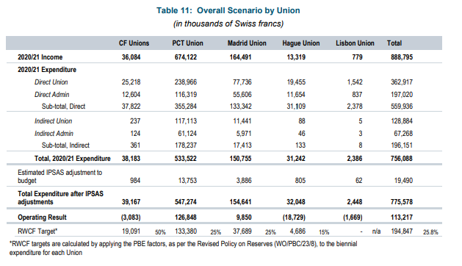
Proposed Program and Budget for 2020/21.

WIPO provides a single budget document, reflecting the budgets of the four current registration systems separately.

Common Expenses Were Originally Divided Among the Unions

To illustrate that the concept of requiring all Unions to pay their fair share of the Organization’s common expenses is not a novel one, the excerpt below shows that the Lisbon Union spent most of its budget on common expenses:

Page 48 of the Draft Program and Budget for 1978 (citation above).

In 1978, and in other years during this period, Annex C contained the budget by Union, and detailed what expenses were considered union expenses and which were common expenses, and described the allocation of expenses to unions. For example:

See also Draft Program and Budget for the 1986-87 Biennium, previously available at: https://www.wipo.int/mdocsarchives/AB_XVI_1985/AB_XVI_2_E.pdf and Draft Program and Budget for the 1988-1989 Biennium, AB/XVIII/2, Annex C, page 4 (May 29, 1987), previously available at: https://www.wipo.int/mdocsarchives/AB_XVIII_1987/AB_XVIII_2_E.pdf

This allocation methodology was carried forward to the 1990-1991 Biennium, AB/XX/2 (May 31, 1989), which was previously available at: https://www.wipo.int/mdocsarchives/AB_XX_1989/AB_XX_2_E.pdf.

By 1992, the methodology had changed somewhat, but a detailed explanation was not provided as to how the common expenses were allocated, except to state that the principles of the distribution were continued from the prior budget (AB/XX/2). Of note, the Film Register Treaty (FRT) contributed toward some costs, but Lisbon appears not to have contributed. Instead, the explanation continued to be “As in the past, the very small income of the Lisbon Union (Union for the Protection of Appellations of Origin and their International Registration) will be used to cover its very small expenses, whereas any excess expenditure will be carried forward to future budgetary periods.”

Proposed Program and Budget, AB/XXII/2/.

The common expenses of the Organization are reflected in the Proposed Program and Budget for the 2020/21 Biennium as Indirect Union and Indirect Admin expenses. In the first draft of the Proposed Program and Budget for the 2020/21 Biennium, the WIPO Secretariat proposed a change to the current allocation methodology for income and expenses so that, as in the 1970s and 1980s, and early 1990s, all of WIPO’s fee-financed unions (PCT, Madrid, Hague, and Lisbon) and CF unions contribute to the common expenses of the Organization, rather than continue to exempt such unions from contributing if their fee income and reserves were such that they did not have the “capacity to pay.” The indirect expenses of the unions are shown in Table 11 of Annex III, Draft Program and Budget 2020/21, p. 173 (WO/PBC/30/10), which is reproduced below with red ovals added to highlight the 1% which the CF, Hague and Lisbon Unions would be expected to contribute.

The treaty provisions of the fee-financed Unions, as well as most CF Unions, require that they contribute to WIPO’s common expenses. In our view, the proposed nominal one per cent contribution is a step in the right direction for each Union to honor its treaty obligations and contribute towards the financial solidarity of all the Unions. Each fee-financed union should be required to contribute toward the common expenses of the Organization.

Distribution of Miscellaneous Income and Projected Deficit of the Contribution financed (CF) Unions

In addition to fee income from the registration systems, WIPO collects miscellaneous income, which is derived from a number of sources, including rental income. According to the methodology used since at least 2008, miscellaneous income has been distributed in five equal parts to the CF, PCT, Madrid, Hague and Lisbon Unions. Table 12 of Annex III, Draft Program and Budget 2020/21, p. 173 (WO/PBC/30/10), shown below, has a green oval to highlight this income.

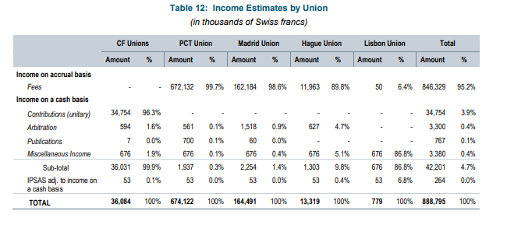
We note that the unitary contributions will not entirely cover the projected expense of the CF Unions, and a nominal 1% contribution by these unions towards the common expenses of the Organization (as proposed by the Secretariat) would further increase the CF unions’ deficit. Moreover, several developing countries have expressed concern this would take financial resources away from programs funded by the CF Unions. To address this concern, during the Program and Budget Committee meeting in July 2019, the United States suggested removing the provision that the CF Unions pay 1% towards the common expenses. In addition, the U.S. suggested that to further reduce the projected deficit of the CF Unions, all “Miscellaneous Income” should be moved to the CF Unions.

Giving the CF Unions six shares (one for each union in the CF Unions group, as opposed to the one share they currently receive) of the miscellaneous income could be a way to address the projected operating deficit of the CF Unions without sharply reducing the income of the other unions with a projected deficit. This proposal would give the CF Unions two million CHF rather than 676,000 CHF, and would still result in a meaningful allocation of miscellaneous income to each registration system (approximately 338,000 CHF).

Recommendation

WIPO Members should revert to the pre-2008 practice of requiring each fee-financed Union to contribute toward the common expenses of the Organization. In addition, WIPO Members should decide to re-apportion the miscellaneous income more fairly to the CF Unions, as outlined above.

[End of Annex and of document]

Earlier in WIPO’s history, there were three additional Unions, the Film Register Treaty Union, the International Registration of Marks (TRT) Union and the UPOV Union with budgets that were also reflected in the WIPO budget document. The first two Unions no longer exist and the UPOV budget is now represented separately.
The budget of the Lisbon Union has consistently reflected a deficit. See Matters Concerning the Madrid and Lisbon Unions, Proposal of the United States to the Madrid Assembly, MM/A/49/4 (September 2015).
See, e.g., AB/VI/2 (1975), page 26, Para 101 (http://www.wipo.int/mdocsarchives/AB_VI_1975/AB_VI_2_E.pdf): “Common Expenses. The Union will continue to bear a small percentage of common expenses. However, the sums involved are too small to be shown in each of the DC Tables (in which amounts are rounded to the nearest 1,000 francs). It is estimated that contributions to common expenses will be 5,000 francs for the year 1976 and this amount is shown under DC.34 ‘Miscellaneous and Unforeseen.’”

