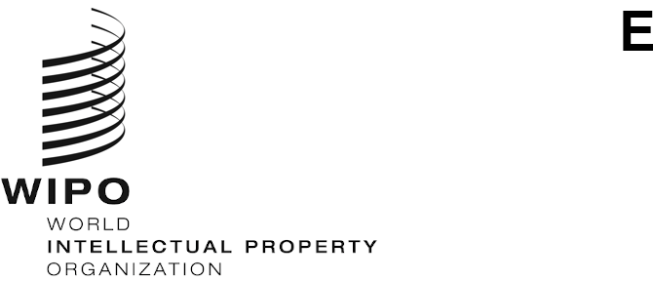
WO/CF/41/1 P/EC/60/1 B/A/50/1 B/EC/66/1 N/A/40/1 LI/A/37/1 LO/A/40/1 IPC/A/41/1 PCT/A/52/1 BP/A/37/1 VA/A/33/1 WCT/A/20/1 WPPT/A/20/1 PLT/A/19/1 STLT/A/13/1
ORIGINAL: english
DATE: december 15, 2020

WIPO Conference – Forty-First (17th Extraordinary) Session

International Union for the Protection of Industrial Property (Paris Union) – Executive Committee – Sixtieth (56th Ordinary) Session

International Union for the Protection of Literary and Artistic Works (Berne Union) – Assembly – Fiftieth (26th Extraordinary) Session

International Union for the Protection of Literary and Artistic Works (Berne Union) – Executive Committee – Sixty-Sixth (51st Ordinary) Session

Special Union for the International Classification of Goods and Services for the Purposes of the Registration of Marks (Nice Union) – Assembly – Fortieth (16th Extraordinary) Session

Special Union for the Protection of Appellations of Origin and their International Registration (Lisbon Union) – Assembly – Thirty-Seventh (14th Extraordinary) Session

Special Union for the International Classification for Industrial Designs (Locarno Union) – Assembly – Fortieth (17th Extraordinary) Session

Special Union for the International Patent Classification (IPC Union) – Assembly – Forty-First (19th Extraordinary) Session

International Patent Cooperation Union (PCT Union) – Assembly – Fifty-Second (30th Extraordinary) Session

Union for the International Recognition of the Deposit of Microorganisms for the Purposes of Patent Procedure (Budapest Union) – Assembly – Thirty-Seventh (17th Extraordinary) Session

Special Union for the International Classification of the Figurative Elements of Marks (Vienna Union) – Assembly – Thirty-Third (15th Extraordinary) Session

WIPO Copyright Treaty (WCT) – Assembly – Twentieth (11th Extraordinary) Session

WIPO Performances and Phonograms Treaty (WPPT) – Assembly – Twentieth (11th Extraordinary) Session

Patent Law Treaty (PLT) – Assembly – Nineteenth (11th Extraordinary) Session

Singapore Treaty on the Law of Trademarks Assembly (STLT) –Thirteenth (7th Extraordinary) Session

Geneva, September 21 to 25, 2020

reports
adopted by the respective Bodies
- Each of the above-mentioned bodies met in the sessions indicated for the purpose of considering the following items of the Consolidated Agenda of the Sixty-First Series of Meetings of the Assemblies of WIPO (document A/61/1): 1, 2, 4, 5, 6, 8, 10(ii), 11, 21 and 22. Furthermore, the Paris and Berne Executive Committees also considered item 3.
- The reports on the said agenda items are consolidated in the General Report of the Assemblies (document A/61/10).
[End of document]

