 |  | E
LI/WG/DEV/10/4
ORIGINAL: English
DATE: SeptemBer 15, 2014

Working Group on the Development of the Lisbon System (Appellations of Origin)

Tenth Session
Geneva, October 27 to 31, 2014

NOTES ON THE DRAFT REVISED LISBON AGREEMENT ON APPELLATIONS OF ORIGIN AND GEOGRAPHICAL INDICATIONS

Document prepared by the Secretariat

Annex I of the present document contains Notes on the Draft Revised
Lisbon Agreement on Appellations of Origin and Geographical Indications, as contained in
document LI/WG/DEV/10/2. Where a provision appears not to require explanation, no note has been provided.

[Annexes follow]

NOTES ON THE [Draft revised lisbon agreement on appellations of origin and geographical indications]

list of articles

[Preamble]

Chapter I: Introductory and General Provisions

Notes on Article 1: Abbreviated Expressions
Notes on Article 2: Subject-Matter
Notes on Article 3: Competent Authority
Notes on Article 4: International Register

Chapter II: Application and International Registration

Notes on Article 5: Application
Notes on Article 6: International Registration
Notes on Article 7: Fees
Notes on Article 8: Period of Validity of International Registrations

Chapter III: Protection

Notes on Article 9: Commitment to Protect
Notes on Article 10: Protection Under Laws of Contracting Parties or Other Instruments
Notes on Article 11: Protection in Respect of Registered Appellations of Origin and Geographical Indications
Notes on Article 12: Protection Against [Acquiring a Generic Character] [Becoming Generic]
Notes on Article 13: Safeguards in Respect of Other Rights
Notes on Article 14: Enforcement Procedures and Remedies

Chapter IV: Refusal and Other Actions in Respect of International Registration

Notes on Article 15: Refusal
Notes on Article 16: Withdrawal of Refusal
Notes on Article 17: Prior Use
Notes on Article 18: Notification of Grant of Protection
Notes on Article 19: Invalidation
Notes on Article 20: Modifications and Other Entries in the International Register

Chapter V: Administrative Provisions

Notes on Article 21: Membership of the Lisbon Union
Notes on Article 22: Assembly
Notes on Article 23: International Bureau
Notes on Article 24: Finances
Notes on Article 25: Regulations

Chapter VI: Revision and Amendment

Notes on Article 26: Revision
Notes on Article 27: Amendment of Certain Articles by the Assembly

Chapter VII: Final Provisions

Notes on Article 28: Becoming Party to This Act
Notes on Article 29: Effective Date of Ratifications and Accessions
Notes on Article 30: Prohibition of Reservations
Notes on Article 31: Application of the Lisbon Agreement and the 1967 Act
Notes on Article 32: Denunciation
Notes on Article 33: Languages of This Act; Signature
Notes on Article 34: Depositary

notes on the preamble:

P.01 The Preamble appears in square brackets, as it is a pending issue whether the Revised Lisbon Agreement should have a Preamble reflecting the objectives of the revision of the Lisbon Agreement or that this is not necessary.

P.02 According to Article 1(xiv), the term “Contracting Parties” means “any State or intergovernmental organization party to this Act”. However, in the draft Preamble, the term would rather refer to the parties adopting the Revised Lisbon Agreement.

Notes on Article 1: Abbreviated Expressions

1.01 Following the example of the Geneva Act of the Hague Agreement Concerning the International Registration of Industrial Designs (hereinafter referred to as “the Geneva Act”), Article 1 explains a certain number of abbreviated expressions and defines several terms used throughout the Draft Revised Lisbon Agreement. While several abbreviated expressions and definitions contained in Article 1 are similar to those contained in the Regulations under the Lisbon Agreement, others have been added whenever it appeared necessary as in the case of the provisions below.

1.02 Items (vi) and (vii) were added to the list of abbreviated expressions in Article 1 as a result of the discussions at the ninth session of the Working Group. Thus, the terms “appellation of origin” and “geographical indication” can be used throughout the Revised Lisbon Agreement without prejudice to the way in which the national or regional legislation of a Contracting Party addresses the subject-matter that is defined in Article 2. The Revised Lisbon Agreement will not oblige Contracting Parties to use the same terminology, nor require them to define the subject-matter in the same way as stipulated in the Revised Lisbon Agreement. A similar approach was taken at the Diplomatic Conference that adopted the Lisbon Agreement in1958. Reference is made in this regard to the Acts of the Lisbon Conference, p. 859 (in an unofficial translation from the official French text): “By introducing a definition for appellations of origin into the Agreement itself, such definition could be invoked for the purposes of registration, without prejudicing a national definition, whether broader or more precise in scope.” In the same vein, Contracting Parties will not be required to distinguish in their national or regional law as between appellations of origin and geographical indications. However, Contracting Parties that do not make such a distinction – but only provide protection on the basis of a broader definition corresponding to the definition of a geographical indication under Article 2 – will be obliged to protect appellations of origin as geographical indications.

1.03 Item (xii) concerns the geographical area where the good or goods designated by the appellation of origin or identified by the geographical indication should originate, in accordance with Article 2.

1.04 Item (xiii): in respect of a good from a geographical area of origin situated in, or covering, more than one Contracting Party, reference is made to Article 2(2), second sentence.

1.05 Item (xiv) defines the term “Contracting Party”, which is used instead of the term “countries” in the Lisbon Agreement and the 1967 Act, as the Revised Lisbon Agreement is aimed to be open for accession by States as well as intergovernmental organizations.

1.06 Item (xv) defines the term “Contracting Party of Origin”. The notion of “Contracting Party of Origin” is used to determine who is eligible to register a given appellation of origin or geographical indication. The determining factors in this respect are: (1) the geographical area of origin of the good; and (2) the legislation under which the appellation of origin or geographical indication is protected in the territory of the Contracting Party where the geographical area of origin is situated – see Article 2(1) –, which is also important for determining which Contracting Party should be regarded as the Contracting Party of Origin in the case of a Contracting Party that is a member State of an intergovernmental organization.

1.07 Item (xvi): the term “Competent Authority” also applies to the authority jointly designated by two or more Contracting Parties in each of which parts of a geographical area of origin are situated – see Article 5(4) –, if such Contracting Parties have established an appellation of origin or geographical indication jointly in respect of a good originating in a
trans-border geographical area of origin, as referred to in Article 2(2), second sentence.

1.08 Item (xvii) defines the term “beneficiaries”, following the concerns expressed in paragraph 199, fourth sentence, of the Report of the sixth session of the Working Group
(LI/WG/DEV/6/7).

1.09 Item (xviii): as the Revised Lisbon Agreement would be open to certain types of intergovernmental organizations, the accession criteria for intergovernmental organizations have been set out in Article 28(1)(iii).

Notes on Article 2: SUBJECT-MATTER

2.01 The subject-matter to which the Revised Lisbon Agreement would apply, as drafted, namely appellations of origin and geographical indications, is defined in several different ways under national and regional laws. Moreover, these laws do not all identify the subject-matter by the terms appellation of origin and geographical indication. Article 2(1) establishes, for the purposes of the Agreement only, common denominators for the titles of protection existing at the national or regional level, while recognizing the differences. The provision does this on the basis of the definitions of Article 2 of the Lisbon Agreement and Article 22.1 of the TRIPS Agreement. The prerequisite “protected in the Contracting Party of Origin” is based on Article 1(2) of the Lisbon Agreement.

2.02 The term “good” has been used throughout the English version of the Draft Revised Lisbon Agreement, to align the terminology used with the one contained in the TRIPS Agreement.

2.03 The phrases “or another denomination known as referring to such area” and “or another indication known as referring to such area” concern denominations and indications that are strictly speaking not geographical, but which have obtained a geographical connotation. Such possibility also exists under the Lisbon Agreement, as confirmed by the Lisbon Union Council in 1970 (see the document entitled “Problems Arising from the Practical Application of the Lisbon Agreement” (AO/V/5 of July 1970) and the Report of the fifth session of the Lisbon Union Council (document AO/V/8 of September 1970)).

2.04 There is some leeway in respect of the cumulative requirements “natural and human factors” in the definition of an appellation of origin. The ‘geographical environment’ of the area of production referred to in Article 2(1)(i) may be determined predominantly by natural factors or predominantly by human factors. In this regard, reference is made to the discussion on this issue at the fourth session of the Working Group, where several delegations indicated the need for such flexibility, notably the Delegations of Indonesia and of Iran (Islamic Republic of). In addition, the Delegation of the Republic of Moldova invited Lisbon member States to give some thought to the case of those 20 appellations of origin for mineral water already registered under the Lisbon Agreement, in order to determine in particular what the exact involvement of the human factor in that kind of product was, and more generally what would be the implication of the human factor in determining the substantial qualities of any other natural resource, such as stones, salt, or any other product mostly influenced by natural factors (see, in particular, paragraphs 72, 78 and 86 of the report of the fourth session of the Working Group
(document LI/WG/DEV/4/7).

2.05 The current Lisbon Agreement contains in its definition of “country of origin” (Article 2, paragraph (2)) a requirement of reputation. The phrase at the end of draft Article 2(1)(i) reading “and which has given the good its reputation” incorporates this requirement into the definition of an appellation of origin. The phrase refers back to the “denomination” that constitutes the appellation of origin, i.e., a denomination as qualified by Article 2(1)(i). With regard to the concerns expressed by some delegations on the possibility that this expression might lead to fact-finding missions, it was clarified at the ninth session of the Working Group that no such fact-finding missions had ever been undertaken either by the International Bureau or by Contracting Parties on the basis of the same provision that applies under the current Lisbon Agreement.

2.06 At the seventh session of the Working Group, it was proposed that an interpretative statement might be adopted at the Diplomatic Conference where the Revised Lisbon Agreement would be concluded, indicating that “notoriété” and “réputation”, in the French version, and “notoriedad” and “reputación”, in the Spanish version, should be considered synonyms for the purposes of the Revised Lisbon Agreement.

2.07 Following the concern expressed by several delegations at the fifth session of the Lisbon Working Group as regards the geographical coverage of the notion of “geographical area of origin”, paragraph (2) makes it clear that the geographical area in question may consist of the entire territory of a Contracting Party or a region, locality or place in such territory. In addition, the second sentence of paragraph (2) specifies that appellations of origin or geographical indications for goods originating in trans-border areas of origin could also be the subject of international registrations under the Revised Lisbon Agreement, without requiring Contracting Parties concerned, however, to establish such appellations of origin or geographical indications jointly. In this regard, see further Note 5.04.

notes on Article 3: Competent authority

  - As the competence for granting or registering rights in appellations of origin or geographical indications varies among national and regional systems for their protection, it is important for the Revised Lisbon Agreement to require each Contracting Party to designate an entity responsible for the administration of the Agreement in its territory and for communications with the International Bureau under the procedures of the Revised Lisbon Agreement and its
Regulations. Rule 4 of the Draft Regulations would require each Contracting Party to notify the name and contact details of the designated entity upon accession to the Revised Lisbon Agreement.

3.02 Although it is preferable that a Contracting Party designates a single Competent Authority, there may be reasons for a Contracting Party to designate more than one, as indicated in the Notes on Rule 4(2). In such a case, the International Bureau may face difficulties in determining to which of these Competent Authorities it should communicate a given notification. Rule 4(2) would therefore require the Contracting Party to provide clear indications in that respect. Failing such clarity, the International Bureau will be obliged to send its notifications to all the Competent Authorities the Contracting Party may have designated and leave it to them to determine which of them is responsible in respect of a given notification. By the same token, the International Bureau would be obliged to accept an application from such Contracting Party irrespective of which of the Competent Authorities presents it.

3.03 Following the discussion at the seventh session of the Working Group, a second sentence was added to Rule 4(1), for the benefit of the necessary transparency in regard to the applicable enforcement procedures in a Contracting Party in respect of appellations of origin and geographical indications.

notes on Article 4: international Register

4.01 Article 4 would make it clear that the International Register of the Revised Lisbon Agreement, to be kept by the International Bureau, would not only incorporate the registrations effected under the Revised Lisbon Agreement, but also the registrations effected under the Lisbon Agreement or the 1967 Act. Rule 7 elaborates on this.

4.02 As explained at the ninth session of the Working Group, there will be a period within which some Contracting Parties will have only acceded to the Revised Lisbon Agreement while others will only be party to the current Lisbon Agreement and a third category will have become party to both. As regards the reference to the 1967 Act, it should be noted that the current Lisbon Agreement, as adopted in 1958, and the 1967 Act should be seen as one entity, in view of Article 16(1)(b) of the 1967 Act and the fact that one Lisbon member State is party to the current Lisbon Agreement, as adopted in 1958, without being party to the 1967 Act, while all other Lisbon member States have acceded to the 1967 Act.

Notes on Article 5: APPLICAtion

5.01 Article 5(2) and Article 5(3) determine that international applications are to be presented to the International Bureau and are filed in the name of the beneficiaries of the appellation of origin or geographical indication, as defined in Article 1(xvii). As regards the entitlement to present an international application, reference is made to Note 1.06. In addition, in view of the discussions at the ninth session of the Working group with regard to the issue of entitlement to file an application under Article 5(2), Rules 5 and 7 of the draft Regulations may require amendment, so as to specify that the beneficiaries will be recorded as the holders of the international registration, whether in their own right as owners of the appellation of origin or the geographical indication in the Contracting Party of Origin, or on the basis of an entitlement derived from the owner in the Contracting Party of Origin.

5.02 The text of Article 5(2)(ii) emerged from the discussions at the fifth and sixth sessions of the Working Group. Following the discussions at the seventh session of the Working Group, the term “legal entity” will not be defined in the Revised Lisbon Agreement. However, the term should be understood broadly and cover, in any event, legal entities having legal standing to assert rights in a given appellation of origin or geographical indication, such as federations and associations representing holders of a right to use the appellation of origin or geographical indication. The phrase “or other rights in the appellation of origin or geographical indication” aims to make it clear that the term “legal entity“ also covers owners of certification marks or collective marks.

5.03 Article 5(3) is an optional provision. It allows Contracting Parties who so desire to permit international applications to be presented directly to the International Bureau by the beneficiaries, as defined in Article 1(xvii), or a legal entity, as referred to in Article 5(2)(ii), as an alternative to submission by the Competent Authority. This option was included in view of the conclusion of the Chair of the Working Group, as reflected in of paragraph 176, final sentence, of the Report of the second session of the Working Group (document LI/WG/DEV/2/5) concerning a suggestion made in response to the Survey on the Lisbon System. In light of the various comments made at the third, fourth and fifth sessions of the Working Group, as regards the requirement of proof of protection in the Contracting Party of Origin, the current text would require that such direct international applications also simply be subject to the provisions in the Regulations concerning mandatory and optional particulars. Following the discussions at the seventh session of the Working Group, paragraph (3)(b) was added, making the application of paragraph (3)(a) subject to the deposit by a Contracting Party of a declaration indicating that it permits direct applications by the beneficiaries, as defined in Article 1(xvii), or a legal entity, as referred to in Article 5(2)(ii).

5.04 Article 5(4) is also an optional provision. The provision is presented in square brackets, as the inclusion of a provision specifically dealing with appellations of origin and geographical indications originating in trans-border geographical areas is still the subject of debate. Under the current Lisbon Agreement, Contracting Parties have registered appellations of origin in respect of goods originating in that part of a trans-border geographical area situated in their own territory. Article 5(4) would make it clear that the Lisbon System also allows for the international registration of an appellation of origin or a geographical indication in respect of goods originating in the whole trans-border geographical area, if the Contracting Parties concerned have jointly established the appellation of origin or the geographical indication. In such a case, they should also designate a common Competent Authority for the appellation of origin or geographical indication concerned. Of course, adjacent Contracting Parties would not be required to establish such appellations of origin or geographical indications jointly. Instead, each Contracting Party may prefer to file an individual separate application only for the part of the trans-border area situated in its territory, and of course not for the entire trans-border area. The same applies in respect of direct applications by the beneficiaries, as defined in Article 1(xvii), or a legal entity, as referred to in Article 5(2)(ii). Direct applications under Article 5(4)(b) – i.e., by the beneficiaries, as defined in Article 1(xvii), or a legal entity, as referred to in Article 5(2)(ii) – are only possible if the adjacent Contracting Parties have both deposited the declaration referred to in Article 5(3)(b). Article 5(4) only deals with the exceptional situation when the adjacent Contracting Parties have jointly established an appellation of origin or geographical indication and would require them to designate a common Competent Authority for the appellation of origin or geographical indication concerned.

5.05 Article 5(5) makes a distinction between two types of mandatory particulars in respect of international applications, namely the particulars that are necessary for the application to obtain a filing date (see Article 6(3)) and other mandatory requirements (see Rule 5(2)).

Notes on Article 6: international registration

6.01 The provisions presented in Article 6 are based on the premise that an internationally registered appellation of origin or geographical indication, in order to be protectable in all Contracting Parties, should, at least, meet the definition requirements of Article 2(1).

Notes on Article 7: Fees

7.01 In order to make Chapter II concerning the application and the international registration as complete as possible, a stand-alone article concerning the registration fee and other fees to be paid has been included as Article 7. As regards the amount of such fees, reference is made to Rule 8, as well as to Article 24(4)(a).

7.02 As regards Article 7(3), it should be noted that, because geographical indications and appellations of origin are based on identifiers of geographical areas, there is a limit to the number that may ever exist. In any event, unlike in other registration systems in respect of intellectual property rights, there will never be a continuous and major flow of new applications. Consequently, provisions will be necessary to deal with any deficit that the Lisbon Union may be faced with, at least as long as the membership of the Revised Lisbon Agreement will not encompass all WIPO member States. The current Lisbon Agreement provides in its Articles 11(3)(v) and 11(4)(b) that the fees should, under normal circumstances, be sufficient to cover the expenses of the International Bureau in maintaining the international registration service of the Lisbon Agreement; and that Lisbon member States should pay contributions in case of a deficit. These provisions are also contained in Articles 24(3)(vi) and 24(4(a) of the draft Revised Lisbon Agreement. However, an alternative approach is presented in Article 7(3) , which would leave it to the Assembly to deal with a deficit, by establishing an ad hoc maintenance fee to be paid in respect of each international registration.

7.03 Following the views expressed by several delegations at the fifth and sixth sessions of the Working Group (paragraphs 207-209 of document LI/WG/DEV/5/7, and paragraphs 200, 213-217, 221-226 of document LI/WG/DEV/6/7), Article 7(4) provides that reduced fees shall be established for certain international registrations, in particular for those from developing countries or least-developed countries. Such fee reductions are to be established by virtue of a decision of the Assembly amending Rule 8.

7.04 The provisions of Article 7(5) and (6) result from the discussions at the eighth and ninth sessions of the Working Group. At the eighth session, the Delegation of the Russian Federation suggested that the Revised Lisbon Agreement should allow a Contracting Party to require the payment of a fee to cover the cost of the examination of international registrations notified to its Competent Authority (“individual fee”). Following the discussions on this proposal, as reflected in document LI/WG/DEV/8/7 Prov., paragraphs 85 to 113, such possibility for Contracting Parties was taken up in the draft Revised Lisbon Agreement, together with the option for the applicant to renounce protection in one or more Contracting Parties by not paying the individual fee. The reason for the introduction of such an individual fee would be to accommodate those countries or intergovernmental organizations, where the law requires applicants and right holders to pay a fee for the work to be carried out by the competent entity at the national or regional level. Moreover, despite the possible establishment of such fees in respect of an international registration under the Revised Lisbon Agreement, the acquisition of rights to protect an appellation of origin or geographical indication in the country requiring the fee would still be cheaper and quicker under the international registration procedure of the Revised Lisbon Agreement than under the national procedure. In addition, following discussions at the ninth session of the Working Group, an additional individual fee possibility was introduced, on the initiative of the Delegation of the United States of America, allowing Contracting Parties to require such a fee also on the basis of maintenance or renewal requirements.

7.05 As discussed at the ninth session of the Working Group, an individual fee system could be introduced without a requirement for the applicant to designate the Contracting Parties in respect of which protection is requested. It was sufficient to provide that non-payment of an individual fee would result in renunciation of protection under Rule 16 in respect of the Contracting Party requiring the fee. Thus, an applicant would have the option to renounce protection in respect of one, some or all contracting parties requiring an individual fee, by simply not paying the individual fee or fees concerned. Any such renunciation could also be withdrawn under Rule 16, subject to payment of the individual fee in addition to the fee for the modification of the entry of the international registration in the International Register. Under Rule 16(4), the period for a Contracting Party to refuse protection in respect of the appellation of origin or geographical indication concerned would of course start at the date on which it receives the notification of the withdrawal of the renunciation.

7.06 The same would apply under Article 29(4) in respect of newly acceding Contracting Parties. In principle, all international registrations in force under the Lisbon System at the time of accession shall be protected by a newly acceding Contracting Party, except those in respect of which it notifies a refusal under Article 29(4) within the applicable time-limit, as specified in the notification it will receive from the International Bureau, or in respect of which an individual fee, that the newly acceding Contracting Party may require, is not paid.

7.07 At the ninth session of the Working Group, the Delegation of the European Union suggested that the possible introduction of individual fees be left to the Assembly. Lacking consensus in the Working Group, the text of Article 7(5) reflects two Options: the proposal of the Delegation of the Russian Federation combined with the proposal of the Delegation of the United States of America (Option A); and the proposal of the Delegation of the European Union (Option B).

7.08 For comparison, Annex II shows statistics concerning fees collected under the Madrid System for the International Registration of Marks, as contained in Section B.3 of the Madrid Yearly Review 2014, WIPO Publication No. 940E/14. Annex III shows information about the geographical coverage of, and the average number of designations in, international registrations under the Madrid System, as contained in Section A.3 of the Madrid Yearly Report 2014. Annex IV shows the current Schedule of Fees of the Madrid System. Finally, Annex V shows information on the individual fees that currently apply under the Madrid System.

Notes on Article 8: period of validity of international registrations

8.01 Article 2(1) specifies, inter alia, that international registrations effected under the Revised Lisbon Agreement are dependent upon the protection of the appellation of origin or geographical indication in its Contracting Party of Origin. At the seventh and eighth sessions of the Working Group, the possible introduction of renewal fees was discussed. As a result, the present draft of the Revised Lisbon Agreement proposes, in Article 7(3), that the Assembly may establish ad hoc maintenance fees in the event that the Lisbon Union faces a deficit. See further the Notes on Article 7 and Rule 8.

8.02 Three possibilities for cancellation are specified. The first possibility (paragraph (2)(a)) refers to a request for cancellation that the Competent Authority of the Contracting Party of Origin, or, in the case of Article 5(3), the beneficiaries or the legal entity referred to in Article 5(2)(ii) or the Competent Authority of the Contracting Party of Origin, may submit at any time to the International Bureau. The second possibility (paragraph (2)(b)) concerns the situation that the registered appellation of origin or geographical indication is no longer protected in the Contracting Party of Origin, in which case its Competent Authority would be obliged to request cancellation of the international registration. The third possibility
(paragraph (3)) may occur if and when the Assembly has established an ad hoc maintenance fee under Article 7(3) and this fee is not paid.

Notes on Article 9: commitment to protect

9.01 The starting point for Article 9(1) is the current Lisbon Agreement, which in Article 1(2) stipulates that the Lisbon member States undertake to protect on their territories the appellations of origin of the other Contracting Parties, under the terms of the Agreement. The corresponding provisions of the Madrid Protocol and the Geneva Act of the Hague Agreement require international registrations to be protected in the same way as the Contracting Parties protect national trademark or industrial design registrations. Similarly, the current draft of Article 9(1) intends to reflect the different types of systems for the protection of geographical indications and appellations of origin around the world by stipulating that: “Each Contracting Party shall protect registered appellations of origin and geographical indications on its territory, within its own legal system and practice.” This text is modeled on Article 1 of the TRIPS Agreement.

9.02 Article 9(1) also recognizes that there are countries that do not distinguish as between appellations of origin and geographical indications. It has been a clear understanding in the Working Group since its second session, that the Revised Lisbon Agreement would not require Contracting Parties to make such distinction, as long as they do protect appellations of origin meeting the definition of a geographical indication as a geographical indication under their national law. This understanding is already reflected in paragraphs 7 and 8 of document LI/WG/DEV/2/2, paragraphs 79 and 80 of document LI/WG/DEV/2/5 and paragraph 56 of document LI/WG/DEV/3/4.

9.03 One of the consequences of the phrase “within its own legal system and practice but in accordance with the terms of this Act”, would appear to be that the national or regional law of a Contracting Party will determine whether and to what extent the enforcement of rights in a geographical indication or appellation of origin can be limited due to acquiescence.

9.04 Article 9(2) is modeled on Rule 8(3) of the Regulations under the current Lisbon Agreement.

Notes on Article 10: PROTECTION under laws of contracting parties and other instruments

10.01 Paragraph (1) leaves Contracting Parties free as regards the form of the legal protection under which they provide the protection to be provided under the Revised Lisbon Agreement in respect of registered appellations of origin or geographical indications. In addition to the form of protection, Contracting Parties would also remain free to determine the name of the title of protection granted under their own legal system – for example, the English term under EU law for “appellation d’origine” is not “appellation of origin”, but “designation of origin”. Another example relates to China, which under its Trademark Law allows for the registration of geographical indications as certification marks on the basis of a definition that contains elements of both Article 2(1)(i) and 2(1)(ii) of the draft Revised Lisbon Agreement.

10.02 Reference is also made to Notes 1.02 and 9.02.

10.03 The provisions of paragraph (2) establish a safeguard clause in respect of other forms of protection that may be available in a Contracting Party than the protection to be accorded under the Revised Lisbon Agreement. As stipulated in Article 15(2), a Contracting Party that has issued a refusal under Article 15 in respect of a registered appellation of origin because it takes the view that the denomination fails to meet the definition of an appellation of origin, should nevertheless provide protection to the denomination as a geographical indication, if the denomination meets the definition of a geographical indication. Reference is also made to Article 19(4) in this regard. The wording “shall not in any way affect” would appear to reflect this aspect more appropriately than the wording “already granted”, as contained in Article 4 of the current Lisbon Agreement, which could be interpreted to mean that the protection was already available in the country in question, for example by virtue of a prior bilateral agreement.

10.04 At the same time, the provisions of paragraph (2) would confirm that the Revised Lisbon Agreement, which would stipulate the level of protection to be accorded in respect of registered appellations of origin and geographical indications, would not itself be an obstacle to the possibility for Contracting Parties to establish more extensive protection than required under the Revised Lisbon Agreement. Obviously, such other protection should not diminish or interfere with the enjoyment of the rights afforded by the Revised Lisbon Agreement.

Notes on Article 11: Protection in respect of registered appellations of origin and geographical indications

11.01 At its sixth session, the Working Group agreed on the basic approach in respect of Articles 11 and 12. At the seventh, eighth and ninth sessions of the Working Group, the text was further refined. At the eighth session of the Working Group, it became clear that not only item (ii) – based on the wording of Article 3 of the current Lisbon Agreement – but also item (iii) of Article 11(1)(a) is problematic for a number of countries that are not party to the Lisbon Agreement or the 1967 Act, as the terms used in these items are alien to the legal framework
of these countries. Current Lisbon member States, however, attach great importance to the
terms used in these items. A possible way out, as contained in Article 11(3) of
document LI/WG/DEV/9/2 and modeled on Article 16.3 of the TRIPS Agreement, as adapted in order to relate to geographical indications and appellations of origin, was discussed at the ninth session of the Working Group. As a result, Article 11 now presents various Options for such a way out. Among these Options, two text proposals are presented in respect of Article 11(1)(a)(ii) and (iii). Option A in that sub-paragraph reflects the text of items (ii) and (iii), as contained in document LI/WG/DEV/9/2, while Option B proposes, instead, to use one item reflecting the wording modeled on Article 16.3 of the TRIPS Agreement. If Option B would prevail, there would be no need for Article 11(3), except for Option D, as presented in that provision, to the extent that that Option would allow for a declaration-based alternative for Contracting Parties in respect of Article 11(1)(a)(i). Option C of Article 11(3) concerns a text based on Article 16.3 of the TRIPS Agreement and Article 4(1)(b) of the WIPO Joint Recommendation Concerning Provisions on the Protection of Well-Known Marks.

11.02 The final part of Article 11(1)(a) clarifies, inter alia, that, when the registered appellation of origin or geographical indication is not reproduced in exactly the same way, such use is also covered by the provisions of Article 11(1)(a) if the differences are immaterial. The footnote to Article 11(1)(a) clarifies that, if the protection of a given registered appellation of origin or geographical indication is subject to an exception in the Contracting Party of Origin, such exception may also be applied by the other Contracting Parties.

11.03 The purpose of Article 11(2) is to prevent the registration of trademarks that consist of or contain a registered appellation of origin or a registered geographical indication by someone not authorized to use the registered appellation of origin or geographical indication. The word “trademark” should be understood in the broadest possible sense, so as to include also collective and certification marks. However, such registrations of trademarks containing a registered appellation of origin or geographical indication by someone who is authorized to use the registered appellation of origin or geographical indication would be acceptable, unless the person in question does so in a way that conflicts with any of the provisions of Article 11(1). In Contracting Parties that protect registered appellations of origin and geographical indications through trademark legislation, the registered appellation of origin or geographical indication will by definition be incorporated in a trademark. Moreover, holders of the right to use a registered appellation of origin or geographical indication may own a trademark that contains the registered appellation of origin or geographical indication as part of the trademark.

11.04 Article 11(2) shall be without prejudice to Article 13(1), which addresses the issue of prior trademark rights. In order to better reflect the priority principle, as identified by the word “prior” in Article 13(1), the word “later” was inserted in Article 11(2), following the discussions at the ninth session of the Working Group.

11.05 Following the discussions at the seventh session of the Working Group, Article 11 no longer contains provisions explicitly dealing with homonymous appellations of origin and geographical indications. The footnote to Article 11 explains the existing practice under the Lisbon Agreement and the 1967 Act in respect of appellations of origin that are the subject of an application and that happen to consist of or contain a term occurring also in another appellation of origin.

Notes on Article 12: protection against [acquiring a generic character] [becoming generic]

12.01 At its sixth session, the Working Group agreed on the basic approach in respect of
Articles 11 and 12. The square brackets around “[be considered to have]” reflect the difference of view as to whether the wording of Article 6 of the current Lisbon Agreement should be used or more straightforward wording.

12.02 The position of anyone who was using a denomination constituting a registered appellation of origin or geographical indication prior to the date on which the international registration took effect in the Contracting Party concerned should be considered safeguarded by Article 15(3). In this connection, the footnote to Article 12 is meant to make it absolutely clear that the provision only deals with generic use initiated after protection of the registered appellation of origin or geographical indication became effective in a given Contracting Party. The term “generic character” also features in Article 4 of the Madrid Agreement on Indications of Source. The term “generic” is defined in the footnote taking into account the provisions of Article 24.6 of the TRIPS Agreement.

12.03 At the eighth session of the Working Group, it was confirmed that Article 12 is problematic for a number of countries. If its text is maintained, a number of countries would need an alternative similar to Article 11(3) or the option of making a reservation under Article 30.

12.04 The square bracketed phrase at the end of Article 12 reflects the concern raised by some delegations at the ninth session of the Working Group that, under trademark-based protection systems for geographical indications, the factual situation in the market-place would determine whether a term has become generic or not.

12.05 The phrases “the denomination constituting” and “the indication constituting” appear in square brackets, following the discussions at the ninth session of the Working Group. The question is whether these phrases can be removed as being unnecessary or should be retained as references to the factual use made of such a denomination or indication. For comparison, Article 6 of the current Lisbon Agreement does not mention “appellation of origin”, but “appellation”.

Notes on Article 13: safeguards in respect of other rights

13.01 In view of the discussion at the sixth session of the Working Group, Article 13 no longer incorporates the relevant provisions of the TRIPS Agreement by reference, but specifies how the provisions of the TRIPS Agreement in respect of prior trademark rights and other legitimate rights would apply under the Revised Lisbon Agreement.

13.02 Following the discussion on Article 13(1) at the ninth session of the Working Group, the provision is now presented on the basis of two Options, i.e. Article 13(1) as contained in document LI/WG/DEV/8/2 (Option A) and a text proposed by the Delegation of the United States of America at the eighth session of the Working Group (Option B). The text of Option A combines elements of Articles 17 and 24.5 of the TRIPS Agreement. The text of Option B builds only on Article 17 of the TRIPS Agreement. According to the WTO Panel Reports on the disputes initiated by Australia and the United States of America, respectively, against the European Union concerning EC Regulation 2081/92, the coexistence provisions under that Regulation in respect of, on the one hand, protected appellations of origin and geographical indications and, on the other hand, prior trademarks can be regarded as limited exceptions under Article 17 of the TRIPS Agreement, which allows for limited exceptions to the rights conferred by a trademark, such as fair use of descriptive terms, provided that such exceptions take account of the legitimate interests of the owner of the trademark and of third parties. It would seem that, in cases of conflicts, as referred to in the chapeau of Article 13(1), the Contracting Party concerned may decide that the prior trademark prevails or that the prior trademark and the registered appellation of origin or geographical indication may coexist, as long as the legitimate interests of the owner of the prior trademark are taken into account as well as those of interested parties holding rights in respect of the registered appellation of origin or geographical indication and other third parties.

13.03 The phrase at the beginning of Article 13(1), reading “Without prejudice to Articles 15 and 19”, clarifies that Article 13(1) would apply if and when a Contracting Party does not submit a declaration of refusal on the basis of the existence of a prior trademark and as long as it does not invalidate the effects of the international registration on the basis of the prior trademark.

13.04 The chapeau of Article 13(1) refers to trademarks that have been applied for or registered as well as trademark rights that have been acquired through use. The reference to trademark rights acquired through use is not meant to create any obligation whatsoever on the part of Contracting Parties to provide that trademark rights can be acquired merely through use, but only that, if trademark rights can be acquired through use in a Contracting Party, these will also benefit from the safeguards in respect of prior trademark rights, as specified in the provision.

13.05 The fact that Article 13 no longer mentions the possibility, for right holders of prior trademarks and holders of the right to use an appellation of origin, to negotiate the modalities of a possible termination of use under the prior trademark, as contained in Article 12 of document LI/WG/DEV/4/2, does not mean to indicate that such possibility would not exist under Article 13 of the present draft. The sentence has been removed because of the comments made during the fourth session of the Working Group, that the existence of such a possibility is obvious and its specification in the Revised Lisbon Agreement, therefore, unnecessary.

13.06 Article 13(2) deals with the situation of appellations of origin and geographical indications that contain overlapping denominations or indications, for example, the appellations of origin “Porto” for a generous wine (liqueur wine) from Porto in Portugal and “Porto Vecchio” for wines from Porto Vecchio on the French island of Corsica.

13.07 Article 13(3) is based on Article 24.8 of the TRIPS Agreement: “The provisions of this Section shall in no way prejudice the right of any person to use, in the course of trade, that person’s name or the name of that person’s predecessor in business, except where such name is used in such a manner as to mislead the public.”

13.08 Article 13(4) does not safeguard all prior rights, but only plant variety and animal breed denominations. Other rights can still be safeguarded, but only if and when used as a ground for refusal under Article 15. Whether they can also be used as a ground for invalidation under Article 19 will depend on the outcome of further discussions in respect of Article 19(1). Lacking a refusal, the Contracting Party may decide, under Article 17(1), that a transitional period shall apply before use under such other right must be discontinued. See further Note 17.02.

Notes on Article 14: LEGAL REMEDIES and Legal Proceedings

14.01 Article 14 is based on the provisions contained in Article 8 of the Lisbon Agreement and the 1967 Act. This provision has been re-worded to take into account the concerns expressed by some delegations at the sixth session of the Working Group (in particular, paragraphs 97 and 163 of the Report contained in document LI/WG/DEV/6/7). As a result, the provision would simply require national or regional legislation to provide for and make available effective legal remedies and legal proceedings for the protection and enforcement of registered appellations of origin and registered geographical indications. The word “legal” is not meant to exclude the application of administrative measures.

Notes on Article 15: Refusal

15.01 Article 15 concerns the procedure for issuing refusals following the receipt of a notification of international registration. As suggested during the fourth session of the Working Group, time limits are not specified in the Agreement but in the Regulations, so that modifications can be adopted by the Assembly of the Special Union and would not require a diplomatic conference, as would be the case if time limits were specified in the Revised
Lisbon Agreement itself. The provision is based on Draft Provision G, as contained in
document LI/WG/DEV/3/2 and is a redrafted version of Article 5(3) of the current Lisbon Agreement.

15.02 As regards Article 15(2), please refer to Note 10.03.

15.03 Article 15(3) introduces the obligation for Contracting Parties to establish procedures enabling interested parties to present possible grounds for refusal to the Competent Authority and request the Competent Authority to notify a refusal under Article 15(1). As under the current Lisbon system, refusals can be based on any ground (see Note 16.01).

15.04 As regards Article 15(5), interested parties affected by a refusal might, alternatively, have the opportunity to resort to arbitration or mediation.

Notes on Article 16: Withdrawal of Refusal

16.01 The possibility to negotiate the withdrawal of a refusal is explicitly mentioned in Article 16(2). The text of the provision results from the discussions at the ninth session of the Working Group. As mentioned in the Acts of the 1958 Diplomatic Conference where the Lisbon Agreement was concluded, “the procedure envisaged provides countries, which receive the notification of an appellation of origin via the International Bureau, with the possibility to oppose any situation that exists de facto or de jure that would prevent protection being granted on all or part of the territory of the restricted Union. The period of one year from the time the notification is received is easily sufficient to allow such opposition. A refusal must be accompanied by the grounds on which the country decides not to grant protection. These grounds constitute a possible basis for discussion for the purpose of reaching an understanding”.

16.02 The term “interested parties” refers to the same persons referred to in Article 15(5). The term also appears in Articles 22 and 23 of the TRIPS Agreement.

16.03 Reference is also made to Article 24.1 of the TRIPS Agreement, which provides that WTO members agree to enter into negotiations aimed at increasing the protection of individual geographical indications under Article 23 and that the exception provisions of Article 24.4 through 24.8 shall not be used by a WTO member to refuse to conduct negotiations or to conclude bilateral or multilateral agreements. In the context of such negotiations, WTO members shall be willing to consider the continued applicability of these provisions to individual geographical indications whose use was the subject of such negotiations.

Notes on Article 17: Prior Use

17.01 Article 17(1) of the draft Revised Lisbon Agreement clarifies that the provisions of Article 5(6) of the current Lisbon Agreement would not be applicable with regard to use under any of the rights safeguarded under Article 13. Neither would Article 17(1) prejudice the right of a Contracting Party to apply the exception specified in the footnote to Article 11(1)(a). The footnote to Article 12 defines what should be considered to be a “generic denomination or indication”.

17.02 Under Article 24.4 of the TRIPS Agreement, WTO members are not required to prevent continued and similar use of a particular geographical indication of another WTO member identifying wines or spirits in connection with goods or services by any of its nationals or domiciliaries who have used that geographical indication in a continuous manner with regard to the same or related goods or services in the territory of that Member either (a) for at least 10 years preceding 15 April 1994 or (b) in good faith preceding that date. Under the Revised Lisbon Agreement, the same effect could be achieved, if the Contracting Party concerned notifies a refusal under Article 15, for example as a result of the procedure that the Contracting Party has put in place, under Article 15(3), allowing interested parties to submit requests to that effect. Any prior use can be used as a ground for refusal, but if prior use other than that referred to in Note 17.01 is not used as a ground for refusal, the phasing out provisions of Article 17(1) would be applicable. Whether a Contracting Party can also use such prior use as a ground for invalidation of the effects of an international registration in its territory will depend on the outcome of the discussions on Article 19. Under Option A of Article 19(1), the initiation of invalidation proceedings on the basis of prior use, as referred to in Article 17(1), would probably result in suspension of the application of any phasing-out period for the duration of the invalidation proceedings.

17.03 As suggested during the fourth session of the Working Group, time limits are specified in the Regulations, so that modifications can be adopted by the Assembly of the Special Union and would not require a Diplomatic Conference, as would be the case if time limits were specified in the Revised Lisbon Agreement itself.

17.04 A defined period for the termination of prior use may also be applied in case a refusal is withdrawn or in case a statement of grant of protection is notified following a refusal.

17.05 In view of the safeguards under Article 13 in respect of the prior rights addressed in that provision, the Revised Lisbon Agreement would not contain phasing out periods in respect of prior uses under such rights, except to the extent that such prior rights incorporate a registered appellation of origin or geographical indication as a generic denomination or indication, and the prior rights manifestly do not extend to that denomination or indication, as specified in the footnote to Article 17. The square brackets correspond to the square brackets in Article 13(2) to (4).

17.06 Article 17(2) clarifies that withdrawal of a refusal that was based on use under a prior trademark or other right addressed in Article 13 would not mean that Article 13 would no longer apply. At the same time, the provision clarifies that withdrawal of such a refusal because of the cancellation, revocation, non-renewal, or invalidation, of the prior trademark or other prior right makes Article 13 inapplicable. Article 17(2) only applies in respect of cases of coexistence allowed for under the law of a Contracting Party. If a Contracting Party does not allow for coexistence, it can issue a declaration of refusal under Article 15 or invalidate the effects of the international registration in its territory under Article 19. In a Contracting Party that allows for coexistence, a situation of coexistence would be established following the withdrawal of a refusal, except when the withdrawal was the result of the cancellation, revocation, non-renewal, or invalidation, of the prior trademark or other right referred to in Article 13.

Notes on Article 18: Notification of grant of protection

18.01 Article 18 concerns the notification of a grant of protection in respect of a registered appellation of origin or geographical indication, and its subsequent publication by the International Bureau. Such a notification can be presented within the one-year period after receipt of the notification of international registration – in case within that period it has become clear that no refusal will be issued – or following a refusal; if a decision has been taken to withdraw the refusal, a statement of grant of protection can be notified instead of a withdrawal of refusal. The procedures are specified in the Draft Regulations, based on Rule 11bis of the Regulations under the current Lisbon Agreement, which resulted from an amendment of the Regulations that entered into force on January 1, 2010.

Notes on Article 19: Invalidation

19.01 Article 19 deals with the possible invalidation of the effects of an international registration in a given Contracting Party. In view of the discussion at the eighth and ninth sessions of the Working Group, Article 19(1) presents two Options. Under Option A, no limitation would apply as to the grounds on the basis of which invalidation can be pronounced, on the understanding that Contracting Parties shall provide that invalidation can be pronounced on the basis of a prior right, as referred to in Article 13. Following the logic of Option A, the footnote shows a non-exhaustive list of possible grounds for invalidation. Option B would limit the grounds for invalidation to two situations: (1) the existence of a prior right, as referred to in Article 13; and (2) non-compliance with the definition. In case of the expiry of the protection in the Contracting Party of Origin, Article 8(2)(b) requires the Contracting Party of Origin to request cancellation of the international registration.

19.02 Article 5(6) of the Madrid Protocol and Article 15(1) of the Geneva Act of the Hague Agreement stipulate that, before an invalidation is pronounced, the holder of the international registration must have been given the opportunity of defending his rights. The current Lisbon Agreement does not contain a provision of this kind. However, this does not mean that a Lisbon member State is prevented from invalidating the effects of an international registration under the Lisbon Agreement. The Lisbon Union Assembly has recognized that such invalidations may take place and introduced Rule 16 in the Regulations under the Lisbon Agreement, with effect from April 1, 2002, requiring the Competent Authority to notify any such invalidation to the International Bureau, once the invalidation is no longer subject to appeal in the Lisbon member State in question, for its recording in the International Register. Article 19(1) of the draft Revised Lisbon Agreement would confirm that the effects of an international registration under the Lisbon System in a given Contracting Party can be invalidated by that Contracting Party; and Article 19(2) would introduce a provision similar to those contained in the Madrid Protocol and the Geneva Act of the Hague Agreement, as referred to above. Following the discussions at the ninth session of the Working Group, Article 19(2) has been drafted in a positively worded manner. However, the model of the corresponding Madrid and Hague provisions raises the question as to who should be given the opportunity to defend his rights, as international registrations under the Lisbon System do not indicate who is the holder of the international registration – but only who is/are the holder(s) of the right to use the appellation of origin or geographical indication that is the subject of the international registration. The current draft of Article 19(2) gives this opportunity to the natural and legal persons in whose name applications can be filed, as specified in Article 5(2), whether or not they are recorded in the International Register as the holder(s) of the right to use the appellation of origin or geographical indication. The provision may need to be revised in light of the outcome of the pending issue reflected in item (iv) of paragraph 5 of the document LI/WG/DEV/10/2.

19.03 As regards Article 19(4), reference is made to Note 10.03.

Notes on Article 20: Modifications and other Entries in the International Register

  - A specific provision addressing the issue of modifications of international registrations and other entries in the International Register has been incorporated in the Draft Revised Lisbon Agreement.

Notes on Article 21: MEMBERSHIP of the LISBON Union

21.01 This provision clarifies that the Contracting Parties to the Revised Lisbon Agreement shall be members of the same Assembly as the States party to the Lisbon Agreement.

Notes on Article 22: Assembly of the Special Union

22.01 The provisions of Article 22 are based, to a great extent, on those contained in Article 9 of the 1967 Act. However, whenever it appeared necessary, as in the case of the voting rights of intergovernmental organizations, such provisions have been supplemented by those contained in Article 21 of the Geneva Act.

22.02 As regards Article 22(2)(b), reference is made to the Guide to the Paris Convention by Prof. G.H.C. Bodenhausen, Note “(n)” on Article 13(2)(b) of the Paris Convention and Note “(d)” on Article 16(1)(b) of the Paris Convention.

22.03 With regard to intergovernmental organizations, Article 22(3)(a) is to be read in conjunction with Article 22(4)(b)(ii).

Notes on Article 23: International Bureau

23.01 The provisions of this Article largely reproduce those contained in Article 10 of the
1967 Act.

Notes on Article 24: Finances

24.01 The provisions of this Article are modeled on those contained in the Geneva Act. Reference is made to Notes 7.01 and 7.02.

Notes on Article 25: Regulations

25.01 This Article makes an express reference to the Regulations and defines the procedure for the amendment of certain provisions of the Regulations.

25.02 Paragraph (2) has been drafted along the lines of the corresponding provisions of the Singapore Treaty and the Patent Cooperation Treaty, which require the same threshold of a three-fourths majority.

25.03 Paragraph (3) establishes the superiority of the provisions under the Revised Lisbon Agreement over those contained in the Regulations so that, in the event of conflict between the two sets of provisions, the provisions of the Revised Lisbon Agreement shall prevail.

Notes on Article 26: Revision

26.01 This provision, which confirms the standard rule that a treaty may be revised by a conference of the Contracting Parties, has been drafted along the lines of the provisions contained in the Singapore Treaty and the Geneva Act.

Notes on Article 27: Amendment of Certain Articles by the Assembly

27.01 The provisions of this Article are largely derived from those contained in the Geneva Act.

Notes on Article 28: Becoming Party to thIS ACT

28.01 The provisions of this Article have been drafted along the lines of Article 27 of the Geneva Act, as adapted in order to reflect accession criteria for intergovernmental organizations that would appear to take account of the conclusions of the Working Group on the Study contained in document LI/WG/DEV/2/3 and discussed at the second session of the Working Group.

28.02 Upon clarifying that the accession to the Revised Lisbon Agreement is not limited to States party to the Paris Convention, paragraph (1)(ii) lays down the accession criteria in respect of States that are not party to the Paris Convention.

28.03 The last sentence of paragraph (3)(b) should be read in conjunction with Article 31 and would allow a member State of the Lisbon Agreement or the 1967 Act that is also a member State of an intergovernmental organization to apply the Revised Lisbon Agreement instead of the Lisbon Agreement or the 1967 Act before the intergovernmental organization accedes.

Notes on Article 29: Effective Date of Ratifications and Accessions

29.01 This provision has been drafted along the lines of Article 28 of the Geneva Act to reflect the fact that both States and intergovernmental organizations may accede to the new instrument.

29.02 The first sentence of paragraph (4), which deals with the effects of accession, has been drafted along the lines of Article 14(2)(b) and (c) of the 1967 Act. A possibility to extend the time periods referred to in Article 15(1) and Article 17 of the Draft Revised Lisbon Agreement has been introduced in the last part of paragraph (4), in view of suggestions made in response to the Survey on the Lisbon system and the discussions at the second session of the Working Group.

29.03 As regards the bracketed reference to Article 7(5) and (6), see Note 7.06.

Notes on Article 30: Prohibition of Reservations

30.01 This Article, which excludes any reservation to the Revised Lisbon Agreement, reproduces the text of Article 29 of the Geneva Act.

Notes on Article 31: Application of the Lisbon Agreement and
the 1967 act

31.01 Paragraph (1) deals with relations between States that are party both to the Revised Lisbon Agreement and the Lisbon Agreement or the 1967 Act. The principle set out is that the Revised Lisbon Agreement alone would apply to the relations between those States. Thus, with respect to persons who derive their right to file an international application from a State bound both by the Revised Lisbon Agreement and by the Lisbon Agreement or the 1967 Act and who wish to obtain protection in other States party both to the Revised Lisbon Agreement and to the Lisbon Agreement or the 1967 Act, as the case may be, only the provisions of the Revised Lisbon Agreement will be applicable.

31.02 Paragraph (2) deals with relations between States party both to the Revised Lisbon Agreement and to the Lisbon Agreement or the 1967 Act, on the one hand, and States party only to the Lisbon Agreement or the 1967 Act without being at the same time party to the Revised Lisbon Agreement, on the other.

31.03 Reference is also made to Note 28.03.

Notes on Article 32: Denunciation

32.01 This is a usual provision. To enable those who have organized their activities as a function of the accession of a Contracting Party to the Revised Lisbon Agreement to carry out the necessary adjustments in the event of that Contracting Party denouncing the Revised Lisbon Agreement, a minimum period of one year is provided in paragraph (2) for a denunciation to take effect. Additionally, paragraph (2) ensures that the Revised Lisbon Agreement will continue to apply to any international application that is pending and to any international registration that is in force with respect to the Contracting Party that has denounced the Revised Lisbon Agreement at the time the denunciation takes effect.

Notes on Article 33: Languages of THIS ACt; Signature

33.01 Article 33 provides, in particular, that the Revised Lisbon Agreement is to be signed in a single original in the six official languages of the United Nations and that all those texts will be equally authentic.

Notes on Article 34: Depositary

34.01 Article 34 states that the Director General is the depositary of the Revised Lisbon Agreement. The nature of the duties of the depositary of a treaty is defined, and a list of those duties is given, in Articles 76 and 77 of the Vienna Convention on the Law of Treaties. Those duties consist, in particular, in keeping the original text of the Revised Lisbon Agreement, in establishing certified copies of the original text and in receiving the instruments of ratification or accession that are deposited.

[End of Annex I; Annex II follows]

Section B.3 of the 2014 Madrid Yearly Review

B.3 Revenue and fees

B.3.1 Total revenue collected by the International Bureau

The IB collects fees in Swiss francs (CHF) for services related to applications for, and registrations and renewals of, marks. Figure B.3.1 depicts the total revenue generated by the Madrid System between 2001 and 2013. The total revenue collected by the IB in 2013 amounted to CHF 55,169 million, a 4.6% increase on 2012. The amount of revenue generated by the System increased in all years presented except for 2002 and 2009, when revenue decreased by 7% and 8.2%, respectively. This reflects the reduction in the numbers of international applications received in these two years (see Figure A.1.1). The highest growth occurred in 2005 (+23.8%) and 2006 (+27.9%), which was partly due to the expansion of Madrid System membership. For example, the Republic of Korea and the US joined the Madrid System in 2003.

Figure B.3.1 Total revenue collected by the International Bureau
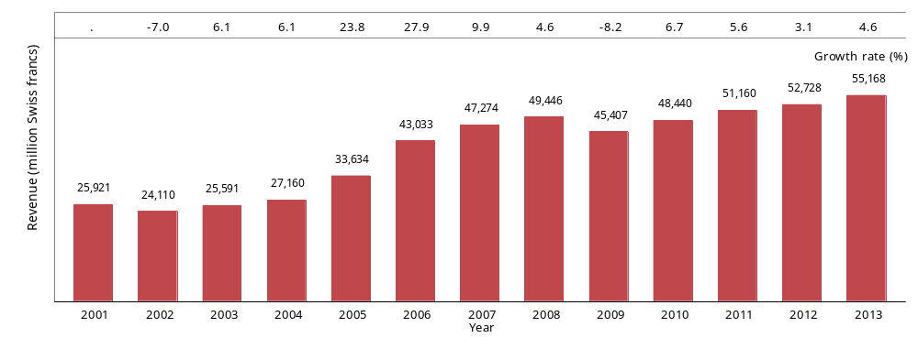
Source: WIPO Statistics Database, March 2014

B.3.2 Fees distributed to Madrid members by the International Bureau

The IB collects and distributes fees to Madrid members. In 2013, the IB distributed around CHF 172.4 million to all designated members. The EU (via OHIM) received the largest share of the total (12.7%), followed by Japan (8.6%), the US (7.3%), Australia (6.5%) and China (4.0%). The top five designated Madrid members—in terms of fees distributed to them—received almost 40% of the total in 2013, which was similar to their combined share for the previous year. The respective shares of the revenue received by the majority of the listed Madrid members in 2013 was similar to their 2012 shares, with the largest variations occurring for the EU, which saw a slight reduction (-0.8 percentage point) and Australia which saw a slight increase (+0.6 percentage point). All of these Madrid members received more revenue from fees collected by the IB in 2013 than in 2012 except for Turkey, which at CHF 4.0 million, received about CHF 70,000 less than in the previous year.

Table B.3.2 Fees distributed to Madrid members by the International Bureau
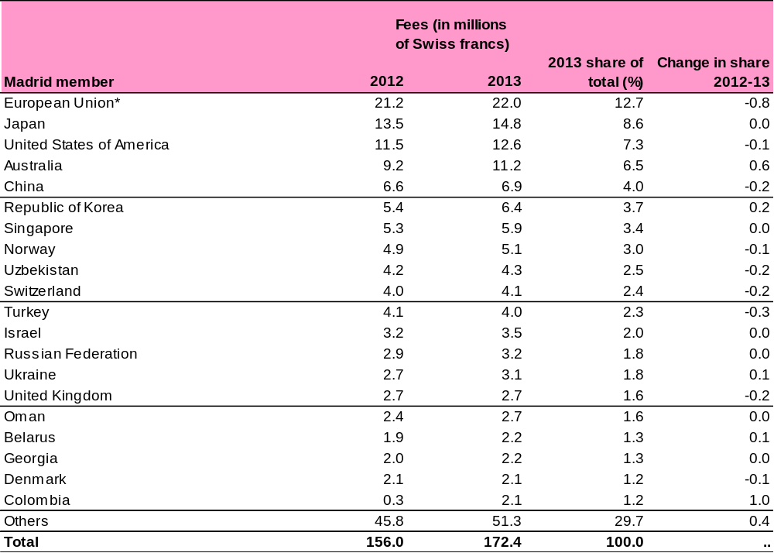
Note: *The fees distributed to the European Union are those distributed to its Office for Harmonization in the Internal Market (OHIM) and are not a sum of all fees distributed to the individual IP offices of each EU country.

Source: WIPO Statistics Database, March 2014

B.3.3 Fees per international registration

The total fees for an international application are determined by a number of factors, such as the number of Madrid members and which specific ones are designated, whether the mark is in color or in black/white, the number of classes of goods and services to be protected, etc. The average fees paid per new registration declined from a peak of CHF 3,734 in 2008 to CHF 3,039 in 2013.

Figure B.3.3 Registration fees
Average fees paid per new registration Distribution of registration fees
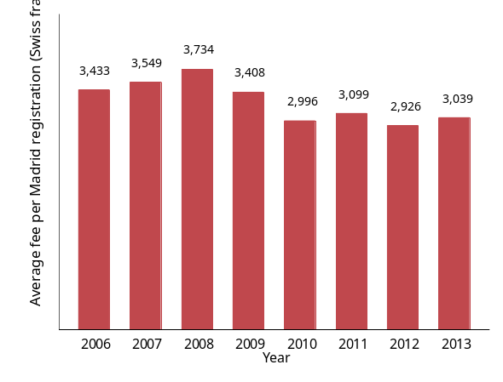 | 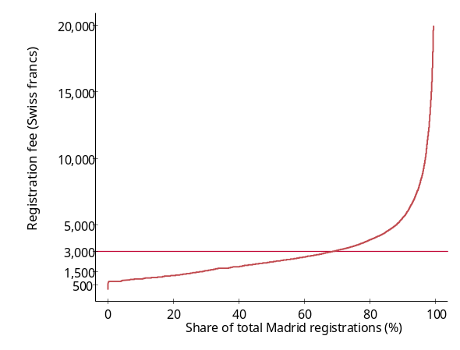
Source: WIPO Statistics Database, March 2014

The average fees paid per registration masks wide variation in registration fees paid by applicants. In 2013, fees ranged from only CHF 190 up to almost CHF 140,000. Similar to 2012, about one-tenth of applicants paid less than CHF 1,000 per registration, and approximately one-third paid between CHF 1,001 and CHF 2,000. A total of 70% of applicants paid fees less than the average CHF 3,039 per registration, and a total of 95% of international registrations cost CHF 8,000 or less. Fees for the remaining 5%, comprising approximately 2,150 registrations, ranged from CHF 8,001 to CHF 88,000. The fees for two registrations were assessed at in excess of CHF 135,000.

[End of Annex II; Annex III follows]

Section A.3 of the 2014 Madrid Yearly Review

A.3 GEOGRAPHICAL COVERAGE OF MADRID INTERNATIONAL REGISTRATIONS

A.3.1 Designations in international registrations

The previous section analyzed the origins of international registrations and considered how many Madrid member countries their holders designated with the aim of extending protection for their marks. Section A.3 builds on this analysis by examining the designated Madrid members in order to map where registration holders seek international trademark protection.

Figure A.3.1.1 shows that the number of designations initially specified in new international registrations recorded in 2013 reached 306,046, averaging 6.9 designations per international registrations and surpassing 300,000 for, the first time since the onset of the global financial crisis in 2008. The 8.3% increase on 2012 was the highest recorded in eight years.

As is the case for international applications and registrations, the upward trend in designations was due to the increase in the number of Madrid members over the years and the ensuing increased usage of the Madrid System, coupled with a general growth in trademark filings worldwide.

In 2013, holders of new international registrations designated, on average, nearly seven (6.9) Madrid members, an average similar to those recorded in the preceding four years. After reaching a peak of 12.1 in 2001, the average number of designations per registration began to decrease over time to the current stable level of seven. The decrease can be explained by the fact that the EU joined the Madrid System in 2004, which has enabled registration holders to designate the EU as a whole via a single designation rather than designating each individual member state separately.

Figure A.3.1.1 Designations in international registrations
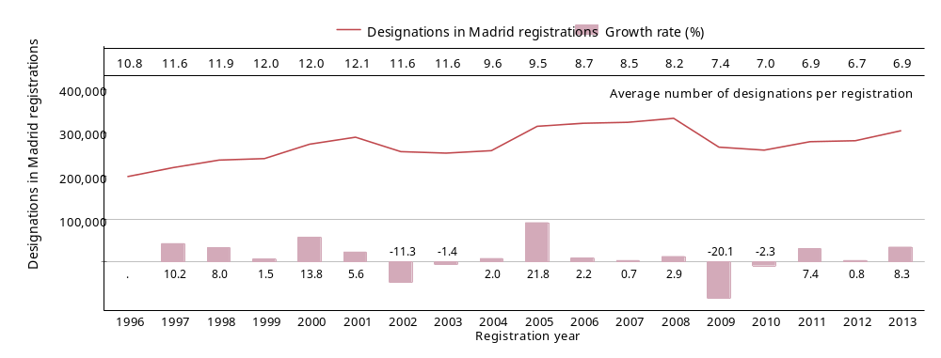
Source: WIPO Statistics Database, March 2014
As explained in subsection A.2.3, international registration holders can designate any of the Madrid members in whose jurisdictions they wish to obtain protection for their marks internationally. Figure A.3.1.2 shows the distribution of designations per international registration recorded in 2013. Similar to the previous year, 17.5% of all new international registrations designated only a single Madrid member; an additional 15.9% of registrations contained two designations, 13.5% contained three, and 9.8% contained four. Four or fewer Madrid members were designated in over half (57%) of all 2013 international registrations. One-third of all registrations were used by holders to seek protection in between 5 and 15 Madrid member jurisdictions, and close to one-tenth (9.4%) chose to designate more than 16 Madrid members.

In some cases, a small number of registrations served to simultaneously extend protection to a large number of Madrid members. For example, only about 129 of the 44,414 registrations recorded in 2013 were used to designate 80 or more of the 92 Madrid members. Of these 129 registrations, only one designated 90 Madrid members.

International registrations designating a single Madrid member indicate that trademark holders wish to extend protection to a single country outside their respective “home” country in which they filed their original national or regional trademark application. Alternatively, it may indicate their desire to extend protection for their trademark to the 28 EU member states simultaneously. Of the 7,753 international registrations recorded in 2013 that contained a single designation, 1,518 (or almost one-fifth of these) designated the EU via its Office for Harmonization in the Internal Market (OHIM).

Figure A.3.1.2 Distribution of designations per international registration, 2013
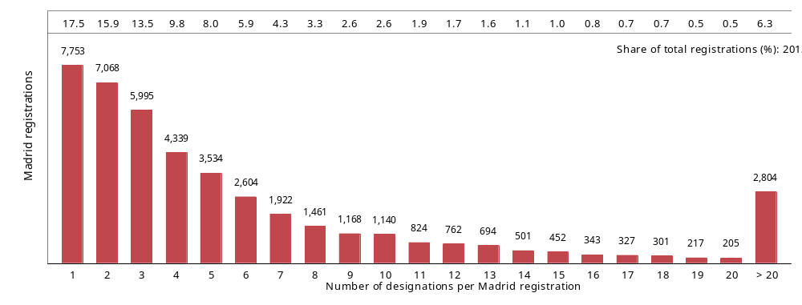
Source: WIPO Statistics Database, March 2014

A.3.2 Subsequent designations in international registrations

As outlined in subsection A.2.3, international registration holders largely define the geographical areas in which to protect their trademarks at the time of filing their Madrid international applications. However, over the life of an active registration, holders may wish to extend protection for their trademarks to jurisdictions covered by additional Madrid members. These designations are called subsequent designations, and they apply to Madrid members for which either no designation was previously recorded or for which the prior designation is no longer in effect.

Owing in part to Madrid System accessions and the incentive for holders to extend protection to new members’ jurisdictions as well as existing ones, the long-term trend shows that subsequent designations have almost doubled since 1996. Although following a trend similar to that for initial designations, Figure A.3.2 shows that the numbers of subsequent designations added to existing international registrations fluctuate more year to year than do the numbers of initial designations depicted in Figure A.3.1.1. The annual growth rates of subsequent designations are markedly higher or lower than, or even contradictory to, those for initial designations for most years.

In 2013, holders subsequently added 45,480 designations to their existing international registrations, a figure that has remained virtually unchanged from their level in 2012. These subsequent designations represent about 13% of all initial and subsequent designations combined that were recorded in 2013.

Subsequent designations increased sharply by 43.2% in 2003, corresponding with the year in which the US became a member of the Madrid System and the year before the accession of the EU to the System. In contrast, subsequent designations decreased by 18.7% at the height of the economic crisis in 2009, on a par with the 20.1% drop in initial designations.

Figure A.3.2 Subsequent designations in international registrations
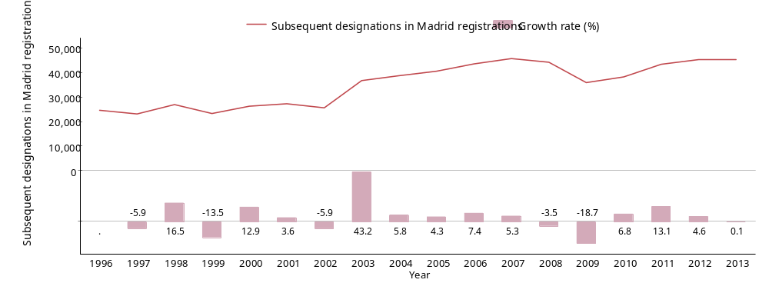
Source: WIPO Statistics Database, March 2014

A.3.3 Designations in registrations by Madrid member

Figure A.3.3.1 shows the countries and the region—in the case of the EU—where international registration holders sought trademark protection in 2013 in the form of initial and subsequent designations. These 20 most designated Madrid members received 58.3% of all initial designations and just over half (50.6%) of all subsequent designations, resulting in a combined share of 57.3% of total designations.

China, the only country to exceed 20,000 total designations (including subsequent designations), was the most designated member in both new and existing registrations. In surpassing the EU, the Russian Federation became the second most designated Madrid member in 2013, receiving 18,239 total designations and consequently exhibiting among the top 20 designated Madrid members one of the highest growth rates (+9.6%). Viet Nam, which was ranked 15th, also experienced high growth of 10.8%, albeit from a lower base.

The EU ranked third in terms of total designations received in 2013. It received the second highest number of initial designations, but ranked 17th in terms of subsequent designations. This lower ranking could indicate that due to its initial designation in many new international registrations, a subsequent designation is thus rendered largely unnecessary for many trademark holders.

Indicating a wide geographical range of countries in which trademark protection is sought, 8 of the 20 listed Madrid members are located on the European continent and, combined, they received around a quarter of all designations. In contrast, the remaining 12 Madrid members, which span Asia, North America and Oceania, received one-third of the total number of designations.

Designated member New Zealand, which joined the Madrid System in 2012, appeared in the top 20 list in 2013 largely as a result of registration holders extending protection for their existing trademarks to this country via subsequent designations. All but three of the listed Madrid members received more designations in 2013 than in 2012. Only Germany, Serbia and Switzerland received fewer.

Figure A.3.3.1 Designations in registrations for the top 20 designated Madrid members, 2013
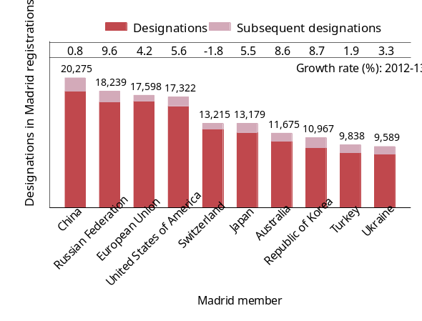 | 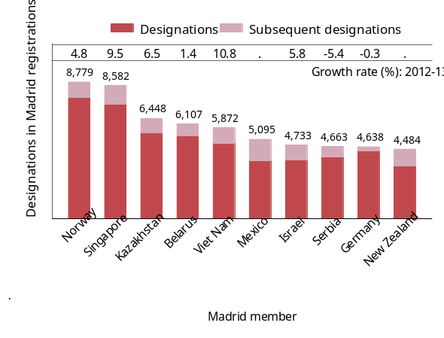
Source: WIPO Statistics Database, March 2014

The upper panel of Table A.3.3.2 shows total designations in Madrid registrations received by the top 10 designated Madrid members from the top 20 origins in 2013. The lower panel of Table A.3.3.2 shows the percentage shares of total designations received by these Madrid members from the top origins.

China received the largest and almost equal shares of designations from mark holders domiciled in Germany (15.2%) and the US (15.1%), followed by those in France (10.5%). In the case of the EU, holders from the US (21%), Germany (13.1%) and Switzerland (10.5%) were the most interested in extending protection for their marks within this region.

Designations from Germany accounted for the largest shares of totals for 6 of the top 10 designated Madrid members. These shares ranged from 14.6% of total designations received by Ukraine to 29.6% of total designations received by Switzerland. Designations of US origin constituted the largest shares for the remaining 4 top 10 designated members, accounting for one-fifth or more of the totals in Australia, Japan and the EU.

For all top designated Madrid members, designations of Chinese origin accounted for higher shares of each of their respective totals in 2013 than in 2012. For instance, they accounted for the fifth largest share of designations received by the Republic of Korea in 2012 but represented the third largest share of designations received by this country in 2013.

Where designations exist for an origin that is the same as the designated Madrid member, this indicates that the trademark holder residing in this origin used another Madrid member that is different from its country of address of origin, on which to base the original international registration. This can be done if the applicant is, for example, a national of the Madrid member or has a real and effective industrial or commercial establishment in the country/region of a Madrid member.

Table A.3.3.2 Designations in registrations for the top 20 origins and top 10 designated Madrid members, 2013

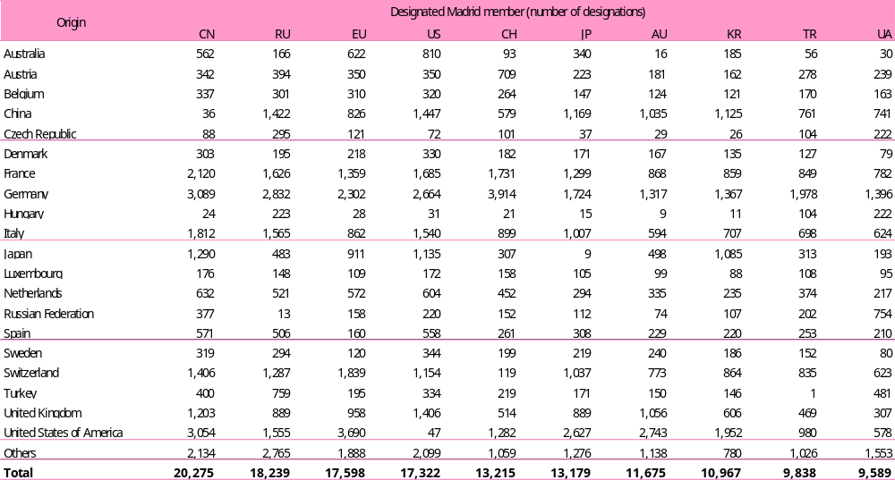

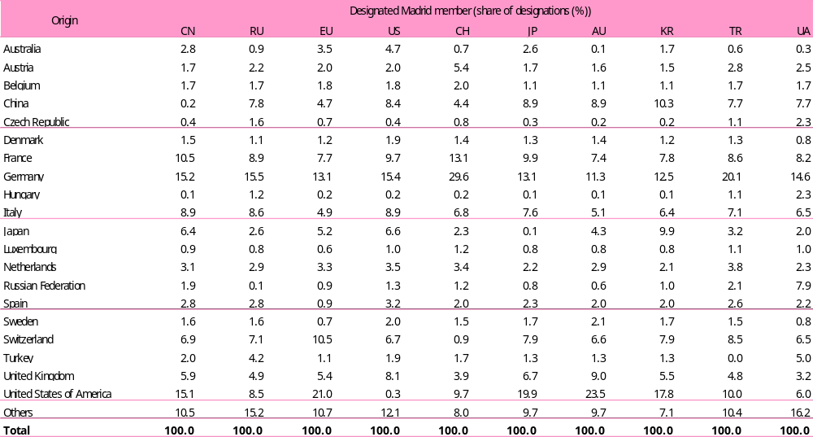
Note: Designated Madrid members: CN (China), RU (Russian Federation), EU (European Union), US (United States of America), CH (Switzerland), JP (Japan), AU (Australia), KR (Republic of Korea), TR (Turkey), and UA (Ukraine)
Source: WIPO Statistics Database, March 2014

[End of Annex III; Annex IV follows]

SCHEDULE OF FEES annexed to the Common Regulations Under the Madrid Agreement Concerning the international registration of marks and the protocol relating to that agreement

Schedule of fees (in force on September 1, 2008)

Swiss francs

1. International applications governed exclusively by the Agreement

The following fees shall be payable and shall cover 10 years:

1.1 Basic fee (Article 8(2)(a) of the Agreement)*

1.1.1 where no reproduction of the mark is in color 653

1.1.2 where any reproduction of the mark is in color 903

1.2 Supplementary fee for each class of goods and services beyond three classes (Article 8(2)(b) of the Agreement) 100

1.3 Complementary fee for the designation of each designated Contracting State (Article 8(2)(c) of the Agreement) 100

2. International applications governed exclusively by the Protocol

The following fees shall be payable and shall cover 10 years:

2.1 Basic fee (Article 8(2)(i) of the Protocol)*

2.1.1 where no reproduction of the mark is in color 653

2.1.2 where any reproduction of the mark is in color 903

2.2 Supplementary fee for each class of goods and services beyond three classes (Article 8(2)(ii) of the Protocol), except if only Contracting Parties in respect of which individual fees (see 2.4, below) are payable are designated (see Article 8(7)(a)(i) of the Protocol) 100

2.3 Complementary fee for the designation of each designated Contracting Party (Article 8(2)(iii) of the Protocol), except if the designated Contracting Party is a Contracting Party in respect of which an individual fee is payable (see 2.4 below) (see Article 8(7)(a)(ii) of the Protocol) 100

2.4 Individual fee for the designation of each designated Contracting Party in respect of which an individual fee (rather than a complementary fee) is payable (see Article 8(7)(a) of the Protocol) except where the designated Contracting Party is a State bound (also) by the Agreement and the Office of origin is the Office of a State bound (also) by the Agreement (in respect of such a Contracting Party, a complementary fee is payable): the amount of the individual fee is fixed by each Contracting Party concerned
Swiss francs

3. International applications governed by both the Agreement and the Protocol

The following fees shall be payable and shall cover 10 years:

3.1 Basic fee*

3.1.1 where no reproduction of the mark is in color 653

3.1.2 where any reproduction of the mark is in color 903

3.2 Supplementary fee for each class of goods and services beyond three classes 100

3.3 Complementary fee for the designation of each designated Contracting Party in respect of which an individual fee is not payable (see 3.4, below) 100

3.4 Individual fee for the designation of each designated Contracting Party in respect of which an individual fee is payable (see Article 8(7)(a) of the Protocol), except where the designated Contracting Party is a State bound (also) by the Agreement and the Office of origin is the Office of a State bound (also) by the Agreement (in respect of such a Contracting Party, a complementary fee is payable): the amount of the individual fee is fixed by each Contracting Party concerned

4. Irregularities with respect to the classification of goods and services

The following fees shall be payable (Rule 12(1)(b)):

4.1 Where the goods and services are not grouped in classes 77 plus 4 per term
in excess of 20

4.2 Where the classification, as appearing in the application, of one or more terms is incorrect 20 plus 4
per incorrectly
classified term

provided that, where the total amount due under this item in respect of an international application is less than 150 Swiss francs, no fees shall be payable

5. Designation subsequent to international registration

The following fees shall be payable and shall cover the period between the effective date of the designation and the expiry of the then current term of the international registration:

5.1 Basic fee 300

5.2 Complementary fee for each designated Contracting Party indicated in the same request where an individual fee is not payable in respect of such designated Contracting Party (see 5.3, below) 100
Swiss francs

5.3 Individual fee for the designation of each designated Contracting Party in respect of which an individual fee (rather than a complementary fee) is payable (see Article 8(7)(a) of the Protocol) except where the designated Contracting Party is a State bound (also) by the Agreement and the Office of the Contracting Party of the holder is the Office of a State bound (also) by the Agreement (in respect of such a Contracting Party, a complementary fee is payable): the amount of the individual fee is fixed by each Contracting Party concerned

6. Renewal

The following fees shall be payable and shall cover 10 years:

6.1 Basic fee 653

6.2 Supplementary fee, except if the renewal is made only for designated Contracting Parties in respect of which individual fees are payable (see 6.4, below) 100

6.3 Complementary fee for each designated Contracting Party in respect of which an individual fee is not payable (see 6.4, below) 100

6.4 Individual fee for the designation of each designated Contracting Party in respect of which an individual fee (rather than a complementary fee) is payable (see Article 8(7)(a) of the Protocol) except where the designated Contracting Party is a State bound (also) by the Agreement and the Office of the Contracting Party of the holder is the Office of a State bound (also) by the Agreement (in respect of such a Contracting Party, a complementary fee is payable): the amount of the individual fee is fixed by each Contracting Party concerned

6.5 Surcharge for the use of the period of grace 50% of the amount
of the fee payable
under item 6.1

7. Miscellaneous recordings

7.1 Total transfer of an international registration 177

7.2 Partial transfer (for some of the goods and services or for some of the Contracting Parties) of an international registration 177

7.3 Limitation requested by the holder subsequent to international registration, provided that, if the limitation affects more than one Contracting Party, it is the same for all 177

7.4 Change of name and/or address of the holder of one or more international registrations for which recordal of the same change is requested in the same request 150

7.5 Recording of a license in respect of an international registration or amendment of the recording of a license 177

Swiss francs

8. Information concerning international registrations

8.1 Establishing a certified extract from the International Register consisting of an analysis of the situation of an international registration (detailed certified extract),

up to three pages 155

for each page after the third 10

8.2 Establishing a certified extract from the International Register consisting of a copy of all publications, and of all notifications of refusal, made with respect to an international registration (simple certified extract),

up to three pages 77

for each page after the third 2

8.3 A single attestation or information in writing

for a single international registration 77

for each additional international registration if the same information is requested in the same request 10

8.4 Reprint or photocopy of the publication of an international registration, per page 5

9. Special services

The International Bureau is authorized to collect a fee, whose amount it shall itself fix, for operations to be performed urgently and for services not covered by this Schedule of Fees.

[End of Annex IV; Annex V follows]

Individual Fees under the Madrid Protocol

(in Swiss francs - Status on July 12, 2014)

The following fees are payable in place of complementary fees when the Contracting Parties mentioned below are designated under the Protocol (see Schedule of Fees under the Regulations, items 2.4, 3.4, 5.3 and 6.4):

1. Designations made in the international application or subsequent to the international registration
Armenia | 221  22 | for one class  for each additional class
Australia | 357 | for each class of goods or services
Bahrain | 274  274 | for one class  for each additional class
 | where the mark is a collective mark or a certification mark:
 | 297  297 | for one class  for each additional class
Belarus | 600  50 | for three classes  for each additional class
Benelux | 211  21 | for three classes  for each additional class
 | where the mark is a collective mark:
 | 301  21 | for three classes  for each additional class

Bonaire, Saint Eustatius and Saba | 195  20 | for three classes  for each additional class
 | where the mark is a collective mark:
 | 279  20 | for three classes  for each additional class
Bulgaria | 376  25 | for three classes  for each additional class
 | where the mark is a collective mark or a certification mark:
 | 683  62 | for three classes  for each additional class
China | 249  125 | for one class  for each additional class
 | where the mark is a collective mark:
 | 747  374 | for one class  for each additional class
Colombia | 365  182 | for one class  for each additional class
 | where the mark is a collective mark or a certification mark:
 | 486  243 | for one class  for each additional class

Cuba | First Part:
Cuba | 274  91 | for three classes  for each additional class
 | where the mark is a collective mark:
 | 320  91 | for three classes  for each additional class
 | Second Part:
 | 82 | independent of the number of classes
 | where the mark is a collective mark:
 | 82 | independent of the number of classes
Curaçao | 272  28 | for three classes  for each additional class
 | where the mark is a collective mark:
 | 540  55 | for three classes  for each additional class
Denmark | 419  107 | for three classes  for each additional class
Estonia | 176  56 | for one class  for each additional class
 | where the mark is a collective mark:
 | 240  56 | for one class  for each additional class
European Union | 1111  192 | for three classes  for each additional class
 | where the mark is a collective mark:
 | 2070  383 | for three classes  for each additional class
Finland | 263  98 | for one class  for each additional class
 | where the mark is a collective mark:
 | 355  98 | for one class  for each additional class
Georgia | 314  115 | for one class  for each additional class
Ghana | First Part:
Ghana | 129  129 | for one class  for each additional class
 | Second Part:
 | 86  86 | for one class  for each additional class
Greece | 133  24 | for one class  for each additional class until the tenth class
 | where the mark is a collective mark:
 | 663  120 | for one class  for each additional class until the tenth class
Iceland | 180  41 | for one class  for each additional class
 | where the mark is a collective mark:
 | 180  41 | for one class  for each additional class
India | 51 | for each class of goods or services
 | where the mark is a collective mark or a certification mark:
 | 144 | for each class of goods or services
Ireland | 325  93 | for one class  for each additional class
Israel | 415  312 | for one class  for each additional class
Italy | 121  41 | for one class  for each additional class
 | where the mark is a collective mark:
 | 403 | independent of the number of classes
Japan | First Part:
Japan | 99  75 | for one class  for each additional class
 | Second Part:
 | 328 | for each class of goods or services

Kenya | 312  223 | for one class  for each additional class
 | where the mark is a collective mark or a certification mark:
 | 312  223 | for one class  for each additional class
Kyrgyzstan | 340  160 | for one class  for each additional class
Mexico | 193 | for each class of goods or services
New Zealand | 115 | for each class of goods or services
Norway | 340  96 | for three classes  for each additional class
 | where the mark is a collective mark:
 | 340  96 | for three classes  for each additional class
Oman | 484  484 | for one class  for each additional class
 | where the mark is a collective mark or a certification mark:
 | 1211  1211 | for one class  for each additional class
Philippines | 95 | for each class of goods or services
Republic of Korea | 233 | for each class of goods or services

Republic of Moldova | 307  64 | for one class  for each additional class
 | where the mark is a collective mark:
 | 370  64 | for one class  for each additional class
San Marino | 178  47 | for three classes  for each additional class
 | where the mark is a collective mark:
 | 320  83 | for three classes  for each additional class
Singapore | 272 | for each class of goods or services
Sweden | 322  126 | for one class  for each additional class
Switzerland | 450  50 | for three classes  for each additional class
Syrian Arab Republic | 116 | for each class of goods or services
Tajikistan | 420  16 | for one class  for each additional class
Tunisia | 155  20 | for one class  for each additional class
Turkey | 207  40 | for one class  for each additional class
Turkmenistan | 178  90 | for one class  for each additional class
Ukraine | 429  86 | for three classes  for each additional class
United Kingdom | 262  73 | for one class  for each additional class
United States of America | 301  301 | for one class  for each additional class
Uzbekistan | 1028  103 | for one class  for each additional class
 | where the mark is a collective mark:
 | 1543  154 | for one class  for each additional class
Viet Nam | 101  84 | for one class  for each additional class

2. Renewal
Armenia | 221  22 | for one class  for each additional class
Australia | 255 | for each class of goods or services
Bahrain | 137  137 | for one class  for each additional class
 | where the mark is a collective mark or a certification mark:
 | 137  137 | for one class  for each additional class
Belarus | 700 | independent of the number of classes

Benelux | 345  61 | for three classes  for each additional class
 | where the mark is a collective mark:
 | 629  61 | for three classes  for each additional class
Bonaire, Saint Eustatius and Saba | 319  56 | for three classes  for each additional class
 | where the mark is a collective mark:
 | 581  56 | for three classes  for each additional class
Bulgaria | 185  37 | for three classes  for each additional class
 | where the mark is a collective mark or a certification mark:
 | 369  74 | for three classes  for each additional class
China | 498  249 | for one class  for each additional class
Colombia | 199  97 | for one class  for each additional class
 | where payment is received within the period of grace:
 | 272 | for each class of goods or services

Cuba | 274  329  91 | for three classes  for three classes of goods or services where payment is received within the period of grace  for each additional class
 | where the mark is a collective mark:
 | 320  375  91 | for three classes  for three classes of goods or services where payment is received within the period of grace  for each additional class
Curaçao | 272  28 | for three classes  for each additional class
 | where the mark is a collective mark:
 | 540  55 | for three classes  for each additional class
Denmark | 419  107 | for three classes  for each additional class
Estonia | 224 | independent of the number of classes
 | where the mark is a collective mark:
 | 280 | independent of the number of classes
European Union | 1533  511 | for three classes  for each additional class
 | where the mark is a collective mark:
 | 3449  1022 | for three classes  for each additional class
Finland | 306  153 | for one class  for each additional class
 | where the mark is a collective mark:
 | 398  153 | for one class  for each additional class
Georgia | 314  115 | for one class  for each additional class
Ghana | 291  291 | for one class  for each additional class
Greece | 108  24 | for one class  for each additional class until the tenth class
 | where the mark is a collective mark:
 | 542  120 | for one class  for each additional class until the tenth class
Iceland | 180  41 | for one class  for each additional class
 | where the mark is a collective mark:
 | 180  41 | for one class  for each additional class
India | 72 | for each class of goods or services
 | where the mark is a collective mark or a certification mark:
 | 144 | for each class of goods or services
Ireland | 332  166 | for one class  for each additional class
Israel | 740  625 | for one class  for each additional class
Italy | 80  41 | for one class  for each additional class
 | where the mark is a collective mark:
 | 241 | independent of the number of classes
Japan | 423 | for each class of goods or services
Kenya | 178  134 | for one class  for each additional class
 | where the mark is a collective mark or a certification mark:
 | 178  134 | for one class  for each additional class
Kyrgyzstan | 500 | independent of the number of classes
Mexico | 204 | for each class of goods or services
New Zealand | 268 | for each class of goods or services
Norway | 385  148 | for three classes  for each additional class
 | where the mark is a collective mark:
 | 385  148 | for three classes  for each additional class

Oman | 727  727 | for one class  for each additional class
 | where the mark is a collective mark or a certification mark:
 | 1453  1453 | for one class  for each additional class
Philippines | 146 | for each class of goods or services
Republic of Korea | 266 | for each class of goods or services
Republic of Moldova | 319  64 | for one class  for each additional class
 | where the mark is a collective mark:
 | 511  64 | for one class  for each additional class
San Marino | 178  47 | for three classes  for each additional class
 | where the mark is a collective mark:
 | 320  83 | for three classes  for each additional class
Singapore | 197 | for each class of goods or services
Sweden | 322  126 | for one class  for each additional class
Switzerland | 500 | independent of the number of classes
Syrian Arab Republic | 116 | for each class of goods or services
Tajikistan | 420  16 | for one class  for each additional class
Tunisia | 222  47 | for one class  for each additional class
Turkey | 202 | independent of the number of classes
Turkmenistan | 448 | independent of the number of classes
Ukraine | 429 | independent of the number of classes
United Kingdom | 291  73 | for one class  for each additional class
United States of America | 370  370 | for one class  for each additional class
Uzbekistan | 514  51 | for one class  for each additional class
 | where the mark is a collective mark:
 | 1028  103 | for one class  for each additional class
Viet Nam | 91  80 | for one class  for each additional class

[End of Annex V and of document]

See, in particular, document LI/WG/DEV/5/7, paragraphs 168 and following, as well as document LI/WG/DEV/6/7, paragraphs 199, 211 and 220.
Unofficial translation of the official French text of the Acts of the Diplomatic Conference that adopted the Lisbon Agreement in 1958.
The fees consist of supplementary fees, complementary fees and individual fees for each Madrid member designated.
The fees payable for an international application consist of the basic fee, an individual fee for each Madrid member designated, a complementary fee for each Madrid member designated if the individual fee is not applicable, and a supplementary fee for each class of goods and services in excess of three.
See subsection B.1.1 of World Intellectual Property Indicators, 2013: www.wipo.int/ipstats/en/wipi/
For example, 47 registrations originating in the US also designated the US.
* For international applications filed by applicants whose country of origin is a Least Developed Country, in accordance with the list established by the United Nations, the basic fee is reduced to 10% of the prescribed amount (rounded to the nearest full figure). In such case, the basic fee will amount to 65 Swiss francs (where no reproduction of the mark is in color) or to 90 Swiss francs (where any reproduction of the mark is in color).
* For international applications filed by applicants whose country of origin is a Least Developed Country, in accordance with the list established by the United Nations, the basic fee is reduced to 10% of the prescribed amount (rounded to the nearest full figure). In such case, the basic fee will amount to 65 Swiss francs (where no reproduction of the mark is in color) or to 90 Swiss francs (where any reproduction of the mark is in color).

