PCT/MIA/30/6
ORIGINAL: English only
DATE: October 12, 2023

Meeting of International Authorities
under the Patent Cooperation Treaty (PCT)

Thirtieth Session

Geneva, November 1 to 3, 2023

Words in Drawings
Document prepared by the International Bureau

Summary
- The use of large numbers of words in drawings remains common in PCT applications. The International Bureau is developing a new approach to presenting original and translated text from front page drawings. Further consideration should be given to future amendments to the PCT Regulations, which should provide practical and enforceable guidance on when and how much text may be used in drawings.

Background
- PCT Rule 11.11 (reproduced below) requires the use of words in drawings to be very limited. However, this requirement is often ignored by applicants and rarely enforced by Offices, either for international applications or domestic applications subject to an equivalent rule.
“11.11 Words in Drawings

“(a) The drawings shall not contain text matter, except a single word or words, when absolutely indispensable, such as “water,” “steam,” “open,” “closed,” “section on AB,” and, in the case of electric circuits and block schematic or flow sheet diagrams, a few short catchwords indispensable for understanding.

“(b) Any words used shall be so placed that, if translated, they may be pasted over without interfering with any lines of the drawings.”

- Document PCT/MIA/24/13 (2017) noted this issue, together with that of abstracts falling outside the range recommended by Rule 8.1(b) (of 50 to 150 words in English). The Summary by the Chair indicated the following (see paragraphs 46 to 48 of document PCT/MIA/24/15):
“46. Authorities nevertheless considered that it was a duty of the applicant to provide a suitable abstract and significant revision of the abstract by the International Searching Authority should not become the normal case. However, this was difficult to enforce in view of the options open to the receiving Office and the International Searching Authority. The former could note defects in Form PCT/RO/106, but was not in a position to judge the substantive merits and the only sanction available for failure to comply was to treat the international application as withdrawn. The International Searching Authority was able to make observations in Box VII of the written opinion, amend the abstract and choose different drawings, but was not able to request anything of the applicant. In the case of the drawings, the applicant was not able to make amendments without demanding international preliminary examination, which would not in any case be reflected in the international application as published. One Authority noted that the applicant may have reasons for drafting an abstract in a particular way and might not wish the International Searching Authority to modify it.
“47. Authorities agreed that there was probably limited scope for the receiving Office to become directly involved in ensuring the quality of the abstracts and there was no need to change the advice given in paragraph 147 of the Receiving Office Guidelines. However, receiving Offices might consider actions in relation to filing systems, such as providing word counts or machine translation systems to give a better indication to applicants of whether their abstracts fell within the normally recommended ranges.
“48. In relation to drawings containing text, Authorities agreed that examiners should give better consideration to whether a figure selected to accompany an abstract would be readable when accompanied by translated text and reduced to fit on the front page. However, one Authority noted that such figures might still remain useful if delivered with sufficient resolution to be expanded effectively on screen. It also noted that the possible case of being able to select multiple figures to accompany the abstract needed to be taken into account. Authorities requested the International Bureau to seek ways to make the text of any drawings selected to accompany the abstract searchable.”
- Since the twenty-fourth session of the Meeting, ePCT-Filing has been updated to show a word count of the main part of the abstract and recommended word counts based on numbers in each publication language that would typically correspond to 50 to 150 words when translated into English. It also invited applicants to provide text versions of words contained in any drawing they propose to be used to accompany the abstract. In addition, progress has been made on software to identify and extract text from drawings. However, the latter is initially expected to be used only after filing, to assist processing by the International Bureau – the performance is not expected initially to be sufficient to allow its integration into filing software.

Processing Text in Front Page Drawings for translation
- The use of large numbers of words in drawings continues to be common. Over 90,000 applications published in 2022 – more than one third of the total – contained more than 10 words in the front page drawing; in over 7,000, the number of words in the front page drawing exceeded the number of words in the abstract; nearly 2,000 included over 200 words, with examples as great as 650 words.
- The current arrangements for processing front page drawings containing text are slow, expensive and produce results that may not be optimal for searchers or readers.
- Rule 48.2(b) paragraphs (ii) and (iii) state that:
“(b) … the front page shall include: …
“(ii) a figure or figures where the international application contains drawings, unless Rule 8.2(b) applies;
“(iii) the abstract; if the abstract is both in English and in another language, the English text shall appear first; …”.
- Rule 48.3(c) states:
“(c) If the international application is published in a language other than English, the international search report to the extent that it is published under Rule 48.2(a)(v), or the declaration referred to in Article 17(2)(a), the title of the invention, the abstract and any text matter pertaining to the figure or figures accompanying the abstract shall be published both in that language and in English. The translations, if not furnished by the applicant under Rule 12.3, shall be prepared under the responsibility of the International Bureau.”
- At present, this is implemented by the International Bureau creating marked up drawings in English and French, where these are not the language of publication. The segments of text are extracted from the drawings. Where the text segments have no existing numbering, letters (AA, BB, …) are assigned to each segment and inserted into the image. The text is then translated into the relevant languages and the translations also inserted in image format into a copy of the drawing. Pasting translated text over the top of the original, as envisaged by Rule 11.11(b) has not been done by the International Bureau for many years.
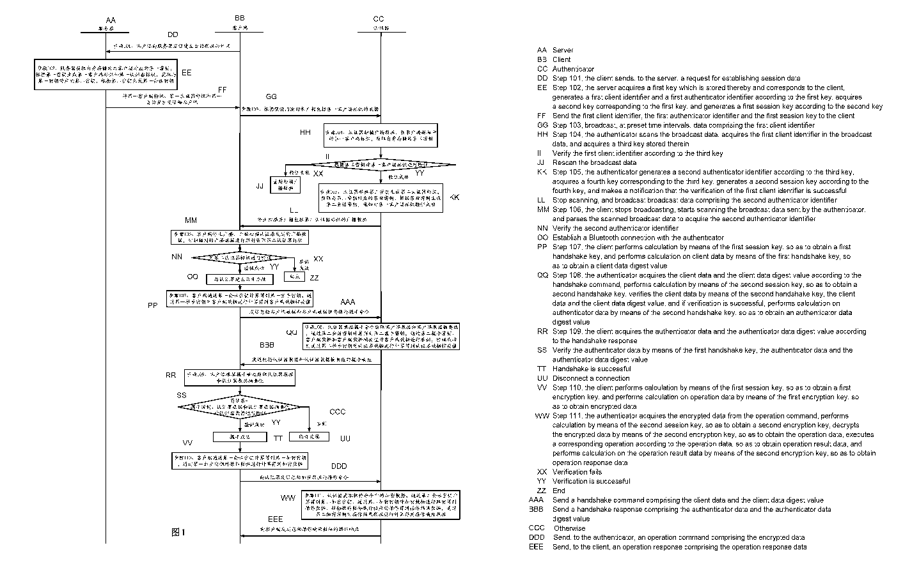
Figure 1: Example of drawing reduced to fit a large number of translated words on a single page

- The process of extracting the text from drawings, annotating the text segments within the drawing and adding the new text into the drawing is labor-intensive. The text appears in image format only and is not searchable. The addition of the text into the drawing frequently means that the original drawing itself needs to be significantly reduced in size to fit onto the page, making both the original and translated text difficult to read.

Proposed New Front Page Drawing Translation Format
- A new system for presenting text from the front page drawing is under development. In the new arrangement, the drawings will not be edited. Instead, the text will be presented as both original language and translated text beneath the drawing. The text from the drawing will be made available along with the abstract, allowing it to be searched.
(57) Resumen: Procedimiento de eliminación de contaminantes mediante electrofiltración La presente invención se refiere a un procedimiento de eliminación de contaminantes de un efluente, que comprende: - introducir el efluente en un reactor, que comprende - un cátodo enfrentado a - una membrana cerámica conductora que comprende óxido de estaño dopado con uno o más óxidos metálicos, que actúa simultáneamente como ánodo y como medio filtrante, y que separa el reactor en dos compartimentos, una cámara de reacción y una cámara de filtración, y - llevar a cabo una electrofiltración en la cual al menos parte del efluente a tratar se hace pasar desde la cámara de reacción a la cámara de filtración a través de la membrana cerámica conductora gracias a un gradiente de presión.

(57) Abstract: The present invention relates to a method for removing pollutants from an effluent, which comprises: - introducing the effluent into a reactor, which comprises - a cathode facing - a conductive ceramic membrane comprising tin oxide doped with one or more metal oxides, which acts simultaneously as an anode and as a filter medium, and which separates the reactor into two compartments, a reaction chamber and a filtration chamber; and - carrying out an electrofiltration in which at least part of the effluent to be treated is passed from the reaction chamber to the filtration chamber through the conductive ceramic membrane by means of a pressure gradient.

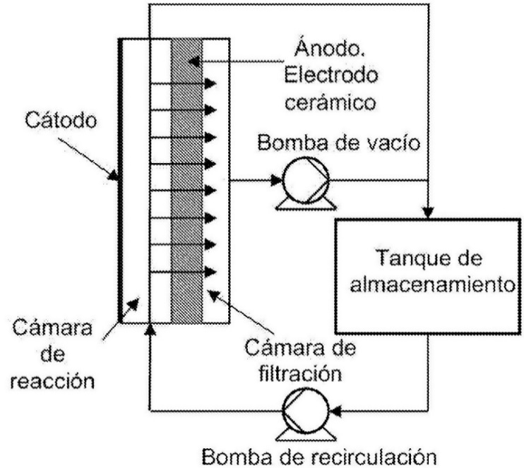

Figura 1

Cátodo Cathode
Cámara de reacción Reaction chamber
Ánodo, Electrodo cerámico Anode, ceramic electrode
Cámara de filtración Filtration chamber
Bomba de vacío Vacuum pump
Tanque de almacenamiento Storage tank
Bomba de recirculación Recirculation pump

Figure 2: Mockup of front page abstract and drawing text with translation in new format
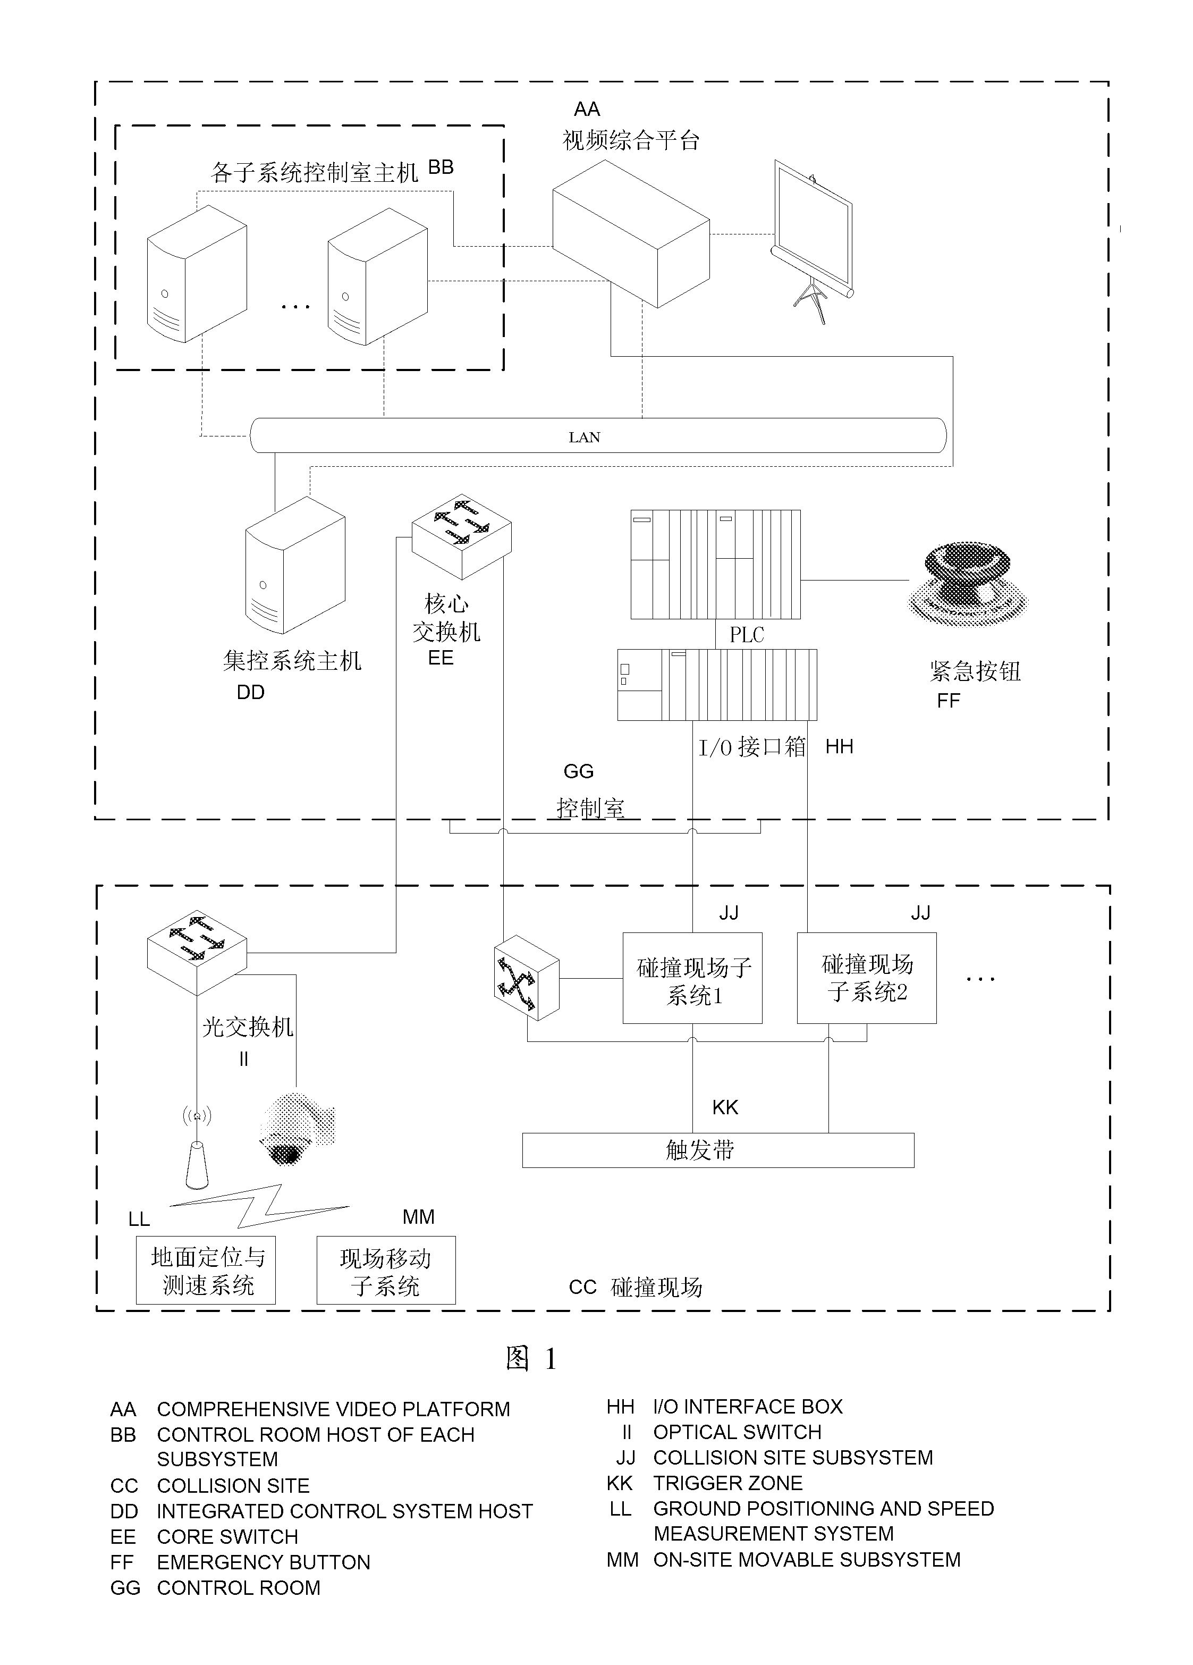
Figure 3: Example of a more general diagram with multiple words in current format

Other Issues
- In the longer term, consideration should be given to the circumstances in which text should be permitted in drawings and the appropriate number of words. Present Rule 11.11(a) and its national equivalents are routinely disregarded by applicants and Offices alike. It is clear that flowcharts are useful in helping to describe many types of invention and specific rules might be created to guide their presentation. However, other forms of drawings frequently also include significant numbers of words. It would be desirable if words in drawings, where truly necessary, were able to be recognized and included in the text available for searching. Further consideration should also be given to the extent to which translation of the text relating to the drawing is important and how any translation should be presented for easy use at acceptable cost.
- In principle, it would be desirable if drawings (including but not limited to flowcharts) that include text could present that text in machine-readable formats that preserve the logical grouping and relationships of text items. However, the options for creating such drawings are so varied that it does not appear practical to identify a standard allowing such drawings to be easily and reliably created and used. The International Bureau does not currently envisage making any proposals in this area, other than potentially for including as metadata any text content extracted manually for the purpose of the front page, or else through the system under development for extracting text from drawings referred to in paragraph 4, above.
- The Meeting is invited to note the contents of this document.

[End of document]

for the purposes of the Gazette, referring to Rules 86.1(i) and 86.2(a).

