WORLD INTELLECTUAL PROPERTY ORGANIZATION

SPECIAL UNION FOR THE INTERNATIONAL PATENT CLASSIFICATION
(IPC UNION)

IPCA6Trans - Installation manual

Date | By | Version | Status | Modification
April 11, 2006 | Moles | 0.1 | Draft | Creation
October 14, 2005 | Moles | 0.2 | Draft | Changes after first installation
November 25, 2005 | Moles | 0.3 | Draft | IPCA6Trans install
December 6, 2005 | Molés | 0.4 | Draft | Added infrastructure diagram
January 12, 2006 | Molés | 0.5 | Draft | Changed to new version of eXist
May 17, 2006 | Molés | 0.6 | Final | Added section “Upgrade IPCA6Trans”
January 29, 2007 | Molés | 0.7 | Final | Added section: Redirect IPCA6Trans to port 80
March 22, 2007 | Molés | 0.8 | Final | Changed version of eXist database.
February 7, 2008 | Fiévet | 1.3 | Validation | QC, strengthening language independence  (some screenshot to be updated)
April 15, 2008 | Conde | 2.3 | Final | Language independence
April 16, 2008 | Conde | 2.4 | Final | Language independence
April 30, 2008 | Collioud | 2.5 | Final | Language independence (correction)
September 30, 2009 | Conde | 2.6 | Final | Language and version independence.
January 29, 2010 | Conde | 2.7 | Final | MSXML 4 as prerequisite
May 30, 2012 | Conde | 2.8 |  | Formatting

Contact: WIPO: Patrick FIÉVET (patrick.fievet@wipo.int)

Table of Contents
IPCA6Trans - Installation manual 1
1. Introduction 5
2. Prerequisites 6
2.1. Windows 6
2.2. MSXML 4.0 6
2.3. Apache 7
2.4. PHP 7
Java 7
2.4.1. Java 2 Standard Edition 7
2.4.2. Jakarta Tomcat 7
2.4.3. Apache-Tomcat JK2 Connector 8
2.5. eXist 8
3. MSXML installation 9
3.1.1. Prerequisites 9
3.1.2. Install 9
4. Server installation 12
4.1. Install Apache 12
4.1.1. Prerequisites 12
4.1.2. Install 12
4.1.3. Test 20
4.2. Install PHP 22
4.2.1. Prerequisites 22
4.2.2. Install 22
4.2.3. Test 23
4.3. Java installation 25
4.3.1. Prerequisites 25
4.3.2. Install J2SE Runtime Environment 25
4.3.3. Install Jakarta Tomcat 27
4.3.4. Test Tomcat 35
4.3.5. Install JK2 Connector 36
4.3.6. Test JK2 Connector 38
4.4. Install eXist 39
4.4.1. Prerequisites 39
4.4.2. Install eXist 39
4.4.3. Test exist 39
4.4.4. Configure eXist 40
4.4.5. Install eXist client tool 41
4.4.6. Test eXist client 47
4.5. Install IPCA6Trans 49
4.5.1. Prerequisites 49
4.5.2. Install IPCA6Trans 49
4.5.3. Test IPCA6Trans 53
5. Client side installation 54
5.1. General Technical requirements 54
5.2. Test 54
5.3. JRE Configuration 54
5.4. Technical Requirements for user IPCA6TRANS Data Manager 57
5.4.1. Component existent verification 58
5.4.2. Component installation 58
5.5. Technical requirements for user Translators coordinator 59
5.6. Technical requirements for user Translator/Revisor/QA 59
6. Security settings: Redirecting IPCA6Trans application to default port 80 and setting authentication (optional) 62
6.1. Test new settings 63
7. Server upgrade 64
7.1. Upgrade of IPCA6Trans 64
7.1.1. Uninstall of IPCA6Trans 64
7.1.2. Installation of a new version of IPCA6Trans 66
7.2. Upgrade of eXist database 68
7.2.1. Backup of the data 68
7.2.2. Uninstall current version of eXist 70
7.2.3. Recovery of the data 71

Introduction
This is the guide to install all the software needed for using the IPCA6Trans toolkit. IPCA6Trans is a web-based application hosted in an Apache web-server with PHP and Tomcat. The clients connect to the application through the network as shown in Figure 1.
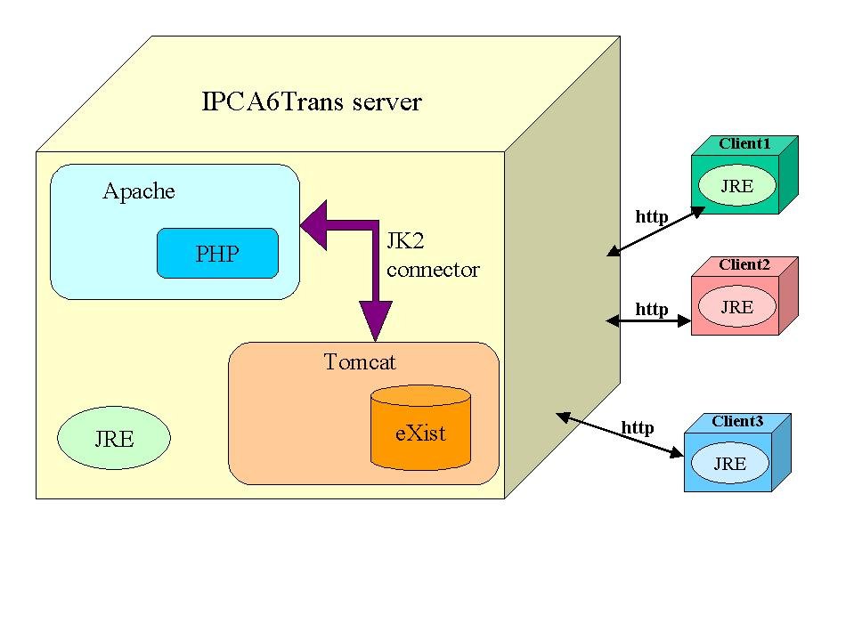
Figure 1 – IPCA6Trans infrastructure
This guide is divided in two parts, the installation on the server side and the installation on the client machines.
In section 3 - MSXML installation, the guide describes how to install and configure Apache web-server with PHP and Tomcat on a Windows XP machine. If you have already all these prerequisites installed, you can go directly to the section 4.5 - Install IPCA6Trans.
The client machines only need the installation of JRE.

Prerequisites
Before we get started, we need to download all the appropriate components. If you are installing the software from the IPCA6Trans CD, go directly to section 2.2 - MSXML 4.0.
Versions used:
Application | Version
Windows | XP SP2
MSXML | 4.0
Apache | 2.0.54
PHP | 5.0.5
Tomcat | 5.5.12
Java 2 Standard Edition | 5.0 Update 5
EXist database | 1.1.1

For easier use of the documentation, before the installation, make sure file extensions are visible.
Use exactly software version indicated in this documentation as other were not tested but incompatibilities were experimented.

Windows
Version: Windows XP SP2
This guide is written for Windows XP. However, it should work fine with Windows 2000. Under Windows 2000, remember to replace C:\WINDOWS with C:\WINNT wherever you see it in this document.

MSXML 4.0
From the Microsoft Dowload center, download MSXML 4.0. Click in the “Download” button in the right side of msxml.msi

- Version: 4.0
- File Name: msxml.msi
- Download: Location: http://www.microsoft.com/downloads/details.aspx?familyid=3144b72b-b4f2-46da-b4b6-c5d7485f2b42&displaylang=en

Apache
From the Apache HTTPD download page, download the latest Win32 Binary (MSI Installer). The latest version should be under a section titled "the best available version".
- Version: 2.0.54
- File Name: apache_2.0.54-win32-x86-no_ssl.msi
- Download Location: http://httpd.apache.org/download.cgi

PHP
On the PHP download page, click on the zip package under the Windows Binaries section. Click on PHP 5.0.5 zip package and choose a mirror to begin downloading.
- Version: 5.0.5
- File Name: php-5.0.5-Win32.zip
- Download Location: http://www.php.net/downloads.php

Java

Java 2 Standard Edition
Visit http://java.sun.com/javase/downloads/index.jsp and click on the link “Download JRE 6 Update 4” on the JRE 6 Update 4 section. Accept the license agreement and download Windows Offline Installation, Multi-language.
- Version: J2SE Runtime Environment 6 Update 4
- File Name: jre-6u4-windows-i586-p.exe
- Download Location: http://java.sun.com/javase/downloads/index.jsp

Jakarta Tomcat
On the Jakarta Tomcat 5 Download page, look for the 5.0.28 bullet and click on the 5.0.28 exe link to begin downloading.
- Version: 5.0.28
- File Name: jakarta-tomcat-5.0.28.exe
- Download Location: http://jakarta.apache.org/site/downloads/downloads_tomcat-5.cgi

Apache-Tomcat JK2 Connector
Until Apache 2.1 is out, we have to deal with the JK2 connector to connect Apache to Tomcat. Download the latest JK 2 Binary Release from the Jakarta site and click on the file named “jakarta-tomcat-connectors-jk2.0.4-win32-apache2.0.49.zip”.
- Version: 2.0.4
- File Name: jakarta-tomcat-connectors-jk2.0.4-win32-apache2.0.49.zip
- Download Location: http://www.apache.org/dist/tomcat/tomcat-connectors/jk2/binaries/win32/

eXist
On the eXist download page, click on the jar and war file under the Stable version section. Choose a mirror to begin downloading.
- Version: 1.1-newcore
- File Name: eXist-1.1.1-newcore.jar
- File Name: exist-1.1.1-newcore.war
- Download Location: http://exist.sourceforge.net/index.html#download

MSXML installation

Prerequisites
- Version: 4.0
- File Name: msxml.msi

Install
2. Run msxml.msi located in the directory MSXML from the installation CD. Click Next> in the first screen.
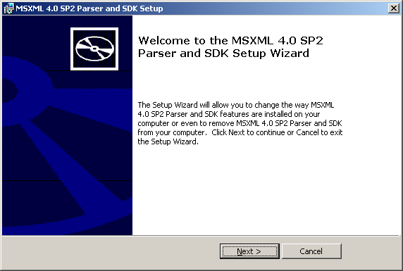

Figure 2 Installing MSXML, step 1

2. Click in “I accept the terms in the License Agreement” and click in Next >

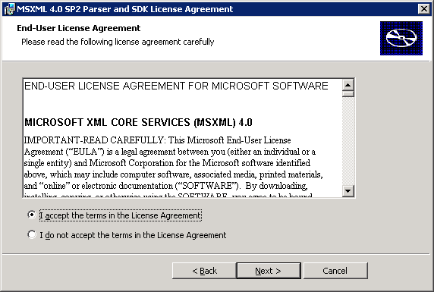

Figure 3 Installing MSXML, step 2
3. Write down your User Name and Organization and click in Next >
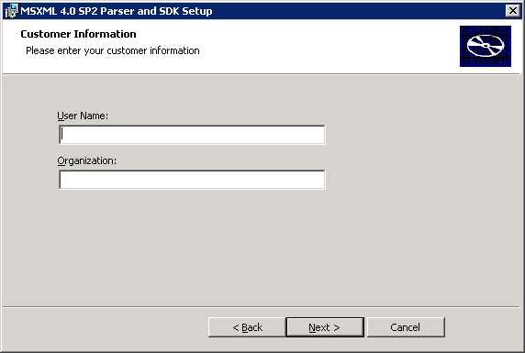

Figure 4 Installing MSXML, step 3

4. Click in Install Now
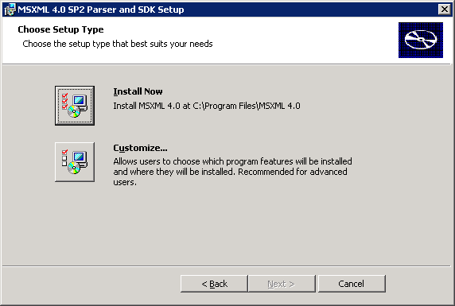
Figure 5 Installing MSXML, step 4

Figure 6 Installing MSXML, step 5

5. Once the installation is completed click in Finish
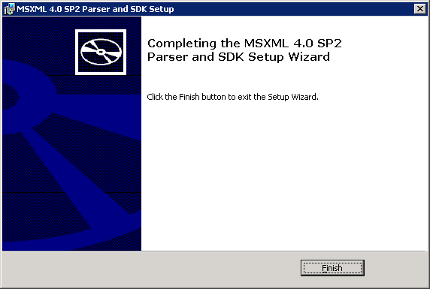

Figure 7 Installing MSXML, step 5

Server installation

Install Apache
For all the installation proceed as described in this document. For installation you need administrator privileges on the machine.

Prerequisites
- Version: 2.0.54
- File Name: apache_2.0.54-win32-x86-no_ssl.msi

Install
1. Run apache_2.0.54-win32-x86-no_ssl.msi located in the directory Apache from the installation CD. Click Next> in the first screen.
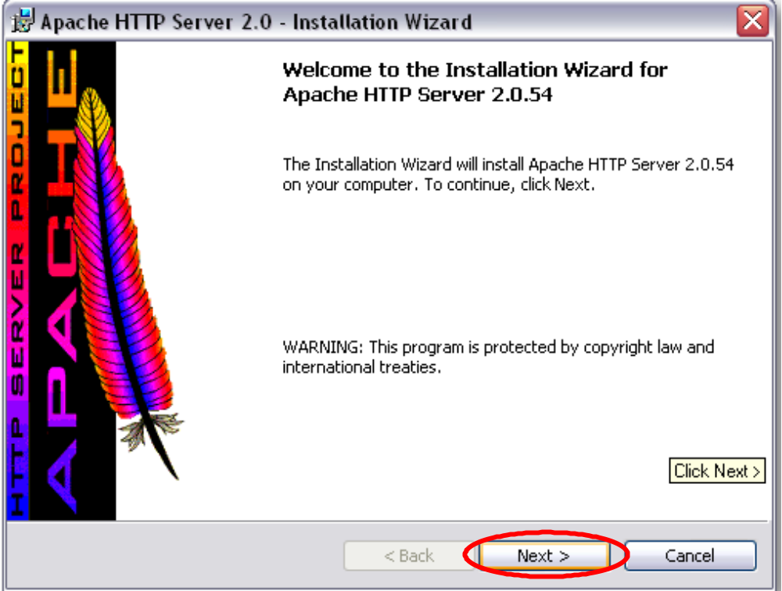
Figure 8 Installing Apache, step 1

2. Choose "I accept the terms in the license agreement", and then click Next >.

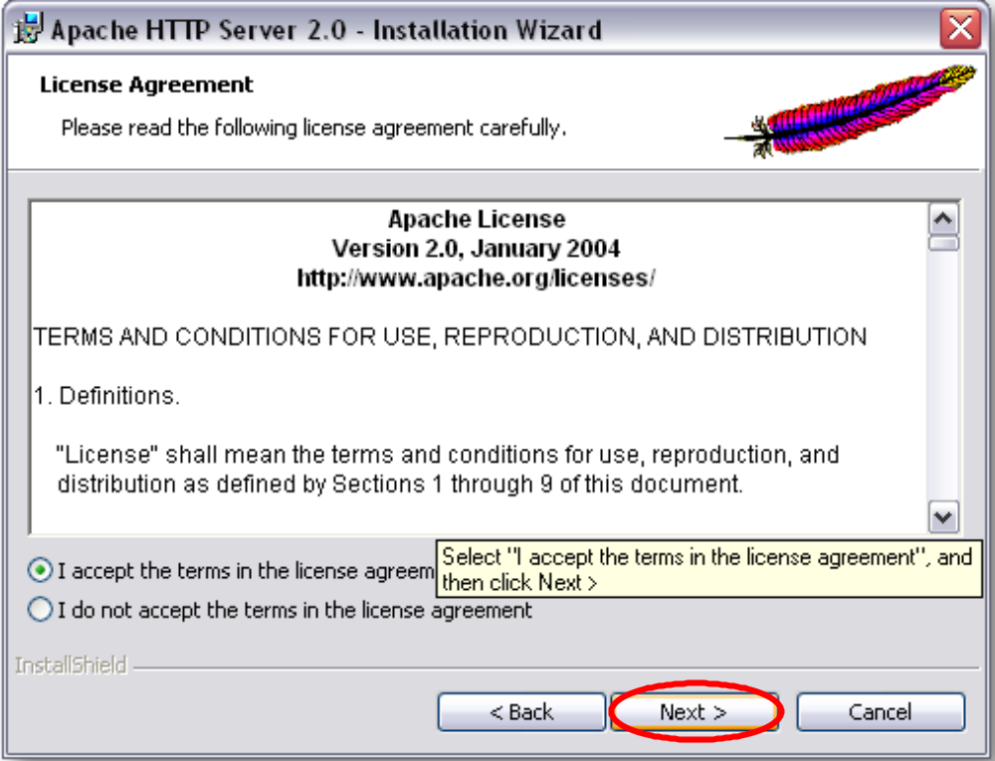
Figure 9 Installing Apache, step 2
3. Click Next >.
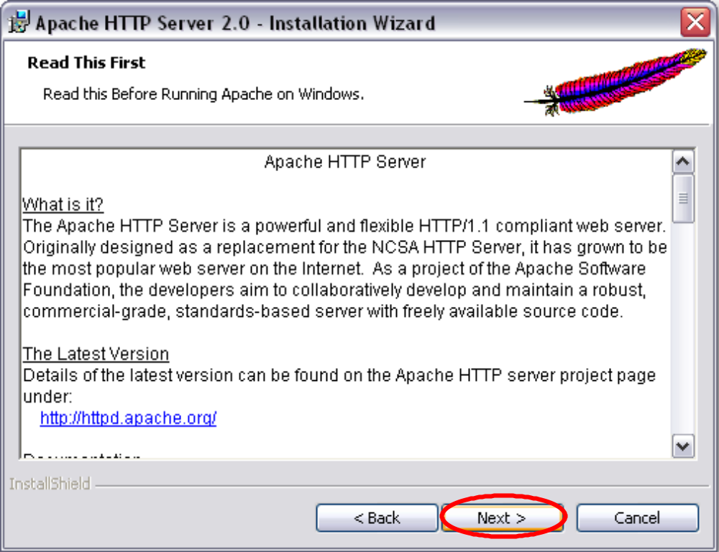
Figure 10 Installing Apache, step 3
4. Fill in the appropriate information. If you do not know what to enter, you can put in localhost for the network domain and server name, (Update the useful information table in the IPCA6TRANS user manual) select "for All Users, on Port 80, as a Service", and then click Next >.
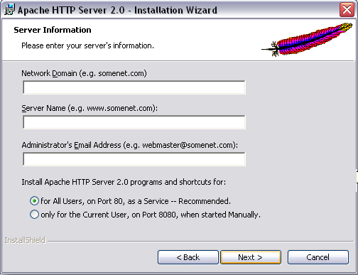
Figure 11 Installing Apache, step 4
5. Choose "Typical", and then click Next >.

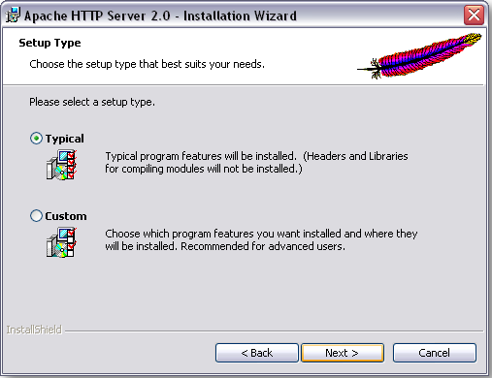
Figure 12 Installing Apache, step 5
6. Click Next >.

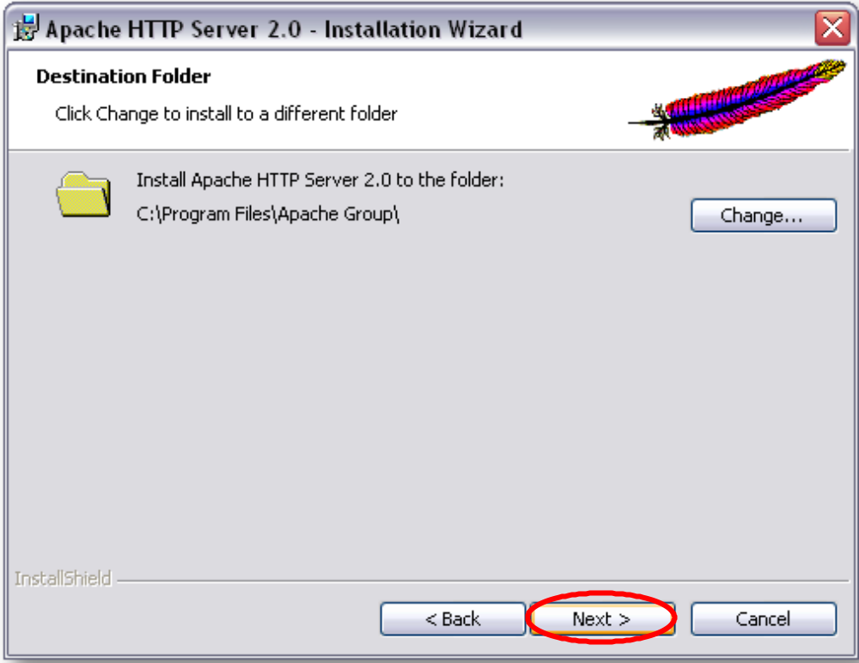
Figure 13 Installing Apache, step 6
7. Click Install.

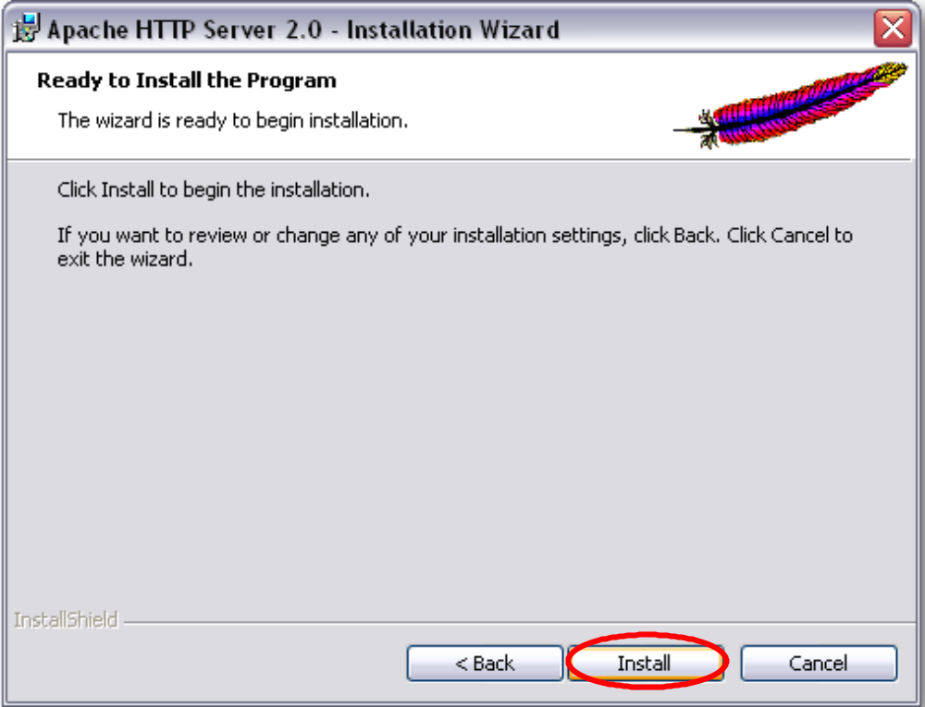
Figure 14 Installing Apache, step 7
8. Click Finish.

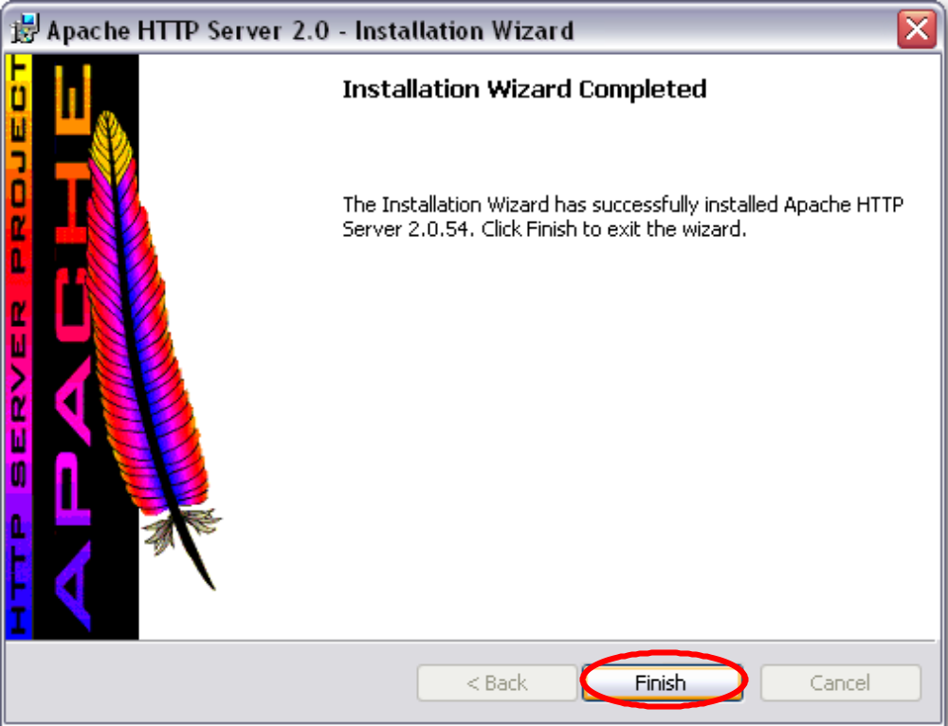
Figure 15 Installing Apache, step 8

Test
Open http://localhost/ in a web browser. If you see something like Figure 16, then the Apache installation is working properly.
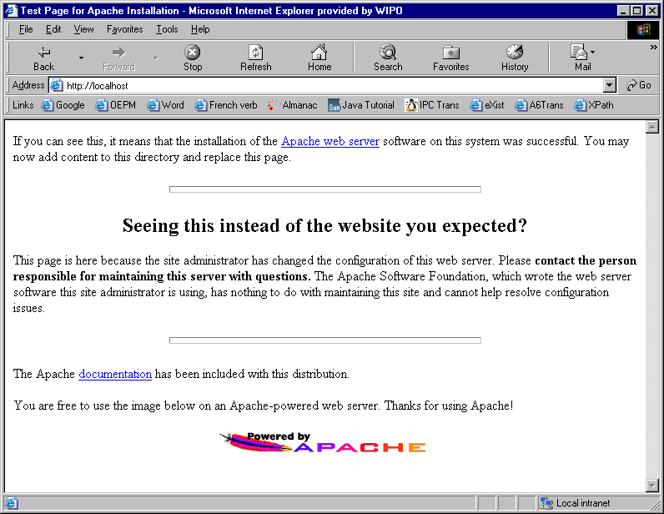
Figure 16 Testing the Apache installation

If you have Windows Firewall enabled (check it in Start → Control Panel → Network and Internet Connections → Change Windows Firewall settings), the first time you access to the Apache welcome page, it will appear the screen shown in Figure 17. Select Unblock on the Windows Security Alert. For other firewalls, make sure port 80 is open.
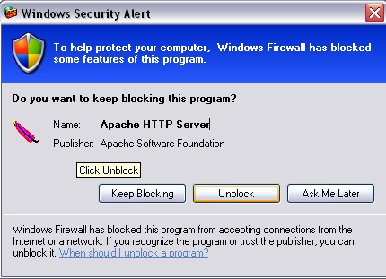
Figure 17 Windows Security Alert window

In the system tray there is a new icon (Figure 18). Single left-click on it to get a menu (Figure 19) that allows Apache HTTPD service management (to start, stop or restart it).

Figure 18 Apache management icon

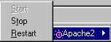
Figure 19 After single click on Apache management icon

Install PHP

Prerequisites
- Version: 5.0.5
- File Name: php-5.0.5-Win32.zip

Install
- From the PHP folder on the installation CD, extract php-5.0.5-Win32.zip to C:\php.
- Create a copy of c:\php\php-ini-recommended.ini and rename it to c:\php\php.ini.
- Open php.ini with a text editor (e.g. Notepad) and change the following lines, and then save it.
  - Search for “include_path” and uncomment (i.e. remove the ; semicolon symbol) the include_path for Windows.
include_path = ".;c:\php\includes"

  - Search for “extension_dir” and change it to:
extension_dir = "C:\php\ext"

  - Search for “doc_root” and change it to match your httpd.conf DocumentRoot directory.
doc_root = "C:\Program Files\Apache Group\Apache2\htdocs"

  - Search the section “extension” and uncomment the lines to able the XML formatting.
extension=php_xmlrpc.dll
extension=php_xsl.dll

  - Search for “session.save_path”. Uncomment the line and set the path to:
session.save_path = "C:\Temp"

  - Search for “session.cookie_path” and change it to:
session.cookie_path = \
- Add C:\php to your PATH System Environment Variable
- From your Desktop, right-click on My Computer and choose Properties.
- Select the Advanced tab.
- Click Environment Variables.
- Under System variables, select “Path” and press the Edit button.
- Move the cursor to the end of the string and add ;C:\php.
- Click OK.
- Click OK.
- Open the httpd.conf file located at C:\Program Files\Apache Group\Apache2\conf\

  - Search for “LoadModule” and add at the end of this section the following line.
LoadModule php5_module "c:/php/php5apache2.dll"

  - Search for “DirectoryIndex” and add index.php
DirectoryIndex index.php index.html index.htm index.html.var

  - Search for “AddType” and add at the end of this section the following line. Note the white space between x-httpd-php and .php:
AddType application/x-httpd-php .php

  - After the just added line, add:
PHPIniDir "C:/php"

Test
- Restart Apache. Click on the Apache system tray icon, and choose Apache 2 > Restart.
- Open http://localhost/ in a web browser. If you see the Apache welcome page, then Apache restarted successfully.
- Copy the file phpinfo.php from the CD to C:\Program Files\Apache Group\Apache2\htdocs. If you prefer, you can create it by hand. To do so, create a new text file called phpinfo.php under C:\Program Files\Apache Group\Apache2\htdocs and copy the following into it.
<?php phpinfo();?>
- Open http://localhost/phpinfo.php in a web browser. If you see something like the Figure 20, then PHP is working properly.

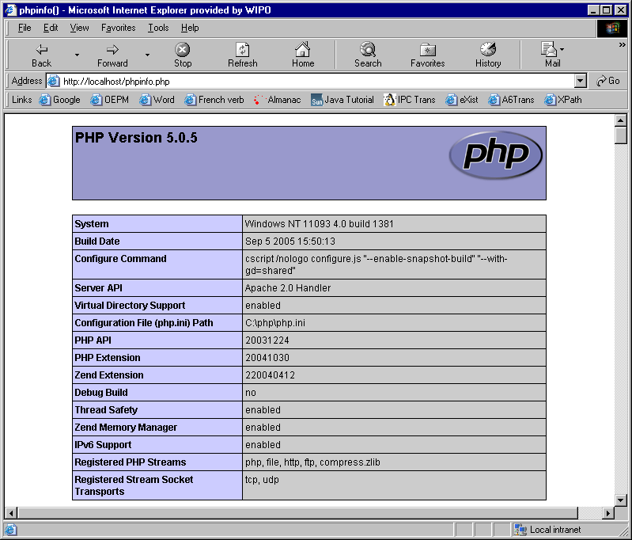
Figure 20 Testing the PHP installation

Java installation

Prerequisites
- J2SE Runtime Environment 6.0 Update 4 (jre-6u4-windows-i586-p.exe)
- Jakarta Tomcat 5.0.28 (jakarta-tomcat-5.0.28.exe)
- Tomcat JK2 Connector 2.0.4 (jakarta-tomcat-connectors-jk2.0.4-win32-apache2.0.49.zip)

Install J2SE Runtime Environment
- From the Java folder on the IPCA6Trans CD, run jre-6u4-windows-i586-p.exe. Select "I accept the terms in the license agreement", and then click Next >.

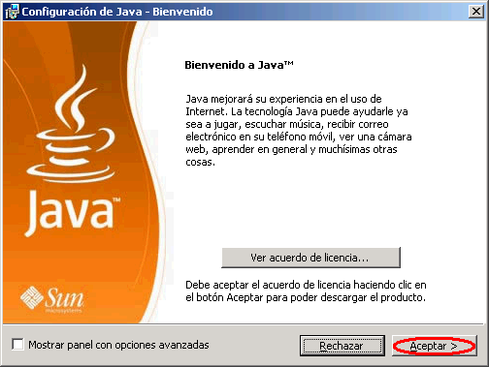
Figure 21 Java installation, step 1

- Click Finish.

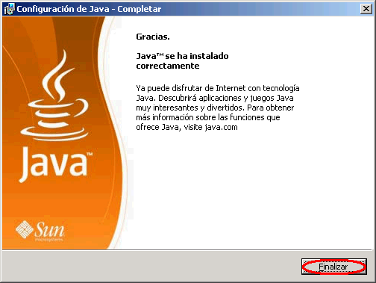
Figure 22 Java installation, step 3.

Install Jakarta Tomcat

- From the Java folder on the IPCA6Trans CD, run jakarta-tomcat-5.0.28.exe. Click Next >.

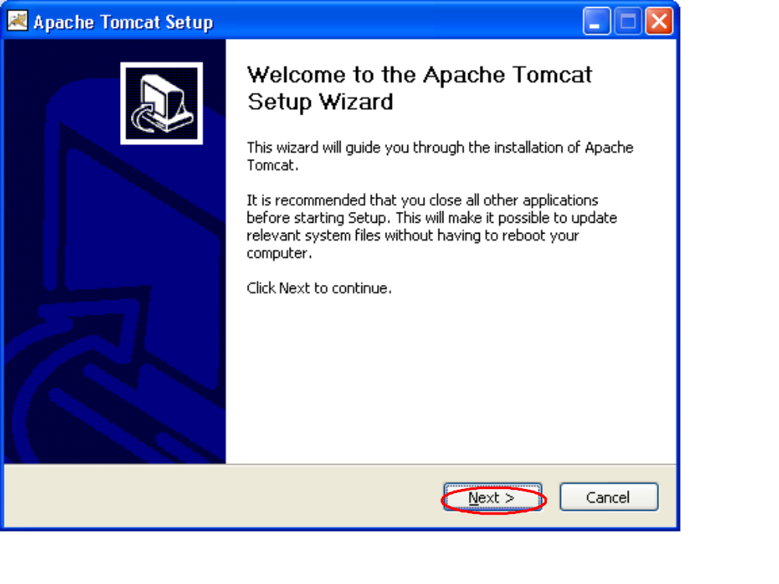
Figure 23 Tomcat installation, step 1
- Click I Agree.

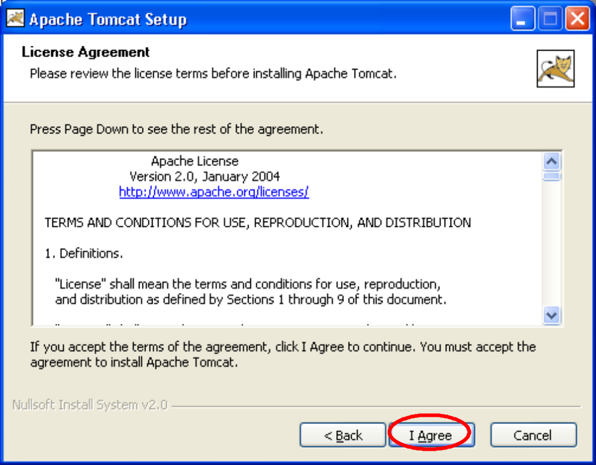
Figure 24 Tomcat installation, step 2
- Select "Full" from the dropdown, and then click Next >.

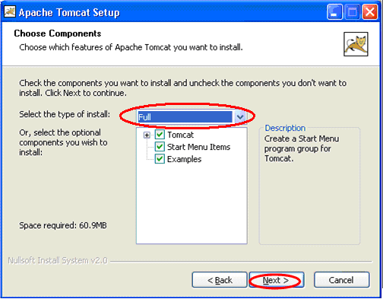
Figure 25 Tomcat installation, step 3
- Click Next >.

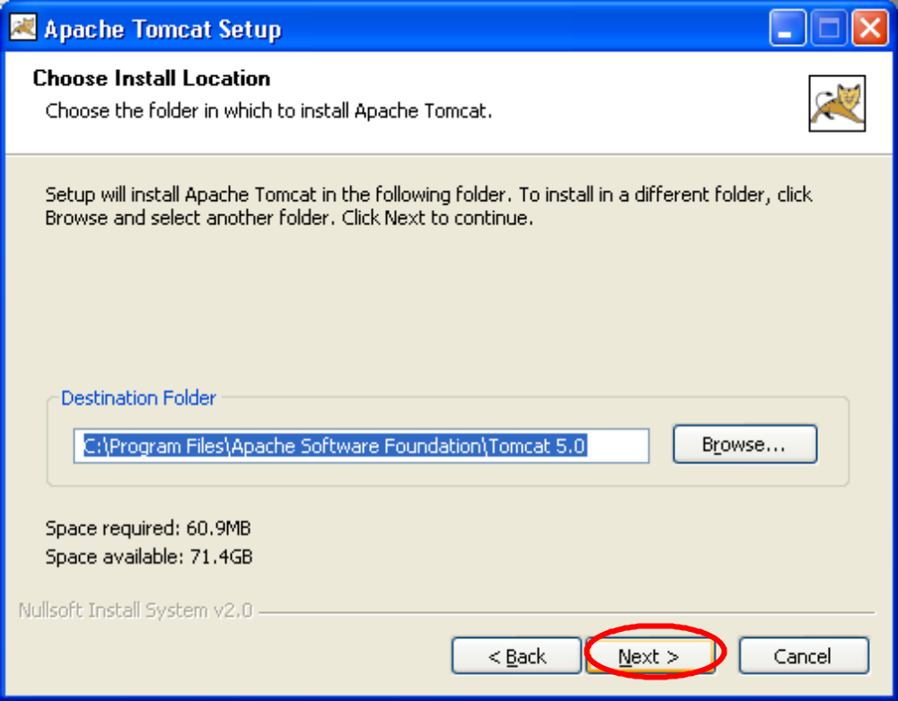
Figure 26 Tomcat installation, step 4
- It is not necessary to enter an admin password (tested without). Click Next >.

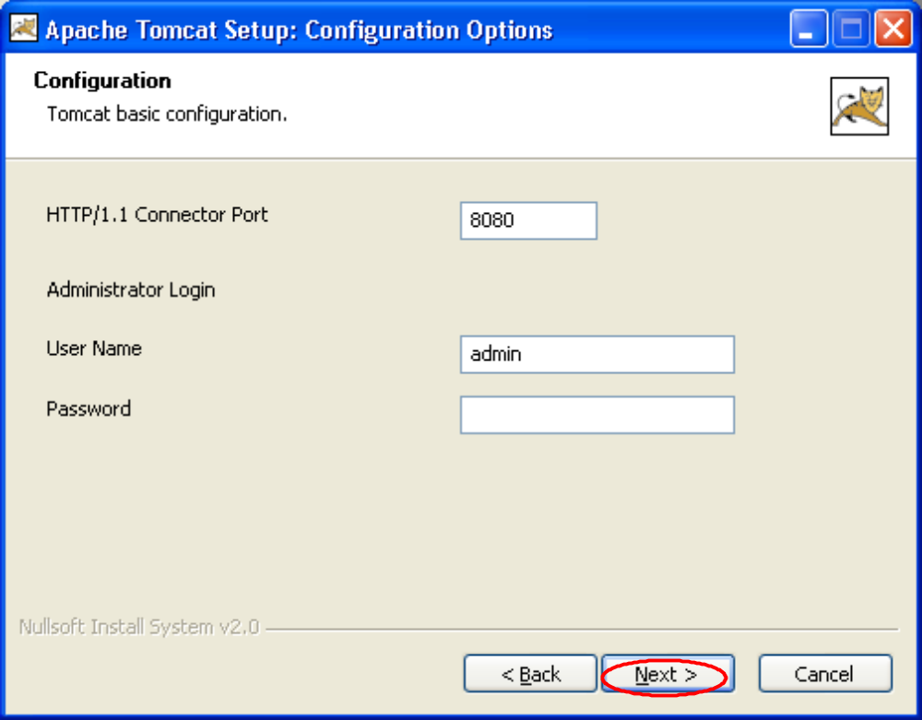
Figure 27 Tomcat installation, step 5
- Verify the J2SE 5.0 JRE installation path is correct, and then click Install.

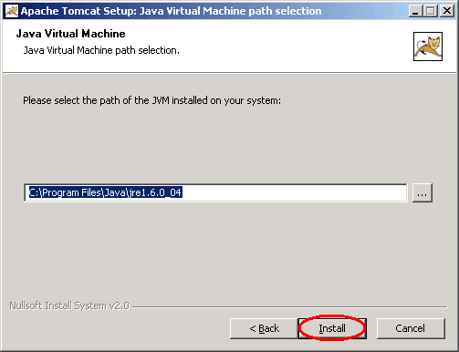
Figure 28 Tomcat installation, step 6
- Uncheck "Show Readme", and then click Finish.

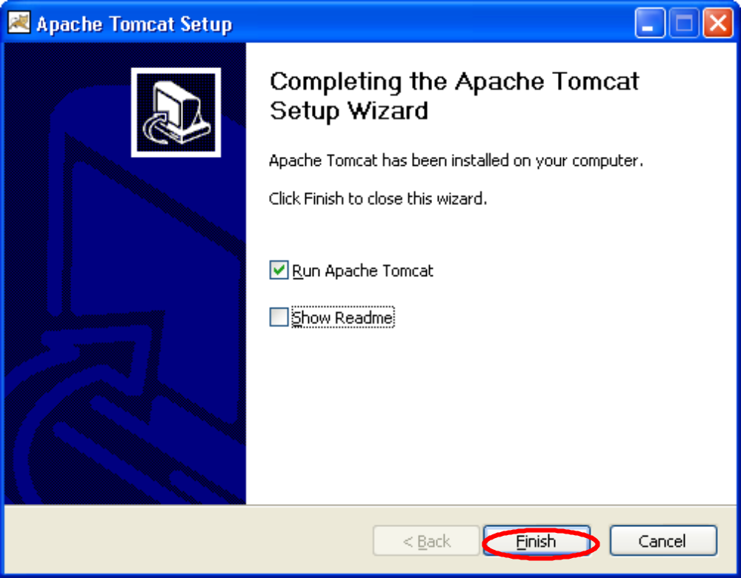
Figure 29 Tomcat installation, step 7

In the system tray, there will be a new icon to manage the Tomcat service.
Usually this icon disappears after the first log out, so we recommend you to create a shortcut in the Desktop. Open an Explorer window and go to C:\Program Files\Apache Software Foundation\Tomcat 5.0\bin. Select tomcat5w.exe, right-click on it and “Create shortcut”, then move it to the Desktop. When double-clicking on it, you will see the service management window like Figure 30.

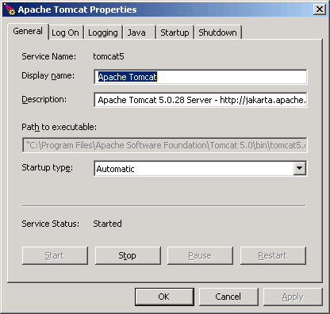
Figure 30 Tomcat service manager

Click on Start to start the Service. At the bottom, you should now see the following:

Figure 31 Tomcat management

Test Tomcat

Open http://localhost:8080/ in a web browser. If you see something like Figure 32, then Tomcat has been successfully installed.

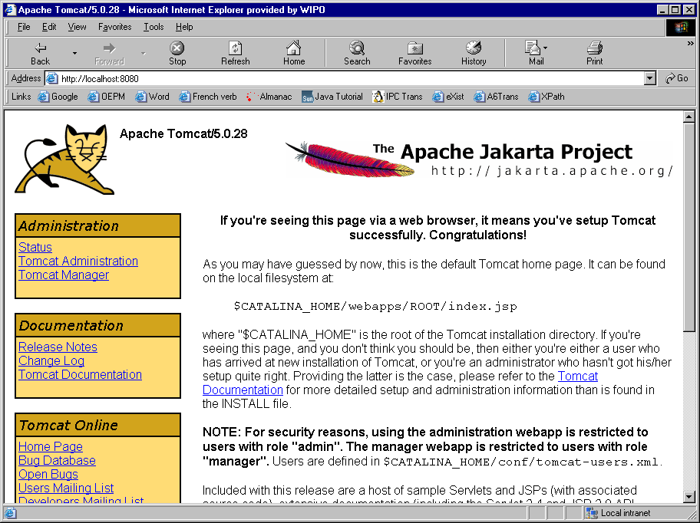
Figure 32 Testing the Tomcat installation

Install JK2 Connector
- From the Java folder on the IPCA6Trans CD open the file jakarta-tomcat-connectors-jk2.0.4-win32-apache2.0.49.zip with Winzip. Extract this zip file to

C:\Program Files\Apache Group\Apache2\

(i.e. mod_jk2.so should appear under C:\Program Files\Apache Group\Apache2\modules

Note that the option “Use folder names” must be not selected.

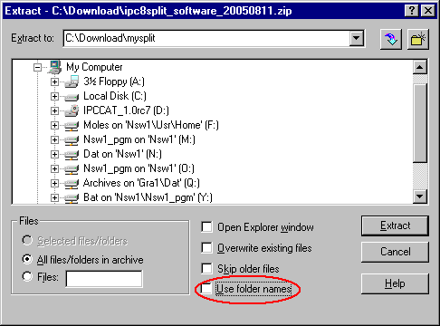

- Open the httpd.conf file located at C:\Program Files\Apache Group\Apache2\conf\
  - Search for "LoadModule" and add the following line at the end of the section.
LoadModule jk2_module modules/mod_jk2.so

- Copy the file workers2.properties located under Java on the IPCA6Trans CD to C:\Program Files\Apache Group\Apache2\conf. Or you can create it copying the following text.
[shm]
file=C:\Program Files\Apache Group\Apache2\logs\jk2.shm
size=1048576
# socket channel
[channel.socket:localhost:8009]
port=8009
host=127.0.0.1
# worker for the connector
[ajp13:localhost:8009]
channel=channel.socket:localhost:8009
[status:status]
[uri:/status/*]
worker=status:status
[uri:/jsp-examples/*]
worker=ajp13:localhost:8009
[uri:/*.jsp]
worker=ajp13:localhost:8009

- Open the file jk2.properties file located in C:\Program Files\Apache Software Foundation\Tomcat 5.0\conf\ and add the following lines to the end of it.

handler.list=channelSocket,request
channelSocket.port=8009
channelSocket.address=127.0.0.1

Test JK2 Connector
- Stop both Tomcat and all Apache services and
- Start Tomcat(possibly twice), and then start Apache services. Note: Always start Tomcat first, and then start Apache server. If you have to bounce Tomcat, remember to take down Apache first and restart it after Tomcat is up and running.
- Open http://localhost:8080/ in a web browser. If you see the Tomcat welcome page, then Tomcat restarted successfully.
- Open http://localhost/ in a web browser. If you see the Apache welcome page, then Apache restarted successfully.
- Open http://localhost/phpinfo.php in a web browser. If you see the PHP info page, then PHP loaded successfully.
- Open http://localhost:8080/jsp-examples/ in a web browser. If you see something like Figure 33, then JK2 connector has been successfully installed.

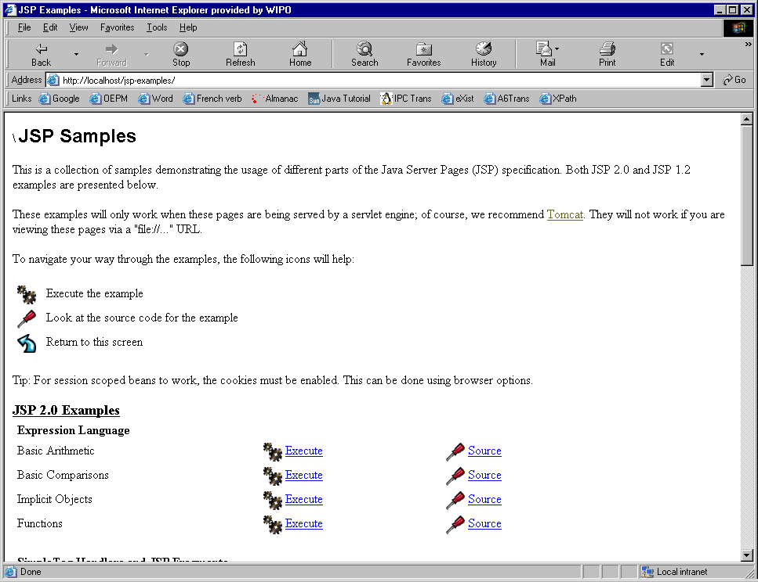
Figure 33 JK2 connector testing

Install eXist

Prerequisites
- Version: eXist 1.1-newcore
- File Name: eXist-1.1.1-newcore.jar and exist-1.1.1-newcore.war

Install eXist
- Stop Tomcat
- From the eXist folder on the IPCA6Trans CD, move the file exist-1.1.1-newcore.war into the folder C:\Program Files\Apache Software Foundation\Tomcat 5.0\webapps and rename this file to exist.war
- Start Tomcat. It will unpack automatically the file and it will create a new directory called exist.

Test exist

Open http://localhost:8080/exist in a web browser. If you see something like Figure 34, then eXist has been successfully installed.

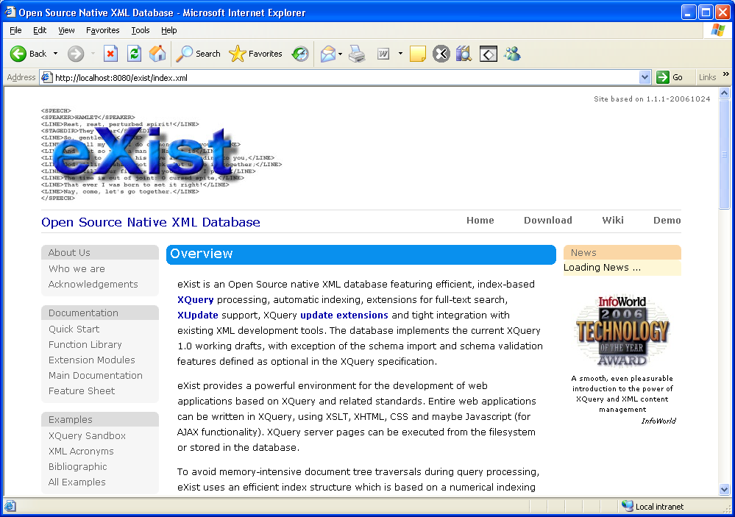
Figure 34 Testing eXist installation

Configure eXist
- Open http://localhost:8080/exist in a web browser.
- Scroll down the page and click on Admin in the left side of the screen.
- Enter admin the username field and keep the password field empty. Click on Submit query. NOTE that the password for the admin user must not be changed, since the application for the translation support will not work properly.
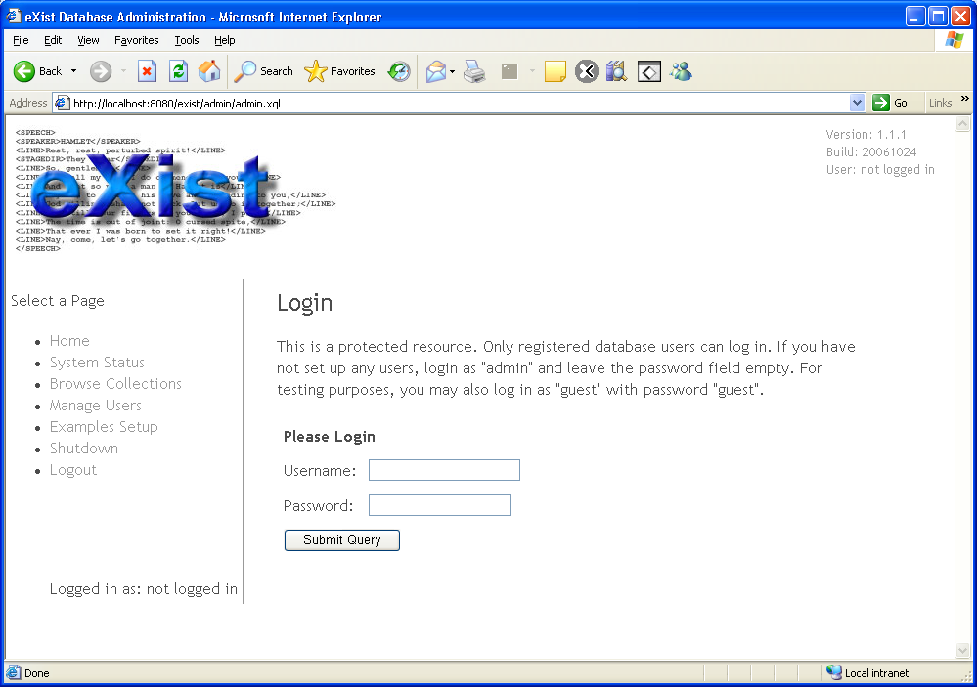
Figure 35 eXist log in

Install eXist client tool

- From the eXist folder on the IPCA6Trans CD, run eXist-1.1.1-newcore.jar with double-click. Click Next >.

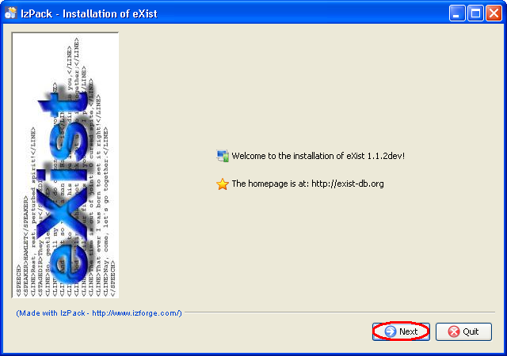
Figure 36 eXist installation, step 1
2. Uncheck sources and javadoc and press Next>.

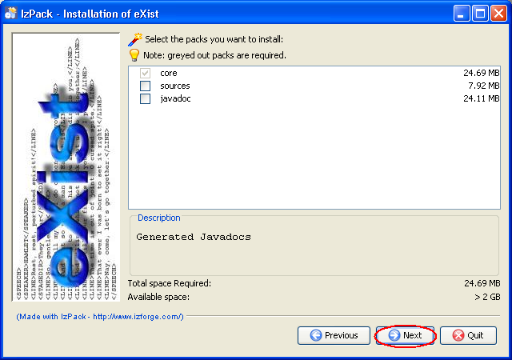
Figure 37 eXist installation, step 2
3. Click Next>.

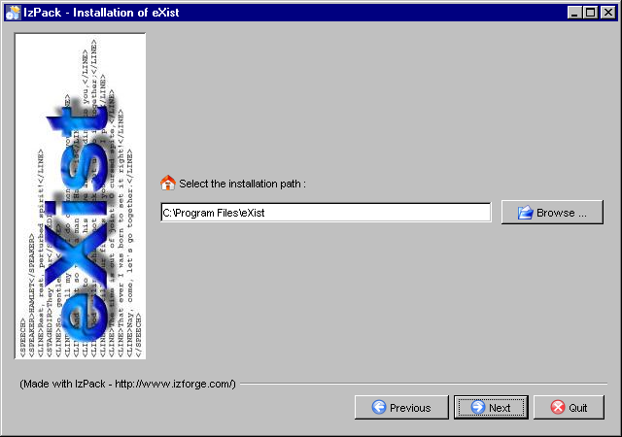
Figure 38 eXist installation, step 3
4. Click OK.
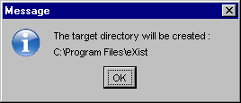
Figure 39 eXist installation, step 4
5. Click Next >.

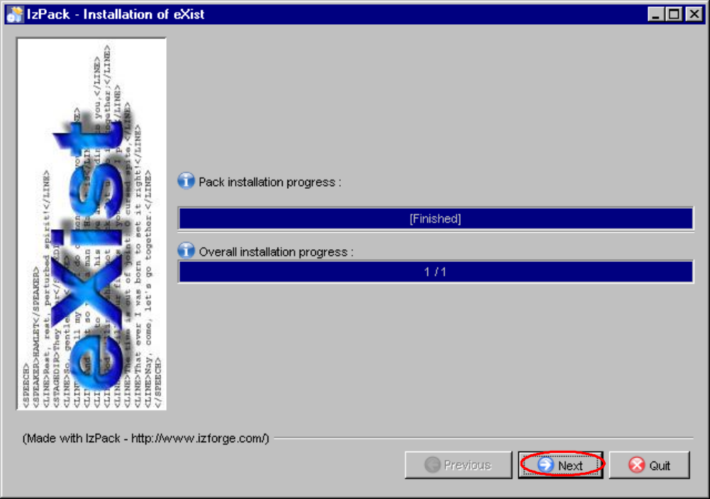
Figure 40 eXist installation, step 5

6. Select “current user” and click Next>.

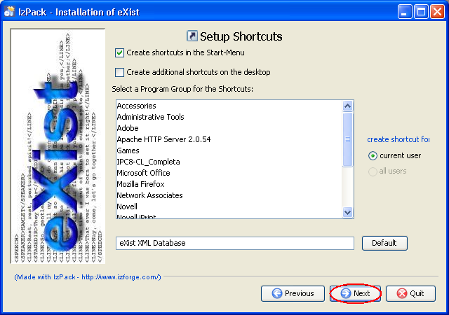
Figure 41 eXist installation, step 6
7. Click Next>.

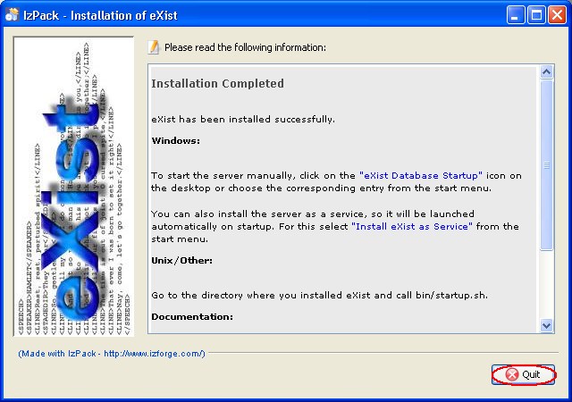
Figure 42 eXist installation, step 7

Test eXist client
- Run the client from the shortcut created in Start > Programs > eXist XML Database > eXist client Shell. Note that Tomcat must be running.
- Enter the password for the admin user and click OK.
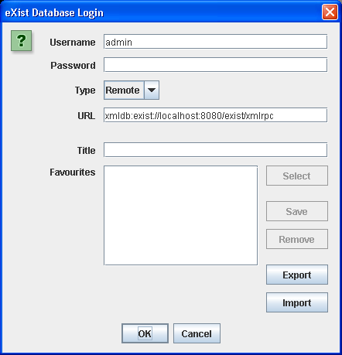
Figure 43 eXist client login

- The client GUI will appear.

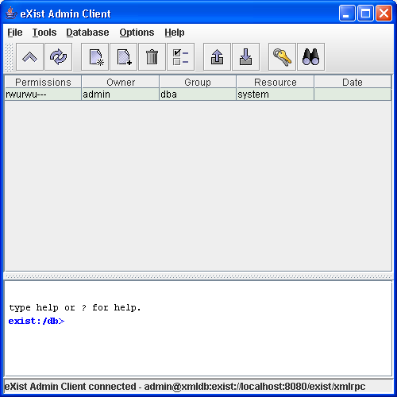
Figure 44 eXist client application

Install IPCA6Trans

Prerequisites
- Apache enabled to recognize PHP pages.
- PHP modules enabled for xmlrpc and xsl.
- Tomcat with JK2 module enabled.
- JRE
- eXist database.

Install IPCA6Trans
- Stop Apache
- Stop Tomcat
- From the IPCA6Trans Editor folder on the IPCA6Trans CD, run the installer ipca6trans_setup.exe
  - The first screen presents the installation program. Press “Next”.
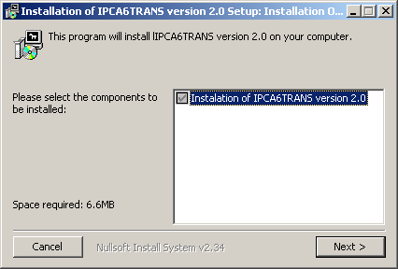
Figure 45 IPCA6TRANS installation, step 1
  - Select the path where Apache Tomcat is installed. If you have not changed it, keep the default one and press “Install”.
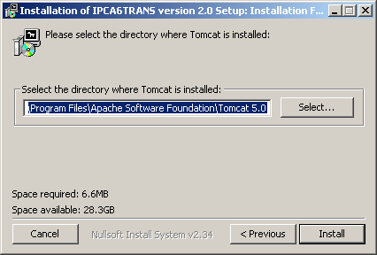
Figure 46 IPCA6TRANS installation, step 2
  - Once IPCA6TRANS is installed in the server, press button “Close”.
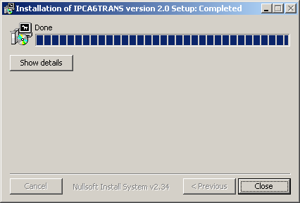
Figure 47 IPCA6TRANS installation, step 3

- Open C:\Program Files\Apache Group\Apache2\conf\httpd.conf (e.g. Notepad) and add the following lines, and then save it.
  - Search for “Alias” section and add an alias for the directory hosting the Web application at the beginning of the section.
Alias /ipca6trans "C:/Program Files/ipca6trans/"
<Directory "C:/Program Files/ipca6trans/">
Options Indexes MultiViews
AllowOverride None
Order allow,deny
Allow from all
</Directory>

  - Search for “DirectoryIndex” line and add index.htm after index.php.

- Start Tomcat. It will unpack automatically the file and it will create a new directory called ipca6transEditor.
- Stop Tomcat.
- Edit the following files a) and b) located in directory
C:\Program Files\Apache Software Foundation\Tomcat 5.0\webapps\ipca6transEditor
a) ipca6transManagerSplit.jnlp
b) ipca6transManagerUnSplit.jnlp
In these files, change <argument>en</argument> to <argument>xx</argument> where xx is your targeted translation language code (ISO 639-1) in lowercase.

- Open a web browser pointing to http://localhost/ipca6trans/admin/configureserver.php. It will appear the following screen.
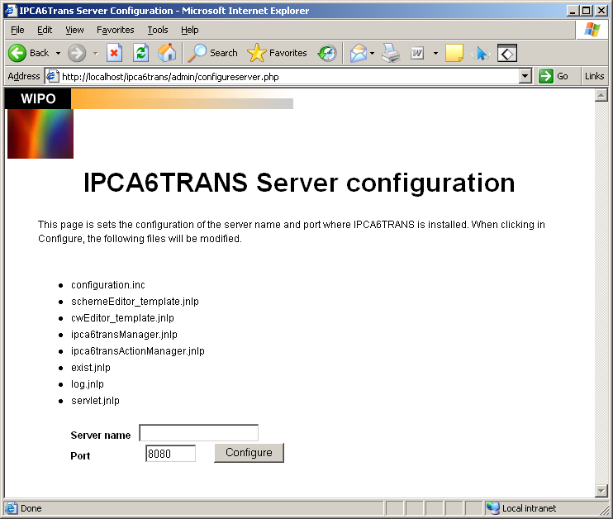
Figure 48 IPCA6TRANS server configuration

  - Enter the name of the server (e.g. myserver.mydomain.org or localhost if only one computer is used as server and client) and the port where Tomcat is listening (8080 by default) and press Configure button. It will apply the server configuration to the list of files shown.

Test IPCA6Trans

Open http://localhost/ipca6trans in a web browser. If you see something like Figure 49, then the tool has been successfully installed.

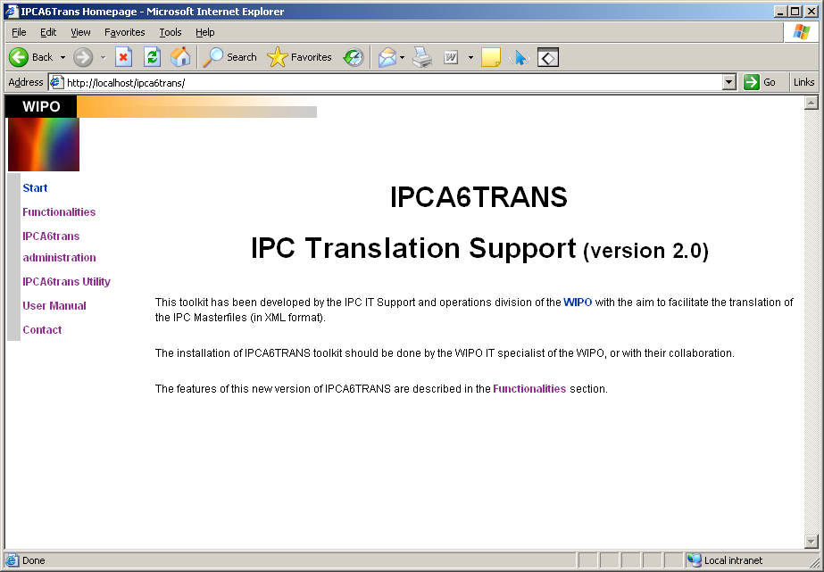
Figure 49 IPCA6TRANS main page

Client side installation
This chapter describes the installation steps required on the client side use IPCA6TRANS. Also the minimum technical requirements are described to run for the first time IPCA6TRANS.

General Technical requirements
The computer where the application is run must have:
- At least 512Mb RAM.
- Internet access.
- JRE v 1.6 or higher. JRE installed (see 2.4.1 - Java 2 Standard Edition for installation)

Test
In the following adapt myserver to the name of the server declared under IPCA6TRANS server configuration (7.1) (localhost if you run it on the same machine).

Open http://myserver/ipca6trans in a web browser. If you see something like Figure 49 IPCA6TRANS main page, then the tool has been successfully installed. You can also provide some parameters to set the language of presentation, for instance,

http://myserver/ipca6trans

JRE Configuration
Once the installation is completed, you have to activate the use of the JRE in your Internet navigator:
- Open A browser window.
- Select Tools → Internet Options.
- Select the Advanced tab and look in the list the Java (Sun) item.
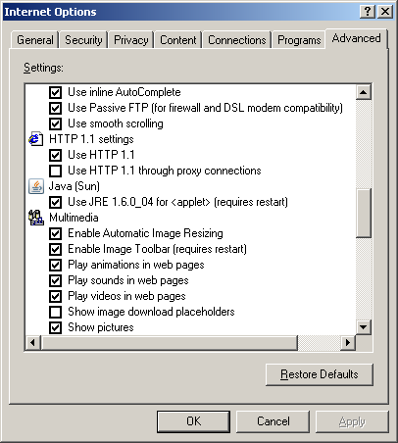
Figure 1 − JRE navigator configuration.
- Select the box with the JRE version.
- Next, select the Security tab and click in the Custom Level tab.
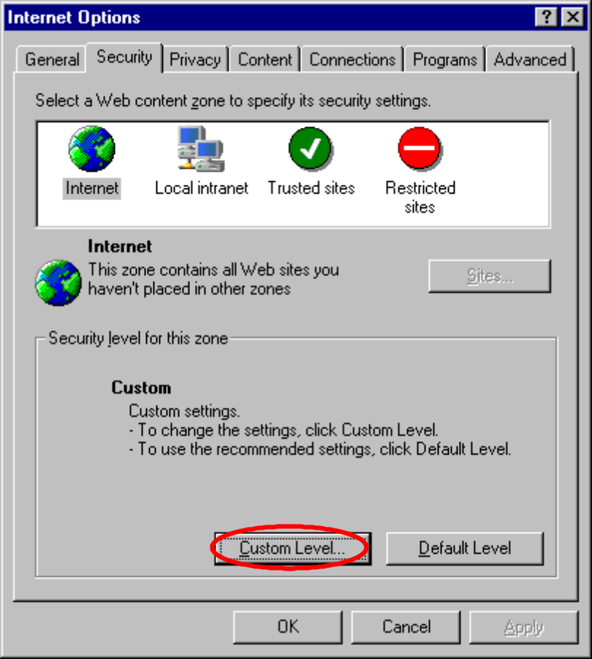
Figure 2 − Configuration of the security level
- Make sure that the "Scripting of Java applets" button is enabled.
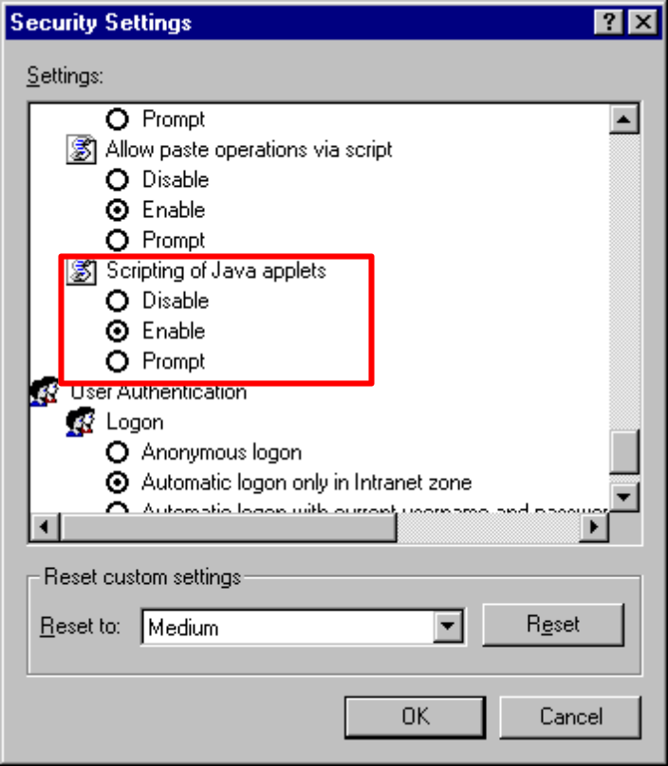
Figure 3 − Configuration of the Java applets
- Click OK to save the changes.

Technical Requirements for user IPCA6TRANS Data Manager
The tasks of the data manager are usually done in the same Server where IPCA6TRANS is installed, or in a computer that might have access to the Server through a “Remote Desktop”. The computer has to have:
- At least 512Mb RAM.
- Enough disk space, around 200 MB
- Internet Access.
- JRE 1.6 or higher.
- Split tool
- Unsplit tool
- Windows Command Prompt.
- Cscript Interpreter.
- Package MSXML 4.0 available in the Command Prompt.
- Client of the Database eXist.

Component existent verification
Component | How to call it | Result
Windows Command Prompt | Start | Run | cmd | A Command Prompt window appears
Cscript Interpreter | Start | Run | cmd  Insert in the Command Prompt::  cscript<enter> | The command Prompt window should show this:  Microsoft (R) Windows Script Host Version X.Y  ...
Package MSXML | Start | Run | cmd  Insert in the Command Prompt:  msxsl<enter> | The command Prompt window should show this:  Microsoft (R) XSLT Processor Version 4.0  ...
JRE 1.6 | Start | Run | cmd  Insert in the Command Prompt:  java –version<enter> | The command Prompt window should show this:  java version "1.4.2_10"  Java(TM) 2 Runtime Environment, Standard Edition (build 1.4.2_10-b03)  Java HotSpot(TM) Client VM (build 1.4.2_10-b03, mixed mode)
EXist client | Start | Programs | eXist XML Database | eXist client Shell | eXist login window. Tomcat must be running in the Server.

Component installation
Component | Component obtaining | Installation
Split | In the IPCA6TRANS installation DVD, the Split tool is located under \DVD_ipca6trans\Software\Scheme_split_unsplit\Split.zip. It can also be obtained by downloading the file from the official IPC site in Toolbox of the IPC | Unzip the ZIP file in a directory, e.g. D:\IPC\Tools\  Update the useful information table in the IPCA6TRANS user manual
Unsplit | In the IPCA6TRANS installation DVD, the Unsplit tool is located under \DVD_ipca6trans\Software\Scheme_split_unsplit\Unsplit.zip. | Unzip the ZIP file in a directory, e.g. D:\IPC\Tools\  Update the useful information table in the IPCA6TRANS user manual

Technical requirements for user Translators coordinator
Translators coordinator tasks are carried out from a computer with access to IPCA6TRANS through the network. Requirements:
- At least 512Mb.
- Internet Access through A browser window.
- JRE 1.6 or higher.
- Excel 2003

Technical requirements for user Translator/Revisor/QA
The translator tasks take place from a computer with access to IPCA6TRANS through a network. Requirements:
- At least 512Mb RAM.
- Internet Access through A browser window.
- JRE 1.6 or higher.

Security settings: Redirecting IPCA6Trans application to default port 80 and setting authentication (optional)
By security reasons, some Offices do not allow to “set visible” two ports in the same machine. If your Office has the constraints to open only one port to the external public, then you have to configure the module mod_jk2 in order to communicate Apache with the IPCA6Trans application hosted in Tomcat. To do so,

- Stop Apache
- Stop Tomcat
- Edit the file C:\Program Files\Apache Group\Apache2\conf\ workers2.properties and add the lines in bold.
[shm]
file=C:\Program Files\Apache Group\Apache2\logs\jk2.shm
size=1048576
# socket channel
[channel.socket:localhost:8009]
port=8009
host=127.0.0.1
# worker for the connector
[ajp13:localhost:8009]
channel=channel.socket:localhost:8009
[status:status]
[uri:/status/*]
worker=status:status
[uri:/jsp-examples/*]
worker=ajp13:localhost:8009
[uri:/*.jsp]
worker=ajp13:localhost:8009

[uri:/exist/*]
worker=ajp13:localhost:8009

[uri:/ipca6transEditor/*]
worker=ajp13:localhost:8009

- Open C:\Program Files\Apache Group\Apache2\conf\httpd.conf (e.g. Notepad). Search for “/ipca6trans” and add the lines in bold that sets the authentication method. Save and close the file.
Alias /ipca6trans "C:/Program Files/ipca6trans/"
<Directory "C:/Program Files/ipca6trans/">
Options Indexes MultiViews
AuthType Basic
AuthName “IPCA6Trans authentification”
AuthUserFile “C:\Program Files\Apache Group\Apache2\bin\ipca6trans_access”
Require valid-user
AllowOverride None
Order allow,deny
Allow from all
</Directory>

- Open a MS-DOS command window and move to the “C:\Program Files\Apache Group\Apache2\bin” directory. To create the file containing the list of users who have access to the application, run the command,
htpasswd -c ipca6trans_access user1

This command creates an entry for user1 with his password encrypted in MD5.
- Add as many users as translators are going to use IPCA6Trans. To do so,
htpasswd ipca6trans_access user2

- Restart Apache
- Restart Tomcat.
- Re-configure IPCA6Trans to listen in the default Apache port 80. Open a web browser pointing to http://localhost/ipca6trans/admin/configureserver.php. Set the server name to your machine and the port to the value 80. Press “Configure”.

Test new settings
- Open http://localhost/ipca6transEditor in a Web browser. If you see a directory listing, the you can access Tomcat with specifying the port 80.
- Additional testing.
- Open C:\Program Files\Apache Software Foundation\Tomcat 5.0\webapps\ipca6transEditor and edit the file “cwEditor_template.jnlp”. Verify that the second line has the new port.
<jnlp spec="1.0+" codebase="http://yourmachine:80/ipca6transEditor">

- Open the file C:\Program Files\ipca6trans\user\configuration.inc and verify that the new value for the port is set.

Server upgrade
This section describes the procedure to upgrade the software on the server side. All these tasks must be done from the server machine.

Upgrade of IPCA6Trans
The upgrade of one version of IPCA6Trans to the next one consists of two steps: un-installation of the current version and installation of the new version.

Uninstall of IPCA6Trans
- Open a Web browser pointing to http://localhost:8080 You should see the Tomcat main page like shown in Figure 50 Tomcat main page.
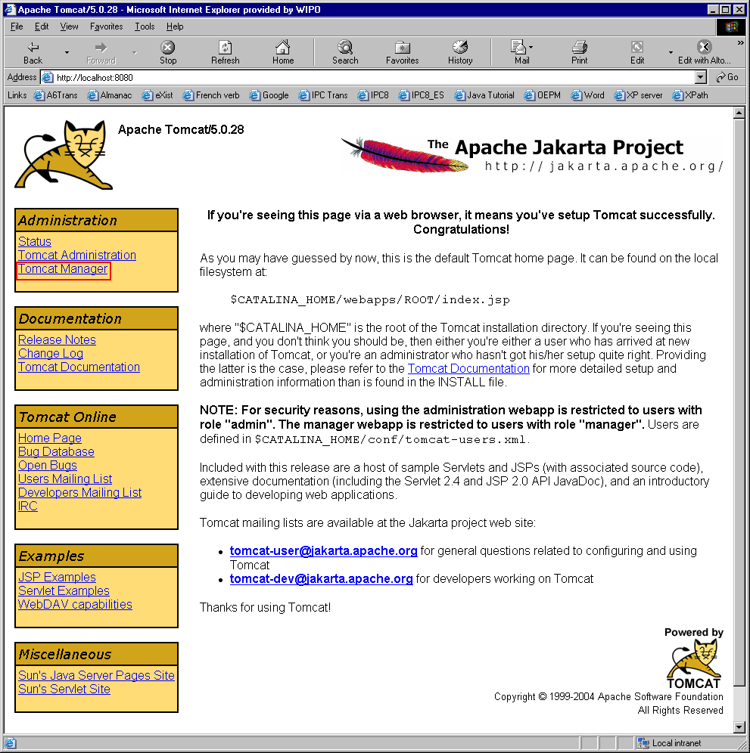
Figure 50 Tomcat main page
- Click on “Tomcat Manager” from the left menu. A pop-up window will appear asking for a username and password. Enter admin as username and type the password (empty by default).
- A screen like the one shown in Figure 51 will list the web applications installed in Tomcat.
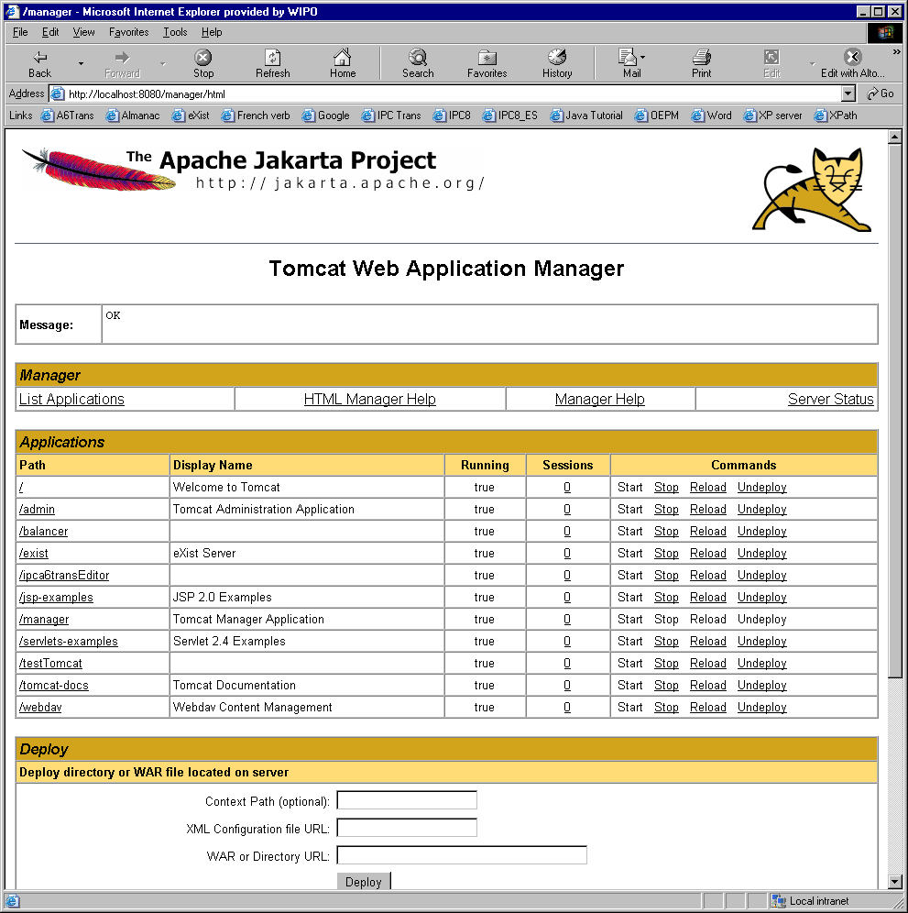
Figure 51 Tomcat Web Application Manager screen
- On the row ipca6transEditor, click on the link Stop and then click on Undeploy. Then, Tomcat will uninstall the current version of IPCA6Trans.
- Stop Apache.
- Stop Tomcat
- Open the folder C:\Program Files\ipca6trans and run the uninstaller.exe program. The following screen will appear. Press the button “Uninstall”.
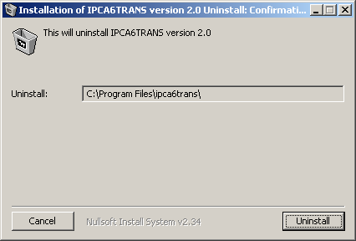
Figure 52 Un-installation of IPCA6Trans

Installation of a new version of IPCA6Trans
- From the IPCA6Trans_software folder on the IPCA6Trans CD, run the installer ipca6trans_setup. The usual sequence of installation screens will appear (in case of any doubt, consult point 3 on page 50). Note that you do not need to configure again the Aliases in Apache.
- Start Tomcat. It will unpack automatically the file and it will create a new directory called ipca6transEditor.
- Stop Tomcat.
- Edit the following files a) and b) located in directory
C:\Program Files\Apache Software Foundation\Tomcat 5.0\webapps\ipca6transEditor
a) ipca6transManagerSplit.jnlp
b) ipca6transManagerUnSplit.jnlp
In these files, change <argument>en</argument> to <argument>xx</argument> where xx is your targeted translation language code (ISO 639-1) in lowercase.

- Edit the file C:\Program Files\ipca6trans\user\configuration.inc, find and change
sDefaultMenuLang = 'EN';
to
sDefaultMenuLang = 'XX';
where XX is your targeted translation language code (ISO 639-1) in uppercase.

- Copy your own translated version of lang.xml to C:\Program Files\ipca6trans\user\xslt
- Run C:\Program Files\ipca6trans\user\translate\buildinc.bat.
- Copy the folder “20060101” from C:\Program Files\ipca6trans\user\, and rename it with the version number that you wish to translate.
- Start Tomcat.
- Start Apache.
- Open a web browser pointing to http://localhost/ipca6trans/admin/configureserver.php and enter the name of the server and the port where Tomcat is listening from.
- Test the installation checking the address http://localhost/ipca6trans (section 4.5.3 -Test IPCA6Trans)

Upgrade of eXist database
Before uninstalling the current version of the eXist database, it is recommended to make a backup of the data. Then uninstall the current version and install of the new one.

Backup of the data
- Run the client from the shortcut created in Start > Programs > eXist XML Database > eXist client Shell or from C:\Program Files\eXist\bin click on client.bat. Note that Tomcat must be running.
- Enter the password for the admin user and click OK.
Figure 53 eXist client login

- The client GUI will appear.

Figure 54 eXist client application
- Select the menu Tools → Backup, Figure 55 will appear. Select the collection you want to keep a back up, e.g. /db/ipc and the local storage location. Then press the OK button.
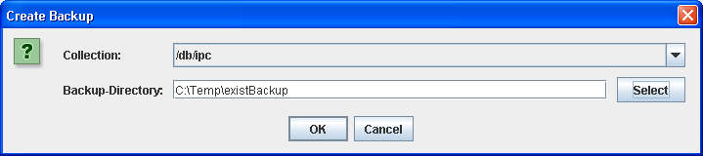
Figure 55 eXist client, backup process
- In the backup directory, eXist will create a folder structure similar to the one stored in the database.

Uninstall current version of eXist
- Open a Web browser pointing to http://localhost:8080 You should see the Tomcat main page like shown in Figure 56.
Figure 56 Tomcat Main page
- Click on “Tomcat Manager” from the left menu. A pop-up window will appear asking for a username and password. Enter admin as username and type the password (empty by default).
- A screen like the one shown in Figure 57 will list the web applications installed in Tomcat.
Figure 57 Tomcat Web Application Manager screen
- On the row exist, click on the link Stop and then click on Undeploy. Then, Tomcat will uninstall the current version of exist.
- Stop Tomcat.
- Uninstall eXist client from C:\Program Files\exist\Uninstaller\uninstaller.jar
- Install the new version of eXist server and the client, as described in 4.4 - Install eXist in page 39.

Recovery of the data
- Open the eXist client and select the menu Tools → Restore. From the backup directory, select the file of type __contents__.xml and press the button “Select backup files for restore”. The process will start and after several minutes all data will be back.

