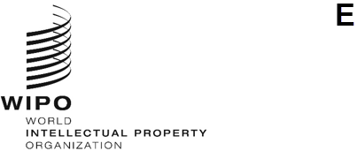

INFORMATION NOTICE No. 9/2023
Geneva Act of the Lisbon Agreement on Appellations of Origin and Geographical Indications
Declaration made under Article 7(4)(a) of the Geneva Act of the Lisbon Agreement: Lao People’s Democratic Republic
- On July 25, 2023, the Director General of the World Intellectual Property Organization (WIPO) received from the Government of the Lao People’s Democratic Republic the declaration referred to in Article 7(4)(a) of the Geneva Act of the Lisbon Agreement on Appellations of Origin and Geographical Indications (hereinafter referred to as the “Geneva Act”), whereby the Lao People’s Democratic Republic wishes to receive an individual fee∗ to cover its cost of substantive examination of each international registration notified to it under Article 6(4) of the said Act.
- In accordance with Rule 8(2)(b) of the Common Regulations under the Lisbon Agreement for the Protection of Appellations of Origin and their International Registration and the Geneva Act of the Lisbon Agreement on Appellations of Origin and Geographical Indications, the Director General of WIPO has, after consultation with the Competent Authority of the Lao People’s Democratic Republic, established the following amounts, in Swiss francs, of the said individual fee:
ITEM |  | Amount  (in Swiss francs)
Individual fee | for each international registration | 94
- This declaration will become effective on October 25, 2023.
October 13, 2023

∗ Regarding the declaration made by the Lao People’s Democratic Republic pursuant to Article 7(4)(a) of the Geneva Act, please note that the individual fee of 2,070,000 Lao Kip (LAK) shall be collected by the International Bureau of WIPO.

