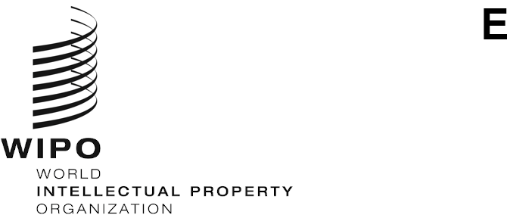
CDIP/31/1
ORIGINAL: ENGLISH
DATE: NOVEMBER 27, 2023

Committee on Development and Intellectual Property (CDIP)

Thirty-First Session
Geneva, November 27 to December 1, 2023

Agenda
Adopted by the Committee
- Opening of the session
- Adoption of the Agenda
See current document.
- General Statements
- Monitor, assess, discuss and report on the implementation of all Development Agenda
Recommendations
- Progress Report on the Implementation of the 45 Development Agenda Recommendations
See document CDIP/31/2.
- Progress Reports – Ongoing Development Agenda Projects
See document CDIP/31/3.
- Report on the International Conference on IP and Development – IP and Innovation for Sustainable Agriculture (April 24, 2023)
See document CDIP/31/4.
- Completion Report of the Project on Copyright and the Distribution of Content in the Digital Environment
See document CDIP/31/6.
- Evaluation Report of the Project on Copyright and the Distribution of Content in the Digital Environment
See document CDIP/31/7.
- Impact Evaluation Report of the Project on Intellectual Property and Socio-Economic Development
See document CDIP/31/8.
4.(i) WIPO Technical Assistance in the Area of Cooperation for Development
- Compilation of Topics Proposed by the Secretariat for Future Webinars on Technical Assistance
See document CDIP/31/INF/5.
- Consideration of work program for implementation of adopted recommendations
- Continuation of discussion on the Adopted Recommendations of the Independent Review – Updated Proposal by the Secretariat and Member States Inputs
See document CDIP/29/6.
- Project on IP and Innovation Collaboration as a Foundation for Technology Transfer and Bringing Research Output to Market – Project Proposal Submitted by the Philippines
See document CDIP/31/5.
- Project on Intellectual Property and Unlocking the Potential of Non-Agricultural Geographical Indications for the Empowerment of Local Communities and Preservation or Revival of Local Arts and Traditions – Project Proposal Submitted by India
See document CDIP/31/9.
- Project on Copyright and the Distribution of Content in the Digital Environment – Phase II – Project Proposal Submitted by Brazil
See document CDIP/31/10.
- Compilation of Topics Proposed by Member States to be Addressed Under the Agenda Item on “Intellectual Property and Development”
See document CDIP/31/11 REV.
- Compilation of Sub-Topics Proposed by Member States for the International Conference on Intellectual Property and Development
See document CDIP/31/12 REV.
- Executive Summary of the WIPO Tool Entitled “Drawing on Creativity, Copyright for Animation Industry Professionals: A Training Tool”
See document CDIP/31/INF/2.
- Executive Summary of the WIPO Tool on the Role of Intellectual Property Rights in the Fashion Industry: From Conception to Commercialization
See document CDIP/31/INF/3.
- Executive Summary of the WIPO Tool on Building a Digital Publishing Economy: Opportunities and Framework for Development
See document CDIP/31/INF/4.

- Intellectual Property and Development
- Addressing Climate Change: IP Helps Achieve the Goals of Carbon Peaking and Carbon Neutrality

- Future work
- Summary by the Chair
- Closing of the session
[End of document]

