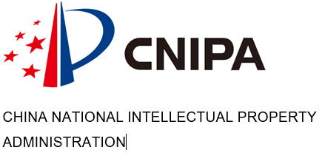

E

WIPO-CNIPA/PCT/BEI/20/1
OriGINAL: english
DATE: November 3, 2020
Advanced PCT Seminar for Chinese Users (virtual)
organized by the World Intellectual Property Organization (WIPO) and
the China National Intellectual Property Administration (CNIPA)
November 19, 2020
08:30-10:30 Central European Time (15:30-17:30 Beijing Time)

PROGRAM

prepared by the International Bureau

November 19, 2020

08:30 – 08:35 Welcome remarks

Speakers: Mr. LIU Jian, Deputy Director General, International Cooperation Department, CNIPA

Mr. Matthias Reischle-Park, Deputy Director, PCT Legal and User Relations Division, WIPO

08:35 – 09:30 Topic 1: PCT recent developments: recent Rule changes and other developments in the PCT

Speaker: Mr. YU Zhilong, Senior Legal Officer, PCT Legal and User Support Section, PCT Legal and User Relations Division, WIPO

09:30 – 09:50 Topic 2 Typical issues experienced by PCT users and practical advice

Speaker: Ms. BAI Lingfei, Head, PCT Operations Section 3, PCT Operations Division, WIPO

09:50 – 10:10 Topic 3: ePCT: latest and future developments

Speaker: Ms. MO Jiao, Customer Service Assistant, PCT eServices Unit, External Systems Development Section, PCT Information Systems Division, WIPO

10:10 – 10:30 Topic 4: Open Q&A session

Moderator: Ms. SUN Hongxia, Director, Division I, International Cooperation Department, CNIPA

Speakers: Mr. YU Zhilong, Ms. BAI Lingfei, Ms. MO Jiao

10:30 Closing of seminar

[End of document]

