Charter for Accessible Publishing
The Accessible Books Consortium promotes the production of e-books and other digital publications in accessible formats such as braille, audio or large print for persons who are blind, visually impaired or otherwise print disabled.

The growing availability of e-books and other digital publications provides an unprecedented opportunity for persons with print disabilities to become the readers of such publications and for them to enjoy an ever-broadening diversity of books. Without diminishing the importance of other ways of delivering accessible content, publishers and authors are eager to explore and develop the advantages that e-books offer. Ensuring that more e-books are fully accessible, however, will only happen if publishers, authors and other stakeholders focus on this issue at a practical level.

Our objective is to make our e-books accessible to all.

With this objective in mind, we, the signatories to this Charter, hereby commit to:

- stating our accessibility policy on our website, including adherence to this Charter;

- nominating a senior manager who will be responsible for accessibility;

- raising awareness among, and provide technical training for, relevant staff;

- designating and publicizing a point of contact in our organization to assist persons with print disabilities to access our publications;
- testing our digital publications for accessibility, incorporating appropriate feature descriptions and metadata;

- monitoring our progress in this area;

- promoting the adoption of accessibility standards throughout the supply chain; and

- supporting national and international collaboration with organizations representing persons with print disabilities so as to increase the availability of publications in accessible formats.

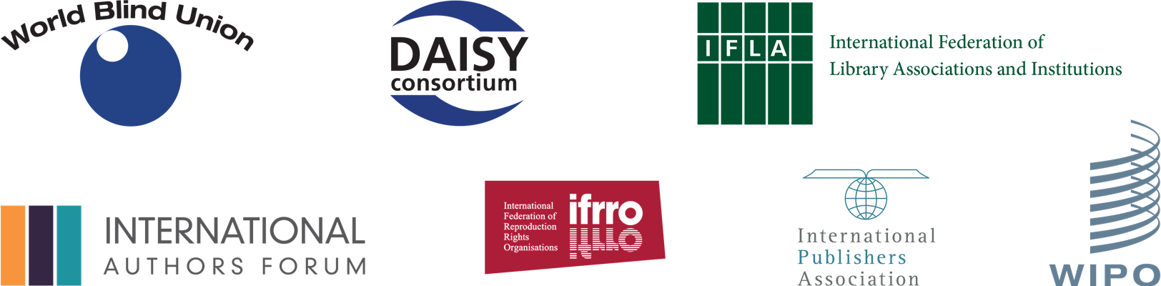

Charter for Accessible Publishing

Organization’s name:

Name and title of person signing on behalf of the organization:

Signature:

Date:

Name, title and e-mail of organizational contact who will assist persons with print disabilities access publications:

Organization’s website address:

If you have any questions or require further information, please contact us at Accessible.Books@wipo.int

