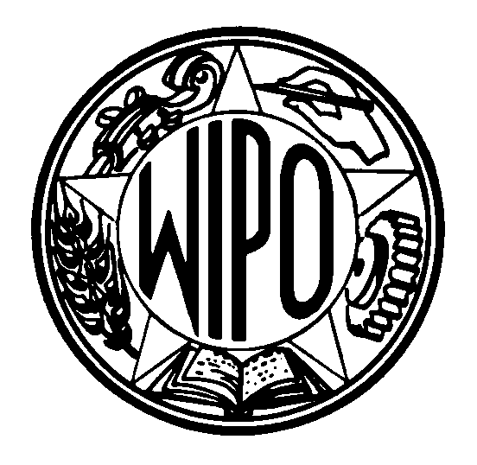
WORLD INTELLECTUAL PROPERTY ORGANIZATION
34, chemin des Colombettes, P.O. Box 18, CH-1211 Geneva 20 (Switzerland)
‡ (41-22) 338 91 11 – Facsimile (International Industrial Design Registry): (41-22) 338 97 38
e-mail: intreg.mail@wipo.int – Internet: http://www.wipo.int

THE HAGUE AGREEMENT CONCERNING
THE INTERNATIONAL DEPOSIT OF INDUSTRIAL DESIGNS

The Hague Act (1960) and the Stockholm (Complementary) Act (1967)

Accession by the Kingdom of Morocco

1 On September 13, 1999, the Government of the Kingdom of Morocco deposited, with the Director General of the World Intellectual Property Organization (WIPO), its instrument of accession to the Hague Agreement Concerning the International Deposit of Industrial Designs of November 6, 1925, as revised at The Hague on November 28, 1960 (“the Hague Act (1960)”) and supplemented at Stockholm on July 14, 1967 (“Stockholm (Complementary) Act (1967)”). The Hague Act (1960) as supplemented by the Stockholm (Complementary) Act (1967) entered into force, in respect of the Kingdom of Morocco, on October 13, 1999.

2 Morocco is already a party to the London Act (1934) of the Hague Agreement. Its accession to the Hague Act (1960) has in particular the following consequences: where the State of origin is a party to both the Hague (1960) and the London Act (1934), a designation of Morocco in an application whose date is October 13, 1999, or later must be effected under the 1960 Act, not under the 1934 Act; this means that the designation of Morocco must be expressly indicated in the application and that a State fee must be paid. On the other hand, where an international deposit bearing a date earlier than October 13, 1999, and containing a designation of Morocco is renewed, the renewal in respect of Morocco is considered to be effected under the London Act (1934) and no State fee is required.

3 The application form will be amended as soon as possible. In the meantime, where the applicant wishes to designate Morocco, that country should be added in Section VII(a) of the form.

4 The accession of Morocco to the Hague Act (1960) brings the number of Contracting States of the Hague Act (1960) to 24, namely, Belgium, Benin, Bulgaria, Côte d’Ivoire, Democratic People’s Republic of Korea, France, Germany, Greece, Hungary, Italy, Liechtenstein, Luxembourg, Monaco, Mongolia, Morocco, Netherlands, Republic of Moldova, Romania, Senegal, Slovenia, Suriname, Switzerland, the former Yugoslav Republic of Macedonia and Yugoslavia.

October 18, 1999

