 | 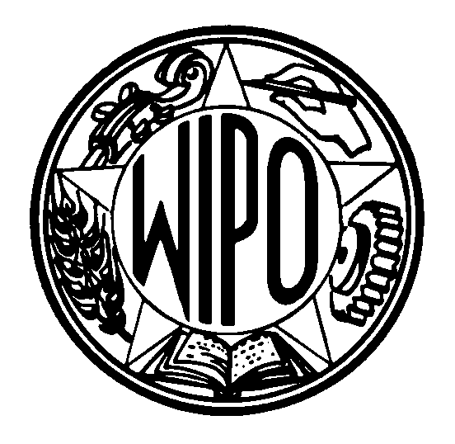 | Information Notice No. 9/2006
WORLD INTELLECTUAL PROPERTY ORGANIZATION
34, chemin des Colombettes, P.O. Box 18, CH-1211 Geneva 20 (Switzerland)
‡ (41) 22 338 91 11 – Facsimile (International Trademark Registry): (41) 22 740 14 29
e-mail: intreg.mail@wipo.int – Internet: http://www.wipo.int

MADRID AGREEMENT AND PROTOCOL CONCERNING THE
INTERNATIONAL REGISTRATION OF MARKS

Statements of grant of protection under Rule 17(6)

As from May 1, 2006, the Office of Armenia sends to the International Bureau statements of grant of protection under Rule 17(6) of the Common Regulations under the Madrid Agreement and Protocol.

The Offices currently sending statements of grant of protection under Rule 17(6) are the Offices of Armenia, Australia, European Community, Georgia, Hungary, Ireland, Japan, Norway, Republic of Korea, Singapore, Sweden, Syrian Arab Republic, Turkey and the United Kingdom (total: 14 Offices). This list will shortly be put on WIPO’s website at http://www.wipo.int/madrid/en/ on the Madrid System for the International Registration of Marks and it will be updated as appropriate.

August 4, 2006

