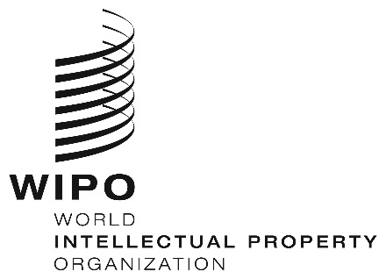
INFORMATION NOTICE NO. 24/2022
Madrid Protocol Concerning the International Registration of Marks
Change in the Amounts of the Individual Fee: Lao People’s Democratic Republic
- In accordance with Rule 35(2)(d) of the Regulations under the Madrid Protocol, the Director General of the World Intellectual Property Organization (WIPO) has established new amounts, in Swiss francs, of the individual fee that is payable when the Lao People’s Democratic Republic is designated in an international application, in a designation subsequent to an international registration and in respect of the renewal of an international registration in which the Lao People’s Democratic Republic has been designated.
- As from October 20, 2022, the amounts of the individual fee payable in respect of the Lao People’s Democratic Republic will be the following:
ITEMS |  | Amounts  (in Swiss francs)
 |  | until  October 19, 2022 | as from  October 20, 2022
Application or Subsequent Designation | – for one class of goods or services  – for each additional class | 91  65 | 71  51
Renewal | – for one class of goods or services  – for each additional class | 91  65 | 71  51

- These new amounts will be payable where the Lao People’s Democratic Republic
(a) is designated in an international application which is received by the Office of origin on or after October 20, 2022; or
(b) is the subject of a subsequent designation which is received by the Office of the Contracting Party of the holder on or after October 20, 2022, or is filed directly with the International Bureau of WIPO on or after that date; or
(c) has been designated in an international registration which is renewed on or after October 20, 2022.
September 20, 2022

