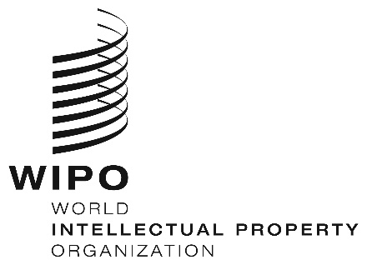
INFORMATION NOTICE NO. 26/2024
Madrid Protocol Concerning the International Registration of Marks
Change in the Amounts of the Individual Fee: Iceland
- The Government of Iceland has notified to the Director General of the World Intellectual Property Organization (WIPO) a declaration modifying the amounts of the individual fee payable with respect to Iceland under Article 8(7) of the Madrid Protocol.
- As from February 16, 2025, the amounts of the individual fee payable in respect of Iceland will be the following:
ITEMS |  | Amounts  (in Swiss francs)
 |  | until  February 15, 2025 | as from  February 16, 2025
Application or Subsequent Designation | – for one class of goods or services | 247 | 257
Application or Subsequent Designation | – for each additional class | 53 | 56
Application or Subsequent Designation | Where the mark is a collective mark:
Application or Subsequent Designation | – for one class of goods or services | 247 | 257
Application or Subsequent Designation | – for each additional class | 53 | 56

ITEMS |  | Amounts  (in Swiss francs)
 |  | until  February 15, 2025 | as from  February 16, 2025
Renewal | – for one class of goods or services | 247 | 257
Renewal | – for each additional class | 53 | 56
Renewal | Where the mark is a collective mark:
Renewal | – for one class of goods or services  – for each additional class | 247  53 | 257  56

- These new amounts will be payable where Iceland
(a) is designated in an international application received by the Office of origin on or after February 16, 2025; or
(b) is the subject of a subsequent designation received by the Office of the Contracting Party of the holder or filed directly with the International Bureau of WIPO on or after that date; or
(c) has been designated in an international registration renewed on or after that date.
December 9, 2024

