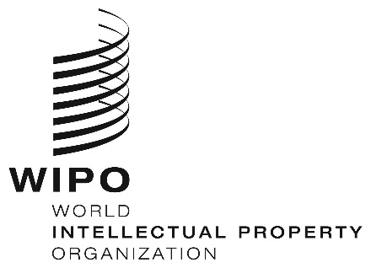
INFORMATION NOTICE NO. 31/2024
Madrid Protocol Concerning the International Registration of Marks
Change in the Amounts of the Individual Fee: Republic of Moldova
- In accordance with Rule 35(2)(d) of the Regulations under the Madrid Protocol, the Director General of the World Intellectual Property Organization (WIPO) has established new amounts, in Swiss francs, of the individual fee that is payable when the Republic of Moldova is designated in an international application, in a designation subsequent to an international registration and in respect of the renewal of an international registration in which the Republic of Moldova has been designated.
- As from January 19, 2025, the amounts of the individual fee payable in respect of the Republic of Moldova will be the following:
ITEMS |  | Amounts  (in Swiss francs)
 |  | until  January 18, 2025 | as from  January 19, 2025
Application or Subsequent Designation | – for one class of goods or services | 252 | 223
 | – for each additional class | 52 | 47
 | Where the mark is a collective mark:
 | – for one class of goods or services | 304 | 270
 | – for each additional class | 52 | 47

ITEMS |  | Amounts  (in Swiss francs)
 |  | until  January 18, 2025 | as from  January 19, 2025
Renewal | – for one class of goods or services | 262 | 233
 | – for each additional class | 52 | 47
 | Where the mark is a collective mark:
 | – for one class of goods or services  – for each additional class | 419  52 | 372  47

- These new amounts will be payable where the Republic of Moldova
(a) is designated in an international application received by the Office of origin on or after January 19, 2025; or
(b) is the subject of a subsequent designation received by the Office of the Contracting Party of the holder or filed directly with the International Bureau of WIPO on or after that date; or
(c) has been designated in an international registration renewed on or after that date.
December 19, 2024

