Project Charter Tool Description

In this document we will explain how to develop a Project Charter. The Project Charter is used to formally initiate a New Product Development (NPD) project.

What is the Project Charter?

New Product Development (NPD) is risky. After all, the goal is to develop something new, something that does not exist in the market at all, or at least is not yet offered by your company, non-profit, or government agency. So it makes sense to clarify what you want to do, why you want to do it, who cares, and how you are going to do it before starting.

By its very name, new product development is always a voyage of discovery. Imagine you propose a voyage of scientific discovery. Your funders would like some idea of the direction you are going, how long you plan to go exploring, what experiments you plan to carry out, what you hope to discover, such as new crop species or minerals, and what new products or services you plan to develop. They will also want to know what kind of crew and additional specialists you will need, as well as the other supplies and resources common for long voyages. If you can provide answers your funders find acceptable, they will accept your proposal and authorize the mission. That is what a Project Charter is: a proposal for a voyage of discovery. If there is a “catch”, it is that, if the Project Charter is approved, then you are expected to deliver what you have proposed.

In The Wide Lens, Ron Adner describes three main types of risk that apply to NPD. Execution risk refers to the ability of your organization or company to actually conduct NPD. Adoption risk refers to whether the intended customer segments will actually buy the product or service and whether the intended end-users actually deploy it. Co-innovation risk refers to the ability of vendors, suppliers, and partners to provide what you need as part of your NPD and if necessary, to conduct their own NPD to develop consumables or other essential products or services needed for you to effectively deploy your product or service. The Project Charter addresses all three risks.

The Project Charter defines what will be developed, why it should be developed, to whom it will be sold, and why they will buy it and use it. Thus, the Project Charter can be a tool for addressing adoption risk. It also defines the metrics that will be used to judge whether the project is successful, and what the scope, duration, and budget for the project will be. It clarifies who are the in-house team members, and any contractor, vendor, or partner members of the team. It specifies who is responsible for the project and what spending authority they have. Thus, the Project Charter can be a tool for addressing execution and co-innovation risk. Once the Project Charter is signed off by an authorized manager, the team can begin the NPD project. As such, as Figure 1 below indicates, the Project Charter is developed during the ramp up to a formal NPD project, at the very beginning of the NPD process. The first gate for the NPD process is the entry into the Idea stage, and sign-off on the Project Charter is the key to passing through that first gate.

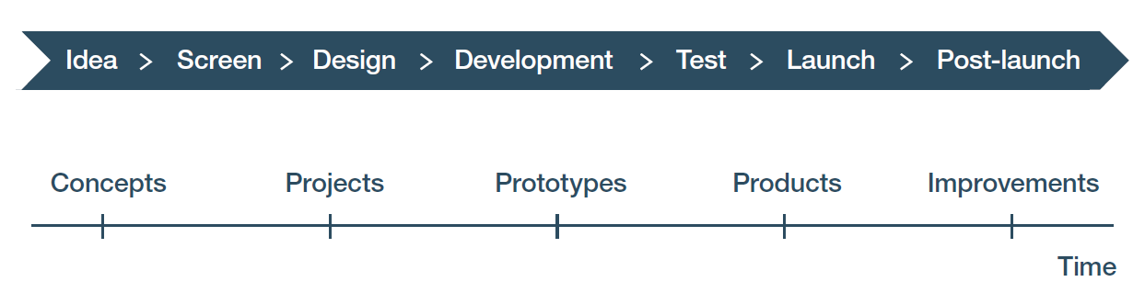
Figure 1: Stages and gates. The green arrow depicts where the Project Charter Tool is used, at the very beginning of the NPD project and entry into the Idea stage. The red arrow depicts the gate where the Project Charter needs to be signed-off on in order to move forward to the next stage.

The Project Charter presents the general product or service idea that is to be explored in the Idea stage, which in turn leads to a product concept. At that point, the Project Charter and the Action Plan (another tool in this Toolkit that is also developed at the very beginning of an NPD project) can be reviewed and amended as appropriate. After this review, and after any appropriate changes are made and approved, together the Project Charter and Action Plan constitute what is also known as a Product Innovation Charter.

The data for the Project Charter comes from the experience and insights of the NPD project team and from mission statements, strategic plans, and other documents of the entity that will carry out the NPD project. Some additional market research may be conducted by team members to prepare sections dealing with what customer segments will be targeted and why they will buy this product or use this service. Other people in the company, organization, or agency may be consulted to develop budget and schedule estimates. But at this point everything is preliminary. The goal here is to get approval to explore the idea further and in more detail. If the Idea and Screening stages in Figure 1 above go well, then approval can be sought, and meaningfully given, to move forward into the Design stage, the Development stage, and the rest of the NPD process.

How do you enter data in the Project Charter Tool?

Upon opening the Tool, the first tab entitled “Project Charter” is a spreadsheet which contains the Project Charter template (see Figure 2 below). Almost all the work is done on this tab. A second spreadsheet on the “Notes and references” tab is for additional data you may need, things to follow-up on, and sources for web-based data or analytical methods. As you work with this tool it may be necessary to resize some cells to fit in the data you wish to enter.

The Project Charter template covers eight things that are important to know before you start spending money on an NPD project:

- What product or service is being developed?
- Why it is being developed?
- Who will use it?
- What metrics will be used to define success?
- What resources are anticipated to be required?
- Who will perform this work?
- What is the anticipated schedule for completion?
- Who is leading the effort and to whom in management will they report, and from whom will they get approval to move forward?

In the following discussion, remember that there is no pre-filled data in any of the tools in the Toolkit. All the data is entered by the user who has applied the general principles discussed here to the specific circumstances of their proposed NPD project. That said, these tool descriptions use snips from completed workbooks from a Biofuels Example, to illustrate what the tools look like once data has been entered, and show how to interpret the results in completed workbooks.

Figure 2: The Project Charter tab of the Project Charter Tool workbook for the Biofuels Example
Before entering data into the template, think about what is driving your NPD project. This Toolkit uses an approach to NPD where meeting the needs of customers and end-users is what drives the process forward. By meeting their needs, you can provide something of value to them, and because of that, when they buy it or use it, you generate value for your company, non-profit, or government agency.

Therefore, before you begin to enter data, think about what you hope to offer to the people who will use the product or service you wish to develop. How are you meeting their needs? Think about your product or service in terms of the core benefit it will offer, and the tangible and augmented features needed to deliver that core benefit (see Figure 3).

The core benefit is what makes it worthwhile to use this product or service. For example, suppose you want to develop an innovative electric kick scooter. If the core benefit is its use for commuting rather than for toddling around town for recreational fun, that suggests one set of features. Recreational use suggests a different set of features, although it will likely overlap to some extent with the set for commuting. The point is: the features vary depending on the core benefit to be provided.

Tangible features create the performance, ease of use and price necessary to realize the benefit. Tangible features reflect the criteria buyers will use when deciding which of the various competing products and services on the market to buy. A commuting kick scooter needs to have skid-resistant tires that work safely in the rain. One for recreation may not need these as the user is unlikely to ride it on rainy days. Foldability, so you can carry it into the workplace and store it there, is likely a desirable feature for a scooter you would use to commute to work. Foldability is probably not very important if you are only using the scooter for recreation.

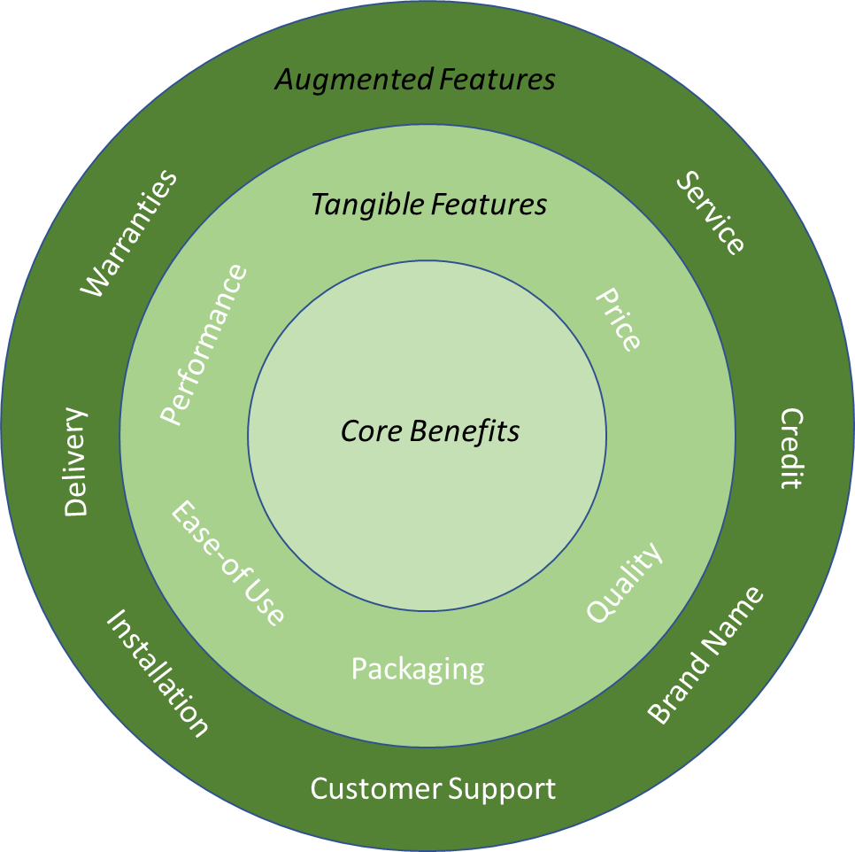
Figure 3: Core benefits offered by a product or service and examples of the tangible and augmented features that deliver it. Figure courtesy of Foresight Science & Technology.

Augmented features are the “nice to have” things that make it easier for a potential buyer to become an actual buyer. If the kick scooter is going to be used for commuting, one-day turn-around service in case of problems is a big plus. While service is always an important feature, a one-day turnaround is probably not as important for a recreational user. On the other hand, prompt delivery may be important for both kinds of users.

Ultimately the only way to be sure about what core benefit has high saliency for your intended users, and which features will be important for them, is to conduct market research. The Voice of the Customer Tool in this Toolkit is used as a basis for that market research. But you need to have some hypotheses about what your intended users will want and have some reason for believing these hypotheses will be sustained before you start an NPD project.

Now you are ready to enter data.

Sections of the Project Charter

The first section of the Project Charter is entitled “Product or service being developed.” For this section, the product or service should be described in sufficient detail that management – and everyone who will work on the project – clearly understands what the final product or service will be. What is being sold in the case of a company, or provided in the case of a non-profit or government agency? It is useful to begin with the core benefit to be provided and include the most important tangible features necessary to realize that core benefit.

Figure 4: Example of Product or service being developed section from the Project Charter Tool workbook for the Biofuels Example

The next section of the Project Charter is entitled “Business case for developing it.” This section addresses two questions. The first is why the buyers will want to buy this product or service and end-users use it. What unmet or under-served needs does this product or service address? What market drivers are at play? The second question is why your entity – your company, non-profit or agency – should be the one to develop it. How does it make money or help meet the mission of your entity?

Figure 5: Example of Business case for developing it section from the Project Charter Tool workbook for the Biofuels Example

The “Targeted customer segments and why they will use it” section defines the initial group of customers being targeted. Taking the electric kick scooter example discussed above, the content of this section will vary depending on whether you are targeting commuters or recreational users.

In Figure 6 below, we demonstrate this section using the Biofuels Example. At the top of the figure, the completed section found in the Project Charter Tool workbook for the Biofuels Example is shown. Here, the initial targeted customer segments for this project are farms and waste collection and treatment facilities. The bottom of the figure describes a different potential customer segment based on targeting mass transportation and government vehicles. Note that if the potential customer segment in this second example was the intended initial customer segment, then the “Product or service being developed” section and the “Business case for developing it” section would be different, as well. For a project targeting mass transportation and government vehicles, the product or service being developed might be a locally produced biofuel, not the mini-refinery, and the “Business case for developing it” section would list the ability to provide locally produced biofuel using the innovative mini-refinery as part of the reason why this company should be in the biofuels business.

Figure 6: Description of two alternative initial targeted customer segments using the Project Charter Tool workbook. The top snip is what is in the Biofuels Example provided as part of the Toolkit. The alternative to the Biofuels Example is the second snip using a green colored cell to make it clear that it is not from the actual Biofuels Example that is provided in the Toolkit.
The Project Charter Tool can be used for an NPD project that addresses a single initial target customer segment or multiple segments. That said, even with multiple segments, the targeted customer segments should be identified by characteristics or needs that can be effectively addressed by the same core benefit provided by the product or service being developed. In the Biofuels Example for an NPD project, the initial target customer segment was defined as potential customers that have biomass available and currently have to buy fuel, such that they could benefit from purchasing mini-refineries that can use on-site biomass for on-site biofuel production. There were two targeted customer segments: farms and waste collection/treatment centers.

In some cases, you may have a platform technology and be developing it to address multiple distinct potential customer segments. Where these segments have different needs and thus seek different core benefits, you should determine which segment presents the best initial market opportunity in terms of both ease of new product development and ability to generate profits and gain significant market traction. To illustrate this, the Biofuels Example could also target mass transportation and government vehicles as a different potential customer segment, where the “Product or service being developed” section would describe the biofuel they desire, not a mini-refinery, and the “Business case for developing it" section would describe the demand for biofuels in these customer segments and the ability to produce and provide biofuel using an innovative scaled-up version of the refinery as a reason why this company should be in the biofuels business. However, if the core product is the mini-refinery, then the Project Charter should focus on customer segments whose needs are met by the mini-refinery. In other words, the whole Project Charter needs to be coherent so if you change one cell in it, you must determine what changes need to be made to all the other cells.

To the right of the Targeted customer segments section is the Success metrics section. These metrics define how you know the project has resulted in value being generated both for buyers and end-users, and for your entity. Usually, these metrics are set in consultation with the manager who will have approval authority over the project. Depending on the size and importance of the NPD initiative, other managers may be involved as well. An example is shown in Figure 7.

Figure 7: Success metrics section from the Project Charter Tool workbook for the Biofuels Example

If you do not have metrics at this time, then the methodology for scoring and screening product ideas using the balanced scorecard tool is a good way to develop them. A balanced scorecard allows you to define a set of success metrics for your project rather than just using a single one. If you do not know how to make a balanced scorecard, you can refer to section 1.4 “Product idea scoring and screening using the balanced scorecard” in Module III “Integrating public domain knowledge into product development processes” of the WIPO publication Using Inventions in the Public Domain: A Guide for Inventors and Entrepreneurs (2020).

Moving further down the spreadsheet, the next section on the right is entitled “Scope, budget, and spending authority.” Scope describes how far through the NPD process this project will run. The usual presumption is that the project will run through the entire NPD process, but if the presumption is different, for example if the project scope is to generate a prototype or completed product but not to launch the product, then you should note that. Budget refers to just that. Be aware that something will always glitch or go wrong in NPD because you are doing something new. So, plan your budget so you have sufficient contingency funds. A rule of thumb is between 10% and 50% depending on how close this is to other projects your entity has done before, the experience of the team, how mature the technology to be used is, and other uncertainties. Finally, spending authority addresses how much the Team Leader can spend against budgeted amounts without prior management approval.

Figure 8: The Scope, budget, and spending authority section from the Project Charter Tool workbook for the Biofuels Example.

The “Team members” section is where you give everyone who will participate in NPD a role. Everyone listed should be identified by their name and role on the team. It is important to include both employees and non-employee consultants, contractors, and partners. If you do not know who will fill a role, say so. That way, members of the team together with management can determine if all the competencies needed to complete this project will be on the team.

Figure 9: The Team Members section of the Project Charter Tool workbook for the Biofuels Example

The final substantive sections deal with the project timeline. The first column defines the major milestones for the NPD project, the second column gives the anticipated completion date. Because the Project Charter will be used to make sure the project is still focused on what it is supposed to be developing, the third column records the actual completion date of a milestone.

Figure 10: Timeline sections from the Project Charter Tool workbook for the Biofuels Example

The spreadsheet ends with places for two signatures. The first is the Team Leader or whoever is submitting the Project Charter for approval on behalf of the team. The other is for formal authorization to proceed by whoever has the authority to do so.

Figure 11: Signature sections at the bottom of the Biofuels Example of the Project Charter Tool

How do you interpret the data in the Project Charter Tool and use it in your NPD process?

In Lewis Carroll’s Through the Looking Glass, often called Alice in Wonderland, there is this delightful passage:

“When I use a word,’ Humpty Dumpty said in rather a scornful tone, ‘it means just what I choose it to mean — neither more nor less.’

’The question is,’ said Alice, ‘whether you can make words mean so many different things.’

’The question is,’ said Humpty Dumpty, ‘which is to be master — that’s all.”

That may be fine in fiction, but it is a nightmare for New Product Development. If you do not know what you are trying to develop, for whom, and why, the odds of reaching a successful outcome are very poor. A good Project Charter can lower some of the potential risks associated with undertaking an NPD project. The team and management should agree on the meaning of terms and expectations found in the Project Charter, to help all parties interpret data in the Project Charter and data collected during the NPD process. The Project Charter should be approved before the formal authorization of an NPD project, and then reviewed again at each subsequent gate at the end of a stage in the NPD process. If the project is not on track after any stage, within budget and otherwise aligned with the Project Charter, then the project should be halted until these issues are resolved. A resolution either brings the project back into alignment with the Project Charter – possibly with modifications to the schedule and/or budget – or the Project Charter is revised and the new version must be authorized. If there is no resolution, then a No Go decision is made and the project is cancelled.

Even the best Project Charter does not guarantee success. But it does let you know when you are veering off track, falling behind schedule, heading over budget, or otherwise getting into trouble at some stage of the NPD process, at which point you need to think about how to rectify the situation or cancel the project before you end up wasting time and money on a project that is unlikely to succeed.

Adner, The Wide Lens: What Successful Innovators See That Others Miss, Portfolio; Revised edition (June 25, 2013).

