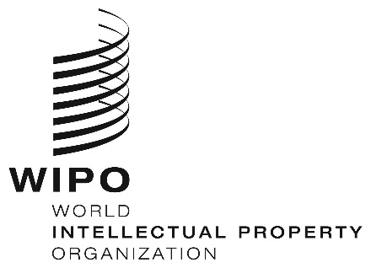
INFORMATION NOTICE NO. 47/2019

Madrid Protocol Concerning the International Registration of Marks

Withdrawal of the notifications made under Rules 34(2)(b) and 40(6) of the Common Regulations under the Madrid Agreement and the Madrid Protocol: Singapore

- The Director General of the World Intellectual Property Organization (WIPO) received a communication from the Office of Singapore withdrawing the notifications made by Singapore under Rules 34(2)(b) and 40(6) of the Common Regulations under the Madrid Agreement and the Madrid Protocol (“Common Regulations”).
- Such withdrawal became effective on April 1, 2019.
- Consequently, as from April 1, 2019:
- the Office of Singapore no longer collects and forwards to the International Bureau of WIPO the fees due under the Madrid Protocol and the Common Regulations; and,
- the Office of Singapore can present to the International Bureau of WIPO requests for the division of an international registration under Rule 27bis(1) of the Common Regulations and requests for the merger of international registrations resulting from division under Rule 27ter(2)(a) of the Common Regulations.

May 7, 2019

