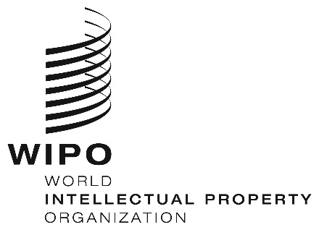
INFORMATION NOTICE NO. 48/2019

Madrid Protocol Concerning the International Registration of Marks

Withdrawal of the notification made under Rule 34(2)(b) of the Common Regulations under the Madrid Agreement and the Madrid Protocol: United Kingdom

- The Director General of the World Intellectual Property Organization (WIPO) received a communication from the Office of the United Kingdom withdrawing the notification made by the United Kingdom under Rule 34(2)(b) of the Common Regulations under the Madrid Agreement and the Madrid Protocol (“Common Regulations”).
- Such withdrawal became effective on May 6, 2019.
- Consequently, as from May 6, 2019, the Office of the United Kingdom no longer collects and forwards to the International Bureau of WIPO the fees due under the Madrid Protocol and the Common Regulations.

May 14, 2019

