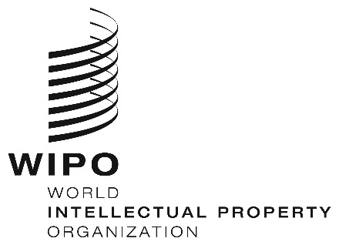
INFORMATION NOTICE NO. 58/2019

Madrid Protocol Concerning the International Registration of Marks

Accession to the Madrid Protocol: Malaysia

- On September 27, 2019, the Government of Malaysia deposited with the Director General of the World Intellectual Property Organization (WIPO) its instrument of accession to the Protocol Relating to the Madrid Agreement Concerning the International Registration of Marks (“the Madrid Protocol”). The Madrid Protocol will enter into force with respect to Malaysia on December 27, 2019.
- The said instrument of accession was accompanied by:
– the declaration referred to in Article 5(2)(b) and (c) of the Madrid Protocol, whereby the time limit of one year to notify a provisional refusal of protection is replaced by 18 months, and a provisional refusal resulting from an opposition may be notified after the expiry of the 18-month time limit;
– the declaration referred to in Article 8(7)(a) of the Madrid Protocol, whereby Malaysia wants to receive an individual fee when it is designated in an international application, in a designation subsequent to an international registration and in respect of the renewal of an international registration where it has been designated, instead of a share in the revenue produced by the supplementary and complementary fees;
– the notification under Rule 7(2) of the Common Regulations, whereby Malaysia requires, when it is designated under the Madrid Protocol, a declaration of intention to use the mark. The footnote 2 in item 11 of the official form MM2 and item 4 of the official form MM4 will be modified to indicate that, by designating Malaysia, the applicant or holder declares that he has the intention that the mark will be used by him or with his consent in Malaysia in connection with the goods and services identified in the international application or subsequent designation concerned;
– the notification under Rule 20bis(6)(b) of the Common Regulations, whereby the recording of licenses in the International Register shall have no effect in Malaysia and, consequently, a license relating to an international registration shall be recorded in the national Register of the Office of Malaysia, complying with the formalities required for such recording directly with this Office, in accordance with the conditions laid down by the legislation of Malaysia, to have effect in this Contracting Party.
- The amounts of the individual fee indicated by the Government of Malaysia under Article 8(7)(a) of the Madrid Protocol will be the subject of a separate information notice.
- With the accession of Malaysia to the Madrid Protocol, the number of Contracting Parties of this treaty and members of the Madrid Union is now 106. A list of the members of the Madrid Union, with information on the dates on which they became party to the Madrid Protocol, is available on WIPO’s website, at the following address: www.wipo.int/madrid/en/members.

October 22, 2019

