E
WIPO/IP/CWS_NS/GE/19/INF/1
ORIGINAL: English
DATE: MAY 7, 2019

WIPO STANDARDS WORKSHOP
ON NAME STANDARDIZATION

organized by the
World Intellectual Property Organization (WIPO)

Geneva, May 2 to 3, 2019

PROGRAM

prepared by the International Bureau of WIPO

Thursday May 2, 2019
Name Standardization
08:00 - 09.30 | Registration: WIPO Access Center
09:30 - 09:45 | Welcome address  Mr. Yoshiyuki Takagi, Assistant Director General, WIPO
Facilitator of Workshop:
Mr. Young-Woo Yun, Head, Standards Section, WIPO
Part 1: Information session
Current practices by IP Offices and others on name standardization, including pros and cons; challenges faced and ways to improve; lessons learned; high-level description of algorithms.
09:45 - 10:00 | Summary of 2016 workshop on Name Standardization  Presentation:  Mr. Edward Elliott, IP Information Officer, WIPO
10:00 - 10:10 | Update on IP5 Applicant Name Standardization  Presentation:  Dr. Jumi Lee, Deputy Director, KIPO
10:10 - 11:20 | Current practice by IP Offices (operations or data analysis)  Presentations:  Mr. Robert McNeill, Assistant Director, Digital Engagement,  IP Australia  Dr. Jumi Lee, Deputy Director, KIPO  Ms. Amanda Myers, Acting Deputy Chief Economist, USPTO  Q&A
11:20 - 11:40 | Coffee
11:40 - 13:00 | Current practice by Intergovernmental Organizations and Non-Governmental Organizations  Presentations:  Dr. Julie Callaert, Research Expert technometrics, KU Leuven  Mr. Bruno Pouliquen, Head, Advanced Applications Technology Center, WIPO  Mr. Geert Boedt, Business Analyst, EPO & Ms. Christina ten Hövel, Key Account Manager, EPO  Q&A
13:00 - 14:00 | Lunch
Part 2: Discussion session
Areas for cooperation between IP Offices or other parties
14:00 - 14:15 | The need for cooperation: what benefits can it bring? Where is it needed? What can it achieve? What difficulties does it raise?  Presentation:  Mr. Stephen Adams, PIUG; Managing Director, Magister Ltd  Q&A
14:15 - 14:45 | What level of coordination is desirable: name normalization, name standardization, or name harmonization?  Roundtable discussion  Moderators:  Mr. Jurjen Dijkstra, PatCom; Manager Content, LexisNexis  Ms. Amanda Myers, Acting Deputy Chief Economist, USPTO
14:45 - 15:15 | Should parties share data or algorithms and work on common projects? If so, what types of projects would be appropriate? What are the legal implications?  Roundtable discussion  Moderators:  Ms. Christina ten Hövel, Key Account Manager, EPO  Dr. Julie Callaert, Research Expert technometrics, KU Leuven
15:15 - 15:45 | What is the best way for parties to work together on these issues? How to determine funding, schedule, participants, etc?  Roundtable discussion  Moderator:  Mr. Michael Burn, Assistant Director, International ICT Cooperation,  IP Australia  Mr. Stephen Adams, PIUG; Managing Director, Magister Ltd
15:45 - 18:00 | Task Force meeting (members only)  NB Room 0.105

Friday May 3, 2019
Global and National Identifiers
08:00 - 09.30 | Registration: WIPO Access Center
Information session
Current practices by Offices and others on applicant identifiers: pros and cons of different approaches; challenges faced and ways to improve results.
09:30 - 09:45 | Results of CWS survey on identifiers  Presentation:  Mr. Edward Elliott, IP Information Officer, WIPO
09:45 - 10:45 | What are global identifiers? What examples exist outside of IP?  Presentations:  Mr. Graham Bell, ISNI; Executive Director, EDItEUR  Mr. Matthew Buys, Director of Engagement, ORCID  Q&A
10:45 - 11:15 | Current practice by IP Offices  Presentations:  Mr. Michael Burn, Assistant Director, International ICT Cooperation,  IP Australia  Q&A
11:15 - 11:30 | Coffee
11:30 - 12:30 | Current practice by IP Offices  Presentation:  Ms. Julie Daltrey, Data Architect, UK IPO & Mr. Gareth Jones, Informatics Analyst, UK IPO  Mr. Nikolay Popov, Head of the Center for Advanced Technologies, Rospatent  Q&A
12:30 - 14:00 | Lunch
Discussion session
Opportunities and challenges with using global identifiers
14:00 - 14:15 | Intro: What are the benefits of using global identifiers?  Presentation:  Mr. Jurjen Dijkstra, PatCom; Manager Content, LexisNexis
14:15 - 14:30 | Intro: What are possible concerns with using global identifiers?  Presentation:  Mr. Jonathan Osha, AIPLA; Managing Partner, Osha Liang LLP
14:30 - 15:00 | What issues could the use of global identifiers raise for applicants, for Offices, and for third parties?  Discussion topic  Moderators:  Mr. Jonathan Osha, AIPLA; Managing Partner, Osha Liang LLP  Ms. Amanda Myers, Acting Deputy Chief Economist, USPTO
15:00 - 15:30 | What are potential areas for cooperation going forward?  Discussion topic  Moderators:  Mr. Geert Boedt, Business Analyst, EPO  Ms. Maike Houtrouw, IP Analyst, Philips Intellectual Property & Standards
15:30 - 16:00 | What features are desirable for creation, exchange, and maintenance of global identifiers?  Discussion topic  Moderators:  Mr. Hao Zhou, Head, Data Development Section, Economics and Statistics Division, WIPO  Ms. Julie Daltrey, Data Architect, UK IPO
16:00 - 16:10 | Closing remarks  Mr. Kunihiko Fushimi, Director, International Classifications and Standards, WIPO
16:10 - 18:00 | Task Force meeting (members only)  NB Room 0.105
[Annex follows]

SPEAKERS’ PROFILES

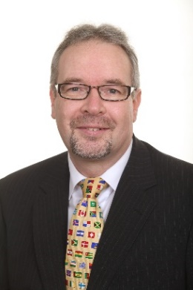
Mr. Stephen Adams
Managing Director, Magister Ltd.

Stephen Adams is the managing director of Magister Ltd., a UK-based consultancy specialising in patents information founded in 1997. Mr. Adams holds a B.Sc. in chemistry from the University of Bristol and an M.Sc. in Information Science from City University, London, and is a Member of both the Royal Society of Chemistry and the Chartered Institute of Library and Information Professionals (CILIP). He is the author of two editions of “Information Sources in Patents”, published by Walter de Gruyter KG, and serves on the Editorial Advisory Board of the Elsevier journal “World Patent Information”. He received the IPI Award in 2012 for outstanding contribution to patent information. He has served three terms on the Board of PIUG Inc., the International Society for Patent Information, as Director-at-Large (2002-2006) and Vice-Chair (2014-2016 and 2016-2018).

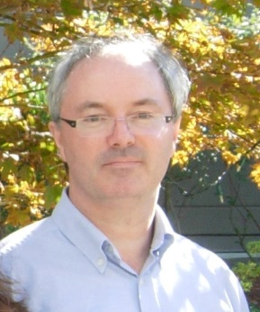
Mr. Graham Bell
Executive Director, EDItEUR

Graham Bell is Executive Director of EDItEUR, responsible for the overall development of EDItEUR’s standards for the global book, e-book and serials sectors, and the management services it provides on behalf of other standards agencies including the ISNI International Agency and the International DOI Foundation. He has two decades of experience working with metadata standards, and is an experienced speaker and trainer. Graham joined EDItEUR as its Chief Data Architect in 2010, initially focussed on ONIX for Books. He previously worked for HarperCollins Publishers in the UK, where he was Head of Publishing Systems. He led the development of bibliographic and digital asset management systems, and was involved with the launches of many HarperCollins digital initiatives including e-audio, e-books and print-on-demand programmes. Prior to HarperCollins, he worked as an editor and in IT roles within the magazine industry with Redwood Publishing and BBC Magazines.

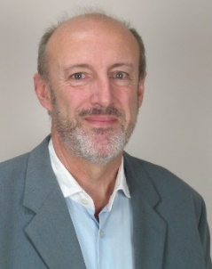
Mr. Geert Boedt
Business Analyst, EPO Vienna

After many years working in IT for international organisations he joined the EPO in 2004 in the Espacenet customer support area and subsequently gained experience in all of the EPO’s public patent information tools.
He moved to become business application manager for the PATSTAT data base; and is an expert on statistical analysis of patent data sets.
He advises researchers and policy makers worldwide on correct interpretation of patent data and value indicators and has many years’ experience of presenting on patent analytics topics.

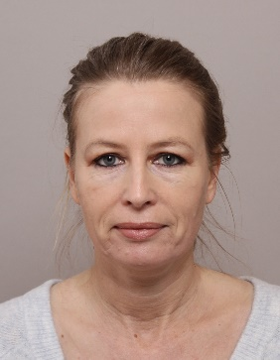
Ms. Christina ten Hövel
Key Account Manager, EPO

Patent formalities expert, directorate User Support The Hague. Christina joined the EPO in 2003. For more than 10 years she worked as expert in different departments, responsible for instructions and advice to Formalities Officers in respect of procedural changes and their implementation. Next to being part of various projects, she has been working as Key Account Manager since beginning of 2015.

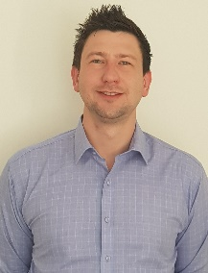
Mr. Michael Burn
Assistant Director, International ICT Cooperation, Innovation & Technology Group, IP Australia

Mr. Burn is responsible for building IP Australia's authority at an International level in technological fields and advancements through leadership, collaboration and cooperation across IP Offices by proactively engaging in International working groups, task forces, standards development, project and ICT deliverables in order to harmonise and build common practice, systems and process to the benefit of our stakeholders. A frequent speaker at International fora including the Committee on WIPO Standards (CWS) and ICT working groups he has significant knowledge and experience in the IP Rights domain; representing Australia at the CWS, managing their contribution across many Task Forces, including leadership of the Blockchain Task Force. Michael has recently overseen the delivery of IP Australia’s authority file, the launch of IPOcollab (an online platform for IPOs to connect, collaborate and share knowledge on projects and topics of choice), and is presently leading development work on common APIs for structured data transfer.

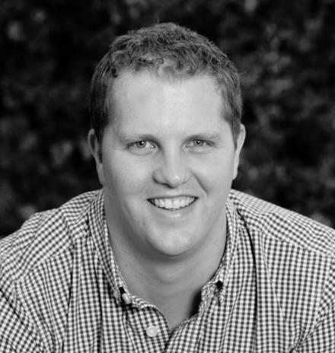
Mr. Matthew Buys
Director of Engagement, ORCID Inc.

Matthew is responsible for driving ORCID sustainability through community engagement, membership, integration, and user adoption efforts following best practice. The engagement team works with our member and user communities to build ORCID as an international-scale research effort. Matthew has been with ORCID since 2015 in various roles. He came to ORCID from Thomson Reuters, where he covered the Eastern and Southern Africa region; and prior to that was Regional Sales Manager at EBSCO Information Services. He completed a BA (Psychology) and Post-Graduate Diploma in Management at the University of the Witwatersrand. In addition, Matthew has also completed courses in Java, Flash, XML, html, Perl and SQL.

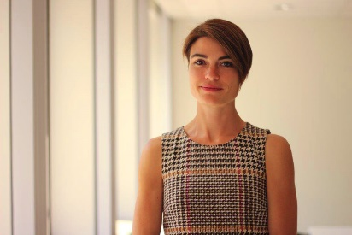
Dr. Julie Callaert
Research Expert technometrics, KU Leuven – ECOOM

Dr. Julie Callaert is Research Expert at ECOOM (Flemish Centre for R&D Monitoring; KU Leuven; Belgium). She manages the Technometrics study group of the centre, which provides patent indicators to the Flemish government in support of their technology policy. Her research is primarily oriented towards the development of novel and enhanced patent indicators, with a particular interest in the dynamics of science and technology interplay, including academic entrepreneurship. She has published on these topics in journals like Research Policy, Scientometrics, Journal of Technology Transfer, Economics of Innovation and New Technology, Industry and Innovation. With her background, and as a member of the INCENTIM research division from the KU Leuven’s Faculty of Business and Economics, she is also involved in several European Framework projects.

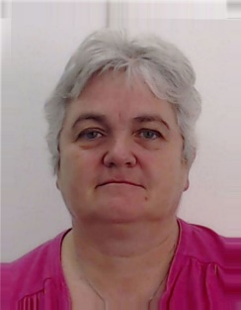
Ms. Julie Daltrey
Data Architect, UK Intellectual Property Office

I have worked at the UK Intellectual Property Office for 30 years in a variety of roles from Mainframe developer, PC developer, IT Team leader, IT Project Manager and for the last 6 years, Data Architect. Over the years I have been involved with all of the IP rights the UK manages, Patents, SPCs, Trade Marks, Designs and Copyright Orphan Works and have a good knowledge of our data and its fitness for purpose. Data Quality is my key personal area of interest and with name and address data being of the greatest concern across the Office it will be very interesting and valuable to hear about the experiences of other Offices in the area of applicant name standardisation and in particular hearing ideas of how we may be able to improve in this aspect in the future.

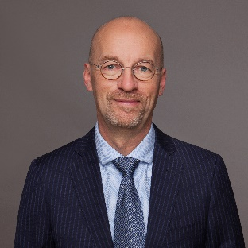
Mr. Jurjen Dijkstra
Manager Content, LexisNexis IP

Born in the Netherlands and living in The Hague area. After graduating as a building engineer I ended up in a R&D department of Fokker Aerospace and came in touch with innovation. Became even more involved in the IP business when I joined a broker organization that supported the commercial development of inventions for SME and private persons. The last 14 years I am working for LexisNexis as the manager IP content, responsible for strategy, content acquisition, harmonizing, adding value and getting the data into our databases.

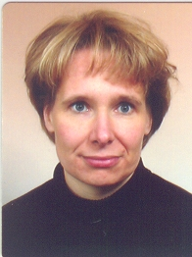
Ms. Maike Houtrow
IP Analyst, Philips Intellectual Property & Standards

Maike Houtrouw graduated in chemical engineering from the Aachen University of Applied Sciences in 1992. In 1993 she joined Philips Research Labs Eindhoven, where she was active in the field of semiconductor processing. From 1998 onwards she worked at Philips Components as a process engineer in the development of aspherical lenses for DVD and Blu-ray storage systems. In 2001 she joint Philips IP&S where she conducted novelty and validity searches, as well as patent landscaping and product risk assessments for various technical fields. She is a member of the WON, where she fulfilled amongst others the role as chair of the working group Search Intelligence. For many years, she participates in the PDG Impact group and is currently acting as taskforce leader for patent assignee name standardization. She is nominated to become a certified Qualified Patent Information Professional.

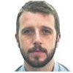
Mr. Gareth Jones
Informatics Analyst, UKIPO

Gareth works in the Informatics team at the UK IPO. Informatics uses creative thinking and problem solving skills to deliver evidence and insight to help others make better decisions. This is achieved through data analysis and visualisation using analytical software. Gareth has recently completed a project automating the cleaning and linking of IPO data to UK company information for analysis purposes.

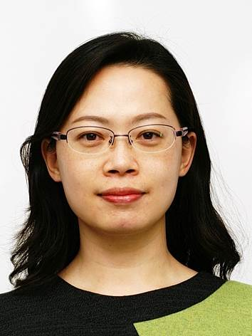
Dr. Jumi Lee
Deputy Director, KIPO

Jumi Lee received the B.S. degree in mathematics and electronics engineering from Ewha Womans University, Seoul, Korea, in 1998 and the M.S.E. and Ph.D. degrees in electrical engineering from Korea Advanced Institute of Science and Technology (KAIST), Daejeon, Korea, in 2000 and 2006, respectively. From 2007 to 2010, she was with DMC R&D Center, Samsung Electronics Co., Ltd., as a Senior Engineer. Since 2011, she has been with Korean Intellectual Property Office, where she is currently a Deputy Director.

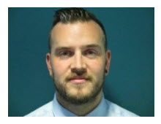
Mr. Robert McNeill
Assistant Director, Digital Engagement, IP Australia

With over eight years’ experience with IP Rights systems ranging from databases to digital customer platforms, Rob has a comprehensive knowledge of customers within Australia’s IP rights system. He is currently responsible digital identity and customer engagement across IP Australia’s various services and manages ongoing efforts to ensure its quality.

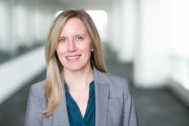
Ms. Amanda F. Myers
Acting Deputy Chief Economist with the Office of the Chief Economist, USPTO

Amanda’s current projects focus on the empirical study of the U.S. trademark system, gender and diversity in patenting and data-driven intellectual property policy and program administration. She has published journal articles and working papers on patent and trademark data and trademark use by firms and contributed to 2013 World Intellectual Property Report Brands – Reputation and Image in the Global Marketplace. Before joining USPTO, Amanda worked as an Economist in the United States Treasury Department, holding positions at the United States Mint and the Treasury Inspector General for Tax Administration. She holds a M.A. in International Economic Relations from American University and a B.S in International Economics from Texas Christian University.

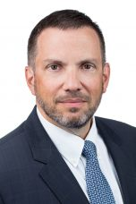
Mr. Jonathan Osha
Managing Partner, Osha Liang

Jonathan Osha servers as a member of the Board of Directors of AIPLA. In this capacity and as a member of AIPLA’s Harmonization Committee, he has participated in the Industry trilateral, IP5 industry, and Global Dossier Task Force meetings representing U.S. industry.
Mr. Osha also serves as Reporter General of the International Association for the Protection of Intellectual Property (AIPPI). AIPPI, as the oldest and largest international IP NGO representing all stakeholders, focuses on substantive and procedural harmonization of IP laws. The Reporter General is responsible for all scientific work of the Organization; Mr. Osha is the first American in this role since its founding in 1897.
In his “day job” Mr. Osha is managing partner of the Osha Liang organization, which he founded 21 years ago. The Osha Liang organization includes a patent and law firm in the United States, patent attorney firms in France and Japan, a representative law office in China, and an IP brokerage company. Osha Liang represents various multinational patent filers in the United States, Europe and Asia and also provides IP valuation and competitive intelligence services. Jonathan is both a patent attorney and an attorney at law. He holds a degree in Electrical Engineering from Cornell University as well as a Juris Doctor degree. His practice focuses on management of complex international IP portfolios, particularly in the fields of electronics and telecommunications.

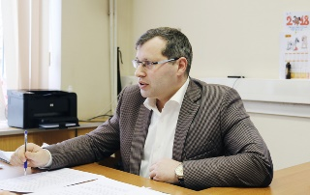
Mr. Nikolay Popov
Deputy Head of the FIPS Project Office, Head of Patent Analytics Division of Federal Institute of Industrial Property, Rospatent

I’ve been working at Russian patent office since 2001. Started my career at the Department of patent information services and marketing of FIPS, where I was responsible for dissemination RU patent information for Russian companies as well as commercial providers all over the world. I was a speaker on WIPO TISCs events many times. Since 2013 I’ve started patent analytics practice at the FIPS. In 2015 I became a co-founder of FIPS Project Office – special unit within the structure of Rospatent, which provides technological and business consulting based on patent analytics in a wide range of industries: oil&gas, medicine, transport and logistic, chemistry etc.

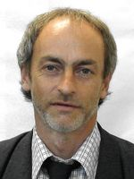
Mr. Bruno Pouliquen
Head, Advanced Applications Technology Center, WIPO

Bruno Pouliquen is heading the Advanced Technology Application Center in the World Intellectual Property Organization (WIPO) in Geneva. He works in WIPO since 2009 and is in charge of applying and exploring machine learning techniques to intellectual property applications. He owns a PhD in computer science (Faculty of Rennes, France, 2002), worked previously in text mining applied to the medical domain and specialized later in multilingual text mining (European Commission, 2001-2009). He published more than 50 scientific papers in the computational linguistic domain. He now works on various aspects of machine learning: machine translation, classification (image & texts) and speech recognition. WIPO was an early adopter of NMT (in production in 2016). This system is now installed and used in various United Nations agencies, as well as in patent offices. Over the years, he has published more than 60 scientific papers in the computational linguistic domain.

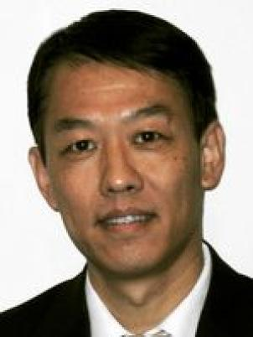
Mr. Hao Zhou
Head, Data Development Section, Economics and Statistics Division, WIPO

Hao Zhou obtained Bachelor of Science in Physics from the Peking University. He worked in the Chinese Patent Office as patent examiner and IPC coordinator, then worked for WIPO as PCT examination coordinator, IT business analyst, senior statistical analyst. He is currently in charge of developing statistical data for WIPO publications.

[End of Annex and of document]

The headquarters of WIPO, 34, chemin des Colombettes, Geneva (NB Room 0.107).

