E
SCCR/35/7

ORIGINAL: FRENCH
DATE: NOVEMBER 6, 2017

Standing Committee on Copyright and Related Rights

Thirty-Fifth Session
Geneva, November 13 to 17, 2017

THE ECONOMIC IMPLICATIONS OF THE ARTIST’S RESALE RIGHT

prepared by Joëlle Farchy, Professor at the University of Paris I, Panthéon-Sorbonne, Paris, France; Kathryn Graddy, Fred and Rita Richman Distinguished Professor in Economics, Brandeis University, Boston

The art market comprises sales of visual arts, including paintings and sculptures. This market is both deeply internationalized and highly speculative. Marked by a deep crisis in the late 1980s, it has experienced an extremely strong recovery since the early 2000s despite a brief downturn in 2008-2009 following the sub-prime crisis. However, in the last two years, its spectacular boom has seemed to be running out of steam and a possible market downturn looms. In 2016, a study announcing the existence of a speculative bubble and the fact that it was bound to burst in the near future received widespread coverage. However, it is difficult to reliably anticipate such a reversal with great accuracy, since speculative activities rely on mimicked behavior.

After presenting the main characteristics of the art market, this paper will analyze the specific form of copyright that applies to this market, the artist’s resale right. The analysis is supplemented by empirical studies and feedback from artists from different geographical zones.

1 – The international art market

  - The market players

Casual sellers, artists and buyers, as well as collectors, meet on the art market. Transactions rarely take place directly between buyers and sellers, but rather through intermediaries, mainly galleries and auction houses.

    - Intermediaries at the heart of the market

Sales of artworks may take place publicly in auctions or privately.

Given their public nature, auctions are the most visible part of the art market. Two major auction houses dominate the market. They are Sotheby’s and Christie’s, with sales of respectively 2.9 and 3 billion dollars in 2016 (see table below). Chinese auction houses have experienced strong growth: six of them are ranked among the top ten auction houses. The Chinese auction house Poly International Auction Co. Ltd., with a focus on the Asian market, has experienced spectacular growth since its establishment in 2005 (turnover of just under 1 billion US dollars in 2016).
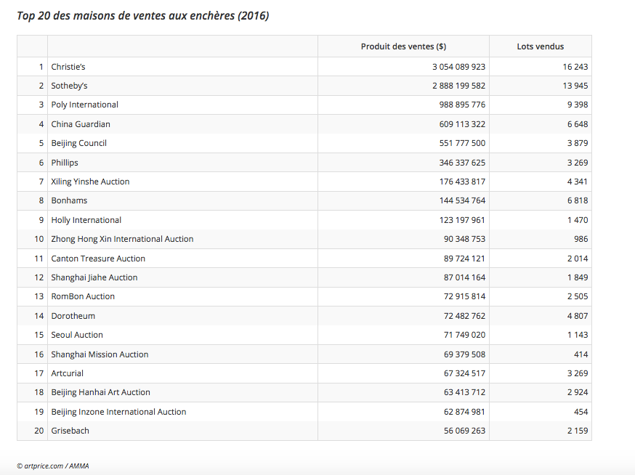

The geographical distribution of auctions worldwide, summarized in the diagram below, reveals the overwhelming share of the United States, the United Kingdom and China. Moreover, auction houses recently opened branches in emerging countries: Christie’s in Dubai in 2006 and Bonhams in 2008, and Sotheby’s in Doha in 2009.

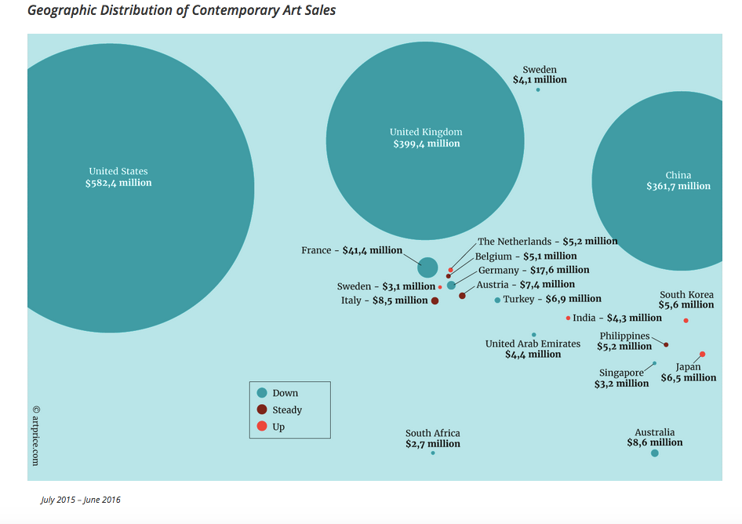

Source: ARTPRICE, 2016

Private transactions are carried out by galleries, brokers and, more recently, by auction houses in conjunction with private direct sales: in 2000, private sales at Christie’s amounted to only 185 million dollars, but according to TEFAF (The European Fine Art Fair), they reached almost one billion in 2016. According to the same source, Sotheby’s private sales are estimated at between 0.6 billion to 1 billion dollars for the United States and the United Kingdom. In the case of the United Kingdom, these are estimates since Sotheby’s, unlike Christie’s, does not disclose publicly the value of its sales. Art brokers and gallery owners watch in dismay as auction houses, attracted by the high profitability of private sales (because they do not involve the same costs as auctions, especially marketing), encroach upon their traditional markets in this way.

The respective importance of brokers and gallery owners varies greatly with the market segment:

- In the initial sale market, the galley owners who contribute to the artists’ careers through promotional activities play a central role. Indeed, transactions on this market take place almost exclusively in galleries, for the artists who manage to have their work shown. The massive sale of works (223) by Damien Hirst at Sotheby’s in 2008 for a record 140 million euros, bypassing galleries that are supposed to represent the artist, is emblematic of the breakdown and the tacit reassignment of roles that had hitherto been generally respected. In China, the role of the galleries is less important than in other countries; 4,400 galleries and merchants operate there, as compared to the 21,000 listed on the US market (source: TEFAF). The very rapid and speculative development of the Chinese market partly explains this peculiarity.

- All the players, auction houses, brokers and even merchants are likely to intervene in the secondary market – or the resale market.

Whether on the primary or secondary market, the role of fairs has grown considerably in recent years because of internationalization. Europe and the United States still dominate this area, even though the number of fairs in Asia has increased significantly (from 3 to 21 in 15 years). Their numbers remain very small in Africa and participating galleries are mostly local. Moreover, the number of galleries from emerging countries participating in large western fairs (Art Basel, Fiac, etc.) is still very limited: in Basel in 2014, more than 90 per cent of participating galleries were from Europe, the United States and Japan.

Geographical distribution of fairs

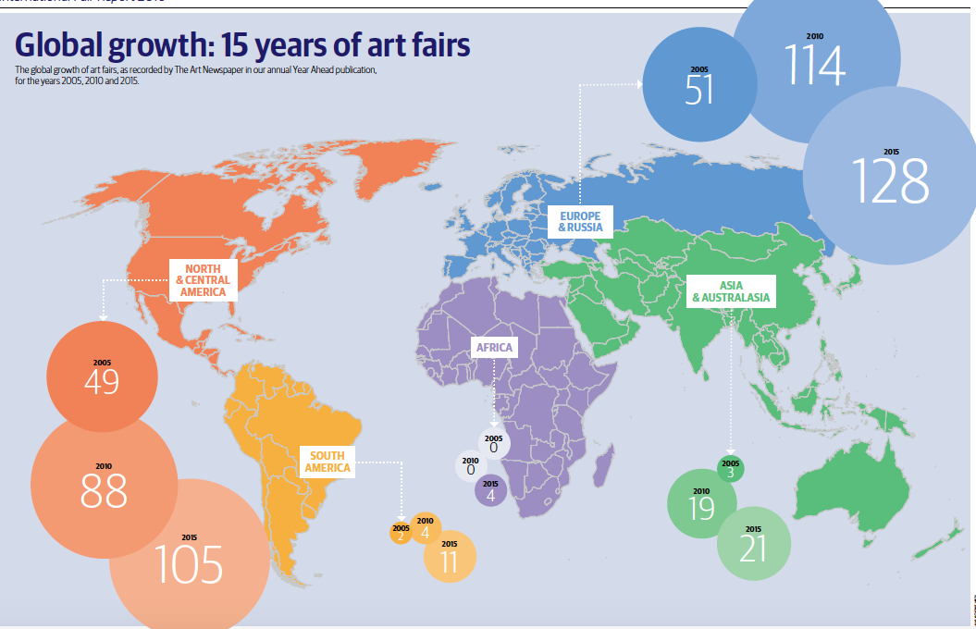

Source: The Art Newspaper, The International Art Fair Report, 2016.

For all transactions, whether public or private, the bulk of trades occur in a physical market. Although the share of electronic transactions has increased rapidly since 2000,

a report estimated that these sales represented less than 10 per cent of the overall market in 2015. More than 75 per cent of them are worth less than 5,000 US dollars each and 25 per cent for less than 5,00 US dollars each. Few of the exclusively online operators manage to gain a firm foothold: the two main operators, Auctionata and Paddle, had announced their merger, but it failed in 2016 and Auctionata ceased operations in May, 2017.

1.1.2 Artists: unequal sales distribution

In the auction market, there is a strong concentration of high-value sales around a small number of particularly well-known artists: in 2013-2014, three of them (the Americans Jeff Koons, Jean Michel Basquiat and Christopher Wool) accounted for 22 per cent of the contemporary art market (in the auction segment of artists born after 1945).

There is considerable imbalance in the distribution of auctions of works by living artists in 2016: a minority of works (1.15 per cent) corresponds to 72 per cent of total sales (see Figure 5 j below). The segmentation of the market by price bracket shows that only a small number of artists make more than a million US dollars in auctions (see Figure 5 k). In this segment, 20 artists made 36 per cent of auction proceeds in 2016.

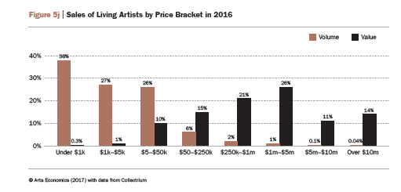
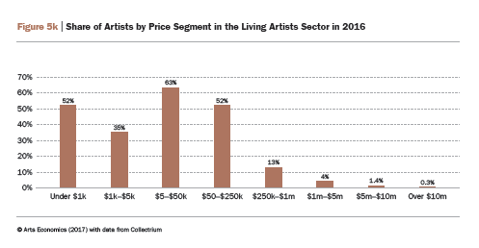

    - Buyers: the emergence of a new category of very wealthy collectors

The motivations for purchasing works of art are very diverse. Some people do it for purely romantic reasons – a passion or a hobby, others to distinguish themselves – for status, ostentation, as a promotional tool or for media coverage. Some do it for financial reasons (investment, speculation, tax savings), and yet others from commitment (defending emerging art scenes).

Whatever their motives may be, the ranks of buyers on auction markets, irrespective of price brackets, are growing. Each year since 2008, the magazine Artnews publishes a list of the most influential of these buyers in the world. The table below shows the weight of American collectors and the recent appearance of influential Chinese collectors. Although purchasing power is not the only factor explaining the purchase of works of art, there is an established correlation between the wealth of a country and the number of major collectors living there. The rise in the number of millionaires in the world caused the advent of a new class of collectors in search of social recognition and likely to bid particularly high amounts. In 2003, the World Wealth Report included 7.6 million HNWIs (high net worth individuals) worldwide; in 2010, this figure was 10.9 million and in 2015 it was 13.9 million. This development has had a significant impact on the high end of the market by rapidly increasing the number of individuals likely to bid more than 1 million dollars. Thomas Seydoux, expert of the art market, says “20 years ago, 20 per cent of the Forbes 500 list were our clients. It was a small world. All of this changed with the emergence of countries like China and Russia, and the growing number of very wealthy people. The number of buyers spending over 5 million has exploded and reached more than a thousand” (Quoted by Georgina Adams, 2014).

The greatest collectors in the world (according to data from Artnews)

 | 1995 | 2005 | 2015
Germany | 15 | 11 | 11
England | 10 | 12 | 10
Brazil | 1 | 2 | 5
Canada | 7 | 5 | 3
China | 4 | 1 | 9
Italy | 9 | 5 | 3
Japan | 8 | 2 | 3
France | 16 | 7 | 9
The Netherlands | 5 | 4 | 2
Switzerland | 6 | 15 | 9
United States | 95 | 110 | 97
Total | 176 | 174 | 161

Source: Moureau, Sagot-Duvauroux (2016)

1.2 Methodological difficulties in evaluating the market as a whole

Several annual sources provide detailed quantitative data on market developments.

1 – Firstly, the ARTPRICE report focuses on the only data on public auctions of fine art.

2 - The TEFAF report provides an estimate for a broader scope, including not only fine art, but also decorative arts and antiques. The TEFAF report also provides an estimate of the overall market sales, including galleries. Clare McAndrew, who wrote the TEFAF report for years, was replaced by Rachel Pownall in 2017.

3 – In 2017, Art Basel produced a competing report on the same topic as TEFAF. Clare McAndrew and her company, Arts Economics, now work for Art Basel.

Thus, since 2017, three different statistical sources exist. Before, the differences between the evaluations of ARTPRICE and TEFAF reports could be explained by taking into account different perimeters. The difference between the 2017 results of the TEFAF and Art Basel reports, which both aim to define the same perimeter, revealed the difficulties encountered in circumscribing the market. Hence:

- For 2016, Art Basel announces a global market value of 56.6 billion dollars (of which 57 per cent is for galleries), or an 11 per cent drop compared to 2015.
- TEFAF estimates the market at 45 billion (of which 62 per cent is for galleries) or a slight increase (1.7 per cent) compared to the previous year.

TEFAF states that it has made a finer selection of galleries than in previous reports, which included businesses that should not have been included. Moreover, TEFAF relies on the Orbis base for galleries, while Art Basel conducts its own survey (sent to 6,500 galleries with a response rate of 17 per cent). Finally, for public sales, the TEFAF report relies on the AMMA database and the Art Basel report uses the Collectrium database. Beyond the differences in methodology, it is still difficult to understand the extent of the disparity between the two assessments. The data for the entire market should therefore be approached with circumspection.

Nonetheless, since the TEFAF reports have been published over the years using a consistent methodology, they make it possible to identify general trends in the evolution of the global market, the value of which more than doubled between 2002 and 2014. The rise in the number of transactions over the same period of time, though significant, was less striking.

The international art market in the world (auctions and dealers)
 | 2002 | 2003 | 2004 | 2005 | 2006 | 2007 | 2008 | 2009 | 2010 | 2011 | 2012 | 2013 | 2014
Amount in euros | 22,264 | 18,631 | 24,385 | 28,833 | 43,331 | 48,065 | 42,158 | 28,335 | 42,951 | 46,351 | 44,091 | 47,419 | 51,216
Number of transactions | 25.8 | 25.4 | 26.6 | 28.2 | 32.1 | 49.8 | 43.7 | 31.0 | 35.1 | 36.8 | 35.5 | 36.5 | 38.8

Source: TEFAF, 2015
To avoid presenting unreliable data, for the rest of this study, we will focus on information derived from public sales.

1.3 Trends in the auction market

Explosion of record prices

The upsurge of the art market in the past ten years is largely attributable to the growth of the price of a minority of auctioned works: in 2016, 0.5 per cent of all transactions accounted for 48 per cent of the total value of auctioned sales. At the other end of the spectrum, over 43 per cent of the transactions contribute only 0.5 per cent of the total value of sales at auctions.

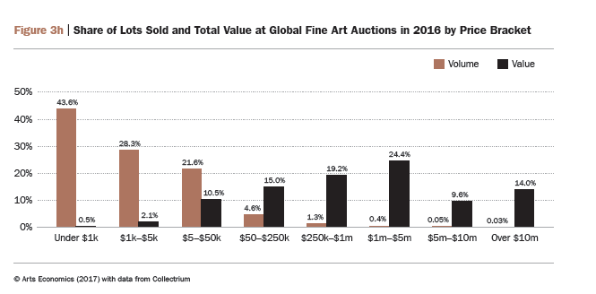

Source: Art Basel, 2017

The situation can be summarized as follows: The art market’s financial firepower keeps on changing scale. After stagnating at a top range of around 10 million US dollars in the 1980s, the top prices of individual artworks reached the 100 million US dollars threshold in the 2000s, and a Qatari buyer paid 300 million US dollars for a work by Gauguin. (ARTPRICE report 2014). According to the report, 116 works sold for over 10 million US dollars, compared to only 18 in 2005. The gap between average and median auction prices, especially in the largest markets (China, the United States and the United Kingdom; see chart below) confirms the importance of a small number of sales for very large amounts.

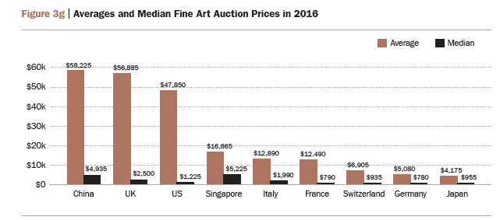

Source: Art Basel, 2017

Guaranteed price strategies adopted by auction houses, combined with a rise in the number of “big buyers”, artificially raise prices and promote both speculation and market volatility.

In more recent times, the evolution of trends by price range show a sharp drop in the number of transactions above 10 million in 2016 and a collapse in other price segments since 2015.

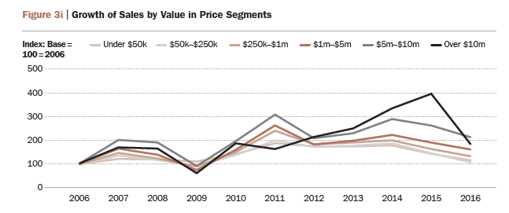

Source: Art Basel, 2017

The growing importance of contemporary works
Since 2000, the market share of works from the modern period has been stable. The ancient art segment, whose supply is becoming scarce, and the impressionist/post-impressionist segment have lost ground. In 2016, impressionist/post-impressionist works represent 18 per cent of the volume of transactions and 12 per cent of their value.
Contemporary and post-war works are the fastest-growing segment in the auction market. In 2016, they represented 37 per cent by volume of transactions and more than 50 per cent by value (compared to only 17 per cent in 2000). The contemporary offering, which is broader and more fluid than other market segments, gives rise to many speculative movements and a surge in prices.
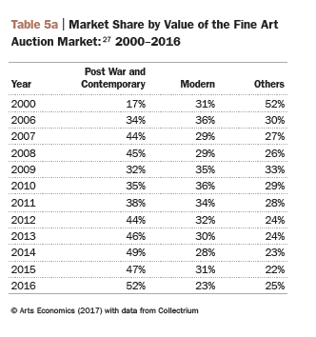

Source: Art Basel, 2017

The evolving importance of different countries

The respective positions of different countries have undergone profound changes since 2005, given the emergence of new markets. The decline of France on the world art scene in the second half of the twentieth century is undeniable, and this country, that was in first place in the 1950s, fell from third to fourth place. After robbing France of the third place in 2007, China continued its rise to take the top position in 2011 with 33 per cent of the market share. Since then, depending on the year, China and the United States compete for first place, ahead of the United Kingdom and France.

Countries’ market share (auction market)
2006 | 2007 | 2011 | 2014 | 2015 | 2016
US 45.9% | US 41.7% | China 33% | China 37.2% | US 38% | China 38%
UK 26.9% | UK 29.7% | US 30% | US 32.1% | China 26% | USA 28%
France 6.4% | China 7.3% | UK 19% | UK 18,9% | UK 25% | UK17%
China 4.9% | France 6.4% | France 5% | France 3.3% | France 3% | France 5%
Source: ARTPRICE, Art Market Trends

Since 80 per cent of auction transactions take place in these four countries, there is little room for other countries, as shown in the graph below. Aside from Switzerland and Germany, other countries have made a marginal contribution to the auction market.

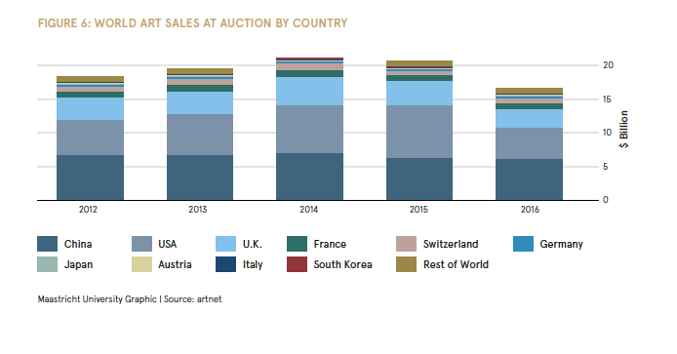

Source: TEFAF, 2017 based on the Artnet database
To understand the activity of different countries, this paper will now analyze exports and imports of works of art and collections (automobiles, watches, etc.). Paintings constitute the largest trading volume.

Europe has a positive art trade balance which, while beneficial for contemporary art, may be viewed as more negative for art from earlier periods as it leads to a weakening of national heritages. The American continent, on the other hand, has a negative balance (imports higher than exports) for antiques and paintings.
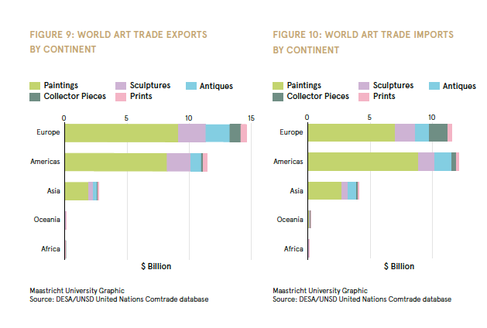

Source: TEFAF, 2017

In Africa and Oceania, there is almost no international trade of works of art and collections; this does not mean that artists from Africa and Oceania are absent from the international market. Rather, when they are present, their works are traded outside of their continent. For instance, a study on the galleries and artists who participated in the Art Basel fair shows that between 2005 and 2012, the number of African galleries present went from 1 (or 0.4 per cent of all participating galleries) to 2 (0.7 per cent of all participating galleries); at the same time, the number of African artists on display in all booths increased from 25 (0.8 per cent) to 94 (2.3 per cent). The increase in the number of African artists represented at the fair is therefore attributable to their being displayed in foreign galleries rather than in African ones.

Mechanisms aimed at building a reputation based on international networks make it difficult for artists from an emerging country to access the international market through local galleries and institutions. Moreover, in reality, the globalization of the art market only concerns a limited market segment, namely the one built around the most expensive sales and a small number of artists and transactions.

1.4 The international market and local niche markets

The globalization of the art market has not eliminated strong local characteristics. The profiles of each of the major geographical areas of international trade are quite unique both in terms of distribution between public and private sales, price levels and type of works traded.

The US and UK markets: world leaders in value

The following diagram shows the market shares of the different countries by price bracket. Above the one million US dollar threshold, the weight of the United States and the United Kingdom is overwhelming. Of the millionaire transactions, 83 per cent take place in New York or London.
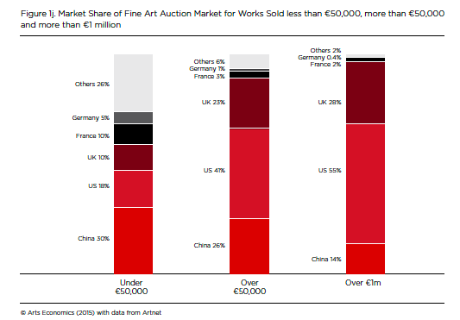

Source: TEFAF, 2015

The US and UK markets are, without a doubt, the two world leaders of the market in terms of value. Most of the works of American artists are sold in their country. While Willem de Kooning, Jackson Pollock, Morris Louis, Sam Francis and Richard Chamberlain are among the deceased artists who reap the highest prices at auctions, names like Jasper Johns, John Baldessari and James Rosenquist are among the most popular living artists at auctions. A younger generation of artists like Wade Guyton, Cecily Brown or Elizabeth Peyton, born in the 1960s and 1970s, is also present.

France: a volume market

As shown in the previous chart, there are many transactions on the French market, but the average hammer prices are low compared to those in the United States or the United Kingdom. While France’s share of works worth less than 50,000 euros on the market is 10 per cent, its share of works worth more than 1 million dollars is now only 2 per cent. French contemporary artists have little presence on the international auction scene. It is essentially the works of artists who passed away a long time ago – like Matisse, Bonnard, Renoir, Rodin, Cézanne, Corot and Boucher – that are sold at record high prices in the United States and not in France.

China: a mainly internal auction market

Unlike Europe and the United States, the Asian market is dominated by auction houses rather than galleries. In addition, private sales by auction houses are virtually non-existent. Lastly, the Chinese public sales market focuses more on old and modern works than on the contemporary art segment.
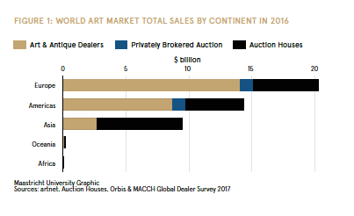

Source: TEFAF, 2017, according to the Artnet database

Since 90 per cent of the auction market in China is aimed at selling the works of Chinese artists, and these sales are mostly intended for Chinese buyers, this market is often described as internal.

Meanwhile, 187 Chinese artists like Liu Wei, Chen Yifei, Zeng Fanzhi, Zhang Xiaogang, Ai Weiwei and Yan Pei Ming are among the top 500 of those with the highest auction sales in the world, especially in the Unites States and the United Kingdom. In total, as shown in the table below, Chinese artists account for 39 per cent of the auction market turnover of all the auction houses in the world.

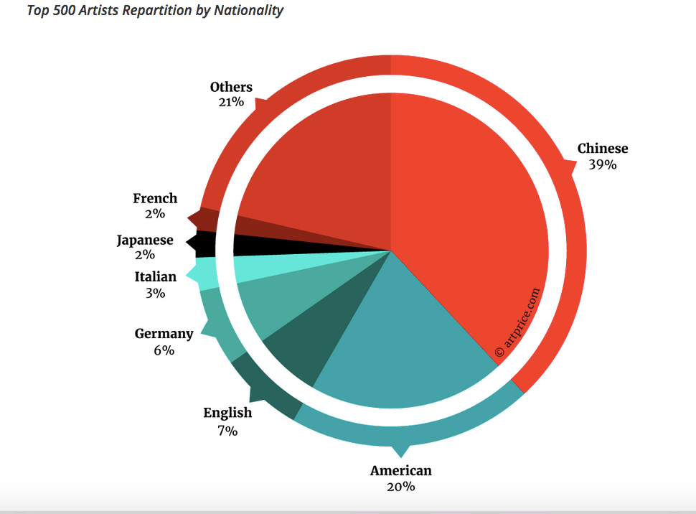

Source: Art Price contemporary art market report, 2016

2 – The resale right: a copyright specifically designed for the art market

The resale right is a specific form of copyright relating only to visual and graphic artists.

2.1 A long history

In Europe, the notion of the resale right (droit de suite) was present in France as far back as 1,893, when attorney Albert Vaunois use the term in the Chronique de Paris to condemn the situation of disadvantaged visual artists compared to that of musicians. Nevertheless, several decades passed before the resale right was introduced to the world by the law of May 20, 1920. Belgium very quickly followed France’s example by introducing the resale right in 1921. Subsequently, the resale right was incorporated into law in Germany in 1965 and in Denmark in 1990. When the European Resale Rights Directive, which harmonized the resale right in European Union countries, was implemented in 2001, 11 countries had recognized the resale right, but it was only enforceable in seven of them: Belgium, Denmark, Finland, France, Germany, Spain and Sweden.

The idea of an artist’s resale right appeared in international legislation as early as 1928, during the Rome Conference. In 1948, the artist’s resale right was formally introduced in Article 14ter of the Berne Convention for the Protection of Literary and Artistic Works during the Brussels Conference. This express mention of the resale right suggests there was a certain consensus on the subject; in fact, this is only a very vague acknowledgement, leaving a wide margin of maneuver for national legislation. This explains the diversity, or indeed confusion, regarding the implementation of the resale right in national legislation.

The artist’s resale right was introduced as an optional obligation in the 1948 Brussels Act of the Berne Convention. Article 14ter provides that if a resale right is enacted in both the artist’s home country and the country where the work of art is sold, then the artist may claim the right to the extent allowed in the country where the work of art was sold. While 185 countries are party to the Berne Convention, not all have implemented the optional obligation of the artist’s resale right.
In the field of visual arts, unlike other forms of production in the cultural industries, once the work is purchased, the artist can neither authorize nor prohibit its use. Thus, the resale right is a remuneration right calculated according to a percentage of the sales made which enables the artist and his/her heirs to follow the works’ economic path and provides them with a source of revenue.

The argument typically put forward to legitimize the resale right is an argument of social justice compared to the creators of other cultural domains, since artists, unlike their colleagues, do not enjoy a right of reproduction or distribution on the use of their works and with regard to other economic players in the art market. The resale right, which associates the creator with the economic life of his work in time, appears as a specific right for graphic and visual artists who produce unique original works or works printed in a limited, numbered series. It was created so that they would not be disadvantaged compared to other creators taking advantage of the successive exploitations of their works. Legend has it that a caricature by Jean-Louis Forain accelerated the advent of the resale right in France so that heirs of renowned artists could continue to benefit from the value of the works. In the caricature, a young boy in rags stands with his sister looking into an auction house window, where a painting, apparently created by their father, is on display, with the caption “Un tableau de papa!” (“One of father’s paintings!”), referring to the sale of The Angelus by Millet for one million francs; the piece had been first sold by the artist for 1,200 francs while his family lived in extreme poverty. The idea is not, however, to create social protection to support all artists.

According to a list provided on the Confédération Internationale des Sociétés d'Auteurs et Compositeurs (CISAC) website, the 74 countries listed below had passed legislation on the resale right as at 2014:
Algeria, Australia, Austria, Azerbaijan, Belgium, Belarus, Bolivia, Brazil, Bulgaria, Burkina Faso, Chile, Colombia, Congo, Costa Rica, Cyprus, Czech Republic, Croatia, Denmark, Ecuador, Estonia, Finland, France, Gabon, Georgia, Germany, Greece, Guatemala, Guinea, Honduras, Hungary, Iceland, India, Iraq, Ireland, Italy, Ivory Coast, Kazakhstan, Kyrgyzstan, Laos, Latvia, Liechtenstein, Lithuania, Luxembourg, Madagascar, Mali, Malta, Mexico, Monaco, Montenegro, Morocco, Netherlands, New Zealand, Nicaragua, Norway, Panama, Paraguay, Peru, Philippines, Poland, Portugal, Romania, Russian Federation, Senegal, Serbia, Slovakia, Slovenia, Spain, Sweden, Tunisia, Turkey, Ukraine, United Kingdom, Uruguay and Venezuela.

A 2015 study by Professor Sam Ricketson of the University of Melbourne lists 80 countries applying the resale right. Some of the largest art markets are in countries that do not apply it, such as China, the United States and Switzerland.

2.2 Income for artists and their heirs

All artists do not benefit from the resale right in the same way. As with any royalties, the resale right is associated with the success of the work. It is not always easy to keep track of the amounts distributed. In France, data provided by ADAGP (the French collective management organization that collects and distributes royalties for graphic and visual artists) are available and mainly concern auctions, given that sales in galleries are much more difficult to ascertain with any real accuracy. Moreover, not all sales governed by the resale right are known to ADAGP, especially since it does not manage known artists such as Henri Matisse or Pablo Picasso. Indeed, some artists (or their heirs) are sufficiently well-known to have chosen to manage their works directly.

All in all, the auctions in France declared to ADAGP and subject to the resale right amounted to 205 million in 2014. Of these auctions, 5.9 million euros were distributed to 3,246 individuals (1,024 living artists and 2,222 heirs of deceased artists), respectively 2.1 and 3.8 million euros as resale rights. A total of 1,838 artists (1,024 living and 814 deceased) generated resale rights averaging 3,218 euros per author and 3,010 euros per work sold. The averages mask inequalities in the distribution: 70 per cent of the artists receive less than 1,000 euros and 5 per cent receive 15,000 euros or more. In 2016, eight artists received more than 100,000 euros in resale rights and two living artists are in the top 20 (see table below). Disregarding the 5 per cent of artists who receive the most, and the 5 per cent who receive the least, the average amount of resale rights paid between 2012 and 2015 is somewhere between 1,800 and 1,950 euros, depending on the year.

Top 20 artists receiving resale rights in 2016
(Resale rights generated on the basis of auctions in France)

Ranking | Resale right | Total sales amount | Number of sales
1 | 288,403 € | 17,361,031 € | 80
2 | 207,374 € | 5,935,931 € | 202
3 | 182,337 € | 9,085,586 € | 189
4 | 167,844 € | 5,667,800 € | 47
5 | 166,643 € | 7,698,665 € | 149
6 | 150,149 € | 12,941,622 € | 87
7 | 127,343 € | 5,941,100 € | 70
8 | 113,684 € | 5,622,056 € | 175
9 | 99,042 € | 3,233,903 € | 46
10 | 93,698 € | 4,863,635 € | 57
11 | 90,189 € | 2,288,267 € | 199
12 | 88,321 € | 3,698,387 € | 52
13 | 84,871 € | 2,298,545 € | 139
14 | 83,747 € | 5,003,661 € | 40
15 | 80,040 € | 2,654,650 € | 136
16 | 78,566 € | 4,719,448 € | 31
17 | 77,244 € | 6,174,326 € | 24
18 | 75,615 € | 2,460,907 € | 46
19 | 74,949 € | 15,354,979 € | 13
20 | 72,453 € | 2,461,684 € | 43

Source: ADAGP

2.3 The importance of implementing mechanisms: the European case

Beyond the debate on the existence or absence of the resale right in a given geographical area, the actual implementing mechanisms are particularly important. Depending on these mechanisms, the effect of the resale right on the market as a whole may vary widely. In Europe, where harmonization has already been largely achieved, three examples illustrate the consequences of implementing the resale right.

First example: In principle, the resale right favors successful artists. However, as it is applied in Europe – with tapering rates of sale and a cap above a certain threshold – it significantly limits these inequitable effects.

Second example: The differentiated effects of the resale right on galleries as intermediaries. As important players in the primary market, they must contribute to the development of the artists’ careers. When fully captured by the artist, the resale right might be a disincentive if galleries take care of the promotional side. In order to limit these effects, recital 18 of the directive provides that “with regard to the particular situation of art galleries which acquire works directly from the author, Member States should be allowed the option of exempting from the resale right acts of resale of those works which take place within three years of that acquisition. The interests of the artist should also be taken into account by limiting this exemption to such acts of resale where the resale price does not exceed 10,000 euros.” The directive specifies that member states may stipulate such exoneration from the resale right, but that this is optional for each individual member state. In any case, a gallery selling an artwork more than three years after it was acquired must pay a resale right, regardless of the resale price

Third example: If the cost of the resale right is borne by the buyer rather than the seller (in accordance with the decision of the European Court of Justice), it puts the gallery owner in an unfavorable position compared to auction houses that make no effort to promote the artist. In fact, buyers cannot negotiate the sales contract at an auction. The sales contract, mentioned in the catalogue, applies equally to everyone. Conversely, the seller can, thanks to the individualization of the relationship with the auctioneer, negotiate the amount of the sales costs as well as the resale right in advance. In order to gain access to certain prestigious markets, auction houses may be required to pay the seller’s fees and the resale right, even if it means transferring these costs to the buyer, who is unable to negotiate. Moreover, and contrary to the European Court of Justice decision, it is debatable whether shifting the payment to the buyer has no effect the amount paid to the artist. An example would be a buyer who is capable of anticipating exactly how much resale right will be levied. His maximum bid is 50,000 euros, which means the resale right will be 2,000 euros if this amount is borne by the seller. If the buyer bears the cost of the resale right, his maximum bid is still 50,000 euros, including the resale right, in other words a price of 48,077 euros and a resale right of 1,923 euros (rather than 2,000) for the artist.

3 – The impact of introducing the resale right in a given geographical area: empirical analysis of the United Kingdom

Few works have focused on empirical demonstration, specific cases and the consequences in terms of price, in terms of income on artists or relocation due to methodological difficulties encountered. Many factors affect sales: some are regulatory; others are attributable to the dynamics of auction houses and their own ability to attract flagship works (network, marketing, etc.) or the behavior of buyer and collector in each market. In order to determine the potential impact of the resale right, it is therefore important to freeze external factors as far as possible and to reason in terms of “all things being equal”, which is always difficult to do. Some empirical studies were nevertheless conducted to identify the effect of introducing the resale right in a given geographical area, the United Kingdom.

The European Directive of 2001 had to be transposed at the national level before January, 2006. Nevertheless, the member states whose legislation at the time made no mention of a resale right could initially limit its application to the resale of living artists, excluding it for deceased artists until January 1, 2010. This delay could be extended for a further 2 years if there were sufficient economic grounds. The states that obtained these extensions were: Austria, Great Britain, Ireland and the Netherlands. The implementation of the Directive met with especially strong resistance from the British, who strongly campaigned for an extension of their period of adaptation until 2012.

The United Kingdom finally adopted the resale right on February 14, 2006, restricting its application to living artists (Statutory Instrument 2006 No. 346). On January 2, 2012, the benefits of the resale right were extended to include the heirs of artists who had died in the past 70 years. This country is almost a textbook case, since by introducing the resale right in 2006, it can be viewed as initiating a natural experiment in order to understand the effects of the resale rights.

3.1 The UK art market

The UK art market, like most major art markets, can be separated into an auction market and a dealer market. The collection of the Artist’s Resale Right (ARR) is relatively straightforward in the auction market because price and quantity sold are transparent.

The auction market

The major auction houses are the English houses of Christie’s and Sotheby’s. Almost all art is auctioned in the ‘‘English’’ or ‘‘ascending price’’ format, in which bidding starts low and the auctioneer subsequently calls out higher and higher prices. When the bidding stops, the item is said to be ‘‘knocked down’’ or ‘‘hammered down’’, and the final price is the ‘‘hammer price.’’ Not all items put up for sale and ‘‘knocked down’’ are sold. If the bidding does not reach the level of the secret reserve price set by the seller, the item will go unsold. Auctioneers say that an unsold item has been ‘‘bought-in.’’ It may be put up for sale at a later auction, sold elsewhere or taken off the market. Auctioneers charge commissions to buyers and sellers for the works that they sell. Sellers’ commissions are negotiable and are kept secret, but buyers’ commissions are known. The royalty rates imposed by the ARR are small compared to standard buyers’ commissions. For example, buyers’ commissions at Sotheby’s in London in 2008 were 25 per cent on the first 25,000 pounds sterling and 20 per cent on 25,000 to 500,000 pounds sterling. Above 500,000 pounds sterling, buyers’ commissions are 12 per cent. In the absence of a reserve price, the incidence of buyers’ commissions falls on the seller in an auction, as does the ARR. A full discussion on the incidence of buyers’ commissions is given in Ashenfelter and Graddy (2005).

The size of the auction market in the UK has been rigorously measured on several occasions as part of the studies that have been undertaken on the implementation of the ARR in the UK. A 2005 study by Graddy and Szymanski, a 2008 study by Horowitz and Szymanski, and a 2010 academic paper by Banternghansa and Graddy all used the Hislop Art Sales Index to measure the size of the market. The Hislop Art Sales Index is a widely used and respected source of data on fine art sales. Specifically, it covers sales of paintings, prints, works on paper, sculptures, miniatures and photographs worth more than 250 pounds. The Art Sales Index covers all of the major auction houses and estimates that it covers over 80 per cent of all auction houses in the UK. It was used in the Leeuwenburgh report on the potential impact of the ARR on the UK art market, published in 2003. The Art Sales Index was also used by TEFAF in a recent study that focused on the potential impact of the harmonization of the ARR across Europe.

The 2005 study by Graddy and Szymanski valued the UK auction market at about 700 million euros. They arrived at this number by aggregating sales listed in the Art Sales Index between March 2003 and March 2004. Note that this number comprised 21,806 distinct works of art, at an average value of just under 31 thousand pounds. The high value results from the skewed distribution: about 1 per cent of works sold accounted for 44 per cent of value. Again, note that only works over 250 pounds are included in the Art Sales Index. In the 2008 study by Graddy, Horowitz and Szymanski, during the period August 2006 through July 2007 a total of 29,538 works were valued at 1.9 billion euros. Thus, the number of works over this 2 ½ year period grew by 35 per cent and the value grew by an astounding 184 per cent. The 2017 TEFAF report valued the 2016 UK auction market at about 2.4 billion, down from a reported 3.8 billion in 2013 according to the 2014 TEFAF report.

The dealer market

The dealer market is opaque and its size is unclear. One study estimated that the art market in the UK is evenly split between auctions and dealers (Kusin and Company (2002)). However, in another measure, undocumented sources indicated that collection houses in the UK were collecting less than 20 per cent of ARRs revenue from dealers (Graddy Horowitz and Szymanski (2008)). Both statements could potentially be correct, if dealers are simply underreporting sales in order to avoid ARRs. The 2017 TEFAF report indicated that there has been a recent surge in dealer and private sales, both in the US and the UK.

3.2. The impact of the introduction of the ARR on the UK art market in 2006

In 2008 the UK Intellectual Property Office commissioned a study in which the authors showed that the UK market continued to grow after the introduction of the ARR.

In terms of the numbers of works sold, the market had clearly expanded over this time period
(22,613 works were sold for the 2003/2004 period in contrast to 29,538 works for the latest yearly period). It is also clear that prices had risen significantly. Since the implementation of the ARR, the average price per artwork (not including items that sold for less than 1,000 euros) was 41,000 pounds sterling whereas just over four years earlier the average price per artwork using the same calculation was 21,000 pounds sterling. It therefore appeared that the market had both expanded and appreciated significantly in this time period. This was consistent with a worldwide expansion in sales of art and a booming contemporary art market. Furthermore, Graddy, Horowitz and Szymanski (2008) showed that the UK art market relative to other markets did not appear to suffer during this period.

It is quite interesting to look at each country’s sales as a proportion of total group sales (by volume and by value). After an initial dip both by value and by volume during the first five and a half months after the introduction of ARR, the UK increased percentage sales on both measures. Importantly, between the period February 15, 2006 and July 31, 2006 and the period August 1, 2006 and July 31, 2007, the per cent of sales by volume increased from 29.35 per cent to 32.46 per cent in the UK (an increase of 10.5 per cent points); by value, sales in the UK increased from 35.28 per cent to 37.34 per cent (an increase of 5.8 per cent). For the same time periods, the volume of US sales increased from 30.83 per cent to 33.20 per cent (an increase of 7.8 per cent – less than in the UK) while the value of sales rose from 50.56 per cent to 52.09 per cent (an increase of about 3 per cent – again less than in the UK). For the same period, sales by both value and volume decreased in France and Germany.

In a more rigorous academic study, Chanont Banterghansa and Kathryn Graddy also came to the same conclusion. Banterghansa and Graddy (2011) set out to compare the counterfactual: what would have happened in the UK if the ARR had not been implemented. Since this is not observable, they compared a treatment group – works sold by auction in the UK between August 1, 1993 and July 31, 2007 that would be subject to the ARR after its implementation – first with all paintings in the UK that would not be subject to the ARR and next with works that would have been subject to the ARR if sold in the UK, but were sold in other countries. They started the comparison in July 1993 as there were few expectations before this point that the ARR would be implemented in the UK.

Banterghansa and Graddy gathered data on prices and quantities sold at auction from Hislop’s Art Sales Index for six yearly periods of sales of art: August 1, 1993 through July 31, 1994, August 1, 1996 through July 31, 1997; August 1, 2000 through July 31, 2001; March 1, 2003 through February 29, 2004; August 1, 2004 through July 31, 2005; and August 1, 2006 through July 31, 2007. For these periods, they downloaded and analyzed all sales of paintings at prices over 1,000 euros, as paintings must be sold at a price above 1,000 euros to be eligible for the ARR. They then constructed price indices for paintings that would be subject to the ARR and paintings that would not be subject to the ARR based on country of origin and whether the artist was still alive. They calculated the difference in price between works subject to ARR in the UK and those not subject to ARR in the UK, relative to the difference in price between works sold in the US that would be subject to the ARR in the UK and those works sold in the US that would not be subject to ARR in the UK, i.e. the relative price growth of ARR works in the UK in relation to this sector in other countries.

The authors concluded that the price growth for art subject to the ARR in the UK – the treatment group -- was higher than for any another other country and higher than the average total market growth. Furthermore, prices for paintings that were subject to the ARR had increased relatively more in the UK than in any other country. This increase was statistically significant for the US, France and Germany. The authors also did a number of robust checks using different data sets and different methodologies to construct the index, and in all cases came to the same conclusion.

Banterghansa and Graddy (2011) also looked at quantities sold at auction by whether or not the paintings were subject to the ARR using the difference on difference analysis. The percentage growth in the number of artworks sold in the UK subject to the ARR was greater than for any other market presented. Furthermore, the results indicated that the UK’s relative growth in the ARR segment was greater than each other country’s relative growth in the ARR segment. In conclusion, the art market in the UK, either despite or because of the introduction of ARR, appears to be doing well.

3.3 The impact of delocalization

The UK case also resulted in a recent comparative analysis over time (before and after the introduction of the ARR) to identify the possible effects of relocation. The globalization of trade is reflected in strong competition among various marketplaces. The whole of Europe is competing with old markets like the United States, but also new markets like China, Hong Kong and India. Because of competition between member states, a 2001 European Directive partially harmonized legislation. The resale right is now applied to the two most important art markets in the EU: France and the United Kingdom. The issue of the risk of relocating transactions in order to avoid paying the resale right has therefore moved outside the boundaries of the European Union. Does London, a major art market, risk becoming less attractive compared to New York, its main rival?

What is interesting about the study of the British case is comparing the evolution of market shares in the United Kingdom before and after the introduction of the resale right and other major marketplaces which have not undergone legislative changes, such as China and the United States (two countries not concerned by the resale right) or France (a country that has been subject to the resale right throughout the period). This method makes it possible to measure the overall evolution of the market throughout the period, to integrate the general trend to a certain extent, and to determine whether the introduction of the resale right causes a reduction of the relative trade volume for works affected by the resale rights, compared to works not affected by it. The market of Chinese auction houses has a number of specific features that make comparisons difficult. As a result, the evolution of the UK’s relative share compared to that of France and the United States is preferred.

A database was created from ARTPRICE and ARTVALUE sources by collecting the list of artists from all periods (contemporary artists, but also modern and old ones) having achieved the largest cumulative sale at an auction (total in value) from 2002 to 2014. As a reminder, the resale right was introduced in the UK in 2006 for living artists and in 2012 for deceased artists. The ARTPRICE top 500 ranking brings together artists having achieved record prices, but also artists commanding lower prices for their works, but who sell large quantities. Thus, the list does not correspond to the 500 most expensive sales of the year. A database of 1,193 different artists who were on the top 500 list for at least a year was established and information on the highest and lowest auction sales of the year for the each artist concerned was collected. This resulted in a database of 9,800 sales. The database consists not only of unique works, but also of works printed in a limited series whose prices are naturally lower for a given artist. The goal of the sample thus created is to describe the diversity of the art market through the diversity of the selected artists and the range of prices (the highest and the lowest bids). The amounts realized though the lowest bids ultimately proved to be paltry sometimes.

Three segments of transactions that, pursuant to the EU directive, are or are not “eligible” for the resale right have been identified: artists who were alive at the time of the sale, artists who have been dead for less than 70 years and artists who have been dead for more than 70 years. From these three transaction segments, it is possible to compare the populations affected by legislative changes in the UK (artists alive before and after 2006, and those who died less than 70 years before and after 2012), and the very same populations in countries that have not implemented these legislative changes. Any negative impact from the resale right should be apparent in the volumes and the net sales in countries where the resale right was introduced as a result of the relocation of the trade of artists falling within its scope.

To understand the impact of the legislative changes of February 14, 2006 (the date the ARR entered into force for living artists) and January 2, 2012 (the date the ARR entered into force for deceased artists), two sales “populations” are compared in each case.

The change in 2006 for living artists

As for the market by volume, the growth rate of the British market by value (238 per cent) is significantly higher than that of the American market (141 per cent). There are no negative effects from the resale right on the market as a whole after 2006. A more detailed analysis was conducted by isolating the living artists affected by the reform.

With regard to the living artists’ market, the UK’s growth is well above that of the overall market for all periods combined: annual average sales rose by 784 per cent in the UK compared to the period before and after 2006, and “only” by 477 per cent in the United States. The number of transactions that took place in the UK after the introduction of the ARR in 2006 did not have a noticeable impact on the living artist market. In terms of value, the annual average sales increased by 871 per cent in the UK and by 359 per cent in the United States. In terms of volume and value, the British market that was affected by the resale right did not suffer any unfavorable change compared to the US market which was not affected by this legislative change.

The change in 2012 for artists who died less than 70 years ago

Overall, the American market is growing more rapidly than the British market (22.6 per cent compared to 14.9 per cent). In terms of value, both the United States and the United Kingdom have high growth rates, with that of the United Kingdom being slightly lower than that of the United States (86 per cent against 107 per cent). Here again, it seems pertinent to conduct a more detailed analysis by isolating the sales in the UK affected by the 2012 legislative change.

For artists who died less than 70 years ago, the annual average number of sales rose by 14.2 per cent in the UK, and by 25.9 per cent in the United States between the periods before and after 2012. Not having undergone legislative change, the United States market is growing faster than the United Kingdom market. France, which has not undergone any legislative changes either, is growing at a slower pace than the United Kingdom. The differences in the evolution of two countries that have not experienced legislative changes (France and the United States), compared to that of the United Kingdom, indicate that it cannot be inferred that the changes are due to the introduction of the resale right. In terms of value, the growth rate in the United States is even more marked than in volume. The hierarchy of growth rates remains the same as in volume: + 156 per cent in the United States, + 80 per cent in the United Kingdom and -11 per cent in France. Once again, the United Kingdom has seen a much less favorable evolution than the United States, which did not implement legislative changes, but a more favorable evolution than France, which did not implement any changes either.

Thus, after all the studies conducted on the UK situation, no impact on the tracking of transactions related to the two resale right reforms can be found.

4 – Experiences from artists

4.1 The UK experience

In this section, we summarize artists’ experience with the ARR in the UK by drawing on a number of interviews that were done with artists immediately after the ARR was implemented, in addition to contemporary interviews. The first set of interviews were included as a part of the 2008 Graddy Horowitz and Szymanski study, and the complete responses are recorded in that study. The contemporary interviews are presented in video and written form on the DACS website. These are all artists describing their experience with ARR and summaries of these interviews are presented below.

Summary of 2008 UK interviews

The artists interviewed in the Graddy Horowitz and Szymanski study (2008) were Ken Howard, Christopher Le Brun, Tim Layzell, Darren Baker, Ken Currie, John Scarland, Nicola Bealing, Bernard McMullen, Brian Pollard, Liam Spencer and one anonymous artist. Of the 11 artists interviewed, all 11 were in favor of, or satisfied with, the ARR. They also approved of DACS, the main collecting society. They all had generally good interactions with DACS. Many were only aware of the ARR when they were contacted by DACS and informed that they were due to receive a payment. All were also in favor of the ARR being inalienable. At that point, most had only received one royalty payment, with the interviews done about a year and half after the ARR was implemented. A number of artists mentioned the fact that dealers were concerned, but that it had not come up between them and the galleries where they were represented.

Only one of the artists interviewed verbalized the concern that the ARR could make buying art that is subject to the right more difficult. He was concerned that collectors might purchase fewer works of eligible art, and instead switch to works that are not subject to royalties. Nonetheless, he did not feel that the ARR was negatively impacting his career and was in favor.

Another artist noted that the galleries were strongly against. He did express the concern that the survey -- performed 1 ½ years after implementation - was premature. One artist expressed the view that the payment was necessary to allow artists to “get by” and another stated that he was treating it like a pension.

The artists in the study were chosen by DACS as artists that had recently received a royalty payment. Note that only approximately 2 per cent of all the 50,000 artists in the DACS database would have had a resale at that time.

It is unsurprising that the artists who were interviewed were in favor. In most cases, these artists had just received an unexpected – but very welcome – payment. The payment at the time could be compared to receiving a gift – but a gift that one felt was earned and deserved. The goodwill toward DACS was undoubtedly increased because DACS was the bearer of this unexpected gift. One artist went so far to say that the answer to the question of whether artists think that the ARR is beneficial is an obvious yes.

Summary of DACS interviews

On the DACS website, four contemporary case studies of artists who have received the ARR are presented. Two artists, Jeremy Deller and Gavin Turk, have their case studies primarily presented as videos, with a short write-up underneath, and two other artists, Chantal Joffe and Angela de La Cruz, have short write-ups regarding their experience with the ARR. A short summary of each of their case studies is presented below.

Jeremy Deller believes strongly that artists should benefit from the subsequent sales of their work. As is often the case with an artist who speaks in favor of the ARR, he states that other creative media have copyright laws in place. He counters the argument that resale rights will be detrimental to the market by saying that many new regulations are greeted with trepidation, but the art market continues to thrive. Perhaps in acknowledgement that implementation is expensive to auction houses (or perhaps based on a misunderstanding that sellers and not auction houses pay the royalty), he states that auction houses are wealthy and should be giving back to society. Although the resale rights for heirs are not explicitly mentioned in the interview, Deller also describes going to see the works of a recently deceased artist. He describes that artist as producing very good work late in his life, perhaps an implicit endorsement of the ARR for heirs.

Gavin Turk starts by describing himself as lucky, as he graduated in 1993 from an art college without a lot of debt. He describes a benefit of the ARR from it being a method to track his works. The fact that he will receive royalties when they are sold demonstrates to him that his art still exists. He describes it as a tracking system that shows how work is moving about in the marketplace. He asserts, however, that the money clearly also helps. Again, although the interview did not explicitly refer to resale rights for heirs, Turk spoke about children inheriting work, and it being expensive to keep up the work. Again, an implicit endorsement for resale rights for heirs.

In a written statement, Chantal Joffe seconds Turks comments about the non-monetary benefit of the ARR being the ability to track work in the secondary market.

Angela de la Cruz is a Spanish-born artist. Her summary is short, but a key take-away is her statement that collectors buy work for a fraction of the price for which it is resold. Her statement is an implicit endorsement for the ARR. In both selections of artists, the collecting society, DACS, which has much to gain from the implementation of the ARR, was involved in the selection of artists interviewed. Nonetheless, resale rights are widely supported by artists in major art markets. A widely cited case in the United States is that of Robert Rauschenberg, and his behavior at the Scull auction. In 1973, Robert and Ethel Scull sold a number of their works at auction. One of the works that was sold was the painting “Thaw”, by Robert Rauschenberg. The Sculls had purchased the painting for 900 dollars and it was resold for 85,000 dollars (see Merryman (1993) for details). As captured during the auction on a documentary film, Rauschenberg very angrily commented, “I’ve been working my ass for you to make all that profit.” The film and incident are widely cited in support of the ARR.

4.2 The Resale Royalty in Australia and its effect on indigenous artists

The artist’s resale royalty in Australia came into effect on June 9, 2010. The scheme applies to profitable resales of works of art over 1,000 dollars, with a 5 per cent royalty payment. The scheme does not apply to private sales or to the first exchange of works to other hands after the June 9 implementation. It applies to existing works as well as new works. The royalty will be extended to artworks by artists from countries that have a resale royalty.

The Australian market has not been as well studied as the UK market, perhaps because of the exclusion of the first change to other hands after the June 2010 implementation. Below, we document one case study of potential resale rights involving an indigenous artist and discussion of the effects on many artists by the National Association for Visual Arts (NAVA). We then discuss information on the ability of the resale right to help track and enforce the Indigenous Art Code, and we discuss potential effects on Indigenous Art Centres.

Much of the debate around resale royalties in Australia relates to the impact the ARR potentially can make on indigenous artists and their communities. Proponents of the scheme assert that resale royalties play a role in addressing indigenous disadvantage by returning a share of profits associated with the appreciation of art works to their creators and descendants. As the Arts Law Centre of Australia notes there are the often-cited examples of works having been initially sold for very low prices and then selling on the open market some time later at record-breaking prices. One example is the resale of Water Dreaming at Kalipinypa by indigenous artist Johnny Warangkula Tjupurrula for 486,500 dollars in July 2000, after its original purchase in the 1970s for around 150 dollars. Another event that drew attention to the issue was last year’s resale of Emily Kngwarreye’s work Earth’s Creation for a record price of over one million dollars.

The Arts Law Centre of Australia has published online a series of case studies on various topics. In one of the case studies, they interviewed Sarrita King, an indigenous artist, about her support for the Australian resale rights royalty scheme.

Sarrita King is an indigenous artist, whose father, William King Jungala, was also a well-known visual artist. She is from the Garindji and Wanyi language groups, and spent a lot of her time growing up in the Australian bush country, from which she credits much of her inspiration. She registered for the royalties scheme and she registered her works on the resale royalty website. She is then able to track her works. She appreciates the ability to track her works as they are resold, and she values that her children may potentially benefit from the royalty scheme. In the interview, she stated that she was especially pleased that older artists would be able to benefit from the scheme, as their works become collectables and increasingly valuable.
The NAVA in Australia has tracked the success of the resale rights royalties scheme. In 2013, they surveyed their members. In a summary of the results, they documented that 90.3 per cent of artists surveyed stated that simple recognition that artists have rights is an important benefit. Furthermore, 70.1 per cent of the artists who participated in the survey stated that earning income via the scheme is a valuable benefit, though only 8 per cent of those surveyed had actually received a payment. NAVA also tracked payments. From the period June 2010 through September 2015, they found that payments totaled 3.7 million dollars. More than 11,100 resales occurred for 1,090 artists. The lowest payment was 50 dollars and the highest royalty payment was 55,000 dollars. Most payments were between 50 dollars and 500 dollars.
In 2016, Art Sales Digest estimated that the auction market alone in Australia was around 105 million dollars. It is always difficult to estimate the size of the dealer market, but often it is roughly given as about equal. That would be mean that for around 210 million dollars total of annual sales (or approximately 840 million dollars over a
4-year period), resale rights payments amounted to only about 0.5 per cent of the market. However, as more time passes following the implementation of the scheme, it is more likely that the amount collected as a proportion of total sales will go up, as the right did not apply to the first change of hands for a work after implementation.
Interestingly, NAVA found that 65 per cent of the artists were Aboriginal or Torres Strait Islander artists and that they received 38 per cent of the total royalties. Of the 50 artists who received the most money, 22 are Aboriginal or Torres Strait Islander artists. If 38 per cent of the royalties went to indigenous artists, this means that over the 5-year period between the study dates of 2010 and 2015, indigenous artists received approximately 1.4 million dollars.
Australia commenced a review of the resale royalty scheme in 2013, which has yet to be finalized. One unfortunate aspect of the implementation of the scheme is that it will by design appear to have collected very small amounts of money as it did not apply to the first sale after implementation in June of 2010. As items are only resold on average every 10 to 20 years, it will be a long time before a true review of the scheme can take place.
The Indigenous Art Code was first proposed by the National Association of Visual Artists, and was later endorsed by a number of Australian groups, including the Australia Council for the Arts. The Industry Alliance Group, composed of dealers, artists, Indigenous Art Centres, public galleries and auction houses, endorsed the code and in July 2010 the code was implemented. The way it was implemented is that dealers (and artists or supporters) sign up to become members of Indigenous Art Code Limited. Dealers and supporters pay a membership fee of 150 dollars for administration, and sign a document promising to uphold the code.
Aboriginal Art Online is an online for-profit company that both sells aboriginal art online and provides information on aboriginal art. While the company states that the benefits to aboriginal artists are likely to be small, it supports the fact that a database will be created by the implementation of resale royalties, which will allow the tracking of aboriginal art and support the Indigenous Art Code of Conduct.
Much of the reporting and payments under the scheme has fallen on Indigenous Art Centers. The Copyright Agency has produced a fact sheet for these centers on reporting and payment requirements. A number of the Indigenous Art Centres are community owned and there is some concern that the resale royalties will be a burden to the very communities it is hoped they will help.
4.3 Resale rights in Africa
As of July 2017, the African countries that recognize the ARR in their law include Algeria, Burkina Faso, Congo, Gabon, the Ivory Coast, Madagascar, Malawi, Mali, Senegal and Tunisia. As noted earlier in this report, the African art market is not well-developed and represents less than 1 per cent of the world market. Yet, because of reciprocity, the ARR is very important to African artists.
African art provides a classic situation where traditional works of art have become valuable and traded in international markets. Australia, with its resale rights legislation, has sought to allow its indigenous population to share in the national and international popularity of their art. As most African nations are relatively poor compared to nations with established art markets where well-known African art is often traded, many believe that it is important that native artists have a way of sharing in the wealth created by their art, without having to rely on the trust or charity of art market middlemen.
For countries that have adopted the ARR, reciprocity is recognized by Article 14ter of the Berne Convention. If a resale right is enacted in both the artist’s home country and the country where the work of art is sold, then the artist may claim the right to the extent allowed in the country where the artwork was sold. However if the country where the art work is sold or the artist’s home country do not recognize the resale right, the artist will not benefit from the right.
Thus, if an African country adopts ARR legislation, its artists are able to share in the proceeds of traded artwork in any other country that has adopted resale rights legislation. This can be an important source of income for African artists.
The Senegalese sculptor Ousmane Sow, one of the early supports of the ARR, was succinctly quoted by ADAGP (Société des Auteurs dans les Arts Graphiques et Plastiques) as follows:
Artists do not live on thin air. And because they enrich the world with their art, they should be protected. So it is fair that those who trade in their works pay them a share of what they earn. That is the purpose of the resale right: to share all forms of enrichment.
Sow supported the ARR, becoming a Vice-President of CISAC, the international network of collecting societies. He understands the benefit of the ARR to African artists in a global economy.
Senegal also has a well-written and documented implementation code for the ARR. Resale rights in Senegal are applied at 5 per cent of the value of the work, with no upper or lower limit on the value of the art works. The absence of an upper limit is consistent with the manner in which rights are applied in Australia, and is likely indicative of the lower market values of artworks that are sold in Senegal. The absence of an upper limit is also consistent with the goal of returning profits to indigenous artists. Similar to Europe and Australia, the rights are applied both for artists and their heirs for 70 years after the death of the artist. In Senegal, there is no lower limit on the value of an artwork for which resale rights are applied.
However, as noted above, it is not primarily the collection of resale rights payments within the home country that makes resale rights so valuable to African artists, but the reciprocity established by the Berne Convention. The importance of recognition of the ARR in African countries lies as much in the reciprocity rules as in the actual recognition within the countries themselves. This reciprocity can become extremely important for artists whose work is regularly sold in the EU.
A case in point is the artist, Romuald Hazoume, from Porto Novo, in the Republic of Benin. Hazoume’s work first came to be known in the UK in 1992, with the Saatchi Gallery’s Out of Africa show. Since then, his work has been featured in a number of museums, including the British Museum, the Guggenheim Museum and the Museo Guggenheim Bilbao. His work has also been featured in a number of galleries, including Gagosian and even sold at auction at Christie’s.
As a demonstration of the lopsided applicability of the ARR, consider the December 1, 2009 auction of Post-War and Contemporary Art at Christie’s in Amsterdam:
Lot 165, Hazoume’s work, “Baby Doll”, sold for 4,375 euros. The Special Notice was the following:
Christie’s charges a premium to the buyer on the Hammer Price of each lot sold at the following rates: 29.75 per cent of the Hammer Price of each lot up to and including 20,000 euros, plus 23.8 per cent of the Hammer Price between 20,001 euros and 800.000 euros, plus 14.28 per cent of any amount in excess of 800.000 euros. Buyer’s premium is calculated on the basis of each lot individually.

Lot 27 of the December 2009 sale was the Dutch painter Jeroen Henneman’s work, “Night on the Ridge Road”, which also sold for 4,375 euros. The Special Notice for this work was as follows:
Artist's Resale Right ("Droit de Suite"). Artist's Resale Right Regulations 2006 apply to this lot, the buyer agrees to pay us an amount equal to the resale royalty provided for in those Regulations, and we undertake to the buyer to pay such amount to the artist's collection agent. Christie’s charges a premium to the buyer on the Hammer Price of each lot sold at the following rates: 29.75 per cent of the Hammer Price of each lot up to and including 20,000 euros, plus 23.8 per cent of the Hammer Price between 20,001 euros and 800.000 euros, plus 14.28 per cent of any amount in excess of 800.000 euros. Buyer’s premium is calculated on the basis of each lot individually.
The point is that although Hazoume is from Benin, much of his work is sold in Europe, which recognizes the ARR. But, because the Republic of Benin has not adopted this right, Hazoume does not receive royalties as do European artists. According to the European Directive as applied in the Netherlands, the resale right on 4,375 euros would amount to.04 * 4,375 euros = 175 euros. Henneman received 175 euros but Hazoume did not. Hazoume spoke to this anomaly during the April 2017 WIPO conference: “I’m speaking for all African artists – you need to act now, otherwise we will just continue with this injustice.” These amounts are especially important to fund the work of artists in developing countries.

5 – Conclusion

The art market has changed over time, with an explosion in prices, an increasing proportion of the market taken up with contemporary art, and the emergence of China as an important market player. The US and the UK remain the dominant players for high value art, defined by works that sell for over 1,000,000 euros. France is an important market for works that sell for less than 50,000 euros, and China is a large and growing market.
Originally established in France in 1920, the ARR has increasingly become an internationally established royalty over the past 100 years.
- An important breakthrough occurred in 1948, when Article 14ter was added to the Berne Convention for the Protection of Literary and Artistic Works and the droit de suite was added as an optional obligation.
- In 2006, another important event occurred when the UK adopted the ARR after the passage of EU Directive 2001/84/EC. This adoption was important because the world’s second largest market now recognized the ARR.
- A recent important development was the implementation of the right in Australia in 2010. Australia explicitly recognized that the royalties could have a large impact on its indigenous population by returning a share of profits to the creators of the works of art. Similar arguments are made for the implementation of the ARR in African countries.
Overall, artists are overwhelmingly in favor of the ARR. Most believe it is a moral issue; artists should share in the profitability of their work, as do other creators.

Summary

1- The international art market
1.1The market players
    - Intermediaries at the heart of the market
1.1.2 Artists, unequal sales distribution
    - Buyers, the emergence of a new category of very wealthy collectors

  - Methodological difficulties in evaluating the market as a whole

1.3 The evolution of the auction market
The explosion of record prices
The growing importance of contemporary artworks
The evolving importance of different countries

  - International market and local niche markets
The US and UK markets: world leaders in value
In France, a volume market
In China, an essentially internal auction market

2 – The resale right, a copyright a copyright specifically designed for the art market
2.1 A long history
2.2 Income for artists and their heirs
2.3 The importance of implementation modalities: the European case.

3 – The impact of the introduction of the resale right in a given geographical area: the empirical analysis of the United Kingdom

3.1 The UK art market
3.2 The impact of the introduction of the ARR on the UK art market in 2006

3.3 The impact of delocalization

4 – Experiences from artists
4.1 The UK experience
4.2 The Resale Royalty in Australia and its effect on indigenous artists
4.3 Resale Rights in Africa

5 – Conclusion

References

Ashenfelter, Orley, and Kathryn Graddy. “Anatomy of the Rise and Fall of a Price-Fixing Conspiracy: Auctions at Sotheby's and Christie's.” Journal of Competition Law and Economics 1.1 (2005): 3-20
Bala - Curioni S, Forti L, Leone L, (2015), “Making Visible Artists and Galleries in the Global Art System”, in Cosmopolitan Canvases, Oxford University Press.
Banternghansa, Chanont, and Kathryn Graddy. “The impact of the Droit de Suite in the UK: an empirical analysis.” Journal of Cultural Economics 35.2 (2011): 81-100.
BENHAMOU F., FARCHY J. (2014), Droit d'auteur et copyright, Paris, La Découverte, collection “Repères”.
Capelle – Blancard Gunther, Farchy Joëlle, Moureau Nathalie (2016) “The impact of the resale right on the British art market”, Working paper, Paris 1.
Farchy Moureau (2016), Présumé coupable, droit de suite et marché international de l’art, Presses des mines, collection cahiers de l’EMNS, Paris.
FILER R. K. (1984), “A Theoretical Analysis of the Economic Impact of Artist’s Resale Royalties Legislation”, Journal of Cultural Economics, 8 (1), p. 1-28.
Ginsburgh V (2011), “Resale Rights”, in R Towse, (eds) Handbook of Cultural Economics, Edward Elgar Publishing, p. 394 – 400.
Graddy, Kathryn and Stefan Szymanski. A study into the likely impact of the implementation of the resale right for the benefit of the author of an original work of art. IP Institute working paper, 2005.
Graddy, Katy, Noah Horowitz, and Stefan Szymanski. A study into the effect on the UK art market of the introduction of the artist's resale right. UK Intellectual Property, 2008.
HANSMANN H. & SANTILLI M. (2001), “Royalties for Artists versus Royalties for Authors and Composers”, Journal of Cultural Economics, 25, 259-281.
Karp L. S., Perloff J. (1993), “Legal Requirements that Artists Receive Resale Royalties”, International Review of Law and Economics, 13, 163 – 177.

Kräussl Roman, Lehnert Thorsten, Martelin Nicolas (2016), “Is There a Bubble in the Art Market?’’, Journal of Empirical Finance, Vol. 35, 99-109.
Landes W. M., Levine D. B. (2006), “The Economic Analysis of Art Law”, in V Ginsburgh and D Throsby (eds) Handbook of the Economics of Art and Culture, Amsterdam, Northholland, 211 – 251.
Leroux Jean-Yves et Moureau Nathalie, “La main visible des grands collectionneurs dans la valeur artistique”, dans Bret Jean-Noël (under the dir. of), l’Art, l’argent et la mondialisation, Paris, L’Harmattan, 2013.
Mc Andrew, Clare. “TEFAF Art Market Report 2014”, The European Art Foundation, 2014.
Merryman, John Henry. “The Wrath of Robert Rauschenberg”,The American Journal of Comparative Law 41.1 (1993): 103-127.
Moureau, Sagot Duvaroux (2016), le marché de l’art contemporain, La découverte.
PERLOFF J. (1998), “Droit de Suite”, in P. Newman editions,The New Palgrave Dictionary of Economics and Law, Macmillan, 645-648.
Pownall, Rachel A. J. “TEFAF Art Market Report 2017”, The European Art Foundation, 2017.
RUSHTON M. (2001), “The Law and Economics of Artist’s Inalienable Rights”, Journal of Cultural Economics, 25 (4), 243-257.
SOLOW J. L. (1998), “An Economic Analysis of the Droit de Suite”, Journal of Cultural Economics, 22 (4), 209-226.
Standford J. D. (2003), “Economic Analysis of the Droit de Suite”, Australian Economic Papers, 42(4), 386 – 398.

Transcontinentales, special edition on the emerging art markets.
Velthuis O. (2015), “There is no Single Global Art Market”, 269, June.
Velthuis O. et Bala - Curioni S. (2015), Cosmopolitan Canvases, Oxford University Press.

WANG G. H. (2010), “The Resale Royalty Right and its Economic Effects”, Journal of Economic Research, 15, 171-182.
Watt R. (2014), Copyright in Visual Art Markets, in R. Watt (eds) Handbook on the Economics of Copyright, Edwar Elgar, 328 – 341.

[End of document]

Kräussl, Lehnert, Martelin, 2016.
This first part was completed with the assistance of Nathalie Moureau.
Given that it is the gallery that builds the artist's career, the artist has a moral obligation to not offer his works of art for sale directly without using the gallery as an intermediary, in order to allow it to achieve a “return on investment”.
Velthuis, 2015.
Hiscox Online Art Trade Report, 2015.
ART Price.
Art Basel Report 2017.
Leroux, Moureau, 2013.
Fine arts, as opposed to decorative arts and furniture.
The periods are demarcated as follows: Old masters: artists born before 1780; 19th century: artists born between 1760 and 1860; Modern art: works by artists born between 1860 and 1920; Post-war: artists born between 1920 and 1945; and Contemporary art: artists born after1945.
Bala-Curioni et al., 2015.
Transcontinentales, 2012.
Velthuis, Bala-Curioni, 2015.
Directive 2001/84/EC on resale right adopted on September 27, 2001.
http://resale-right.org/wp-content/uploads/2017/02/SG14-0464_Droit_de_suite_2014-05-15_FR-2.pdf.
Proposed international treaty on droit de suite/resale royalty right for visual artists, Academic study prepared by Sam Ricketson, Professor of Law, Melbourne Law School and Barrister, Victoria.
In other cultural sectors, the introduction of neighboring rights in French legislation in 1985 was aimed precisely at involving the economic partners of the creator (producers, publishers, etc.) in the success.
This document is available at: http://www.opsi.gov.uk/si/si2006/20060346.
The exact value from March 1, 2003 to February 28, 2004 was 667,767,456 euros or 460,529,280 pounds sterling.
The exact value from August 1, 2006 through July 31, 2007 was 1,899,901,621 euros or 1,310,276,980 pounds sterling.
Graddy, Horowitz, and Szymanski, 2008.
https://www.dacs.org.uk/for-artists/artists-resale-right/case-studieshttps://www.dacs.org.uk/for-artists/artists-resale-right/case-studies, accessed on April 15, 2017.
https://www.artslaw.com.au/case-studies/entry/sarrita-king/https://www.artslaw.com.au/case-studies/entry/sarrita-king/, accessed on April 22, 2017.
These figures coincide with the figures presented by Judy Grady from Australia at the WIPO International Conference on the Artist’s Resale Right in 2017.
The code can be found online at http://www.indigenousartcode.org/wp-content/uploads/2011/06/Indigenous-Art-Code.pdf, accessed on April 22, 2017.
http://www.aboriginalartonline.com/resources/resale-royalty.php, accessed on April 22, 2017.
http://www.christies.com/lotfinder/Lot/romuald-hazoume-b-1962-baby-doll-5265849-details.aspx, accessed on July 6, 2017.
http://www.christies.com/lotfinder/paintings/jeroen-henneman-night-on-the-ridge-road-5265713-details.aspx?from=salesummery&intobjectid=5265713&sid=d037b8fa-b167-45cb-a6d6-a618ba531fa4, accessed on July 6, 2017.
In this illustrative example, as is usually the case, the amount of the Artist’s Resale Right is swamped by the size of the buyer’s premium. The buyer’s premium for each of these two lots amounted to.2975 * 4,735 euros = 1,301.56 euros. Thus, the amount of the Artist’s Resale Right is an order of magnitude smaller than other transaction costs.

