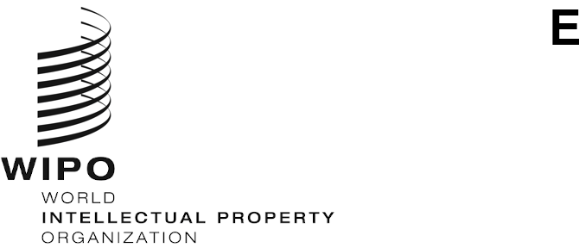
SCCR/40/5
ORIGINAL: ENGLISH
DATE: NOBEMBER 5, 2020

Standing Committee on Copyright and Related Rights

Fortieth Session

Geneva, November 16 to 20, 2020

PROGRESS REPORT ON THE STUDY ON STAGE DIRECTORS’ RIGHTS

prepared by Professor Ysolde Gendreau, University of Montreal and Professor Anton Sergo, Russian State Academy of Intellectual Property

Since the last meeting of the Standing Committee on Copyright and Related Rights, which was held in Geneva in October 2019 and during which we presented a progress report, much has happened that has affected the pace at which we can complete this study. Some events have slowed us down, but it has been possible to move forward.

The Covid-19 pandemic has had a major impact on the speed at which we can work. Starting in mid-March, for example, it has been impossible to have access at the law libraries in Montreal. This state of affairs lasted till mid-August. For a short while, it was possible to go to the libraries; but since the beginning of October, any document must be precisely identified prior to asking a librarian to fetch it. It is very awkward to write when documentation is impossible or difficult to obtain for the slightest verification. Not everything is online…

Because everyone’s working conditions have been suddenly changed, the possibility of actually reaching people for interviews has also been slowed down. Interviews had started, of course, and we have a sizable number of them; but it must be said that, even when people have been identified for interviews, it does not automatically follow that they will want to collaborate. Of course, we want to have as international a group of interviewees as possible; but, as in any field, some milieus are more difficult to penetrate than others, just as some reactions have been extremely professional and helpful.

These interviews have enabled us to obtain concrete testimonies from stage directors, lawyers, associations of various types (collective management organizations, mere professional associations, etc.). They reveal a wide variety of experiences: some relate very structured environments, while others betray what may be considered as a traditional quest for professional recognition as creators through difficulties in obtaining remuneration and public acknowledgement.

For example, one of the interviews with a stage director from a country where there is no official recognition of their status as author or performer betrays a very informal environment for the theatrical world. Even if corporate sponsorships used to be essential to supplement box office revenue and to provide salaries during rehearsals, changes in fiscal rules have meant that corporations no longer sponsor shows. Stage directors are often told they cannot be paid because the show has not resulted in profits. The relationships between the parties can be ambiguous because the same person can play many roles (producer, actor, director). Directors are not represented by agents or unions and must therefore rely on their personal bargaining power. Awareness of how stage directors are treated in other countries makes them more aware of what they can negotiate.

In another country, one where stage directors are formally granted related rights by the law, the awareness of this protection is rather low. There is no collective management organization. The labour contract is perceived as the main instrument of protection. A stage director may learn that the producer of a play obtains payment for the recording of performances for broadcasting, but his remuneration from that transaction is not automatic and depends on his own contract with the producer. Guidelines prepared by a professional association concerning minimum remuneration do not always work in practice. The exportation of productions is sometimes seen as a problematic issue: producers from some foreign countries will not “buy” the stage directions with the rights in the play, but producers from that country will insist on selling their own stage directions when a production is acquired.

The drafting of the study itself has indeed started. The international texts and several national laws have been laid out in order to understand the current normative backdrop. The analysis of International Acts has already be done and was presented at the meeting of the WIPO Standing Committee on Copyright and Related Rights on April 5, 2019. As could be expected, the standard international texts do not provide a clear guidance for the protection of stage directors. It is in the national legislations or in the development of case law that one can sometimes find specific bases for protection. The absence of professional translations of many national legislations sometimes makes it difficult to ascertain the precise meaning and scope of the laws. In the absence of explicit legal rules, contracts – with their innate revelation of the parties’ respective bargaining powers – play an important role for the individuals in a given situation, but hardly create standards that can automatically be extended to fellow colleagues.

The existence of this study has elicited an unexpected reaction. As part of its 15th anniversary celebrations, the Instituto Autor, a research centre founded by the Spanish collecting organization SGAE that has the status of accredited observer at WIPO, has commissioned one of the authors of this study to write a short paper on the protection of stage directors to be featured in a special publication project. Until the end of 2020, the article is available online on the website of the Instituto at http://www.institutoautor.org/es-ES/SitePages/EstaPasandoDetalleAgenda.aspx?i=2421&s=1&p=1 All the papers that have been commissioned on this occasion will be put together in a book in 2021 that will be distributed in both paper and electronic formats. As can be seen from the current website, articles written by non-Spanish-speaking contributors are featured in their original version along with their translations into Spanish. Participation in this project means that the study that the SCCR has commissioned should be receiving additional visibility in (primarily) the Spanish-speaking world. In order not to deflect attention from the study that will be presented to the SCCR, the paper emphasizes historical elements in the appreciation of the status of stage directors. Nevertheless, some of the research that was done for that text should find its way into the study and add perspective to the authors’ findings. The copyright team at WIPO gave its approval to the author to accept the invitation issued by the Instituto Autor.

On the basis of the work that has already been done, we can say that the completion of the study in time for the 41st SCCR meeting in 2021 is in the plans. The integration of the interviews in the report remains a trying issue because there is no common thread to unite them. Case studies also need to be devised. Given that WIPO has participated in an important analysis of the state of copyright laws towards the end of the 1980’s in which the status of stage directors was discussed, the study that is now conducted upon the suggestion by the Russian Federation ought to reawaken the international debate on this issue.

[End of document]

