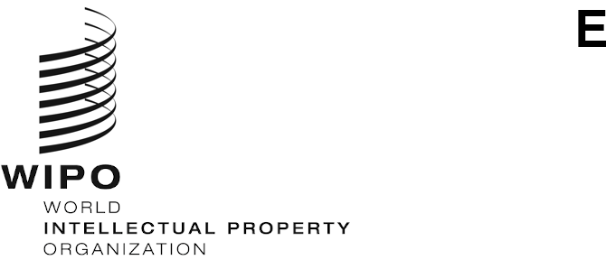
SCCR/44/7
Original: French
Date: November 5, 2023
Standing Committee on Copyright and Related Rights
Forty-fourth session
Geneva, November 6 to 8, 2023
PROPOSAL FOR A STUDY ON THE RIGHTS OF AUDIOVISUAL AUTHORS AND THEIR REMUNERATION FOR THE EXPLOITATION OF THEIR WORKS
prepared by the Delegation Côte d'Ivoire

PROPOSAL FOR A STUDY ON THE RIGHTS OF AUDIOVISUAL AUTHORS AND THEIR REMUNERATION FOR THE EXPLOITATION OF THEIR WORKS TO BE SUBMITTED TO THE STANDING COMMITTEE ON COPYRIGHT AND RELATED RIGHTS
We wish to propose that the World Intellectual Property Organization (WIPO) launch an awareness-raising exercise by commissioning a study on the situation of audiovisual authors. The focus of the study would be on existing models of legal protection for audiovisual authors worldwide and the impact that they have on the exercise of their rights and on how they are remunerated. In Europe, Latin America and Africa, there have been some interesting legislative developments regarding the collective management of remuneration rights, the aim of which is to improve the position of rights holders, in particular audiovisual authors, in the face of the explosion in the exploitation of their works, especially online. Those developments need to be assessed.
Scriptwriters and directors, among others, are at the heart of the creative process in the audiovisual industry, but their legal and economic position varies considerably from country to country. In some territories, they are not even recognized as authors of audiovisual works and therefore enjoy no legal protection. As the volume of audiovisual production grows, partly owing to the development of on-demand and online services, and the widespread use of “buyout contracts”, whereby creators are pressured into formally relinquishing their rights in exchange for a lump-sum payment, there is an urgent need to assess the legal and economic protection of audiovisual authors. The urgency of the matter has only sharpened in the light of the challenges arising from rapid advances in artificial intelligence (AI) and their impact on creators’ ability to earn a living from their work.
Ideally, the study should address not only the situation of screenwriters and directors as the main co-authors of audiovisual works, but also provide a broader overview of all the other authors who, through their respective contributions, contribute to their creation. It should provide an assessment of the rights they are granted by law in different parts of the world and how they exercise them, their contractual relationship with producers, the different ways in which their works are exploited, and the role played by their collective management organizations.
The study should focus on the ability and/or the right of audiovisual authors to receive ongoing remuneration for the exploitation of their works on the various media, especially given the emergence of new means of exploiting such works through on-demand and online services (right of making available).
Through an analysis of the most effective legal regimes in place worldwide, the study should identify solutions to ensure that audiovisual authors are properly remunerated for the economic exploitation of their works and that they can continue to create.
We believe that Committee members and observers would benefit from an exchange of knowledge and practices on this issue, which is of critical importance to the global community of audiovisual authors.

[End of Document]

