 | 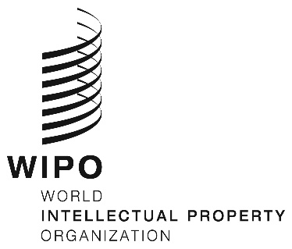 | E
WIPO/CR/NBO/2/19/INF/1
ORIGINAL: English
DATE: MAY 23, 2019

International Conference for Least-Developed and Developing Countries on Copyright and the Management of Public Sector Information

Nairobi, June 14, 2019

Organized by

the World Intellectual Property Organization (WIPO)

in cooperation with
the Kenya Copyright Board (KECOBO)

PROGRAM

prepared by the International Bureau of WIPO

Friday, June 14, 2019

8.30 – 9.00 | Registration
9.00 – 9.15 | Opening ceremony  Welcome address by :  Ms. Sylvie Forbin, Deputy Director General, Copyright and Creative Industries Sector, World Intellectual Property Organization (WIPO)  Mr. Edward Sigei, Executive Director, Kenya Copyright Board
9.15 – 11.00 | Topic 1: | An introduction to Public Sector Information (PSI) – basic concepts and social and economic relevance  Moderator: WIPO  Speakers: Mr. Paul Uhlir, Scholar (former), National Academy of Sciences (NAS), Washington  Mr. Joseph Fometeu, Professor of Law, Université de Ngaoundéré, Yaoundé  Mr. Thomas Ewert, Legal and Policy Officer European Commission, Brussels
11.00 – 11.15 | Coffee Break
11.15 – 12.45 | Topic 2: | Public Sector Information and Copyright
Moderator: WIPO/KECOBO

Speakers: Mr. Kenneth Crews, Professor of Law/Attorney, Gipson Hoffman & Pancione, Los Angeles

Mr. Ben Sihanya, IP and Constitutional Professor & Advocate, University of Nairobi Law School & Sihanya Mentoring, Nairobi

Ms. Cristiana Sappa, Professor of Law, IÉSEG School of Management, Paris

12.45 – 14.00 | Lunch Break

14.00 – 15.30 | Topic 3: | Licensing Public Sector Information
Moderator: WIPO/KECOBO

Speakers: Ms. Cristiana Sappa

Ms. Raquel Xalabarder, Professor, Universitat Oberta de Catalunya
15.30 – 16.30 | Topic 4: | Showcase of National initiatives / strategies / best practices
 |  | Moderators: WIPO/KECOBO
Speakers: Mr. Aziz Dieng, Principal technical adviser, Ministry of Culture, Creative Industries and IP of the Republic of Senegal, Dakar

Mr. Mikhail Zhuravlev – (Russian Federation) (Video-message)

Mr. Paul Uhlir (United States of America)

Mr. Maximilano Marzetti – (Argentina) (Video-message)

16.30 – 16.45 | Coffee Break
16.45 – 17.30 | Topic 4 | Showcase of National initiatives / strategies / best practices (Continued)  Speakers: Ms. Sarah Venites, Intellectual Property Division, Ministry of Foreign Affairs (Brazil)  Mr. Tomoaki – (Japan) (Video-message)  Ms. Cristiana Sappa (Italy/France)
17.30 – 18.00 | Topic 5 | Closing roundtable on challenges and opportunities in managing PSI for developing and least developed countries:  Moderator: TBD  Speakers: Selected participants and speakers

