IP DATA EXCHANGE SURVEY COLLATED RESULTS
Document prepared by the Secretariat

Questions
If your Office conducts data exchange with other Offices, can you indicate how many?

Response | Percent | Count
Less than 5 Offices | 64.90% | 24
5-10 Offices | 8.10% | 3
More than 10 Offices | 27.00% | 10

Does your Office want to extend data exchange with:

Response | Count
Big-sized Offices such as IP5? | 28
Medium-sized Offices? | 22
Small-sized Offices? | 16

How does your Office utilize data received from another Office?
(Please choose all that apply)

Response | Count
Internal use (e.g., for examination) | 36
Published for search purposes | 18
To provide to the commercial data providers | 6
Training data for AI models | 13
Value add products such as patent analytics reports | 15
Other | 5

Does your Office provide its own data for its own bulk data download service?
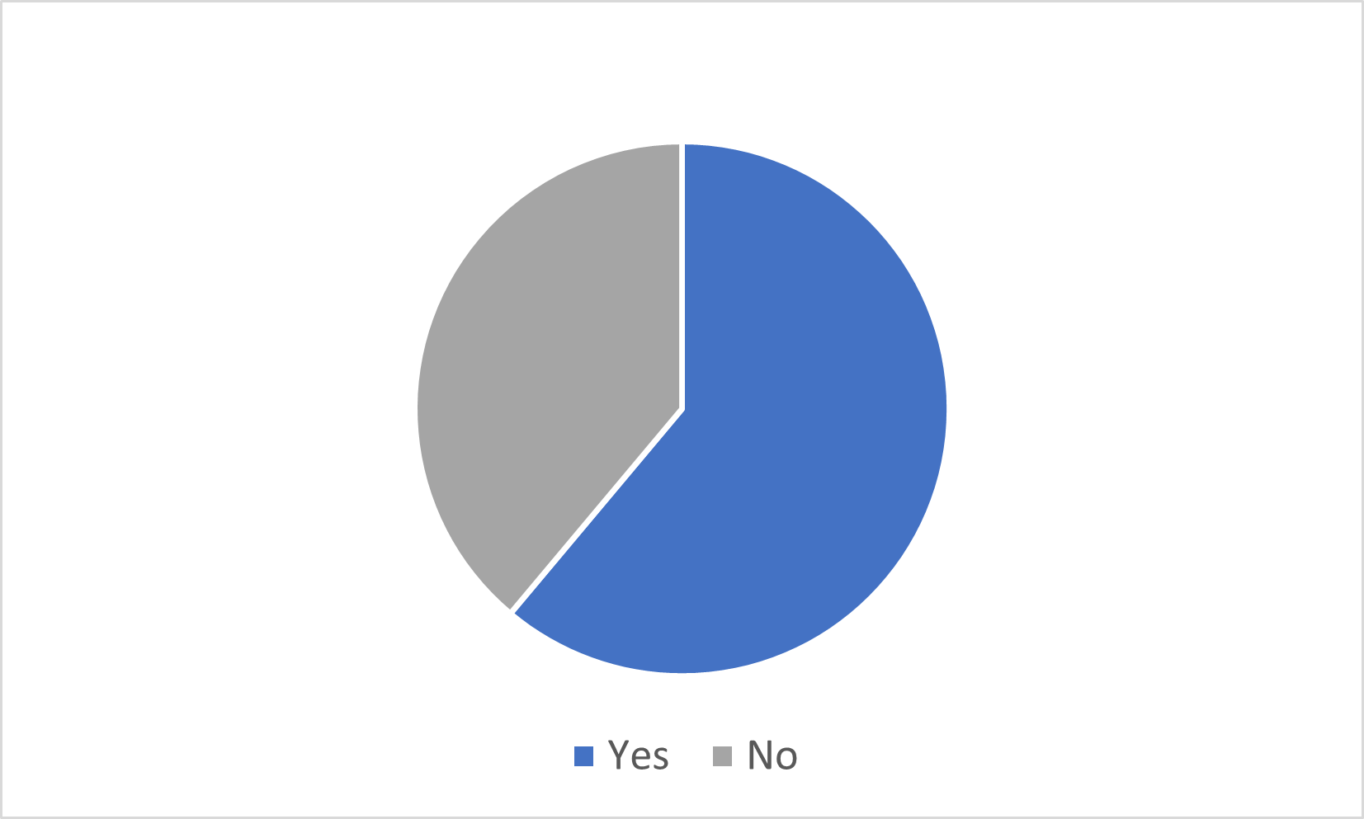
62%

If your Office has initiated bulk IP data exchange with another Office:
(Please choose all that apply)

Response | Count
Negotiate bilaterally | 28
Using existing frameworks (e.g., IP5 Information Dissemination Policy) | 13
Other | 11

Does your Office obtain IP data for free or through a paid service?
(Please choose all that apply)

Response | Count
Data exchange with IP offices (free) | 32
Data exchange with IP offices (paid) | 4
Public DB (e.g., DOCDB) (free): | 17
Public DB (e.g., DOCDB) (paid): | 1
Private sector (free) | 6
Private sector (paid) | 14
Our Office does not obtain IP data of other offices | 3

What kind of IP data would your Office like to exchange?
(Please choose all that apply)

Response | Count
IP gazette | 22
Bibliographic data / Abstract | 30
Full text data of claims and descriptions | 26
Office actions | 20
Legal status | 26
Full IP right applications / grant or registration (PDF, XML etc.) | 22
Other | 4

What kind of IP data would your Office rather NOT like to exchange?
(Please choose all that apply)

Response | Count
IP gazette | 5
Bibliographic data / Abstract | 1
Full text data of claims and descriptions | 3
Office actions | 9
Legal status | 3
Full IP right applications / grant or registration (PDF, XML etc.) | 6
Other | 22

What kind of challenges does your Office currently face when exchanging data? (Please choose all that apply)

Response | Count
Digitization or textualization of non-text based IP documentation, e.g., the partner Office does not have its gazette data in machine readable text form | 21
Different data commercialization policy, e.g., the partner Office sells its gazette data to private companies while my Office makes gazette data free | 9
Data format change without notification or with a short notice, e.g., the gazette data format provided by partner Office suddenly changed, and consequently it took a long time to build a dedicated program to systematically handle the changed data | 12
Irregular provision of data, e.g., bulk data provided by partner Offices on a weekly basis was skipped without notice | 10
Discontinuation of data provision without notice, e.g., gazette data provision from partner Offices was suddenly stopped, and it required considerable amount of time and effort to resume the data provision | 7
Data quality, e.g., XML tags for gazette data provided by partner Offices were being provided incorrectly | 13
Data correction and confirmation process, e.g., when the gazette data is corrected, it should be confirmed by the provided Office and all other recipient Offices which is very complicated | 7
Non-standard data format or unfamiliar data format | 12
Lack of human resources to support activities | 18
Insufficient IT resourcing | 20
Please provide other examples of challenges that your office has experienced with data exchange | 6
No challenges | 4

Does your Office have any national laws or regulations that regulate the transfer of IP data out of your jurisdiction?

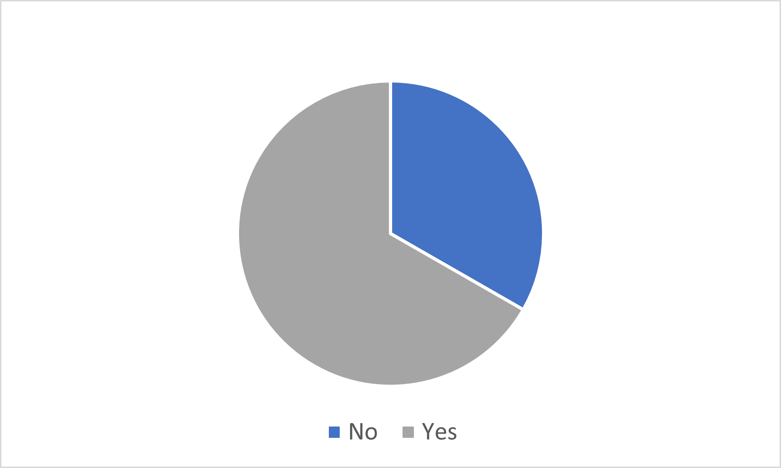
65%

What WIPO products does your Office currently contribute data to?
(Please choose all that apply)

Response | Count
PATENTSCOPE | 24
Global Brand Database | 20
Global Design Database | 14
Other | 11
None of the above | 5

Which format does your Office use to exchange data?
(Please choose all that apply)

Response | Count
WIPO Standards | 31
Other Standard | 2
Hybrid - WIPO Standards and other standards | 10

If an IP data exchange platform were to be established to support bulk download, who does your Office think should host the platform?

Response | Count
WIPO | 24
Regional IPOs | 1
Each IPO | 7
Other | 5

How should IP data be handled, centralized or decentralized?
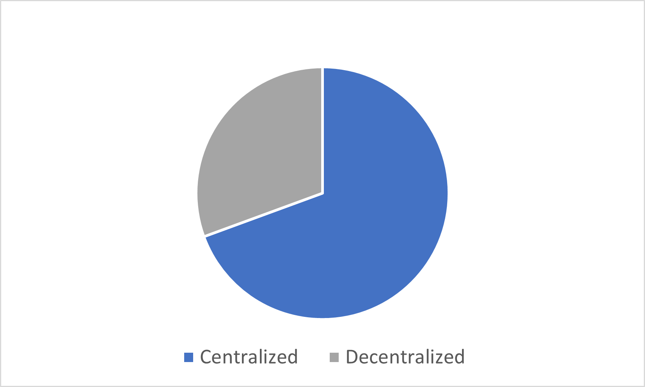
70%

What features would your Office like to implement in this platform?
(Please choose all that apply)

Response | Count
Bulk download | 24
Support multi data format (e.g., data format converter) | 20
Textualization by the platform administrator | 13
Data cleaning by the platform administrator | 11
Supporting IP enforcement | 18
Against counterfeiting (e.g. block chain technology) | 13
Access restriction to select users | 16
Support documents in multiple languages | 23
Localization of user interface and support materials | 15
Help desk or other manuals | 22
Other | 7

What is your Office's concern on the platform?
(Please choose all that apply)

Response | Count
Security | 29
Cost | 29
Time | 26
Other | 5

Which of the following “Proposed Solutions” in the Consolidated Proposal would you consider important? (Please choose all that apply, and provide reasons if any)

Response | Count
To develop and operate a standard that prescribes recommended criteria at such level in providing IP data including data exchange by IPOs to the public and other IPOs | 22
To establish a forum, such as a bulletin board, with appropriate access restrictions, where requests to the corrective authority for data cleaning and answers from the authority can be shared only by authorized persons, and to use this forum among the IPOs receiving the data provided by the country to which the authority belongs | 16
To build and use a global data platform to be used as a hub for data exchange | 25
To collect and share best practices for data exchange | 23

Which of the following “Proposed Solutions” in the Consolidated Proposal concerns your Office? (Please choose all that apply, and provide reasons if any)

Response | Count
To develop and operate a standard that prescribes recommended criteria at such level in providing IP data including data exchange by IPOs to the public and other IPOs | 17
To establish a forum, such as a bulletin board, with appropriate access restrictions, where requests to the corrective authority for data cleaning and answers from the authority can be shared only by authorized persons, and to use this forum among the IPOs receiving the data provided by the country to which the authority belongs | 9
To build and use a global data platform to be used as a hub for data exchange | 18
To collect and share best practices for data exchange | 18

How does your Office prioritize the Tasks below for the Consolidated Proposal?
(Please number in the descending order: “1” is the highest priority)

Solution | Overall rank
To collect share best practices on expansion and promotion of the efficiency, acceleration and use of IP data digitalization | 1
To develop a draft standard that prescribes recommended criteria at such a level in providing IP data including data exchange by IPOs to public and other IPOs | 2
To make concept planning for the global data platform to be used as a hub for data exchange | 3
To consider a forum, such as a bulletin board, with appropriate access restrictions, where requests to the corrective authority for data cleaning and answers from the authority can be shared only by authorized persons | 4

Does your Office have any other suggestions on the Consolidated Proposal?
(Note: there were several suggestions, but those are not provided here.)

[Annex II follows]

