OVERALL PATENT PROSECUTION MODEL (DRAFT)

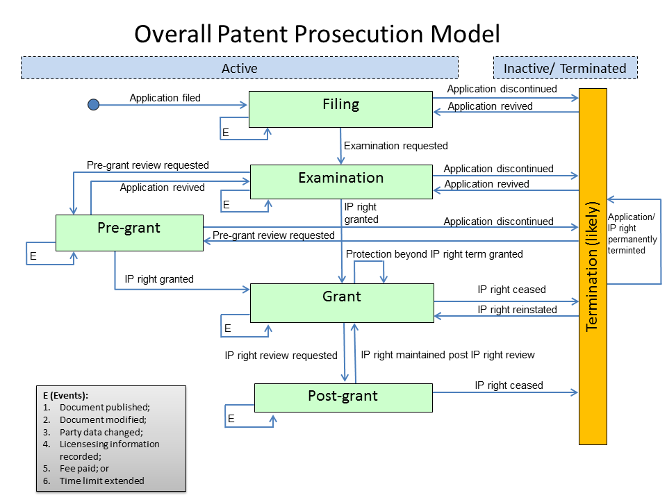

[Annex II follows]

