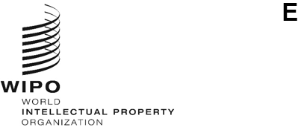
a/65/8
ORIGINAL: English
DATE: July 13, 2024
Assemblies of the Member States of WIPO
Sixty-Fifth Series of Meetings
Geneva, July 9 to 17, 2024
JOINT proposal of the Central European and Baltic States Group (CEBS) AND GROUP B on the Assistance and Support for Ukraine’s Innovation and Creativity Sector and Intellectual Property system
submitted by the Central European and Baltic States Group (CEBS) and Group B
In a communication to the Secretariat received on July 12, 2024, the Central European and Baltic States Group (CEBS) and Group B submitted the enclosed joint proposal in the framework of Agenda Item 18, “Assistance and Support for Ukraine’s Innovation and Creativity Sector and Intellectual Property System”.
[Annex follows]

Proposed decision

AGENDA ITEM 18. ASSISTANCE AND SUPPORT FOR UKRAINE'S INNOVATION AND CREATIVITY SECTOR AND INTELLECTUAL PROPERTY SYSTEM (document A/65/7)
The Assemblies of WIPO each in so far as it is concerned:
Recalling their Decisions on the Assistance and Support for Ukraine’s Innovation and Creativity Sector and Intellectual Property System contained in documents A/63/10 and A/64/14;
Take note of the Report on the Assistance and Support for Ukraine’s Innovation and Creativity Sector and Intellectual Property System contained in document A/65/7, and the continued negative impacts of the ongoing war on Ukraine's innovation and creativity sector and IP system; and
Request the International Bureau:
  - to continue its close cooperation with Ukraine to ensure its ongoing support and assistance to the creators, innovators, and members of the IP community, focusing on mitigating the adverse effects of the war and rebuilding an innovative and creative ecosystem in Ukraine that benefits all stakeholders and strengthens the country’s economy; and
  - to provide an updated assessment of the medium- and long-term impacts of the war on Ukraine’s innovation and creativity sector and ecosystem; and
  - to take steps to ensure that publications on WIPO resources and platforms comply with the principles of sovereignty, independence, and territorial integrity of Ukraine within its internationally recognized borders;
  - to report on the implementation of this decision and other relevant activities at the 2025 WIPO Assemblies, and annually thereafter.

[End of Annex and of document]

