|  |  |  |
| --- | --- | --- |
|  | WIPO-E | **E** |
| mm/A/50/1 | | |
| ORIGINAL: English | | |
| DATE: July 4, 2016 | | |

**Special Union for the International Registration of Marks   
(Madrid Union)**

**Assembly**

**Fiftieth (29th Extraordinary) Session**

**Geneva, October 3 to 11, 2016**

progress report on the MADRID SYSTEM GOODS AND SERVICES DATABASE

*prepared by the International Bureau*

# INTRODUCTION

This document presents progress in the development of the database of acceptable indications of goods and services for the purposes of the Madrid System procedures (hereinafter referred to as the “Madrid System Goods and Services Database” or “MGS Database”).

In September 2009, the Assembly of the Madrid Union approved a two-year project to develop the MGS Database, as described in document MM/A/42/3, and funding in the amount of 1.2 million Swiss francs from the Madrid Union Reserve Funds for its implementation during the 2010‑11 biennium (see document MM/A/42/4, paragraph 28). Seven previous Progress Reports have been presented to the Assembly of the Madrid Union (see documents MM/A/42/3, MM/A/43/2, MM/A/44/3, MM/A/45/2, MM/A/46/2, MM/A/48/2 and MM/A/49/2).

On January 1, 2012, the MGS Database project transitioned into operational mode, which meant that ongoing operational support was thereafter funded from the regular budget.

The present document is a report on the progress of the MGS Database since the previous Progress Report (see document MM/A/49/2), that is, between June 1, 2015, and May 30, 2016.

## **RESULTS ACHIEVED**

On June 1, 2015, the Madrid Goods and Services Manager (MGS) was available on the public website of the World Intellectual Property Organization (WIPO) with the following features:

* 17 language interfaces, namely Arabic, Chinese, Dutch, English, French, German, Hebrew, Italian, Japanese, Korean, Norwegian, Portuguese, Russian, Serbian, Spanish, Turkish, Ukrainian; and
* 20 participating IP national or regional Offices providing acceptance information for display in MGS. At least partial acceptance information was made available to WIPO by the Offices of, namely, Austria, Belarus, Benelux, China, the European Union, Germany, Israel, Italy, Japan, Mexico, Norway, Portugal, the Republic of Korea, Serbia, the Russian Federation, Singapore, Switzerland, Turkey, Ukraine and the United States of America.

On January 1, 2016, the MGS Database was brought into line with the 2016 version of the tenth edition of the Nice Classification. Updates were integrated in the 17 languages then available online.

COOPERATION

1. Between June 2015 and May 2016, seven new countries joined the list of MGS‑participating countries, thus bringing the number of Contracting Parties of the Madrid System displaying acceptance information in MGS to a total of twenty-seven.
2. Acceptance information provided by MGS-participating countries is used in the WIPO‑exclusive function “Check acceptance by designated Contracting Party (dCP)”. This function enables a trademark applicant to know, not only that a term accepted by the International Bureau will be accepted in a designated Contracting Party (dCP) but, most importantly, that terms can be rejected by certain Contracting Parties and thus provoke the communication of a provisional refusal from that Contracting Party.
3. Due to the global coverage of the Madrid System, and although the increased use of MGS should facilitate, in time, the harmonization of trademark classification practices among Member States, reasons exist for terms not to be accepted in all possible designated Contracting Parties (dCP) of the Madrid System, such as requirements in terms of specificity for describing goods and services in some jurisdictions, or the existence of specific national laws prohibiting the use of certain terms.
4. The seven new participating countries, for which acceptance information was made available in the MGS function “Check acceptance by designated Contracting Party (dCP)” are:

* Estonia (EE) - June 2015
* Finland (FI) - September 2015
* Colombia (CO) - October 2015
* Denmark (DK) - November 2015
* Sweden (SE) – December 2015
* United Kingdom (GB) – December 2015
* Mongolia (MN) – April 2016

LINGUISTIC DIVERSITY

1. In April 2016, thanks to the cooperation established with the Intellectual Property Office of Mongolia (IPOM), the Mongolian language interface was implemented in MGS as the eighteenth language.
2. The 18 language interfaces available in MGS as of April 2016 are: Arabic, Chinese, Dutch, English, French, German, Hebrew, Italian, Japanese, Korean, Mongolian, Norwegian, Portuguese, Russian, Serbian, Spanish, Turkish, Ukrainian.
3. For the time being, the Mongolian interface only gives access to a Mongolian database limited to the Nice Classification alphabetical list, but IPOM indicated its willingness to continue translating the rest of the MGS Database in order to increase its usefulness for Mongolian applicants.
4. It is worth noting that most of the languages available in MGS to help national users both for national and international trademark filing are non-European languages and that cooperation is under way to add further non-European languages, reflecting the global reach of WIPO services.

RELEASE OF NEW FUNCTIONALITIES

1. In March 2016, a new version of MGS was made available on the WIPO website. This version brought about improvements and new functionalities meant to enhance the usefulness of MGS and access to classification related information.
2. The Explanatory Notes of the Nice Classification were made accessible for the first time in all language interfaces of MGS, thus giving access to important trademark classification guidance to applicants in their national language. The Explanatory Notes relating to the various classes provide useful information to ascertain the correct classification of a good or a service and complement the information provided by the general indications of the class headings associated with the various classes of the Nice Classification.
3. The Similar Group Codes used by the Japan Patent Office (JPO) and the Korean Intellectual Property Office (KIPO) were made accessible for the first time in MGS. These Japanese and Korean codes define two different granular taxonomies associated with groups of goods or services that are deemed to be similar to each other in trademark relative grounds examination. Trademark applicants in Japan and the Republic of Korea are encouraged to refer to these codes before filing a trademark application in order to identify the existence of similar registered trademarks.
4. It is worth noting that non-Asian users also benefit from access to the Asian similar group codes because these codes can facilitate prior mark similarity searches before filing an international application in which Japan or the Republic of Korea is designated.

CONTENT OF THE MGS DATABASE

1. The core language of the MGS Database is English and new goods or services are integrated on the basis of their English descriptions. Over the years, English descriptions of goods and services from various sources have been examined and integrated into the MGS Database.
2. Annex I presents the content, as of April 2016, of the MGS Database in terms of origin of integrated data. The different sources are:

* the Nice Classification, i.e. descriptions from the Alphabetical List and from class headings;
* the TM5-ID list, i.e. descriptions from the harmonized list elaborated jointly by the European Union Intellectual Property Office (EUIPO), JPO, KIPO, the State Administration for Industry and Commerce of the People's Republic of China (SAIC) and the United States Patent and Trademark Office (USPTO);
* the USPTO Manual;
* the European Harmonized Database published in TMclass (EUIPO's classification tool); and
* "Others" including data extracted from other sources, mainly on the basis of frequency of occurrence in, e.g., the Madrid International Register or international applications received by the International Bureau.

1. It is worth noting that some descriptions of goods or services originating from external sources are integrated into the MGS database but are not proposed in the MGS pick-list of descriptions proposed for compiling lists of goods and services. This means that they are not displayed in the results of the Browse and Search functions of MGS. They are integrated only for the purpose of indicating that these descriptions will be accepted by the International Bureau if included in an international application and are displayed as such in the function "Check acceptance by WIPO”[1]. Most of the time, these descriptions are already represented in the database by synonymous descriptions.
2. As of April 2016, 78,197 English descriptions had been reviewed and integrated into the MGS Database, 78 per cent of which being proposed for selection in the MGS pick-list and 22 per cent of which being additional descriptions used for the validation in "Check acceptance by WIPO".
3. Annex II presents the content of the MGS English Database in terms of distribution between the MGS pick-list (descriptions proposed for selection by applicants) and the additional set of operationally accepted data (descriptions reflecting the operational examination flexibility of the International Bureau).
4. It should be noted that in order to limit the translation and validation work by cooperating national Offices to the highest quality data, only the descriptions proposed in the MGS pick-list are sent to Offices for translation and/or acceptance checking.
5. Annex III gives an overview of the relative representation in the various MGS languages.
6. Annex IV gives an overview of the relative content of the MGS Database in terms of acceptance status by Contracting Parties as displayed in the function “Check acceptance by designated Contracting Party (dCP)”.

UPDATES OF THE MGS DATABASE

1. The acceptance status available for each of the MGS-participating Contracting Parties is gathered from a variety of sources:

* acceptance information provided directly by national Offices that translate the Database and/or check acceptance or rejection of its English content;
* the harmonized TM5 - ID list of goods and services;
* the USPTO Manual of Acceptable Identifications of Goods and Services;
* the European Harmonized Database; and
* the KIPO’s list of Acceptable Identifications of Goods and Services.

1. In 2015, further cooperation was established with the EUIPO so that access to the European Harmonized Database could enable regular updates of MGS acceptance status for the European Union (EM) as well as for all European countries participating in the MGS function "Check acceptance by designated Contracting party".

**FURTHER ENRICHMENT OF THE MGS DATABASE**

ACCEPTANCE CHECKING BY NATIONAL OFFICES

1. Cooperation between the International Bureau and Contracting Parties in the Madrid System, or countries preparing their accession to the Madrid System, continues with a view to increasing the amount of acceptance information available in MGS to provide trademark applicants with useful information for the purpose of international filing, i.e., information that enables them to know in advance whether certain terms in their lists would provoke, or not, a provisional refusal from countries they designate.

INTEGRATION OF NEW INDICATIONS OF GOODS AND SERVICES

1. In order to make MGS as relevant as possible to trademark applicants for international as well as national filings, the MGS Database will continue to be enriched with indications of goods and services extracted from various sources, such as:

* frequently used terms extracted on a regular basis from international applications received in the International Bureau as well as from the International Trademark Register;
* the harmonized TM5 ID-list;
* the European Harmonized Database;
* national lists of goods and services received from national IP Offices, such as those already made available by the following countries: Australia, China, Germany, Japan, the Republic of Korea, Switzerland; and
* national trademark registers from countries cooperating with WIPO in the Global Brand Database project, and from which frequently used terms not already present in MGS will be examined for integration. Frequently used terms have so far been extracted from the national registers of Australia, Canada, Israel, Japan, Mexico, New Zealand, the Russian Federation, Singapore, Switzerland and the United States of America.

**BUDGET**

1. In 2015, the Assembly of the Madrid Union approved the use of project funds remaining at the end of 2015 to assist some national Offices in the translation of the MGS Database into their national languages (see document MM/A/49/2, paragraph 28).

1. Annex V presents a table indicating the breakdown of the initial allocation

(232,000 Swiss francs) made available by WIPO for the translation of the MGS Database and the actual payments made up to May 30, 2016, for the translation work carried out by national Offices originally selected or having requested to receive financial support. In particular, the table shows, under “Roll-over to 2015”, the funds still available for each participating Office to continue with the translation of the MGS Database.

1. As of May 2016, a total amount of 105,987 Swiss francs remained available for financing the translation of the MGS Database into languages for which a Memorandum of Understanding (MoU) has been signed between WIPO and the corresponding national Office.

*34. The Assembly is invited to:*

1. *take note of the “Progress Report on the Madrid System Goods and Services Database” (document MM/A/50/1), including its paragraph 33 related to the remaining project funds; and*
2. *request the International*

*Bureau to submit to the Assembly in 2017 a new Progress Report on the Madrid System Goods and Services Database, including the use of remaining project funds.*

[Annexes follow]

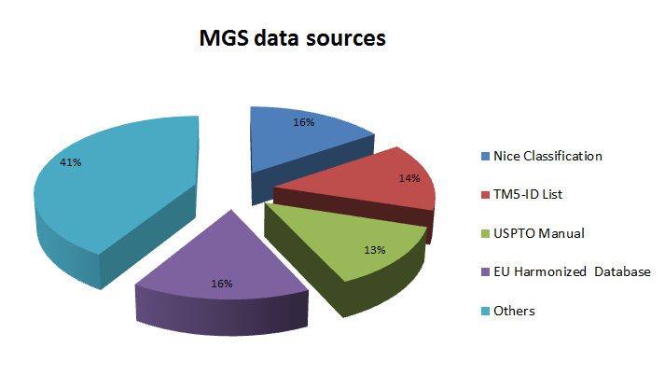

[Annex II follows]

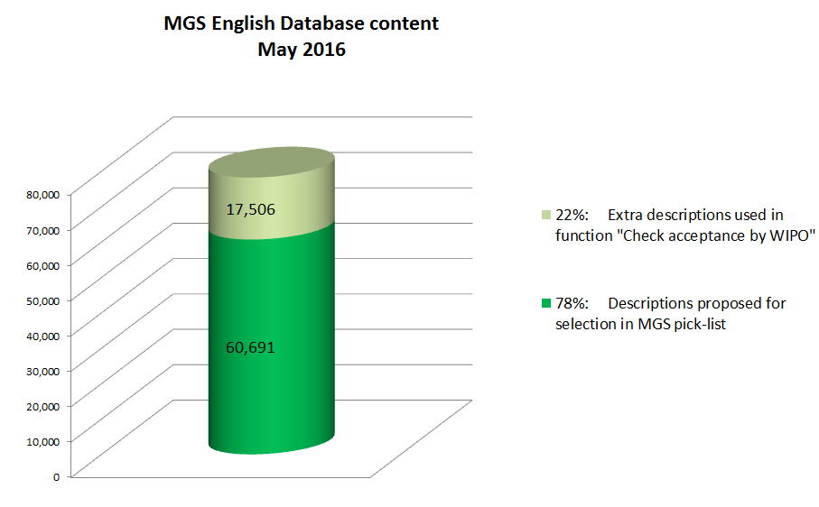

[Annex III follows]

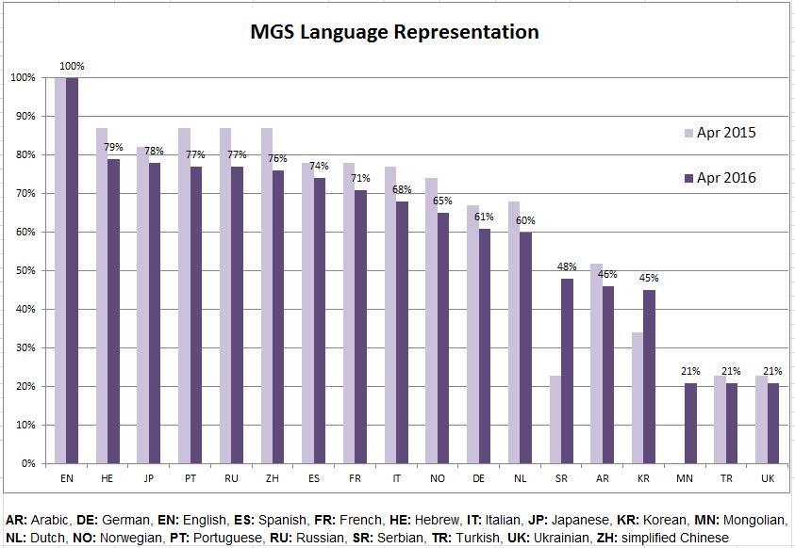

[Annex IV follows]

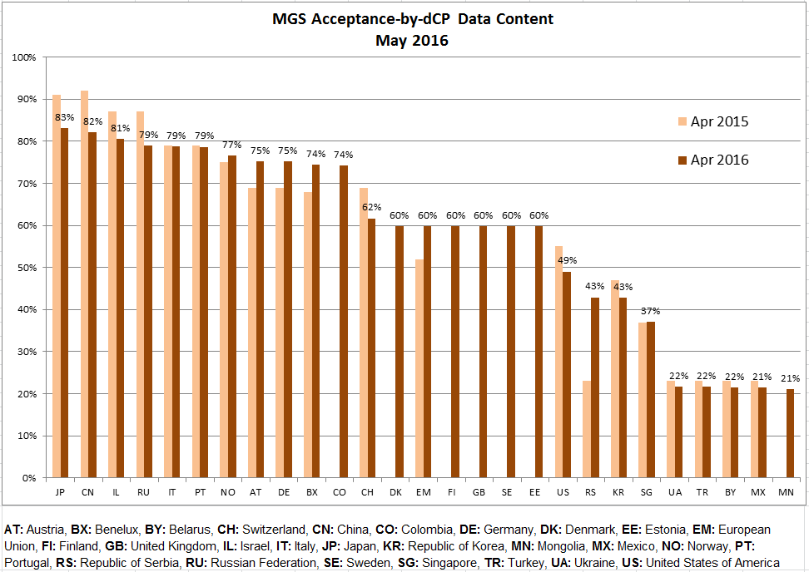

[Annex V follows]



[End of Annex V and of document]

1. Due to certain technical issues regarding the relationship between the MGS Database and the operational examination environment, some discrepancies may appear in exceptional circumstances. The International Bureau is currently taking measures to resolve these issues.