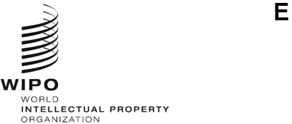
MM/A/58/inf/1
ORIGINAL: English
DATE: July 4, 2024
Special Union for the International Registration of Marks
(Madrid Union)
Assembly
Fifty-Eighth (33rd Extraordinary) Session
Geneva, July 9 to 17, 2024
madrid union suRpluses for the 2022/23 biennium
Document prepared by the Secretariat
- The present document provides Member States with an updated status of Madrid Union surpluses for the 2022/23 biennium and the Net Assets of the Madrid Union as at December 31, 2023.
- The surplus of income over expenditure for the Madrid Union amounted to 10 million Swiss francs in the 2022/23 biennium, as indicated in the WIPO Performance Report (WPR) for 2022/23 (document WO/PBC/37/7).

- Article 8(4) of the Protocol Relating to the Madrid Agreement Concerning the International Registration of Marks provides that “[t]he annual product of the various receipts from international registration, with the exception of the receipts derived from the fees mentioned in paragraph (2)(ii) and (iii), shall be divided equally among the Contracting Parties by the International Bureau, after deduction of the expenses and charges necessitated by the implementation of this Protocol.” Regulation 3.13 of the Financial Regulations and Rules of WIPO provides that “[i]f, after the closure of the financial period, any Union shows a surplus of income, such surplus shall be accounted for under the reserve funds, unless otherwise decided by the General Assembly or the Assembly of the Union concerned.”

- In accordance with Financial Regulation 3.13, it is foreseen to retain such surpluses within the Reserves of the Madrid Union to cover the expenses of the following Capital Master Plan (CMP) projects (document WO/PBC/37/7) amounting to 13.9 million Swiss francs: (i) Phase II of the Madrid IT Platform project; (ii) Phase II of the AIMS Transformation 2.0 project; and (iii) Building Management System for HVACS Facilities and Lighting, recommended by the thirty-seventh session of the Program and Budget Committee (PBC) to the Assemblies of WIPO in July 2024 (document WO/PBC/37/13).
[End of document]

