WIPO |  | E  PCT/A/VII/6  ORIGINAL: English  DATE: May 26, 1981
WORLD INTELLECTUAL PROPERTY ORGANIZATION
GENEVA
international patent cooperation union
(pct union)
assembly
Seventh Session (5th Extraordinary)∗
Geneva, June 29 to July 3, 1981
amendment of rule 34 of the pct regulations
Proposal submitted by the USSR State Committee for Inventions and Discoveries

1. The International Bureau has received from the USSR State Committee for Inventions and Discoveries (“State Committee”) a proposal to amend Rule 34.1(c) (vi) according to which that Rule would read as follows:

“(vi) such patents issued by, and such patent applications published in, any other country after 1920 as are in the English, French or German language and in which no priority is claimed, provided that the national Office of the interested country sorts out these documents and places them at the disposal of each International Searching Authority and also provided that these documents are classified according to the International Patent Classification”.

2. According to the communication from the State Committee (set out in the Annex to this document), the International Searching and Preliminary Examining Authorities have been notified previously of the proposal by the State Committee since the State Committee will only proceed with the proposal if none of the International Searching and Preliminary Examining Authorities signifies that it objects to the proposal. In this regard, it is to be noted that Rule 34 is one of the provisions of the PCT Regulations which, according to Rule 88.3, may be amended only if no State, referred to in Article 58(3) (a) (ii)∗ and having the right to vote in the Assembly, votes against the amendment.

3. The Assembly is invited to consider the proposal referred to in paragraph 1 and, if it sees fit, to amend Rule 34.1(c) (vi) in accordance with the proposal.

[Annex follows]

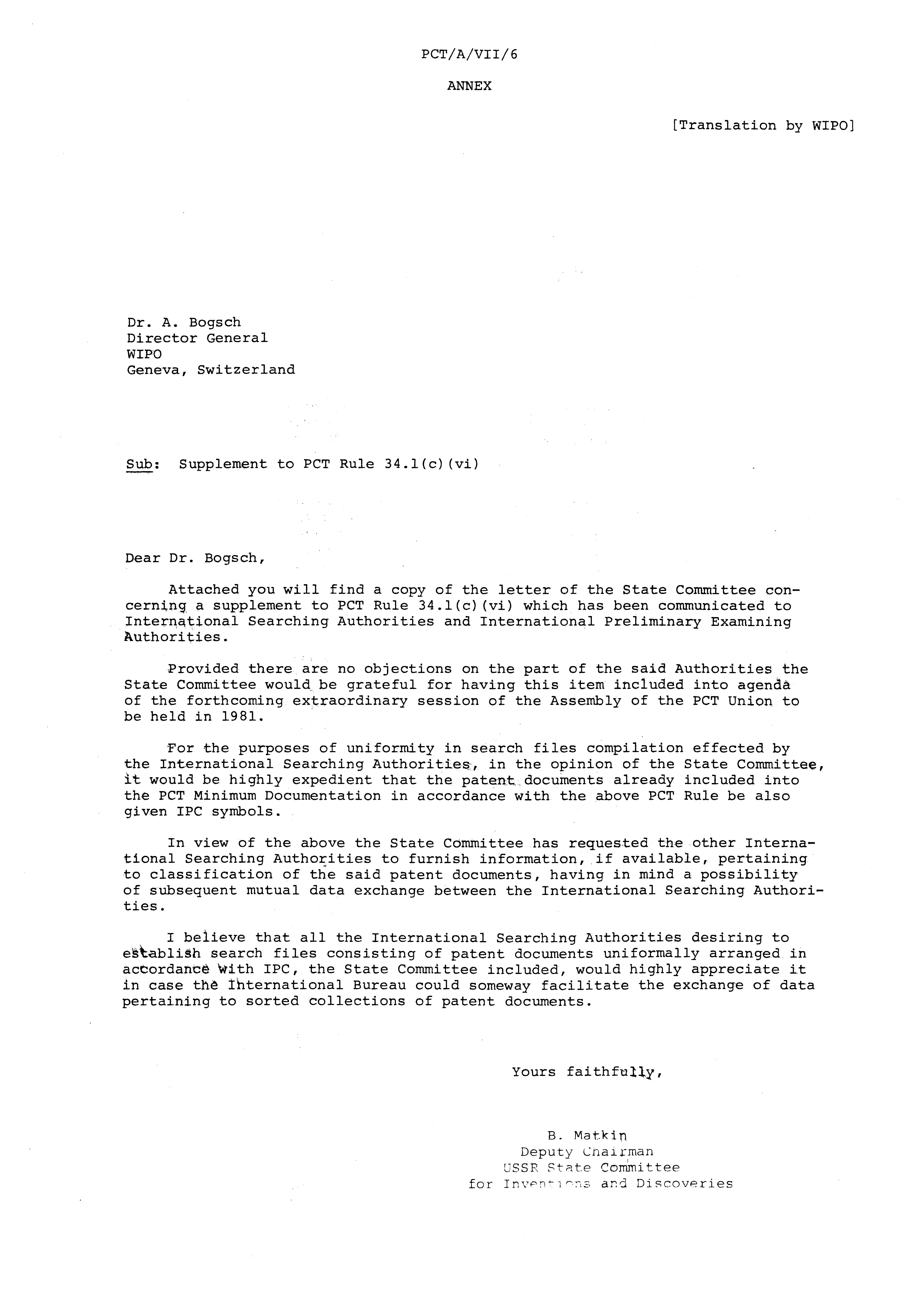
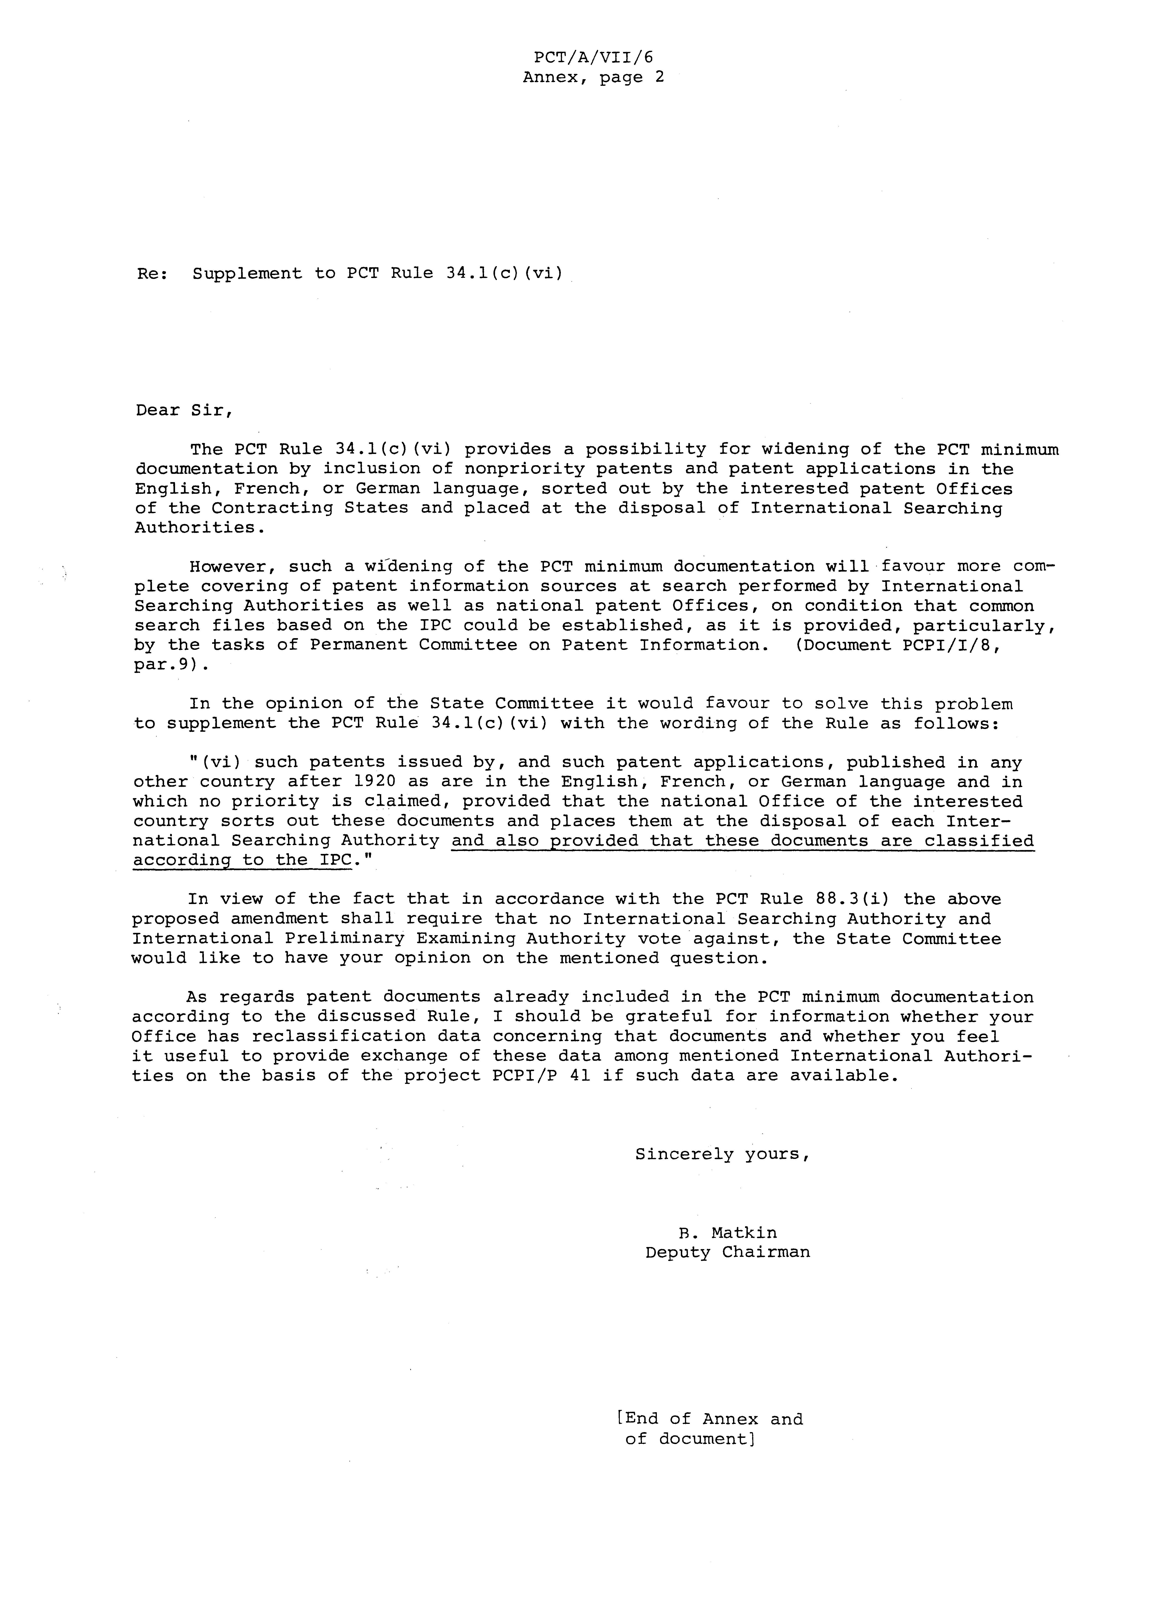

 Editor’s Note: This electronic document has been created from the paper original and may contain errors. Please bring any such errors to the attention of the PCT Legal Division by e-mail at pct.legal@wipo.int
 Article 58 (3) (a) (ii) reads as follows : “(3) (a) The Regulations specify the Rules which may be amended “(i) … “(ii) only if none of the Contracting States whose national Office acts as an International Searching or Preliminary Examining Authority dissents, and, where such Authority is an intergovernmental organization, if the Contracting State member of that organization authorized for that purpose by the other member States within the competent body of such organization does not dissent”.

