E
wo/cc/71/1
ORIGINAL: english
DATE: july 7, 2015

WIPO Coordination Committee

Seventy-First (46th Ordinary) Session
Geneva, October 5 to 14, 2015

Approval of Agreements

Memorandum by the Director General

In accordance with Article 13(1) of the Convention Establishing the World Intellectual Property Organization, any agreement entered into with a view to establishing working relations and cooperation with other intergovernmental organizations shall be concluded by the Director General after approval by the WIPO Coordination Committee.

AGREEMENT WITH THE REGIONAL CENTER FOR BOOK DEVELOPMENT IN LATIN AMERICA AND THE CARIBBEAN (CERLALC)

The Director General of WIPO and the Director of the Regional Center for Book Development in Latin America and the Caribbean (CERLALC) have prepared a Memorandum of Understanding (MoU) to strengthen their collaboration within the framework of the mandates assigned to them and for the benefit of their respective Member States. The text of the MoU is set forth as Annex I to the present document.

The Director General of WIPO and the Executive Secretary of the United Nations Economic and Social Commission for Asia and the Pacific (ESCAP) have prepared a Memorandum of Understanding (MoU) to strengthen their collaboration through the implementation of joint activities and programs, within the mandates assigned to them and for the benefit of Member States in the Asia and Pacific region. The text of the MoU is set forth as Annex II to the present document.

The Coordination Committee is invited to approve the MoU between WIPO and CERLALC and the MoU between WIPO and ESCAP as set forth in Annexes I and II of the present document.

[Annexes follow]

WO/CC/71/1
ANNEX I

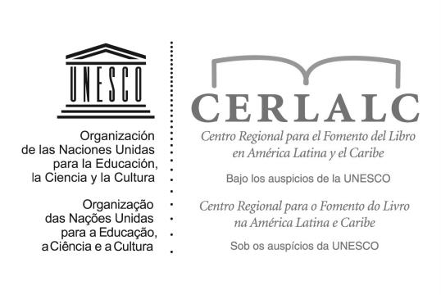 | 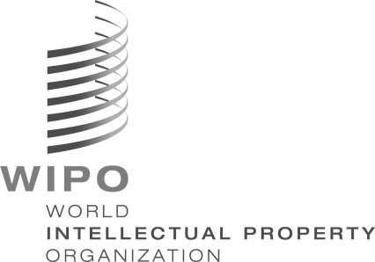

MEMORANDUM OF UNDERSTANDING BETWEEN THE REGIONAL CENTER FOR BOOK DEVELOPMENT IN LATIN AMERICA AND THE CARIBBEAN (CERLALC) AND THE WORLD INTELLECTUAL PROPERTY ORGANIZATION (WIPO)

This Memorandum of Understanding (MoU) is made and entered into by and between CERLALC having its offices in Calle 70 # 9-52, Bogotá, D.C. Colombia, and WIPO, having its office in 34, chemin des Colombettes, Geneva 20, Switzerland.

Considering that:

THE REGIONAL CENTER FOR BOOK DEVELOPMENT IN LATIN AMERICA AND THE CARIBBEAN, hereinafter referred to as “CERLALC”, is an intergovernmental organization of
21 Member States (19 countries of Latin America and the Caribbean, namely Argentina, Bolivia (Plurinational State of), Brazil, Chile, Colombia, Costa Rica, Cuba, Dominican Republic, Ecuador, El Salvador, Guatemala, Honduras, Mexico, Nicaragua, Panama, Paraguay, Peru, Uruguay and Venezuela (Bolivarian Republic of), as well as Portugal and Spain). It was created through a joint initiative of the United Nations Educational, Scientific and Cultural Organization (UNESCO) and Colombia, by a Cooperation Agreement signed on April 23, 1971

and

THE WORLD INTELLECTUAL PROPERTY ORGANIZATION, hereinafter referred to as “WIPO”, is an intergovernmental organization established by the WIPO Convention on July 14, 1967, recognized as a specialized agency of the United Nations, with the mission to lead the development of a balanced and effective international intellectual property system that enables innovation and creativity for the benefit of all

Wish to strengthen their collaboration within the framework of the mandates assigned to them and for the benefit of their respective Member States;

Have agreed as follows:

Article 1
Objective

This Memorandum of Understanding (hereinafter referred to as “MoU”) aims at establishing cooperation between WIPO and CERLALC (hereinafter “the Parties”), including coordination and collaboration on common projects and activities for the promotion and dissemination of information, by research and training, on copyright issues in Latin America and the Caribbean.

Article 2
Areas

The main areas of cooperation under this MoU include:

(a) The development of copyright law and policy, particularly regarding the challenges posed by new technologies;

(b) The design and development of campaigns, workshops and meetings in order to increase awareness and better understanding of the need to promote and protect copyright and related rights, including the promotion of copyright and related rights treaties administered by WIPO and other international instruments on intellectual property protection;

(c) The preparation of joint studies, surveys and any other kind of research project on copyright issues;

(d) The provision of technical assistance in Latin American and Caribbean countries in order to develop or update research studies on the economic impact of the copyright-based industries in the national economies;

(e) The development and improvement of information resources, such as web pages, databases, specialized journals, among others; and

(f) The training on copyright matters of government officials, attorneys, legal and academic experts, civil society representatives, copyright stakeholders, and other representatives of the private sector.

Article 3
Institutional Cooperation

(a) With due regard to their respective competences, institutional settings and operational frameworks, the Parties shall inform and consult with each other, as appropriate, on issues of mutual interest, including legal, regulatory and development issues, on which cooperation may foster the purposes of the Parties.

(b) Where issues of mutual interest are identified and the Parties consider that they may profit from cooperation and resulting synergies, the Parties shall define an appropriate structure for
the planning, execution and monitoring of their cooperation, as well as for the dissemination of results.

(c) The Parties will exchange their publications concerning issues of common interest and related fields.

(d) Appropriate arrangements may be made from time to time for reciprocal representation of CERLALC and WIPO at meetings convened under their respective auspices, which consider matters in which the other Party has an interest.

(e) The Parties shall meet, face to face or by remote means, at least annually to take stock of progress and identify possible new areas of cooperation.

(f) Each Party shall appoint a Representative who shall coordinate relations with the other Party, including between technical experts of the Parties, and who shall keep the Head of his or her Organization informed. Any change of Representative shall be communicated in writing to the other Party.

Article 4
Approval of Activities and Projects and Financial Contribution

Each activity and project developed under this MoU, including those requiring financial or human resource support, will be subject to the mutual agreement of the Parties. Both Parties recognize that implementation of these activities and project execution will be subject to the availability of adequate resources of the Parties.

Article 5
Dispute Resolution

Any dispute regarding the interpretation or implementation of this MoU shall be settled amicably among the Parties.

Article 6
Entry into Force, Expiration and Modifications

This MoU will enter into force on the date of the latter of the signatures by the duly authorized representatives of the two Parties. This MoU will have a term of two years from its effective date and will be extended automatically for equal periods, unless either party has indicated a desire not to continue. Each of the Parties may terminate this MoU with a six-month advance written notice. This Agreement may be amended at any time. Any such amendment shall be agreed by mutual consent and shall be effected by an exchange of letters.

In witness whereof, the Director of CERLALC and the Director General of WIPO have signed the present Agreement in two originals, in English and Spanish, on the dates appearing under their respective signatures.

For the Regional Center for Book For the World Intellectual Property
Development in Latin America and Organization (WIPO)
the Caribbean (CERLALC)

Place and date: Place and date:

Mr. Fernando Zapata López Mr. Francis Gurry
Director Director General

[Annex II follows]

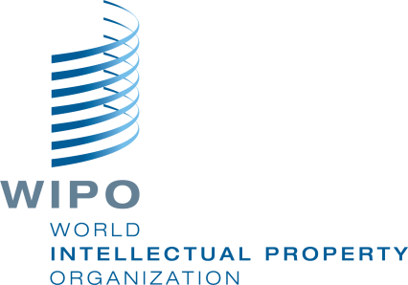
THE UNITED NATIONS ECONOMIC AND SOCIAL
COMMISSION FOR ASIA AND PACIFIC

MEMORANDUM OF UNDERSTANDING
between
The World Intellectual Property Organization
and
The United Nations Economic and Social Commission for Asia and the Pacific

This Memorandum of Understanding (MoU) is drawn up between

The World Intellectual Property Organization (WIPO),

and

The United Nations Economic and Social Commission for Asia and the Pacific (ESCAP)

hereinafter referred to as “the Parties”

With regard to cooperation and implementation of joint activities and programs

Recognizing that WIPO is a specialized Agency of the United Nations, and has the mandate to promote the protection of intellectual property through cooperation among States and, where appropriate, in collaboration with any international organizations,

Recognizing that ESCAP is the United Nations Regional Commission serving the Asia-Pacific region, and has the mandate to promote inclusive and sustainable economic and social development in the region,

Recalling the good institutional relations that for many years have existed between the two Organizations,

Wishing to strengthen their collaboration within the framework of the mandates assigned to them and for the benefit of Member States in the Asia-Pacific region.

WIPO and ESCAP have decided to conclude this MoU and have agreed as follows:

Article I
Cooperation

The Secretariats of WIPO and ESCAP, with a view to promoting the attainment of the objectives laid down by the Convention Establishing WIPO and ESCAP's mandates from General Assembly/ECOSOC/ ESCAP Commission resolutions and to increasing the effectiveness of their individual activities, agree to strengthen their cooperation on matters of mutual interest.

Article II
Fields of Cooperation

The following non-exhaustive list includes fields to which cooperation shall relate, in the context set forth in Article I, and which will be further elaborated by the Secretariats of WIPO and ESCAP:

- Capacity building in the strategic use of intellectual property as a tool for economic, social, cultural and technologicl development;

- Developing and strengthening national IP and innovation strategies to meet national policy and economic objectives;

- Developing appropriate regulatory frameworks and building the infrastructure needed to harness the potential of IP for economic growth and development;

- Promoting access to and use of technological and scientific information, including that contained in patent documents, with special emphasis for the benefit of least developed countries, with a view to stimulating and promoting development outcomes .

Article III
Reciprocal Representation

The Secretariats of WIPO and ESCAP, following their usual practice, shall send each other invitations to participate in meetings organized by them individually on matters of common interest, and may jointly sponsor such meetings where they see fit. For this purpose, WIPO and ESCAP shall also make any necessary arrangements for ensuring reciprocal representation at appropriate meetings convened under their respective auspices.

Article IV
Exchange of Information and Documents

The Secretariats of WIPO and ESCAP shall undertake exchange of relevant information and documents, subject to the restrictions and arrangements as may be considered necessary by either Party to preserve the confidential nature of certain information and documents.

Article V
Financial Implications

Any minor or ordinary expenditure relating to the implementation of the Agreement shall be borne by the respective Party.

If the cooperation proposed by one of the Parties to the other in accordance with this MoU entails expenditure beyond minor or ordinary expenditures, consultations shall be held between WIPO and ESCAP to determine the availability of resources required, the most equitable way of meeting such expenditures and, if resources are not readily available, the most appropriate way to obtain the necessary resources.

Article VI
Modification

The MoU may be modified by mutual consent of the Parties, expressed in writing and formalized through an exchange of letters specifying the date of entry into force of the modification concerned.

Article VII
Entry into Force

This MoU shall enter into force upon its signature by the Director General of WIPO and the Executive Secretary of ESCAP, and subject to the approval of the United Nations Economic and Social Commission for Asia and the Pacific.

Article VIII
Termination

This MoU may be terminated through mutual written agreement of the Parties, or by one Party giving the other six months’ prior notice. In such a case, unless otherwise agreed, obligations previously incurred through specific cooperation projects will not be affected.

Article IX
Focal Points

The Parties will designate a focal point to facilitate coordination and communication on matters related to the implementation of this MoU and will keep each other informed of changes in the designated focal point.

The focal point for ESCAP is:

The focal point for WIPO is:

IN WITNESS WHEREOF, the undersigned, duly authorized thereto, have signed the Agreement.
In Geneva, on [date]

For the United Nations Economic and Social Commission for Asia and the Pacific (ESCAP) | For the World Intellectual  Property Organization  (WIPO)
Ms.Shamshad Akhtar

Ms. Shamshad Akhtar  Executive Secretary | Mr. Francis Gurry  Director General

[End of Annex II and of document]

