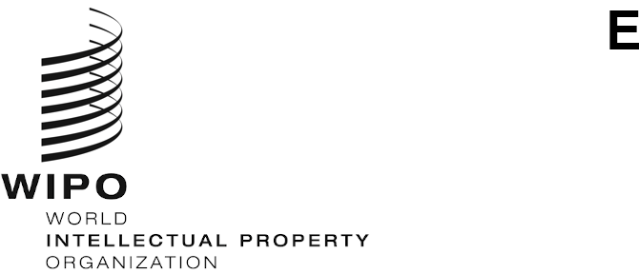
WO/GA/54/12
ORIGINAL: English
DATE: September 28, 2021

WIPO General Assembly

Fifty-Fourth (25th Ordinary) Session
Geneva, October 4 to 8, 2021

Report on the Advisory Committee on Enforcement (ACE)
prepared by the Secretariat
During the period under consideration, the Advisory Committee on Enforcement (ACE) held an Online Dialogue on September 21, 2021, from 12 noon to 2.30 p.m. The meeting was chaired by Mr. Todd Reves (United States of America). A Provisional Summary by the Chair has been published as document WIPO/ACE/OD/1/3.
2. While the fifteenth session of the ACE, originally scheduled to take place from October 5 to 7, 2020, had to be postponed due to the COVID-19 pandemic, the need for sharing experiences and learning from one another was more pertinent than ever, as WIPO Member States faced the challenges of adapting their intellectual property (IP) enforcement strategies to the new reality of the global health crisis. The ACE Online Dialogue offered ACE members and observers an additional avenue for policy dialogue on building respect for IP and IP enforcement in a shortened, fully virtual format.
3. The content and format of the ACE Online Dialogue had been determined by the Group Coordinators through consensus reached in close coordination facilitated by the ACE Secretariat. As a supplementary forum to the regular ACE sessions, the ACE Online Dialogue focused on one particular topic, namely New Developments in Combating Piracy and Counterfeiting on the Internet, from the perspectives of geographically diverse expert speakers.
4. The topic was addressed through seven expert presentations. The presentations comprised: “China’s Developments in Combating Counterfeiting and Piracy on the Internet” by the China State Administration for Market Regulation (SAMR), “Germany’s New Approach to Combating Internet Crimes – The Act on Criminal Liability for the Operation of Criminal Trading Platforms in the Light of the Combat Against Intellectual Property Infringements” by the Federal Ministry of Justice and Consumer Protection of Germany, “Developments in the Online Enforcement of Intellectual Property in the Group of Central European and Baltic States” by the Hungarian Intellectual Property Office (HIPO), “Collaborative Enforcement in the Digital Environment: Synergies to Strengthen State Action During the COVID-19 Pandemic” by the National Institute for the Defense of Competition and Protection of Intellectual Property (INDECOPI) of Peru, “The Philippine Approach to Intellectual Property Protection in Digital Trade” by the Intellectual Property Office of the Philippines (IPOPHL), “The Experience of the Russian Federation in Combating the Spread of Pirated Content on the Internet” by the Federal Service for the Supervision of Communications, Information Technology and Mass Media (Roskomnadzor) and “Using the Internet to Support Effective Intellectual Property Enforcement – Freeing Up Capacity, Boosting Collaboration and Extending the Reach of Education and Awareness Activities” by the Companies and Intellectual Property Commission (CIPC) of South Africa.
5. The expert presentations were followed by a question and answer session, moderated by the Chair, with interventions from the Delegations of the United States of America and Yemen as well as the Representatives of the European Union and the International Telecommunications Union (ITU).
6. The WIPO General Assembly is invited to take note of the “Report on the Advisory Committee on Enforcement (ACE)” (document WO/GA/54/12).
[End of document]

All working documents are available at: https://www.wipo.int/meetings/en/details.jsp?meeting_id=64708.

