E
WO/PBC/22/4
ORIGINAL: ENGLISH
DATE: july 4, 2014

Program and Budget Committee

Twenty-Second Session
Geneva, September 1 to September 5, 2014

SUMMARY ANNUAL REPORT OF THE DIRECTOR OF THE INTERNAL AUDIT AND OVERSIGHT DIVISION (IAOD)

prepared by the Secretariat

- In accordance with paragraph 25 of the Internal Oversight Charter, the Director, Internal Audit and Oversight Division (IAOD), shall present a status report in writing to the Program and Budget Committee (PBC). The report provides information on IAOD’s main activities between July 1, 2013 and June 30, 2014.
- The following decision paragraph is proposed.
3. The Program and Budget Committee took note of the Summary Annual Report of the Director of the Internal Audit and Oversight Division (IAOD) (document WO/PBC/22/4).

[Summary Annual Report by Director, IAOD follows]

TABLE OF CONTENT

LIST OF ACRONYMS 4
BACKGROUND 5
PLANNING, STANDARDS AND NORMS 5
SIGNIFICANT INTERNAL OVERSIGHT FINDINGS AND RECOMMENDATIONS 6
INVESTIGATIVE ACTIVITIES IN THE REPORTING PERIOD 13
INSTANCES WHERE INFORMATION OR ASSISTANCE WAS REFUSED 15
STATUS OF IMPLEMENTATION OF PREVIOUS RECOMMENDATIONS 15
EXTERNAL ASSESSMENT OF IAOD’s WORK 18
OTHER OVERSIGHT WORK 18
OVERSIGHT RESOURCES 20

ANNEXES
ANNEX I – Status of oversight assignments
ANNEX II – List of IAOD reports
ANNEX III – Investigation statistics
ANNEX IV – List of IAOD recommendations closed without implementation
ANNEX V – List of IAOD consulting and advisory activities

LIST OF ACRONYMS

BCM | Business Continuity Management
CPE | Country Portfolio Evaluation
ERP | Enterprise Resource Planning
FIT | Funds-in-Trust
HOIA | Head of Internal Audit Services
HR | Human Resources
HRMD | Human Resources Management Department
IAOC | Independent Advisory Oversight Committee
IAOD | Internal Audit and Oversight Division
IGC | Intergovernmental Committee on Intellectual Property and Genetic Resources, Traditional Knowledge and Folklore
IIA | Institute of Internal Auditors
IOC | Internal Oversight Charter
IP | Intellectual Property
IT | Information Technology
JGP | Joint Grievance Panel
JIU | Joint Inspection Unit
PBC | Program and Budget Committee
PCT | Patent Cooperation Treaty
PLD | Patent Law Division
PPR | Program Performance Report
RBM | Results based management
RIAS | Representatives of Internal Audit Services
RRP | Rewards and Recognition Program
SMT | Senior Management Team
SRP | Strategic Realignment Program
SRR | Staff Regulations and Rules
UAT | User Acceptance Test
UN | United Nations
UNEG | UN Evaluation Group
UNRIS | UN Representatives of Investigation Services
UNRIAS | UN Representatives of Internal Audit Services
VSP | Voluntary Separation Program

SUMMARY ANNUAL REPORT OF THE DIRECTOR of INTERNAL AUDIT AND OVERSIGHT DIVISION

July 1, 2013 to June 30, 2014

BACKGROUND
- The purpose of WIPO’s Internal Audit and Oversight Division (IAOD) is to provide independent and effective internal oversight for WIPO, in accordance with the provisions set out by the Member States in the Internal Oversight Charter (IOC).
- The WIPO IOC requires the Director, IAOD to present a Summary Annual Report to the Independent Advisory Oversight Committee (IAOC) with a copy to the Director General and the External Auditor, of activities undertaken, including orientation and scope of such activities, the schedule of work undertaken and the progress on the implementation of prioritized recommendations. This Summary Report is also presented to the General Assembly and enables major stakeholders and WIPO staff generally to be informed of IAOD reports, activities, and the challenges faced by IAOD in fulfilling its mandate. IAOD also presents a status report on annual work plans in writing to the Program and Budget Committee (PBC).

PLANNING, STANDARDS AND NORMS
- The activities of IAOD include internal audit and evaluation of WIPO’s control systems, programs, projects and business processes. IAOD monitors and assesses the adequacy and effectiveness of WIPO’s control environment, and effective and efficient use of resources. IAOD also investigates allegations of misconduct, wrongdoings or irregularities including but not limited to: fraud and corruption, waste, abuse of privileges and immunities, abuse of authority, and violation of WIPO regulations and rules.
- For its audit activities, IAOD adheres to the International Professional Practices Framework promulgated by the Institute of Internal Auditors (IIA). Similarly, in conducting investigative work, IAOD is guided by the Uniform Principles and Guidelines for Investigations endorsed by the Conference of International Investigators in 2009. Evaluation follows international standards in evaluation practice as set out by the United Nations Evaluation Group (UNEG).
- In accordance with the IOC, in developing its plan, IAOD considered the following factors: risk assessment, relevance, country impact, oversight cycle, comments made by WIPO management and comments made by Member States. IAOD also factored in its available resources.
- IAOD has developed a risk assessment methodology which is based on the IIA guidance as well as generally accepted good practice adopted for such exercises. IAOD used its risk assessment methodology to determine the level of audit coverage necessary for the current biennium.
- IAOD also makes a concerted effort to include in its oversight plan areas that are consistent with WIPO’s policy and program priorities to the extent that these are contained in public documents and/or are communicated to IAOD. IAOD keeps abreast of general policy orientation through the review of strategic and operational documents, such as those of the General Assembly, the Program and Budget, Standing Committees, as well as revisions to Staff Regulations and Rules (SRR), and other programming and planning documents. Moreover, the Director, IAOD or his alternates participate in both regular and ad hoc senior management meetings of the Director General or in regular one-on-one meetings with the latter. Through these processes, IAOD gains awareness of program priorities and overall objectives of the Organization.
- In preparing its plan, IAOD also took into consideration the work done by other oversight actors such as the External Auditor, the Joint Inspection Unit (JIU) or evaluations commissioned by the Committee on Development and Intellectual Property (CDIP). Coordinating with other oversight bodies allows IAOD to provide proper oversight coverage while avoiding “oversight fatigue” in areas facing multiple oversight activities; internal and external audit and evaluation for example.
- In line with the IOC, IAOD took into account, during the whole planning process, the comments from Member States, the IAOC, the Director General and management.
- Finally, as regards investigations, IAOD made all efforts to timely deal with complaints received. Much success has been achieved in this respect during the reporting period, as described in the section on “Investigative Activities”. This allowed IAOD to start undertaking more proactive work in the area of fraud prevention, deterrence and detection.
- Oversight plans for 2013 and 2014 were issued to Program Managers and shared with all WIPO staff using WIPO’s Intranet. The plan for 2013, with small adjustments, was completed on time and within budget. The plan for 2014 is currently being implemented as described in Annex I.

SIGNIFICANT INTERNAL OVERSIGHT FINDINGS AND RECOMMENDATIONS
- IAOD reported findings in the following major areas: Program and project management through various assignments, Madrid and The Hague revenue generation process, Human Resources (HR) management, Events management, Knowledge sharing and Information security. In accordance with the IOC, the following comments reflect the results of the oversight work done during the period.
- Management has already taken action on the issues identified. All recommendations made by IAOD are addressed by Management through a plan with suggested activities, responsible staff and a deadline. Management action plans are issued with IAOD reports or discussed in detail in the month following the issuance of the report. IAOD and Management meet on a regular basis to review the status of implementation of outstanding recommendations.

Performance management
- The Validation of the Program Performance report (PPR) and the audit of Results Based Management (RBM) in WIPO allowed taking stock of the progress made in RBM in WIPO.
- IAOD conducted surveys with WIPO Member States, WIPO Program Managers and the United Nations (UN) and other International Organizations. The survey results place WIPO among the Organizations that have made significant progress in developing and implementing a result based management system.
- The progress made in developing a better Results Framework (expected results, performance indicators, baselines and targets) and building up the in-house knowledge in implementing RBM at WIPO is commendable. The outcome of these efforts can be seen in the improved work planning process and quality of related documentation. The development of a formal accountability framework to consolidate the current structure and improve the overall organizational governance should be set as a priority to enhance performance management. IAOD is pleased to note that a proposal for an accountability framework will be presented to Member States in September 2014.
- Other areas for improvement include annual RBM overview/orientation for Member States representatives. Similarly, a staff training plan, based on identified training needs for RBM should be developed and integrated into WIPO’s corporate training program.
- The validation exercise showed that progress has been made on performance indicators and performance data. However, more can be done to provide relevant outcome/impact based results as well as ensuring all performance indicators have proper baselines.

Country Portfolio Evaluation
- The independent country portfolio evaluation Thailand focused on an analysis of 70 activities covering, since 2007, the WIPO Academy, Business Modernization activities, a Development Agenda Project on Intellectual Property (IP), Product Branding and support to the accession process to the Madrid and the Hague Systems. It also assessed WIPO’s approach, the role of the Regional Bureau for Asia and Pacific and that of External Offices, coordination and WIPO strategic positioning in the country.
- Overall 57 out of 70 sampled activities contributed to the achievement of WIPO’s expected results at the output level over the last six years. WIPO’s activities have been in line with the country’s institutional and regional needs and have contributed to WIPO’s strategic goals. WIPO has positioned itself as an important IP player in Thailand, especially for the Department of Intellectual Property.
- Activities of the various programs developed in Thailand have been found however not to be prioritized as parts of consolidated country plans or frameworks because the responsibility for consolidated planning and monitoring of in-country operations has not been defined. WIPO activities did not significantly contribute to the building of capacities because of the lack of in-depth assessment and planning. Activities were not regularly followed-up on their effects in order to maintain a high quality of service and not always sustainable for lack of exit strategies, joint needs assessments and planning with partners capable of ensuring sustained long-term benefits.

Funds-in-Trust (FIT) management
- WIPO’s resources for undertaking programming activities are primarily drawn from its regular biennial budget. In addition, extra-budgetary resources are made available to WIPO, through a number of agreements with donor countries for carrying out specific activities within the scope of its mandate. These agreements do mostly take the form of Memoranda of Understanding (MOU) and funds are managed through FITs.
- At the transaction level, a high level of compliance was noted with established WIPO procedures for initiating, approving and recording transactions related to FITs. In the management and administration of FITs, there is need for a formal strategy with respect to extra-budgetary resources including FITs which will allow better alignment of FITs activities with the organization-wide expected results and program objectives. This strategy should also outline the context within which both WIPO and donors could better achieve their respective objectives through FITs agreements.
- Clear definition of roles and responsibilities amongst WIPO programs, External Offices and Regional Bureaus would further strengthen planning, execution, monitoring and reporting of FITs activities and enable more effective donor relationship management. This also requires better coordination and cooperation among WIPO programs jointly involved in the use of funds and management of FITs.

Program 1 (Patent Law)
- IAOD conducted its first evaluation of normative work in WIPO. This proved to be a challenge in the absence of similar evaluations done in other organizations of the UN System despite the importance of normative work in the mandate of UN organizations.
- Program 1 is pursuing the general objective of “progressive development of balanced international patent law and practice that serves Member States, users and society as an instrument to encourage innovation and technology transfer, in particular, in developing countries and countries with economies in transition”. Program 1 activities are performed in the following areas of work: supporting discussions and activities of the Standing Committee on the Law of Patents; Legislative and policy advice given to Member States; and Treaty administration with respect to the Budapest Treaty, the Paris Convention and the Patent Law Treaty (PLT).
- The evaluation found that Program 1 has been working effectively, delivering planned outputs through dedicated work of very good quality and relevance to the needs of receivers of services. The Program, notwithstanding the delivery on all its key results as per the Program and Budget, only made modest progress towards achieving its overall objective i.e. progressive development of balanced international law and practice. In efficiency terms, the Program performed well delivering timely and quality outputs. A more accurate planning, monitoring and results framework is required to enable a more precise assessment of the effectiveness, relevance and impact of the components of the Program. The framework as contained in the 2010/11 Program and Budget had significant weaknesses that were addressed in more recent Program and Budget documents.

Madrid and The Hague systems Revenue Generation Process
- The Madrid System of International Registration of Marks facilitates the registration of marks (trademarks and service marks). The Hague System for the International Registration of Industrial Designs provides a mechanism for registering a design in countries and/or intergovernmental organizations member of the Hague Agreement.
- The above systems offer the owner of a trademark or an industrial design a means of obtaining protection in several countries by simply filing one application with the International Bureau of WIPO, in one language, with one set of fees in one currency (Swiss Francs). An international registration produces the same effects in each of the designated countries, as if the trademark/the design had been registered directly with each national office, unless protection is refused by the national office of that country.
- For Madrid and The Hague Systems to achieve the strategic goal of providing premier global IP services on marks and designs, a strategy document needed to be drawn up to serve as a road map to clearly define the business objectives and means to achieve them in the medium to long run. Management has now prepared and approved such a document.
- The current fee structure and payment process need to be analyzed with a view to developing a more efficient payment process and an effective fee structure to maintain financial sustainability given the expected increase in membership and geographical expansion of both systems. Process improvements should also aim to more effectively capture and analyze the cost of transactions and enhance the precision of the unit cost formula.
- A thorough analysis of staffing requirements, coupled with needed skills and competencies for both Systems, will provide management with valuable information to make informed decisions to address the issues effectively in a constantly evolving IP environment. Indicatively, expected expansion in memberships may result in the need to recruit staff with specific language skills.
- Further areas for improvement were noted for customer service and quality control functions where operational effectiveness and efficiency will be enhanced if proper tools are identified and utilized. To increase consistency and efficiency, a first step would be to develop policies and guidelines for both services.
- The Information Technology Modernization Project which aims to enhance IT systems used in both Madrid and The Hague Systems is expected to be completed by the end of 2014. Management should conduct a post-implementation review of the project.

Evaluation of Support Services to the Intergovernmental Committee on Intellectual Property and Genetic Resources, Traditional Knowledge and Folklore (IGC)
- The main objective of this evaluation was to assess the effectiveness and efficiency of support services provided by the WIPO Secretariat to the IGC. This assessment looked at the extent to which support services have met the needs of the IGC, and identified lessons for this and other multilateral processes.
- In conclusion, the overall needs of the IGC were being met by WIPO with a 96 per cent positive rating from participants. In providing the necessary expertise, the Secretariat was found to be playing its role effectively. Practical recommendations were made on communication and publications, registration process and the selection process for the WIPO Voluntary Fund. Also, given the current juncture reached in the negotiations, some participants suggested that the Secretariat could be even more pro-active.

Human Resources management: Staff separation, Benefits and entitlements, and Rewards and Recognition
- The implementation of the Voluntary Separation Program (VSP) between October 2009 and June 2010 resulted in separation from service of 87 staff members on regular budget posts, at an estimated total cost of 22 million Swiss francs. The VSP proposal, approved by the Member States, was that the vacated posts would be used to recruit skills and competencies not available internally such as managerial and specific language skills as well as technological and IP expertise.
- The Secretariat’s proposal was also not to replace positions of regularized long-term serving employees, resulting in a net reduction in headcount. This did not happen. The Human Resources Management Department (HRMD) explained however that filling of the vacated VSP posts with new competencies/skills closed skills gaps and helped realign the Organization’s needs leading to improved productivity and income levels
- Review of the VSP and individual separation agreements indicated that the monetary value of the severance packages were less than the cost of retention of staff had they opted to stay in service until retirement. However, the calculations of the compensation elements appended to a number of separation agreements were not detailed and did not clearly define the compensation elements and derogations provided under the Staff Regulations and Rules. In several instances, the exit forms for separating staff members were not properly completed and none of the separation agreements reviewed contained a clause reminding staff members of their obligations of confidentiality regarding WIPO information, which continue after their separation.
- Other international organizations were surveyed regarding agreed separation from services. The summary results of the survey suggest that WIPO’s practices with regards to agreed separation from service do not differ markedly from the practice of other international organizations.
- IAOD also conducted an audit of staff benefits and entitlements. Personnel costs constitute a significant portion of WIPO’s total expenditure budget (about 63.3% in the 2012/13 biennium). In addition to payroll costs, personnel costs include other benefits and allowances such as education grant, home leave, dependency allowance, language allowance, assignment grant and rental subsidy, which are administered by the HR Operations Service.
- Although HR Operations follows certain standard practices as a matter of routine when dealing with staff requests, these practices are not properly documented. Consistent and efficient delivery of services will be further improved by fully documenting and integrating the existing standard practices in an HR Operations Manual.
- A review of sampled transactions indicated some non-compliance with the provisions of the SRR relating to the processing of education grant, rental subsidy and dependency allowances. Full compliance with the SRR will ensure the effectiveness of the defined internal controls and limit any potential financial losses to the Organization.
- IAOD also reviewed transactions related to assignment grants, representation allowances, and mobility and hardship allowances and no exceptions were noted.
- Finally, IAOD joined HRMD in the evaluation of the rewards and recognition pilot program (RRP). The RRP aims at acknowledging and publicly appreciating outstanding performance and at recognizing and rewarding exceptional performance demonstrated by staff and teams as well as creating interest and motivation for all staff to achieve similar acknowledgement and rewards in the future.
- The RRP is composed of three mechanisms: informal acknowledgement by managers on a regular basis; formal acknowledgement by letters of appreciation for outstanding performers; and Performance Rewards with a monetary value for individuals and teams.
- The results of the first phase of the evaluation showed that the RRP should be continued with the same mix of informal recognition and formal rewards for individuals and teams with and without monetary value. The program would benefit from offering more team awards and less individual ones and more rewards in kind (e.g. trainings, participation in targeted missions or events) than monetary ones.
- On the longer term, there is a recognized need for thinking about other elements (than those addressed in the RRP) that contribute to the creation of a performance culture.

Information Security and Data migration
- Management and staff provided evidence of their commitment to the establishment, maintenance and improvement of an Information Security Management System at WIPO. One key achievement is the International Organization for Standardization (ISO) certification obtained over the protection of the Patent Cooperation Treaty (PCT) Information Technology (IT) Systems.
- The audit made recommendations for enhancing internal controls and business process improvements on information risk register completeness, a centralized IT vulnerability tracking system, shared access and periodic review for system administration activities, AIMS (PeopleSoft©) user account deactivation and reviews and formalized agreed security requirements with the UN International Computing Centre.
- A more specific information technology related project was reviewed. The HR implementation project is one of the important components of the implementation of a comprehensive Enterprise Resource Planning (ERP) system in WIPO. One of the critical tasks of the system implementation process is the conversion or migration of data from the legacy HR system (i.e. SIGAGIP) to the new ERP System (PeopleSoft©), which IAOD audited during the period under review.
- As the audit was conducted concurrently with the ongoing project activities, to improve project implementation, timely input was provided to the project management team on the development and implementation of a robust data reconciliation plan and checklist.
- The implementation of this conversion project faced delays mainly due to a large number of failed User Acceptance Test (UAT) cases during the testing stage. The main reason for this was the lack of early involvement of all concerned functional divisions from the inception stage of the project. Some of the UAT failures were also attributable to inaccurate or incomplete data migration. A root cause analysis of the project delay and UAT failures will be very beneficial as lessons learned to be used in subsequent phases of the HR implementation project.

Knowledge Sharing
- WIPO has developed a number of useful policies, processes and procedures related to knowledge sharing. Improvements have been made in the “working as one” approach promoted by the Strategic Realignment Program (SRP). Innovative or multi-dimensional approaches for the sharing of knowledge are not however prevalent across the Organization, in particular for strategy development or the planning of missions.
- Communication events have enhanced wider understanding of issues in WIPO but there is still a lack of effective information and knowledge sharing across sectors. There is an absence of coherent organization wide tools and processes to facilitate content management and a lack of clarified roles on records keeping in the Organization. Knowledge sharing is not a significant component of WIPO's organizational culture.
- Several technology applications and tools have been developed and implemented in WIPO in the last few years, including the redesigned web site, a Wiki, the Intranet and the ERP, which have had a positive impact on information and knowledge sharing. A strategic approach toward digital transformation and better content management is required to provide better methods for organizing, accessing and using data and information in WIPO.

Events Management
- While events are an important component of WIPO activities and a means by which the Organization achieves its objectives and expected results in line with its RBM system, events management is currently not fully integrated with other tools and systems used to support RBM at WIPO. As a result, events are currently managed outside the results chain instead of within an integrated system.
- WIPO existing planning and implementation tools must be enhanced to improve scheduling and coordination, and better control should be exercised during quarterly review of work plans to avoid potential cases of multiple events in the same location during the same period.
- Late event requests and travel authorizations incur higher travel costs for the Organization as the opportunity to purchase lower-priced tickets is lost. Also, additional savings could be made by using Webinars in lieu of staff or third party travels for small events in locations where the technology is available and effective. Appropriate measures should be taken to better benefit from these potential savings.

INVESTIGATIVE ACTIVITIES IN THE REPORTING PERIOD
- Since 2008, IAOD has registered a total of 127 investigation cases, of which 115 were closed as at June 30, 2014. In the reporting period, 26 new cases were registered and 16 cases were closed (as compared with 16 cases received and 28 cases closed in the previous period).
- Among the new cases, three were referred to the IAOC in accordance with paragraph 5 of the Internal Oversight Charter. Following the recommendations made by the IAOC, the cases were referred to outside WIPO investigation units, two within UN organizations and one to an external contractor. Two of the three cases were still under preliminary evaluation as at June 30, 2014.
- Overall twelve cases were open at the time of issuing this report. Apart from cases that were being dealt by outside parties, all cases but two had been open for less than three months, at the time of issuing this report. In two cases, the outcome of the investigations was delayed by the subjects’ absence on extended sick leave.
- The average duration of cases closed during the reporting period was three months, compared to six months in the previous reporting period.
- The type of complaints received over the reporting period is described in the table below. The nature of complaints received remain in the same categories with harassment, breach of international civil servants’ obligations and HR practices appearing as the three first categories of allegations of misconduct.
Table 1 – Type of complaints received during the reporting period
Report of misconduct/complaint Category | Total | %
Harassment/Discrimination/Abuse of Authority | 7 | 27%
Statements, pronouncements and activities incompatible with the obligations of an international civil servant | 7 | 27%
Irregular HR practices | 4 | 15%
Unauthorized communication of information | 3 | 12%
Other fraudulent and corrupt practices (other than benefits and entitlements fraud)/Misappropriation or misuse of funds and assets (other than the misuse of ICT resources) | 3 | 12%
Benefits and Entitlements Fraud/Providing false information to the Organization | 1 | 4%
Misuse of ICT resources | 1 | 4%
Total | 26

- Three of the 26 new cases registered during the reporting period were referred to IAOD for investigation by the Joint Grievance Panel (JGP), compared to one in the previous period. Three cases were received through the hotline for reporting misconduct. All other cases were registered further to complaints or requests filed by WIPO staff members, either in their individual capacity or as management representatives.
- Of the 16 cases closed during the reporting period, four (25 per cent) led to a full investigation, either further to a decision by the Director, IAOD based on the outcome of the preliminary evaluation, or following a referral from the JGP. IAOD did not find evidence of misconduct by the alleged perpetrator in any of these two JGP cases. In the two other cases, IAOD concluded that allegations of misconduct were substantiated. In these cases, disciplinary proceedings were initiated and staff members were dismissed.
- The investigative activities undertaken during the reporting period have also led IAOD to draw some lessons. A number of management implication reports and recommendations to improve existing systems, policies and procedures have been issued. Issues brought to management attention encompassed topics such as outside activities, video monitoring retention periods, and access to unauthorized web sites, conflict of interest and dependency status determination.
- The table and chart in Annex III provide additional statistical information on investigation cases.
- During the reporting period, IAOD, after in-depth consultations, issued the Investigation Policy, which had been pending since August 2010, as well as a revised version of the Investigation Procedures Manual. Based on the Uniform Guidelines for Investigations adopted by the Conference of International Investigators (involving the UN System and various other international organizations) the Investigation Policy and the revised Manual clarify, inter alia, the following:
  - Staff members’ duty to report any wrongdoing;
  - The confidentiality of the investigation procedure;
  - The role of investigations in the internal justice system;
  - The two stages of investigation activities, with a preliminary evaluation followed, or not, by a full investigation;
  - Due process rules reinforced, with investigation subjects offered the possibility of assistance by observers and the opportunity to comment on investigation reports before their finalization; and
  - A framework for optimal timelines for the various stages of the investigative activity.

- The hotline to report possible misconduct or other wrongdoing was also implemented and advertised to all staff during the reporting period. It consists of an online reporting form and a dedicated phone number. The hotline led to seven reports of alleged misconduct, three of them being formally registered as cases.
- Finally, IAOD conducted a preliminary fraud risk assessment to analyze and evaluate fraud risks within WIPO and review WIPO’s strengths and weaknesses in terms of fraud risk management. The assessment made practical recommendations to enhance fraud prevention and detection in the Organization. WIPO has agreed to: continue embedding fraud as a risk factor to be routinely considered by staff and management; increase fraud awareness with training, resources permitting, as well as on an ongoing basis outside formal training; and, publicize the outcome of the Internal Justice System following investigations establishing fraud, to strengthen their potential as a deterrent and to reinforce the culture of fair and equal treatment.

INSTANCES WHERE INFORMATION OR ASSISTANCE WAS REFUSED
- In accordance with paragraph 27(g) of the IOC, the Director, IAOD reports that no staff member refused to provide information or assist in an ongoing oversight process during the reporting period. However, as mentioned above, some staff members refused to be interviewed by IAOD on medical grounds – using ad hoc medical certificates – resulting in investigations being delayed.

STATUS OF IMPLEMENTATION OF PREVIOUS RECOMMENDATIONS
- The Director General is responsible for ensuring that all recommendations made by the Director, IAOD and other oversight entities are responded to promptly, indicating actions taken regarding specific report findings and recommendations. The Director General discharges this responsibility through the Program Managers responsible for the specific operational areas within the Organization. The implementation of all oversight recommendations by WIPO Program Managers is subject to regular follow-up by IAOD.

Chart 1 – Recommendations by Priority - June 30, 2014
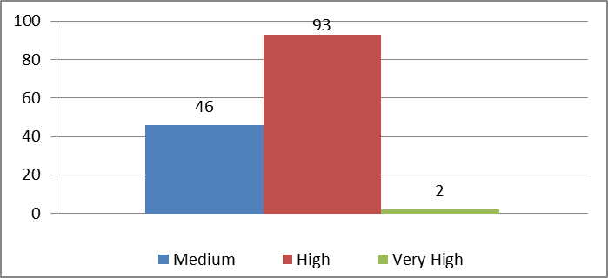
- At the date of the present report, there are 141 recommendations now recorded as open by Program Managers which include 95 that address very high-risk (two) and high-risk (93) issues. The two very high risk recommendations relate primarily to physical access control to WIPO premises and fraud prevention in the badging system. Eight (or 8.4 per cent) of the high/very high risk recommendations have been open for more than two years (Chart 2).
Chart 2 – Aging of Oversight Recommendations - June 30, 2014
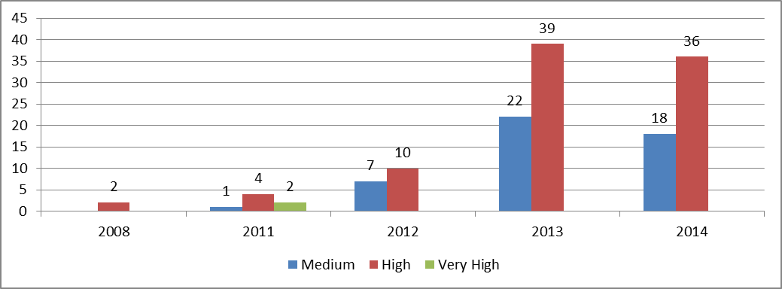
- Since the 2012 summary annual report, IAOD reports using a Web based recommendation management system, TeamCentral©. The software continued to support IAOD in facilitating an ongoing dialogue with Program Managers and their delegates regarding implementation of recommendations.
Chart 3 –Recommendations in TeamCentral© by source - June 30, 2014
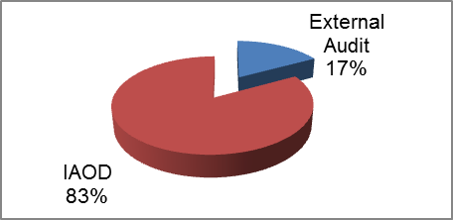
- The External Auditor uses the same tool to follow up on recommendations from external audit. This unique system simplifies the follow-up process.
- As showed in Chart 4, cross-sectoral and support services programs have a significant number of recommendations open. Likewise, recently audited programs by IAOD and the External Auditor, such as the PCT or Madrid and The Hague Systems, need to address an important number of open recommendations.
Chart 4 - Open recommendations by Program
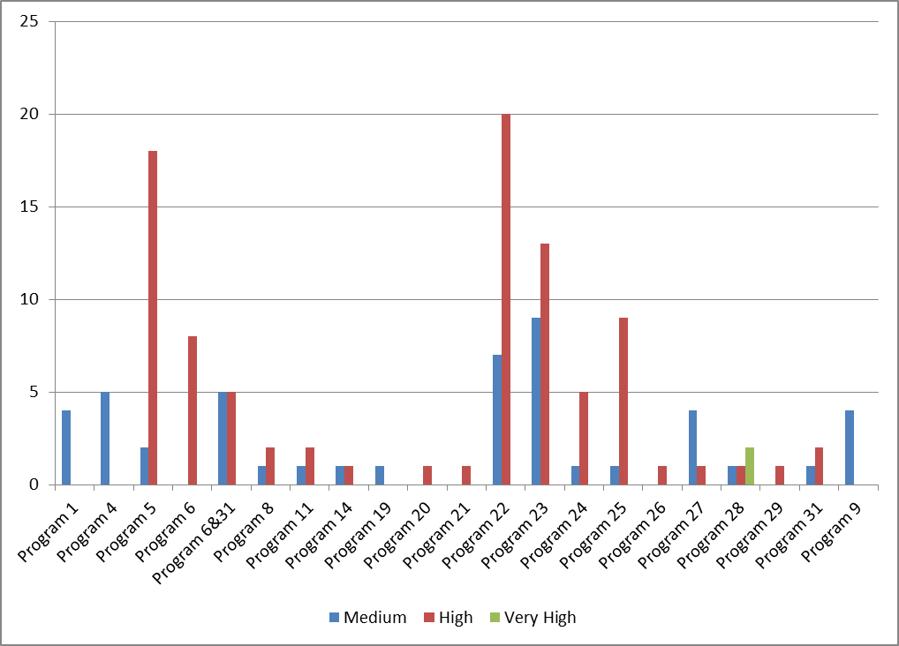
- In accordance with the IOC this summary annual report must provide “a description of all recommendations which were not approved by the Director General, together with his reasons for not doing so”. Annex IV provides the one recommendation closed during the reporting period without implementation together with the reasons for not implementing it.

EXTERNAL ASSESSMENT OF IAOD’s WORK
- In accordance with the IOC and with international standards, IAOD asked external experts to assess its internal audit and evaluation functions.
- The IIA conducted the assessment for the internal audit function and they concluded that IAOD generally conforms to the standards, the code of ethics, and the definition of internal auditing. The IIA’s Quality Assessment Manual suggests a scale of three ratings, “generally conforms,” “partially conforms,” and “does not conform.” “Generally conforms” is the top rating and means the assessors have concluded that the relevant structures, policies, and procedures of the activity, as well as the processes by which they are applied, comply with the requirements of the standards, the code of ethics, or the definition of internal auditing in all material respects.
- An external credentialed evaluator conducted the assessment for the evaluation function and concluded that overall, IAOD’s evaluation function is generally consistent with UNEG norms and standards. The review concludes that there are specific areas that partially conform and require the attention of IAOD in order to strengthen their consistency with UNEG norms and standards and to contribute to the performance of the evaluation function. Although taken individually or collectively the assessed gaps in conformity do not threaten the fundamental integrity of the evaluation function, they warrant action in each of the three assessed areas of independence, credibility and utility.
- The assessors made recommendations for the continuous improvement of IAOD’s work in servicing the Organization. IAOD prepared an action plan to implement the recommendations.

OTHER OVERSIGHT WORK

Consultative and Advisory work
- In addition to its normal oversight work, and in line with the IOC, IAOD provides advice in two forms. First, by participating as observer in various committees (WIPO Investment Committee and the Conference Hall Ad hoc Contract Committee). Second, by providing advice as requested on the regulatory framework or policy documents as listed in Annex V.

The Independent Advisory Oversight Committee
- IAOD has been regularly invited by the IAOC to attend its quarterly meetings in order to answer detailed questions concerning the work and functioning of the Division. The 30th through 33rd meetings of the IAOC took place in the period covered by this report.
- IAOD has benefitted from the advice and guidance from the IAOC as reflected in the latter’s reports.

Satisfaction Survey
- To better understand expectations from colleagues and get their feedback on oversight work, IAOD has routinely used satisfaction surveys since January 2012. Such surveys allow IAOD to better identify areas for improvement of its own work.
- Nine surveys were issued to audited and evaluated entities during the reporting period. On average the work was rated as 82 per cent satisfactory. The highest average score was for the teams that “conducted themselves in an objective, professional and courteous manner” with a 95 per cent satisfaction rate. The lowest average mark was recorded while assessing if “IAOD took account of (management) suggestions for areas of audit/evaluation.” with a 66 per cent satisfaction rate.
- The additional comments sent by the audited/evaluated units help IAOD identify shortcomings and work on corrective actions. To measure also the mid-term impact of oversight work, IAOD began in 2014 issuing surveys on satisfaction a year after the assignment to measure the outcome and gains from the implementation of recommendations. Yet, at the time of reporting, there were too few surveys returned to be able to reliably assess perceived impact of oversight work.

The External Auditor
- The excellent professional and working cooperation and coordination established with the External Auditor has continued with regular information sharing meetings on audit, internal control and risk management issues. The External Auditor and IAOD shared strategies, annual plans and individual reports with a view to ensuring efficient oversight coverage and avoiding any potential unnecessary duplication.

The Ombudsman and the Ethics Office
- During the reporting period, the Director, IAOD met regularly with the Ombudsman and the Ethics Office, as required by the IOC, to ensure good liaison and avoid any unnecessary duplication of activities. The discussions have been very helpful and useful in ensuring that the separate and independent mandates of IAOD, the Ombudsman and the Ethics Office are carried out effectively.

Networking with other oversight functions
- The IOC makes specific provisions on participation in various formal networks of the UN for oversight functions. IAOD recognizes the value and importance of developing relationships with its peers. During the period under review, IAOD continued its active and useful collaboration and networking with other UN organizations and entities. In particular IAOD actively participated in:
  - The 43rd Annual Meeting of Representatives of Internal Audit Services (RIAS) of the UN, in Rome in September 2013. IAOD leads the work on benchmarking;
  - The 14th Conference of Internal Investigators held in Tunis in September 2013;
  - The annual UNEG meeting in April 2014 in Bangkok. During the reporting period, IAOD was a member of the UNEG Strategic Objective working group on Standards and Norms; and
  - The establishment of the UN Representatives of Investigation Services (UNRIS). The mandate of the group is to strengthen investigation practices and professionalism by providing a forum for development of policies and procedures; to promote and support independence, collaboration and common professional positions of its members to add value to their Organizations; and to exchange information and provide advice, as necessary, to members of the group and UN fora.
- In April 2014, IAOD hosted the Heads of Internal Audit in European-based International Organizations meeting at WIPO. There were more than 50 participants representing 35 Organizations. Substantial discussions took place on the audit of governance, the three lines of defense in effective risk management and internal control, performance auditing, as well as more inward looking discussions on joint training activities and benchmarking through the IIA global audit information network (GAIN) survey.

Outreach activities to colleagues in the organization
- To better explain and advocate for its work, IAOD took several initiatives to continue to reach out to colleagues:
  - IAOD is still on the agenda for induction trainings organized for new staff;
  - All staff emails were sent when the hotline for reporting misconduct was launched and the Investigation Policy issued; and
  - IAOD launched a newsletter that will have two issues a year.

OVERSIGHT RESOURCES
- The IOC specifically requires the Director, IAOD to comment on the adequacy of resources allocated to internal oversight within the Organization.

Budget and Staff
- IAOD work force has been an issue in the past with an insufficient number of posts or resources for external consultants and a high number of vacancies. The number of posts has been established to a proper level since 2012 with 11 staff members. Beginning with the 2012/13 biennium, resources for contracted expertise have been sufficient to hire contractual services to assist in the oversight work. As regards vacancies, posts were filled in the 2012/13 biennium. For the first six months of 2014 however, the post of Head, Investigation section remained vacant, when the previous incumbent moved to another post. This vacancy will be filled as of July 1, 2014.
- To discharge its mandate, the current level of resources, 0.75 per cent of WIPO’s Budget and 0.88 per cent of WIPO’s staff, is low compared to some standards such as those recommended by JIU reports on oversight functions. The level of resources has however allowed IAOD to cover the areas it identified as priorities in its workplans. Audit has covered high risk areas, IAOD independent Evaluation reports have become a reality in the 2012/13 biennium and the workload for Investigations is under control. The level of resources seems appropriate in the current context where the Organization has made significant progress in terms of internal controls and risk management and has not, for the moment, significantly changed its Strategic Objectives and business model.

Table 2- 2012 IAOD Budget and expenditures after transfers
 | Approved Budget 2012/13 | Budget after transfers 2012/13 | Expenditures 2012/13 | Utilization rate (%)
Personnel Resources | 4,250 | 3,987 | 3,987 | 100%
Non-personnel Resources | 800 | 805 | 699 | 87%
TOTAL | 5,050 | 4,792 | 4,687 | 98%
- During the reporting period, use was made of contracted experts for various oversight activities. This was particularly valuable for work related to evaluations and specialized audits and investigations.

training
- Essential for continued professional development of its staff, and in accordance with WIPO training policy, IAOD ensures that all of its staff members possess and improve knowledge, skills and other competencies needed to perform their individual responsibilities, with a view to continuously improving the quality of oversight work undertaken. IAOD staff members were trained during the reporting period on fraud prevention and detection, development evaluation, risk management, International Public Sector Accounting Standards (IPSAS), the COSO framework, data mining software, quality assessments, report writing and PeopleSoft©.
[Annexes follow]

Status of 2013 Oversight assignments
Plan | Sector | Status
Program evaluation: Program 1 Patent Law and Innovation | Innovation and Technology
Second Country Portfolio evaluation (CPE) in Thailand (selected based on the presence of an IP strategy) | Development or Global Issues
Evaluation on the Secretariat’s services in organizing meetings of the WIPO Intergovernmental Committee on Intellectual Property and Genetic Resources, Traditional Knowledge and Folklore (IGC) | Global Issues
Review of Payment Obligations | Administration and Management
Audit of Information Security | Administration and Management
Review of Revenue Generation Process Under Madrid and the Hague Systems | Brands and Design
Review of Management of Staff Separation from Service | Human Resources
Review of an SRP initiative: Strengthen  Results-Based Management | Cross-cutting
Review of major development related projects (which can include Funds in Trust (FIT) as well). | Development or Global Issues
Benefits and Entitlements Fraud/Providing false information to the Organization (3 cases ) | Not relevant
Misuse of ICT resources (0 cases) | Not relevant
Statements, pronouncements and activities incompatible with the obligations of an international civil servant (3 cases) | Not relevant
Harassment/Discrimination/Abuse of Authority (5 cases) | Not relevant
Unauthorized communication of information (3 cases) | Not relevant
Irregular HR practices (4 cases) | Not relevant
Miscellaneous (1 case) | Not relevant
Fraud Risk assessment | Cross-cutting
Investigation Policy and Investigation Procedure Manual | Cross-cutting
Advisory and consulting engagements | Cross-cutting
Networking with Other Agencies | IAOD
Independent Advisory Oversight Committee | IAOD
Other indirect activities | IAOD
Follow-up of open recommendations | All
Training | IAOD
Evaluation of Knowledge Management in WIPO | Cross-cutting
Strategic Objective evaluation - International Cooperation on Building Respect for IP | Global Issues | Rolled-over to 2014 Replaced by the IGC evaluation in 2013
Review of Business Continuity Management (BCM) | Cross-cutting | Rolled-over 2014 to take into account management’s request
Code:
In progress or on-going
Completed
Not started

Status of Oversight assignments in 2014 (up to June 30, 2014)
Plan | Sector | Status
Evaluation of Strategic Goal VI: International Cooperation on Building Respect for IP | Global Issues
Evaluation of knowledge-sharing in WIPO | Cross-cutting
External Assessment of IAOD’s evaluation function¹ | IAOD
Program evaluation: Program 30 Small and Medium Enterprises | Innovation and Technology
First phase of evaluation of Rewards and Recognition Program - Pilot 2013 (coauthored with HRMD) | HRMD
Country Portfolio Evaluation  (GRULAC country) | Development
Validation of the 2012-2013 Program performance Report (PPR) | WIPO all
Staff benefits and entitlements | HRMD
Events management | WIPO all
External Assessment of IAOD’s internal audit function | IAOD
Review of Business Continuity Management (BCM) | Cross-cutting
Assets management | WIPO all
WIPO Academy | Development
Audit of Information Security | Administration and Management
Review of Management of Staff Separation from Service | Human Resources
Review of an SRP initiative: Strengthen  Results-Based Management | Cross-cutting
Statements, pronouncements and activities incompatible with the obligations of an international civil servant (4 cases) | Not relevant
Unauthorized communication of information (2 cases) | Not relevant
Irregular HR practices (1 case) | Not relevant
Harassment/Discrimination/Abuse of Authority (4 cases) | Not relevant
Misuse of ICT resources (1 case) | Not relevant
Other fraudulent and corrupt practices (other than benefits and entitlements fraud)/Misappropriation or misuse of funds and assets (other than the misuse of ICT resources) – 2 cases | Not relevant
Fraud Risk assessment | Cross-cutting
Advisory and consulting engagements | Cross-cutting
Networking with Other Agencies | IAOD
Independent Advisory Oversight Committee | IAOD
Other indirect activities | IAOD
Follow-up of open recommendations | All
Training | IAOD
Code:
In progress or on-going
Completed
Not started
[Annex II follows]
List of IAOD Reports
July 1, 2013 to June 30, 2014

Audit of Information Security at WIPO | IA 2013-01
Audit of Madrid and the Hague Systems  (Revenue Generation Process) | IA 2013-02
Audit of Management of Staff Separation from Service | IA 2013-03
Audit of Data Migration to the New Human  Resources Management System | IA 2013-04
Audit of Results Based Management | IA 2013-05
Audit of Funds-in-Trust managed by WIPO | IA 2013-06
Audit of management of staff benefits and entitlements | IA 2014-01
Audit of Events management | IA 2014-02
Validation of the Program Performance report | VALID 2014-01
Evaluation of Program 1 (Patent Law) | EVAL 2012-03
Evaluation of Support Services to the  Intergovernmental Committee on Intellectual Property  and Genetic Resources, Traditional Knowledge  and Folklore (IGC) | EVAL 2013-03
Country Portfolio Evaluation in Thailand | EVAL 2013-05
Evaluation of Knowledge sharing in WIPO | EVAL 2014-01
Rewards and Recognition Program - Pilot 2013 (coauthored with HRMD) | EVAL 2014-06
Fraud Risk Assessment report | FRA 2014-01
26 investigation cases registered.
16 investigation cases closed, representing during the reporting period 12 preliminary evaluation reports, four investigation reports, seven management implication reports, and one ad hoc report.

[Annex III follows]

INVESTIGATION STATISTICS
Between March 2008 (when the Investigation Section was established) and June 30, 2014 (end of the reporting period), IAOD registered a total of 127 investigation cases and closed 115 of them. The table below shows the outcome of the cases that were closed (allegations substantiated or not) in 2008 to 2013 and the status of the 12 open cases as of 30 June 2014 (in abeyance, under preliminary evaluation, under investigation).
Chart 5– Status of cases per year up to June 30, 2014
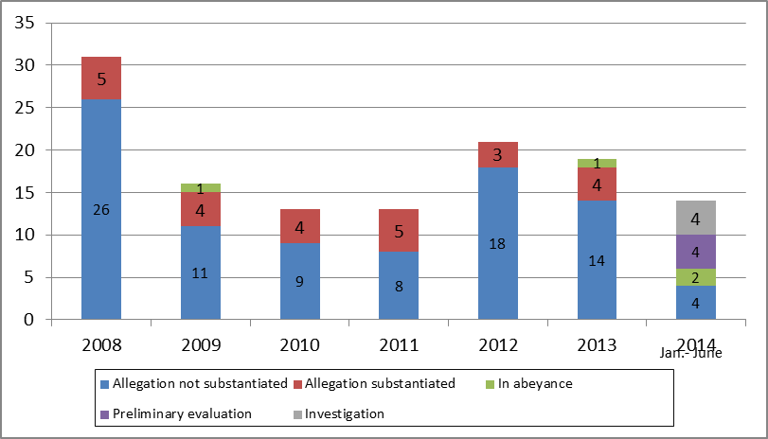
The table below gives an indication of the type of allegations received since 2010.
Table 3 – Cases by category of allegations per year
Count of Status | Year
Case Category | 2010 | 2011 | 2012 | 2013 | 2014 | Grand Total
Benefits and Entitlements Fraud/Providing false information to the Organization | 23% | 23% | 19% | 16% | 0% | 16%
Harassment/Discrimination/Abuse of Authority | 15% | 0% | 14% | 26% | 29% | 18%
Irregular HR practices | 15% | 15% | 24% | 21% | 7% | 18%
Misuse of ICT resources | 23% | 8% | 5% | 0% | 7% | 8%
Other fraudulent and corrupt practices (other than benefits and entitlements fraud)/Misappropriation or misuse of funds and assets (other than the misuse of ICT resources) | 8% | 31% | 5% | 5% | 14% | 11%
Statements, pronouncements and activities incompatible with the obligations of an international civil servant | 15% | 15% | 19% | 16% | 29% | 19%
Unauthorized communication of information | 0% | 8% | 14% | 16% | 14% | 11%
Grand Total | 100% | 100% | 100% | 100% | 100% | 100%
[Annex IV follows]

LIST OF IAOD RECOMMENDATIONS CLOSED WITHOUT IMPLEMENTATION

No. | Reference | Recommendation Description | Explanation  (Secretariat)
1. | Recommendation 9 from the Joint Inspection Unit Review of Management and Administration in WIPO: Budget, Oversight and Related Issues (JIU/REP/2005/1) | The Director General should direct that transfer of positions with posts be discontinued | Organizational context and changes in relevant management strategies since 2005  The WIPO international registration systems (PCT, Madrid and the Hague Systems) have experienced continuous growth accompanied by changes in the geography of demand (in the PCT) and significant automation and modernization of our processing (examination, translation and customer service) operations. These changes have resulted in the need for aligning existing, and acquiring new, skills to ensure that the International Bureau is equipped to address the demands of applicants and stakeholders, including IP offices. This requires an active management of the workforce to ensure that it remains fit for purpose, including re-training of existing employees, recruitment of new skills where needed (foreseen and approved within the Program and Budget) and in some cases redeployment of staff between Programs within the parameters set by the Financial Regulations and Rules. These strategies have ensured that WIPO has navigated through a serious global economic crisis, which impacted our income during the period 2009-2011, without any adverse impact on our staff.  The strengthening of WIPO’s results based management, as part of its Strategic Realignment reform Program, has firmly anchored a results-based approach in work planning, organizational design and workforce planning strategies. This ensures that the resources deployed to Programs are in accordance with the expected results to be achieved, as approved by Member States in the Program and Budget, and take duly into account program implementation strategies including right-sourcing, cost efficiency measures and productivity improvements. The institutionalization of a results-based approach to guide human resource allocation decisions has recently been further cemented with the issuance of a set of post management guidelines.  The measures taken by WIPO to improve the coherence of its internal structure and to align it with its activities and goals were acknowledged by the JIU in its Review of Management and Administration in WIPO (JIU/REP/2014/2 paragraph 53). The Inspectors further noted that they “supported the objectives of such restructuring, as the WIPO business model makes it necessary to closely monitor the areas where activities are increasing or declining so as to adapt the structure accordingly and redeploy staff as required”.  Conclusion  The extensive changes in management approaches and strategies at WIPO since 2005 and its needs to adapt its organizational structures in accordance with its business requirements, as acknowledged by the JIU in its 2014 Review of Management and Administration in WIPO, supersedes the outstanding recommendation arising out of the Management and Administrative Review carried out by the JIU in 2004 that transfers with posts be discontinued. The transfer of human resources with posts will take place within the regulatory framework (FRR and SRR) and only when justified by business needs or in other exceptional circumstances. The Director General will submit a proposal for the revision of the Staff Regulations and Rules to the WIPO Coordination Committee in September 2014 with a new provision (New Rule 4.3.1) to this effect.

[Annex V follows]

LIST OF IAOD CONSULTING AND ADVISORY ACTIVITIES

- Information Security Policies
- Financial Disclosure Policy
- Internal Justice System and Revised SRR
- Institutional Integrity Initiative
- Respectful work place
- WIPO Risk Manual
- Outside activities
- Whistleblower protection policy revision
- Alternative Dispute Resolution non staff
- ICT Strategy
- Financial Liability
- Office Instructions on the new Internal Justice System
- WIPO Ethics training evaluation and recommendations
- Office Instruction On Framework Contracts on Non Staff Resources
- Document disclosure practice
- Office Instruction on Financial Liability
- United Nations Transparency and Accountability Initiative
- Mobile Communications devices
- Policy on distribution of sensitive information to the public
- Policy on risk management and controls
- Member State questions on whistleblower protection policy
- Staff Regulations and Rules
- HRMD Rewards and Recognition Review
- Accountability framework
- Gender Policy and Action Plan
- Office Instruction on the Property Survey Board

[End of Annex V and of document]

Combining likelihood and impact gives risk values. The risk assessment model was revised in 2011 by improving the definitions for likelihood and impact, which results in a more detailed assessment of risk at WIPO. IAOD defined nine parameters for calculating likelihood (time since last audit report, audit results, inherent risk of the business function, changes in business processes, change in management, financial materiality, management/IAOC concerns, fraud history, function criticality -core/non-core) and two for calculating impact (financial and reputation). IAOD defined a further four weighting categories (financial risk, strategic risks, operational risks, legal and compliance risks) which correspond to risk classifications.
The list of reports features in Annex II
See document WO/PBC/22/9
Financial Regulation 4.5 and Financial Rule 104.1
User Acceptance Testing is generally one of the last phases of the testing process in a system implementation project where the testing is conducted by the actual end-users of the system to ensure that it is able to handle tasks in real world scenarios.
A web site that allows anyone to add, delete, or revise content in collaboration with others
Office Instruction No. 29/2013 on Official Travel and Related Expenses: Events at WIPO are defined as: “all conferences, seminars, expositions, conventions and assemblies that arise from the official assignments, duties, and obligations of WIPO program delivery”
WIPO Internal Oversight Charter paragraph 5 : “ (..)Conflicts of interest shall be avoided. Significant and material conflicts of interest are required to be reported to the IAOC who shall recommend such actions that may be needed to mitigate and reduce the undesirable effects of any conflicts of interest. (..)”
The two cases related to fraud in medical claims and serious abuse of the flexitime system.
IOC paragraph 23.
Office Instruction (OI) 16/2010, paragraph 7.
OI 16/2010 paragraph 3.
WO/GA/41/9
Program 1 Patent Law, Program 4 Traditional Knowledge, Traditional Cultural Expressions and Genetic Resources, Program 5 The PCT System, Program 6 Madrid and Lisbon Systems, Program 8 Development Agenda Coordination, Program 9 Africa, Arab, Asia and the Pacific, Latin America and the Caribbean Countries, Least Developed Countries, Program 11 The WIPO Academy, Program 14 Services for Access to Information and Knowledge, Program 19 Communications, Program 20 External Relations, Partnerships and External Offices, Program 21 Executive Management, Program 22 Program and Resource Management, Program 23 Human Resources Management and Development, Program 24 General Support Services, Program 25 Information and Communication Technology, Program 26 Internal Oversight, Program 27 Conference and Language Services, Program 28 Safety and Security, Program 29 New Conference Hall, Program 31 The Hague System.
Both reports and management action plans can be consulted on WIPO’s public website on IAOD’s page.
WO/IAOC/30/2, WO/IAOC/31/2, WO/IAOC/32/2 and WO/IAOC/33/2
- JIU/REP/2006/2 on oversight lacunae in the UN System which recommends that for organizations with total resources of US$ 250 million to US$ 800 million – 0.60 to 0.90 per cent to be spent on internal oversight; - JIU/REP/2010/5 the audit function in the UN System which recommends 6 to 10 auditors (not even counting investigators or evaluators) for WIPO; and - JIU/REP/2011/7 Strengthening the investigation function in the UN System
Source: Program Performance Report as at December 31, 2013, figures in thousands of Swiss francs. Staff commitments are allocated annually.
An internal control framework designed by the Committee of Sponsoring Organizations (COSO) of the Treadway Commission: the American Accounting Association (AAA), the American Institute of Certified Public Accountants (AICPA), Financial Executives International (FEI), the IIA, and the National Association of Accountants (now the Institute of Management Accountants [IMA]).
Work conducted by external consultants, IAOD being the subject of the external assessment.

