|  |  |  |
| --- | --- | --- |
|  | WIPO-E | **E** |
| WO/PBC/22/6 | | |
| ORIGINAL: ENGLISH | | |
| DATE: July 24, 2014 | | |

**Program and Budget Committee**

**Twenty-Second Session**

**Geneva, September 1 to 5, 2014**

FINANCIAL MANAGEMENT REPORT FOR THE 2012/13 BIENNIUM

*prepared by the Secretariat*

1. The Financial Management Report (FMR) of the World Intellectual Property   
Organization (WIPO) for the 2012/13 Biennium is transmitted to the Program and Budget Committee (PBC) in accordance with Regulation 6.7 of the Financial Regulations and Rules (FRR) which requires that the FMR be transmitted to all the interested States.

2. It is to be noted that the FMR is not subject to an external audit.

3. The following decision paragraph is proposed.

*4.* *The Program and Budget Committee recommended to the Assemblies of the Member States of WIPO to approve the Financial Management Report for the   
2012/13 Biennium.*

[FMR for the 2012/13 Biennium follows]

World Intellectual Property Organization

**FINANCIAL MANAGEMENT REPORT FOR THE 2012/13 BIENNIUM**

**PREFACE**

2012/13 recorded increases in most income streams when compared with those of the previous biennium, despite a global economic recovery which remained erratic and uncertain throughout the period. With the exception of the Hague System, income streams exceeded budgeted amounts. In addition, the Organization continued its implementation of various cost efficiency measures, and thus exceeded the requirement, as stipulated by the Assemblies of the Member States in October 2011, to reduce expenditure by 10.2 million Swiss francs.

The Organization generated a surplus of 68.9 million Swiss francs against budget during the biennium. Expenditure against the amounts allocated from reserves for various projects totalled 45.3 million Swiss francs and IPSAS adjustments, made to align WIPO’s result on a budgetary basis to its result in accordance with IPSAS, amounted to 11.0 million Swiss francs. The overall result of the Organization was therefore a surplus of 34.6 million Swiss francs.

This financial management report shows the Organization’s results for the 2012/13 biennium by means of a comparison with the budget and with the results against budget for the previous biennium. It also gives details of the Organization’s financial performance during 2012/13 and of its financial position at the end of both 2012 and 2013 in accordance with IPSAS.



Francis Gurry

Director General

**Financial Management Report**

**2012/13**

This financial management report is expressed in Swiss francs and shows the financial results of WIPO and the unions administered by WIPO [1]*.

The first pages provide a summary of the results which show surplus income of 68.9 million Swiss francs (pre IPSAS) and also the situation of the different unions, as well as those of the reserves and the main provisions. This summary is followed by details of the financial performance of the Organization during the biennium and of its assets and liabilities at the end of both 2012 and 2013. In accordance with WIPO’s introduction of IPSAS in 2010, the Organization now produces a set of financial statements, which is subject to an external audit, for each year of the biennium. Copies of the audited financial statements, together with the accompanying reports from the External Auditor, are available as separate documents from the Organization.

The financial information is followed by details regarding the contributions for the 2012/2013 biennium. The distribution of 333 million Swiss francs to the Member States during the biennium under the Madrid and Hague Agreements is explained in a separate chapter.

For the sake of transparency, the trust funds allocated by the Member States have been treated as a fully-fledged entity, independent of WIPO’s accounts and are presented in a separate chapter.



Francis Gurry

Director General

**TABLE OF CONTENTS**

KEY FINANCIALS AND OTHER PARAMETERS 6

SUMMARY OF RESULTS BY UNION 7

Table 1 Reserve and Working Capital Funds by Union at end 2013 7

Table 1.2 Income and expenditure by Union – 2012/13 Biennium (Budgetary Basis) 7

Table 1.3 Reserve-funded Special projects as of end 2013 8

Table 1.4 Major Construction Projects as of end 2013 8

BUDGET 9

Table 2 Approved Budget and Transfers by Program – 2012/13 biennium 11

Table 3 Posts Report by Program – 2012/13 Biennium 12

EXPENDITURE 13

Table 4 Budget and Expenditure Report by Program – 2012/13 Biennium 13

Table 5 Expenditure by Object of Expenditure – 2012/13 Biennium 14

Personnel Resources 14

Evolution of Personnel Expenditure by Year 15

Travel and Fellowships 16

Evolution of Travel and Fellowships Expenditure by Year 16

Contractual Services 17

Evolution of Contractual Services Expenditure by Year 17

Operating Expenses 18

Evolution of Operating Expenses by Year 18

Equipment and Supplies 19

Evolution of Equipment and Supplies Expenditure by Year 19

INCOME 20

Table 6 Income 2012/13 20

INVESTMENTS 2012/13 22

Financial Risks 22

Table 7 Investments in 2012 and 2013 23

FINANCIAL STATEMENTS 24

Statement of Financial Position 26

Statement of Financial Performance 27

Statement of Changes in Net Assets 28

Statement of Cash Flow 29

Statement of Comparison of Budget and Actual Amounts – Revenue 30

Statement of Comparison of Budget and Actual Amounts – Expense 31

Analysis of Statement of Financial Position 32

Analysis of Statement of Financial Performance 39

Statement of Financial Position by Source of Funding 44

Statement of Financial Performance by Source of Funding 45

CONTRIBUTIONS AND WORKING CAPITAL FUNDS 46

Table 8 and Table 8bis Contributions according to the unitary contribution system 46

Table 9 Outstanding contributions as at December 31, 2013, and arrears in contributions of the least developed countries (LDCs) having a special (frozen) account 49

Table 10 Contributions received in advance 55

Table 11 Working Capital Funds as at December 31, 2013 56

DISTRIBUTION MADRID AND HAGUE 63

Madrid Union - Supplementary fees – 2012 63

Madrid Union - Complementary fees - 2012 65

Madrid Union – Total of fees - 2012 67

Madrid Union - Supplementary fees – 2013 68

Madrid Union – Complementary fees – 2013 70

Madrid Union – Total of fees 2013 72

Protocol Relating to the Madrid Agreement – Individual fees – 2012 73

Protocol Relating to the Madrid Agreement – Individual fees – 2013 74

Madrid Union – National handling fees - 2013 75

Madrid Union – Payment made in accordance with Rule 39 of the Common Regulations under the Madrid Agreement and Protocol 76

Hague Union – State and designation fees – 2012 77

Hague Union – State and designation fees – 2013 78

Madrid and Hague Unions – Distribution 2012 79

Madrid and Hague Unions - Distribution 2013 80

Madrid and Hague Unions - Recapitulation 2012-2013 81

TRUST FUNDS 82

# KEY FINANCIALS AND OTHER PARAMETERS

(in millions of Swiss francs)



# SUMMARY OF RESULTS BY UNION

Table 1 below provides a comprehensive summary of the financial performance in 2012/13 by Unions. The table also presents the Reserves and Working Capital Funds (RWCF) as at the end of 2013 which amounted to 208.8 million Swiss francs.

## Table 1 Reserve and Working Capital Funds by Union at end 2013

*(in thousands of Swiss francs)*



Table 1.2 below provides the comparison between the budgeted and actual income and expenditure on a budgetary basis by Unions and by direct/indirect expenditure type. The distribution by direct and indirect expenditure has been carried out in line with the methodology adopted by the WIPO Assemblies as part of the approval of the Program and Budget for the 2012/13 biennium (Annex III of the Program and Budget 2012/13).

## Table 1.2 Income and expenditure by Union – 2012/13 Biennium (Budgetary Basis)

*(in thousands of Swiss francs)*



Table 1.3 below provides the summary of Reserve-funded Special projects which were under implementation at the end of 2013. The total remaining project balances at the end of 2013 amounted to 25.0 million Swiss francs. It should be noted that the creation and presentation in the annual financial statements of a separate reserve for Reserve-funded Special projects is a recommendation of the External Auditor.

## Table 1.3 Reserve-funded Special projects as of end 2013

*(in thousands of Swiss francs)*



Table 1.4 below provides the summary of the two construction projects which were under implementation at the end of 2013.

## Table 1.4 Major Construction Projects as of end 2013

*(in thousands of Swiss francs)*



# BUDGET

**Budget**

The Program and Budget for the 2012/13 biennium was approved by the 49th Session of the Assemblies of the Member States of WIPO in October 2011 (document A/49/18). The budget was approved in the amount of 647.4 million Swiss francs subject to “efforts by the Secretariat to reduce expenditure through cost efficiency measures by 10.2 million Swiss francs, from 647.4 million Swiss francs to 637.2 million Swiss francs, through, *inter alia* travel policies for staff and third parties, premises management, policies for payments of SSA’s and honoraria for experts and lecturers, internship programs, receptions and rental of premises and equipment during conferences and a reduction of personnel costs through improved organizational design. These cost efficiency measures will not affect Program delivery, results and targets as set out in the Program and Budget proposal. The Secretariat will report back to Member States on the implementation of the efficiency measures in the annual Program Performance Reports”. The Final Budget after Transfers amounted to 648.4 million Swiss francs, reflecting the creation of 5 “flexibility” posts under Program 5 (The PCT System) in view of higher-than-budgeted levels of PCT registration activities, resulting in additional allocation of personnel resources in the amount of 981 thousand Swiss francs for the biennium.

**Transfers**

Table 2 overleaf shows transfers of financial resources made across Programs during the 2012/13 biennium. The transfers were made in line with Regulation 5.5 of the WIPO Financial Regulations and Rules which reads: “The Director General may make transfers from one Program of the Program and Budget to another for any given financial period, up to the limit of five per cent of the amount corresponding to the biennial appropriation of the receiving Program, or to one per cent of the total budget, whichever is higher, when such transfers are necessary to ensure the proper functioning of the services.”

The main transfers across Programs in the 2012/13 biennium were as follows:

* Transfer of resources to Program 3 (Copyright and Related Rights) for the holding of the Diplomatic Conferences on the Beijing Treaty for the Protection of Audiovisual Performances (Beijing Treaty) and the Marrakesh Treaty to Facilitate Access to Published Works for Persons Who Are Blind, Visually Impaired or Otherwise Print Disabled (Marrakesh VIP Treaty). The Diplomatic Conference for the Beijing Treaty was convened in Beijing, China, from June 20 to 26, 2012, and the Diplomatic Conference for the Marrakesh VIP Treaty was held in Marrakesh, Morocco, from June 17 to 28, 2013. The transfers to Program 3 originated from Program 2 (Trademarks, Industrial Designs and Geographical Indications) and Program 4 (Traditional Knowledge, Traditional Cultural Expressions and Genetic Resources) due to the postponement of possible Diplomatic Conferences on the adoption of an International Treaty on the Law of Industrial Designs (Program 2) and Genetic Resources, Traditional Knowledge and Traditional Cultural Expressions (Program 4).
* The provision of resources for the DA project on the Strengthening and Development of the Audiovisual Sector in Burkina Faso and Certain African Countries (Program 3), approved by the 9th session of the CDIP, as well as additional resources for two existing projects: the DA project on IP and Technology Transfer: Common Challenges-Building Solutions (Program 30); and on IP and Brain Drain (Program 16).
* The non-personnel allocations for the 2012/13 Budget after Transfers reflect downward adjustments made for cost efficiency gains across most Programs, in accordance with the Organization’s commitment to reduce expenditures by 10.2 million Swiss francs in the 2012/13 biennium. Cost efficiencies and related savings were achieved in areas such as staff missions and third party travel, organization of meetings and events, procurement of goods and services, telecommunications, ICT services, mail expedition service, translation services and premises management.
* Transfers of additional resources to reinstate the provisions for after service employee benefits that were initially budgeted at a lower level than in the previous biennia. These transfers, which concerned personnel resources, affected all Programs, except Program 29 which had no budgeted posts.
* Transfers of additional resources for translation services in the PCT and Conference and Language Services in view of increased workload, reflected under Programs 5 (The PCT System) and 27 (Conference and Language Services), due to the increased number of applications and the implementation of the WIPO Language Policy, respectively.

Additional details on the resource transfers by Program are included in the Program Performance Report for the 2012/13 biennium.

## Table 2 Approved Budget and Transfers by Program – 2012/13 biennium

*(in thousands of Swiss francs)*



## Table 3 Posts Report by Program – 2012/13 Biennium



# EXPENDITURE

The overall budgetary expenditure for the 2012/13 biennium amounted to 611.8 million

Swiss francs. This represented a utilization rate of 94.5 per cent against the approved budget of 647.4 million Swiss francs.

The Organization further accelerated the implementation of various cost efficiency measures following the directives of Member States as per the approval of the biennial Program and Budget. The following detailed progress reports on the status of the implementation of cost efficiency measures were provided to Member States: Financial Overview for 2012; Progress Report on the Implementation of Cost Efficiency Measures, September 2012 (document WO/PBC/19/9) and Report on the Implementation of Cost Efficiency Measures, September 2013 (document WO/PBC/21/19). The final report on the cost efficiency measures implemented during the 2012/13 biennium is included in the Program Performance Report for 2012/13.

Table 4 provides an overview of the 2012/13 Approved Budget, Budget after Transfers, expenditure and budget utilization rate by Program. Detailed explanations on resource utilization by Program and achievement of expected results are included in the Program Performance Report for the 2012/13 biennium.

Table 5 presents the comparison of the 2012/13 Approved Budget, Budget after Transfers and actual expenditure by cost categories.

## Table 4 Budget and Expenditure Report by Program – 2012/13 Biennium

*(in thousands of Swiss francs)*



## Table 5 Expenditure by Object of Expenditure – 2012/13 Biennium

*(in thousands of Swiss francs)*



## Personnel Resources

Total personnel costs in the 2012/13 biennium amounted to 413.4 million Swiss francs in accordance with both the 2012/13 Approved Budget and the Budget after Transfers. The personnel expenditure in 2012/13 was 17 million Swiss francs higher than the personnel expenditure of 396.4 million Swiss francs in the 2010/11 biennium. This increase was mainly due to the impact of statutory increases, step increases, the contract reform, regularizations of long serving temporary staff and reclassifications.

The Coordination Committee at its 42nd session in September-October 2011, approved the proposed amendments to the Staff Regulations with effect from January 2012. Among the amendments, two new appointment types were introduced, namely, temporary and continuing appointments, in line with the contractual framework recommended by the International Civil Service Commission (ICSC). As indicated in document WO/CC/65/1, “the aim of the proposed amendments is to allow WIPO, in the first instance, to improve its contractual framework and recruitment procedures. The anticipated benefits will be: transparency in contract types; improved benefits for temporary staff; more efficient recruitment of staff, and a resolution of the conditions of service of LSTEs (long-serving temporary staff).” At the end of the biennium, the contract reform process had been largely completed.

The 2012/13 Approved Budget contained provisions for the regularization of up to  
60 long-serving temporary employees performing continuing functions. As of the end of the biennium, all 60 LSTE posts had either been filled or the competitions were nearing completion.

Also, the 2012/13 Approved Budget contained provisions for the after-service employee benefits, including ASHI (After Service Health Insurance) in the amount of two per cent of post costs, compared to six per cent in previous biennia. This was done “in order to retain overall posts costs at a level which is accommodated by the projected income envelope of the Organization”. The Program and Budget document for 2012/13 also stated that “the Director General wishes to indicate that a pick-up in the projected income levels would first and foremost be proposed to be utilized to reinstate this provision at the appropriate time”. Accordingly, the 2012/13 actual expenditure for personnel includes the provision of 18.9 million Swiss francs for after-service employee benefits.

The table below shows the evolution of personnel resources by year. The spike in 2013 is due to the one-off charge in December 2013 of the amount of 12.5 million Swiss francs towards the re-instatement of the provision for after-service employee benefits, as explained above. The amount of 12.5 million Swiss francs is a part of the total provision of 18.9 million Swiss francs for after-service employee benefits charged to the regular budget mentioned above.

### Evolution of Personnel Expenditure by Year

*(in millions of Swiss francs)*



## Travel and Fellowships

Overall expenditure for Travel and Fellowships amounted to 30.9 million Swiss francs for the biennium, a decrease of 8.6 million Swiss francs, or 21.7 per cent, compared to the Budget after Transfers.

### Evolution of Travel and Fellowships Expenditure by Year

*(in millions of Swiss francs)*



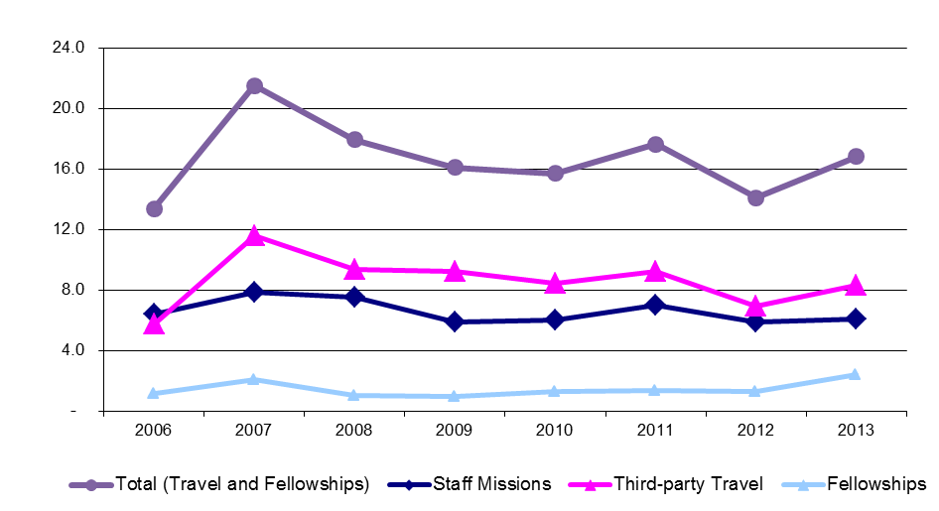

The increase in expenditure for Third-party Travel in 2013 from 2012 was primarily due to the holding of the Extraordinary Assemblies of Member States in December 2013 as well as the overall increase of activities in the second year of the biennium. For the biennium as a whole, a decrease can be observed compared to 2010/11 largely due to the impact of cost efficiency measures put in place during the biennium.

The increase in the 2012/13 Budget after Transfers for Fellowships resulted from the contract reform process launched in January 2013. Specifically, in the Arbitration and Mediation Center, case managers were employed under Short Term Labor Contracts (SLCs). In order to recognize the arrangement through which the Organization provides young professionals with case management experience to strengthen their knowledge and professional competence in the areas under the Arbitration and Mediation Center’s responsibility, a WIPO Fellowship program was created in 2013. As a consequence, the budget provisions previously under the category of Short-term employees were moved to the Fellowships category. In addition, a higher expenditure was incurred on course fellowships under Program 11 (The WIPO Academy) in 2012/13. This was due to the increase in training programs, including joint master programs, offered to Member States.

## Contractual Services

Contractual services related expenditure amounted to 111.1 million Swiss francs in the 2012/13 biennium. This represents a decrease of 15.5 million Swiss francs, or 12.2 per cent, compared to the 2012/13 Budget after Transfers.

### Evolution of Contractual Services Expenditure by Year

*(in millions of Swiss francs)*



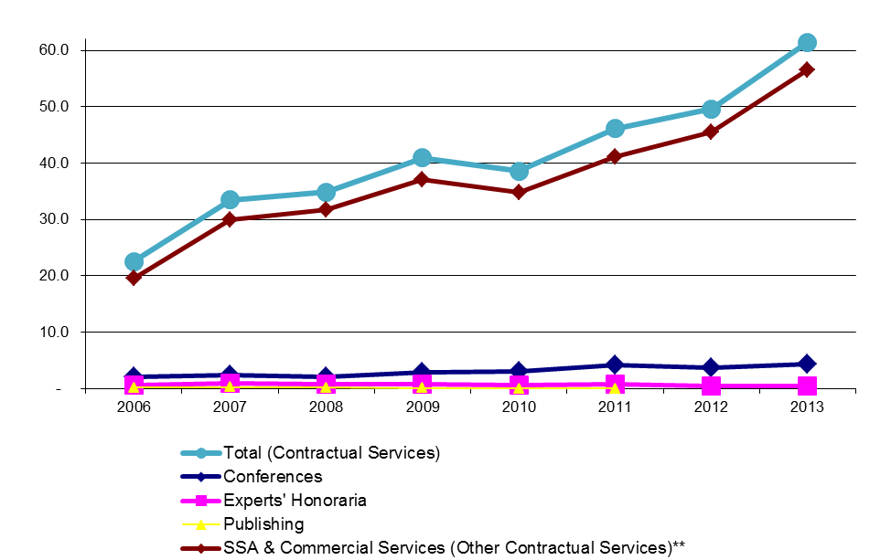

The increase in the 2012/13 Budget after Transfers under SSA & Commercial Services was primarily due to additional provisions for (i) the outsourcing of translation under Program 5 (The PCT System), (ii) the completion of the SRP initiative under Program 21 (Executive Management) and (iii) the outsourcing of increased translation volumes resulting from the implementation of the WIPO Language Policy under Program 27 (Conference and Language Services).

Increased expenditure under SSA & Commercial Services in 2013 as compared to 2012 was due mainly to higher translation volumes in Program 5 (The PCT System) and increased outsourcing of managed infrastructure services (network and servers) to the UN International Computing Center (UNICC) under Program 25 (ICT).

## Operating Expenses

Operating expenses amounted to 50.0 million Swiss francs, a decrease of 5.5 million Swiss francs, or 10 per cent, compared to the 2012/13 Budget after Transfers.

### Evolution of Operating Expenses by Year

*(in millions of Swiss francs)*



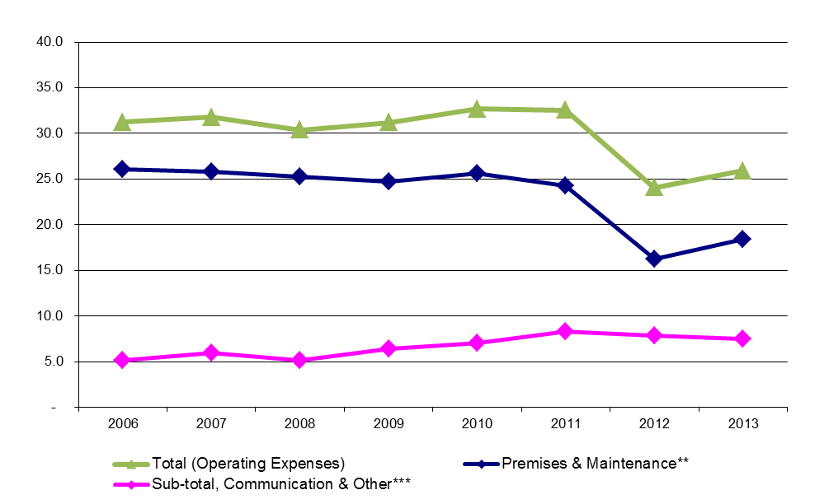

The significant increase in expenditure under Administrative and Bank Charges as compared to the Budget after Transfers was due to the fact that interest payments for the New Construction Project were budgeted under Premises and Maintenance; whereas, the actual charge was made against Administrative and Bank Charges.

The decrease in Premises and Maintenance related expenditure in 2012/13 compared to prior biennia was primarily due to a cancellation of the rental of office spaces outside the WIPO campus following the finalization of the New Building. Such reduction was partly offset by somewhat higher charges and maintenance costs linked to the operation of the New Building.

## Equipment and Supplies

Equipment and Supplies related expenditure amounted to 6.5 million Swiss francs in 2012/13, a reduction of 3.5 million Swiss francs, or 35 per cent, compared to the biennial Budget after Transfers. The reduction was entirely under the sub-category Furniture and Equipment.

### Evolution of Equipment and Supplies Expenditure by Year

*(in millions of Swiss francs)*



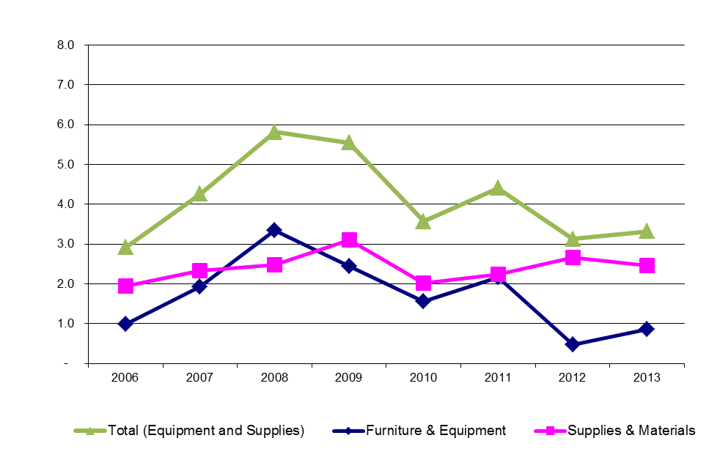

Higher expenditure under Supplies and Materials as compared to the 2012/13 Budget after Transfers was mainly in relation to the purchase of software under Program 25 (ICT). Part of the increase, compared to the previous biennium, also related to increased costs for software maintenance, paper supplies and library resources.

The reduction in the 2012/13 expenditure as compared to the previous biennium under Furniture and Equipment was primarily due to a reduction in the purchase of IT equipment, specifically servers. In 2012/13, the server services were increasingly outsourced to UNICC.

# INCOME

## Table 6 Income 2012/13

*(in millions of Swiss francs)*



Actual income on a budgetary basis amounted to 680.7 million Swiss francs; an increase over the budgeted estimates by 33.3 million Swiss francs or 5.1 per cent.

Income from assessed contributions amounted to 35.1 million Swiss francs, higher than the biennial target, primarily due to the change of the contribution class of Republic of Korea from V to IVbis.

Fee income from the PCT System amounted to 514.9 million Swiss francs; an increase of 34.3 million Swiss francs, or 7.1 per cent, as compared to the budgeted target of 480.6 million Swiss francs. The number of PCT international applications filed in the 2012/13 biennium reached 400,612 applications; an increase of 32,612 applications, or 9 per cent as compared to the budgeted target of 368,000 applications for the biennium.

Fee income from the Madrid System amounted to 108 million Swiss francs; an increase of 3.6 million Swiss francs, or 3.4 per cent, as compared to the budgeted target of 104.4 million Swiss francs. The number of registrations and renewals (R&R) under the Madrid system amounted to 131,241 during the biennium, exceeding the budgeted target of 128,900 by 2,341, or 1.8 per cent. Fee income from the Hague System reached 6.3 million Swiss francs, 4.9 million Swiss francs, or 43.6 per cent, lower than the budgeted target of 11.2 million Swiss francs. This decrease was due to a 37.3 per cent decrease in the number of Hague R&R, or 6,647 R&R, as compared to the budgeted target of 17,800 R&R.

Arbitration income amounted to 3.3 million Swiss francs exceeding the budgeted target of 2.7 million Swiss francs by 19 per cent. This increase was primarily due to case income under two domain name dispute resolution policies: Uniform Domain Name Dispute Resolution Policy (UDRP) and Legal Rights Objections (LRO) which were not part of the original income estimates.

Income from publications totaled one million Swiss francs, in line with the budgeted target.

Interest income reached 3.4 million Swiss francs, 57.8 per cent lower than the 2012/13 budgeted estimates, primarily due to the reduction of interest rates paid on WIPO deposits with the Swiss National Bank.

Miscellaneous income amounted to 8.7 million Swiss francs exceeding the budgeted amount by 4.1 million Swiss francs or by over 90 per cent. This includes various accounting adjustments in respect of prior years, currency adjustments, rental income, United Nations Development Programme (UNDP) administrative charges, etc. The increase from the budgeted target was mainly due to credit notes in relation to UNICC services.

# INVESTMENTS 2012/13

All of WIPO’s investments are made in accordance with WIPO’s Policy on Investments which was approved by the Member States at the forty-ninth session of the Assemblies (document A/49/14) which took place in 2011.

Investments are therefore made as follows:

1. All Swiss franc investments for WIPO are held with the Swiss National Bank (BNS) provided that the rate offered is higher than that available from commercial banks having the required credit rating.

(b) Investments other than those made with BNS are linked to money market funds and time deposits held by banks with a credit worthiness rating of AA-/Aa3 (Standard and Poor’s / Moody’s) or higher and to high grade corporate or government banks rated AA-/Aa3 or higher.

(c) Monies held for Funds in Trust (Special Accounts) are placed in money market funds and time deposits with banks meeting the required credit rating.

Table 7 details investments made during the biennium. It is worth noting that, under the terms of the Policy on Investments, the Organization is currently unable to make deposits with either of its two principal relationship banks, UBS and Crédit Suisse, as their long-term credit ratings are below the minimum level stipulated in the policy.

Financial Risks

WIPO has developed risk management policies in accordance with its Financial Regulations and Rules. The Organization is exposed to certain financial risks, including credit, interest, liquidity and foreign currency exchange risks. The primary objective of the WIPO Policy on Investments is the minimization of risk to principal funds while ensuring the liquidity necessary to meet cash flow requirements. Within this general objective the principal considerations of the Organization’s investment management are, in order of importance:

(1) Preservation of capital;

(2) Liquidity;

(3) Rate of return.

*Credit Risk*

Investments are held in banks with sovereign risk or with credit ratings of AA-/Aa3 or higher. Accounts receivable are almost exclusively from Member States representing sovereign governments, and therefore risks related to credit are considered minor.

*Interest Risk*

As only 3 per cent of the operating budget is financed from revenue derived from investment income, the Organization’s exposure to the risk of falling interest rates is limited. The Organization does not use financial instruments to hedge interest rate risk.

*Liquidity Risk*

The Organization does not have significant exposure to liquidity risk as it has substantial unrestricted cash resources which are replenished from the results of its operations. The Organization’s investment policy has been developed to ensure that investments are held primarily in liquid short-term deposits.

*Foreign Currency Exchange Risk*

The Organization is exposed to foreign currency exchange risk arising from fluctuations of currency exchange rates. To the maximum extent possible, short, medium and long term investments are managed by matching currencies held, forecast cash inflows and forecast disbursements by currency and period. The Organization does not use derivative financial instruments to hedge exchange risk.

## Table 7 Investments in 2012 and 2013



# FINANCIAL STATEMENTS

For each of the two years of the 2012/13 biennium, the annual financial statements of WIPO have been prepared in accordance with International Public Sector Accounting Standards (IPSAS).

**The Move to IPSAS**

On November 30, 2005, the High-Level Committee of Management (HLCM) recommended that all United Nations system organizations adopt IPSAS as their accounting standard effective no later than 2010. This recommendation was driven by a clearly identified need within the UN system to move to improved, independent and universally accepted accounting standards, with the aim of increasing quality and credibility in financial reporting. The IPSAS standards are developed by the International Public Sector Accounting Standards Board (IPSASB) which is part of the International Federation of Accountants (IFAC).

At the forty-third session of the Assemblies (September 24 to October 3, 2007), the Member States agreed in principle to the adoption by WIPO of IPSAS by 2010. The project to implement IPSAS at WIPO involved significant IT development and modifications, and the proposal for this work was approved by the forty-sixth session of the Assemblies in December 2008. Although many UN organizations pushed back the original IPSAS implementation deadline, WIPO maintained the 2010 target date. As WIPO received an unqualified audit opinion for its 2010 financial statements, it became one of only nine UN organizations to adopt IPSAS by the originally planned date of January 1, 2010.

**The Accounting Impacts of IPSAS**

Applying IPSAS has required the introduction of the full accrual basis of accounting. Accrual basis accounting involves the recognition of transactions and events when they occur, meaning that they are recorded in the accounting records and reported in the financial statements of the financial periods to which they relate, and not only when cash or its equivalent is received or paid.

Under IPSAS, WIPO is required to recognize the value of future employee benefits (for example, accumulated annual leave, repatriation grants, After Service Health Insurance) that WIPO staff have earned but not yet received. These liabilities are recorded to capture the full cost of employing staff, whereas prior to the introduction of IPSAS these types of benefits were shown as an expense only when paid.

IPSAS requires that the property (land and buildings), equipment and certain intangible assets (software, land surface rights) of the Organization be capitalized in the financial statements and depreciated over their useful economic lives.

The application of IPSAS also affects the way in which the Organization is able to record revenue relating to its activities. In many cases, WIPO collects fees and charges for services before the services are performed completely, or before the fee is earned in accordance with the treaties, agreements, protocols and regulations administered by the Organization. In these cases IPSAS requires that the revenue from fees collected is deferred until it is deemed to have been earned in accordance with the regulations governing the particular revenue source. This leads to the recognition of significant deferred revenue liabilities in the WIPO financial statements.

The application of IPSAS does not currently impact the preparation of the WIPO Program and Budget, which is still presented on a modified accrual basis. As this basis differs from the full accrual basis applied to the financial statements, reconciliation between the budget and the financial statements is provided in accordance with the requirements of IPSAS.

**Presentation of Financial Information under IPSAS**

As IPSAS requires the preparation of annual financial statements, WIPO financial statements are prepared individually for each calendar year of the biennium. These annual financial statements are presented separately from the Financial Management Report, and for complete financial information of the Organization prepared in accordance with IPSAS requirements, reference should be made to the WIPO annual financial statements.

Under IPSAS, the financial statements include the following elements:

* Statement I - Statement of Financial Position
* Statement II - Statement of Financial Performance
* Statement III - Statement of Changes in Net Assets
* Statement IV - Statement of Cash Flow
* Statement V - Statement of Comparison of Budget and Actual Amounts
* Notes to the Financial Statements

In the Financial Management Report, statements I-V are presented for the biennium 2012/13. Financial information is provided to give an understanding of the differences between the result of the Organization on a budgetary basis and the result of the Organization per the IPSAS financial statements. Other extracts from the annual financial statements also provide further details of the assets and liabilities of the Organization.

**Change in Accounting Policy**

In 2013, the accounting policy relating to the recognition of revenue from international patent applications was changed. Following identified changes in payment patterns, a new model was developed to calculate the balances of debtors and deferred revenue related to this activity. The new model incorporates available data by individual application and applies the relevant foreign currency exchange rates. It also defers the revenue from fees for extra pages until publication for all formats of application, and incorporates all fee reductions, including developing country reductions. As a result, the new model provides more reliable calculations of the balances of debtors and deferred revenue. The effect of this change in accounting policy was recognized retrospectively, requiring restatement of the 2011 and 2012 comparative numbers which are presented in the following tables.

Following restatement, the 2012 surplus increased from 15.7 million Swiss francs to 19.5 million Swiss francs. The restated net assets as at December 31, 2011 are 174.2 million Swiss francs, compared to the previously presented 162.5 million Swiss francs. The restated net assets as at December 31, 2012 are 193.7 million Swiss francs, compared to the previously presented 178.2 million Swiss francs:



**STATEMENT I**

**STATEMENT OF FINANCIAL POSITION**

**as at December 31, 2013**

**(in thousands of Swiss francs)**

Statement of Financial Position



**STATEMENT II**

**STATEMENT OF FINANCIAL PERFORMANCE**

**for the biennium ended December 31, 2013**

**(in thousands of Swiss francs)**

Statement of Financial Performance



**STATEMENT III**

**STATEMENT OF CHANGES IN NET ASSETS**

**for the biennium ended December 31, 2013**

**(in thousands of Swiss francs)**

Statement of Changes in Net Assets



**STATEMENT IV**

**STATEMENT OF CASH FLOW**

**for the biennium ended December 31, 2013**

**(in thousands of Swiss francs)**

Statement of Cash Flow



**(1)** – Excluding interest earned and interest paid on borrowings.

**STATEMENT V**

**STATEMENT OF COMPARISON OF BUDGET AND ACTUAL AMOUNTS – REVENUE**

**for the biennium ended December 31, 2013**

**(in thousands of Swiss francs)**

Statement of Comparison of Budget and Actual Amounts – Revenue



(1) - represents the approved 2012/13 biennial budget.

(2) - represents the 2012/13 Final Budget after Transfers.

(3) - represents the difference between the 2012/13 Final Budget after Transfers and actual revenue on a comparable basis for the biennium 2012/13

**STATEMENT V**

**STATEMENT OF COMPARISON OF BUDGET AND ACTUAL AMOUNTS – EXPENSE**

**for the biennium ended December 31, 2013**

**(in thousands of Swiss francs)**

Statement of Comparison of Budget and Actual Amounts – Expense



(1) – represents the approved 2012/13 biennial budget. The biennial budget of 647.4 million Swiss francs was approved by the Assemblies of the Member States of WIPO on September 29, 2011, subject to:

“Efforts by the Secretariat to reduce expenditure through cost efficiency measures by 10.2 million Swiss francs, from 647.4 million Swiss francs to 637.2 million Swiss francs, through, inter alia, travel policies for staff and third parties, premises management, policies for payments of SSAs and honoraria for experts and lecturers, internship programs, receptions and rental of premises and equipment during conferences and a reduction of personnel costs through improved organizational design."

(2) – represents the 2012/13 Final Budget after Transfers. The Final Budget after Transfers reflects the increase for Program 5 (The PCT System) by 981 thousand Swiss francs related to the creation of 5 posts, due to the higher-than-budgeted number of PCT International Applications in 2012 (Financial Regulation 5.6 on Flexibility Adjustments).

(3) - represents the difference between the 2012/13 Final Budget after Transfers and actual expense on a comparable basis up to December 31, 2013.

**Analysis of Statement of Financial Position**

Analysis of Statement of Financial Position

**Movement in Net Assets (Reserve and Working Capital Funds)**

As at December 31, 2013, the Organization has net assets (or reserve and working capital funds - RWCF) on an IPSAS basis of 208.8 million Swiss francs. As presented in the Financial Management report for the biennium 2010/11, the Organization had net assets of 162.4 million Swiss francs as at December 31, 2011. The effect of the change in accounting policy relating to the recognition of revenue from international patent applications required restatement of the 2011 balances, resulting in restated net assets as at December 31, 2011 of 174.2 million Swiss francs. The table below summarizes the increase in net assets during the biennium 2012/13:

Movement in Net Assets (RWCF) 2012/13



The result for the biennium on an IPSAS basis was a surplus of 34.6 million Swiss francs. This includes a restated surplus of 19.5 million Swiss francs for the year 2012. The result and net assets for 2012 were restated following the change in accounting policy relating to the recognition of revenue from international patent applications.

The surplus on an IPSAS basis of 34.6 million Swiss francs can be compared to the budget result for the biennium, which was a surplus of 68.9 million Swiss francs. The difference of 34.3 million Swiss francs between the budget result and the IPSAS financial statements is analyzed in detail in the chart Movement from Budget Result to IPSAS Result 2012/13 (see section Analysis of Statement of Financial Performance). However, in summary the IPSAS result also includes projects financed from reserves (defined as ‘entity differences’ by IPSAS), and impacts from movements in assets and liabilities which must be recognized under IPSAS (‘accounting basis differences’).

**Summary of Assets and Liabilities**

The chart below provides a summary of the statement of financial position of WIPO as at December 31, 2013.

Summary of Assets and Liabilities December 31, 2013



The Organization has cash balances of 409.9 million Swiss francs, representing 45.5 per cent of total assets, although this includes amounts which are classified as restricted under IPSAS. The Organization holds significant fixed assets (land, buildings, investment property, intangible assets and equipment) with a total net book value of 396.4 million Swiss francs. Other assets of the Organization totaling 94.2 million Swiss francs include accounts receivable, inventories and advance payments. Within this, the most significant balance is PCT debtors totaling 62.4 million Swiss francs.

Payables (accounts payable and transfers payable) and advance receipts total 340.8 million Swiss francs, and principally include deferred revenue of 215.8 million Swiss francs. Employee benefit liabilities of 150.5 million Swiss francs are mainly comprised of the After Service Health Insurance (ASHI) liability of 119.6 million Swiss francs, while borrowings represent the FIPOI loan (22.3 million Swiss francs) and the BCG/BCV loan (122.2 million Swiss francs). Other liabilities totaling 55.9 million Swiss francs include 54.9 million Swiss francs of current accounts held on behalf of applicants and contracting parties.

The net current assets (current assets less current liabilities) of the Organization are 76.8 million Swiss francs as at December 31, 2013, representing a significant increase of 17.9 million Swiss francs compared to the balance at the end of the previous biennium.



**Cash and Cash Equivalents**



Total cash and cash equivalent balances have increased by 30.2 million Swiss francs between December 31, 2011 and December 31, 2013. For the purposes of IPSAS presentation, cash balances are split between unrestricted and restricted. Restricted funds include funds held on behalf of third parties for the registration of trademarks or industrial designs, and subscriptions to WIPO periodicals. Also included are fees collected on behalf of contracting parties to the Madrid Agreement and Protocol, Hague Agreement and on behalf of PCT International Searching Authorities (ISAs) by the WIPO International Bureau Receiving Office. In addition, the deposits received in connection with pending procedures related to trademarks, other than the portion estimated to represent advance receipts to the Organization, represent funds collected on behalf of third parties and are considered restricted funds.

**Fixed Assets**



The Organization recognizes equipment purchases as assets if they have a total cost above an established threshold of 5,000 Swiss francs.

The Madrid Union Building, which is classified under IPSAS as an investment property, was revalued during 2012, resulting in an increase of 0.5 million Swiss francs in its valuation.

Land surface rights continue to decrease by an annual amount of 0.4 million Swiss francs as they are amortized over a 78 year period. From January 1, 2012 the Organization has applied IPSAS 31 Intangible Assets. This has led to the capitalization of externally acquired and internally developed software in the financial statements for a total amount of 2.7 million as at December 31, 2013.

Land and buildings have increased over the biennium to 360.1 million Swiss francs as at December 31, 2013. In 2012 and 2013, the Organization has capitalized significant costs as work in progress concerning the New Conference Hall and Security Construction, and also costs relating to improvements to occupied buildings. These increases in the value of buildings have been partly offset by 12.6 million Swiss francs of depreciation over the biennium.

**Other Assets**



Other assets are principally PCT debtors, with a balance of 62.4 million Swiss francs as at December 31, 2013. This represents PCT applications which have been filed with receiving offices and possibly received by WIPO, but for which no corresponding fee payment has been received by the Organization. Other debtors and prepayments as at December 31, 2013 are mainly comprised of prepaid expenditure of 4.9 million Swiss francs, and USA taxes reimbursable of 3.7 million Swiss francs. Advances are mainly advances to staff for education grants of 4.5 million Swiss francs.

**Payables and Advance Receipts**



Transfers payable represent fees collected by the Organization on behalf of the contracting parties of the Madrid Agreement and Protocol and the Common Regulations of the Hague Agreement. In addition, the Organization’s PCT International Bureau collects funds from applicants to cover the cost of payments of International Searching Authorities. The Organization holds these funds on a temporary basis until they are transferred to the final beneficiary in accordance with the various treaties and agreements administered by the Organization. The total balance has increased during the biennium, moving from 64.2 million Swiss francs at the end of 2011 to 78.6 million Swiss francs at the end of 2013. This movement is principally due to the reclassification of a portion of Madrid Union deposits from advance receipts, starting in 2012. Until 2011, Madrid Union deposits were all included within advance receipts, but from 2012 an exercise was undertaken to separately estimate the balance representing funds collected on behalf of third parties which was reclassified to transfers payable.

Revenue from fees related to the processing of international applications (Trademark, Industrial Design, Patents) is recognized when the application has been published. Fees and charges collected before publication are recognized as deferred revenue within advance receipts. Advance receipts concern principally PCT deferred revenue, with a balance of 194.9 million Swiss francs as at December 31, 2013. At this date it is estimated that approximately 145,700 applications had been filed which were awaiting publication.

**Employee Benefits**



As can be seen from the table above, by far the most significant employee benefit liability for the Organization is post-employment medical benefits (After Service Health Insurance – ASHI), which represents 79.4% of the total liability as at December 31, 2013. The ASHI liability has increased by 16.2 million Swiss francs over the period of the biennium 2012/13, and this movement is detailed in the table below:



The liability is calculated by an independent actuary, and reflects the total future cost of WIPO’s share of health insurance premiums for both existing WIPO retirees and the projected number of active WIPO staff who will retire in the future. The current service cost in the table above is the net impact for the period resulting from the increase in age of current staff and their dependents, the number of persons retiring, new hires and separations other than retirement. The interest cost is the impact resulting from the fact that each member of the active staff is one year closer to reaching the age of eligibility for ASHI retirement.

**Borrowings**



The Organization has borrowed funds (50.8 million Swiss francs and 8.41 million Swiss francs approved in 1977 and 1987 respectively) from the Foundation for Buildings for International Organizations (FIPOI) for the purpose of constructing its headquarters buildings in Geneva, Switzerland. These loans were originally subject to interest payments. However, in 1996 the Swiss Federal Department of External Relations agreed to waive any further payments of interest and the loans currently require the reimbursement of principal only.

In February 2008, the Organization entered into a contract with the Banque Cantonale de Genève and the Banque Cantonale Vaudoise to borrow 114.0 million Swiss francs, plus a possible supplementary amount of 16.0 million Swiss francs, to be used to finance part of the cost of the construction of the New Building available for use until February 28, 2011. The supplementary amount of 16.0 million Swiss francs was drawn down on January 27, 2011. The interest rate has been fixed at the Swiss franc Swap LIBOR for up to 15 years, plus a margin of between 0.30 per cent to 0.70 per cent dependent on the length of the term as determined by the Organization. Interest payments in 2013 totaled 3.2 million Swiss francs. In addition to the payment of interest, the contract provides for an annual repayment of principal equal to 3.0 per cent of the total amount borrowed beginning on February 28, 2012 for the original loan of 114.0 million Swiss francs and the supplementary loan of 16.0 million Swiss francs.

In October 2010, an amendment to the loan agreement was approved by the Banque Cantonale de Genève, the Banque Cantonale Vaudoise and WIPO providing an additional amount of 40.0 million Swiss francs to be used to finance part of the cost of the construction of the New Conference Hall and available for use during the period March 31, 2011 to March 31, 2014. This period was extended to March 31, 2015 in early 2014. The interest rate has also been fixed at the Swiss franc Swap LIBOR for up to 15 years, plus a margin of between 0.30 per cent to 0.70 per cent dependent on the length of the term as determined by the Organization. The contract again provides for an annual repayment of principal equal to 3 per cent of the total amount borrowed, to begin on March 31, 2015 for the loan of 40.0 million Swiss francs. As at December 31, 2013 the Organization had not drawn down the additional amount of 40.0 million Swiss francs. It is noted that the Organization pays an annual commission of 0.15 per cent on undrawn loan amounts during the period of availability.

**Financial Position by Segment**

According to the requirements of IPSAS, WIPO is required to disclose its assets and liabilities by each of the segments which make up the Organization. WIPO’s segment reporting is presented in a format which represents the various Unions as the segments that make up the Organization. A separate segment has been established for voluntary contributions representing amounts administered by WIPO on behalf of individual donors to carry out programs related to WIPO’s mandate. WIPO’s assets and liabilities, other than the reserves representing net assets, are owned by or are the responsibility of the entire Organization and not assets or liabilities of individual Unions or segments. The assets and liabilities generally support a wide range of service delivery activities across multiple Unions. The only exception is the investment property in Meyrin which is owned by the Madrid Union. Therefore, individual assets and liabilities are not reflected in the disclosure of information for individual segments or Unions but are shown separately as unallocated assets and liabilities. Only the net assets including the working capital funds and reserves are shown by individual segment, as shown in the table below:



**ANALYSIS OF STATEMENT OF FINANCIAL PERFORMANCE**

Analysis of Statement of Financial Performance

**Reconciliation of Budget Result to IPSAS Result 2012/13**

The budget result for the biennium 2012/13 was a surplus of 68.9 million Swiss francs, compared to a surplus of 34.6 million Swiss francs per the IPSAS financial statements. The chart below summarizes the principal differences between the two results:

Movement from Budget Result to IPSAS Result 2012/13



*Entity Differences*

The WIPO financial statements as prepared in accordance with IPSAS include all areas and activities of the whole Organization. The inclusion of the results before IPSAS adjustments for Special Accounts (surplus of 3.7 million Swiss francs) and Projects financed from reserves (deficit of 45.3 million Swiss francs) represent ‘entity differences’ between the budget result and the surplus per the financial statements.

*Accounting basis differences*

The application of full accrual basis accounting in accordance with IPSAS leads to a number of ‘accounting basis differences’ which impact the result for the year. The net impact of these adjustments for the biennium as shown in the table above is a surplus of 7.3 million Swiss francs:

* Under IPSAS, revenue from voluntary contributions under Special Accounts is recognized as the conditions in the donor agreements are fulfilled and expense is incurred in line with the program of work. Where contributions received exceed the cost of work performed, the contributions are treated as deferred revenue liabilities, resulting in a reduction in the result for the biennium of 3.7 million Swiss francs.
* In applying IPSAS, revenue from fees is deferred until it is deemed to have been earned, which in the case of international applications is when final publication takes place. For PCT applications, a receivable is also recognized where an application has been filed but no fee has been received by the Organization. The balance of deferred revenue from fees (PCT, Trademarks, Industrial Designs) increased from 185.8 million Swiss francs as at December 31, 2011 to 198.5 million Swiss francs as at December 31, 2013. Over the same period, receivables from PCT fees increased from 56.3 million Swiss francs to 62.4 million Swiss francs. The net impact is a decrease in revenue of 6.6 million Swiss francs. During the biennium 2012/13, deferred revenue of 1.8 million Swiss francs has also been recognized relating to the financing of security constructions by the Foundation for Buildings for International Organizations (FIPOI). In summary, the 8.4 million Swiss francs adjustment for the deferral of revenue is made up as follows:



* The result for the biennium on an IPSAS basis includes the depreciation expense of buildings and equipment and the amortization expense of intangible assets, as the cost of these assets is spread over their useful lives. The total cost of depreciation and amortization for the biennium was 16.0 million Swiss francs.
* IPSAS requires that employee benefits earned by staff but not yet paid be recognized as liabilities of the Organization. The IPSAS adjustments bring the total liabilities recognized in the financial statements into line with the IPSAS compliant calculations of these liabilities, including those prepared by external actuaries. In the biennium 2012/13, these IPSAS adjustments have increased personnel expenditure by a total of 2.7 million Swiss francs. The IPSAS adjustments required in the biennium are impacted by the application of the budget charge against post costs, which is applied in accordance with paragraph 26 of the WIPO Program and Budget for the 2012/13 biennium. This budget charge leads to the build-up of a provision, which reduces the IPSAS adjustment required to recognize after service employee benefit liabilities in the WIPO financial statements.
* Under IPSAS, costs relating to the construction and improvement of buildings are capitalized. This reduces the expense for the biennium 2012/13 by 34.0 million Swiss francs. Similarly, the acquisition of certain equipment and software is capitalized under IPSAS, reducing the expense for the biennium by 3.7 million Swiss francs.
* Other accounting basis differences concern principally the Madrid Union Building investment property owned by the Organization, which is recognized in the financial statements under IPSAS at its fair value. A revaluation of this property performed as at December 31, 2012 resulted in an increase in the fair value of 0.5 million Swiss francs, with a corresponding impact on the surplus for the biennium.

**Revenue**

The chart below provides an analysis of revenue for the biennium 2012/13 on an IPSAS basis:

Composition of Revenue 2012/13 on an IPSAS Basis

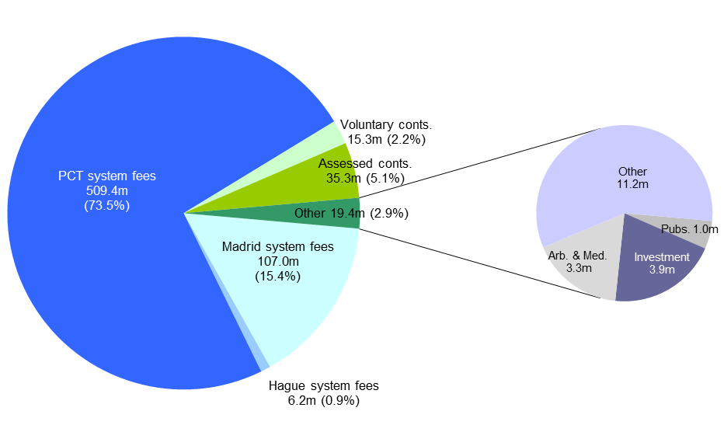

IPSAS adjustments to revenue impact mainly PCT system fees due to increases in deferred revenue, and the deferral of revenue from voluntary contributions.

Detail of IPSAS Basis Revenue 2012/13



**Expenses**

The chart below provides an analysis of expenses for the biennium 2012/13 on an IPSAS basis:

Composition of Expenses 2012/13 on an IPSAS Basis



IPSAS adjustments to expenses are principally the capitalization of construction expenses (note that this impacts several expense categories including construction, operating expenses, personnel expenditure and contractual services) and the charge for depreciation, amortization and impairment.

Detail of IPSAS Basis Expenses 2012/13



**Financial Performance by Segment**

Most revenue is accounted for by Union in WIPO’s accounts. Revenue from interest earnings has been allocated among the Unions based upon total cash reserves and current revenue. Expenses are accounted for by program and then re-allocated to the various Unions based upon a methodology accepted by the WIPO General Assembly as part of the adoption of WIPO’s 2012/13 Program and Budget.

All expenses are allocated among the Unions making up the segments based upon the approved allocation methodology. Expenses for the Special Accounts segment relating to voluntary contributions to the Organization are recorded as actual cost. The only inter-segment charge represents the costs of program support incurred by the Unions in support of Special Accounts. Program support costs are charged to the Special Accounts based on a percentage of total direct expenditure specified in the agreement with the donor making the voluntary contribution.



**STATEMENT OF FINANCIAL POSITION BY SOURCE OF FUNDING**

(in thousands of Swiss francs)

Statement of Financial Position by Source of Funding



**STATEMENT OF FINANCIAL PERFORMANCE BY SOURCE OF FUNDING**

(in thousands of Swiss francs)

Statement of Financial Performance by Source of Funding



# CONTRIBUTIONS AND WORKING CAPITAL FUNDS

## Table 8 and Table 8bis Contributions according to the unitary contribution system

*Basis for determining contributions*

Each Member State’s contribution is determined on the basis of the decisions taken in 2003 by the WIPO Conference and the competent Assemblies of certain Unions administered by WIPO in relation to the unitary contribution system (document A/39/15, paragraphs 166 and 167).

*Determination of contributions*

The amounts of the contributions for the 2012/13 biennium were approved on October 5, 2011, by the Assemblies of the Member States of WIPO and the Unions administered by WIPO (document A/49/18, paragraph 207).













## Table 9 Outstanding contributions as at December 31, 2013, and arrears in contributions of the least developed countries (LDCs) having a special (frozen) account



















## Table 10 Contributions received in advance



## Table 11 Working Capital Funds as at December 31, 2013













*Total of Working Capital Funds*



*Total of outstanding Working Capital Funds*



# DISTRIBUTION MADRID AND HAGUE

## Madrid Union - Supplementary fees – 2012

**Fees collected**

In 2012, WIPO collected 3,240,900 Swiss francs as supplementary fees for registrations and renewals, based on the scale in force since September 1, 2008 [Article 8(2)(b) of the Madrid Agreement and Article 8(2)(ii) of the Protocol Relating to the Madrid Agreement].

**Distribution**

Pursuant to Rule 37 of the Common Regulations under the Madrid Agreement Concerning the International Registration of Marks and the Protocol Relating to that Agreement, the coefficient mentioned in Article 8(5) and (6) of the Agreement and of the Protocol, from which countries party to the Agreement and, as the case may be, the Protocol benefit in respect of the distribution of supplementary and complementary fees, is as follows:

|  |  |
| --- | --- |
| one, | for Contracting Parties undertaking none of the examinations listed below; |
| two, | for Contracting Parties which examine only for absolute grounds of refusal; |
| three, | for Contracting Parties which also examine for prior rights following opposition by third parties; |
| four, | for Contracting Parties which also examine ex officio for prior rights; |
|  | also, for Contracting Parties which carry out ex officio searches for prior rights with an indication of the most significant prior rights. |

The number of designations included in the registrations or renewals for which WIPO collected a supplementary fee of 100 Swiss francs in respect of each class of goods and services over and above the third was as follows, where the coefficient was:

|  |  |  |
| --- | --- | --- |
| one, | 934 | Antigua and Barbuda, Bonaire, Saint Eustatius and Saba[2], Liechtenstein[3] |
| two, | 28 319 | Austria[4], Italy, Liechtenstein[5], Monaco, Saint Martin (Kingdom of the Netherlands) |
| three, | 105 058 | Austria[6], Benelux, Croatia, France, Germany, Latvia, Lesotho, Lithuania, San Marino, Slovenia, Switzerland, The former Yugoslav Republic of Macedonia |
| four, | 221 402 | Albania, Algeria, Armenia, Azerbaijan, Belarus, Bhutan, Bosnia and Herzegovina, Botswana, Bulgaria, China, Cuba, Curaçao1, Cyprus, Czech Republic, Democratic People's Republic of Korea, Egypt, Hungary, Iran (Islamic Republic of), Kazakhstan, Kenya, Kyrgyzstan, Liberia, Madagascar, Mongolia, Montenegro, Morocco, Mozambique, Namibia, Poland, Portugal, Republic of Moldova, Romania, Russian Federation, Sao Tome and Principe, Serbia, Sierra Leone, Slovakia, Spain, Sudan, Swaziland, Syrian Arab Republic, Tajikistan, Ukraine, Viet Nam, Zambia |

The collected amount of 3 240 900 Swiss francs must be divided by 1,258,354 [934 + (28,319 x 2) 56,638 + (105,058 x 3) 315,174 + (221,402 x 4) 885,608]. It follows that the sum due for each mark for which protection has been applied for amounts to 2.57550737 Swiss francs per coefficient point [3,240,900 : 1,258,354] that is, where the coefficient is:

|  |  |
| --- | --- |
| one, | 2.57550737 Swiss francs |
| two, | 5.15101474 Swiss francs |
| three, | 7.72652211 Swiss francs |
| four, | 10.30202948 Swiss francs |



## Madrid Union - Complementary fees - 2012

**Fees collected**

In 2012, WIPO collected 38,083,700 Swiss francs in complementary fees corresponding to 380,837 designations (made on registration, subsequent to registration or on renewal), based on the scale in force since September 1, 2008 [Article 8(2)(c) of the Madrid Agreement and Article 8(2)(iii) of the Protocol Relating to the Madrid Agreement].

**Distribution**

The amounts are distributed in proportion to the number of designations [Article 8(6) of the Madrid Agreement and of the Protocol Relating to the Madrid Agreement] and to a coefficient [Rule 37 of the Common Regulations under the Madrid Agreement Concerning the International Registration of Trademarks and the Protocol Relating to that Agreement].

The number of designations for which WIPO collected 100 Swiss francs as complementary fees was as follows, where the coefficient was:

|  |  |  |
| --- | --- | --- |
| one, | 1 060 | Antigua and Barbuda, Bonaire, Saint Eustatius and Saba1, Liechtenstein2 |
| two, | 29 266 | Austria3, Italy, Liechtenstein4, Monaco, Saint Martin (Kingdom of the Netherlands) |
| three, | 109 080 | Austria5, Benelux, Croatia, France, Germany, Latvia, Lesotho, Lithuania, San Marino, Slovenia, Switzerland, The former Yugoslav Republic of Macedonia |
| four, | 241 431 | Albania, Algeria, Armenia, Azerbaijan, Belarus, Bhutan, Bosnia and Herzegovina, Botswana, Bulgaria, China, Cuba, Curaçao1, Cyprus, Czech Republic, Democratic People's Republic of Korea, Egypt, Hungary, Iran (Islamic Republic of), Kazakhstan, Kenya, Kyrgyzstan, Liberia, Madagascar, Mongolia, Montenegro, Morocco, Mozambique, Namibia, Poland, Portugal, Republic of Moldova, Romania, Russian Federation, Sao Tome and Principe, Serbia, Sierra Leone, Slovakia, Spain, Sudan, Swaziland, Syrian Arab Republic, Tajikistan, Ukraine, Viet Nam, Zambia |

The collected amount of 38,083,700 Swiss francs must be divided by 1,352,556 [1,060 + (29,266 x 2) 58,532 + (109,080 x 3) 327,240 + (241,431 x 4) 965,724]. It follows that the sum due for each designation for which protection has been applied for amounts to 28.15683787 Swiss francs per coefficient point [38,083,700 :1,352,556] that is, where the coefficient is:

|  |  |
| --- | --- |
| one, | 28.15683787 Swiss francs |
| two, | 56.31367574 Swiss francs |
| three, | 84.47051361 Swiss francs |
| four, | 112.62735148 Swiss francs |

1 Until December 29, 2010

2 Until December 31, 2009

3 Until June 30, 2010

4 As from January 1, 2010

5 As from July 1, 2010



Madrid Union – Total of fees - 2012

## Madrid Union - Supplementary fees – 2013

**Fees collected**

In 2013, WIPO collected 2,997,200 Swiss francs as supplementary fees for registrations and renewals, based on the scale in force since September 1, 2008 [Article 8(2)(b) of the Madrid Agreement and Article 8(2)(ii) of the Protocol Relating to the Madrid Agreement].

**Distribution**

Pursuant to Rule 37 of the Common Regulations under the Madrid Agreement Concerning the International Registration of Marks and the Protocol Relating to that Agreement, the coefficient mentioned in Article 8(5) and (6) of the Agreement and of the Protocol, from which countries party to the Agreement and, as the case may be, the Protocol benefit in respect of the distribution of supplementary and complementary fees, is as follows:

|  |  |
| --- | --- |
| one, | for Contracting Parties undertaking none of the examinations listed below; |
| two, | for Contracting Parties which examine only for absolute grounds of refusal; |
| three, | for Contracting Parties which also examine for prior rights following opposition by third parties; |
| four, | for Contracting Parties which also examine ex officio for prior rights; |
|  | also, for Contracting Parties which carry out ex officio searches for prior rights with an indication of the most significant prior rights. |

The number of designations included in the registrations or renewals for which WIPO collected a supplementary fee of 100 Swiss francs in respect of each class of goods and services over and above the third was as follows, where the coefficient was:

|  |  |  |
| --- | --- | --- |
| one, | 1 013 | Antigua and Barbuda |
| two, | 27 849 | Italy, Liechtenstein, Monaco, Saint Martin (Kingdom of the Netherlands) |
| three, | 105 208 | Austria, Benelux, Croatia, France, Germany, Latvia, Lesotho, Lithuania, San Marino, Slovenia, Switzerland, the former Yugoslav Republic of Macedonia |
| four, | 231 717 | Albania, Algeria, Armenia, Azerbaijan, Belarus, Bhutan, Bosnia and Herzegovina, Botswana, Bulgaria, China, Cuba, Cyprus, Czech Republic, Democratic People's Republic of Korea, Egypt, Hungary, Iran (Islamic Republic of), Kazakhstan, Kenya, Kyrgyzstan, Liberia, Madagascar, Mongolia, Montenegro, Morocco, Mozambique, Namibia, Poland, Portugal, Republic of Moldova, Romania, Russian Federation, Rwanda6, Sao Tome and Principe, Serbia, Sierra Leone, Slovakia, Spain, Sudan, Swaziland, Syrian Arab Republic, Tajikistan, Ukraine, Viet Nam, Zambia |

The collected amount of 2,997,200 Swiss francs must be divided by 1,299,203 [1,013 + (27,849 x 2) 55,698 + (105,208 x 3) 315,624 + (231,717 x 4) 926,868]. It follows that the sum due for each mark for which protection has been applied for amounts to 2,30695280 Swiss francs per coefficient point

[2,997,200 : 1,299,203] that is, where the coefficient is:

|  |  |
| --- | --- |
| one, | 2.30695280 Swiss francs |
| two, | 4.61390560 Swiss francs |
| three, | 6.92085840 Swiss francs |
| four, | 9.22781120 Swiss francs |

6As from August 17, 2013



## Madrid Union – Complementary fees – 2013

**Fees collected**

In 2013, WIPO collected 38,841,700 Swiss francs in complementary fees corresponding to 388,417 designations (made on registration, subsequent to registration or on renewal), based on the scale in force since September 1, 2008 [Article 8(2)(c) of the Madrid Agreement and Article 8(2)(iii) of the Protocol Relating to the Madrid Agreement].

**Distribution**

The amounts are distributed in proportion to the number of designations [Article 8(6) of the Madrid Agreement and of the Protocol Relating to the Madrid Agreement] and to a coefficient [Rule 37 of the Common Regulations under the Madrid Agreement Concerning the International Registration of Trademarks and the Protocol Relating to that Agreement].

The number of designations for which WIPO collected 100 Swiss francs as complementary fees was as follows, where the coefficient was:

|  |  |  |
| --- | --- | --- |
| one, | 1 140 | Antigua and Barbuda |
| two, | 28 727 | Italy, Liechtenstein, Monaco, Saint Martin (Kingdom of the Netherlands) |
| three, | 108 708 | Austria, Benelux, Croatia, France, Germany, Latvia, Lesotho, Lithuania, San Marino, Slovenia, Switzerland, the former Yugoslav Republic of Macedonia |
| four, | 249 842 | Albania, Algeria, Armenia, Azerbaijan, Belarus, Bhutan, Bosnia and Herzegovina, Botswana, Bulgaria, China, Cuba, Cyprus, Czech Republic, Democratic People's Republic of Korea, Egypt, Hungary, Iran (Islamic Republic of), Kazakhstan, Kenya, Kyrgyzstan, Liberia, Madagascar, Mongolia, Montenegro, Morocco, Mozambique, Namibia, Poland, Portugal, Republic of Moldova, Romania, Russian Federation, Rwanda6, Sao Tome and Principe, Serbia, Sierra Leone, Slovakia, Spain, Sudan, Swaziland, Syrian Arab Republic, Tajikistan, Ukraine, Viet Nam, Zambia |

The collected amount of 38,841,700 Swiss francs must be divided by 1,384,086  
[1,140 + (28,727 x 2) 57,454 + (108,708 x 3) 326,124 + (249,842 x 4) 999,368). It follows that the sum due for each designation for which protection has been applied for amounts to 28.06306834 Swiss francs per coefficient point [38,841,700 : 1,384,086] that is, where the coefficient is:

|  |  |
| --- | --- |
| one, | 28.06306834 ch francs |
| two, | 56.12613668 Swiss francs |
| three, | 84.18920502 Swiss francs |
| four, | 112.25227336 Swiss francs |

6 As from August 17, 2013



## Madrid Union – Total of fees 2013



## Protocol Relating to the Madrid Agreement – Individual fees – 2012

**Fees collected**

In 2012, WIPO collected 114,655,623 Swiss francs in individual fees under Article 8(7) of the Protocol Relating to the Madrid Agreement, of which 106,916,028 in the form of whole payments or for the first part of the individual fee, and 7,739,595 in the form of second payments for designations, as per Rule 34(3)(a).

(A) The number of designations for which WIPO collected individual fees, in the form of whole payments or first part payments, was as follows:



(B) The number of designations for which WIPO collected a second payment was as follows:



**Distribution**

The individual fees were credited to the Contracting Parties' accounts with the International Bureau within the month following that of the recordal of the international registration, the subsequent designation or renewal for which the fee had been paid [Rule 38 of the Common Regulations].

7 As from August 29, 2012

8 As from December 10, 2012

9 As from July 25, 2012

## Protocol Relating to the Madrid Agreement – Individual fees – 2013

**Fees collected**

In 2013, WIPO collected 130,543,348 Swiss francs in individual fees under Article 8(7) of the Protocol Relating to the Madrid Agreement, of which 122,012,496 in the form of whole payments or for the first part of the individual fee, and 8,530,852 in the form of second payments for designations, as per Rule 34(3)(a).

(A) The number of designations for which WIPO collected individual fees, in the form of whole payments or first part payments, was as follows:



(B) The number of designations for which WIPO collected a second payment was as follows:



**Distribution**

The individual fees were credited to the Contracting Parties' accounts with the International Bureau within the month following that of the recordal of the international registration, the subsequent designation or renewal for which the fee had been paid [Rule 38 of the Common Regulations].

10 As from July 8, 2013

11 As from February 19, 2013

12 As from October 16, 2013

## Madrid Union – National handling fees - 2013

**Fees collected**

In 2013, WIPO collected 4 700 Swiss francs in national handling fees, as established by the Office(s) concerned, for the international registration demands sent during the course of the year through IRPI, the new means of electronic communication between the Contracting Parties of the Madrid Agreement and/or the Protocol relating to the Madrid Agreement and the International Bureau, operational as from December 2013.

The number of the international registration demands for which WIPO collected a national handling fee was as follows:

|  |  |  |
| --- | --- | --- |
|  | Number of international registration’s demands | National fees collected; Swiss francs |
| Benelux * | 47 | 4 700 |

The national handling fees were credited to the Contracting Party’s account with the International Bureau during the month following that of the receipt of the international registration demand.

*As from December 4, 2013

## Madrid Union – Payment made in accordance with Rule 39 of the Common Regulations under the Madrid Agreement and Protocol

Rule 39 of the Common Regulations under the Madrid Agreement Concerning the International Registration of Marks and the Protocol Relating to that Agreement (adopted by the Madrid Union Assembly with effect as of April 1, 1996) allows the continuation of the effects of international registrations in certain States (hereinafter “successor States”) that have become independent and whose territory formed part, prior to their independence, of the territory of a country party to the Madrid Agreement. The payment made to the International Bureau for each continuation of effects consists of a fee of 41 Swiss francs, transferred by the International Bureau to the national Office of the successor State, and a fee of 23 Swiss francs paid to the International Bureau.

(A) In 2012, the total number of continuations of effects recorded was 22, for which the International Bureau received the sum of (22 x 23 =) 506 francs and the National Office of the following successor State the sum of (22 x 41 =) 902 francs, which was transferred to the Office as follows:



(B) In 2013, the International Bureau did not receive any continuation of effects.

## Hague Union – State and designation fees – 2012

**Fees collected**

In 2012, WIPO collected 2,394,931 Swiss francs in standard designation fees under Rules 12.1(a)(ii) and 12.1(b) or in individual designation fees, for international registrations governed exclusively by or partially by the 1960 Act or the 1999 Act, pursuant to Rule 12.1(a)(iii) or, for their renewal, in standard designation fees, pursuant to Rule 24.1(a)(ii) or in individual designation fees, under Rule 24.1(a)(iii) of the Common Regulations under the Hague Agreement, according to the scale in force since January 1, 2010.



13 As from March 21, 2012

14 As from June 13, 2012

## Hague Union – State and designation fees – 2013

**Fees collected**

In 2013, WIPO collected 2,569,667 Swiss francs in standard designation fees under Rules 12.1(a)(ii) and 12.1(b) or in individual designation fees, for international registrations governed exclusively by or partially by the 1960 Act or the 1999 Act, pursuant to Rule 12.1(a)(iii) or, for their renewal, in standard designation fees, pursuant to Rule 24.1(a)(ii) or in individual designation fees, under Rule 24.1(a)(iii) of the Common Regulations under the Hague Agreement, according to the scale in force since January 1, 2010.



15 As from December 24, 2013

## Madrid and Hague Unions – Distribution 2012

(amounts expressed in Swiss francs)

- International marks registration service (Madrid): supplementary and complementary fees, continuations of effect

- International industrial designs registration service (Hague): State fees and designation fees



## Madrid and Hague Unions - Distribution 2013

(amounts expressed in Swiss francs)

- International marks registration service (Madrid): supplementary and complementary fees, handling fees

- International industrial designs registration service (Hague): State fees and designation fees



## Madrid and Hague Unions - Recapitulation 2012-2013

(amounts expressed in Swiss francs)



# TRUST FUNDS

**Trust funds as at December 31, 2013**



**Trust funds as at December 31, 2013**

(expressed in Swiss francs)



Note: Trust fund in the form of voluntary contributions (from the Australian, French, Norwegian, South African, Swedish and Swiss Governments, the Christensen Fund and New Zealand) aimed at facilitating the participation of the representatives of accredited indigenous and local communities in the work of the Intergovernmental Committee on Intellectual Property and Genetic Resources, Traditional Knowledge and Folklore.



Note: Trust fund in the form of a cooperation agreement between the Government of Australia and WIPO to promote the further development of intellectual property systems in least developed countries (LDCs) and developing countries.



Note: Trust fund in the form of a technical cooperation agreement between the Government of Brazil and WIPO for the implementation of training and capacity-building of the technical staff of the National Institute of Industrial Property (INPI) and the dissemination of the intellectual property culture in Brazil.

The accounts and financial reports for this trust fund were kept in US dollars. As a consequence, foreign exchange differences have been incurred and these have been absorbed by WIPO.



Note: Trust fund in the form of a technical cooperation agreement between the Government of Brazil and WIPO for the dissemination of the intellectual property culture and the incorporation of best practices.



Note: Trust fund in the form of a technical cooperation agreement between the Government of Brazil and WIPO for the implementation of initiatives for South-South Technical Cooperation, to increase the capacity of developing countries in the use of intellectual property tools.



Note: Trust fund in the form of a technical cooperation agreement between the Government of Costa Rica and WIPO for the modernization of the patents and marks systems of the National Intellectual Property Office. The accounts and financial reports for this trust fund are kept in US dollars.



Note: Trust fund in the form of a cooperation agreement between the Government of El Salvador and WIPO for the modernization and strengthening of the national industrial property system. The accounts and financial reports for this trust fund are kept in US dollars.



Note: Trust fund in the form of an agreement between the European Community (EC) and WIPO intended for the modernization of the intellectual property system in Bangladesh.

The accounts and financial reports for this trust fund were kept in euros. As a consequence, foreign exchange differences have been incurred and these have been absorbed by WIPO.



Note: Trust fund in the form of an agreement between the European Community (EC) and WIPO intended for the modernization of the intellectual property system in Pakistan.

The accounts and financial reports for this trust fund are kept in euros.



Note: Trust fund in the form of a cooperation agreement between the Finnish Copyright Society and WIPO in the field of activities of its culture and creative industries sector.

The accounts and financial reports for this trust fund are kept in euros.



Note: Trust fund in the form of a cooperation agreement between the Finnish Ministry of Education and Culture and WIPO in the field of activities of its culture and creative industries sector. The accounts and financial reports for this trust fund are kept in euros.



Note: Trust fund in the form of a cooperation agreement between the Finnish Ministry of Education and Culture and WIPO in the field of activities of its copyright and related rights sector. The accounts and financial reports for this trust fund are kept in euros.



Note: Trust fund in the form of a voluntary contribution from the Government of France intended for the WIPO program of cooperation for development in the field of copyright training.



Note: Trust fund in the form of a voluntary contribution from the Government of France intended for the WIPO program of cooperation for development in the field of industrial property (Paris Union).



Note: Trust fund in the form of a voluntary contribution from the Government of Germany to provide WIPO with junior professional officers.



Note: Trust fund in the form of a technical cooperation agreement between the Technical Secretariat of the Ibero-American Program on Industrial Property and Promotion of Development and WIPO for the modernization and strengthening of the national industrial property systems in various Ibero-American countries.



Note: Trust fund in the form of a cooperation agreement between the Government of Italy and WIPO in the field of intellectual property promotion and the fight against counterfeiting and multimedia piracy.



Note: Trust fund in the form of a voluntary contribution from the Government of Italy to provide WIPO with a junior professional officer.



Note: Trust fund in the form of a voluntary contribution from the Government of Japan intended for the WIPO program of cooperation for development in the field of industrial property for Africa and the Least Developed Countries (LDCs).



Note: Trust fund in the form of a voluntary contribution from the Government of Japan intended for the WIPO program of cooperation for development in the field of copyright and related rights.



Note: Trust fund in the form of a voluntary contribution from the Government of Japan intended for the WIPO program of cooperation for development in the field of industrial property.



Note: Trust fund in the form of a voluntary contribution from the Government of Japan to provide WIPO with a junior professional officer.



Note: Trust fund in the form of a cooperation agreement between the Government of Libya and WIPO for the modernization and strengthening of the national industrial property system.



Note: Trust fund in the form of a cooperation agreement between the Government of Mexico and WIPO for the development and strengthening of the national industrial property system.



Note: Trust fund in the form of an agreement between the National Institute of Industrial Property of Portugal and WIPO intended for the development of joint cooperation activities for the benefit of Portuguese speaking countries. The accounts and financial reports for this trust fund are kept in euros.



Note: Trust fund in the form of a voluntary contribution from the Government of the Republic of Korea intended for the WIPO program of cooperation for development in the field of copyright and related rights.



Note: Trust fund in the form of a voluntary contribution from the Government of the Republic of Korea to provide WIPO with a professional officer to administer the Trust Fund/Republic of Korea/Copyright.



Note: Trust fund in the form of an agreement between the Korean Intellectual Property Office (KIPO) and WIPO, intended for the WIPO program of cooperation for development in the field of industrial property in developing countries and the least developed countries.



Note: Trust fund in the form of a voluntary contribution from the Government of the Republic of Korea to provide WIPO with professional officers.



Note: Trust fund in the form of an agreement between the Korean Intellectual Property Office (KIPO) and WIPO, intended for intellectual property education.



Note: Trust Fund in the form of a voluntary contribution from the Government of Spain intended for the WIPO program of cooperation for development in the field of industrial property in Latin American countries. The accounts and financial reports for this trust fund were kept in Euros. As a consequence, foreign exchange differences have been incurred and these have been absorbed by WIPO.



Note: Trust Fund in the form of a voluntary contribution from the Government of Spain intended for the WIPO program of cooperation for development in the field of industrial property in Latin American countries.



Note: Trust fund in the form of voluntary contributions from the private sector and public interest organizations, aimed at facilitating the access to copyrighted works by the visually impaired and persons with print disabilities.



Note: Trust fund in the form of a cooperation agreement between the United States Patent and Trademark Office (USPTO) and WIPO in the field of copyright in developing countries.

The accounts and financial reports for this trust fund are kept in US dollars.



Note: Trust fund in the form of a cooperation agreement between the United States Patent and Trademark Office (USPTO) and WIPO in the field of enforcement of intellectual property rights.

The accounts and financial reports for this trust fund are kept in US dollars.



Note: Trust fund in the form of a cooperation agreement between the United States Patent and Trademark Office (USPTO) and WIPO for services relating to the intellectual property needs of small and medium-sized enterprises.

The accounts and financial reports for this trust fund are kept in US dollars.



Note: Trust fund in the form of a technical cooperation agreement between the Government of Uruguay and WIPO for the development of the national intellectual property system.

The accounts and financial reports for this trust fund were kept in US dollars. As a consequence, foreign exchange differences have been incurred and these have been absorbed by WIPO.



Note: Trust fund in the form of a technical cooperation agreement between the Government of Uruguay and WIPO for the development of the national intellectual property system.

[End of document]

1. * Paris Union (128th and 129th years), Berne Union (125th and 126th years), Madrid Union (121st and 122nd years), The Hague Union (87th and 88th years), Nice Union (55th and 56th years), Lisbon Union (54th and 55th years), WIPO (43rd and 44th years), Locarno Union (42nd and 43rd years), IPC Union (38th and 39th years), PCT Union (35th and 36th years), TRT Union (33rd and 34th years), Vienna Union (27th and 28th years).
2. Until December 29, 2010
3. Until December 31, 2009
4. Until June 30, 2010
5. As from January 1, 2010
6. As from July 1, 2010