|  |  |  |
| --- | --- | --- |
|  | WIPO-E | **E** |
| WO/PBC/25/6 | | |
| ORIGINAL: ENGLISH | | |
| DATE: June 10, 2016 | | |

**Program and Budget Committee**

**Twenty-Fifth Session**

**Geneva, August 29 to September 2, 2016**

Progress Report on THE IMPLEMENTATION OF THE JOINT INSPECTION UNIT’S (JIU) RECOMMENDATIONS

*prepared by the Secretariat*

1. This document provides an overview of the status of implementation of outstanding recommendations addressed to the WIPO legislative bodies, resulting from the reviews of the Joint Inspection Unit (JIU) during the period 2010 to 2015 including the JIU’s Review of Management and Administration in WIPO (MAR).
2. Annex I to the present document contains recommendations addressed to the legislative bodies of United Nations system organizations, where these recommendations are marked for action by WIPO. The current status of acceptance/implementation of recommendations reflects the Secretariat’s proposals and assessments, where these were possible to provide, for consideration by Member States.
3. Since the last report submitted to Member States (WO/PBC/24/7) on the same subject, the JIU issued five reports, of which three were relevant to WIPO. New reports have been signaled as such, with the status updates from reports issued in prior years highlighting the change from the previous reporting period.
4. As of the end of April 2016, subject to the endorsement of Member States in respect of recommendations contained in the present report, there will be five recommendations addressed to WIPO’s legislative bodies, which will remain outstanding, all other recommendations having been closed (implemented, considered not relevant to WIPO, or not accepted).

**Chart 1. All JIU Recommendations Relevant to WIPO from Reports 2010-2015**

**Status as at end April 2016**

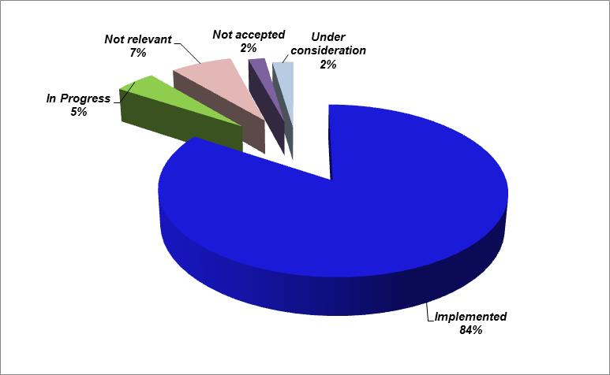

**Chart 2. Number of All JIU Recommendations Relevant to WIPO 2010-2015**

**as at end April 2016[1]**

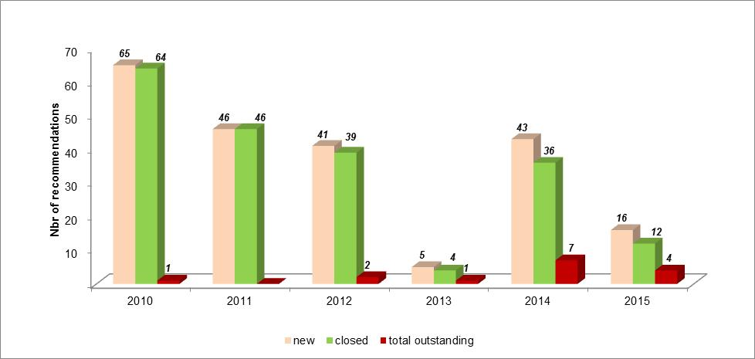

**Chart 3. JIU Recommendations Addressed to Legislative Bodies 2010-2015**

**As at end April 2016**

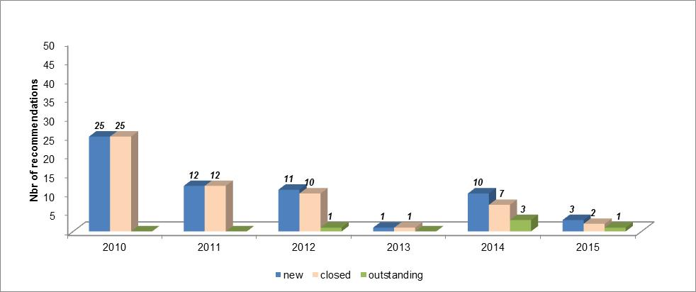

1. In 2015, the JIU has initiated a series of reviews within the context of a system-wide review of the acceptance and implementation of JIU recommendations, resulting in organization-specific Management Letters (ML), which have now been issued for several organizations[2]. In response to the recommendations contained in the ML addressed to WIPO, which was issued in early 2016, certain changes have been made to the contents of the present report. These changes relate to the following:
   1. In order to contribute to further facilitating the review of JIU Reports by Member States, hyperlinks to JIU reports relevant for WIPO have been added to the report titles in the document for ease of reference and navigation. Annex II has been added to provide a complete and comprehensive list of all active[3] JIU reports in a summary view for Member States’ information; and
   2. Annex II includes hyperlinks to the comments of Executive Heads on JIU reports and recommendations collated by the Chief Executives’ Board (CEB), which are presented to the UN General Assembly. WIPO addresses its comments to its Member States through the present report, and not the CEB document, so the latter is provided for Member States’ information only.
2. The layout of the table in Annex I has also been enhanced to facilitate review.
3. Within the context of the dialogue with the JIU on the subject of the ML, WIPO has proposed a number of changes to the process of formulating, reporting and disseminating JIU recommendations with a view to improving and streamlining the process further. These will continue to be discussed with the JIU over the coming months.
4. The following decision paragraph is proposed.
5. *The Program and Budget Committee (PBC):*

*(i) took note of the present report (document WO/PBC/25/6);*

*(ii) welcomed and endorsed the Secretariat’s assessment of the status of the implementation of recommendations under*

*JIU/REP/2015/5 (Recommendation 2); JIU/REP/2015/4 (Recommendation 1); JIU/REP/2014/9 (Recommendation 1); JIU/REP/2012/12 (Recommendation 4); JIU/REP/2011/3 (Recommendations 3 and 9);*

*JIU/REP/2010/7 (Recommendation 7); JIU/REP/2010/3 (Recommendation 17)*

*as set out in the present report; and*

*(iii) called on the Secretariat to propose assessments for the open recommendations made by the Joint Inspection Unit (JIU) for Member States’ consideration.*

[Annexes follow]

**JIU RECOMMENDATIONS ADDRESSED TO THE LEGISLATIVE BODIES OF JIU PARTICIPATING ORGANIZATIONS – STATUS AS AT END APRIL 2016**

I. RECOMMENDATIONS FROM JIU REVIEWS HELD IN 2015

**JIU/REP/2015/6** “Review of the organizational ombudsman services across the United Nations system” [](https://www.unjiu.org/en/reports-notes/JIU%20Products/JIU_REP_2015_6_English.pdf)

This report was issued by the JIU on January 13, 2016. All recommendations are therefore new within the context of this report to Member States.

|  |  |
| --- | --- |
| **Recommendation 5**  D:\Users\doyon\AppData\Local\Microsoft\Windows\Temporary Internet Files\Content.IE5\RNX63FW3\new[1].png | The legislative bodies of the United Nations system organizations should make it possible for the ombudsman to report to them on systemic issues identified on a regular basis. |
| **Management/Focal Point Assessment** | The Ombudsman currently prepares and submits the annual report to the Director General. |
|  |  |
| **Acceptance** | Accepted |
| **Implementation** | Not started |
|  |  |
| **Responsible Officer** | Ombudsman |

**JIU/REP/2015/5** “Review of Activities and Resources devoted to address Climate Change in the United Nations system organizations” [](https://www.unjiu.org/en/reports-notes/JIU%20Products/JIU_REP_2015_5_English.pdf)

This report was issued by the JIU on September 25, 2015. All recommendations are therefore new within the context of this report to Member States.

|  |  |
| --- | --- |
| **Recommendation 2**  D:\Users\doyon\AppData\Local\Microsoft\Windows\Temporary Internet Files\Content.IE5\RNX63FW3\new[1].png | The governing bodies of the United Nations system organizations should support and endorse the participation of their respective organizations involved in cross-cutting areas directly or indirectly related to climate change in a system-wide United Nations strategy to combat climate change, in a manner consistent with the outcome of the twenty-first session of the Conference of the Parties to UNFCCC (COP21). |
| **Management/Focal Point Assessment** | WIPO’s Biennial Program and Budget includes an explicit Expected Result on ensuring an “environmentally and socially responsible Organization in which WIPO staff, delegates, visitors and information and physical assets are safe and secure”, which is fully supported and endorsed by Member States. |
|  |  |
| **Acceptance** | Accepted |
| **Implementation** | Implemented |
|  |  |
| **Responsible Officer** | Director, Premises Infrastructure Division (PID) |

**JIU/REP/2015/4** “Public information and communications policies and practices in the United Nations system” [](https://www.unjiu.org/en/reports-notes/JIU%20Products/JIU_REP_2015_4_English.pdf)

This report was issued by the JIU on August 12, 2015. All recommendations are therefore new within the context of this report to Member States.

|  |  |
| --- | --- |
| **Recommendation 1**  D:\Users\doyon\AppData\Local\Microsoft\Windows\Temporary Internet Files\Content.IE5\RNX63FW3\new[1].png | The legislative/governing bodies of the United Nations system organizations should request the executive heads to embrace the nine benchmarks proposed in the present report, in order to enhance the strategic role of the public information and communications function in contributing to the achievement of organizational goals and priorities, thereby promoting global support for their organization. |
| **Management/Focal Point Assessment** | The Member States of WIPO provide detailed substantive input to the Secretariat on the communications function in Program and Budget and Program Performance discussions. The Organization-wide approach to communications includes adherence to the benchmarks proposed in the report. |
| **Acceptance** | Accepted |
| **Implementation** | Implemented |
|  |  |
| **Responsible Officer** | Director, Communications Division |

II. RECOMMENDATIONS FROM JIU REVIEWS HELD IN 2014

**JIU/REP/2014/9** “Contract Management and Administration in the United Nations system” [](https://www.unjiu.org/en/reports-notes/JIU%20Products/JIU_REP_2014_9_English.pdf)

|  |  |
| --- | --- |
| **Recommendation 1** | The legislative bodies of the United Nations system organizations should direct the executive heads of their organizations to update and, when necessary, develop specific policies, procedures, guidance and follow-up systems to ensure effective and efficient management of post-award contract activities. |
| **Management/Focal Point Assessment** | As of 2016, strategic suppliers are required to be met twice a year and a vendor performance review is undertaken at this time on the basis of agreed KPIs. The contract database enabling the storage and the follow up of such performance reviews was put in place in 2015 already. A legal contract manager has been engaged and part of the role is to follow up on all the vendor performance processes for the above mentioned contracts. The HLCM Procurement Network has approved that work should be undertaken jointly to have common guidance and procedures on vendor performance. WIPO’s Procurement manual will be modified subsequent to the issuance of the harmonized procedure, but a WIPO procedure is already in place. |
|  | *Previously “in progress”* |
| **Acceptance** | Accepted |
| **Implementation** | Implemented |
|  |  |
| **Responsible Officer** | Director, Procurement and Travel Division (PTD) |

|  |  |
| --- | --- |
| **Recommendation 3** | The legislative bodies of the United Nations system organizations should direct the executive heads of their organizations to put in place a system whereby the persons designated to manage contracts after award are notified in writing about their accountability and responsibilities when managing a contract, and possess the required qualifications to manage the contract. |
| **Management/Focal Point Assessment** | WIPO has built the necessary database to do this, and has the technical tool to manage the notification. |
|  | *Previously “under consideration”* |
| **Acceptance** | Accepted |
| **Implementation** | In progress |
|  |  |
| **Responsible Officer** | Director, PTD |

**JIU/2014/2** “Review of Management and Administration in the World Intellectual Property Organization (WIPO)”[](https://www.unjiu.org/en/reports-notes/JIU%20Products/JIU_REP_2014_2_%20English.pdf)

|  |  |
| --- | --- |
| **Recommendation 1** | The WIPO General Assembly should review the WIPO governance framework as well as current practices with a view to strengthen the capacity of the governing bodies to guide and monitor the work of the organization. In doing so, Member States may wish to consider in their deliberations the options suggested in this report. |
| **Management/Focal Point Assessment** | At its 24th session, the Program and Budget Committee (PBC), recognizing the need to address the issue of governance, in accordance with the request of the 54th Assemblies of the Member States of WIPO:  “(i) engaged in active discussions on this subject at both its 23rd and 24th sessions. These resulted in the proposals made during the 23rd session, as reflected in Annexes I and II of document WO/PBC/23/9, and in the Chair’s document circulated during the 24th session (attached as Annex I to the present document (WO/PBC/24/17)). While divergences in the views of delegations remained, delegations expressed willingness to continue discussions on this subject;  (ii) agreed that discussions continue on the subject of governance at WIPO during the PBC’s 25th session in light of recommendation 1 of the JIU’s Review of Management and Administration in the World Intellectual Property Organization (MAR) (document JIU/REP/2014/2); and  (iii) agreed that Member States would provide proposals for specific topics for discussion in good time prior to the 25th session, and no later than July 1, 2016, and requested the Secretariat to compile these as part of the documentation for that session.” (WIPO/PBC/24/17) |
|  | *Previously “under consideration”* |
| **Acceptance** | Accepted |
| **Implementation** | In progress |
|  |  |
| **Responsible Officer** | Assistant Director General, Administration and Management Sector (A&M) and Chief of Staff |

|  |  |
| --- | --- |
| **Recommendation 6** | The Coordination Committee should revisit the present principles concerning geographical distribution in order to ensure broader geographical diversity within the WIPO professional workforce. |
| **Management/Focal Point Assessment** | At its annual meeting on October 12, 2015, the Coordination Committee “noted that consultations shall take place under the guidance of the Chair of the WIPO Coordination Committee, to review the 1975 Principles on Geographical Representation, with a view of presenting a proposal to the Coordination Committee during the 2016 Assemblies of the Member States.” ([See WO/CC/71/7 PROV., page 13). To launch this process, the Chair held a first consultation meeting with Regional Coordinators on January 28, 2016. For that meeting, a set of proposed discussion topics together with related information was prepared by the Secretariat upon the request of the Chair. A follow up meeting took place on March 4, 2016, and a third meeting is planned for May. |
|  | *No change from previous status*  *Assessment has been updated* |
| **Acceptance** | Under consideration |
| **Implementation** |  |
|  |  |
| **Responsible Officer** | Director, Human Resources Management Department (HRMD) |

III. RECOMMENDATIONS FROM JIU REVIEWS HELD IN 2012

**JIU/REP/2012/12** “Strategic planning in the United Nations system” [](https://www.unjiu.org/en/reports-notes/JIU%20Products/JIU_REP_2012_12_English.pdf)

|  |  |
| --- | --- |
| **Recommendation 4** | The legislative bodies of the United Nations system organizations should formulate and define relevant system-wide sectorial strategic frameworks through the Economic and Social Council to address the long‑term goals established by the 2005 World Summit Outcome, adopted by the General Assembly in resolution 60/1, as well as those established by the missions and mandates of the system organizations as a result of global conferences. |
| **Management/Focal Point Assessment** | System-wide common goals are enshrined in the 2030 Development Agenda i.e. the 17 SDG’s, which provide the framework for the preparation of strategic plans across the UN system. |
|  | *Previously “under consideration”* |
| **Acceptance** | Accepted |
| **Implementation** | Implemented |
|  |  |
| **Responsible Officer** | Director, Program Planning and Finance (Controller) |

**JIU/REP/2012/9** “Lump-sum payments in lieu of entitlements” [](https://www.unjiu.org/en/reports-notes/JIU%20Products/JIU_REP_2012_9_English.pdf)

|  |  |
| --- | --- |
| **Recommendation 3** | The legislative/governing bodies of United Nations system organizations should request their respective executive heads to suspend, if not already the case, the payment of additional DSA (15 or 40 per cent), to those officials travelling on organizational budgets. |
| **Management/Focal Point Assessment** | In order to arrive at a coherent overall travel policy, this recommendation will be considered in the light of the results of the ongoing JIU review of travel policies in the United Nations system. |
|  | *No change from previous status*  *Assessment has been updated* |
| **Acceptance** | Under consideration |
| **Implementation** |  |
|  |  |
| **Responsible Officer** | Director, PTD |

IV. RECOMMENDATIONS FROM JIU REVIEWS HELD IN 2011

**JIU/REP/2011/3** “South-South and Triangular Cooperation in the United Nations system” [](https://www.unjiu.org/en/reports-notes/JIU%20Products/JIU_REP_2011_3_English.pdf)

|  |  |
| --- | --- |
| **Recommendation 3** | The legislative bodies of United Nations system organizations should request the Executive Heads to establish identifiable and dedicated structures, mechanisms and focal points tasked with developing agency-specific corporate policy and support strategy, and ensure coordination on South-South and triangular cooperation within their respective organizations and inter-agencies, through the reallocation of the necessary staff and resources for this purpose, as appropriate. |
| **Management/Focal Point Assessment** | WIPO has established a dedicated unit serving as a focal point within the Development Sector for facilitating South-South cooperation among developing countries. The Section ensures a coherent planning of and reporting on South-South activities at the organizational level and interfaces with all relevant internal and external stakeholders. |
|  | *Previously “under consideration”* |
| **Acceptance** | Accepted |
| **Implementation** | Implemented |
|  |  |
| **Responsible Officer** | Deputy Director General, Development Sector (DS) |

|  |  |
| --- | --- |
| **Recommendation 9** | The legislative and governing bodies of the United Nations system organizations should request the Executive Heads to apportion a specific percentage – not less than 0.5 per cent – of core budget resources for the promotion of South-South cooperation (SSC) in their respective areas of competence, in consultation with programme countries; and to agree with donor countries to use a specific portion of extrabudgetary resources to finance SSC and triangular cooperation initiatives. |
| **Management/Focal Point Assessment** | a) The regular budget resources for the promotion of South-South cooperation are reflected in the costs of the unit referred to under Recommendation 3.  b) For the 2014/15 biennium, a mapping exercise of South-South cooperation activities was undertaken at the request of WIPO Member States (document CDIP/17/4). The total non-personnel cost of the identified South-South activities amounted to 1,5% of the total non-personnel costs in the 2014/15 biennium. |
|  | *Previously “under consideration”* |
| **Acceptance** | Accepted |
| **Implementation** | Implemented |
|  |  |
| **Responsible Officer** | Deputy Director General, DS |

V. RECOMMENDATIONS FROM JIU REVIEWS HELD IN 2010

**JIU/REP/2010/7** “Policies and Procedures for the Administration of Trust Funds in the United Nations System Organizations” [](https://www.unjiu.org/en/reports-notes/archive/Policies%20and%20procedures%20for%20the%20administration%20of%20trust%20funds%20in%20the%20United%20Nations%20system%20organizations.pdf)

|  |  |
| --- | --- |
| **Recommendation 7** | The legislative bodies of the United Nations system organizations should review the harmonized cost recovery policies and principles for trust funds and activities financed by other extrabudgetary resources, once they have been agreed within the CEB, with a view to updating the cost recovery policies of their organizations accordingly. |
| **Management/Focal Point Assessment** | Harmonization of cost recovery policies continues to be under discussion in the UN Finance and Budget Network. However, the WIPO Policy on the Management of Voluntary Contributions was published on December 16, 2015. This policy summarizes the critical policy elements guiding the acceptance and management of voluntary contributions, and defines the roles, responsibilities, and key procedures for the same, and includes guidance on cost recovery. |
|  | *Previously “under consideration”* |
| **Acceptance** | Accepted |
| **Implementation** | Implemented |
|  |  |
| **Responsible Officer** | Director, PPF (Controller) |

**JIU/REP/2010/3** “Ethics in the United Nations System” [](https://www.unjiu.org/en/reports-notes/archive/Ethics%20in%20the%20United%20Nations%20system.pdf)

|  |  |
| --- | --- |
| **Recommendation 17** | The legislative bodies should direct their respective executive heads to put forward proposals for an internal mechanism to be established that would set out the modalities for the ethics office and/or the internal oversight service to investigate or undertake reviews of allegations brought against the executive head of the organization, including reporting the outcome of the investigation or review directly to the respective legislative body. |
| **Management/Focal Point Assessment** | Paragraph 21 of the WIPO Internal Oversight Charter provides: “Allegations of misconduct against the Director General shall be reported by the Director, IOD to the Chair of the General Assembly with a copy to the Chairs of the Coordination Committee and the IAOC. The Director, IOD shall seek the advice of the IAOC on how to proceed further.”  WIPO Finance Regulations and Rules, Annex III “Terms of Reference of the WIPO Independent Advisory Oversight Committee”, paragraph 2 (e) (ii) provides: In accordance with the Internal Oversight Charter, the IAOC shall provide advice to the Director IOD, on how to proceed in cases of allegations of misconduct against the Director General (DG). If the Director IOD, on grounds of conflict of interest, is unable to evaluate or investigate, the IAOC shall review the allegations and provide advice to the Chair of the General Assembly with a copy to the Chair of the Coordination Committee on how to proceed.” |
|  | *Previously “under consideration”* |
| **Acceptance** | Accepted |
| **Implementation** | Implemented |
|  |  |
| **Responsible Officer** | Director, Internal Oversight Division (IOD) |

[Annex II follows]

**LIST OF ACTIVE[4] JIU REPORTS RELEVANT TO WIPO AS AT END APRIL 2016**

This annex serves to provide links to active JIU reports relevant to WIPO. All JIU reports, notes and management letters may be accessed/are available through the JIU’s website. [](https://www.unjiu.org/en/reports-notes/Pages/default.aspx)

| **REFERENCE** | **LINK TO JIU REPORT** | **COMMENTS** | **OTHER DOCUMENTS** |
| --- | --- | --- | --- |
| JIU/REP/2015/6 | [Review of the organizational ombudsman services across the United Nations System](https://www.unjiu.org/en/reports-notes/JIU%20Products/JIU_REP_2015_6_English.pdf) |  |  |
| JIU/REP/2015/5 | [Review of Activities and Resources Devoted to Address Climate Change in the United Nations System Organizations](https://www.unjiu.org/en/reports-notes/JIU%20Products/JIU_REP_2015_5_English.pdf) |  |  |
| JIU/REP/2015/4 | [Public Information and Communications Policies and Practices in the United Nations System](https://www.unjiu.org/en/reports-notes/JIU%20Products/JIU_REP_2015_4_English.pdf) |  |  |
| JIU/REP/2014/9 | [Contract Management and Administration in the United Nations System](https://www.unjiu.org/en/reports-notes/JIU%20Products/JIU_REP_2014_9_English.pdf) | [CEB Comments](https://www.unjiu.org/en/reports-notes/CEB%20and%20organisation%20documents/A_70_676-Add1_English.pdf) |  |
| JIU/REP/2014/6 | [Analysis of the Evaluation Function in the United Nations System](https://www.unjiu.org/en/reports-notes/JIU%20Products/JIU_REP_2014_6_English.pdf) | [CEB Comments](https://www.unjiu.org/en/reports-notes/CEB%20and%20organisation%20documents/A_70_686_Add1_English.pdf) | [Complementary annexes to JIU/REP/2014/6](https://www.unjiu.org/en/reports-notes/Other%20related%20documents/Supplimentaryl%20Paper_JIU_REP_2014_6.pdf) |
| JIU/REP/2014/2 | [Review of Management and Administration in the World Intellectual Property Organization (WIPO)](https://www.unjiu.org/en/reports-notes/JIU%20Products/JIU_REP_2014_2_%20English.pdf) |  | [WIPO Comments](https://www.unjiu.org/en/reports-notes/CEB%20and%20organisation%20documents/WIPO%20Comments_English.pdf) |
| JIU/REP/2014/1 | [An analysis of the resource mobilization function within the United Nations System](https://www.unjiu.org/en/reports-notes/JIU%20Products/JIU_REP_2014_1_English.pdf) | [CEB Comments](https://www.unjiu.org/en/reports-notes/CEB%20and%20organisation%20documents/A_69_737_Add1_English.pdf) |  |
| JIU/REP/2013/1 | [Review of Long-Term Agreements in Procurement in the United Nations System](https://www.unjiu.org/en/reports-notes/JIU%20Products/JIU_REP_2013_1_English.pdf) | [CEB Comments](https://www.unjiu.org/en/reports-notes/CEB%20and%20organisation%20documents/A_69_73_Add1_English.pdf) |  |
| JIU/REP/2012/12 | [Strategic Planning in the United Nations System](https://www.unjiu.org/en/reports-notes/JIU%20Products/JIU_REP_2012_12_English.pdf) | [CEB Comments](https://www.unjiu.org/en/reports-notes/CEB%20and%20organisation%20documents/A_67_873_Add1.pdf) |  |
| JIU/REP/2012/10 | [Staff-Management Relations in the United Nations Specialized Agencies and Common System](https://www.unjiu.org/en/reports-notes/JIU%20Products/JIU_REP_2012_10_English.pdf) |  | [Complementary paper to JIU/REP/2012/10](https://www.unjiu.org/en/reports-notes/CEB%20and%20organisation%20documents/Complementary%20Paper_JIU_REP_2012_10.pdf) |
| JIU/REP/2012/9 | [Lump-Sum Payments in Lieu of Entitlements](https://www.unjiu.org/en/reports-notes/JIU%20Products/JIU_REP_2012_9_English.pdf) | [CEB Comments](https://www.unjiu.org/en/reports-notes/CEB%20and%20organisation%20documents/CEB%20comments%20on%20JIU_REP_2012_9.pdf) |  |
| JIU/REP/2012/4 | [Staff Recruitment in United Nations System Organizations: a comparative analysis and benchmarking framework: Overview](https://www.unjiu.org/en/reports-notes/JIU%20Products/JIU_REP_%202012_4_English.pdf) | [CEB Comments](https://www.unjiu.org/en/reports-notes/CEB%20and%20organisation%20documents/A_67_888_Add1_English.pdf) |  |
| JIU/REP/2012/2 | [The Management of sick leave in the United Nations System](https://www.unjiu.org/en/reports-notes/JIU%20Products/JIU_REP_2012_2_English.pdf) | [CEB Comments](https://www.unjiu.org/en/reports-notes/CEB%20and%20organisation%20documents/A_67_337_Add1_2012_2.pdf) |  |
| JIU/REP/2011/7 | [The Investigation Function in the United Nations System](https://www.unjiu.org/en/reports-notes/JIU%20Products/JIU_REP_2011_7_English.pdf) | [CEB Comments](https://www.unjiu.org/en/reports-notes/CEB%20and%20organisation%20documents/A_67_140_Add1.pdf) |  |
| JIU/REP/2011/5 | [Accountability Frameworks in the United Nations System](https://www.unjiu.org/en/reports-notes/JIU%20Products/JIU_REP_2011_5_English.pdf) | [CEB Comments](https://www.unjiu.org/en/reports-notes/CEB%20and%20organisation%20documents/A_66_710_Add.1.pdf) |  |
| JIU/REP/2011/4 | [Multilingualism in the United Nations System Organizations: Status of implementation](https://www.unjiu.org/en/reports-notes/JIU%20Products/JIU_REP_2011_4_English.pdf) | [CEB Comments](https://www.unjiu.org/en/reports-notes/CEB%20and%20organisation%20documents/A_67_78_Add1.pdf) |  |
| JIU/REP/2011/3 | [South-South and triangular cooperation in the United Nations System](https://www.unjiu.org/en/reports-notes/JIU%20Products/JIU_REP_2011_3_English.pdf) | [CEB Comments](https://www.unjiu.org/en/reports-notes/CEB%20and%20organisation%20documents/A_66_717_Add.1.pdf) |  |
| JIU/REP/2010/7 | [Policies and Procedures for the Administration of Trust Funds in the United Nations System Organizations](https://www.unjiu.org/en/reports-notes/archive/Policies%20and%20procedures%20for%20the%20administration%20of%20trust%20funds%20in%20the%20United%20Nations%20system%20organizations.pdf) | [CEB Comments](https://www.unjiu.org/en/reports-notes/CEB%20and%20organisation%20documents/A_68_348_Add1_English.pdf) |  |
| JIU/REP/2010/3 | [Ethics in the United Nations System](https://www.unjiu.org/en/reports-notes/archive/Ethics%20in%20the%20United%20Nations%20system.pdf) | [CEB Comments](https://www.unjiu.org/en/reports-notes/CEB%20and%20organisation%20documents/A_65_345_Add.1.pdf) |  |

[End of Annex II and of document]

1. New and closed recommendations are shown in the year in which the relevant Report of the JIU was issued.
2. Up to end April 2016, Management Letters have been issued to the International Atomic Energy Agency (IAEA), the World Food Programme (WFP), the World Meteorological Organization (WMO), the UN Secretariat, as well as WIPO.
3. JIU reports containing outstanding recommendations, including all those included in the present report.
4. JIU reports containing outstanding recommendations, including all those included in the present report.