E
H/LD/WG/9/INF/1
ORIGINAL: English
DATE: october 14, 2020
Working Group on the Legal Development of the Hague System for the International Registration of Industrial Designs
Ninth Session
Geneva, December 14 to 16, 2020
study of renewal fees and amounts in national or regional multiple design systems
prepared by the International Bureau

I. introduction
At its eighth session, held from October 30 to November 1, 2019, the Working Group on the Legal Development of the Hague System for the International Registration of Industrial Designs (hereinafter referred to as the “Working Group” and the “Hague System”) discussed document H/LD/WG/8/4, entitled “Financial Sustainability of the Hague System and Possible Revision of the Schedule of Fees”.
The Working Group considered favorably the submission of a proposal to amend the amount of the basic fee for each additional design included in the same international application, as contained in the above document. Moreover, noting a significant difference between the amount of the renewal fee for the first design and that for each additional design, the Working Group requested the International Bureau to prepare a study on the possible increase in the amount of the basic renewal fee for each additional design, to be discussed at the next session.
Following the request of the Working Group, this document presents a comparative analysis of the renewal fee structures and amounts in national or regional design systems which accept multiple designs as under the Hague System. The document however does not attempt to propose any amendment to the Schedule of Fees at this stage.

Ii. CURRENT FEE STRUCTURE AND main sources of income
- The Schedule of Fees comprises several items, among which, fees intended for the International Bureau as follows:
- Basic international application fee (Items I.1 to I.3);
- Basic renewal fee (Item III.7); and
- Other fees (Items V and VI).
- Similar to the basic international application fee, the basic renewal fee is charged per design, which is also common in national and regional systems accepting multiple designs. The current amounts of the basic fee are 200 Swiss francs for one design and 17 Swiss francs for each additional design.
- As indicated in the table below, the income received under the basic renewal fee in 2019 was approximately 939,000 Swiss francs, representing 18.2 per cent of the total income of the Hague System. After the basic international application fee (representing 77.2 per cent of the total income), the basic renewal fee is the second main source of the income.
The Hague System – Fees and Income in 2019
Fees for the International Bureau |  | Cases | Amount | Share
International applications (items I.1 to 3) |  | 5,042 filings | 3,972 | 77.2%
 | Basic fee for the first design | 5,042 designs | 1,998 | 38.4%
 | Basic fee for additional designs | 13,493 designs | 256 | 5.0%
 | Publication fee per reproduction | 94,765 reproductions | 1,611 | 31.3%
 | Publication fee per page (for paper filing) | 233 pages | 35 | 0.7%
 | Additional fee for description per word exceeding 100 words | 28,500 words | 57 | 1.1%
 | Applications abandoned (Rule 14(3)) | 70 filings | 15 | 0.3%
Renewal (item III.7) |  | 3,547 renewals | 939 | 18.2%
 | Basic fee for the first design | 3,547 designs | 710 | 13.8%
 | Basic fee for additional designs | 13,703 designs | 229 | 4.4%
Other fees (items V and VI) |  |  | 236 | 4.6%
 | Change in ownership/name/address  (V. items 13 and 14) | 169 registrations | 20 | 0.4%
 | Renunciations/limitations (V. items 15 and 16) | 31 registrations | 4 | 0.1%
 | Certified copies; extracts and other information (item VI) | 2,284 cases | 212 | 4.1%
Total |  |  | 5,147 | 100%

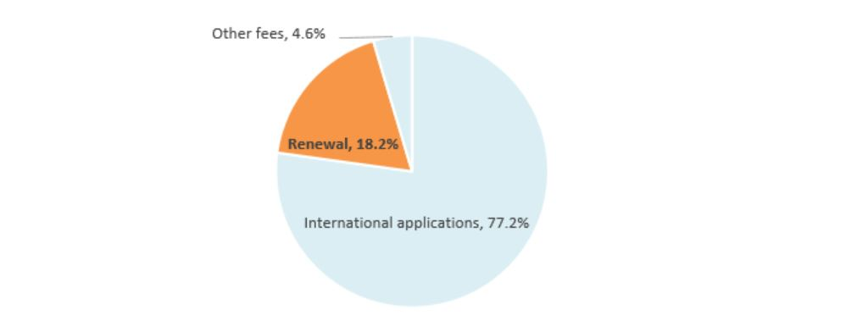

III. RENEWAL FEE STRUCTURES AND AMOUNTS IN NATIONAL OR REGIONAL MULTIPLE DESIGN SYSTEMS
- The structure of renewal fee applicable to industrial designs vary from one jurisdiction to another. In some jurisdictions, the amount of renewal fee increases gradually and at each time of renewal, while the amount remains the same for each renewal in other jurisdictions. When it comes to the renewal of multiple designs, in some jurisdictions, a flat fee applies regardless of the number of designs, or up to a certain number of designs after which an additional fee applies (for instance, a flat fee up to 10 designs, and an additional fee up to 20 and so on). However, in many other jurisdictions under which multiple designs are accepted, the renewal fee is charged per design, as in the case under the Hague System.
- In view of the above, the Secretariat conducted a comparative analysis of the fee structure in 33 jurisdictions. Those jurisdictions have been selected using the following three objective criteria (in design count):
- frequently designated Contracting Parties: top 20 most designated Contracting Parties in international applications in 2019;
- active users of the Hague System: top 20 origins from which most international applications were filed in 2019; and
- jurisdictions in which design systems are used actively: top 20 jurisdictions which received most design applications in 2018.
- It turns out that, out of these 33 jurisdictions, 18 have a fee structure similar to the Hague System, meaning that for designs that were filed together at the time of application, a fee is charged in respect of each at the time of renewal. In 11 of those jurisdictions, the same fee is being charged for each design whilst in the seven others the fee for each additional design stays the same but is lower than that for the first design (as is exactly the case under the Hague System). The graph below illustrates these findings:
Rate of Renewal Fee for Each Additional Design Against that for the First Design

10. Under the Hague System, the amount of the basic renewal fee for the first design is 200 Swiss francs and that for each additional design contained in the same international registration is 17 Swiss francs per design. This means that the rate of the renewal fee applicable to each additional design against that for the first design is 8.5 per cent.

11. Accordingly, the analysis proceeds to compare such rate applicable to each additional design in those seven jurisdictions with a fee structure similar to that under the Hague System and it has turned out that the average rate is 50.2 per cent, as presented in the chart below:
Average Rate of Renewal Fee for Each Additional Design

IV. conclusions
- As noted by the Working Group at its eighth session, the 8.5 per cent rate for each additional design against the amount of the basic renewal fee for the first design appears far lower than the prevailing average rates in other multiple design systems having exactly the same renewal fee structure as under the Hague System.
- Given the mandate received from the Working Group, the International Bureau will continue this study with a view to proposing a possible increase in the amount of the basic renewal fee for each additional design, to be discussed at a future session.

[End of document]

Refer to document H/LD/WG/8/8 “Summary by the Chair”, paragraph 27.
According to the internal monthly report provided by the Income Section of the Finance Division.
The figures for international applications are based on the international registrations with a recording date in 2019. Similarly, renewal and change cases are counted on a recorded basis.
In thousands of Swiss francs.
This amount includes the surcharge collected pursuant to Rule 24(1)(c) for a late renewal.
For example, the European Union, Japan, Norway and the Republic of Korea are such jurisdictions.
For example, Denmark, Sweden, Switzerland and Turkey are such jurisdictions.
For example, France is such a jurisdiction.
For example, Morocco and Spain are such jurisdictions.
Those jurisdictions are: Australia, Austria, Benelux, Cyprus, Czech Republic, Denmark, European Union, Germany, Italy, Monaco, Norway, Republic of Korea, Serbia, Singapore, Spain, Sweden, Turkey and the United Kingdom.
The data are those available on the websites of the Offices or through the WIPO Lex website (as of September 2020). Except for the Republic of Korea, a registration may be renewed every five years.
In the case of Norway, the amount of renewal fee increases gradually and at each time of renewal with respect to the first design only and the amount of the fee applicable to each additional design remains the same. Therefore, the amounts applicable at the first renewal (for the 6th to 10th years) are used for comparison.

