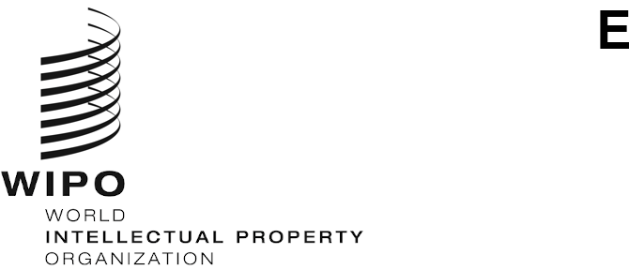
MM/LD/WG/18/1
ORIGINAL: ENGLISH
DATE: October 12, 2020

Working Group on the Legal Development of the Madrid System for the International Registration of Marks

Eighteenth Session

Geneva, October 12 to 16, 2020

Agenda
adopted by the Working Group
- Opening of the Session
- Election of the Chair and two Vice-Chairs
- Adoption of the Agenda
See the present document.
- Proposed Amendments to the Regulations Under the Protocol Relating to the Madrid Agreement Concerning the International Registration of Marks
See document MM/LD/WG/18/2 Rev.
- New Means of Representation
See document MM/LD/WG/18/3.
- Partial Replacement
See document MM/LD/WG/18/4.
- Study of the Cost Implications and Technical Feasibility of the Gradual Introduction of the Arabic, Chinese and Russian Languages into the Madrid System
See documents MM/LD/WG/18/5 and MM/LD/WG/18/5 Corr.
- Summary by the Chair
- Closing of the Session
[End of document]

Document MM/LD/WG/18/5 Corr. concerns the English version only.

