MM/LD/WG/18/8
ORIGINAL: French
DATE: August 13, 2020

Working Group on the Legal Development of the Madrid System for the International Registration of Marks

Eighteenth Session

Geneva, October 12 to 16, 2020

Proposal by The Delegation of Switzerland
- In a communication dated May 1, 2020, the International Bureau received a proposal from the Delegation of Switzerland concerning limitations provided for in the Madrid System for the International Registration of Marks, for consideration by the Working Group on the Legal Development of the Madrid System for the International Registration of Marks at its eighteenth session, which will be held in Geneva from October 12 to 16, 2020.
- The above-mentioned proposal is attached to this document as an Annex.
[Annex follows]
Proposal by the Delegation of Switzerland: limitations in international applications
The last few sessions of the Working Group on the Legal Development of the Madrid System for the International Registration of Marks (Working Group) have been partially devoted to the question of which Office was responsible for examining limitations in the International Register. The discussions have shown that the issue lacked clarity and transparency and that some limitations recorded in the International Register had never been examined by an Office, either before or after registration.
The situation is not satisfactory. Discussions on this subject during the 17th Working Group (based on document MM/LD/WG/17/9) showed that it was difficult to address different types of limitations at the same time. Furthermore, the Delegation of Switzerland, as proposed during the 17th session of the Working Group, only addresses the issue of limitations embodied in international applications (Rule 9 of the Common Regulations) in this document and would like the 18th session of the Working Group in June 2020 to recommend that several amendments to the Common Regulations be adopted in order to clarify the role of each of the Offices involved.
The issues related to other types of limitations and to cancellations may be processed subsequently.

Preamble
Switzerland is convinced that, as the Office through which all requests for limitations to the International Register are submitted, since it is the custodian of the Madrid and Nice Agreements, the International Bureau should play a central role in examining limitations. It is nonetheless aware that a solution centered on the International Bureau would not be acceptable to all of the Offices that are members of the Madrid System. It therefore proposes that the various interests at stake be taken into account in order to achieve a solution satisfactory to all parties.

1. LIMITATION EMBODIED IN INTERNATIONAL APPLICATIONS (RULE 9 OF THE COMMON REGULATIONS
In making an international application, a holder may indicate a desire for limitations of protection for a list of goods or services in respect of specific designated Contracting Parties (Rule 9(4)(a)(xiii) of the Common Regulations).

1.1 Examination by the Office of Origin
Most Offices, as Offices of Origin, consider that it is their certification duty (Rule 9(5)(d)(vi) of the Common Regulations) to ascertain that the limitation list in an international application is covered both by the list for the underlying mark and by the main list in the international registration. It is only through such vetting that international registration in its entirety (main list and limited list) can be assuredly based on the underlying mark.
Although this principle is very widely accepted, Switzerland proposes that the current Rules be amended in order to state the principle clearly (see the proposed amendment at the end of the document).

1.2 Examination by the International Bureau
The International Bureau currently examines limitations in international applications in accordance with Rule 12 (classification, see Rule 12(8bis) of the Common Regulations). It also examines such limitations in line with Rule 13 (accuracy), although this is not required in any provision in the Common Regulations.
Switzerland therefore proposes explicit provisions on the subject (see the proposed amendment at the end of the document).
However, Switzerland considers that the International Bureau must do more. It should consider in its examination whether the scope of the limitation is acceptable (is the limitation covered by the main list?). The aims here would be to avoid the recording of “gross” errors (which may occur, despite the certification duty of the Office of Origin) and to promote the harmonization of (practical) interpretations among Offices.
As many Offices believe in the primacy of the certification duty of the Office of Origin, irregularity notifications issued by the International Bureau could be based on and included in Rule 13 of the Common Regulations insofar as the final decision on the recording of the limitation would not rest with the International Bureau. Upon notification by the International Bureau, the Office of Origin could either amend the list or leave it unchanged. If it remains unchanged, an annotation, such as “extensive term, in the opinion of the International Bureau”, could be made to the limitation list. The purpose of such an annotation is to ensure that the information included in the Register is transparent.
Switzerland proposes an amendment to that end (see the proposed amendment at the end of the document).

1.3 Examination by the designated Office
Switzerland believes that the designated Office should not be able to question the examination made by the Office of Origin as regards the limitation contained in the international application. By accepting the limitation, the Office of Origin makes it clear that it considers that it is covered by the basis, which is the national registration, of which it is the guarantor. Just as the designated Office does not question that the main list of the international application is protected by the list of the national registration, it should not question that the “limited” list is equally protected by the main list of the international application. This examination is part of the certification duty of the Office of Origin.
During the 17th session of the Working Group, Switzerland indicated in its proposal that “there is no need for a specific provision to enable the designated Office to examine the scope of a limitation, given the primacy of the certification duty of the Office of Origin.”
This year, Switzerland would like to explicitly provide that the designated Office may not challenge this examination. This proposal would be “alternative 1”. It could be made by means of an interpretative declaration of Rule 17(2)(iv) of the Common Regulations, through which it is stated that the provisional refusal cannot be based on the ground that the limitation is, in reality, an extension. Rule 27(5) of the Common Regulations, which only applies to limitations recorded according to Rule 25 of the Common Regulations does not, in the opinion of Switzerland, require amendments to indicate this fact, as no other interpretation is possible.
If “alternative 1” is not accepted, the text should be left as it currently stands in the Common Regulations (alternative 2).

2. Illustrations of our proposals

Alternative 1 (our preferred solution)
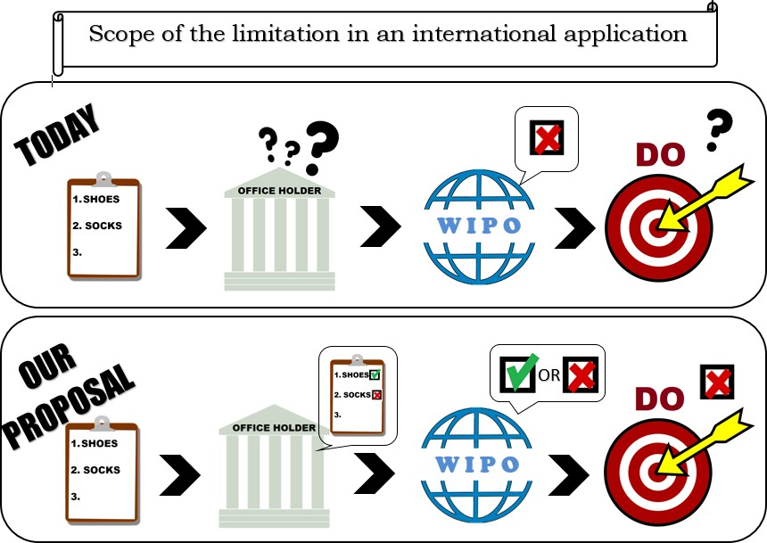

Alternative 2
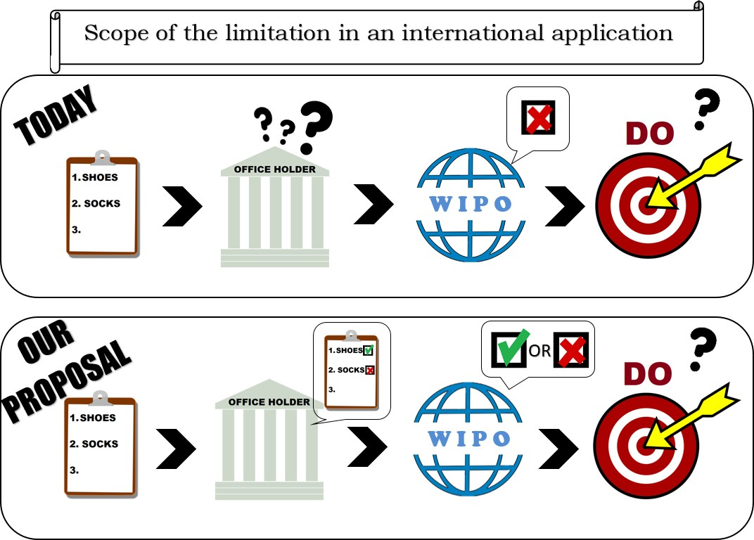

3. Proposed amendments

3.1.1 Role of the Office of Origin

Rule 9
Requirements Concerning the International Application
[…]
(5) [Additional Contents of an International Application]
[…]
(d) The international application shall contain a declaration by the Office of Origin certifying
[…]
(vi) that the goods and services indicated in the international application are covered by the list of goods and services appearing in the basic application or basic registration, as the case may be, and, where applicable, that the goods and services indicated in any limitation are covered by the list of goods and services indicated in the international application.
[…]

3.1.2 Role of the International Bureau

Rule 13
Irregularities with Respect to the Indication of Goods and Services
- [Communication of Irregularity by the International Bureau to the Office of Origin] If the International Bureau considers that any of the goods and services is indicated in the international application by a term that is too vague for the purposes of classification or is incomprehensible or is linguistically incorrect or, where applicable, if it considers that some of the goods and services indicated in a limitation are not covered by the main list of the international application, it shall notify the Office of Origin accordingly and at the same time inform the applicant. In the same notification, the International Bureau may suggest a substitute term, or the deletion of the term.
(2) [Time Allowed to Remedy Irregularity]
(a) The Office of Origin may make a proposal for remedying the irregularity within three months from the date of the notification referred to in paragraph (1).
(b) If no proposal acceptable to the International Bureau for remedying the irregularity is made within the period indicated in subparagraph (a), the International Bureau shall include in the international registration the term as appearing in the international application or the limitation in the international application, provided that the Office of Origin has specified the class in which such term should be classified; the international registration shall contain an indication to the effect that, in the opinion of the International Bureau, the specified term is too vague for the purposes of classification or is incomprehensible or is linguistically incorrect, or extensive in relation to the main list, as the case may be. Where no class has been specified by the Office of Origin, the International Bureau shall delete the said term ex officio and shall notify the Office of Origin accordingly and at the same time inform the applicant.

3.1.3 Role of the designated Office

3.1.3.1 Alternative 1

Rule 17
Provisional Refusal
(2) [Content of the Notification] A notification of provisional refusal shall contain or indicate
[…]
(iv) all the grounds on which the provisional refusal is based, together with a reference to the corresponding essential provisions of the law,¹
- Interpretative statement endorsed by the Assembly of the Madrid Union: “In Rule 17(2)(iv), the fact that the scope of the limitation included in the international application is extensive in relation to the main list of the international application is not a ground for provisional refusal.”

3.1.3.2 Alternative 2
No amendments.
[End of Annex and of document]

The eighteenth session of the Working Group on the Legal Development of the Madrid System for the International Registration of Marks was initially scheduled to be held from June 22 to 26, 2020. This session was postponed until October because of the COVID-19 pandemic.

