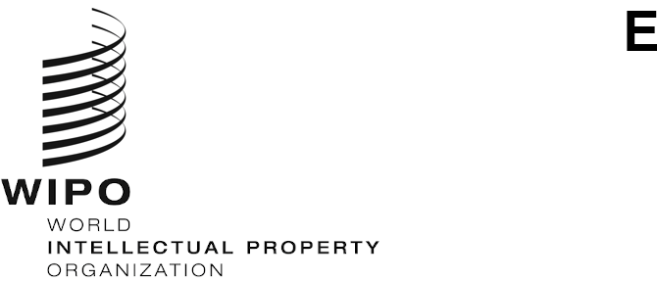
MM/LD/WG/18/inf/1 Prov. 3
ORIGINAL: ENGLISH
DATE: October 8, 2020

Working Group on the Legal Development of the Madrid System for the International Registration of Marks

Eighteenth Session

Geneva, October 12 to 16, 2020

Proposed Timetable
prepared by the Secretariat
Monday, October 12, 2020
From 12 noon to 2 p.m.
- Opening of the Session
- Election of the Chair and two Vice-Chairs
- Adoption of the Agenda
See document MM/LD/WG/18/1 Prov. 3.
- Proposed Amendments to the Regulations Under the Protocol Relating to the Madrid Agreement Concerning the International Registration of Marks
See document MM/LD/WG/18/2 Rev.

Tuesday, October 13, 2020
From 12 noon to 2 p.m.
- New Means of Representation
See document MM/LD/WG/18/3.

Wednesday, October 14, 2020
From 12 noon to 2 p.m.
- Partial Replacement
See document MM/LD/WG/18/4.

Thursday, October 15, 2020
From 12 noon to 2 p.m.
- Study of the Cost Implications and Technical Feasibility of the Gradual Introduction of the Arabic, Chinese and Russian Languages into the Madrid System
See documents MM/LD/WG/18/5 and MM/LD/WG/18/5 Corr.

Friday, October 16, 2020
From 12 noon to 2 p.m.
- Summary by the Chair
- Closing of the Session
Other Items
Discussions on documents MM/LD/WG/18/6 “Provisional Refusal”, MM/LD/WG/18/7 “Dependency” and MM/LD/WG/17/9 “Proposal by the Delegation of Switzerland” would take place at the nineteenth session of the Working Group.
[End of document]

The proposed timetable is merely indicative. If the Working Group does not finish discussions on an item by the end of the day, discussions on that item would continue at the start of the next day, unless otherwise proposed by the Chair.
Document MM/LD/WG/18/5 Corr. concerns the English version only.
The Secretariat suggests that the Working Group dedicate Friday, October 16, 2020, to discuss, exclusively, the Draft Summary by the Chair, which would be available on that day at 11 a.m.

