|  |  |  |
| --- | --- | --- |
|  | WIPO-E | **E** |
| CDIP/12/INF/2 REv. | | |
| ORIGINAL: English | | |
| DATE: September 16, 2013 | | |

**Committee on Development and Intellectual Property (CDIP)**

**Twelfth Session**

**Geneva, November 18 to 21, 2013**

Study on Patents and the Public Domain (II)[1]

*prepared by Professor James G. Conley, Clinical Professor of Technology, Kellogg Center for Research in Technology and Innovation, Kellogg School of Management, Northwestern University, Evanston, Illinois, United States of America; Mr. Peter M. Bican, Doctoral Candidate, Chair of Technology and Innovation Management, WHU – Otto Beisheim School of Management, Vallendar, Germany; and Doctor Neil Wilkof, Dr. Eyal Bressler and Company, Ramat-Gan, Israel*

The Annex to this document contains a Study on Patents and the Public Domain (II) prepared under the project on Patents and the Public Domain.(CDIP/7/5/Rev.). The Study analyzes the relationship at the micro level between the patent system and the public domain, building upon the findings of the Study on Patents and the Public Domain (I) (CDIP/4/3 Rev./STUDY/INF/2) prepared under the project on Intellectual Property and Public Domain (CDIP/4/3/Rev.). The study is divided into three parts. In Part I, the study offers a conceptual integrative model that seeks to explain the relationship between patents and the public domain both during the pendency of the registered patent right and after the expiry of the right; In Part II, the study focuses its attention to the so-called non-practicing entities (NPE's) and how their respective business models enrich the public domain; and in Part III it describes patent practices of entities more broadly and considers the potential impact of patent management on the public domain.

The Study has been prepared by a group of eminent experts, namely: Professor James G. Conley, Clinical Professor of Technology, Kellogg Center for Research in Technology and Innovation, Kellogg School of Management, Northwestern University, Evanston, Illinois, United States of America; Mr. Peter M. Bican, Doctoral Candidate, Chair of Technology and Innovation Management, WHU – Otto Beisheim School of Management, Vallendar, Germany; and Doctor Neil Wilkof, Dr. Eyal Bressler and Company, Ramat-Gan, Israel.

*The CDIP is invited to take note of the information contained in the Annex to this document.*

[Annex follows]

*Table of Contents*

**Executive Summary 2**

**Introduction 3**

**1)** **Objective / Study I vs. Study II 5**

**2)** **Scope 5**

**3)** **Research Question 6**

**4)** **Methodology 6**

**Part I: Public Domain and Patents 7**

**1)** **The Universe of Freely Accessible Information 7**

**2)** **Non-Discrete Boundaries of the Public Domain 10**

a) Invention – “Myth of the Sole Inventor” and the Public Domain 14

b) Patentable Subject Matter and Obviousness 15

c) Abandoned Patents and their Value to the Public Domain 15

d) Trade Secrets – Effects of a “Semi-Alternative” to Patents 18

e) A Local Right – the “Global Patent Arbitrage” 19

f) The “de-facto” Public Domain 20

g) Public Domain Post Expiry 21

**Part II: Patent Owners and Non Practicing Entities (NPEs) 22**

**1)** **Introduction 22**

**2)** **“Practicing” Patents – The Actors 25**

**3)** **Non-Competing Entities (NCE) 28**

**4)** **Universities & Public Research Organizations 29**

**5)** **Sovereign IP Funds 32**

**6)** **Patent Litigation as Business Model? 34**

a) Patent Assertion Entities (PAE) 35

b) Patent Aggregators 39

**7)** **Patent Intermediaries 41**

a) Patent Risk Solution Providers: RPX & AST 41

b) Patents as Trading Goods on an Active Market 42

c) Patent Pools 43

d) Other Patent Intermediaries 45

**8)** **NPE's Interplay and Effect on the Public Domain 46**

**Part III: Patent Management – Interplay and Effect on Public domain 50**

**1)** **Patenting and the Innovation Process 50**

a) Patent Awareness 50

b) Incremental Improvements and Tree of Subsequent Knowledge Release 50

c) Freedom to Operate 54

d) Hidden Applications 55

e) Submarine Patents 56

f) Patent Scope Refinements 56

**2)** **Patent Donations and Open Innovation 58**

a) Insource Knowledge 59

b) Patent Donations and Un(der)-used Patents 59

c) Teaming Up 61

**3)** **Patent Challenges and Evergreening 61**

**Conclusion 65**

**Tables, Equations & Figures 67**

**1)** **Tables 67**

**2)** **Equations 67**

**3)** **Figures 68**

**Executive Summary**

"In comparison with the ancients, we stand like dwarves on the shoulders of giants." *Bernard de Chartres[2]*

This study analyzes the relationship at the micro level between the patent system and the public domain, building upon the findings of the Study on Patents and the Public Domain (I).[3] It seeks to enhance the understanding of the impact of certain enterprise practices in the field of patents on the public domain and on the important role of a rich and freely accessible public domain. The discussion herein is not focused on the legal and normative aspects of patents and the public domain, but rather on how the intersection of patents with the public domain impacts on patent practice and commercialization.

This study explores the effect of the patent regime over time on the existence of a rich and growing public domain. By integrating data from professional and scholarly literature, WIPO and OECD reports, as well as data from both public and subscription sources, the practices and business models of firms such as non-practicing entities are described. The patent management and prosecution techniques of patent owners are then reviewed. Throughout the review, the effect of enterprise practices on the public domain is discussed.

The methodology of this research, Study on Patents and the Public Domain (II), focuses on the empirical and graphical analysis of the subject of patents as well as on the public domain’s role in light of various business data, in situ information and patent prosecution and registration metrics. In so doing, it seeks to complement the normative, legal emphasis taken in Study on Patents and the Public Domain (I). The study is divided into three parts.

In Part I, the study offers a conceptual integrative model that seeks to explain the relationship between patents and the public domain both during the pendency of the registered patent right and after the expiry of the right. The public domain consists of both de-jure and de-facto components. Contrary to what might be expected, the potential contribution by the patent system to the public domain occurs not only when a registered patent expires after the conclusion of its full statutory term, but also takes place prior to the completion of such full statutory term. These dynamics are explicated in a series of graphical and formulaic representations, augmented by explanatory text, in support of the authors' heuristic model. The possibility for patent arbitrage of the public domain by countries in which no patent right is sought, and the potential of such arbitrage to contribute to national innovation, especially for developing countries, are also discussed.

In Part II, the study focuses its attention to the so-called non-practicing entities (NPE's) and how their respective business models enrich the public domain. NPE's are variously defined and their precise contours continue to be debated. In some embodiments those entities have a propensity to litigate often: they do not have (or choose not to exploit), the capability to design, manufacture or distribute products that are covered by the patent. The following categories of potential NPE's are discussed: (i) patent assertion entities; (ii) patent aggregators; (iii) non-competing entities; (iv) patent intermediaries; and (v) universities and research organizations. The characteristics of each of these types of NPE's are discussed, with particular focus on the possible contribution of each to the public domain. The study proposes a linear representation in the form of two graphical continua that set out the contribution of each type of entity to the public domain and the propensity of each entity as patent holder to enforce its rights. It can be noted that the order of the entities along the continua differs, depending upon which aspect of the public domain is being described.

Part III describes patent practices of entities more broadly and considers the potential impact of patent management on the public domain. Both patent strategies and the on-the-ground implementation of these strategies are considered, as well as how such activities carried out by patent actors can contribute to a rich and freely accessible public domain. Part 3 first considers patenting and the innovation process and describes the role that the public domain plays. It then discusses patent donations and open innovation, followed by attention to the challenges posed by patent evergreening, with particular focus to the development of the generic pharmaceutical market by the enactment of the Hatch-Waxman Act in the U.S.

The authors find that the patent systems since 1883 have been a rich source of publicly available invention disclosures with over 94% of those disclosures being free to use by all. Of those disclosures that issued as patents, over 90% are free to use by all. Of the 5-6% of the disclosures that are enforceable patents, most are free to use in all countries of the world where there is no equivalent patent. The growing rate of patenting across the globe is feeding this public body of inventive disclosures that are over time all entering the public domain.

The emergence of patent market intermediaries such as non-practicing entities has enabled patent owners to capture value through unpopular and inefficient means such as litigation. A number of specialty firms have formed that reduce these inefficiencies. All non-practicing actors including Universities and Government sponsored entities are becoming more active and strategic in their patent market activities. There is evidence that the nascent markets for patents are becoming more specialized and efficient and hence more valuable for patent owners and licensors.

A conclusion of the analysis in this report is that the relationship between patents, innovation and a rich and freely accessible public domain is complex and nuanced. While no generalization of this relationship emerges, it is possible to conceptualize a heuristic model that can materially contribute to our understanding of this important issue. The model takes into account differences in the time horizon under consideration, the relevant jurisdictions involved, the commercial and other goals of the various actors and their ability to carry out their plans. Where appropriate the authors point the way to avenues for future research that can further elucidate the ways by which patent activity contribute to, and continue to enrich, the public domain.

**Introduction**

“The innovation economy is governed by the rules of intellectual property as incentives for independent inventors and entrepreneurs to innovate.”[4]

A starting point in any discussion of intellectual property rights, such as patents, is that patents are a form of property rights.[5] As such, they entitle the right holder to exclude others from exploiting the patent, and in particular from making, using, or selling the claimed invention for a limited period of time. This limited life exclusive right is granted as the *quid pro quo* of enabling disclosure. The disclosure of inventions through patent related publications creates free access to the associated information. After expiry or abandonment of the right, the patent enriches the public domain of information. In the United States, the patent right has constitutional origins.[6]

“[T]he legal protection of property rights has an important economic function: to create incentives to use resources efficiently.”[7] It can be reasonably argued that the art of commercial flying was catalyzed when the Wright brothers publicly demonstrated their invention of controlled flight and were issued a patent (US821393) on May 22, 1906 for their flying machine.[8] By disclosing the flying machine to the public in exchange for patent rights these inventors opened the door to a new form of mass air transportation and global mobility. The present legacy actors in the air frame market include companies such as Embraer (Brazil), Boeing (USA), Airbus (Europe) and Bombardier (Canada).

Recently public markets have begun to appreciate the value of intangibles such as intellectual property rights. Opportunistic patent infringement litigation, as has been seen in the past,[9] is being practiced in pursuit of the largely illiquid value that exists in patents and portfolios thereof.

Practicing entities and those who invest resources to develop and commercialize patent protected innovations have exposure to such opportunistic litigation. Uncertainties around significant potential economic liability tend to drive settlement. The resulting ecosystem has led to the rise of intermediaries known as non-practicing entities, or NPEs. These firms are motivated by settlement and licensing and not necessarily by the creation of new knowledge. What is the effect of these rising market actors on a rich and freely accessible public domain?

The authors will review relevant WIPO data, which demonstrate that patent activities (including both applications and registrations) are continuing to increase, thereby also ultimately enriching the public domain in a similar fashion. Markets, in turn, are creating the demand for innovative technologies that foster this growth in patent prosecution activity.

1. **Objective / Study I vs. Study II**

The objective of this study, called Study (II), as laid out by the project description of

WIPO[10] is as follows:

“Building upon the findings of the Study on Patents and the Public Domain being undertaken under Project DA_16_20_01, this project will further the analysis of the relationship between the patent system and the public domain. In particular, the project will enhance understanding of the impact of certain enterprise practices in the field of patents on the public domain and the important role of a rich and accessible public domain.”

As noted above, Study (II) builds upon Study (I). The objective of Study (I) is described as “to deepen the analysis of the implications and benefits of a rich and accessible public domain and to explore the role of the patent system and patent information in identifying, accessing and using subject matter in the public domain.”[11]

Study (II) is directed at complementing the normative approach to the public domain taken in Study (I), but with a focus on the micro level. By so doing, the context of the public domain at the micro level will enhance the understanding how “…individual actors of the patent system actually behave in making choices over using, or not using, exclusive patent rights, and how those behaviors affect the public domain...”[12] Moreover, by identifying and illuminating the practices of actors in the patent area, the authors will offer an analysis of the consequent effects of such actions on the status of a rich and freely accessible public domain. In contrast to the methods of Study (I), in this study we intend to present tabular and graphical forms of relevant data to inform our analysis.

1. **Scope**

This Study owes its origins to the fourth session of WIPO’s Committee on Development and Intellectual Property (CDIP), which took place in Geneva from November 16 to 20, 2009. At that session, the CDIP agreed to undertake a study under the name of Project on Intellectual Property and the Public Domain, within the context of Recommendations 16[13] and 20[14] of the WIPO Development Agenda. Both recommendations fall under Cluster B of the overall Recommendations, which are subtitled “Norm setting, flexibilities, public policy and public domain.”

It is apparent that, while only Recommendations 16 and 20 specifically mention “public domain,” a vital and freely accessible public domain should assist in the fulfillment of many of other Development Agenda items, particularly those which refer to issues such as technology transfer and dissemination and scientific cooperation. This Study may therefore have a wider scope of applicability.

1. **Research Question**

The WIPO brief to the authors of this study further explains:[15]

“With a view to addressing the issues raised under Recommendations 16 and 20, understanding how certain uses of patents by enterprises affect the preservation of the public domain should be useful for deepening the analysis on the complex relationship between the patent system and the public domain.”

Having regard to the afore stated question of “how certain uses of patents by enterprises affect the preservation of the public domain,” the present study aims to address the issues under consideration, as described above, using various analytical, descriptive and empirical methods. In particular, intellectual property rights generally, and patents, in particular, are viewed by some primarily in terms of being an emerging asset class.[16] Moreover, some researchers argue that patents are increasingly being misused for certain strategic motives that, disregard their initial purpose, viz., granting an exclusive right on inventions for a limited period of time in exchange for disclosure of the invention.[17]

To explore these considerations, Study II will further address the most common patent-based strategies of firms and an analysis of the effect of these strategies on the public domain.

1. **Methodology**

The authors reviewed a variety of information sources including the academic and professional literature relevant to the research question and collected input from multiple sources. Where possible, all sources have been referenced in footnotes to facilitate further consideration of the authorities and examination of the available literature. Where appropriate, data obtained from sources such as WIPO, public literature, both in print and online, and various private firm sources, and online sources, were used to inform the analysis and identity of patent owners active in the relevant markets and to characterize the dynamics of such markets. In undertaking this analysis the authors make no moral, ethical or legal judgments of the named entities or the legislations or treaties discussed.

**Part I: Public Domain and Patents**

In proceeding with an analysis of patents and the public domain in a manner that complements Study (I), the authors first offer an original model for understanding the public domain. This model rests on an appreciation for the considerable body of both academic and popular literature that provide multiple perspectives on the public domain and how it may be affected by multiple intellectual property rights regimes.[18]

1. **The Universe of Freely Accessible Information**

The premise of the proposed model is that there exists a universe of freely accessible information (U) that in principle can be quantified in some aggregate fashion. **Figure 1** is a simplified, two dimensional depiction of that information universe which the authors have crafted in an attempt to relate all known legal categories of private information rights to the greater body of freely accessible information. Note that freely accessible in the context of this model does not mean free to use the private intellectual property rights that are the *quid-pro-quo* of disclosure and/or use.

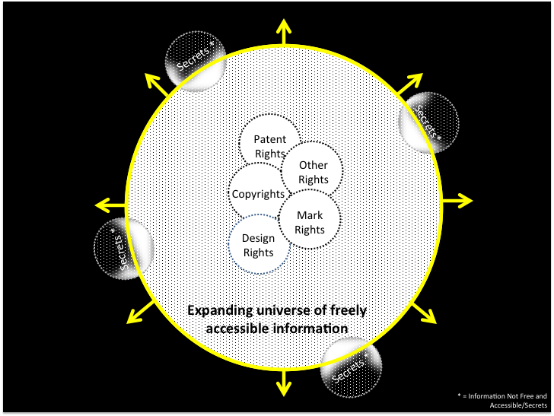

**Figure 1: IP and the Public Domain.[19]**

According to the model, this universe of freely and accessible information (e.g. data, databases, information publicly disclosed and explicitly communicated in any form) can be accessed by those with access to public information networks and/or facilities such as networked public libraries. For the moment, this model does not account for challenges associated with language translations and the like. Further, it does not account for barriers such as the cost of access to information networks.

With the rapid adoption and growth of widespread data gathering and distribution functionality, the amount of information being created within this universe is growing at an exponential rate. Hence, the amount of information that is available for interested parties to access and consume is continuously expanding. Dedicated research entities, such as universities, or bodies such as CERN (European Organization for Nuclear Research), primarily exist to efficiently advance and push out the frontier of freely accessible information and human knowledge, as embodied within the outer perimeter of the circle that encompasses the information universe.

However, at any given point in time, a portion of the information within the circle is private property of a sort that is not freely accessible for use. In the main, this otherwise accessible information is protected by intellectual property rights regimes, such as patents for inventions (P); copyrights for original expressions (C); design rights for ornamentation (ID); mark rights for unique source identifiers (M), and other rights (O), such as geographical indications, plant breeder’s rights, mask works, utility models, databases and, explicit traditional knowledge.

Note that some of these rights regimes may overlap with each other. Such overlaps come in several forms: (i) the two sets of intellectual property rights may mutually cover the common subject matter; (ii) the two sets of intellectual property rights may cover only a part of the common subject matter; and (iii) the two sets of intellectual property rights may cover different aspects of the common article.[20] An example of (i) is copyright and trademark protection, which may both cover the same artistic subject matter.[21] An example of (ii) is plant-related inventions (patent on the genetic parts) and plant breeder's rights (morphological aspects), which may also extend to market exclusivity rights in certain jurisdictions (see further Table 1 below).[22] An example of (iii) is patent and design protection, where each right protects a different legal aspect of the article.[23]

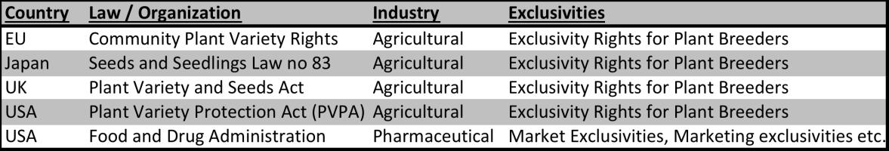

**Table 1: Selected Overlapping Rights[24]**

It should be carefully noted that beyond the universe of freely accessible information outside the large circle in **Figure 1** lies a sub-universe of non-disclosed private information that is by its very nature not accessible. Trade secrets, being the prime example, consist of information of commercial or other value to its creator that is not generally known to the public[25] and, which is maintained in confidence by its owner. As such, the associated information resides outside the universe of freely accessible information. Over time however, some of this secret information may be disclosed by way of reverse engineering, independent discovery, or even unauthorized disclosure. When this occurs, the information in principle becomes part of the universe of freely accessible information.

Still, some types of information may not become freely accessible to the public, even after the expiry of the private right in the information. For example, an original work of creation may be kept in confidence and never be disclosed. If so, even after the expiry of the statutory period for protection of the copyright in that work, for as long as the information remains secret, it continues not to be accessible to the public. Hence, the model depicts islands of information on the periphery of the universe of freely available information, some portion of which has become freely accessible while some continues to remain a secret (and hence outside the universe boundary).

While considering the islands of intellectual property regimes lying within the universe of freely accessible information, note that their respective boundaries are dotted and not discrete. This reflects in part the fact that the legal environment that governs these rights continues to evolve. Moreover, the nature of the intellectual rights embodied in these islands is not static.

Considering the patent circle, subject matter patentable at one point of time may not be patentable in the future. Further, over time, limited exclusive rights, such as patents and copyrights will expire by term maturation, invalidation, abandonment and the like. Hence, the information that is a private patent right will with time eventually become free for all to use. Additionally, all intellectual property rights, including patent rights, are jurisdictional. Hence, what may be protected in one jurisdiction may be free for all to use and practice in another. To this end, what is inside or outside of any given island of intellectual property is dependent on at least time (t) and geographical jurisdiction (g). Note that the above patent example is representative and not comprehensive. Moreover, the authors appreciate that WIPO-administered international treaties (such as the Berne Convention), international treaties managed by other organizations (such as the TRIPS Agreement, which is administered by the World Trade Organization), and various regional treaties and arrangements (such as the European Patent Convention) may all influence what information may exist within or without a private intellectual right domain in any given jurisdiction.

With the aforementioned visual depiction and textual explanation of freely accessible information and private intellectual rights regimes in hand, we can now express a relationship that characterizes the public domain within the context of private intellectual property rights:

*Public Domain (g,t) = U – P – C – M – ID – O + S*

**Equation 1: The Public Domain.**

Whereas:

g = Geography

t = Time

U = Universe of known and freely accessible information

P = Patent rights,

C = Copyrights,

M = Mark rights

ID = Design rights

O = Other rights (e.g. geographical indications, plant breeder’s rights, mask works, utility models, databases, explicit traditional knowledge)

S = Previously secret information

While this representation of the public domain is a simplification, the above relationship may point the way towards preliminary quantification of what information is in the public domain in any particular legal jurisdiction (g), nation or intellectual property region at any particular point in time (t). If the above relationship can be used to quantify the public domain in a particular jurisdiction, some form of this relationship applied across jurisdictions may yield a more global estimate of the scope of public domain. That said, it is recognized that this relationship is challenged by the lack of a discrete and common unit of analysis. The authors leave it to those more skilled in information quantification to test and improve the model.

1. **Non-Discrete Boundaries of the Public Domain**

A measureable impact of the patent right on the public domain as discussed in Study 1 is the number of patent disclosures generated over time, which have now entered the public domain. According to WIPO data approximately 147 million patent applications have been filed across the globe since 1883 (see with **Figure 2**).

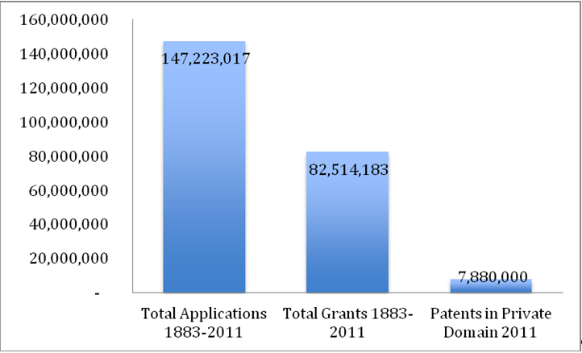

**Figure 2: Summary of Patent Applications vs. Patent Grants vs. Patents in Private Domain in 2011.[26]**

At present approximately eight million of those applications are either pending or have ripened into a valid patent right and hence constitute a private right lying outside the public domain (**Figure 2**). The information contained in all other inventions filed since 1883 has entered the public domain via expiration, abandonment or invalidation of the patents. In absolute terms, around 95% of the patent applications that have been pursued since 1883 have fed the richness of the public domain.

The details of the process by which a patent moves from the private into the public domain require further elaboration. Accordingly, this study briefly sets out the life cycle of a patent disclosure, starting with the filing of a patent application at the respective Patent Office. The authors base their example on the process in effect at the European Patent Office (EPO) (**Figure 3**).

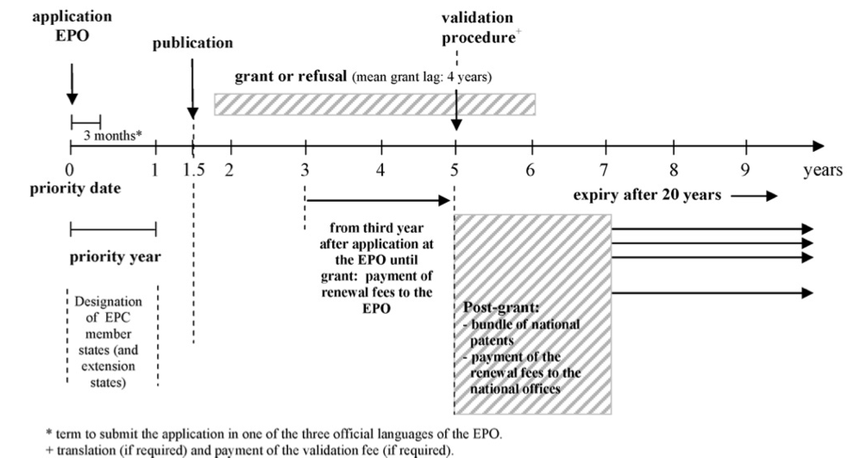

**Figure 3: Patent Application filed at the EPO.[27]**

After the applicant files, the information in the application will remain undisclosed within the EPO for 18 months. Thereafter the patent application is disclosed to the public. Disclosure itself does not imply that the patent will be granted. On average, within a period of four years from the date of filing with the EPO, a determination will be made to either grant or refuse the patent right. The maximum period during which the owner will be able to enforce its rights in the patent typically expires 20 years from date of application.

In most countries, the patent owner has to pay a renewal fee (also called a maintenance fee in the US) at discrete intervals over the life of the patent grant in order to maintain the right.[28] If the maintenance fees are not paid in due time (taking into account any extensions provided by the law of the jurisdiction), the patent rights are formally abandoned and unenforceable. When this occurs, assuming that use of the invention does not fall within the scope of a broader patent of a third party or is not otherwise prohibited by law, the invention enters the public domain, whereby the invention is freely accessible for use by all. Stated otherwise, and based on the foregoing, at the moment that the patent expires or is abandoned, it *traverses* from the private domain into the public domain.

**Figure 4** below facilitates a more detailed explanation of the nature of the dynamic boundary of the patent right regime described above.

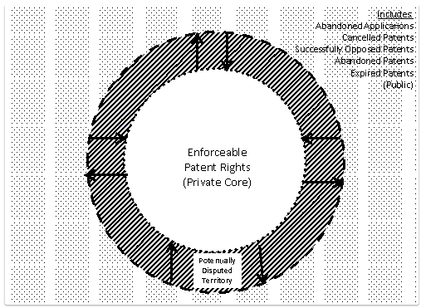

**Figure 4: Patent Rights Component of the Public Domain.[29]**

From **Figure 4**, we can see that issued, enforceable patent rights are at the core of the domain of private patent rights. Peripheral to this core is a region that we refer to as “potentially disputed territory," where patent ownership rights may be claimed, approved or even granted, but for a variety of reasons remain uncertain relative to the enforceable core. A patent right may migrate across into "potentially disputed territory" because of legal dynamics of what is patentable and/or enforceable. For example, US patent 5747282 was duly issued and became enforceable on May 5, 1998. Hence, this right was at one time located within the core region of **Figure 4**. In March of 2010, however, a US district court judge invalidated a number of the claims of this patent, effectively moving the right into "potentially disputed territory," subject to further judicial review. Eventually, the Supreme Court of the United States in a unanimous decision invalidated many of the isolated gene sequence claims of this and similar patents, ruling that such claims are not patentable.[30] As a result, many of the claims of this patent have now moved out of "potentially disputed territory" and into the public domain.

Moreover, other forms of patent rights, most notably utility models, may also exist in "potentially disputed territory". A utility model is a form of patent right that differs from a patent of invention on several dimensions. Most notably, (i) the requirements for filing and registering a utility model are less stringent (especially regarding "inventive step"); (ii) the term of protection is usually shorter; (iii) registration may be limited to only certain fields and may not include processes; and (iv) no substantial examination takes place prior to registration. This means that the validity of a utility model will be raised, if at all, only in the context of an enforcement proceeding. [31]

Further, the frontier of what is included within the ambit of enforceable private patent rights is subject to various legal, legislative and administratively-imposed expansions and contractions over time (see arrows in **Figure 4**). **Table 2** lists a number of such public actions that have had some measureable effect on what can or cannot be included within the core of the patent domain. Note that while the definition of what is an enforceable private patent right is tied to a particular jurisdiction, legal contractions, expansions and public pressures can occur in multiple jurisdictions, as set out in **Table 2**.



**Table 2: The “Ever Moving“ Patent Right.[32]**

Despite the historic dynamics of what is patentable and many recent contracting pressures, patent applications are steadily rising. Between 1990 and 2005 patent applications filed at the United States Patent and Trademark Office (USPTO) rose from 175,000 to 380,000 annually. [33] In 2012 the total number of patent applications filed at the USPTO amounted to 565.566.[34] A similar trend can be observed for PCT applications at WIPO, (see with **Figure 5**). These patent applications constantly increase the “public storehouse of knowledge that results from the disclosure of patented inventions.” [35]

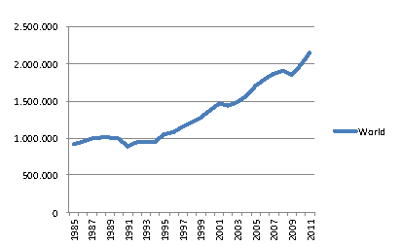

**Figure 5: Total Patent Applications (direct and PCT National Phase Entries) 1985-2011.****[36]**

“A well-stocked and healthy public domain is therefore crucial, it is said, to ongoing innovation in both the cultural and scientific arenas, at least standing alongside intellectual property’s incentive of exclusivity and potential financial reward in pursuit of the same general goal.”[37]

1. **Invention – “Myth of the Sole Inventor” and the Public Domain**

In many jurisdictions, patent rights are tied to the inventor. This raises the following question: “who are those inventors?” How valid is the myth that it is the sole inventor that leads to the “*Eureka* moment” of a game-changing invention? And what role does the public domain play?

Research surveying numerous significant technologies concluded that “almost all of them are invented simultaneously or nearly simultaneously by two or more teams working independently of each other.”[38] Freely accessible knowledge plays a pivotal role in this knowledge-creation: “Invention appears in significant part to be a social, not an individual, phenomenon. Inventors build on the work of those who came before, and new ideas are often either “in the air” or result from changes in market demand or the availability of new or cheaper starting materials.”[39] Without this prior work, sometimes published and accessible via disclosed patents, this transfer of knowledge would not have been possible, or at least deferred. It appears to be a rare occurrence that even a famous inventor comes up with a solution in isolation from other contributors.[40]

1. **Patentable Subject Matter and Obviousness**

For an invention to be patentable, it must usually satisfy certain jurisdictional, such as:[41]

(1) patentable subject matter,

(2) novelty,

(3) involve an inventive step (called "non-obviousness" in the USA)

(4) susceptible to industrial application (called "usefulness" in the USA).

It is typically stated that novelty is subjected to an objective test; in principle either the invention is new, or it is not, having regard to a single piece of prior art. With respect to non-obviousness, however, the test facilitates more subjective considerations. Who is the hypothetical person of ordinary skill in the art? What is permitted to combine multiple prior art and, how “obvious” is obvious? Accordingly, the test for non-obviousness, however termed, may vary from country to country and even within a jurisdiction, depending upon changes in the administrative and judicial position.

A good example of this is found in the U.S. decision in *KSR International Co. Inc. . v. Teleflex, Inc*. [550 U.S. 398 (2007)],[42] which held that the U.S. Court of Appeals for the Federal Circuit had applied too rigid a standard in determining obviousness. Instead, the Supreme Court articulated a more flexible approach, especially with respect to the combining of prior art references. The upshot of the ruling is that the test for establishing non-obviousness was arguably made more challenging, i.e. it arguably made it more difficult to obtain a patent in the United States. With respect to the public domain, the result is to potentially narrow the universe of inventions that will be eligible for patent protection, with the concomitant result that the public domain with respect to the subject matter of that invention has been enriched *ab initio*.

Another way to look at this decision is that it may affect the time function of the public domain, as provided for in **Equation 1** above. Instead of leaving the issue of obviousness to be resolved after grant or registration within the context of the "potentially disputed territory" described in **Figure 4** above, an invention (or part thereof) examined under the test set out by the Supreme Court in the *KSR* decision may be determined *ab initio* to be obvious. As such, the information contained within the patent application is from the outset recognized as part of the public domain.

Given all of the above, the boundary between the private patent right and the public domain as depicted in either Figure 1 or Figure 4 is dynamic and not discrete.

1. **Abandoned Patents and their Value to the Public Domain**

The patent term describes the time frame during which a patent right is privately owned before it is released to the public domain. Usual notions on patent terms only consider the statutory term, i.e. the maximum time frame that a patent right can be enjoyed by the patent holder, being, in most jurisdictions, 20 years. But not every rights holder or rights beneficiary actually exploits the rights granted for the full term of the patent. Sometimes a patent holder will chose to surrender its exclusive rights in the patent before the end of the statutory patent term, hence the concept of the *effective patent term*.[43]

The effective patent term is the length the patent protection is actually maintained by the patent owner. As noted above, most national patent offices require the payment of maintenance or renewal fees (post grant) in addition to the application fees (pre grant). If the maintenance fee is not paid in a timely manner, the patent right is formally abandoned, hence it traverses from the private to the public domain.[44]

Reasons for not maintaining the patent till its statutory end may include:

- the patent holders reach the conclusion that they will not be able to monetize their invention or that the patent is not worth the cost of maintenance.

- the patent holder has been able to monetize the invention but reaches the conclusion that he has extracted all returns associated with the invention even before the end of the patent term. For example, a small inventor has completed a successful licensing deal and he cannot foresee reaching any further licensing contracts with other companies. By ceasing to pay the maintenance fees, a patent holder saves additional costs he cannot likely recover.

- the patent holder neglects to pay the maintenance fee on time (or within the grace period, if provided).

- the patent holder goes out of business and abandons the patent by not paying the maintenance fees.

It is not possible to predict which patent rights will be abandoned before the end of their statutory period because this information can only be measured retrospectively. Scholars recently examined the variable length of the “effective patent term”. One study[45] bases its findings on data from patents that were granted by the USPTO in 1992, (see details in **Table 3**):

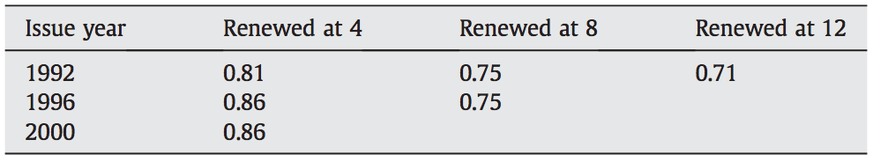

**Table 3: Summary Statistics on Renewals for Patents.[46]**

Overall, the above renewing rates, 43.13% of all patents granted in 1992 were maintained till the full term. Hence more than 55% of all issued patents are contributed to the public domain by the owners before the end of their statutory “life.”

Another review of USPTO maintenance fee payment data found similar ratios of abandonment for, both small and large filers.[47] **Figure 6** displays the maintenance rate at the 3rd interval (12 year interval) for small entity owners, whereas **Figure 7** shows the rate for large entity owners.

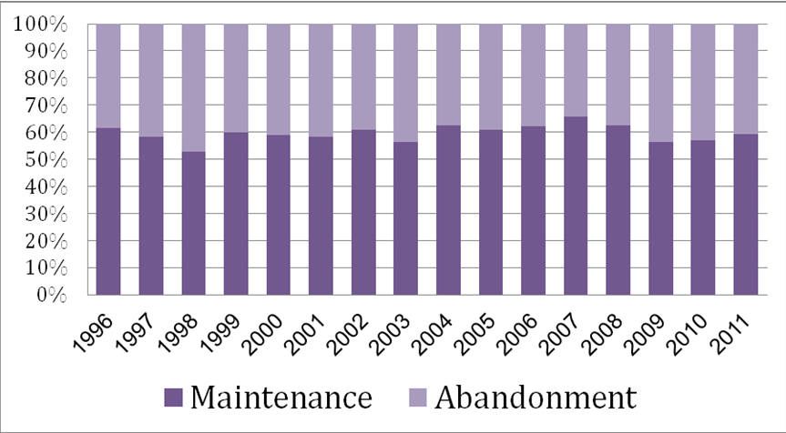

**Figure 6: Patent Maintenance Small Firms in % at Year 12 (3rd Interval).[48]**

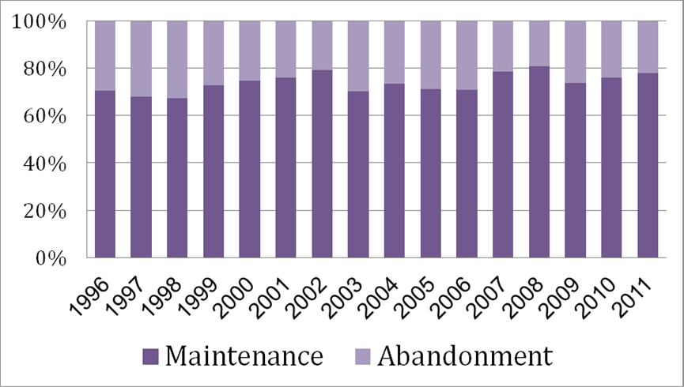

**Figure 7: Patent Maintenance Large Firms in % at Year 12 (3rd Interval).[49]**

The trend in patent abandonment at each maintenance fee stage can also be observed at the European level per certain industries (pharmaceuticals and electronics) with data from between 1985 and 1990.[50] Within these industries, for example within the UK (**Figure 8**, top-right corner), only 24% (pharmaceuticals) respectively 29% (electronics) live up to the age of 18, the last observed data point in this study.

It is apparent that the majority of patents granted do not sustain an enforceable right or “live” until the end of their statutory grant, i.e. they are being released to the public domain. Unlike the issue of obviousness or related changes in what is patentable, in this instance it is the free and ultimate choice of the patent owner to abandon his private property right and to effectively release the use of information contained within the patent claims into the public domain.

These observations point to the need for further research addressing how industry actors make use of the information contained in abandoned patents rights. This could be of special interest in both developed and developing countries. In particular, does it occur more frequently in some industries than in others? On the individual country level, are there certain local conditions that foster abandonment of patents? If any, what are the differences between developed and developing countries?

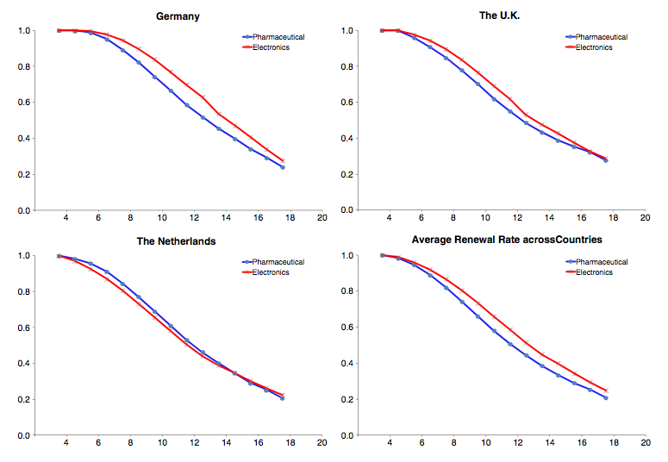

**Figure 8: Renewal Rates in selected EU Countries – Average of Patents applied for between 1980 and 1985.[51]**

1. **Trade Secrets – Effects of a “Semi-Alternative” to Patents**

As graphically described in **Figure 1**, the private domain of inventive information includes explicit forms, some of which are patented and some of which are confidential and not generally known to the public. Patents do not protect undisclosed information, which may be protected from misappropriation by legal regimes such as trade secrets.[52] Trade secrets can serve as a partial alternative to patent protection and thereby affect the flow of knowledge to the public domain in a different way than patents. Figure 1 depicts the role of trade secrets with the universe of known and accessible information. In theory, while trade secrets could remain secret indefinitely, therefore never enriching the public domain, as explained on **Figure 1** above, in practice, there are a number of circumstances by which some of the information maintained as proprietary trade secrets will become part of the public domain and thereby be freely accessible.

In approaching trade secrets and their role within the public domain, a further refinement is appropriate. Unlike patents, where legal protection is the result of a conscious and intentional act on the part of the inventor, the conditions under which trade secrets are created, used and protected, are more variegated. Inventors intentionally create trade secrets in the context of a patent application, whereby at a minimum the invention is maintained in confidence until the time of filing (indeed the inventor may decide to abandon the patent application and continue with protection of the information as a trade secret, provided that the application has not been published). But there are others who simply create confidential information without any systematic consideration of how and for what duration to protect the confidential information. The dynamics that characterize trade secret creation, protection and use are thus very different from those describing patent activity.

1. **A Local Right – the “Global Patent Arbitrage”**

The depiction of the public domain displayed in **Figure 1** and further characterized in Equation 1 suggests that developing countries can especially benefit from the public domain. More specifically, our illustration of the public domain suggests both time and geography as independent variables. A *global patent arbitrage* emerges:

(1) At any particular time (t), patent applications and ensuing issuances, which are feeding and redefining the private domain, are more likely in the main to be concentrated in developed nations (such as the United States, European Union and Japan). Hence, these inventions are available to the public domain in those countries, where no equivalent rights for the invention are pursued or exist.[53]

For example, the invention for which a patent is applied, published and ultimately granted in only one country, is effectively contributed to the public domain in all other sovereign states. Entities in these nations are thus free to use the invention without the cost of licensing or any other limitation on use (unless, as mentioned on p. 20 below, there is a valid third party patent in the jurisdiction that might still block the use of the invention or the use is prohibited under an appropriate local law). As such, these entities can use the invention competitively in their own markets and those with no corresponding patent protection. Further, through such exploitation, these entities can gain a competitive advantage in developing improvements to the invention, which then can be the basis for seeking future proprietary patent rights in ANY country. This situation is the basis for a global arbitrage on invention information disclosed in patent publications.

(2) Over time, inventions in the private domain at any time eventually enter the public domain of the country where the private patent right existed (e.g. after expiry of the patent). Those entities from non-patent countries can then capitalize abroad on their accumulated domestic experience and knowledge, seeking to export such knowledge and experience (having used these inventions in their home country in a royalty- free manner) to markets in the developed world where related registered patent rights no longer exist, and thus compete strictly on the basis of price (e.g., Indian generics manufacturers in the pharmaceutical area).

(3) With sufficient experience in innovation and development, the entities in such countries may successfully progress up the learning curve of innovation capacity. The goal is to innovate and develop their own proprietary patented market solutions in order to gain access to the markets of the developed world with the appropriate amount of patent protection, sufficient to differentiate products, and to profit from their own investments in innovation. Teva, Ranbaxy, Andryx and other companies are examples of firms founded in developing countries who used global patent arbitrage to compete and eventually become competitive on both the price and product dimensions of the marketing mix.[54]

One can argue that the above scenario is more likely to play out in developing and/or less developed nations with the capacity to innovate or the infrastructure to build capacity to innovate. The antecedent of such innovation and invention is human capital. It has been argued that the most capable human capital tends to move from the developing world to the developed world. If so, there is potential risk that there may not be enough effective human capital left in the developing world to take advantage of global patent arbitrage.

Pushing against this claim is the presence of diaspora communities in concentrated pockets of innovation and development in the developed world (such as from India, Israel, China and Taiwan (Province of China). It is claimed that such diaspora communities maintain an on-going connection with the counterparts in their country of origin, thereby enriching both settings.[55] Here, the patent arbitrage runs full circle to the benefit of all concerned. This and other related questions exceed the focus of this report but merit further study.

1. **The “de-facto” Public Domain**

The *de-facto* public domain, as used in this report, posits a different type of “access” to the information universe of known information. It assumes that the patent right is valid and subsisting. As such, there is access to the patent, but it is not freely available for use.

However, not all patents are being enforced. In fact, the majority of patents are never subject to litigation or injunction: “[In the USA n]inety-nine percent of patent owners never even bother to file suit to enforce their rights. They spend $4.33 billion per year to obtain patents, but no one seems to know exactly what happens to most of them.”[56] Thus, as a matter of probabilistic behavior, the patent holder will not seek to enforce his patent should a third party make use of it without authorization.[57]

Regarding our depiction of the universe of freely accessible information in **Figure 1**, **Figure 4** and the related **Equation 1**, valid and enforceable patents are not freely accessible during the pendency of the patents, hence they are not part of the universe of known and freely accessible information. However, given that such patent rights are publicly known through disclosure, it can be argued that since patent owners may not bother to enforce their rights, such rights become part of a *de-facto* public domain. While patent rights are legally not usable in the absence of their enforcement, they become *de-facto* so*.* As a result, even if the patent is not *de jure* part of the public domain, it is *de-facto* free for use, i.e. it is part of what we refer to as the de-facto public domain.

In a manner similar to trade secrets, which are not accessible only for as long as they are not disclosed, rights within the *de-facto* public domain are free to use only to the extent their owner does not seek to enforce them, which at least in the US appears to be almost always the case. It is the contention of the authors that the public domain can only be understood if both the *de-jure* and *de-facto* components are addressed.

Building on **Figure 1** and the related **Equation 1**, we extend the above to define the public domain in light of the *de-facto* public domain:

*Public Domain (g,t) = U – P – C – M – ID – O + S + D*

**Equation 2: De-Facto Public Domain Extension.**

Whereas:

g = Geography

t = Time

U = Universe of known and freely accessible information

P = Patent rights,

C = Copyrights,

M = Mark rights

ID = Design rights

O = Other rights (e.g. geographical indications, plant breeder’s rights, mask works, utility models, databases, traditional knowledge)

S = Previously secret information

D= “De-facto” public domain or patented inventions that are free to use because they are not enforced

1. **Public Domain Post Expiry**

As described elsewhere, other forms of non-IP based exclusivity can extend the proprietary market advantages of an innovation even though the patent right has formerly expired.[58]

Given this particular characterization of patent rights and the public domain, we now proceed to address the question of the role of private actors such as non-practicing entities (NPEs) and the impact of their existence on a rich and freely accessible public domain.

**Part II: Patent Owners and Non Practicing Entities (NPEs)**

1. **Introduction**

In this section, the community of patent owners is first characterized on the basis of data and analysis from academic and professional literature. With this baseline, the term NPE or non-practicing entities, their practices and potential effect on the public domain are further explored. Without access to ownership, patent rights could not be exploited by the respective market participants. In a second step, the authors connect ownership of rights to the characterization of NPEs.

It shall be noted that the definition and interpretation of NPEs differs widely. Part II incorporates a variety of information, definitions, primary and secondary sources (if not highlighted otherwise, all based on US data, since most NPE activity and research focuses almost exclusively on the USA) to illustrate the various forms of NPEs and their activities. The authors incorporated these sources to the best extent possible into their definition of NPEs. However, due to the diverse nature and understanding of NPEs and the inconsistent typology used in both practice and literature, the information incorporated in this section, based on secondary sources, would need to be scrutinized regarding their origins.

Patent rights are usually owned by members of one of the following groups: individuals, firms (business), universities,[59] and government and research facilities.[60] **Figure 9** presents a summary of entities interested in pursuing ownership rights based on PCT (Patent Cooperation Treaty) applications[61] on a country-by-country basis:

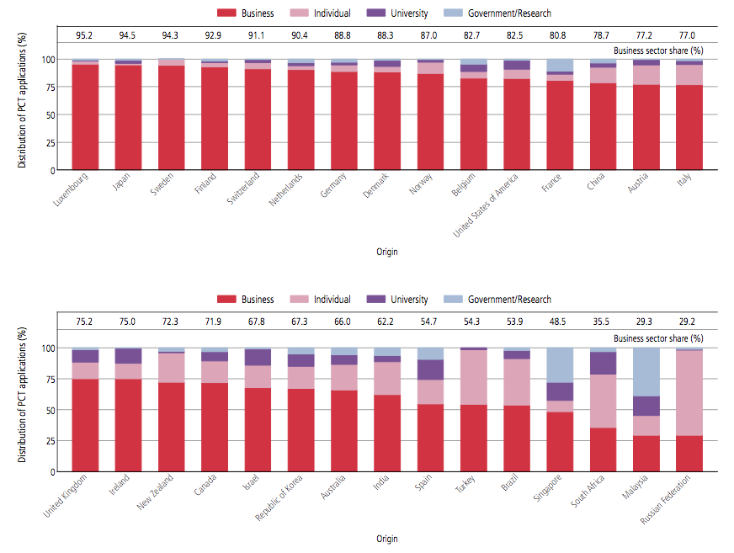

**Figure 9: Distribution of PCT applications by type of applicant for top 30 origins, 2011.[62]**

As evident in **Figure 9**, the share of PCT applications arising from business entities dominates in many countries of origin. Even though patents are often transferred after application or even grant, **Figure 9** presents an indication of the general ownership structures of patents in the respective jurisdictions.

Using a sample of German firms, scholars observed a u-shaped relationship regarding firm size and the number of patent applications: small and large size companies are reported to be the most active patent applicants, whereas mid-sizes companies exhibit less patent activity.[63] These findings suggest that mainly small and large companies contribute to the ongoing enrichment of the public domain by patent information disclosures. Seeking patent registration is an implicit management decision to eventually enrich the public domain with regard to the information embodied there in. **Table 4**, **Table 5** and **Table 6** summarize the largest pursuers of PCT applications by type of entity:

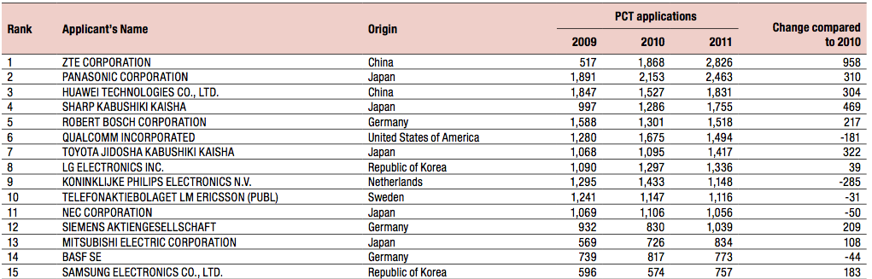

**Table 4: PCT Applications by firms.****[64]**

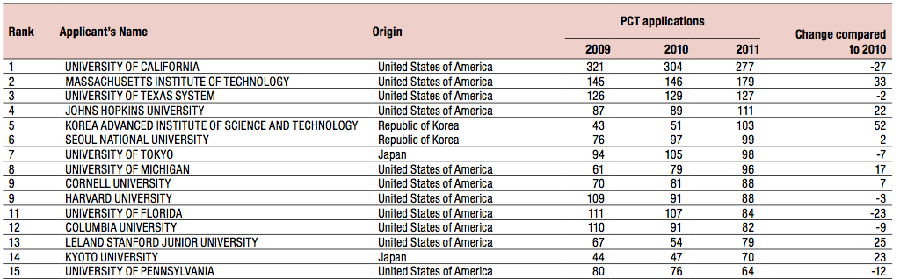

**Table 5: PCT Applications by Universities.[65]**

Comparing PCT applications for universities on a worldwide scale, **Figure 10** confirms the ranking of largest PCT filers worldwide in **Table 5**.

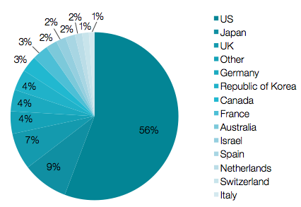

**Figure 10: PCT Patent Applications by Universities, Developed World Countries 1980-2010.****[66]**

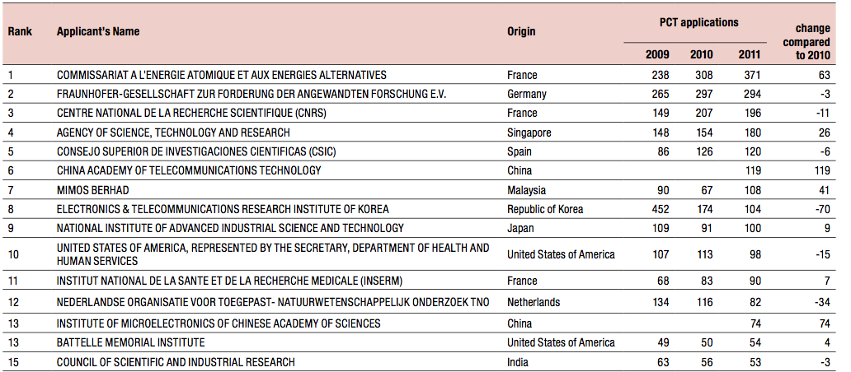

**Table 6: PCT Applications by Public/Governmental Research Organizations.[67]**

Comparing PCT applications for governmental/research organizations on a worldwide scale, the result in **Figure 11** also reflects the ranking of largest PCT filers worldwide in **Table 6**.

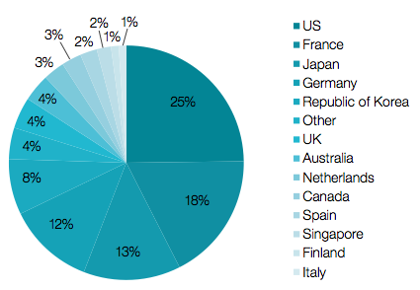

**Figure 11: PCT Patent Applications by Government/Research Organizations, Developed World Countries 1980-2010.[68]**

The trend in filings from universities and public research organizations (PRO) is growing, as can be seen over time in **Figure 12**:

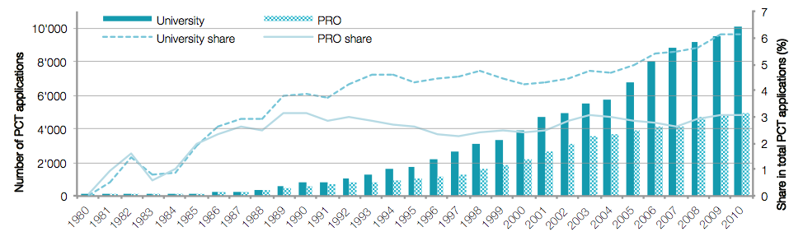

**Figure 12: Worldwide University and PRO PCT Applications over Time.[69]**

The contribution of developing countries to this growth in PCT applications is increasing: there is an ongoing trend in patenting among universities and PROs especially, in China and India, see with upward **Figure 13**:

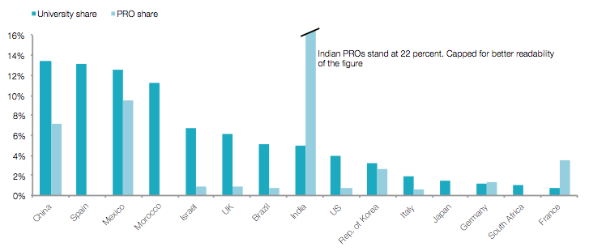

**Figure 13: University and PRO Patent Applications for Selected Countries.[70]**

1. **“Practicing” Patents – The Actors**

As characterized above in **Figure 9**, patent owners are typically individuals, institutions or businesses. Once procured, the way the patent right is used and practiced can be a further distinguishing dimension of ownership.

The term “non-practicing entity” is a diffuse and opaque depiction of a subset of patent owners. This terminology literally encompasses all entities, which own invention rights but elect for whatever reason to not practice the invention. As so conceived, this also includes universities. In what follows we endeavor to more precisely describe this sub classification within the broad group of NPE market actors.

Besides the litigation-centric definition,[71] NPEs can also be defined by their lack of capabilities, namely: “an entity that does not have the capability to design, manufacture, or distribute products with features protected by the patent.”[72] The FTC (Federal Trade Commission in the USA) follows this logic by describing the prototypical NPE activity “… as developing and transferring technology.”[73] This definition is based on a wider understanding of practicing and non-practicing entities.[74]

The following characterization of NPEs exists in the literature:

(1) Patent Assertion Entities (PAE): Acquiring patents with the aim of out-licensing (and sometimes engaging in litigation), often leveraging underutilized patents by creating a market that did not previously exist,[75] sometimes by using patents of (arguably) uncertain quality. Depending upon the business model used, litigation may only be applied as *ultima ratio*.[76]

(2) Patent Aggregators: companies acquiring patents, for both offensive and defensive purposes, sometimes acting as a PAE on a larger scale.[77]

(3) Patent Intermediaries: midstream entities, which operate between the boundaries of the entities above. They usually do not engage in litigation.

(4) Universities and research institutions.

(5) Individual inventors and

(6) Non-Competing Entities (NCE): “operating companies asserting patents outside their area of products or services.”[78]

Separately, legal professionals have introduced various sub-categories of intermediaries, presented in **Table 7**, categorizing such entities using the rubric of *IP business models:*

|  |  |  |  |
| --- | --- | --- | --- |
| **IP Business Models** | | | |
| *1* | Patent Licensing and Enforcement Companies (PLECs) | *11* | IP-Backed Lending Firms |
| *2* | Privateers | *12* | Royalty Stream Securitization Firms |
| *3* | Institutional IP Aggregators/Acquisition Funds | *13* | Analytics Software and Services Firms |
| *4* | IP/Technology Development Companies | *14* | University Technology Transfer Intermediaries |
| *5* | Licensing Agents | *15* | IP Transaction Exchanges & Trading Platforms /  IP Transaction Best Practices Development Communities |
| *6* | Litigation Finance/Investment Firms | *16* | Defensive Patent Pools, Funds and Alliances |
| *7* | IP Brokers | *17* | Technology/IP Spinout Financing Firms |
| *8* | IP-Based M&A Advisory Firms | *18* | Patent-Based Public Stock Index Publishers |
| *9* | IP Auction Houses | *19* | IP Insurance Carriers |
| *10* | On-Line IP/Technology Exchanges, Clearinghouses, Bulletin Boards, and Innovation Portals |  |  |

**Table 7: IP Business Models.[79]**

The term NPE has hence become a catch all describing a variety of entities, depending on the context applied.[80] Some NPEs, like universities, exist to grow and feed the public domain of useful human knowledge.

PAEs appear to exist to exploit patent rights. In most cases, PAEs, as we define them, do not engage in R&D. Whether or not they engage in R&D could be a distinguishing factor amongst the various types of NPEs. Some NPEs, such as PAEs, arguably do not feed the public domain other than through expiring patents. They do not sell goods or services that may advance the human condition. They do not necessarily invest licensing proceeds or revenues in subsequent R&D to improve products, services or the efficiency of markets. They do, however, use the prospect of litigation as a primary tool to motivate settlements and hence realize revenue.

It can be argued that NPEs or more specifically PAEs can offer inventors a valuable service, since they might support under-resourced inventors in getting a financial return from their patented invention (especially those who lack the necessary financial resources to enforce or commercialize their invention themselves). A reasonable question in this regard is how “efficient” is the service provided by the respective NPEs? Simply raising transaction costs may merely compromise the efficiency of the market.

Others view NPEs as a potential threat to innovation, especially in high tech industries.[81] In what follows the authors analyze NPEs, their business model and implications for the public domain, especially in the context of the United States, where NPEs are quite active.

As **Figure 14** shows, NPEs involvement in patent infringement cases has increased over time and accounts (as of 2012) for more than 60% of all patent infringement cases in the United States (see **Figure 19** for absolute numbers).

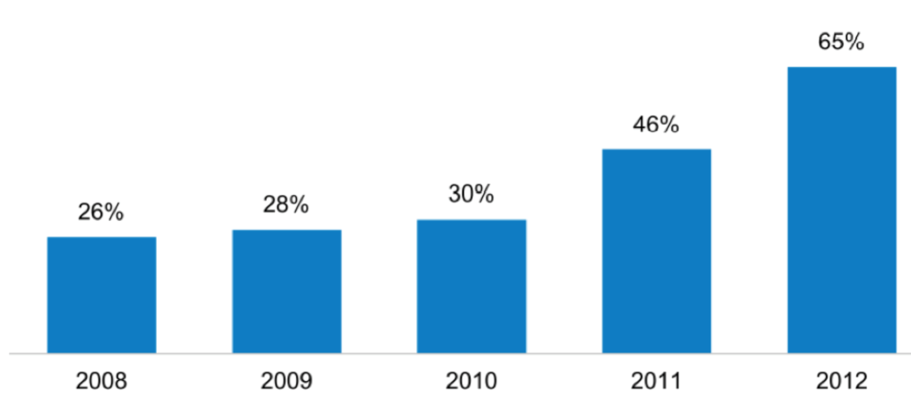

**Figure 14: NPE Cases as a % of all Patent Infringement Cases.[82]**

The increasing involvement of PAEs in patent infringement can also be measured by filing activity: nine of the ten most frequent filers of patent litigation in 2012 in the US were monetizing entities, as one study coins firms, which “…concentrate on creating income from licensing or litigating patents, rather than producing a product.”[83].

While a number of NPE types, as characterized above, may engage in litigation, some are more aggressive and opportunistic with litigation to drive settlement activities than others. In the USA the executive branch of the government has recently characterized the abusive practices of such firms.[84]

1. **Non-Competing Entities (NCE)**

An often-overlooked fact is that even entities intensively engaged in R&D activities can behave like PAEs, or at least demonstrate comparable practices. When asserting their patent portfolio (often via underused patents or patents falling outside their core business, i.e. patents not employed in their usual line of products or services), such practicing entities have been called NCEs or *corporate trolls*. [85] As can be seen in **Figure 15**, the relevance of income from licensing activities differs amongst firms. Most firms in the sample generate income from royalty payments of less than one to three percent of annual revenue. For some companies, income from royalty payments has become a major source of revenue.

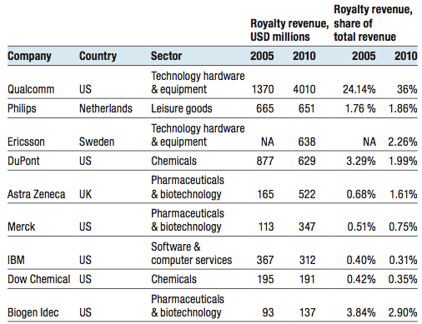

**Figure 15: Revenues from Royalties over time, selected companies.[86]**

IBM is a prominent example: a portion of IBM’s yearly stream of revenue stems solely from IP licensing – not from marketing innovations that are IP protected, but from revenue streams directly associated with the right.[87] This revenue comprises mainly payments from licensing out IP, know-how, and consulting fees.[88].Qualcomm, one of the major chip manufacturers worldwide for cell phone and wireless base stations, is another example. It licenses more than 4,500 patents to over 125 companies in the home electronics, telephone network equipment and cell phones industries, contributing a substantial share of Qualcomm’s total revenue, as can be seen in **Table 15**. Aggressive litigation can motivate settlement amongst licensees. Hence the practices of multinationals like IBM, Qualcomm or GE may fit the NPE sub classification of NCE.[89]

1. **Universities & Public Research Organizations**

Universities (at least publicly funded universities undertaking research) and public research entities such as Fraunhofer-Gesellschaft and/or CERN are generally dedicated to enrich the public domain of knowledge in a manner that improves the human condition. They are engaged in the filing of patent applications. One public research organization (PRO) active in the filing of patents (**Figure 16**) and licensing of IP (**Figure 17**) is the German Fraunhofer-Gesellschaft.

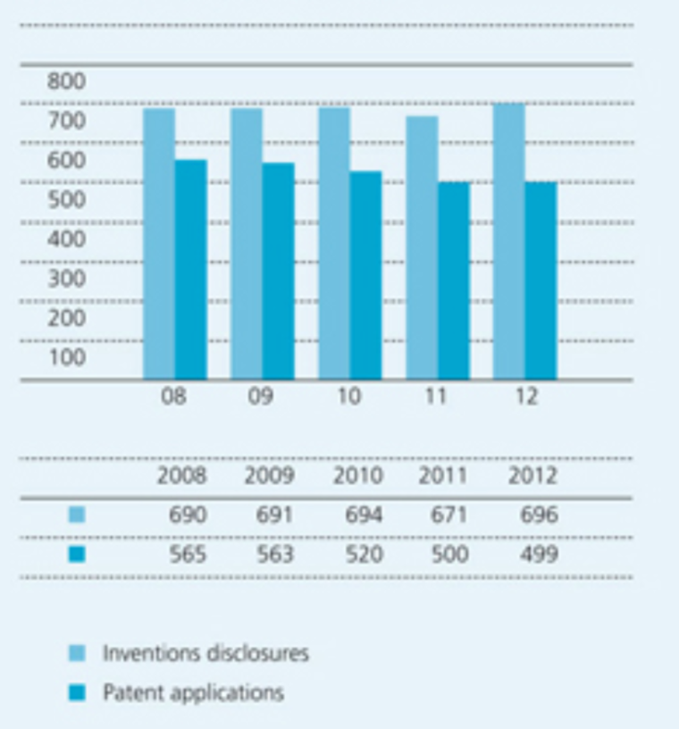

**Figure 16: Innovations and Patent Applications 2008-2012.[90]**

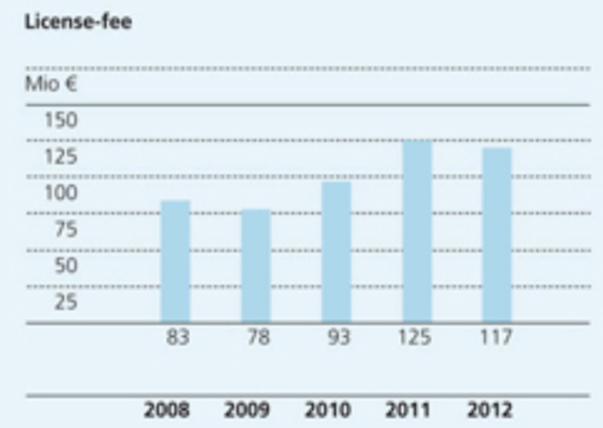

**Figure 17: License Fees 2008-2012.[91]**

In terms of universities, **Table 8** lists the self-reported licensing income of US based universities for the calendar year 2011. These are significant revenue events for the top schools (comparing licensing fees/revenue of the Fraunhofer-Gesellschaft with those top-ranked research-oriented universities in the USA would rank them amongst the top five in 2011). The possibility of large revenues tends to drive university patenting in hope of securing future income streams through the associated tech transfer. The prospect of patent litigation windfalls has recently pushed these same universities to be more litigious. In 2012 the largest jury damages award by any plaintiff in global patent litigation was earned by Carnegie Mellon University, Pittsburgh, Pennsylvania, USA based on the assertion of their private patent rights (see **Table 9**).

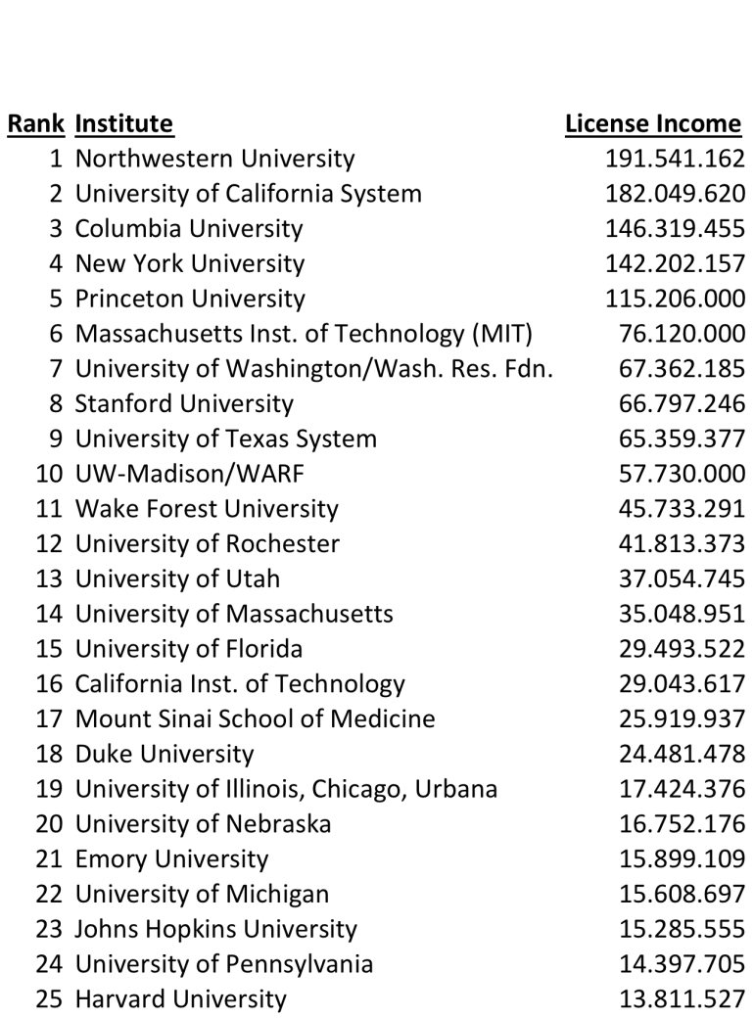

**Table 8: Licensing Revenues 2011 for the TOP 25 Universities in the USA.[92]**

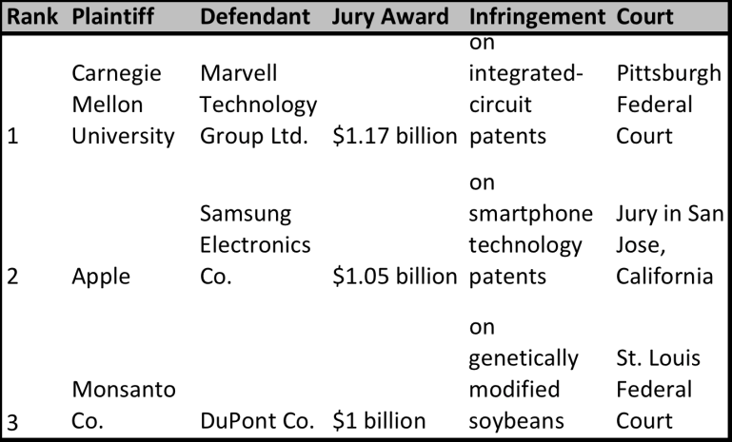

**Table 9: Largest Jury Awards in the USA, Year 2012.[93]**

It is suggested[94] that universities do not license the majority of their patented inventions. Therefore licensing revenues based on patented university research are still a scarce and unpredictable good.[95] As can be seen within the universities listed in **Table 8**, the top five universities account for 52% (USD 777million) of the revenue of the top 25 universities (USD 1.5billion), which itself accounts for around 83% of the top 150 universities (USD 1.8billion).[96]

Comparing licensing revenues to total research expenditure, licensing income (including also options and assignments) remained only a fraction of total university and PRO funding or research expenditure, see with **Table 10**:

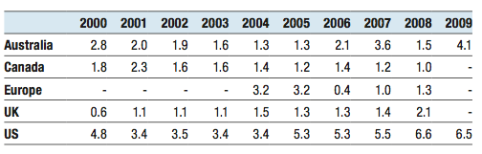

**Table 10: IP Income in% of Research Expenditure, Selected Countries.[97]**

In the case of Australia (**Table 10**), the total income from IP licensing, options and assignments revenue accounted for only 2.8% of its research expenditure in 2000. With the exception of the USA, **Table 10** does not indicate a general trend to a higher share of IP licensing income within the countries displayed.

Researchers at universities are frequently more interested in fostering the spread of knowledge through scientific publications that are not coupled with a private patent right,[98] since most incentive schemes at universities are mainly linked to the quality and quantity of academic publications. Not surprisingly, therefore, substantial knowledge created at universities remains outside the patent framework and is automatically contributed to the public domain (absent copyright restrictions) upon publication.

As can be seen from **Table 10**, the IP income in percent of expenditure is higher for the USA compared to its peers. One explanation for this discrepancy could be the Bayh-Dole Act. Enacted in the U.S. on December 12, 1980, it created a uniform patent policy for the various federal agencies that fund research, whereby the recipient entity is entitled to retain ownership of the invention made by virtue of the public funding. Universities have been perhaps the major beneficiaries of this law and it has resulted in the growth of technology transfer activities by many universities. One observer has described this Act as "[p]ossibly the most inspired piece of legislation to be enacted in America over the past half-century…"[99] It has been estimated that over 10 countries have enacted legislation based on the Bayh-Dole framework.[100]

It can be argued that by channeling university research towards disclosure of, or publications through, the patent system, the Bayh-Dole Act has the effect of ultimately releasing more information into the public domain than would otherwise be the case over the long term. Over the shorter term, however, it may lead to a diminished release of such information into the public domain. As mentioned above, academics seek to publish their results as soon as possible in order to advance their careers. On the other hand, it is possible that Bayh-Dole will lead to more research being consolidated into patents than might be the case if we simply relied on the researcher to publish his preferred results through conventional channels. Thus, even if the release is only at the expiry of the patent, it is still more likely to enter the public domain than if Bayh-Dole was not in place.

It would be interesting to further analyze in university and PRO settings whether IP-licenses under exclusive or non-exclusive terms contribute more to the enrichment of the public domain.[101]

1. **Sovereign IP Funds**

Amongst other appropriability mechanisms, patent ownership is widely perceived to offer competitive benefits to the owning individual or firm. Patent ownership can be facilitated by public fund usage in a manner that gives advantage to owners or actors of a particular nation state. The influence of public authorities and/or institutions on the markets for patent assets is increasing. State-owned investment funds comprising financial assets (e.g. stocks, bonds, property or other instruments) are often called sovereign wealth funds (SWF).[102] **Figure 18** characterized the differences between SWFs and other state-owned investment vehicles:

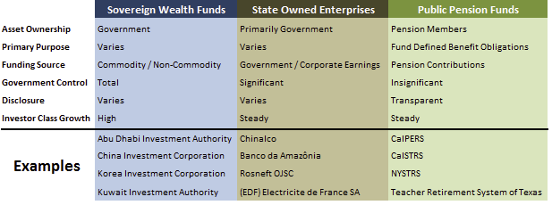

**Figure 18: Characteristics of Sovereign Investment Vehicles.[103]**

SWFs growing economic influence and importance can be seen in their assets under investment relative to hedge funds: SWFs and hedge funds assets under investment both amounted to approx. $1 trillion in 2005. This shifted to 2.2 times the number of hedge fund assets ($5 trillion to $2 trillion) under management by SWF (this number represents about one-third of the total market cap of the S&P 500).[104]

Scholars investigated SWF’s behavior in terms of technology transfer to their domestic industries. Taking over a majority stake in companies (or team up with other shareholders) is a possible avenue to initiate this technology transfer. Within the newly opened research and development facilities in the SWF’s domestic country, these firms can develop new technologies under the actual intellectual property regime of the SWF-holding country.[105]

Another strategy that could recently be observed is the targeted acquisition of IP assets by SWFs. This includes acquisitions by France Brevets, Taiwanese Patent Bank - Taiwan (Province of China), and Intellectual Discovery – South Korea. Each of these is briefly summarized:

France Brevets - France

France Brevets (FB), founded in March 2010, is the first European state-owned investment fund aiming for patents promotion and monetization, backed by €100 million, half of which was invested by the French state and half by the French Caisse des Dépôts.[106] France Brevets “…mission is to enable universities, schools of engineering and research bodies, as well as private companies to exploit their patents more effectively on an international scale, primarily through the operation of patent clusters for licensing purposes, and by promoting cross-fertilization in the management of public and private-sector patents.”[107]

Taiwanese Patent Bank - Taiwan (Province of China)

In reaction to the ongoing patent disputes that also involve Taiwanese manufacturers (e.g. Apple vs. HTC, or cases against Taiwanese LCD panel makers) the Taiwanese government amended their IP strategy in 2011, in aiming to create a "patent bank." [108] Through this bank, Taiwanese (Province of China) manufacturers will be supported in creating patent portfolios and framing patenting strategies during the R&D phase(s) and later by being backed up against suits and in expanding market share. This patent bank would be set up as a defensive patent aggregator.[109]

Intellectual Discovery – the Republic of Korea

Intellectual Discovery in South Korea was established in 2010 by the Korean government.[110] Already holding about 1,000 patents,[111] in industrial fields such as mobile communication, semiconductor, network, energy, etc., Intellectual Discovery describes its business model as “…operating a program for sharing patents necessary for technology development of various industrial groups and providing licenses thereof… [and providing] various licensing opportunities to return reasonable compensation for the values of patents owned by individual inventors, universities, research institutes and companies.”[112]

A useful way to analyze the effect of SWFs on the public domain is to focus on the main activity or activities of each. For example, as described above, the Taiwanese Bank could be classified as a defensive patent aggregator. As such, our comments herein about patent aggregators can be seen as applicable here as well. This derivative approach to understanding the relationship between a given SWF and the public domain can be then applied more generally.

1. **Patent Litigation as Business Model?**

While it is difficult to generalize the public domain impact of NPEs such as SWFs, this challenge increases when evaluating other types of NPEs that use the risk of potential patent litigation to force settlements. A commonality in these types of NPE’s is the centrality of patent litigation as an expense item in the business model, which has gained increased attention during recent years.

High US$ infringement lawsuits or out of court settlements with payments in three-digit millions dollars have peaked public interest towards these business models.[113] The increased attention can also be verified by the increase in number of NPE lawsuits against practicing entities over time. **Figure 19** shows an increase in the average number of lawsuits involving NPEs in the USA from around 200 (per year between 2001 to 2004) to around 3.000 (year 2012), whereas **Figure 20** displays the average number of companies involved in these lawsuits in the USA: from around 600 (per year between 2001 and 2004) to around 4.000+ (per year between 2010 to 2012).

Who are the NPEs that either engage in this litigation and/or act as intermediaries to benefit from the risks of uncertainties inherent in this kind of litigious market environment? In what follows, we further characterize PAEs and offensive patent aggregators.

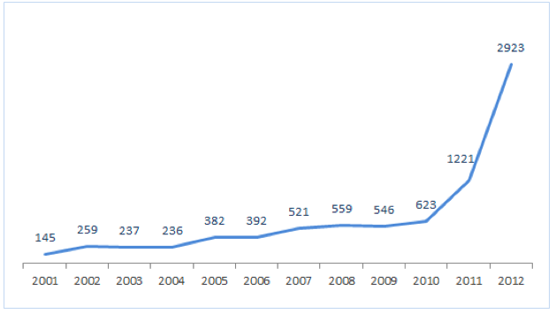

**Figure 19: Lawsuits involving NPEs over time.[114]**

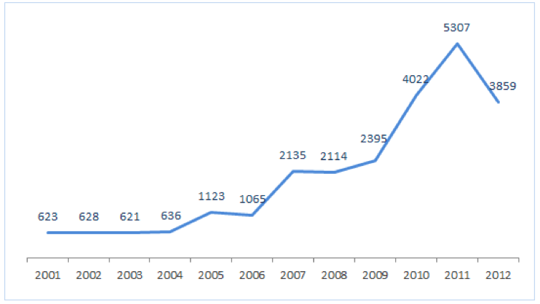

**Figure 20: Practicing Entities involved in NPE Lawsuits over time.[115]**

1. **Patent Assertion Entities (PAE)**

Patent Assertion Entities or PAEs can be anybody using patented inventions not to monetize them through product or process commercialization but rather solely to enforce their patent rights. “Enforcing” in this context does not necessarily imply legal engagement. The potential threat of legal consequences by not entering into a proposed licensing agreement can also be seen as a form of “enforcement” of the patent right.

The role of opportunistic, aggressive legal agents in enabling enforcement is not new. As such, PAE type behavior has existed in the market place for some time:

*“[A]mong a host of dormant patents, some will be found which contain some new principle . . . which the inventor, however, had failed to render of any use in his own invention. And some other inventor, ignorant that such a principle had been discovered... had the genius to render it of great practical value . . . when, lo! the patent-sharks among the legal profession, always on the watch for such cases, go to the first patentee and, for a song, procure an assignment of his useless patent, and at once proceed to levy black-mail upon the inventor of the valuable patent.”*[116]

Note that the above is a quotation from a US Senator and former Chief Justice of the Michigan Supreme Court given in 1878. Hence the PAE business model and patent acquisition model has been practiced in the US for more than 130 years.

The former general counsel of Sun Microsystems, Mike Dillon,[117] depicts infringement actions by PAEs to be “… a destructive perversion of the intent behind the U.S. patent system. The plaintiffs in these cases are not investing in R&D to promote the progress of science and useful arts", nor are they adding value to society. Instead, they are using the current system to maximize lucrative settlements.” PAEs do not engage in the pursuit of knowledge sense, nor in undertaking any R&D or in following the traditional scientific inquiry.

As mentioned above, the definition of NPEs and PAEs varies by context and source. In order to point to the potential size and influence of PAEs, **Table 11** presents some of the NPEs that may fall into the category of PAEs, ranked as per size of their patent holdings.

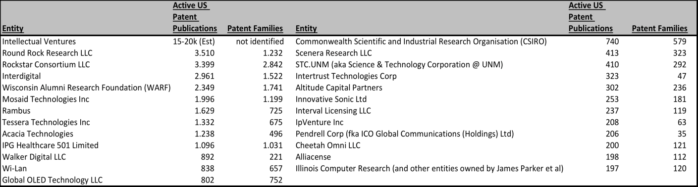

**Table 11: Largest NPEs by Patent Holdings.[118]**

Scholars [119] detected three characteristics that increase the probability of a patent being purchased by a PAE rather than by a practicing entity:

* + - 1. scope of the patent, i.e. infringement probability,
      2. the technology’s field patent density, i.e. effort and cost of alternative innovations and protection mechanisms through e.g. patenting around and
      3. quality of the patent, i.e. its likelihood of endorsement in court.

The third characteristic may be surprising:[120] Scholars suggest that PAEs acquire high quality[121] patents rather than relying on patents of questionable quality (a presumed effect of the patent offices being understaffed and therefore perhaps issuing questionable quality patents).[122] This makes sense from the perspective of positive litigation probability outcomes.

Opportunistically seeking patents for new technologies that they can acquire, PAEs may be active participants on the market for technology exchange, both on the sell and buy side of the market. As sellers, their business model relies on licensing or technology sales transactions to generate profits. On the buy side, as mentioned above, they seek to acquire technology suited to their business model. However, unlike other players in the technology-licensing field, they normally do not offer licenses of their technology upfront on the market (ex-ante), as do e.g. technology vendors, but tend to act upon evidence of infringement (ex-post).[123] This is not to say that the original inventor did not attempt to license ex ante but finally had to resort to litigate (ex post) often on a contingency fee basis to realize a return.

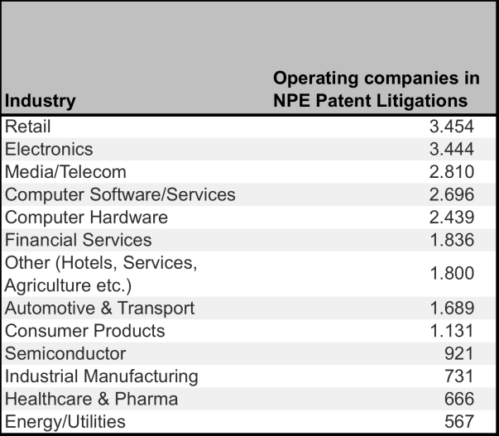

**Table 12: NPE Patent Litigation by Industry.[124]**

After having identified potential infringers, the rights holder will file suit against them, in some cases without upfront notice or contact. **Table 12** gives a broad indication of firms under NPE litigation activity per industry in January 2013. Per this analysis, companies in retail and technological fields are most likely to be faced with litigation from NPEs.[125]

Such patent owners will frequently file suit in a jurisdiction that is deemed friendly to patent owner plaintiffs.[126] Often the marketing literature of such PAEs consists of an infringement claim chart.

Usually the financial risk for the PAE plaintiffs is limited, since they may employ so called “contingency lawyers,” who are compensated based on what they receive through settlement or trial – on average between 30% and 50% of any recovery.[127]

A defendant company targeted by PAE litigation has mainly two options to react to the upcoming lawsuit: (1) to settle before trial or potential preliminary injunction, bypassing the risk of a sizable judgment and with it the threat of being banned to ship its products or (2) fight in court. The relevance of damage awards can be observed in **Table 13**, which includes damage award numbers realized by both practicing and non-practicing entities:

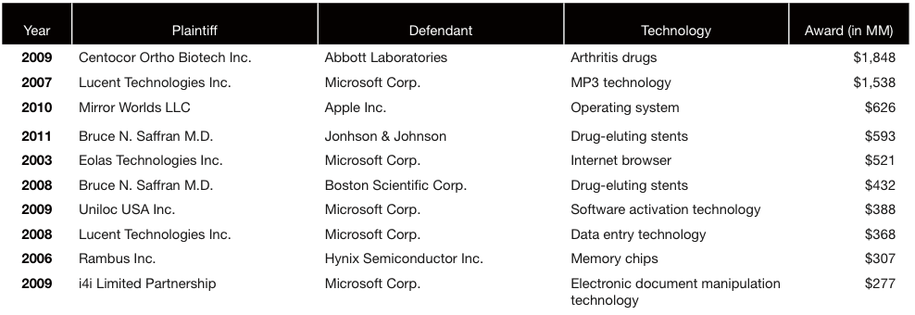

**Table 13: Top Ten Largest Initial Adjudicated Damages Awards 1995-2011.[128]**

As to these statistics, itwould appear that US-based patent litigation is a high stakes venture, particularly for practicing entity defendants.

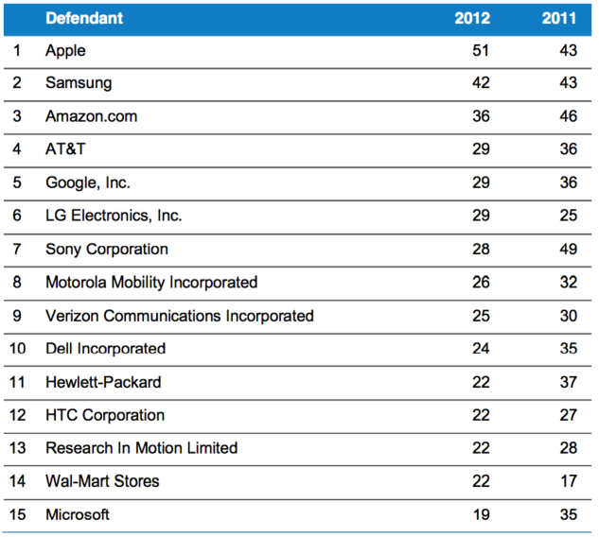

**Table 14: Top NPE Defendants by Number of new Cases filed.****[129]**

Other statistics[130] from RPX claimed that most companies being targeted are smaller both in size and revenue. However, per **Table 14**, big companies with successful product innovations are the preferred targets of NPEs.[131]

Conclusions or observations that may be motivated by the recent rising number of PAE lawsuits[132] should consider that this may be an unintended consequence of changes in the law. Until the recent AIA (*America Invents Act* of 2011), each (NPE) plaintiff was able to list many defendants. Recent changes in US law (as part of the AIA) limited the number of defendants in a US federal patent infringement case. NPEs, and especially PAEs, may be responding by simply filing more cases. More longitudinal data after this change in law is necessary to better assess the impact of the AIA on the filing behavior of NPEs.

Considering all of the above, the effect of PAE activity seems to shrink the de-facto public domain. This is because they make it less likely that actors can rely on the probabilistic likelihood that no action will be taken against them, despite the fact that PAEs are not otherwise engaged in practicing the invention (or in conducting R&D themselves) and hence there is no competitive relationship between the parties.

1. **Patent Aggregators**

Patent Aggregators procure patents from various sources, including inventors, with the aim of eventually extracting monetary value from them. Perhaps the best example of a patent aggregator is Intellectual Ventures (IV). Founded in 2000 by two former high-ranking Microsoft employees, IV has accumulated approximately 30,000 patents (claiming to hold more than 40,000 IP assets),[133] ranking fourth in the list of largest patent holders in the USA in 2010.[134] Through in-house invention effort and an in-house lab, IV is also a filer of patent applications (450 patent applications filed in 2009). Individual inventors have been paid a total of $315 million to sell their patent assets to IV.[135] In addition, IV enters partnership agreements with universities, research institutes and individuals, funding their research with the goal of capitalizing on latter patented inventions, as described in **Figure 21**.

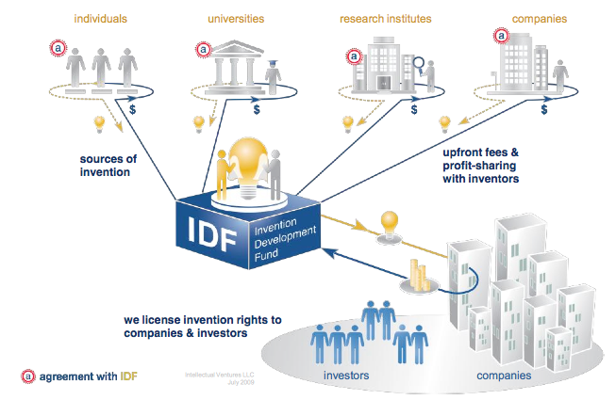

**Figure 21: IV and Partnering with Inventors.[136]**

Recently, Intellectual Ventures has been facing increasing pressure to monetize its aggregated patent portfolio. The founder once explained Intellectual Ventures and its $5 billion in funds as a venture capital funding operation. Researchers at the University of California's Hastings School of Law suggest that successful 10-year funds of that size would need to generate $40 billion in revenue.[137] Even for a portfolio with 40.000 IP assets under management, this figure looks challenging to achieve through licensing revenues or partnerships.

Another option to monetize the portfolio is litigation. The founder once stated in 2006 “… I've never filed a patent lawsuit. I hope never to file a patent lawsuit. That may be unrealistic, but it would be great if I could avoid doing it.... Lawsuits are a ridiculous way to do business.”[138]

However, in January 2013, Microsemi became the fifth company, which recently settled a patent infringement suit with Intellectual Ventures (following prior settled lawsuits involving camera-maker Olympus, SK Hynix, Elpida and McAfee), indicating a rise in patent assertion activities by IV.[139]

Intellectual Ventures’ potential success with litigation is fostered by the extent of aggregation of patents, giving it a unique position in the market. Instead of basing an infringement suit only on one or a few patents, IV is able to combine patents it accessed from various sources to make an infringement lawsuit more difficult to successfully defend. Invalidating one patent might be a successful approach for some defendants, but invalidating multiple patents is, in practice, more difficult, especially when they build on each other or cover related inventions. The preferred result from filing lawsuits is for the defendants to enter into licenses "to compensate … IV for the value of the inventions they use…."[140]

Here, as well, the issue of patent aggregation in the service of patent assertion impacts primarily on the scope of the de-facto public domain. One way to neutralize that effect would be to withdraw patents from the market before they get acquired. This “drying” of the market would deprive such entities of their business currency.

1. **Patent Intermediaries**

Patent market intermediaries come in many shapes and sizes including patent risk solutions providers, patent transaction market enablers and patent pools that play a variety of roles and may arguably impact the public domain.

1. **Patent Risk Solution Providers: RPX & AST**

RPX Corporation (RPX) and Allied Security Trust (AST) are forms of NPE’s that offer to mitigate the risk of exposure to infringement litigation by purchasing patents (no in-house R&D) that may otherwise fall into the hands of PAEs. These companies are also called defensive patent aggregators. **Figure 22** compares these two firms:



**Figure 22: RPX Corporation (RPX) vs. Allied Security Trust (AST).[141]**

RPX and AST acquire patents of interest to limit the exposure of members/subscribers (RPX customers) to infringement litigation. The approach is twofold: by actively acquiring patents, companies like RPX attempt to “dry out” the market for patents. The acquired patents form a pool to which RPX members are granted immediate benefit based on an annual subscription. Annual subscription fees facilitate a license to the current portfolio (**Figure 23** shows the portfolio growth over time), which gives companies broader freedom to operate.[142]

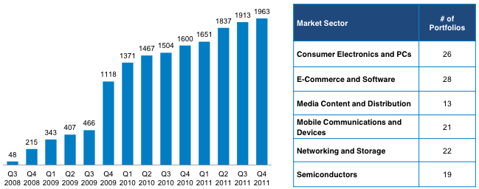

**Figure 23: Cumulative RPX Patent Portfolio and Portfolio Rights Growth.[143]**

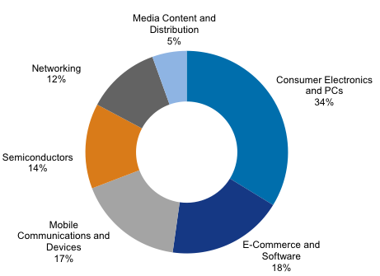

**Figure 24: RPX Network Composition by Revenue.[144]**

The majority of RPX members come from the consumer electronics, e-commerce and mobile devices industries. The cost of the annual subscription is related to firm size.[145]

Neither RPX nor AST have initiated patent infringement litigation. As defensive patent aggregators they *have effectively* placed these patents within the de-facto public domain. Will this lead to a “free-rider-mentality” among potential future customers i.e. why should a potential customer of RPX become a subscriber when patents of interest are already in the RPX portfolio? Since they will not be enforced by RPX, the potential customer has reduced legal exposure to them and *free rides* on the payment of other subscribers. This possibility underscores the difference between a systemic use of the de-facto public domain, as exemplified by defensive patent aggregators, and actors that rely on the de-facto public domain based on probabilistic considerations.

1. **Patents as Trading Goods on an Active Market**

Online IP platforms (for example Tynax.com or Yet2.com) attempt to match buyers and sellers interested in acquiring IP. Such platforms list detailed information and requirements about the patents or technology for sale or sought. Another example is Intellectual Property Exchange International, Inc. (IPXI). Its declared mission is to “…to meet the price discovery, transaction, and data distribution needs of IP-owners, investors and traders, as well as other market participants by creating the central marketplace for IP assets and trading products.”[146] These privately organized exchanges indicate market reactions to the need of more transparency and the changing IP business landscape through the emergence of NPEs (especially PAEs). Nevertheless, it does not appear, based on their current forms of activity, that such platforms impact directly the de-facto public domain or lead to maintenance or enforcement of patent rights that might otherwise be in any form of the public domain. It is clear, however, that unlike aggregators such as IV, these entities themselves do not always create new patentable knowledge to feed the richness of the public domain.

1. **Patent Pools[147]**

A patent pool is described as “…the aggregation of intellectual property rights which are the subject of cross-licensing, whether they are transferred directly by patentee to licensee or through some medium, such as a joint venture, set up specifically to administer the patent pool.”[148] It is an agreement under which IP rights of various owners are bundled with the usual goal of licensing them amongst the pool members or also to external parties.

One of the aims of patent pools is to mitigate risk. Various companies contribute patents (mainly from proprietary R&D), usually into a joint venture or via cross-licenses, to avoid costly litigation among each other and to ensure freedom to operate.[149] Usually, patent pools are formed for multi-purposes with a specific long-term goal, as did e.g. the DVD 6C/3C Patent Pools: the DVD technology has been the biggest success in home video entertainment since VHS. This can, in part, be explained by patent pools including the major players of the entertainment industries at that time. However, as with any patented invention, pooled patents may pose a barrier to entry for those not included in the pool.[150]

Patent pools increase the ability of doing business for companies by enhancing the innovation base on which to build their products. They seem to favor a more conservative approach to infringement lawsuits, which might not only enhance the innovation output of companies within the pool, but also of competition outside the pool.

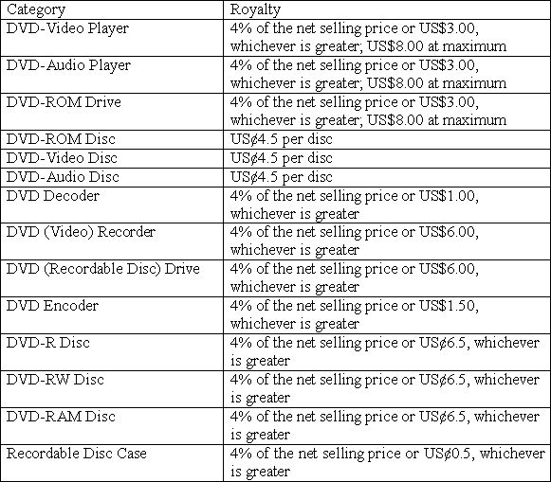

**Table 15: DVD6C Licensing Group, Licensing Fees, January 2005.[151]**

**Figure 25** and **Figure 26** show that the popularity of patent pools over the last century varies over time and within industries.

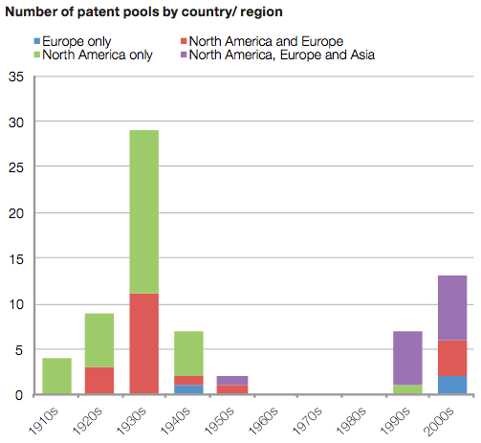

**Figure 25: Popularity of Patent Pools.[152]**

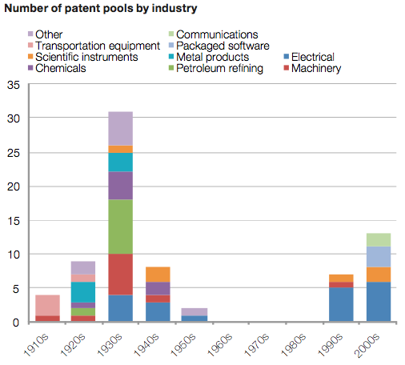

**Figure 26: Patents Pools by Industry.[153]**

No generalizable conclusions can be offered regarding the effect of patent pools on the public domain. Unlike defensive patent aggregators, which allow potential "free riding" behavior but which do not otherwise constrain behavior, patent pools may potentially enable anti-competitive conduct. As suggested in the DVD-consortia case, patent pools might be seen as potentially granting or denying access to entire markets. Often, patents included in a pool are more of a substitute nature, thereby possibly leading to higher prices (due to accumulated, increased licensing fees), which might then present lower incentives for companies to innovate, hence less new knowledge being created and ultimately released into the public domain. Seen in this way, patent pools might lie outside the pale of what constitutes the de-facto public domain.

Patent pools in and of themselves do not create knowledge that feeds the richness of the public domain. They are patent aggregation and rights governance vehicles that reduce transactions costs for those that contribute to the pool.

1. **Other Patent Intermediaries**

Another way for companies to react to litigation threats of PAE's is *crowdsourced* intellectual property research. Despite the argument that PAE's seem generally to acquire patents of reasonable or even high quality, sometimes PAE's do acquire and then seek to assert poorer quality patents. Given the growth of patent activity, represented for example in **Figure 5**, it is difficult, even for resource rich entities, to survey and analyze this knowledge disclosed. Increasing efforts might be necessary to legally challenge the quality of asserted patents, especially in terms of novelty and distinctiveness. This makes it more difficult that relevant prior art will be identified; hence invalidation of patents being asserted might be less likely.

Companies (such as Article One, Patexia, or Ask Patents), acting as intermediaries, offer solutions to this problem by using means of crowdsourcing.[154] For instance, Article One offers a platform on which companies can post the relevant patent study/search in question. The Article One community of independent (free-lance) researchers worldwide then checks on novelty by searching for prior art in various forms: prior art could be found in form of patents, articles and the like. Should a researcher find suitable prior art he will be rewarded financially for his efforts.[155] One obstacle of this crowdfunded intermediary model is that it mainly serves the interest of resource-rich multinational entities, which are often the prominent targets of patent infringement lawsuits.[156]

By providing companies with another means to challenge patents of questionable quality, the crowdsourcing intermediary model might also have a positive effect on the public domain. This is not only with respect to improving patent quality, but also in improving the patent filing and prosecution process. The 2011 Leahy-Smith America Invents Act in the USA grants researchers and patent attorneys the right to electronically file evidence related to pending applications.[157] This evidence could support patent examiners in evaluating the quality or patentability of inventions. This could not only contribute to growth in the known information realm (and after patent expiry in the universe of known and freely accessible information), but also serve the sole inventor who could rely more on the quality of patents issued. Further, in terms of our model, these benefits could be expressed most notably in the “Potentially Disputed Territory” (see in **Figure 4**), by providing that inventions not worthy of patent protection are not registered *ab initio*. As well, it could make it easier and more efficient for parties to successfully challenge granted patents, thereby enabling the associated patent information to enter the public domain.

1. **NPE's Interplay and Effect on the Public Domain**

In **Figure 27** and **Figure 28** we sum up the classification of NPEs described in Part II. Using linear representations in the form of two graphical continua we attempt to illustrate and compare the contribution of each type of entity to the public domain and the propensity of each entity as patent holder to enforce its rights.

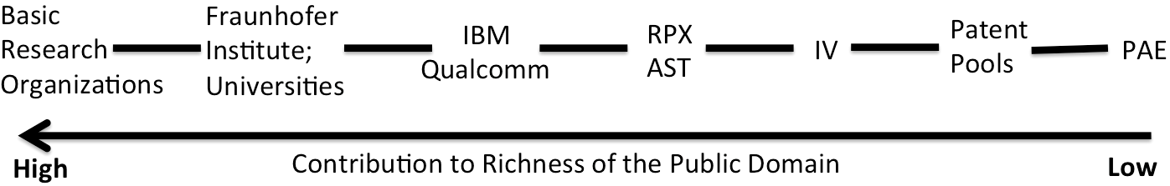

**Figure 27: NPE’s Contribution to Richness of the Public Domain.[158]**

Research organizations (here in the broader sense, also including universities undertaking research), are not all identical in their behavior, especially in disposing of or commercializing their research results. Basic research organizations such as CERN tend to undertake mostly fundamental research with a low degree of commercialization. Hence, its involvement in litigation is minimal. Other institutes, such as the Fraunhofer Gesellschaft or universities, are more active players in licensing or litigating the fruits of their research endeavors, as mentioned above.[159]

One might ask why patent aggregators as IV, who perform proprietary R&D and also engage in patenting their inventions, contribute less to the public domain than patent intermediaries as RPX. As mentioned above, RPX does not enforce their patent rights, hereby also enabling firms, which did not subscribe to RPX, to free ride on their patent-portfolio as if these patents had been contributed to the public domain.

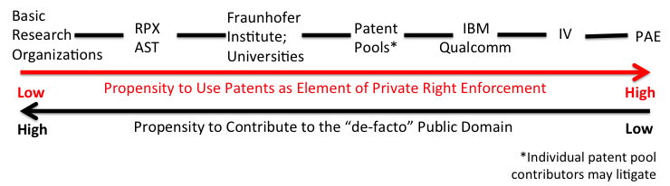

**Figure 28: NPE’s Propensity to Use Patents as Element of Private Right Enforcement.[160]**

As can be seen, the order of the entities along the continua differs depending upon which aspect of the public domain is being described. Overall, there is a tendency towards an inverse relationship: entities that contribute more to the richness of the public domain tend to a lower propensity to use patents as elements of private rights enforcement, hence tend to a higher propensity to contribute to the “de-facto" public domain.

In the light of the above, the authors would be remiss if they did not address the argument in favor of the potential social and economic benefits that derive from the activities of PAE's. The view is often expressed that PAEs are entities that drive up cost of innovations through transaction cost inefficiencies without providing any benefit to the public.[161] What is forgotten in such narratives is that inventors are not always (indeed, not usually) successful in commercializing their invention themselves, therefore monetizing them by selling the invention to non-practicing entities, especially PAEs, might be the only practicable way for them to financially benefit from their patented invention. In certain cases, PAEs invest in inventors even before the related patents issue, with the result that the invention will more likely be disclosed, with the concomitant eventual benefit to the public domain. Stated otherwise, “[a]n inventor’s patent helps to level the economic playing field by making it difficult for dominant market enterprises to ignore inventors.”[162] Without a plethora of options for monetizing patents, in whatever form, fewer incentives for people to innovate will entail fewer patented inventions, ultimately decreasing the flow of knowledge disclosed to and entering the public domain.

Still, in the case of NPEs, it is argued that patent rights and the uncertainties around the legal liabilities that they may create effectively increase the cost of doing business: some see intellectual property as a sort of innovation tax,[163] increasing not only the costs of products for the end-user, but also limiting the flow into and amount of knowledge within the public domain.[164] Assuming this argument of intellectual property as an innovation tax is valid, it should be considered in the broader context of doing business: IP laws are not the only laws that exist and that drive up costs for doing business: health laws, safety laws, labor laws, environmental laws (just to name a few) increase the cost of doing business (extent depends on the jurisdiction, public perception of values, industry settings etc.). As such, intellectual property (here patents), is just another cost businesses have to bear to encourage and motivate innovating activities for the greater public benefit.[165]

Possible inefficiencies of the patent system are not *caused* by NPEs. NPEs, and especially PAEs, might make these inefficiencies of the patent system more visible, such as patent offices struggling to handle the ever-increasing workload of patent applications, and the seemingly repeated granting of poor quality patents. Thus, the question of whether NPEs are enriching the public domain (welfare enhancing or welfare decreasing) is a reasonable research query.

Some market participants in the USA, being the dominant market for NPEs, seek to limit the economic incentives for NPEs, especially for the PAE business model, by amending the existing laws. The Shield Act (Secure High-voltage Infrastructure for Electricity from Lethal Damage) has been brought on and may possibly be signed into law in the foreseeable future.[166] The Shield Act in its proposed form would require a NPE to pay the legal costs of an infringement lawsuit in case the ruling court decides that the law suit does not demonstrate a reasonable likelihood of succeeding (“loser pays rule”).[167] The Shield Act would span over few industries, namely software and computer hardware patents. Its justification is controversial: supporters of the act claim that the act would protect technology companies by shifting the financial burden on the plaintiff, which “buy the patents solely to sue the American tech startups that created the products.”[168] Opponents to the act, such as the AIPR (American Innovators for Patent Reform), view the act as “anti-innovation and pro-monopoly, making it easier for computer industry giants to infringe patents, and more difficult for innovators to enforce their IP rights.”[169]

Given the above, might NPEs ultimately contribute to an enrichment of the public domain by forcing companies to monitor more carefully their intellectual property position and, as appropriate, by investing more in capabilities to invent around, to improve, ultimately enlarging the public domain? If so, the result might be for companies to resist settling lawsuits brought by NPE's at an early stage, leading to a potential disruption especially in the PAE infringement-business model.

The IP business solution provider Innography summarizes the NPE experience as follows: “The primary lesson we learn from NPEs is that they know exactly the outcome they want before they make contact; they either want to sell you something they own, buy or license something you own or seek damages through litigation. They will use all the leverage they have, so it is important to understand your portfolio and have a solid plan in place to defend it.”[170] It is the authors’ interpretation that the NPEs referenced in the white paper by Innography are actually PAEs.

The situation of firms stretching the boundaries of the patent system is not a new phenomenon. It has already been observed at various occasions in time. For example, in the late 19th century, railroad technology owners preferred technical cooperation with rivals to using their intellectual property to delineate property rights.[171] In that sense the market “regulated” monetization activities by (1) railroad firms sticking together and fighting all claims of infringement, and (2) patent claims becoming “narrower and clearer, as railroad technology became more codified.”[172]

Similar tendencies can be observed today through the emergence of above described patent intermediaries: pooling patents to shield against potential infringement law suits (e.g. via companies as RPX), patent pools to combine know-how and simplify technology transfer, active trading markets for patents, and the like.

**Part III: Patent Management – Interplay and Effect on Public domain**

In the previous section the authors attempt to characterize the full breadth of NPEs and speculated how their business model may impact the richness of the public domain as defined in Part I. In this section we describe patent practices of entities more broadly and consider the possible impacts on the public domain.

1. **Patenting and the Innovation Process**
2. **Patent Awareness**

Do patents spur the innovation process? This issue is often brought up in connection with the pharmaceutical industry: the high cost of patented prescription drugs may prevent some patients from being treated with life-saving medications. Even though this may occur during the period of patent protection, would a reduction in price or in economic value of patents, e.g. by limiting the availability of compensation for infringement, pose a solution? Of course, in this way, availability of medications would be more widespread (and presumably at a cheaper price). But how might such policies impact the incentives to undertake risky R&D for a market with lower barriers to entry?

1. **Incremental Improvements and Tree of Subsequent Knowledge Release**

In general, most patents granted are improvements in a crowded art, since only few patents are issued for truly pioneering inventions.[173]

To improve means[174] to “… advance or make progress in what is desirable..., to make useful additions or amendments… [or to] enhance in value or quality…,” in simple terms:[175] “…to make something better.” A prior invention needs to exist to enable someone to copy, transform or combine it, hence to improve on it.[176]

However, the existence of an invention alone does not mean that it is openly available and accessible to everyone. An invention might be protected as a trade secret, so the potential group of people being able to build further upon and to improve it will be small. Patents, by disclosing the invention, make this underlying invention freely and easily available and accessible. Patent databases even foster the availability of *ready-to-improve-on-knowledge* ever further, serving as an accelerator in the flow of knowledge.

Successful patented inventions encourage more innovation. If a new product opens up a new product category, it can often be observed that this new product provides incentives for other companies to develop products with similar or even superior capabilities in order to capitalize on the established market. This behavior might be referred to as a virtuous cycle of invention and innovation in the interest of social welfare. A good example is the drug Losec (named Prilosec[177] in the US, compound: Omeprazole, FDA approval in 1989) from AstraZeneca, which became the best-selling drug in the world in 2000.[178] It treated heartburn more efficaciously and opened up the market for the so-called PPI category, the proton pump inhibitors (PPI). Soon after other drugs in the same category entered, such as Prevacid[179] (compound: Lansoprazole, FDA approval in 1995) or Protonix[180] (compound: Pantoprazole Sodium, FDA approval in 2001).

How does this relate to firms, invention activities and the public domain? Many businesses see themselves faced with boundaries in which to operate, due to restrictions imposed by the intellectual property being owned by others. When successfully negotiating or other commercial options are not promising, the only way to be able to continue operating might be to find something new: to innovate, or to invent around, as happened in the PPI market context.

Such companies, inventing around existing intellectual property boundaries, made it possible, because they were aware of these boundaries: they had been publicly disclosed, so they knew where they were restricted and on what grounds they could potentially build upon existing information. Thus, for example, Takeda (with Prevacid) and Wyeth (with Protonix) were motivated to invent around the patent on the Omeprazole compound held by AstraZeneca in order to successfully enter the growing market for PPIs.

These new, additional inventions did not only have the described effect on the micro level, viz. creation or re-invention of (new) products, but also have an impact on the macro level: new knowledge was being created and subsequently released to the knowledge base, eventually enriching and enhancing the public domain. Thus, over time, the patents on the compounds for Prilosec, Protonix and Prevacid have all expired and have moved to the public domain.

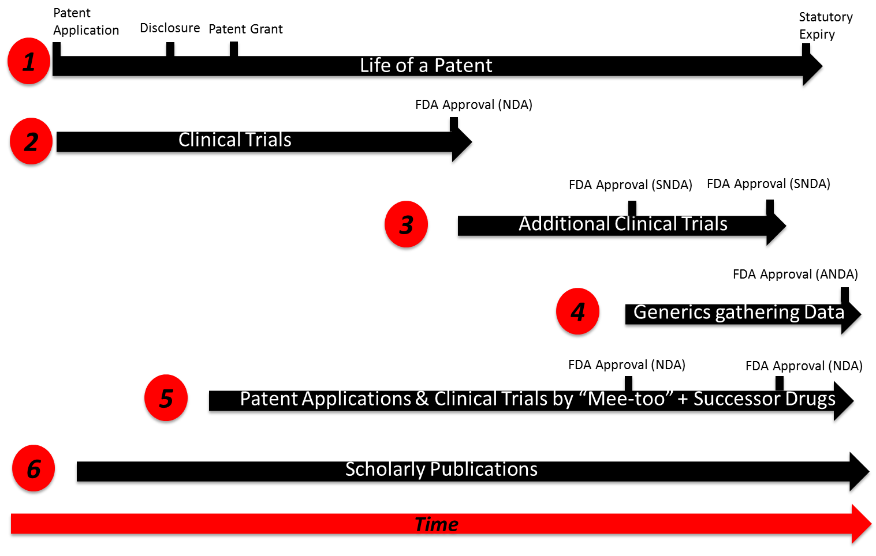

**Figure 29: Subsequent Knowledge Release through Patents.[181]**

Knowledge embodied within the patent or knowledge originating from the original omeprazole compound patent (as seen in the competing PPI compounds above) is enriching the public domain. Building on the example of the PPI category drug Prilosec, a *tree of subsequent knowledge release* can be derived from the original patent disclosure, as displayed with **Figure 29**. Thus knowledge based and derived from a patent (timeline 1 in **Figure 29**) contributes to an enrichment of the public domain: to receive approval of a new drug, firms have to conduct a series of clinical trials (e.g. for patient treatment and variety of the drug), generating and releasing additional information (timeline 2 in **Figure 29**).

Subsequent to approval and marketing of the original drug, further clinical trials are conducted to investigate drug interaction and long-term effects and to prove efficacy of the drug for other disease indications (timeline 3 in **Figure 29**). Generic manufacturers (timeline 4 in **Figure 29**) are preparing and releasing their own data to the public to demonstrate the necessary conditions (e.g. bioequivalence) to finally realize an approved ANDA (abbreviated new drug application) for the generic version of the drug.[182]

Successor and generic drugs, as seen in the example of Prilosec and the PPI market context above, also produce and release proprietary data, ultimately enriching the public domain further (timeline 5 in **Figure 29**). Scholarly publications (timeline 6 in **Figure 29**) are usually accompanying the knowledge creation and distribution process throughout the lifetime of the product or invention, generating an additional, original out-flow of knowledge and into the public domain. All knowledge streams to the public domain in timeline 2-6 are a consequence of the original patent (disclosure) and its subsequent commercial success.

Contributions from the design around effect are many: most importantly, the accumulation of knowledge, grounded in the disclosure of prior knowledge through the patent. The effect of this begins to manifest from the moment of disclosure. Note: it is not necessary that this information be both free and accessible; simple disclosure can trigger the Prevacid and Protonix *design around effect*.

The use permission barriers of IP rights may cause a small fraction of actors to refrain from starting up an innovation project or leading to abandonment of an existing innovation project. As seen above, competitor firms more typically adapt their innovation project or invest in outside intellectual property to cope with the patents at issue (on Omeprazole). Another common practice is to simply continue innovating without considering the requisite intellectual property.[183] This approach might be legally questionable, but will also likely result in an increase in knowledge in the public domain (assuming some form of disclosure).

Patentees often seek patent protection before evaluating whether the patented invention can be transformed into a marketable innovation.[184] This behavior might also be seen in respect of the following: patents are widely perceived as a sign of innovativeness and quality and hence the market signaling effect may justify the pursuit of rights independent of commercialization potential.

Recently, researchers published a quality index[185] to test whether patent process quality affects the behavior of patent applicants. The authors detected that filing behavior of applicants adapted itself to each patent system’s broad standard for patent quality. However, this finding alone revealed little evidence to conclude that a patent system with a higher ranking in the patent index is more likely to encourage patent disclosure and hence enrich the public domain. Still, the study[186] made clear that a stringent system for patent grants might not encourage innovative activity.

Only a small fraction of patents registered domestically are also registered in other countries: research shows that in the photovoltaic industry in China, only 1% of Chinese patents are also applied for abroad, compared to other countries (USA: 7%, Japan: 26%, Germany: 15%).[187] Comparable ratios have also been observed by WIPO,[188] building a hypothetical conversion ratio by analyzing the ratio between residential patent applications and PCT applications, see with **Figure 30**.

**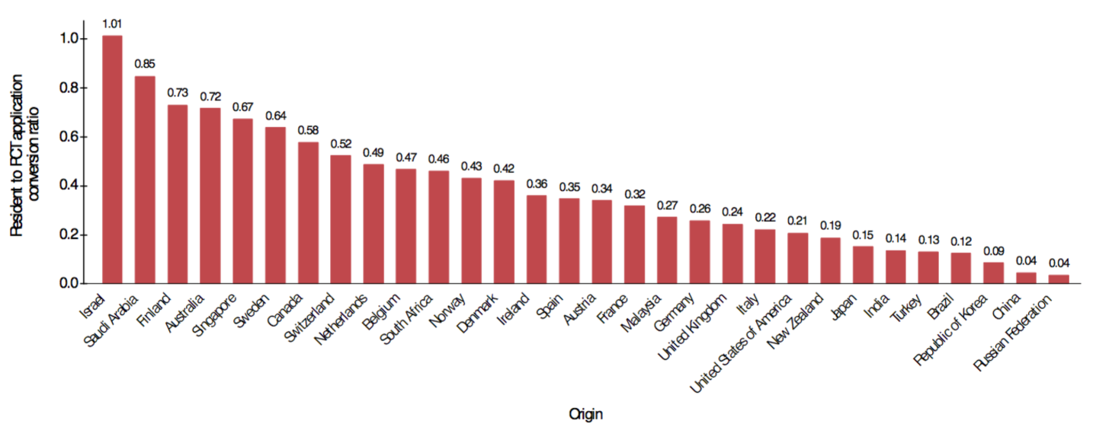****Figure 30: Ratio of Residential Applications vs. PCT Applications.[189]**

As can be seen from **Figure 30**, for example, in India only 14% of all residential patent applications are converted into PCT applications.[190] The implications for such domestic-market-centric patenting behavior on the public domain should not be ignored. In all countries in which the patent is not registered, the invention effectively enters the public domain thereby potentially enriching it immediately. This can be argued to be comparable to a royalty- free dedication of use rights to the public in all jurisdictions, except where the patent has been granted, registered and kept in force.

The example of the rise of China’s role in the photovoltaic industry (market share in cell and module production increasing from 1.6% in 2003 to a world-market leader position with 27% in 2007) suggests that intellectual property/patents do not manifest themselves as a competitive advantage in every industry. In these segments and related fields, the competition density is extremely high, preventing the technology from accumulating enough market power to lock-out followers. Further, the core technology has already been in the public domain for some time. More recently granted patents seem to mainly focus on incremental improvements. As such, they do not so broadly cover the field so as to successfully block competition, thereby enriching the public domain and encouraging further knowledge creation by competitors. The same has been observed for wind technologies or biofuel.[191]

Another interesting instance of subsequent knowledge release is the experimental use exception and, in particular, the so-called 'Bolar' exception with respect to medical products. The UK Intellectual Property Office has well-described the Bolar exception as follows:

"In order to market a medicinal product a manufacturer must first obtain regulatory approval by conducting clinical tests and trials to prove that the product is safe and effective. Producers of generic medicines are able to use the original manufacturer's approval if they can demonstrate that the generic version is bioequivalent to the approved medicine. However, the generic producer runs the risk of patent infringement if they conduct clinical trials on a patented product before the patent has expired. The 'Bolar’ exemption means that these necessary studies, tests and trials will not amount to patent infringement."[192]

Within the analytical framework developed for this report, the Bolar exemption can be viewed as a variation of the de-facto public domain. Here, the "right" to use the patented invention within the de-facto public domain is statutory in nature. As a result, the information contained in the patent has been released for use by the producer of a generic medicine for specified purposes at a point of time that precedes the expiry date of the patent. The accessibility of this information as part of the de-facto public domain means that the producer of a generic medicine will be in a position to bring the generic product to market, to the benefit of the public, earlier than if the manufacturer was required to wait until the expiry of the patent before commencing the relevant experimentation and clinical trials.

1. **Freedom to Operate**

Freedom to operate correlates with two strategies by companies, commonly known as *defensive-* and *offensive patenting*. Defensive patenting describes the process of registering or acquiring patents with the main goal of preempting the risk of litigation. This strategy may ultimately drive up the cost of doing business.[193] Offensive patenting, on the other hand, focuses on exploiting intellectual property to obtain revenues, for examples, via licensing.[194]

Interestingly, the patent portfolios of companies favoring a more defensive patenting strategy are reported to differ from those of companies pursuing offensive patent strategies. Defensive strategists obtained a higher number of citations on their patents and less oppositions to their patent portfolio.[195] These findings might help to indicate which strategy a specific company follows.

“One of the major reasons that companies get patents is that they’re afraid that their competitors have them, and they don’t want to be the only one left who doesn’t have the ability to play in this game.”[196] These defensive patenting strategies could also be flanked by strategic disclosure strategies, also known as defensive publication or preemptive publication. Scholars[197] define strategic disclosure as “… the act of defining prior art through publication that conveys no property right to the conveying party,” or simply, information that has been disclosed cannot be patented anymore (the novelty attribute is dispelled).

The effect of strategic disclosure on freedom to operate is comparable to the effect of strategic defensive patenting: competitors are not able to build barriers in which to operate or to enter the field by patenting the invention itself. Especially in cases in which the monetization of inventions seems uncertain, or the estimated costs of patent prosecution and protection seem to outweigh potential economic benefits, a strategic disclosure may offer a cost-sensitive alternative to try and ensure freedom to operate. One of the most recognized services to publicly disclose an invention is “Research Disclosure,” which describes itself as the “The industry standard defensive publication service.”[198]

Surprisingly, research shows that fewer than 30% of the firms surveyed were aware of the possibilities strategic disclosing offers. Of the various patent management practices of firms, strategic disclosure has probably the biggest impact on the public domain. Barrier-free knowledge is immediately released to the public domain, readily accessible and further exploitable with no boundaries or transaction costs (as compared with e.g., due diligence, design around, license fee, or license negotiations) attached to it. As such, a strategic disclosure may be comparable to patent donations or open innovations (see below) in its effect on the public domain.

1. **Hidden Applications**

Hidden applications, as the name suggests, are almost the diametric opposite to strategic disclosures. As a general rule, patent applications will not be released to the public knowledge base for the first 18 months (after the date of the first filing of the application). After that time, it usually is published automatically.There are exceptions, however. For example, under rule 35 U.S.C. § 122(b), all applicants who certify “… that the invention disclosed in the application has not and will not be the subject of an application filed in another country, or under a multilateral international agreement, that requires publication of applications 18 months after filing."[199]

Generally speaking, the time lag between the filing of an application and its grant depends on various factors, such as the patent office in which the application was filed, the number of claims, and the newness and sophistication of the invention.[200] During the time between application and grant, the published invention is freely available. However, this is a short-lived and chimerical advantage: should a competitor detect the (still ungranted) invention, it would still have to undertake investments to bring the invention to market. Would such a competitor be willing to take that risk (assuming that he would not try to negotiate a license), even though most studies analyzed show grant rates between 50% and 60% of applications?[201]

One tactic to camouflage an invention is to hide it (should it be refused by the examiner or withdrawn by the applicant) before it is automatically published, even though this tactic is not commonly used in practice since it limits the ability to expand the original patent application to other countries.[202] Such measures might have a negative impact on the public domain, since the invention will not be publicly disclosed and hence accessible. Practices such as these foster ambiguity in the market place, both for other patent offices and inventors, both being less able to identify prior art and to develop further inventions based on otherwise published and accessible knowledge.

1. **Submarine Patents**

Amplifying this negative effect on the public domain and innovation activity are “submarine” strategies. The aim here is to maintain a patent in the pending (unpublished, hence “hidden”) status to conceal its existence to competitors, similar to an undetected submarine.[203] Once the patent is granted, i.e. the submarine surfaces, it immediately attacks its enemies, here, by enforcing its patent rights against its competitors or any other company it deems infringing on the claimed invention of early priority.

Beside the effect that less knowledge is being released to the public domain, such a measure also discourages other players in the market from investing in innovation, since they might have to factor in a probabilistic fear of being sued for infringement by enforceable prior art *surfacing out of the blue*. Recent changes in patent laws aimed to mitigate the application of such submarine strategies.[204]

1. **Patent Scope Refinements**

To widen the protection a patent grants, some applicants engage in patent scope refinement activities. These are, for example, (1) continuation applications, (2) continuation-in-part applications (CIP), (3) filing “patents of addition” and (4) divisional applications.

Obtaining the widest scope of patent protection possible is in the natural interest of every inventor. Inventors, where possible, try to refine their patent claims during the lifetime of the patent to react to technology trends and evolutions in the design[205] of the patent holder’s invention. One way to accomplish this is by a continuation application, defined by the AIPPI (International Association for the Protection of Intellectual Property) as “a second application for the same invention claimed in a prior application and filed before the first application becomes abandoned or patented.”[206]

A slightly modified version of the continuation application is the continuation-in-part application (CIP): “an application filed during the lifetime of an earlier application, repeating some substantial portion or all of the earlier application and adding matter not disclosed in the earlier application.”[207] Sharing the priority date of the original specification, CIPs can be used to better protect claims under examination. However, such a measure might negatively influence the public domain because the examination process might be suspended and the scope of the original protection refined (possibly also creating uncertainty among competitors and making it more difficult for them to rely on prior art or undertaking inventive activities), this by adding, changing or withdrawing various claims.[208]

It can also be argued that by adding new claims, the knowledge in the public domain might ultimately be enriched, by providing an incentive to clarify the existing invention, innovating further, and ultimately increasing the number and scope of patent applications.

The AIPPI characterizes patents of addition as “…patents filed during the lifetime of an earlier application and which relate to an improvement or modification of the invention of the earlier application not having been disclosed in the earlier application.”[209] Differing from a CIP, a patent of addition has the same priority date as the prior application; hence it expires together with the original patent. Also, a patent of addition can be filed even though such addition (as defined above) lacks the requirement of *inventiveness*.[210] The only condition is that the addition is covered within the same inventive concept.[211]

Focusing on a larger set of claims, companies often employ the method of divisional applications: “a later application for a distinct or independent invention disclosing and claiming (only a portion of and) only subject matter disclosed in the earlier or parent application.”[212]

The continuation application (including the CIP), patent of addition and divisional application all represent instruments which may be used to camouflage the intentions of the patent applicant and serve to increase the degree of ambiguity within the patent system, thereby raising the costs of doing business for competitors. Applicants, searching for prior art, might also be misled, unable to detect relevant prior art in the patent office databases. As a result, companies might refrain from further innovation or be encouraged to also hide their inventions from the public domain, further contributing to a diminution of the knowledge available in the public domain at a given point of time.

The AIPPI has examined a selected group of countries with respect to the availability of divisional, continuation or continuation-in-part applications within their patent system. The authors have prepared a short summary of its findings to give an overview of the above describes strategies within different jurisdictions (**Table 16**):

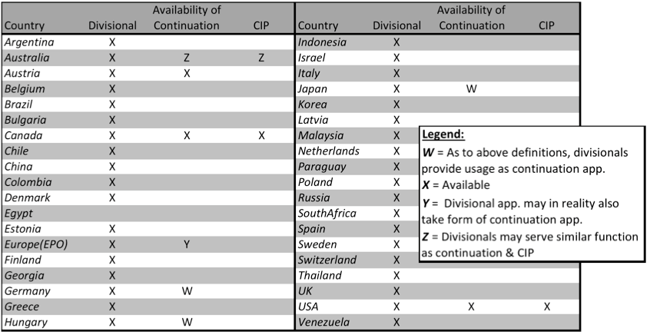

**Table 16: Availability of Divisional, Continuation or Continuation-In-Part Applications per Selected Countries.[213]**

Even though continuations are frequently used (e.g. 29% of patents issued to US corporate assignees between 1981–2004 involved some form of continuations), their effect on the richness of the public domain should be carefully considered.[214]

1. **Patent Donations and Open Innovation**

Sharing to combine new and existing knowledge is one effective way for companies to react in times of globalization and rapid technological change.[215]

Applications for and the granting of private patenting rights have grown substantially over the past decade. But, similarly, alternative strategies of sharing knowledge, such as open innovation, have also evolved. Rochelle C. Dreyfuss describes open innovation as “… innovation outside the IP law system.”[216] But does open innovation lead to an exchange of knowledge outside the boundaries of traditional IP rights, making them obsolete? In the following, the authors will show that open innovations may be an alternative to existing business strategies and that the importance of IP persists also in open innovation contexts,

Coined in 2003, the term open innovation embodies the idea of companies benefitting most when innovating both inside and outside their own premises. This can take place in various forms, most commonly: team up on the use of freely accessible knowledge, disposing (i.e. via a market transaction or by license) of unused IP and insource knowledge to complement and complete internal innovation.[217]

1. **Insource Knowledge**

The FMCG[218] giants P&G and Philips are each often-cited as an examples of successful open innovation strategies. Philips looks both for “inside-out” and “outside-in” innovation, partnering up with other companies, institutes or universities.[219]

Open innovation appears to be a promising way to inject refreshing start-up-blood into the veins of traditional companies. However, in most cases, its effect on the public domain might not be as promising as one might expect. New inventions that are patented can lead to marketable innovations that increase the public domain in the long run. In the short run, however, innovation initiatives under the rubric of *open innovation* do not necessarily lead to open and unrestricted access of these innovations: *Open innovation* does not equal *Open IP*. To the contrary, proprietary rights, especially patents, play a crucial role for companies in appropriating returns of innovations created through *open innovation- developed* inventions.

Indeed, merely presenting new ideas to the public, i.e. releasing them for comment and further development by external sources, does not automatically result in increased new innovations. Google shut down Google Labs in July 2011, an open-to-the-public-platform where the public could comment on new ideas or innovations.[220] While disclosed ideas presented to the public make their way into the public domain and ultimately enrich it, the IP governance of this kind of ecosystem seems challenging and might require individually tailored and specific licensing conditions.

1. **Patent Donations and Un(der)-used Patents**

A picket-fence-defense is a strategy in which patents are placed voluntarily into the public domain. As a result, the invention becomes prior art and competitors might be deterred from patenting their own related incremental advances. This is so partly because they might fear infringing on other, related patents still under patent protection, or simply because they do not seek to compete with a product relying on publicly available knowledge, hence prior art.[221]

Lowering the barriers for public use of patented inventions is one proposed way in which universities are contributing to the enrichment of the public domain. Universities Allied for Essential Medicines (UAEM) is an initiative fostering the more wide spread use of university patent knowledge. Following its goals, UAEM proposes[222] “…that the university simultaneously license the drug to generic companies, who are able to produce the drug for people living in low- and middle-income countries, at a lower, more affordable price…,” claiming it would not hurt revenues of pharmaceutical companies in high-income countries.

Scholars have raised the possibility that the opportunity costs associated with the use of IP- coping mechanisms can be diminished. In particular, they suggest that[223] “ [t]he development of a standardized contract to license technology by public research institutions could reduce transaction costs and act as a blueprint for licensing between private partners as well.” While this seems like a worthy objective, most pharmaceutical companies who take a license from a university on a compound request exclusivity of right of use.[224]

Another option is to leave such initiatives to the free market, i.e. private initiatives like Creative Commons or Science Commons:[225] Creative Commons, one of the most known open source licensing platforms, help actors and organizations with claimed easy-to-implement standardized licenses to manage and accumulate information protected by copyright.[226] The initiative behind Creative Commons is aimed at forming a comparable licensing platform for patent rights, i.e. Science Commons. Despite these efforts, it is believed that no more than ten percent of patents are subject to licensing agreements with external parties (**Figure 31**).

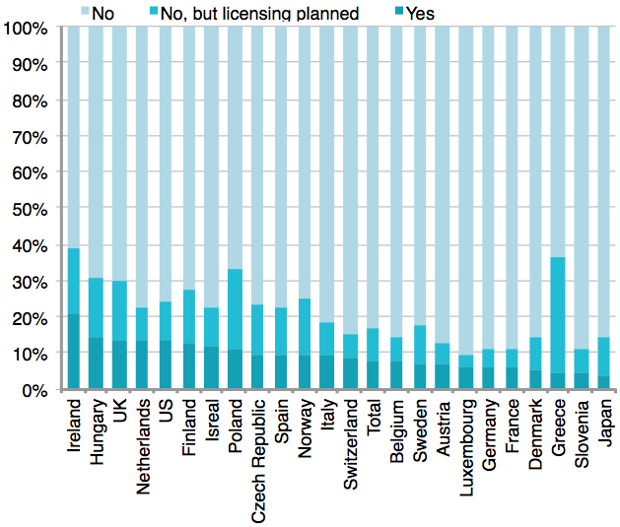

**Figure 31: % of Total Patents Owned vs. Licensed Patents, Years 2003-2005.[227]**

Xerox Corporation is a notable example: especially in the 1980's and 1990's, this company was the source of many groundbreaking inventions in various technological eras. However, the management of Xerox/PARC was foresighted enough to understand that not all inventions, no matter how brilliant, would necessarily fit the company's current business model and therefore could likely be commercialized successfully in-house:

Accordingly, Xerox/PARC licensed a part of its patented technology to this small start-up company called Apple in return for a share in it.[228] Steve Jobs and Apple were now able to build on that knowledge, developing it further, patenting both new and incremental innovations stemming from Xerox/PARC’s prior art, ultimately enriching the public domain with additional knowledge. This knowledge gain might probably not have been possible if Xerox/PARC would have just kept the patented knowledge about the related inventions in-house (or maintained it solely as a trade secret).

1. **Teaming Up**

Open innovation activities are not only used in high tech settings. Other industries are in part opening up to strengthen their innovative capabilities. Traditionally, the cost of R&D, hence innovating, is high in the pharmaceutical and biotechnology industries. Companies in these industries spent more than $100 billion in 2010 to realize 21 U.S. Food and Drug Administration-approved new chemical entities (NCEs),[229] as they struggle to neutralize the effects of the inevitable patent cliff (also called shark fin)[230] for major blockbuster drugs.[231]

In the pharmaceutical industry context, scholars[232] observed the reactions to open innovation via an "openness shock". Thus, patent owners of genetically engineered mice released rodents to academic researchers. The genetically engineered rodents were protected by patents. [233] Following this openness shock, these scholars[234] observed citation rates rising regarding the released genetically engineered rodents, together with increased diversity among the researchers involved. As well, new avenues for research were discerned. This increase in innovating activities, even in connection with seemingly remote applications, could ultimately lead to a broader enrichment of knowledge available in the public domain (when and if ultimately released to the public).

All of the foregoing still leaves open the question how to monetize pharmaceutical innovations coming from open innovation platforms. The “old” system of innovation was based to a large extent on control of property, hence IP, creating a *virtuous circle*: “…companies invest in internal R&D, make discoveries, use these discoveries to create new products and services, reap profits, and reinvest in further R&D, all of which leads to additional breakthroughs”[235] and a continuing enrichment of the public domain over time.

In particular, by observing how firms engage in open innovation activities, the role of IP may be sharpened. Typically firms start opening up in business areas that are outside their core business model, or when their economic survival is endangered in a way that demands drastic changes. As scholars[236] have shown in several scenarios, IP was the door opener either to be able to reach higher margins on the market or for use as a bargaining chip to “pool” with other firms.

1. **Patent Challenges and Evergreening**

In 1984 the Hatch-Waxman Act was enacted as a US policy tool in an effort to balance the interest of generic and branded drug companies in the pharmaceutical industry and to foster drug price competition leading to increasing generic drug use and to lower healthcare costs.

The Hatch-Waxman legislation did so by ensuring that branded[237] (also known as innovator) drug manufacturers would have meaningful patent protection and a period of marketing exclusivity to enable them to recoup their investments in the development of valuable new drugs. On the generic side for example, after expiry of the statutory patent protection and marketing exclusivity for these new drugs, the consumer would profit from (in most cases) immediate availability of lower priced generic bioequivalents of the formerly branded drugs, shortening the time-to market-period of generic drugs after patent expiration.[238]

As intended, these instruments led the branded drug pioneering companies not only to lose their market share faster than before the Hatch-Waxman Act, but also to experience a diminishing market-share compared with the generic competition: ”The level of generic competition is very different one decade after, compared with before, the [Hatch-Waxman] Act. In the early 1980s, the level of generic dispensing in the US was around 10%. By contrast, in the mid-1990s, the level of generic prescribing approached 40%.”[239] This can also be observed from the mid-1990s on, see with **Figure 32**: the level of generic prescribing exceeded 60% by 2007.

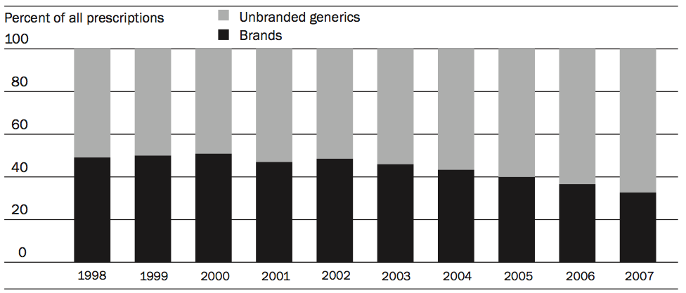

**Figure 32: Share of Total Retail dispensed Prescription Drugs (Branded- and Generic Drugs).[240]**

In addition, this was not the only effect that could be observed. One of the main interplays and effects of the act was the decrease in the effective market life of the original patented compound.[241]

In the case of pharmaceuticals, a new invented compound usually gets patented shortly after discovery.[242] After clinical trials and review[243] the governmental agency[244] responsible for admission of the drug to the local market, grants admission to release the drug to the market. To avoid early entry of generic manufacturers and to prolong the monopoly position the patent offers, the branded drug manufacturers attempt to extend the life of the original patent position (patent on the compound of the drug) by “patenting around” the invention, e.g. patenting modes of production and methods of delivery.[245] This patent management practice has sometimes been termed “evergreening.” If the patent on the original compound expires, it should in theory be released to the public domain. However, if the original compound cannot be freely exploited (due to other patents, for example protecting the drug-manufacturing process, thereby possibly limiting generic market access), the effect on the public domain could be as if the original monopoly position of the compound patent has been sustained by other means.[246]

The generic manufacturer’s interest is diametrically opposed - enter the market as early as possible post compound patent expiry. After a (branded) drug is approved for sale, a generic manufacturer might want to sell a competing product (composed of the same bioequivalent compound[247]), filing an Abbreviated New Drug Application (ANDA) with the US Food and Drug Administration (FDA).[248] To secure the earliest FDA approval possible and hence market entry, generics are entitled to patent challenges, i.e. generic drug applications with so-called “Paragraph IV” certifications, providing a way to pursue entry when, in the generic drug manufacturers’ view, the relevant patents underlying the branded drug are invalid or do not cover or affect the proposed generic product.[249]

Not challenging any branded drug patents would result in a delay of potential generic FDA approval until all patents expire. Thus, at any time during the patent life cycle a generic firm can file an ANDA claiming that one or more patents are invalid or not infringed by their proposed bioequivalent generic version of the drug. The Hatch Waxman Act (1984) fosters these patent challenges with an exclusive period of 180 days of exclusivity that in fact creates a duopoly of drug providers (the original branded drug producer and the first generic “challenger”). During these 180 days after the approval of the first generic version of the drug, only the brand manufacturer and the manufacturer of the first approved generic version of the branded drug are entitled to sell the drug on the market, promising duopoly profits for the generic manufacturer and enabling him to be recognized in the market as the *price leader*.

Does this really apply to all drugs or, to paraphrase: which drugs are actually being challenged? Some scholars demonstrate that 96% of drugs in the top quintile versus just 29% of drugs in the bottom quintile of sales are challenged by such generic paragraph IV ANDA applications. [250]

Nevertheless, they also point out that not only drug sales matter for the likelihood of a patent challenge, but also do patent characteristics, refuting that the effective market life of blockbuster drugs[251] is not very different compared to drugs in other categories: “Fixed effects models show that within drugs, lower quality patents and those that, unless challenged, extend market life the most, are much more likely to be challenged. Patent challenges are disproportionately targeting patents, especially low quality ones, that aim to extend patent term.”[252] The patent challenges by generic firms lead to the following effect: the average **nominal** patent term of 15.9 years shrinks to an average **effective** market life (i.e. the effective period till generics enter the market) of 12.2 years.[253] Absent patent challenges, the release of the patent to the public domain would effectively have to last until the expiration of the last patent affiliated with this drug (as listed in the FDA Orange Book).[254]

This life span is almost stable in comparison to the previous decade, but greater than before the Hatch–Waxman area.[255] On average, in the pharmaceutical industry neither the nominal patent term nor the statutory patent term will be fully exploited by the patent owner; the patent will be released to the public domain even four years before both end. The monetary effects on the public domain have already been quantified. One study[256] summarizes the short run welfare gains from patent challenges in the hypertension market between 1997 and 2008 to be US$93 billion.[257]

**Conclusion**

“In today's emerging and competitive market, it is axiomatic that where there is commercial significance, there will be legal significance.”[258]

Firms’ behavior towards intellectual property and patents has changed during recent decades. Following up on the above-mentioned statement, “patent strategy is deceptively simple in its form, but complex in its execution,”[259] we can conclude that patent strategy has evolved to the same degree of complexity, as has its execution.

This study analyzed the relationship between the patent system and the public domain on the micro level, building upon the findings of the Study on Patents and the Public Domain (I).[260] The analysis is not based on a legal argument about moral grounds of patents and the public domain, but an economical and practical evolution of patents and their intersection with the public domain.

Scholars have long suggested that patents are motivators of investment in innovation, reward the inventors and continually enrich the public domain by regularly adding publicly disclosed and freely accessible knowledge.[261] In times of dramatic technological change and the emergence of business models such as non-practicing entities or open innovation, intellectual property grows in both commercial and policy significance.

Throughout history firms have applied various methods to protect their property, be it tangible or intangible. This study has explored the effect of the patent regime over time on the existence of a rich and growing public domain. By integrating data from multiple sources including the scholarly literature, WIPO and OECD reports and data from both public and subscription sources, the recent practices and emergent business models of firms such as non-practicing entities are described. Patent management and prosecution techniques of all patent owners were reviewed. Throughout the review, the effect of all firm practices on the public domain is discussed.

In Part I, the study offers a conceptual integrative model that seeks to explain the relationship between patents and the public domain both during the pendency of the registered patent right and after the expiry of the right. The public domain consists of both de-jure and de-facto components. Contrary to what might be expected, the potential contribution by the patent system to the public domain occurs not only when a registered patent expires after the conclusion of its full statutory term, but also takes place prior to the completion of such full statutory term. The possibility of a “global patent arbitrage” of the public domain by countries in which no patent right is sought, and the potential of such arbitrage to contribute to national innovation, especially for developing countries, is presented.

In Part II, the study directs its attention to so-called non-practicing entities (NPE's) and how their respective business models enrich the public domain. NPE's are variously defined and their precise contours continue to be debated, but most do agree that the most aggressive amongst these entities have a propensity to litigate and they do not have (or choose not to exploit) the capability to design, manufacture or distribute products that are covered by the patent.

The characteristics of each type of NPE are discussed, with particular focus on the possible contribution of each to the public domain. A preliminary delineation for comparing on a relative basis the public domain contributions of multiple NPE forms including basic public research institutions and patent assertion entities is presented. With such delineation, some clarity is brought to the question of how the various forms of NPEs and their respective patent activities contribute to the richness of the public domain.

Part III describes patent practices of entities more broadly and considers the possible impact of patent management on the public domain. Both patent strategies and the on-the-ground implementation of these strategies are considered, as well as how such activities carried out by patent actors can contribute to a rich and freely accessible public domain.

The authors find that the patent system since 1883 has been a rich source of publicly available invention disclosures with over 94% of those disclosures being free to use by all. Of those disclosures that issued as patents, over 90% are free to use by all. Of the 5-6% of the disclosures that are enforceable patents, most are free to use in all countries of the world where there is no equivalent patent. The growing rate of patenting across the globe is feeding this public body of inventive disclosures that are over time all enriching the public domain. While the increasing rate of patenting is creating more private rights, most of these rights are not maintained over the full statutory life of the patent grants. Hence most owners elect to fully contribute their rights to the public domain before the end of the statutory patent grant again enriching the public domain of freely available inventions.

The emergence of patent market intermediaries such as non-practicing entities has enabled patent owners to capture value through inefficient, unpopular means such as litigation. A number of specialty firms have formed that reduce these inefficiencies. All non-practicing actors including Universities and Government sponsored entities are becoming more active and strategic in their patent market activities. There is evidence that the nascent markets for patents are becoming more specialized and efficient and hence more valuable for patent owners and licensors. We find no evidence that suggests that the practices of these firms are reducing the rate at which owners are contributing their patents to the public domain as outlined above. The buyer and seller side activities in these markets may make it easier for patent owners to decide which patents to maintain or abandon and hence contribute to the freely accessible public domain.

The influences of these firms and their methods of operation in the emerging markets for patents and the corresponding effects of the public domain are reviewed and diagramed in an effort to assess the contribution of these firms and their practices to the public domain.

The picture that arises from our analysis is that the relationship between patents, innovation and a rich and freely accessible public domain is complex and nuanced. While no generalization of this relationship emerges, it is possible to conceptualize a heuristic model that can materially contribute to our understanding of this important issue. The model takes into account differences in the time horizon under consideration, the relevant jurisdictions involved, the commercial and other goals of the various actors and their ability to carry out their plans. Where appropriate the authors point the way to avenues for future research that can further elucidate the ways by which patent activity contribute to, and continue to enrich, the public domain.

**Tables, Equations & Figures**

1. **Tables**

Table 1: Selected Overlapping Rights. 8

Table 2: The “Ever Moving“ Patent Right. 13

Table 3: Summary Statistics on Renewals for Patents. 16

Table 4: PCT Applications by firms. 23

Table 5: PCT Applications by Universities. 23

Table 6: PCT Applications by Public/Governmental Research Organizations. 24

Table 7: IP Business Models. 26

Table 8: Licensing Revenues 2011 for the TOP 25 Universities in the USA. 30

Table 9: Largest Jury Awards in the USA, Year 2012. 31

Table 10: IP Income in% of Research Expenditure, Selected Countries. 31

Table 11: Largest NPEs by Patent Holdings. 36

Table 12: NPE Patent Litigation by Industry. 37

Table 13: Top Ten Largest Initial Adjudicated Damages Awards 1995-2011. 38

Table 14: Top NPE Defendants by Number of new Cases filed. 38

Table 15: DVD6C Licensing Group, Licensing Fees, January 2005. 44

Table 16: Availability of Divisional, Continuation or Continuation-In-Part Applications per Selected Countries. 58

1. **Equations**

Equation 1: The Public Domain. 9

Equation 2: De-Facto Public Domain Extension. 21

1. **Figures**

Figure 1: IP and the Public Domain. 7

Figure 2: Summary of Patent Applications vs. Patent Grants vs. Patents in Private Domain in 2011. 10

Figure 3: Patent Application filed at the EPO. 11

Figure 4: Patent Rights Component of the Public Domain. 12

Figure 5: Total Patent Applications (direct and PCT National Phase Entries) 1985-2011. 14

Figure 6: Patent Maintenance Small Firms in % at Year 12 (3rd Interval). 17

Figure 7: Patent Maintenance Large Firms in % at Year 12 (3rd Interval). 17

Figure 8: Renewal Rates in selected EU Countries – Average of Patents applied for between 1980 and 1985. 18

Figure 9: Distribution of PCT applications by type of applicant for top 30 origins, 2011. 22

Figure 10: PCT Patent Applications by Universities, Developed World Countries 1980-2010. 24

Figure 11: PCT Patent Applications by Government/Research Organizations, Developed World Countries 1980-2010. 24

Figure 12: Worldwide University and PRO PCT Applications over Time. 25

Figure 13: University and PRO Patent Applications for Selected Countries. 25

Figure 14: NPE Cases as a % of all Patent Infringement Cases. 27

Figure 15: Revenues from Royalties over time, selected companies. 28

Figure 16: Innovations and Patent Applications 2008-2012. 29

Figure 17: License Fees 2008-2012. 30

Figure 18: Characteristics of Sovereign Investment Vehicles. 33

Figure 19: Lawsuits involving NPEs over time. 35

Figure 20: Practicing Entities involved in NPE Lawsuits over time. 35

Figure 21: IV and Partnering with Inventors. 40

Figure 22: RPX Corporation (RPX) vs. Allied Security Trust (AST). 41

Figure 23: Cumulative RPX Patent Portfolio and Portfolio Rights Growth. 41

Figure 24: RPX Network Composition by Revenue. 42

Figure 25: Popularity of Patent Pools. 44

Figure 26: Patents Pools by Industry. 45

Figure 27: NPE’s Contribution to Richness of the Public Domain. 46

Figure 28: NPE’s Propensity to Use Patents as Element of Private Right Enforcement. 47

Figure 29: Subsequent Knowledge Release through Patents. 51

Figure 30: Ratio of Residential Applications vs. PCT Applications. 53

Figure 31: % of Total Patents Owned vs. Licensed Patents, Years 2003-2005. 60

Figure 32: Share of Total Retail dispensed Prescription Drugs (Branded- and Generic Drugs). 62

[End of Annex and of document]

1. The views expressed in the study are those of the authors, and not necessarily those of the WIPO Secretariat or its Member States.
2. As cited in: WikiWikiWeb, *Shoulders Of Giants*, January 15, 2006, <http://c2.com/cgi/wiki?ShouldersOfGiants>, accessed on January 31, 2013.
3. Study I examined the patent system and its relationship with a rich and accessible public domain at the macro level, focusing, inter alia, on how the patent system, in general and as a whole, interplayed with the preservation of the public domain, see with: WIPO – Commitee on Development and Intellectual Property (CDIP), *Study on Patents and the Public Domain*, September 6, 2011, <http://www.wipo.int/edocs/mdocs/mdocs/en/cdip_8/cdip_8_inf_3_rev.doc>, accessed on January 2, 2013.
4. Federal Reserve Chairman Alan Greenspan, “Intellectual Property Rights Speech,” *Stanford Institute for Economic Policy Research Economic Summit*, Stanford California (February 27 2004), <http://www.federalreserve.gov/BoardDocs/speeches/2004/200402272/default.htm>, accessed on July 24, 2006, summarized in: David Orozco and James G. Conley, “The "Longer Walk" After eBay v. MercExchange,“ *42 les Nouvelles,* 2007: 426-428.
5. Andrew Beckerman Rodau, "Patents Are Property: A Fundamental But Important Concept," *Suffolk University Law School Faculty Publications*, Paper 54 (January 2009), <http://lsr.nellco.org/suffolk_fp/54>, accessed on January 14, 2013.
6. For example, in the USA patent law is based upon the constitution, whereas European patent law covers a wide range of legislations, e.g. national patent laws, the Strasbourg Convention of 1963, the European Patent Convention of 1973, various European Union directives etc. In England, patent law dates back to the English Statute of Monopolies of 1623, first enacted in 1624. See for more information with Wikipedia, *History of Patent Law*, January 28, 2013, <http://en.wikipedia.org/wiki/History_of_patent_law>, accessed on January 31, 2013.
7. Richard Posner, *Economic Analysis of Law*, 8th edition, (New York, NY: Aspen Publishers, 2010); Andrew Beckerman Rodau, *supra* note 5.
8. See for an overview of the story of the Wrights’ Brothers: Harold Evans, *They made America* (New York, NY: Time Warner Book Group, 2004).
9. Colleen V. Chien, “Patent Assertion Entities,” *Presentation to the DOJ/FTC hearing on PAEs*, Washington, DC, December 10, 2012; Steven W. Usselman and Richard R. John, "Patent Politics: Intellectual Property, the Railroad Industry, and the Problem of Monopoly," *The Journal of Political History,* 18/1 (2006): 96-125, both cited in: Executive Office of the President, “PATENT ASSERTION AND U.S. INNOVATION,” *Report*, June 2013, <http://www.whitehouse.gov/sites/default/files/docs/patent_report.pdf >, accessed on June 25, 2013.
10. WIPO – Commitee on Development and Intellectual Property (CDIP), *Project on Patents and the Public Domain*, November 18, 2011, <http://www.wipo.int/edocs/mdocs/mdocs/en/cdip_7/cdip_7_5_rev.doc>, accessed on January 2, 2013.
11. WIPO at *supra* note 3.
12. WIPO at *supra* note 10.
13. WIPO, “The 45 Adopted Recommendations under the WIPO Development Agenda,” *WIPO – Development Agenda*, 2007, <http://www.wipo.int/ip-development/en/agenda/recommendations.html>, accessed on January 13, 2013.
14. Ibid.
15. WIPO at *supra* note 10.
16. Bloomberg Businessweek, *Inside Nathan Myhrvold's Mysterious New Idea Machine*, July 2006, <http://www.businessweek.com/stories/2006-07-02/inside-nathan-myhrvolds-mysterious-new-idea-machine>, accessed on January 17, 2013.
17. Knut Blind, Katrin Cremers, Elisabeth Mueller, “The influence of strategic patenting on companies' patent portfolios," *Research Policy*, 38/2 (2009): 428-436, as cited in: Peter Neuhäusler, "The use of patents and informal appropriation mechanisms - Differences between sectors and among companies," *Technovation*, 32/12 (2012): 681-693.
18. Since this study focuses on patents and the public domain, the understanding of the public domain might differ for other rights, e.g. the public domain in copyright may not be same as the public domain in trademarks. For example, see with: Hector MacQueen and Charlotte Waelde, “Introduction: the many faces of the public domain,” in: *Intellectual Property - the many faces of the public domain*, edited by Charlotte Waelde and Hector MacQueen (Cheltenham, UK: Edward Elgar Publishing Ltd: 2007).
19. Own Illustration. Note that the details of the patent rights circle are expanded upon in **Figure 4**.
20. Neil Wilkof and Shamnad Basheer, eds., *Overlapping Intellectual Property Rights* (Oxford, UK; Oxford University Press, 2012), "Introduction," p. iviii.
21. Craig S. Mende and Belinda Isaac, "When Copyright and Trademark Rights Overlap," in Wilkof and Basheer, *supra* note 20.
22. Mark D. Janis, "Interfaces in Plant Intellectual Property," in Wilkof and Basheer, *supra* note 20.
23. David Musker, "The Overlap between Patent and Design Protection," in Wilkof and Basheer, *supra* note 20.
24. Own Illustration; selected Analogous Exclusivity Rights, compiled from: Muriel Lightbourne, “Plants and intellectual property rights in the US, Japan, and Europe,” *IP Bulletin*, 2005, <http://www.iip.or.jp/e/e_summary/pdf/detail2004/e16_11.pdf>, accessed on January 31, 2013 and “Plant breeders' rights,“ Wikipedia: The Free Encyclopedia, Wikimedia Foundation, February 2, 2013, <http://en.wikipedia.org/wiki/Plant_breeders%27_rights>, accessed February 4, 2013. See also with: Dipak C. Jain and James G. Conley, “Patent Expiry and Pharmaceutical Market Opportunities at the Nexus of Pricing and Innovation Policy,” *INSEAD Working Paper*, 2012/89/MKT (2012), <http://ssrn.com/abstract=2156237>, accessed November 14, 2012.
25. US UTSA.
26. Own Illustration, data extracted from: WIPO, *WIPO IP Statistics Data Center*, November 2012, <http://ipstatsdb.wipo.org/ipstats/patentsSearch>, accessed on January 20, 2013. Please see there for further assistance on underlying definitions, e.g. on total patents worldwide.
27. Dietmar Harhoff, Karin Hoisl, et al., "Patent validation at the country level - The role of fees and translation costs," *Research Policy*, 38/9 (2009): 1423-1437.
28. The renewal fees for European patent applications are as follows: “These fees shall be due in respect of the third year and each subsequent year, calculated from the date of filing of the application. If a renewal fee is not paid in due time, the application shall be deemed to be withdrawn,“ see with: EPO, *The European Patent Convention Article 86 (1)*, November 29, 2000, <http://www.epo.org/law-practice/legal-texts/html/epc/2010/e/ar86.html >, accessed on January 31, 2013. For an overview of the renewal fees due, please see with: EPO, *Renewal Fees – Schedule of Fees*, database query under <http://www.epoline.org/portal/portal/default/epoline.Scheduleoffees>, accessed on January 31, 2013.
29. Own Illustration.
30. Supreme Court of the United States, *Association for Molecular Pathology et al v. Myriad Genetics, Inc. et al*, No. 12-398, U.S. (2013)
31. See Robert Harrison, "Patents and Utility Models", in Wilkof and Basheer, supra note 20.
32. Sources: Patents Bill by the House of Representatives, *Supplementary Order Paper of Tuesday, 14 May 2013 - Proposed amendments to SOP No 120*, <http://media.nzherald.co.nz/webcontent/document/pdf/201319/Supplementary%20Order%20Paper.pdf>; Dan Cossins, “Supreme Court Considers Gene Patents,” *The Scientist*, April 16, 2013, <http://www.the-scientist.com/?articles.view/articleNo/35120/title/Supreme-Court-Considers-Gene-Patents/>; Peter Judge, “German Court Declares Software Patents Legal,” *TechWeekeurope*, May 21, 2010, <http://www.techweekeurope.co.uk/news/german-court-declares-software-patents-legal-7211>; Deutscher Bundestag, *Software-Patente in der Kritik*, May 14, 2013, <http://www.bundestag.de/presse/hib/2013_05/2013_261/02.html>; Patralekha Chatterjee, “Novartis Loses Patent Bid: Lessons From India’s 3(d) Experience, ”*Intellectual Property Watch*, April 1, 2013, <http://www.ip-watch.org/2013/04/01/novartis-loses-patent-bid-lessons-from-indias-3d-experience/>; Vikas Bajaj and Andrew Pollack, “India Orders Bayer to License a Patented Drug,” *The New York Times*, March 12, 2012, <http://www.nytimes.com/2012/03/13/business/global/india-overrules-bayer-allowing-generic-drug.html?_r=0>; Interview with Andrew Bentham, Partner at J A Kemp, 2013; Supreme Court of the United States, *BOWMAN v. MONSANTO CO. ET AL.*, May 13, 2010, <http://www.supremecourt.gov/opinions/12pdf/11-796_c07d.pdf>; Nathan Vardi, “President Obama Wallops The Patent Trolls,” *Forbes*, June 4, 2013, <http://www.forbes.com/sites/nathanvardi/2013/06/04/president-obama-wallops-the-patent-trolls/>; Bruce D. Sokler and Richard G. Gervase, Jr., “Supreme Court Holds That Reverse Payment Patent Settlements Are Subject to Antitrust Scrutiny,” June 22, 2013, *The National Law Review*, <http://www.natlawreview.com/article/supreme-court-holds-reverse-payment-patent-settlements-are-subject-to-antitrust-scru>; all online sources accessed on June 22, 2013. Interview with Claudio Roberto Barbosa, Partner at Kasznar Leonardos Intellectual Property - Brazil, São Paulo, Brazil, 2013.
33. Bernard Caillaud and Anne Duchêne, "Patent office in innovation policy: Nobody's perfect," *International Journal of Industrial Organization*, 29/2 (2011): 242-252.
34. USPTO, *Performance and Accountability Report FY 2012*, <http://www.uspto.gov/about/stratplan/ar/USPTOFY2012PAR.pdf>, accessed on January 31, 2013.
35. Andrew Beckerman Rodau, *supra* note 5.
36. Data extracted from: WIPO, *IP Statistics Data Center*, November 2012, <http://ipstatsdb.wipo.org/ipstats/searchresultsLinerGraph>, accessed on January 31, 2013.
37. Hector MacQueen and Charlotte Waelde, *supra* note 18.
38. Mark A. Lemley, “The Myth Of The Sole Inventor,” *Michigan Law Review*, 110 (March 2012): 709-760. Contradicting Lemley: John Howells and Ron D. Katznelson, “A Critique of Mark Lemley’s “The Myth of the Sole Inventor”,” *works.bepress.com*, 2011, < http://bitly.com/Lemley-Critique>, accessed on August 13, 2013: “But the direct purpose of the patent system that Lemley ignores, and from which the other incentives naturally flow, is to encourage investment in new inventions once they have been made and disclosed. According to our Constitution, substantial incentives for risky investments in new inventions are provided by granting exclusive rights – rights that, by definition, only one party can receive. The patent system is therefore designed to select the earlier of “near-simultaneous” inventions that is nonobvious; contrary to Lemley‘s unsupported assertions, the evidence show that, under this system, simultaneous invention is extremely rare.“
39. Ibid.
40. Ibid.
41. See for USPTO with: USPTO, *General Information Concerning Patents*, April 2012, <http://www.uspto.gov/patents/resources/general_info_concerning_patents.jsp#heading-5>, accessed on January 31, 2013; for EPO, see with: EPO, *How to get a European patent*,” June 2009, <http://www.epo.org/applying/european/Guide-for-applicants/html/e/ga_b.htm>, accessed on January 31, 2013.
42. Supreme Court of the United States, *KSR INTERNATIONAL CO. v. TELEFLEX INC. ET AL.,* No. 04-1350 U.S. (2007).
43. We use the *effective patent term* in the context of abandoned patents, not to be misleading with its application in the pharmaceutical context. For an application in the pharmaceutical context see with: Holly Soehnge, “The Drug Price Competition and Patent Term Restoration Act of 1984: Fine-Tuning the Balance between the Interests of Pioneer and Generic Drug Manufacturers,“ *Food & Drug Law Journal*, 58/51 (2003): 51.
44. All timespans after the date of issue, see with USPTO, *Maintain Your Patent*, January 2013, <http://www.uspto.gov/patents/process/maintain.jsp>, accessed on January 13, 2013. Similar Provisions apply at other patent offices, see for Europe: EPO, *Supplement to OJ EPO 3/2012*, 2012, <<http://documents.epo.org/projects/babylon/eponet.nsf/0/198B1304AEF3E22BC12579BF003DA59A/$File/Rules_relating_to_fees_20120401.pdf>>, accessed on January 13, 2013.
45. Deepak Hegde and Bhaven Sampat, "Examiner citations, applicant citations, and the private value of patents," *Economics Letters*, 105/3 (2009): 287-289.
46. Ibid.
47. Own Illustration, data compiled by Michael Deem, Northwestern University; source: *USPTO Bulk Downloads: Patents*, via Google Patents, <http://www.google.com/googlebooks/uspto-patents.html>, accessed on August 15, 2012.
48. Ibid.
49. Ibid.
50. Yi Deng, "A dynamic stochastic analysis of international patent application and renewal processes," *International Journal of Industrial Organization*, 29/6 (2011): 766-777.
51. Ibid.
52. Mark A. Lemley, “The Surprising Virtues of Treating Trade Secrets as IP Rights,“ *Stanford Law Review*, 61/311 (2008): 311-354.
53. The same opportunity for arbitrage may not exist for copyright or other IP rights.
54. Philip Kotler and Kevin Lane Keller, *Marketing Management 14e*, (New Jersey, USA: Prentice Hall, 2011).
55. Annalee Saxenian, “The new Argonauts,” *Words into Action*, <http://people.ischool.berkeley.edu/~anno/Papers/IMF_World_Bank_paper.pdf>, accessed on June 26, 2013.
56. John R. Allison et. al., “Valuable Patents,” *Boalt Working Papers in Public Law*, Boalt Hall, UC Berkeley (January 2013): 1-59.
57. Indeed, probabilistic behavior may describe the patent system more generally, see Mark A. Lemley and Carl Shapiro, "Probabilistic Patents", *Journal of Economic Perspectives* 19 (2005): 75-98.
58. For more information on post-expiry marketing rights, see: Dipak C. Jain and James G. Conley, *supra* note 24.
59. University sector includes all educational institutions.
60. Government and research institutions include private non-profit organizations and hospitals.
61. For more information on PCT applications, see with: WIPO, “Patent Cooperation Treaty ("PCT") (1970),” *WIPO – PCT Resources*, 2013, <http://www.wipo.int/pct/en/treaty/about.html>, accessed on January 26, 2013.
62. Source: WIPO, “PCT Yearly Review 2012,” *WIPO Economics & Statistics Series*, March 2012, <http://www.wipo.int/freepublications/en/patents/901/wipo_pub_901_2012.pdf>, accessed on January 30, 2013.
63. Peter Neuhäusler, "The use of patents and informal appropriation mechanisms - Differences between sectors and among companies," *Technovation*, 32/12 (2012): 681-693. How far these results can be generalized, especially for developing markets, cannot be concluded from the data provided in the study.
64. Source: WIPO, “PCT Yearly Review 2012,” *WIPO Economics & Statistics Series*, March 2012, <http://www.wipo.int/freepublications/en/patents/901/wipo_pub_901_2012.pdf>, accessed on January 30, 2013.
65. Ibid.
66. See with WIPO, “World Intellectual Property Report – The Changing Face of Innovation,“ *WIPO Economics and Statistics Series*, <http://www.wipo.int/econ_stat/en/economics/wipr>, accessed on January 30, 2013.
67. WIPO, *supra* note 64.
68. WIPO, *supra* note 66.
69. In absolute numbers (left) and as a percentage of total PCT applications (right), see with: WIPO, *supra* note 66.
70. Displayed as a share of total national applications for selected countries, in percent, for different time spans, see with: WIPO, *supra* note 66.
71. For example, see with: Mark A. Lemley and Carl Shapiro, “Patent holdup and royalty stacking,” *Texas Law Review*, 85 (2007): 1991–2048 and John M. Golden, “Patent trolls and patent remedies,” *Texas Law Review*, 85 (2007): 2111–2161, cited in: Timo Fischer and Joachim Henkel, "Patent trolls on markets for technology - An empirical analysis of NPEs’ patent acquisitions," *Research Policy*, 41/9 (2012): 1519-1533.
72. PwC, *Patent Litigation Study - Litigation continues to rise amid growing awareness of patent value*, 2012, <http://www.pwc.com/en_US/us/forensic-services/publications/assets/2012-patent-litigation-study.pdf>, accessed on February 21, 2013.
73. Federal Trade Commission (FTC), Press Release: Federal Trade Commission, Department of Justice to Hold Workshop on Patent Assertion Entity Activities, November 2012, <http://www.ftc.gov/opa/2012/11/paeworkshop.shtm>, accessed February 17, 2013.
74. Ibid.
75. Ashby Jones, “Cisco's Patent Counterattack Fails,“ *The Wallstreet Journal*, February 6, 2013, <<http://online.wsj.com/article/SB10001424127887324906004578288370005621206.html>>, accessed February 17, 2013.
76. Innography, “What You Can Learn From Non-Practicing Entities And Patent Trolls,” *Innography – White Papers*, 2012, <http://www.innography.com/resources/white_papers.aspx>, accessed on January 17, 2013.
77. Wei Wang, “PATENT LAW: Non-practicing Complainants at the ITC: Domestic Industry or Not?,“ *Berkeley Technology Law Journal*, 27 (2012): 409-981.
78. RPX Corporation, *2012 NPE Activity Report*, 2013, <http://www.rpxcorp.com/siteFiles/SiteManager/0BF995E82CFF591EE80EFE8AC69259E7.pdf >, accessed on July 31, 2013.
79. Adapted from: Raymond Millien, ”Landscape 2013: Who are the Players in the IP Marketplace?,” *IPWatchdog*, January 23, 2013, <http://www.ipwatchdog.com/2013/01/23/ip-landscape/id=33356/>, accessed on January 31, 2013. Due to the nature and scope of this paper, we did not deeper analyze the 19 categories. For a deeper analysis see with the source, also referencing a directory of IP players in the US market.
80. For example, under the SHIELD Act in the USA, universities and individual inventors are not considered NPEs, see with: Govtrack.us, 2013, <http://www.govtrack.us/congress/bills/113/hr845>, accessed on July 24, 2013.
81. Timo Fischer and Joachim Henkel, "Patent trolls on markets for technology - An empirical analysis of NPEs’ patent acquisitions," *Research Policy*, 41/9 (2012): 1519-1533.
82. RPX Corporation, *2012 NPE Activity Report*, 2013, <http://www.rpxcorp.com/siteFiles/SiteManager/0BF995E82CFF591EE80EFE8AC69259E7.pdf >, accessed on July 31, 2013. For more information on the methodology of data generation see with the report. With similar results: Sara Jeruss, Robin Feldman and Thomas Ewing, “The America Invents Act 500 Expanded: Effects of Patent Monetization Entities,“ *available at SSRN*, April 2013, <http://ssrn.com/abstract=2247195>, accessed on April 9, 2013.
83. Sara Jeruss, Robin Feldman and Thomas Ewing, *supra* note 81.
84. Executive Office of the President, “PATENT ASSERTION AND U.S. INNOVATION,” *Report*, June 2013, <http://www.whitehouse.gov/sites/default/files/docs/patent_report.pdf >, accessed on June 25, 2013.
85. Joseph N. Hosteny, “Litigators Corner: Is IBM a PatentTroll?,” *Intellectual Property Today*, May 2oo6, <http://www.hosteny.com/archive/Hosteny%2005-06.pdf>, accessed on January 28, 2013.
86. Please note that only a minority of companies report royalty revenue data in their annual reports. This table provides some examples. For more information see with: WIPO, *supra* note 66.
87. Reporting other forms of IP and custom development income and taking these into account, total revenue from royalties would increase IBM’s royalty revenue in **Figure 15** from USD 312m to more than USD 1.1 billion in 2010, around eleven percent of total revenue, see with WIPO, *supra* note 66.
88. Triple Helix Innovation, *What universities can learn from IBM’s IP licensing strategies*, 2012, <http://triplehelixinnovation.com/what-universities-can-learn-from-ibms-ip-licensing-strategies/1998>, accessed on December 21, 2012.
89. Ben Charny, “Patent Trolls Lurk in Supreme Court Case,” *eWeek.com*, March 29, 2006, <http://www.eweek.com/c/a/Enterprise-Applications/Patent-Trolls-Lurk-in-Supreme-Court-Case/>, accessed on December 24, 2012.
90. Fraunhofer-Gesellschaft, *Active Rights and Patent Applications of the Fraunhofer-Gesellschaft 2008-2012*, 2013, <http://www.fraunhofer.de/en/about-fraunhofer/business-model/patents-licenses.html>, accessed on July 27, 2013.
91. Ibid.
92. The Chronicle of Higher Education, *supra* note 96.
93. Adopted from Margaret Cronin Fisk, “Patent Trial Awards Soar With Some Big Ones Cut by Judges,” *Bloomberg.com*, Jan 17, 2013, <<http://www.bloomberg.com/news/2013-01-18/patent-trial-awards-soar-with-some-big-ones-cut-by-judges.html>>, accessed on January 27, 2013.
94. Stephen Hansen et al., *The effects of patenting in the AAAS scientific community*, 2nd edition 2006, New York, NY, <<http://sippi.aaas.org>>, accessed on December 21, 2012.
95. Triple Helix Innovation, *supra* note 88.
96. Own calculation, based on data from The Chronicle of Higher Education, *Sortable Table: Universities With the Most Licensing Revenue, FY 2011*, August 27, 2012, <http://chronicle.com/article/Sortable-Table-Universities/133964/>, accessed on December 27, 2012.
97. See also for further information on methodology etc. with: WIPO, *supra* note 66.
98. Fiona Murray and Scott Stern, “Evidence from Patent-Paper Pairs,” *Northwestern University and MIT Sloan School: unpublished paper*, February 2004, <http://citeseerx.ist.psu.edu/viewdoc/download?doi=10.1.1.203.3353&rep=rep1&type=pdf>, accessed on June 21, 2013.
99. The Economist, *Opinion: Innovation's golden goose*, Dec 12th 2002, <http://www.economist.com/node/1476653>, accessed on July 29, 2013.
100. Association of University Technology Managers (AUTM), *Bayh-Dole Act*, 2013, <http://www.autm.net/Bayh_Dole_Act1.htm>, accessed on July 29, 2013.
101. This topic is outside the scope of this report and must be left to further research.
102. Global Finance, “Largest Sovereign Funds (SWFs) – 2012 Ranking”, *Global Finance – Economic Data*, 2013, <http://www.gfmag.com/tools/global-database/economic-data/12146-largest-sovereign-wealth-funds.html#axzz2Mw31vDNL>, accessed on March 8, 2013.
103. SWF Institute, *Difference in Sovereign Vehicles*, 2013, <http://www.swfinstitute.org/statistics-research/difference-in-sovereign-vehicles/>, accessed on February 27, 2013.
104. Shannon A. Murphy, “Leviathan's Double Bottom Line: Sovereign Wealth Funds As Tools Of Strategic Statecraft,” *MIT Archives*, June 2012, <http://dspace.mit.edu/bitstream/handle/1721.1/72891/808385758.pdf?sequence=1>, accessed on March 8, 2013.
105. Bryan J., Balin, “Sovereign Wealth Funds: A Critical Analysis,“ *available at SSRN*, September 2009, <http://ssrn.com/abstract=1477725>, accessed on February 25, 2013.
106. France Brevets, *Who we are?,* 2013*,* <http://www.francebrevets.com/en/who-we-are>, accessed on February 26, 2013. The Caisse des Dépôts is a public financial institution in France, for more information see with: Caisse des Dépôts, *Organisation*, 2013, <http://www.caissedesdepots.fr/en/the-group/organisation.html>, accessed on February 26, 2013.
107. Ibid.
108. Yu-Tzu Chiu, “Taiwanese to Form Patent Bank to Defend Local Companies,” *IEEE SPECTRUM*, October 2011, <http://spectrum.ieee.org/at-work/innovation/taiwanese-to-form-patent-bank-to-defend-local-companies>, accessed on February 26, 2013.
109. Defensive patent aggregators are firms aiming to mitigate the risk of exposure to infringement litigation by purchasing patents that may otherwise fall into the hands of PAEs, see also with page 45 of this report.
110. Ghyo Sun Park and Seong Don Hwang, “The rise of the NPE,” *ManagingIP.com*, December 2010/January 2011, <http://www.managingip.com/Article/2740039/The-rise-of-the-NPE.html>, accessed on February 26, 2013.
111. Patents held by Intellectual Discovery are not limited to the state of Korea, as can be seen exemplary in a patent for the “Increasing Contrast In Electronic Color Displays Via Surface Texturing Of Leds,” assigned to Intellectual Discovery, see with USPTO, *Patent US 8,384,103 B2*, filed on March 4, 2010, <http://www.uspto.gov/web/patents/patog/week09/OG/html/1387-4/US08384103-20130226.html >, accessed on February 19, 2013.
112. Intellectual Discovery, *Business Model - IP Licensing*, 2012, <http://i-discovery.com/>, accessed on February 19, 2013.
113. Michael J. Mazzeo, Jonathan Hillel and Samantha Zyontz, “Excessive or Unpredictable? An Empirical Analysis of Patent Infringement Awards,“ June 17, 2011, Available at SSRN: <http://ssrn.com/abstract=1765891>, accessed on June 20, 2013.; Tom Krazit and Anne Broache, “BlackBerry saved,” *CNET News*, March 3, 2006, <http://news.cnet.com/BlackBerry-saved/2100-1047_3-6045880.html>, accessed on January 14, 2013.
114. PatentFreedom, *Litigations Over Time*, Data captured as of January 18, 2013, <https://www.patentfreedom.com/about-npes/litigations/>, accessed on January 28, 2013.
115. Ibid.
116. Senator Issac Christiancy, (R – Michigan) 1878, as cited in: Executive Office of the President, “PATENT ASSERTION AND U.S. INNOVATION,” *Report*, June 2013, <http://www.whitehouse.gov/sites/default/files/docs/patent_report.pdf >, accessed on June 25, 2013.
117. Mike Dillon, “Tax on Innovation,“ The Legal Thing, Sept. 14, 2006, <<https://blogs.oracle.com/dillon/entry/congressman_smith_comes_to_town>>, accessed on January 14, 2013.
118. PatentFreedom, *Largest Patent Holdings*, Data captured as of January 18, 2013, <<https://www.patentfreedom.com/about-npes/holdings/>>, accessed on January 28, 2013.
119. Timo Fischer and Joachim Henkel, *supra* note 81.
120. See for example with Brad Plumer, “Innovation’s down, but patent trolls are thriving,” *The Washington Post*, September 9, 2011, <http://www.washingtonpost.com/blogs/wonkblog/post/innovations-down-but-at-least-patent-trolls-are-thriving/2011/09/21/gIQABGdKlK_blog.html>, accessed on March 28, 2013.
121. John R. Allison, Mark A. Lemley, Kimberly A. Moore and R. Derek Trunkey, “Valuable Patents,“ *Georgetown Law Journal*, 92/435 (2003-2004): 435-479.
122. This issue of patent quality is one that has periodically plagued patent offices, such as the USPTO. The June 1930 cover article of *Popular Science* was entitled “Swamped by a flood of inventions the patent offices has become a national disgrace.”
123. Timo Fischer and Joachim Henkel, *supra* note 81.
124. PatentFreedom, *Exposure by Industry*, Data captured as of January 18, 2013, <https://www.patentfreedom.com/about-npes/industry/>, accessed on January 28, 2013.
125. As mentioned above, the definitions of NPEs and PAEs differ widely. Therefore, the underlying definition of NPEs used in **Table 12** cannot be applied synonymously to the definition of NPEs used in this report.
126. Mike Dillon brings up the example of Marshal, Texas, where over 88% of jury verdicts would favor the plaintiff: “…rumor has it that in the town's barbershop the "doctrine of equivalents" is a common topic of conversation…,” see with: Mike Dillon, “Tax on Innovation,“ The Legal Thing, Sept. 14, 2006, <<https://blogs.oracle.com/dillon/entry/congressman_smith_comes_to_town>>, accessed on January 14, 2013.
127. Ibid.
128. PwC, *Patent Litigation Study - Litigation continues to rise amid growing awareness of patent value*, 2012, <http://www.pwc.com/en_US/us/forensic-services/publications/assets/2012-patent-litigation-study.pdf>, accessed on February 21, 2013.
129. RPX Corporation, *2012 NPE Activity Report*, 2013, <http://www.rpxcorp.com/siteFiles/SiteManager/0BF995E82CFF591EE80EFE8AC69259E7.pdf>, accessed on July 31, 2013.
130. RPX Corporation, *RPX Analyst Day*, March 8, 2012, <http://files.shareholder.com/downloads/ABEA-5XYKB4/2318251075x0x551346/409b5f43-ce6b-4ae3-993d-264e383845b1/RPX%20Analyst%20Day%20v4.pdf>, accessed on February 25, 2013.
131. The data presented in this table do not provide additional information about the sub classification of NPEs, hence how many of these cases have been initiated by PAEs. However, the same report later summarizes that around 92% of all cases filed by NPEs in 2012 were filed by PAEs. For more information, see with RPX Corporation, *supra* note 129.
132. As to data provided by RPX Corporation NPE cases filed nearly doubled between 2011 and 2012, see with RPX Corporation, *supra* note 129.
133. Steven Musil, “Intellectual Ventures settles patent lawsuit with Microsemi,” *CBS Interactive*, January 21, 2013, <http://news.cnet.com/8301-1001_3-57565040-92/intellectual-ventures-settles-patent-lawsuit-with-microsemi/>, accessed on January 28, 2013.
134. Daryl Lim, “Post eBay - A Brave New World?,” *European Intellectual Property Review*, 10 (2010): 483-485.
135. As to Steve Lohr, “Turning Patents Into ‘Invention Capital’,” *The New York Times*, February 17, 2010, <http://www.nytimes.com/2010/02/18/technology/18patent.html?emc=eta1&_r=0>, accessed on January 28, 2013.
136. Intellectual Ventures, *Invented in India*, July 2009, <http://www.wipo.int/meetings/en/2009/ip_gc_ge/presentations/suvarna.pdf>, accessed on January 28, 2013.
137. Steven Musil, *supra* note 133.
138. Nicholas Varchaver, “Who's afraid of Nathan Myhrvold?,” *CNNMoney*, June 26, 2006, <http://money.cnn.com/magazines/fortune/fortune_archive/2006/07/10/8380798/index.htm>, accessed on January 28, 2013.
139. Steven Musil, *supra* note 133.
140. As cited in: Paul McNamara, “Intellectual Ventures sues AT&T, Sprint and T-Mobile,” *Network World*, February 16, 2012, <http://www.networkworld.com/community/blog/intellectual-ventures-sues-att-sprint-and-t-mobile>, accessed on January 28, 2013.
141. Own Illustration, self-compiled by the authors from RPX, <http://www.rpxcorp.com>, and AST, <http://www.alliedsecuritytrust.com>, accessed on February 25, 2013.
142. RPX Corporation, *RPX Analyst Day*, March 8, 2012, <http://files.shareholder.com/downloads/ABEA-5XYKB4/2318251075x0x551346/409b5f43-ce6b-4ae3-993d-264e383845b1/RPX%20Analyst%20Day%20v4.pdf>, accessed on February 25, 2013.
143. Ibid.
144. Ibid.
145. For more details see with: RPX Corporation, *Annual Rate Calculator*, 2013, <http://www.rpxcorp.com/index.cfm?pageid=85>, accessed on April 5, 2013.
146. IPXI, “World's First Financial Exchange Focused on Intellectual Property Taps Former President & COO of Chicago Climate Exchange to Take Helm,” *IPXI News Releases*, December 14, 2009, <http://www.ipxi.com/news-events/news/news-releases/38-test-content-news-release.html>, accessed on February 27, 2013.
147. Simon den Uijl, Rudi Bekkers and Henk J. de Vries, “Managing Intellectual Property Using Patent Pools: Lessons from Three Generations of Pools in the Optical Disc Industry,” *California Management Review*, 55/4 (Summer 2013): 31-50. This section is based on, among various other sources, a student’s presentation during the Intellectual Capital Management Class of James G. Conley at the Kellogg School of Management, Northwestern University, USA, on March 12, 2012 (additional information is available upon request).
148. Joel I. Klein, “An Address To The American Intellectual Property Law Association, On The Subject Of Cross-Licensing And Antitrust Law,” Department of Justice, May 2, 1997,<http://www.justice.gov/atr/public/speeches/1118.htm>, accessed on January 28, 2013.
149. For more details on innovation gridlock and freedom to operate, see on page 55, Patenting and Innovation Process.
150. For example, Chinese companies filed a lawsuit against the 3C Patent Pool in 2004, see with: Huang Yong, “Basic IP Principles of Antitrust Law,” *Chinaipmagazine* (July 2012), <http://www.ciplawyer.com/article.asp?articleid=1622 >, accessed on June 24, 2013. This may also be scrutinized under antitrust issues, which are not subject of this report.
151. Toshiba Corporation, *DVD6C Announces Changes to DVD Licensing Program*, March 1, 2005, <http://www.toshiba.co.jp/about/press/2005_03/pr0101.htm>, accessed on January 28, 2013.
152. Adopted from Josh Lerner and Jean Tirole, “Public Policy toward Patent Pools,” *Innovation Policy and the Economy*, 8 (2007): 157-186, see with WIPO, *supra* note 66.
153. Ibid.
154. Neil Wilkof, “Crowdsourcing against "Bad" Patents and Patent Trolls: But Not All Black and White,” *IP Finance*, January 25, 2013, <http://ipfinance.blogspot.de/2013/01/crowdsourcing-against-bad-patents-and.html>, accessed on June 20, 2013.
155. Article One, *How it works*, 2013, <http://www.articleonepartners.com/how-it-works>, accessed on March 7, 2013.
156. Neil Wilkof, *supra* note 154.
157. Olga Kharif, “Crowdsourcing the Fight Against Tech Patent Trolls,” *Bloomberg Businessweek*, January 17, 2013, <http://www.businessweek.com/articles/2013-01-17/crowdsourcing-the-fight-against-tech-patent-trolls>, accessed on March 7, 2013.
158. Own Illustration.
159. The trend towards universities becoming hubs of commercialization through patents and IP is discussed in the book “Towards the Third Generation University” (J.G. Wissema, *Towards the Third Generation University*, Cheltenham, UK: Edward Elgar, 2009). Hence all patents procured by entities such as RPX are in essence contributors to what we termed the “de-facto public domain.” The same cannot be said of patent aggregators such as IV.
160. Own Illustration.
161. Andrew Beckerman Rodau, *supra* note 5.
162. Ibid.
163. As described by Mike Dillon, general counsel of Adobe Systems Incorporated, in: Mike Dillon, “Tax on Innovation,“ The Legal Thing, Sept. 14, 2006, <<https://blogs.oracle.com/dillon/entry/congressman_smith_comes_to_town>>, accessed on January 14, 2013.
164. Andrew Beckerman Rodau, *supra* note 5.
165. Ibid.
166. The Library of Congress, *Bill Text 112th Congress (2011-2012) H.R.6245.IH*, August 1, 2012,<http://thomas.loc.gov/cgi-bin/query/z?c112:H.R.6245:>, accessed on January 14, 2013; H.R. 668 – "Secure High-voltage Infrastructure for Electricity from Lethal Damage," 2013, <<http://www.shieldact.com/>>, accessed on January 14, 2013.
167. Sam Favate, “Bill Would Require Patent Trolls to Pay Legal Costs,” *WSJ Law Blog*, August 6, 2012, <http://blogs.wsj.com/law/2012/08/06/bill-would-require-patent-trolls-to-pay-legal-costs/>, accessed on January 14, 2013.
168. Ibid, citing co-sponsor of the bill, Republican congressman Peter DeFazio (Oregon).
169. “AIPR Believes that Proposed "Saving High-tech Innovators from Egregious Legal Disputes Act of 2012" a.k.a the SHIELD Act (H.R.6245) is Anti-Innovation and Pro-Monopoly,” *Yahoo News*, August 21, 2012, <http://news.yahoo.com/aipr-believes-proposed-saving-high-tech-innovators-egregious-192234378.html>, accessed on January 14, 2013.
170. Innography, “What You Can Learn From Non-Practicing Entities And Patent Trolls,” *Innography – White Papers*, 2012, <http://www.innography.com/resources/white_papers.aspx>, accessed on January 17, 2013.
171. Michele Boldrin and David K. Levine, "The Case Against Patents," *Journal of Economic Perspectives,* 27/1 (2013): 3-22, as cited in: Executive Office of the President, “PATENT ASSERTION AND U.S. INNOVATION,” *Report*, June 2013, <http://www.whitehouse.gov/sites/default/files/docs/patent_report.pdf >, accessed on June 25, 2013.
172. Colleen V. Chien, “Patent Assertion Entities,” *Presentation to the DOJ/FTC hearing on PAEs*, Washington, DC, December 10, 2012; Steven W. Usselman and Richard R. John, "Patent Politics: Intellectual Property, the Railroad Industry, and the Problem of Monopoly," *The Journal of Political History,* 18/1 (2006): 96-125, both cited in: Executive Office of the President, “PATENT ASSERTION AND U.S. INNOVATION,” *Report*, June 2013, <http://www.whitehouse.gov/sites/default/files/docs/patent_report.pdf >, accessed on June 25, 2013.
173. Kimberly A. Moore, *supra* note 184.
174. See for definition: “Improving,” Merriam-Webster Online Dictionary, < http://www.merriam-webster.com/dictionary/improving>, accessed January 13, 2012.
175. “Improve,“ Wikipedia: The Free Encyclopedia, Wikimedia Foundation, September 2012, <http://en.wikipedia.org/wiki/Improve>, accessed January 13, 2012.
176. These basic foundations of knowledge creation are demonstrated by Kirby Ferguson, *Everything is a Remix*, 2011-2012, <http://www.everythingisaremix.info/watch-the-series/>, accessed on January 20, 2013.
177. FDA, *Orange Book: Approved Drug Products with Therapeutic Equivalence Evaluations*, February 1, 2013, <http://www.accessdata.fda.gov/scripts/cder/ob/docs/obdetail.cfm?Appl_No=019810&TABLE1=OB_Rx>, accessed on February 1, 2013.
178. Robert Bazell, “The costly side effects of Nexium's ad blitz,“ *msnbc.com*, August 14, 2007, <http://www.msnbc.msn.com/id/20249591/ns/health-second_opinion/t/costly-side-effects-nexiums-ad-blitz/#.T65gmZ91BxI>, accessed on January 19, 2013, as cited in: James G. Conley, Peter M. Bican and Holger Ernst, “Value Articulation - A Framework for the Strategic Management of Intellectual Property,” *California Management Review, 55/4 (Summer 2013):* 102-120.
179. FDA, *Orange Book: Approved Drug Products with Therapeutic Equivalence Evaluations*, February 1, 2013, <<http://www.accessdata.fda.gov/scripts/cder/ob/docs/obdetail.cfm?Appl_No=020406&TABLE1=OB_Rx>>, accessed on February 1, 2013.
180. FDA, *Orange Book: Approved Drug Products with Therapeutic Equivalence Evaluations*, February 1, 2013, <http://www.accessdata.fda.gov/scripts/cder/ob/docs/obdetail.cfm?Appl_No=020988&TABLE1=OB_Rx>, accessed on February 1, 2013.
181. Own Illustration.
182. Example based on the new drug application/grant process at the FDA. Similar processes/conditions apply in other jurisdictions.
183. Elisabeth Mueller, Iain M. Cockburn and Megan MacGarvie, “Access to intellectual property for innovation: Evidence on problems and coping strategies from German firms," *Research Policy* (2012), <http://dx.doi.org/10.1016/j.respol.2012.09.005>, accessed on January 19, 2013.
184. Kimberly A. Moore, K. A., "Worthless Patents," *Berkeley Technology Law Journal*, 20/4 (2005): 1521-1552.
185. The quality index combines nine operational design components “…that shape the transparency and stringency of patent systems and affect the extent to which they comply with patentability conditions …. (1) the ownership of an invention, (2) the intermediate search report during the examination process, (3) the allotted period for an examination request, (4) post-grant opposition, (5) the grace period, (6) the option to hide patent applications, (7) the option to adapt patents through continuation-in-parts and other mechanisms, (8) resource allocation per examiner and (9) the examiners’ workload.” For more details see with: Matthis de Saint-Georges and Bruno van Pottelsberghe de la Potterie, “A quality index for patent systems,“ *Research Policy*, (2012), <http://dx.doi.org/10.1016/j.respol.2012.09.003>, accessed on January 18, 2013.
186. Ibid.
187. Arnaud de la Tour, Matthieu Glachant and Yann Ménière, “Innovation and international technology transfer: The case of the Chinese photovoltaic industry,” *Energy Policy*, 39 (2011): 761–770.
188. Variances in ratios might stem from a differing underlying methodology, see for more details with the report: WIPO, *supra* note 64.
189. WIPO, *WIPO PCT Yearly Review 2013*, <http://www.wipo.int/export/sites/www/freepublications/en/patents/901/wipo_pub_901_2013.pdf>, accessed on July 25, 2013.
190. Please see for details on the methodology with the above-mentioned report.
191. Arnaud de la Tour et al. with further references: Arnaud de la Tour, Matthieu Glachant and Yann Ménière, “Innovation and international technology transfer: The case of the Chinese photovoltaic industry,” *Energy Policy*, 39 (2011): 761–770.
192. Intellectual Property Office, *The Bolar Exemption – Introduction*, 2013, <http://www.ipo.gov.uk/pro-types/pro-patent/p-policy/p-policy-pharmaceutical.htm>, accessed on July 31, 2013.
193. “Apple v Samsung: iPhone, uCopy, iSue,“ *The Economist*, September 1st, 2012, <http://www.economist.com/node/21561888>, accessed on January 14, 2013.
194. Colleen V. Chien, “From Arms Race to Marketplace: The Complex Patent Ecosystem and Its Implications for the Patent System,” *Hastings Law Journal*, 62 (2010-2011): 297-356.
195. Knut Blind, Katrin Cremers, Elisabeth Mueller, “The influence of strategic patenting on companies' patent portfolios," *Research Policy*, 38/2 (2009): 428-436.
196. Mark A. Lemley, “Reconceiving Patents in the Age of Venture Capital,” *4* *Journal of Small and Emerging Business Law*, 137 (2000): 1521-1552, cited in: Kimberly A. Moore, *supra* note 184.
197. Tilo Peters, Jana Thiel and Christoper L. Tucci, “Protecting Growth Options in dynamic markets: The role of strategic disclosure in integrated intellectual property strategies,” *California Management Review,* 55/4 (Summer 2013): 121-142.
198. Questel Ireland Ltd, *Research Disclosure*, 2013, < http://www.researchdisclosure.com/>, accessed on January 14, 2013. For further information see also with: WIPO at *supra* note 3.
199. USPTO - United States Patent and Trademark Office, “Clarification of the United States Patent and Trademark Office's Interpretation of the Provisions of 35 U.S.C. § 122(b)(2)(B)(ii)-(iv),” *Office of Patent Legal Administration / Pre-OG Notices*, November 2003, <http://www.uspto.gov/web/offices/pac/dapp/opla/preognotice/35usc122b2binterpret.htm>, accessed on January 21, 2013.
200. Johannes Koenen and Martin Peitz, “The Economics of Pending Patents,” *CESifo Working Paper Series*, No. 3657 (November 30, 2011), <http://ssrn.com/abstract=1968858>, accessed on January 22, 2013.
201. Ibid.
202. Matthis de Saint-Georges and Bruno van Pottelsberghe de la Potterie, *supra* note 185, also citing the USPTO: “…an applicant may request that the application not be published, but only if the invention has not been and will not be the subject of an application filed in a foreign country that requires publication 18 months after filing (or earlier claimed priority date) or under the Patent Cooperation Treaty. . . .”
203. Ibid.
204. Submarine patent practice was possible previously under the United States patent law, but far less so practical since the U.S. signed the TRIPS agreement. Since 1995, patent terms (20 years in the U.S.) are measured from the original filing or priority date, and not the date of issuance (before that, the patent term started upon issuance only, hence from the date the “submarine surfaces”). A few potential submarine patents may result from pre-1995 filings that have yet to be granted and may remain unpublished until issuance. Submarine patents are considered by some, including the US Federal Courts, as a procedural laches (a delay in enforcing one's rights, which may cause the rights to be lost).

     Moreover, the publication of the application after 18 month from the filing/priority date does not apply to all applications. However, the practical applicability of a delay such as the submarine tactic (as deployed before 1995) seems remote, independent of hidden applications as described above.
205. We refer to “design“ in a broader sense, not just the optical appearance of an invention.
206. AIPPI – International Association for the Protection of Intellectual Property, *Summary Report - Question Q193. Divisional, Continuation and Continuation in Part Patent Applications*, 2007, <https://www.aippi.org/download/commitees/193/SR193English.pdf>, accessed on January 18, 2013, cited in: Matthis de Saint-Georges and Bruno van Pottelsberghe de la Potterie, *supra* note 185.
207. Ibid.
208. Matthis de Saint-Georges and Bruno van Pottelsberghe de la Potterie, *supra* note 185.
209. AIPPI, *supra* note 206.
210. As described above.
211. Matthis de Saint-Georges and Bruno van Pottelsberghe de la Potterie, *supra* note 185.
212. AIPPI, *supra* note 206.
213. Note that this table (own illustration, adapted from the source below) provides only a rudimentary overview. For more details on the application of divisional, continuation or continuation-in-part applications in varying jurisdictions, please see with the original report: AIPPI, *supra* note 206.
214. Deepak Hegde et al., “Which U.S. Firms Use Continuations in Patenting?,” *Management Science*, 55/7 (2009): 1214–1226.
215. Erin Shinneman, “Owning Global Knowledge: The Rise Of Open Innovation And The Future Of Patent Law,” *Brooklyn Journal of International Law*, 35/3 (2010): 935-964.
216. Rochelle C. Dreyfuss, “Evaluating the Public Impact of Open Innovation,” *The Australian Economic Review*, 44/1 (2011): 66–72.
217. Erin Shinneman, *supra* note 214.
218. FMCG: Fast Moving Consumer Goods, also known as CPG (Consumer Packaged Goods).
219. Neil Wilkof, “An Innovation Cliff? Is It P&G's Problem or All Our Problem?,” *IP Finance*, September 15, 2012, <http://ipfinance.blogspot.co.il/2012/09/an-innovation-cliff-is-it-p-problem-or.html>, accessed on July 20, 2013; Philips Research, *Open Innovation*, 2013, <http://www.research.philips.com/open-innovation/index.html >, accessed on June 20, 2013.
220. Alec Foege, “The Trouble With Tinkering Time,” *The Wallstreet Journal*, January 18, 2013, <http://online.wsj.com/article/SB10001424127887323468604578246070515298626.html#>, accessed on January 19, 2013.
221. Melba Kurman, “What universities can learn from IBM’s IP licensing strategies,“ innovationexcellence.com, 2011, <http://www.innovationexcellence.com/blog/2011/07/09/what-universities-can-learn-from-ibm’s-ip-licensing-strategies/>, accessed on August 5, 2013; see further with *Strategic Disclosure* under section *Freedom to Operate*.
222. Universities Allied for Essential Medicines, *The Access Gap*, 2010, <http://essentialmedicine.org/issues/access-gap>, accessed on January 30, 2013.
223. Elisabeth Mueller, Iain M. Cockburn and Megan MacGarvie, “Access to intellectual property for innovation: Evidence on problems and coping strategies from German firms," *Research Policy* (2012), <http://dx.doi.org/10.1016/j.respol.2012.09.005>, accessed on January 19, 2013.
224. However, for example in the USA, in the case of government funded research under the Bayh-Dole Act (as described above), the government retains march-in rights and “…a non-exclusive license to practice the patent throughout the world,” see with Association of University Technology Managers (AUTM), *Bayh-Dole Act*, 2013, <http://www.autm.net/Bayh_Dole_Act1.htm>, accessed on July 29, 2013.
225. For more information see with: <http://creativecommons.org/>, <http://sciencecommons.org/about/>, accessed on January 28, 2013.
226. Shane Greenstein et al., "Digitization, Innovation, and Copyright: What is the Agenda?," *Strategic Organization*, 11/1 (2013): 110-121.
227. WIPO, *supra* note 66.
228. Ibid.
229. The FDA defines a new chemical entity as “…a drug that contains no active moiety that has been approved by FDA in any other application submitted under section 505(b) of the act,” FDA, “CFR - Code of Federal Regulations Title 21,” *FDA databases*, January, 2012, <http://www.accessdata.fda.gov/scripts/cdrh/cfdocs/cfcfr/CFRSearch.cfm?fr=314.108>, accessed on January 15, 2013.
230. Dipak C. Jain and James G. Conley, *supra* note 24.
231. Thea C. Norman et al., “Leveraging Crowdsourcing to Facilitate the Discovery of New Medicines,” *www.ScienceTranslationalMedicine.org*, 3/ 88 (June 2011): 1-3.
232. Fiona Murray et al., "Of Mice and Academics: Examining the Effect of Openness on Innovation," *National Bureau of Economic Research Working Paper Series No. 14819*, 2009: <http://www.nber.org/papers/w14819.pdf>, accessed on January 19, 2013, cited in: Rochelle C. Dreyfuss, *supra* note 216.
233. Ibid.
234. Ibid.
235. Erin Shinneman, *supra* note 214.
236. Joel West and Scott Gallagher, “Challenges of open innovation: the paradox of firm investment in open source software,” *R&D Management,* 36/3 (June 2006): 319–331.
237. In most jurisdictions, generic drugs are named after the ingredient, whereas branded drugs are marked under a trademarked brand name.

     See also for an interplay between branded name drugs and generics: James G. Conley, Peter M. Bican and Holger Ernst, “Value Articulation - A Framework for the Strategic Management of Intellectual Property,” *California Management Review, 55/4 (Summer 2013):* 102-120.
238. For more information on the Hatch-Waxman Act, see with Daniel E. Troy, “Drug Price Competition and Patent Term Restoration Act of 1984 (Hatch-Waxman Amendments),“ *FDA News & Events*, August 1, 2003, <http://www.fda.gov/NewsEvents/Testimony/ucm115033.htm>, accessed on January 13, 2013.
239. Henry G. Grabowski and John M. Vernon, "Longer patents for increased generic competition in the US. The Waxman-Hatch Act after one decade," *PharmacoEconomics*, 10/2 (1996): 110-123; Ernst R. Berndt and Murray Aitken, "Brand Loyalty, Generic Entry and Price Competition in Pharmaceuticals in the Quarter Century after the 1984 Waxman-Hatch Legislation," *International Journal of the Economics of Business*, 18/2 (2011): 177-201.
240. Source: Murray Aitken, Ernst R. Berndt and David M. Cutler, "Prescription Drug Spending Trends In The United States: Looking Beyond The Turning Point," *Health Affairs,* 28/1 (2009): w151-w160.
241. Ibid.
242. Even though companies could also protect the discovery by means of trade-secrets, this is in most cases perceived as to risky, since (1) once the information would have been released to the public it cannot be patented anymore (not new!), (2) or even worse: a competitor might patent the same invention before the original inventor.
243. Dipak C. Jain and James G. Conley, *supra* note 24.
244. Admitting government agencies for selected countries: Australia (Therapeutic Goods Administration), China (State Food and Drug Administration, SFDA), Europe (European Medicines Agency, EMA), India (Drugs Controller General of India, DCGI), USA (Food and Drug Administration, FDA).
245. Each drug is covered by 2.7 patents on average, see with C. Scott Hemphill and Bhaven N. Sampat, "Evergreening, patent challenges, and effective market life in pharmaceuticals," *Journal of Health Economics*, 31/2 (2012): 327-339.

     Research suggests that patenting around is not only practiced by branded drug manufacturers, but also by other companies like generic manufacturers, see with: Andrew F. Christie, Chris Dent, Peter McIntyre, Lachlan Wilson and David M. Studdert, “Patents Associated with High-Cost Drugs in Australia,“ *PLOS ONE*, April 2013, <http://www.plosone.org/article/fetchObject.action?uri=info%3Adoi%2F10.1371%2Fjournal.pone.0060812&representation=PDF>,
246. As with all inventions, which are still under an active patent, this does not affect the ability to access the public patent records and develop incremental improvements based on this invention. In addition, newer patents might not hinder generic competition in all cases: for example, a newer patent on a new manufacturing process does not refrain from producing a generic version of the drug using an older, off-patent manufacturing process.
247. This is called a bioequivalent drug, for more information see with: <http://en.wikipedia.org/wiki/Bioequivalence>, accessed on January 15, 2013.
248. See for more details on ANDA and its process at the FDA under: FDA, *Abbreviated New Drug Application (ANDA): Generics,* April 2013, <http://www.fda.gov/Drugs/DevelopmentApprovalProcess/HowDrugsareDevelopedandApproved/ApprovalApplications/AbbreviatedNewDrugApplicationANDAGenerics/default.htm>, accessed on January 15, 2013.
249. C. Scott Hemphill and Bhaven N. Sampat, *supra* note 245.
250. Ibid.
251. Blockbuster drugs are drugs with annual sales exceeding one billion USD, see with: Murray Aitken, Ernst R. Berndt and David M. Cutler, "Prescription Drug Spending Trends In The United States: Looking Beyond The Turning Point," *Health Affairs*, 28/1 (2009): w151-w160.
252. C. Scott Hemph C. Scott Hemphill and Bhaven N. Sampat, *supra* note 245.
253. Ibid.
254. Dipak C. Jain and James G. Conley, *supra* note 24.
255. Patricia M. Danzon and Michael F. Furukawa (2011), "Cross-National Evidence on Generic Pharmaceuticals: Pharmacy vs. Physician-Driven Markets," *National Bureau of Economic Research Working Paper Series No. 17226*, July 2011, http://www.nber.org/papers/w17226, accessed on January 13, 2013; Henry G. Grabowski and John M. Vernon, "Longer patents for increased generic competition in the US. The Waxman-Hatch Act after one decade," *PharmacoEconomics*, 10/2 (1996): 110-123.
256. Lee G. Branstetter, Chirantan Chatterjee and Matthew Higgins, "Regulation and Welfare: Evidence from Paragraph IV Generic Entry in the Pharmaceutical Industry,"*National Bureau of Economic Research Working Paper Series No. 17188*, June 2011, <http://www.nber.org/papers/w17188>, accessed on January 13, 2013.
257. As with C. Scott Hemphill and Bhaven N. Sampat, *supra* note 245, they only account for static rather than dynamic effects of patent challenges.
258. James G. Conley, “Practice: Managing intellectual property in the global marketplace: The practitioner's perspective,” *Kellogg World*, Spring 2004, <http://www.kellogg.northwestern.edu/kwo/spr04/indepth/conley.htm>, accessed on January 22, 2013.
259. Daryl Lim, “Post eBay - A Brave New World?,” *European Intellectual Property Review*, 10 (2010): 483-485.
260. Study I examined the patent system and its relationship with a rich and accessible public domain at the macro level, focusing, inter alia, on how the patent system, in general and as a whole, interplayed with the preservation of the public domain, see with: WIPO at *supra* note 3.
261. Suzanne Scotchmer, *Innovation and Incentives* (Cambridge, MA: MIT Press, 2004).