 |  | E
CDIP/13/INF/2
ORIGINAL: english
DATE: february 12, 2014

Committee on Development and Intellectual Property (CDIP)

Thirteenth Session
Geneva, May 19 to 23, 2014

COUNTRY STUDY ON INNOVATION, INTELLECTUAL PROPERTY AND THE INFORMAL ECONOMY: TRADITIONAL HERBAL MEDICINE IN GHANA

prepared by Dr. George Owusu Essegbey, Director, Science and Technology Policy Research Institute (STEPRI), Council for Scientific and Industrial Research (CSIR), Ghana, Mr. Stephen Awuni, Research Scientist, CSIR-STEPRI, Ghana, Mr. Ivan Tetteh Essegbey, MIS Officer, National Catholic Secretariat, Ghana, Ms. Mavis Akuffobea, Research Scientist, CSIR-STEPRI, Ghana, Ms. Baaba Micah, Research Scientist, CSIR-STEPRI, Ghana

1. The Annex to this document contains a Study on Innovation, Intellectual Property and the Informal Economy in Ghana, undertaken in the context of the Project on Intellectual Property (IP) and the Informal Economy (CDIP/8/3) approved by the Committee on Development and Intellectual Property (CDIP) in its Eighth Session, held in November 2011.

2. The CDIP is invited to take note of the information contained in the Annex to this document.

[Annex follows]

Executive Summary

Introduction

Traditional herbal medicine is important in the health care delivery system in Ghana as in most African countries. For people living in the marginalized areas of the country, accessing health care is a challenge in terms of the distance and the cost. In Ghana, the estimated ratio of the Traditional Medicine Practitioner (TMP) to the population is 1:400 as against a ratio of the orthodox doctor to the population of 1:12,000 (STEPRI, 2007). The TMP is therefore an important actor, in the health care delivery system in Ghana.

However, traditional medical practice is basically of the informal economy (IE). The challenge is how to shape policies and programs to exploit the informality and ensure the advancement of traditional medicine through innovation and with an appropriate and facilitative Intellectual Property (IP) system. In this regard the specific objectives of Ghana include i) conduct an appraisal of the policy and institutional framework for traditional medicine practice with the view of identifying constraints; ii) assess the extent of implementation of policies relating to traditional medicine; iii) analyze innovation in traditional medicine in terms of products, entrepreneurial activities and production processes; and iv) assess the nature of the intellectual property regime of traditional medicine and the options for improvement.

Methodology

The methodology for the Ghana study was in line with the harmonized methodology for the WIPO case studies in the selected African countries developed at the Pretoria November 2012 workshop. There was a mapping of the key institutions including the Ministry of Health, the Traditional and Alternative Medicine Directorate (TAMD) and the Traditional Medical Practice Council, which are the responsible establishments for policy formulation, planning and oversight of traditional medicine practice. The knowledge institutions such as the Centre for Scientific Research into Plant Medicine (CSRPM) and Kwame Nkrumah University of Science and Technology (KNUST) were also mapped along with the regulatory and other institutions such as the Food and Drugs Authority (FDA) and the Registrar General’s Department (RGD). An interview guide was used to conduct key informant interviews in these institutions.

However, the major focus was on the Traditional Medicine Practitioners (TMPs). A sample of 107 Traditional Medicine Practitioners (TMPs) was drawn for a survey. Interviews and Focus Group Discussions were used to collect data from the TMPs regarding the practice, challenges, policy impacts and intellectual property rights protection. A semi-structured questionnaire of close-ended and open-ended questions was used in conducting the survey.

The findings

There were several findings from the Ghana study. Some of the main highlights are the following: Informality: In this study, assessing the level of formality among the respondents was done on the basis of three main criteria – i) registration of the TMP, ii) transactions with banks and specifically the contracting of loans and iii) contribution of social security. The Traditional Medicine Practice Act, 595 of the year 2000 required all TMPs whether formal or informal operating in Ghana to register with the Traditional Medicine Practice Council. Of the sample, about 33% had not registered either with the Council or with any institution or association, about 83% had not contracted loan from any bank and 69% did not pay social security for themselves or their employees. It appears therefore that even though there is a fairly high level of registration (67%) among the TMPs in conformity with the legal requirements for practicing, their practice was more informal than formal considering other criteria.

Marketing of herbal products: Marketing of the traditional herbal products further illustrates the nature of the informality as well as the connections with the formal sector. Most of the TMPs – 62% of the respondents - operated their own personal herbal shops, some of which were no larger than tables constructed to display the products. Locally these products were sold at markets, lorry stations and directly to consumers through hawking. Still some got sold in chemical shops as well as hospitals and clinics. Interestingly, about 9.7% of the sample indicated that their products were exported mainly to neighboring countries giving an indication of the export potential of traditional herbal medicine.

Training: On the issue of training and knowledge acquisition, 55% of the respondent TMPs acquired the skill through observing their parents or other family relations in a family business, 35% through apprenticeship and about 10% claimed they had a divine call from God for the healing of certain diseases. The point is that, there is need for some upgrading of knowledge and skills to enhance practice.

Compliance with regulations: By law, traditional medicine products like all medicinal products have to be registered with the Food and Drugs Authority (FDA). There is testing for safety and quality assurance before approval and registration. In the study, 52% of the respondents had at least one of their products registered with the FDA and or the Ghana Standards Authority (GSA) or have tested the product at the Centre for Scientific Research into Plant Medicine (CSRPM). Those who did not register any of their products gave reasons such as the cumbersome nature of the registration procedures and the fees charged being too high. Yet it is significant that some TMPs seem to be able to comply effectively. Compliance with the national regulations goes to improve the quality of herbal medicinal products and enhance the acceptability and efficacy for the consumers. However, their concerns about the process of compliance need to be addressed.

Innovations: TMPs have produced a number of innovations in products, packaging, processes of production, marketing and health care delivery. The products include pills, tablets, capsules, creams in tubes and mixtures bottled for longer shelf life similar to allopathic drugs. There are also a range of health products e.g. tea bags and beverages. Apart from the product innovations, there are also process innovations. For example, TMPs, especially those operating on fairly enhanced scale, have adopted a variety of modern equipment to increase production and improve on quality. Indeed traditional medicine is being transformed in Ghana with the diverse innovations.

Competition as driver of innovation: Competition is a major driver of innovation in traditional medicine practice. There is the competition within the practice itself with TMPs seeing what others have come out with and deciding to match these or improve upon them. But there is also the competition that comes from imported products especially from China, India and Korea. Some natural health products also come in from the US and South Africa. Generally the market competition is a strong stimulus for innovation.

Policy Impacts: On the whole, Ghana’s policy formulation and implementation in traditional medicine have been positive. The public policies have enhanced the recognition of traditional medicine and facilitated knowledge transfer and innovation. The policy documents include the Policy on Traditional Medicine Development (2003), Strategic Plan Document for the Development of Traditional Medicine (2005 – 2009) and Code of Ethics and Standards of Practice Document 2006 (translated into three local languages). In line with government policy, herbal clinics have been set up in some hospitals providing services for those who prefer these. More important is the inclusion of traditional medicine on the list of the Essential Drugs List of the Ministry of Health. A few of the respondents (16%) had their products on this list. It is a high recognition of traditional medicine practice which must be sustained.

Intellectual Property Protection: The Registrar-General’s Department (RGD) is responsible for the administration of the industrial property with due regards to e.g. Trade Marks Act, 2004 (Act 664), Industrial Designs Act, 2003 (Act 660), the Patents Act, 2003 (Act 657) and the Legislative Instrument 1616. The RGD performs the functions of receiving applications for obtaining the respective industrial property, processing and granting the industrial property where deserving.
What came up strongly in the Ghana study was the apparent recourse to social norms for the protection of intellectual property rather than the modern industrial property mechanisms. Primarily the TMP respondents in the field study used secrecy in protecting their innovations. Clearly there is the need for improving on the legal and institutional framework for IP protection. For example, patenting is an ideal option for protecting IP generally. But TMPs simply do not have the capacity to meet the criteria for patenting e.g. the product should be novel and not exist in the prior art and should be industrially applicable. The country should therefore continue the efforts to develop an appropriate or a sui generis system for granting rights to owners of intellectual property in traditional medicine.

Developing national program to promote innovation: The crux of Recommendation 34 of WIPO’s Development Agenda is to conduct case studies to assist member countries to develop national programs for promoting innovation in the informal economy and to maximize impacts, notably on employment generation. Firstly, there should be an explicit national informal economy policy that provides a holistic approach to the development of the informal sector. Such a policy should outline among other things, the principles of developing IE, the goals and objectives and the mechanisms of development. Such a policy document can provide further impetus for the advancement of traditional medicine practice in Ghana and the operations of the informal TMPs. Secondly existing IE policies do not explicitly refer to innovation. National innovation policies continue to be dominated by institutionalized Research and Development perspectives with little reference to IE innovation. The situation calls for inclusive strategies to ensure cogent connections between the modern science and technology system and the traditional medicine system.

Conclusion

The case study confirms the view that TMPs normally operate in the informal economy and are predominantly micro or small entrepreneurs. The important characteristic about the informality of traditional medicine practice is that, there is a continuum of informal-formal within which the micro, small, medium and large entrepreneurs are operating – see for background the conceptual framework elaborated for this project (de Beer et al, 2013). The Ghana Study shows that on the basis of the TMP innovations, there can be policy measures to enhance competitiveness and promote scalability. Overall, market competition, policy, legislation and regulation are important drivers for innovation. The innovations in product and process provide opportunities for policy interventions with the view of supporting further advancement of traditional medicine. However, the challenge is to elaborate a regulatory framework for the practice of traditional medicine while creating space for the informal practitioner to gainfully operate.

Table of Contents
Executive Summary 1
Introduction 5
Methodological Section 7
Section I: The Informal Economy and the Traditional Medicine Sector 9
1.1 The Significance of Traditional Medicine in Ghana 9
1.2 The Role of the Traditional Medicine within the IE and its Relative Size 12
1.3 Key Features of the Traditional Medicine Sector 17
Section II: Innovation (Learning and Knowledge Flows) in the IE 22
2.1 Key Features of the Innovation System of Traditional Medicine 22
2.2 Innovation Profile of the Sector and Learning and Innovation process 26
2.3 Obstacles to Innovation and Scalability 36
Section III: Mechanisms to Protect and Appropriate Innovation to Generate Returns from Innovation in the IE 42
3.1 Appropriation Mechanisms in the Informal Economy 42
3.2 Scenarios Building – Costs and Benefits of Intellectual Property Protection in TM 44
IV) Supporting Innovation in the IE – The Policy Approach 46
4.1 Review of the existing IE policy framework 47
4.2 Policies aimed at IP and Innovation in the Informal Economy 48
4.3 Policy Recommendations and Conclusion 52
Conclusion 55
List of Abbreviations and Acronyms 56
APPENDIX 1: LIST OF PERSONS AND ENTERPRISES INTERVIEWED FOR THE STUDY 57
B. LIST OF KEY INFORMANTS* AND THEIR ORGANISATIONS 59
C. MEMBERS OF FOCUS GROUP DISCUSSIONS FROM GHAFTRAM 59
APPENDIX 2: QUESTIONNAIRE FOR THE STUDY OF THE TRADITIONAL HERBAL MEDICINE IN GHANA 60
APPENDIX 3: THE STUDY TEAM 64
References 65

Introduction

Traditional herbal medicine is important in the health care delivery system in Ghana as in most African countries especially given the extensive access to health care it guarantees for the people. The majority of the people live in rural areas where even with the national efforts to implement a “Health for All” program including building health care facilities, access to health care is a challenge in terms of the distance and the cost. In Ghana, the estimated ratio of the traditional medicine practitioner (TMP) to the population is 1:400 as against a ratio of the orthodox doctor to the population of 1:12,000 (STEPRI, 2007). In almost every community, there is a traditional herbal practitioner capable of dispensing healthcare services as have evolved over years of the practice of traditional medicine. It is therefore important to appraise the performance of traditional medicine with the view for enhancement.

The trend in Ghana as in other African countries is the evolution of traditional medicine into a fledgling health industry in spite of its traditional characteristics which distinguish the traditional medicine from allopathic. For example, it is based on indigenous knowledge or traditional knowledge (TK) and it is lacking in modern intellectual property rights such as patents. More importantly, traditional medicine is of the informal economy and many of the practitioners operate as micro and small scale entrepreneurs. On one hand, informality is desirable whereas on the other hand, it appears to be a disadvantage. The challenge is how to shape policies and programs to exploit the informality and ensure the advancement of traditional medicine.

A major challenge is the apparent limited scientific approach to traditional medical practice as compared to allopathic or orthodox medicine. For example, the allopathic health products come through an elaborate and extremely stringent process based on modern scientific knowledge and replicable testing. The health professionals e.g. doctors and pharmacists are also trained and grounded on the scientific knowledge of the practice. There are systems for assessing and assuring quality control not only of the healthcare products but also of the practice. Such a strong modern scientific base is generally lacking in the traditional medical practice. Although the argument is often made that traditional medicine is not allopathic medicine and therefore it is not expected to conform to its processes and systems, the issues of assuring quality and efficacy of healthcare product and practice are pertinent. Thus there is the fundamental challenge of infusing scientific knowledge into traditional herbal medicine, especially the new knowledge that is emerging from research on the practice of traditional medicine.

The challenge of building a reliable intellectual property (IP) system is a national burden. The merits and demerits of intellectual property are well discussed. For allopathic medicine, the IP system grants protection of right of exploitation for recovery of investment and preservation of knowledge for future innovations. Patents and trademarks are pillars of the allopathic pharmaceutical industry. These industrial properties guarantee to a great extent, the authenticity of the product in a very transparent manner, barring any faking. However, the IP system of traditional medicine which is known to be predominantly that of secrecy may not offer such guarantees. There have been efforts towards creating and enhancing new forms of IP systems in traditional medicine such as creating a sui generis system for IP. It is not so much the issue of foisting modern intellectual property systems on the local systems of production to meet international demands as for example the Trade-Related Intellectual Property System (TRIPS), but to enhance innovation and entrepreneurship. How this is done particularly in the health sector is crucial to the achievement of the overall goal of delivery health care on rights-based principles especially equity (Adusei, 2013). Traditional medicine is primarily based on the exploitation of indigenous knowledge. Traditional knowledge (TK) comes with its own system of intellectual property protection encapsulated in the social norms and practices. This is one of the distinguishing features of the typical informal economic actors (de Beer et al, 2013). However, enhancing the performance of the traditional medicine industry will require innovations in intellectual property systems to ensure its effectiveness.
The envisaged case study therefore focuses on the prevailing dynamics of the traditional medicine sector. It examines the issues pertaining to the drivers and inhibitors of the innovations in the sector, the socio-economic and political influences, the critical actors and their relationships and behaviors, among other things. The study is interested in the changing features of traditional medicine and the extent to which they meet the exigency of the practice – a vehicle for healthcare delivery principally on the basis of traditional knowledge to everyone in the society. At the heart of the changing features is innovation, which for the purposes of the study has been defined as “innovation activities could include the acquisition of machinery, equipment, software, and licenses; engineering and development work, design, training, marketing and R&D when undertaken to develop and/or implement a product or process innovation. Objectives to innovate include the desire to increase market share or enter new market, to improve the product range, to increase capacity to produce new goods, to reduce costs, etc.” (de Beer et al, 2013; p.21). In traditional medicine in Ghana the kind of innovation described is relevant and conspicuous.

The range of different types of practice of traditional medicine is wide. It is a continuum between the purely spiritual practice anchored in all kinds of rituals and the purely herbal practice based only on the use of herbs or herbal concoctions. This study will be limited to only the practice based on herbs and in particular, herbal medicines produced in the country’s emerging traditional medicine industry. Ghana’s Traditional Medicine Practice Act 595 of 2000 defines herbal medicines as “any finished labeled medicinal products that contain as active ingredients, aerial or underground parts of plants or other plant materials or a combination of them whether in crude state or a plant preparation.” Clearly, the definition focuses on the crucial elemental substances active for enhancing health conditions. These herbal products will be at the heart of the study along with the processes and institutional framework for their production. The traditional knowledge dimensions in the innovations will be explored given the emphasis on intellectual property in the study.

The study of traditional medicine in Ghana attempts to assess the state of practice in Ghana broadly posing a number of questions. For example, there are questions relating to the form and practice of traditional medicine, the characteristics of informality, the relevance or irrelevance of intellectual property and the policy and strategies for impact of innovation and sustainability of traditional medicine. There are questions pertaining to the options for appropriation mechanisms of intellectual property and the benefits coming with such mechanisms to the innovator and the larger society. Indeed in all the developments in Ghana’s traditional medicine, there are salient questions relating to the dynamics of innovation and the extent of impact on traditional medicine in the country. Ultimately, the accrual of benefits to the populace is what is of essence. In terms of the overall national health expectations, society should benefit from traditional herbal medicine in terms of the efficacy, availability, access and quality. The questions to pose and find answers to include:

- How far has traditional medicine developed since the establishment of the TAMD and the formulation of the policy guidelines?
- As an informal enterprise, how can traditional medicine practice be enhanced?
- Who are the critical actors and what are their roles, functions and relationships?
- To what extent are there linkages among the critical actors in the National Innovation System and how strong are these linkages?
- What are the drivers and inhibitors of innovation of traditional medicine?
- What is the nature of innovation and how widespread are the innovations in traditional medicine?
- What are the connections with the indigenous knowledge base or traditional knowledge (TK) and how are these sustained in the modernizing practice?
- What are the gaps of the protection of traditional medicine innovations?
- Is the intellectual property system relevant to traditional medicine?
- Is the IP system in Ghana facilitating innovations in the sector and how may the facilitation be enhanced or stimulated?

Thus the overall goal of the Ghana study is to find out how innovations in traditional medicine can be enhanced. In this regard, the Ghana study will aim at the following specific objectives:

- conduct an appraisal of the policy and institutional framework for traditional medicine practice with the view of identifying gaps or constraints;
- assess the extent of implementation of policies relating to traditional medicine;
- assess the human resource development strategies in the formal and informal sectors;
- analyze innovation in traditional medicine in terms of products, entrepreneurial activities and production processes; and
- assess the nature of the intellectual property regime of traditional medicine and the options for improvement.
It is important to relate this case study with the two others that are being carried out in South Africa and Kenya within the same conceptual framework of innovations in the informal economy and intellectual property appropriation. This is being done in the context of the project ‘Intellectual Property and the Informal Economy’ which implements Recommendation 34 of WIPO’s Development Agenda “with a view to assisting Member States in creating substantial national programs, to request WIPO to conduct a study on constraints to intellectual property protection in the informal economy, including the tangible costs and benefits of intellectual property protection in particular in relation to generation of employment” (de Beer et al, 2013; p.2). The project is being implemented under the auspices of the Committee on Development and Intellectual Property (CDIP) of WIPO.

Methodological Section

The methodology for the present study is in line with the harmonized methodology for the WIPO case studies in the selected African countries developed at the Pretoria November 2012 workshop. The systemic perspectives of innovation and activities of the informal sector served as a basis for the design of the study, the related data collection and analysis.

As a first step, there was a mapping of the critical actors in the national innovation system of traditional medicine. The mapping was carried out through desk research and interactions with key informants to identify the main organizations or institutions driving the traditional medicine industry in the country and more specifically contributing to innovation. The organizations and their roles and functions were identified including policy institutions, regulators, training institutions and practitioner associations. Specifically, these were the Ministry of Health and its agencies such as the Traditional and Alternative Medicine Directorate (TAMD) and the Traditional Medicine Practice Council (TMPC), which are the institutions in charge of policy formulation, planning, monitoring and evaluation and oversight of the practice. The knowledge institutions were the Centre for Scientific Research into Plant Medicine (CSRPM) and the Kwame Nkrumah University of Science and Technology (KNUST). The regulatory institutions were the Ghana Standards Authority (GSA) and the Food and Drugs Authority (FDA).

The Traditional Medical Practitioners (TMPs) and their associations were at the center of the study. Data or information on traditional medicine practice was gathered through a survey using questionnaires administered to a total sample of 107 TMPs. A semi- structured questionnaire of close- ended and open ended questions was used in conducting the survey of the traditional herbal practice and industry, their capacity to innovate, knowledge flows and networking among them and the protection of their intellectual property. Focus Group Discussions were organized for TMPs to discuss the issues of the practice, challenges, policy impacts, intellectual property rights protection and specifically the case of the exploitation of TK in traditional medicine. The list of the sources of data is in the appendix.

The purposive and snowball sampling methods both of which were non probability sampling techniques were used to select the sample. For the purposively drawn sample, a list of registered Traditional Herbal Medicine Practitioners was obtained from the Traditional Medicine Practice Council (TMPC) of the Ministry of Health. In addition, other lists were obtained from the associations of TMPs and the TAMD of the Ministry of Health. These lists were used to select traditional herbal practitioners as respondents in Accra and other locations in the regions. The snowball sampling method was also used to select respondents on the recommendation of others. These two sampling methods were used synergistically to make the sample more representative of the population. Follow up questions were used to solicit other useful responses.

Using interview guides, there were interviews with key informants in the knowledge centers, policy institutions as well as all the identifiable principal institutions such as the Registrar General’s Department (RGD) to obtain information for the assessment and analysis of the policy initiatives, human resource development strategies, the IP systems and its management in relation to traditional medicine and the policy environment generally. Interviews were conducted to gather information from the health care institutions, CSRPM, GSA and FDB, which were relevant in the innovation process. Interviews were also conducted in the chemical shops and pharmacies where traditional medicine drugs were stocked for sale to the general public and also interviews with consumers or customers of traditional herbal products.

The main study locations were Accra, Kumasi, Koforidua, Cape Coast, Takoradi and Tamale. A few other locations were added to enhance the regional coverage of the survey in Ghana. Data were collected from 30th January 2013 – 15th February 2013.

Data were coded and analyzed using the Statistical Package for Social Scientists (SPSS) software. Pictures as well as audio recordings were done to help in gathering the data and for cleaning and validating the data. The focus group discussions were recorded and transcribed.

Section I: The Informal Economy and the Traditional Medicine Sector

1.1 The Significance of Traditional Medicine in Ghana

The health sector is an important sector as underscored in Ghana’s development framework – Ghana Shared Growth and Development Agenda (GSGDA – 2010 – 2013). For a country aiming to sustain its middle-income status, the health of its population is critical. The health status of the country’s population has generally improved over years as illustrated by some of the key health statistics in Table 1.

Table 1: Ghana Health Status Indicators – 1988 – 2008
Indicator | 1988 | 1993 | 1998 | 2003 | 2008
Infant Mortality Rate (per 1000 live births) | 77 | 66 | 57 | 64 | 50
Under 5 Mortality Rate (per 1000 live births) | 155 | 119 | 108 | 111 | 80
Neonatal Mortality Rate (per 1000 live births) | 44 | 41 | 30 | 43 | 30
Post-Neonatal Mortality Rate (per 1000 live births) | 33 | 26 | 27 | 21 | 21
Child Mortality | 84 | 57 | 54 | 50 | 31
Crude Birth Rate (per 1000) | 47 | 44 | 39 | 33 | 30.8
Crude Death Rate (per 1000) | 17 | 12.5 | 10 | 10 | 9.4
Life Expectancy at birth (in years) | 54 | 55.7 | 57 | 58 | NA
Total Fertility Rate | 6.4 | 5.5 | 4.6 | 4.4 | 4.0
Source: Ghana Health Service, 2009

Nevertheless, the improvement in Ghana’s health status is not as far-reaching as one would have expected. For example, in 1988, life expectancy was 54. It improved to only 58 in 2003. Currently, WHO estimates life expectancy in Ghana at 62 for males and 65 for males giving a life expectancy of roughly 64 years. Under-five mortality rate has also reduced from 155 in 1988 to 80 in 2008 and it is currently (in 2013) estimated by WHO to be 78. This is only a marginal improvement from the 2008 condition. Yet compared to other African countries, Ghana may be said to have quite a good health profile as shown in Table 2.

Table 2: Comparative Health Statistics for Ghana and Other Countries
Indicator | Ghana | Nigeria | Kenya | South Africa | Regional Indicator
Life Expectancy (years) | 64 | 53 | 60 | 58 | 56
Under 5 mortality rate (per 1,000) | 78 | 124 | 73 | 47 | 107
Maternal mortality (per 100,000 live births) | 350 | 630 | 360 | 300 | 480
Prevalence of HIV/AIDS (per 100,000 population) | 907 | 2,095 | 3,880 | 11,087 | 2,725
Incidence of malaria (per 100,000 population) | 26,763 | 31,913 | 8,526 | 35 | 20,913
Source: WHO, 2013 ( http://www.who.int/gho/countries/ )

Ghana’s life expectancy of 64 years is the best among the countries compared in Table 2 and its maternal mortality is second to South Africa’s. It also has the lowest HIV/AIDS prevalence rate. Compared to the African regional indicators, Ghana’s statistics are generally much better except for the incidence of malaria. One may argue that the improvements in the health sector came as a result of the high priority accorded the health sector in Ghana. Yet, whilst overall one may conclude that the health statistics have improved, clearly there is need for further improvement. It is not only the challenge of improving on the national health statistics but also and fundamentally addressing the burden of equitable healthcare delivery across geographical locations and demographic strata (Apoya, 2012). It is in the light of this that the Health Policy aims at addressing the key constraints namely: large gaps in access to health care between urban and rural as well as the rich and poor; gaps in access to healthcare due to poverty, deprivation and ignorance; relatively high morbidity and mortality from communicable diseases such as HIV and tuberculosis; increasing prevalence of non-communicable diseases with high disability and mortality e.g. cancers, cardiovascular diseases; threats of epidemic-prone diseases and diseases of pandemic potential such as influenza; and low level of overall health expenditure and inadequate social protection. Addressing the challenges in the health sector requires innovative approaches especially as it will facilitate more equitable access to healthcare. The formulation and implementation of Ghana’s traditional medicine (TM) policy is meant to serve as one of the innovative approaches for more equitable health care delivery.
It is not only in Ghana that TM is providing a means for health care. Countries in Africa, Asia and Latin America use traditional medicine (TM) to help meet their primary health care needs. In Africa, up to 80% of the population use traditional medicine for primary health care. In China, traditional herbal preparations account for 30-50% of the total medicine consumption whilst in Ghana, Mali, Nigeria and Zambia, it is the first line of treatment for 60% of children with high fever resulting from malaria (WHO, 2003). These statistics show the important role herbal remedies play both in the culture and health care settings.

The term traditional medicine was historically perceived to be a type of health care practice that could not be classified in the same category as that of Modern Medicine (Patwardan, 2005). However, traditional medicine has now become more clear-cut in terms of its identity with orthodox medicine. Traditional medicine is broad and diverse and this explains the reason why there is no single universally accepted definition of the term. This notwithstanding, one of the most acceptable definitions of TM has been provided by the World Health Organization (WHO). According to the WHO (2002), Traditional Medicine (TM) is “the sum total of the knowledge, skills and practices based on the theories, beliefs and experiences indigenous to different cultures, whether explicable or not, used in the maintenance of health as well as in the prevention, diagnosis, improvement or treatment of physical and social imbalance, and relying exclusively on practical experience and observation handed down from generation to generation, whether verbally or in writing”. The authors take note of the “physical and social imbalance” in the definition as it reflects a typical worldview of the Traditional Medical Practitioner (TMP) and his or her patient. In the particular context of Ghana and for that matter Africa, health care goes beyond the physical reaching to the social and psychological dimensions. In this regard, healthcare delivery must be situated in the socio-cultural setting to have effect.

Indeed there was further elucidation of TM. In 2011 WHO defined Traditional medicine and healers as ‘the sum total of the knowledge, skills, and practices based on the theories, beliefs, and experiences indigenous to different cultures, whether explicable or not, used in the maintenance of health as well as in the prevention, diagnosis, improvement or treatment of physical and mental illness’ (WHO 2011). The definition provided by the WHO extended to mental illness and made it even more explicit that the psychological attributes of healthcare is also crucial in traditional medicine. This is important as it is a basic feature of the philosophy of the typical TMP (Payyappallimana, 2009). It is a very relevant perspective in Ghana’s traditional medicine.

Many people in the world especially in the developing countries use traditional or herbal medicine as alternative to biomedicine. Herbal medicine forms part of traditional medicine. Herbal medicine includes herbs, herbal materials, herbal preparations and finished herbal products, which contain as active ingredients parts of plants, or other plant materials, or combinations. WHO estimates that about 60% of the world’s people uses herbal medicine for treating their sicknesses and up to 80% of the population living in the African Region depends on traditional medicine for some aspects of primary health care (WHO, 2000).

Traditional medicine has come to provide a significant means of enhancing availability and access to the entire population irrespective of geographical location, economic ability or social standing. That health is a priority in the national development agenda and also for the fact that the health of the population underpins the productive capacity the nation, traditional medicine is a crucial sub-sector. If nothing at all, it provides panacea to illnesses or diseases in the population. Table 3 illustrates the diversity of diseases against which traditional medicine practitioners provide health care services.

Table 3: Traditional Medicine Practitioners ‘Areas of Specialty in Ghana
Diseases | Frequency | %
Heart disease/hypertension/high BP/stroke/blood circulatory | 47 | 43.9%
Infertility in men/sexual weakness/erectile dysfunction | 38 | 35.5%
Fever related/Malaria/Headache/migraine | 37 | 34.6%
Diabetes | 33 | 30.8%
Typhoid/ Jaundice/Hepatitis B | 31 | 29.0%
Skin Ulcers/Chronic sore/surgical wound/Keloids | 31 | 29.0%
Women Infertility/Fibroids/Miscarriage/ANC/PNC | 30 | 28.0%
Piles/Hemorrhoids | 27 | 25.2%
General bodily pains/joint/waist/arthritis /rheumatism | 20 | 18.7%
ARI/Asthma/coughing/chest pains | 17 | 15.9%
STI/HIV/AIDS | 15 | 14.0%
Stomach problems/constipation | 14 | 13.1%
Hernia | 10 | 9.3%
All other diseases | 43 | 40.3%
Based on Field Data, 2013

To understand the importance of the health care delivery of the TMPs, the respondents were asked to indicate their areas of specialty or the diseases they provide health care. Most TMPs are generally accused of making exaggerated claims about their traditional medical preparations. However, the study shows that there is a fairly high level of ‘specialization’ among the TMPs and whereas one expected most of them to claim to “cure” a wide range of diseases, many of them restricted themselves to a few areas as shown in Table 3. It may be deduced that the majority of the practitioners best treat diseases relating to heart diseases/hypertension/blood pressure (43.9%), followed by fever related/malaria (34.6%), infertility in men/sexual weakness (35.5%), diabetes (30.8%) and infertility in women/fibroid (28%) etc. There were multiple claims but these were not as pronounced as it is generally assumed. The indication of health care for strokes and heart-related diseases is quite interesting. These are rather expensive diseases to address in the allopathic system. TMPs thus provide an important alternative for those in the low-income brackets and the poor. Fertility challenges are important socio-cultural challenges. TMPs health care solutions are generally said to be authentic. In all this, the important point is the diversity in the specialties as a whole rather than of the individuals. More importantly, they are oriented towards the health challenges that the ordinary people need health care solutions. It underscores the importance of traditional medicine in Ghana’s health care delivery system.

1.2 The Role of the Traditional Medicine within the IE and its Relative Size

Ghana’s economy generally needs structural transformation to sustain and grow as a middle-income country. The economy is still heavily supported by agriculture, which currently accounts for 25.6% of national output. Industry accounts for 25.9% and services 48.5%. See Table 4.

Table 4: Sectoral Contributions to National Output, 2006 – 2011
Sector | 2006 | 2007 | 2008 | 2009 | 2010 | 2011
Agriculture | 30.4 | 29.1 | 31 | 31.8 | 31.8 | 25.6
Industry | 20.8 | 20.7 | 20.4 | 19 | 19.1 | 25.9
Services | 48.8 | 50.2 | 48.6 | 49.2 | 51.1 | 48.5
Source: ISSER, 2012; p.15

Before the 2000s, agriculture was the leading contributor to the GDP with almost 40%. Now the services sector is the leading contributor which also includes the health sector. As illustrated in Table 4, the services sector has been dominant in recent years. Agriculture’s contribution reduced from 30.4% in 2006 to 25.6 in 2011. In 2010, agriculture contributed 31.8% to national output. The services on the other hand contributed 48.8% in 2006, increasing to 51.1% in 2010. But the importance of the health sector is more evident in analyzing the public expenditure. In 2010, about 15% of the total Medium-Term Expenditure Framework (MTEF) was allocated to the health sector. Given the broad national development agenda, health care will continue to be a priority in Ghana. The challenge is the deepening of its productive characteristics and the exploitation of its potential for contributing to the national economic output. This is where traditional medicine has a potential.

The sectoral importance can also be understood from the perspective of the formal and informal economy. As the Conceptual Study has illustrated, in Sub-Saharan Africa the gross value-added for the informal sector including agriculture as a percentage of total GDP is 63.6%. For the informal sector excluding agriculture, the Gross Value Added (GVA) as a percentage of the total GDP is 31.3% (Charmes, 2012). Compared to other regions such as North Africa, Asia and Latin America, the GVA percentages of the informal sector in the economic sectors are the highest. Traditional medicine as an informal economic activity therefore rates highly in its contribution to the gross domestic production and value addition.

In many developing countries including Ghana, traditional medicine has assumed a greater role in the primary health care of individuals and communities (WHO, 2002). Like other developing countries, herbal medicine continues to be part of the people’s health care systems. In a market survey, van Andel et al (2012) estimated that about 951 tons of crude herbal medicine was sold on Ghana’s herbal medicine market in 2010 with an approximate value of $7.8 million. This comprised of different parts of the plants from the dried leaves to the barks and used against a range of ailments including malaria, fever, asthma, intestinal problems and sexually transmitted diseases.

Globally, studies have shown that even in the advanced countries, more people with the most advanced orthodox medicine system are making use of herbal medicine to cater for their health care requirements (WHO, 2001). For instance, a survey conducted in the member states of the European Union in 1991 revealed that 1,400 herbal drugs were used in the European Economic Community by patients (WHO, 1996). One-third of American adults have also used alternative treatment and there is a fast growing interest in traditional medicine system in the developed world (WHO, 2001). Also in Africa, the percentage of the population that uses traditional medicine ranges from 90% in Burundi and Ethiopia, to 80% in Burkina Faso, the Democratic Republic of Congo and South Africa; 70% in Benin, Cote d’Ivoire, Ghana, Mali, Rwanda and Sudan; and 60% in Tanzania and Uganda (WHO, 2000). The widespread usage of herbal medicines in Ghana and elsewhere in Africa is a clear indication of the attitude and beliefs people have about the medicine.

A number of factors have been identified as responsible for the widespread use of herbal medicine. Research has shown that traditional medicines are important and effective therapeutic regimens in the management of a wide spectrum of diseases some of which may not be effectively managed using Western medicines. According to Mander et al. (2007: 190) among South African black population, traditional medicine apparently desirable and necessary for treating a range of health problems that Western medicine cannot adequately treat. Traditional medical practice comes in forms which can be confounding at times. For example, in Nigeria, arthropods are reportedly used to cure thunderbolt (‘magun’), child delivery (‘igbebi’), bedwetting (‘atole’), yellow fever (‘ibaapanju’) and a host of many other ailments that cannot be treated using Western medicines and therapy (Lawal and Banjo, 2007). The link between arthropods and healthcare may be far-fetched when assessed through the lenses of modern orthodox medicine. Yet, set in the belief systems of the human communities, and the aura of the TMP, healthcare may be successfully delivered culturally or psychologically.

Besides, inadequate accessibility and inability to afford modern medicines and drugs to treat and manage diseases in middle and low income countries, especially in Africa, may have contributed to the widespread use of TM in these regions especially in poor households. A study conducted in 36 low and middle-income countries by the World Health organization and Health Action International (HAI), drugs were inaccessible to a large section of the populations (Cameron et al. 2008). This indicates that the usage of traditional medicine can be attributed to its accessibility.

The acceptance of Western religion, education, urbanization and globalization phenomena in Africa is also affecting the use of traditional medicine. Teshome-Bahiru (2006) found out that the process of urbanization has greatly impacted on the use of TM in both rural and urban communities of Addis Ababa, Ethiopia. Kiringe (2005) also pointed out the impact of Western education and religion on the use of TM. According to Kiringe (2005) the introduction of Western culture particularly into rural parts of Africa has had a tremendous negative impact on the role traditional medicine plays. Western education and increased contact with the world has really affected the way people perceive things. However, it is quite clear in most of the African countries’ modern health care system that traditional medicine has role to play.

In the specific case of Ghana, the general acceptance of TM has been consolidated in the national policy and legislative regime. The Traditional Medicine Practice Act 595 of Ghana has established clearly the basis and parameters of TM. It defines traditional medicine as “a practice based on beliefs and ideas recognized by the community to provide health care by using herbs and other naturally occurring substances.” It is in consonance with the definition of the World Health Organization. In its broad sense, the practice is not only based on herbs but other substances including animal parts and earth substances. It allows for a wide range of interpretation. What is also important to highlight is that, both definitions of Act 595 and the WHO take account of the socio-cultural perspectives of the practice including traditional knowledge which is entrusted either communally or individually.

The informal economy or sector is particularly important for traditional medicine practice. As a socio-cultural and economic practice, it is situated in the informal economy though currently extends to the formal economy. More importantly, the graduation of the practice from the purely informal to the formal is a good illustration of how contextual influences affect the form and content of practice. These are some of the findings emerging from the Ghana case study and which some of the data point to.

In the conceptual framework of the study (de Beer et al, 2013), we note that the International Conference of Labour Statisticians (ICLS) in 1993 defined the “informal sector” to refer to the “economic activities that take place in unincorporated enterprises which are defined as enterprises owned by individuals or households that are not constituted as separate legal entities independently of their owners, and for which no complete accounts are available that would permit a financial separation of the production activities of the enterprise from the other activities of its owner(s)”. We note also the broadening of the definition in 2003 by the ICLS which included “informal employment”, i.e. informal employment both inside and outside of informal enterprises. Informal employment comprises the total number of informal jobs that are, in law or in practice, not subject to national labor legislation, income taxation, social protection or entitlement to certain employment benefits, whether carried out in formal sector enterprises, informal sector enterprises, or households. The ICLS therefore highlighted these key characteristics of the informal employment:

- Own-account workers and employers employed in their own informal sector enterprises;
- Members of informal producers’ cooperatives;
- Own-account workers engaged in the production of goods exclusively for own final use by their household;
- Contributing family workers working in formal or informal sector enterprises; and
- Employees holding informal jobs, whether employed by formal sector enterprises, informal sector enterprises or as paid domestic workers by households.
In the traditional herbal medicine sector, there is a general informality which even the effort to transform into modern practice is not able to completely erase. As has been stated in the conceptual framework, the more appropriate conceptualization of the informal sector is to look at it as a continuum (from formal to informal) where different activities and actors on either side of the continuum occupy different locations. Small firms in the formal sector probably may share many commonalities with firms of the IE with regard to innovation and the use of appropriation of intellectual property. Also, the transition from informal to a formal enterprise status is also gradual (de Beer et al, 2013). Thus the study recognizes the importance of the continuum and the need for allowing for informal “formal” production units – which in the traditional medicine sector is highly pertinent – whilst maintaining the emphasis on the informal sector and the extent of innovation in this sector.

Indeed the case study of the TM sector has shown that traditional medical practice is spread across the continuum of informal-formal practices. From this perspective alone, there are interesting issues for analysis – the complexity of the informal-formal activities, the effect on innovation trends, the drivers and inhibitors, the policy implications, etc.

The formation of cooperatives or associations of the TMPs is a characteristic of the informal-formal continuum. In the past going as far back as the 1960s, TMPs made efforts to form associations to seek the welfare of TMPs and advance the practice. The efforts in forming associations progressed to the point where they have founded a Ghana Federation of Traditional Medicine Practitioners Association. Belonging to an association is perhaps the first point of formalizing practice. Going beyond the association is the registration with the Traditional Medicine Practice Council (TMPC) of the Ministry of Health, which perhaps is the highest point of formalization. In the sample of 107 TMPs surveyed a significant percentage the TMPs have registered with the Council as shown in Table 5.

Table 5: Level of Formality of Traditional Herbal Practitioners: Registration, Contracting of Bank Loan and Social Security contribution
Is your Enterprise Registered? | Total | Contracted Bank Loan? |  | Contributes to Social Security |  | Total
Is your Enterprise Registered? | Total | Yes | No | Yes | No | Total
Yes | 72 | 17 | 55 | 33 | 39 | 72
No | 35 | 1 | 34 | 0 | 35 | 35
Total | 107 | 18 | 89 | 33 | 74 | 107
Source: Field Data

The size of the enterprise needs to be used in relation to other characteristics. In this study, assessing the level of formality among the respondents was also done with three main criteria – i) registration of the enterprise, ii) transactions with the banks and specifically the contracting of loans and iii) contribution of social security. Whereas about 67% of the respondents have registered their enterprises, about 83% have not contracted loan from any bank and 69% do not pay social security for their employees. It appears therefore that even though there is a significantly high level of business registration among the TMPs – and this is done in conformity to the legal requirements for practicing – the level of formalization of their business was limited. Their practice is more informal than formal. As to whether they had ever received and financial assistance from government, almost all respondents (97%) had never had any such assistance. Whereas it points to a significant degree of self-reliance of the TMPs in financial terms, it also points to certain neglect on the part of government.

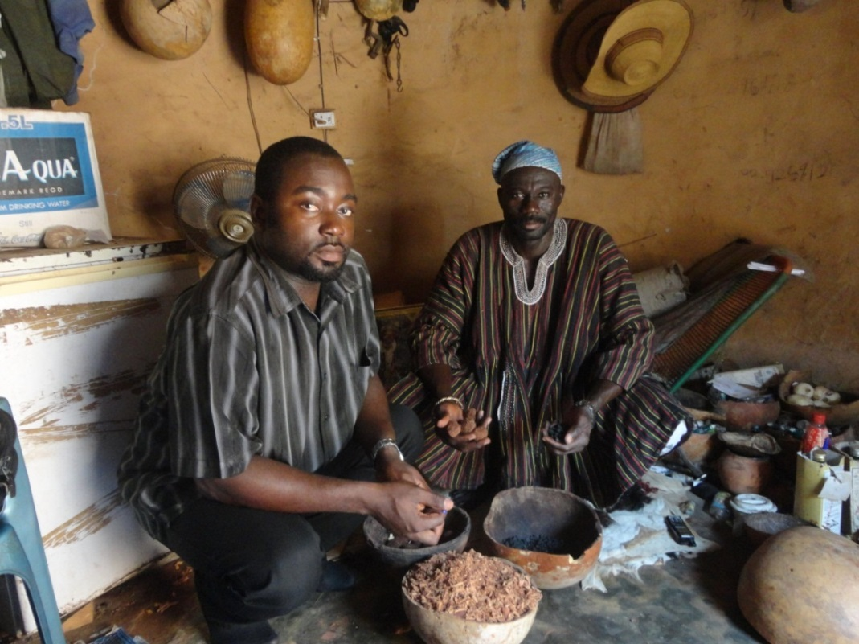
Photo 1: Picture of Stephen Awuni (left) a member of the Study Team with Alhassan Gushenaa, a TMP - Location- Kumbungu, Tamale, the Northern Region capital of Ghana

An important characteristic of the significant informality of the TM practice is the size of the enterprises operated by the TMPs. The majority of them of about 70% have only up to 5 employees, which places them firmly in the category of micro enterprises according to the Ghanaian classification of enterprises as in Table 6.

Table 6: The Grouping of the TMPs and Number of Employees
Groups | Number of Employees | Number of TMPs in Group | Percentage of Sample (%) | Average of Employees in Group
Group 1 | 1 – 5 | 73 | 68.2 | 2
Group 2 | 6 – 10 | 14 | 13.1 | 7
Group 3 | 11 – 15 | 4 | 3.7 | 13
Group 4 | 16 – 20 | 6 | 5.6 | 18
Group 5 | 21 – 30 | 3 | 2.8 | 25
Group 6 | >=30 | 7 | 6.5 | 66
Total |  | 107 | 100
Source: Field Data, 2013

The National Board for Small Scale Industries (NBSSI) gives the following classification of enterprises in Ghana: micro enterprises – between 1 and 5 employees; small – between 6 and 29; medium – between 30 and 99; large – 100 and above. The Association of Ghana Industries (AGI) also has a similar categorization of enterprises except that there are additional categories: large medium enterprises (101 – 299), large enterprises (300 – 499) and very large enterprises (over 500 employees). The survey data given in Table 5 can be interpreted by the categorization of enterprises in Ghana on the basis of number of employees. Thus, a significantly high proportion of 68% is made of up of micro-enterprises. In fact, about 27% were working alone (according to the field data) and as shown in Table 4, the average number of employees of Group 1 – the micro entrepreneurs – was two (2). The micro nature of the traditional medicine practice points to the need for strategic policies for sustainability and economic viability.

During the interviews it was quite clear that in many cases, the employees were apprentices or at best temporary labour. So really the TMPs covered in the survey operated at the micro level of the economy. Still the number qualifying as small scale enterprises is quite significant constituting about 25% of the sample. The medium (and large) enterprise also constitutes about 6.5% of the sample. Thus the connections with the other relevant sectors of the economy and the value chain components are fairly expansive.

Sources: Based on Field Data, 2013

Marketing of the traditional herbal products illustrates an aspect of the connections. Most of the TMPs surveyed operated their own personal herbal shops, some of which were no larger than tables constructed to display the products. Still, the majority of the respondents (62%) indicated they owned shops where the products were sold. Locally these products were sold at markets, lorry stations, drug store as well as hospitals and clinics as specified in Figure 1. Some also sold their products through hawking. The sale outlets for practitioners who manufactured their drugs ranged from local to international markets. Though those marketing their products locally and internationally constituted only 9.7% of the sample, it was the indication of the export potential of traditional medicine.

Indeed the linkage to the international market is one that can be more strategically sought. The potential for traditional medicine linkage to the other sectors is highlighted in some of the applications in the local manufacturing sector. Traditional medicine has become the base for manufactured natural health products such as body creams against skin diseases and ointments, health supplements coming in the form of mixtures and pills. Local industries such as Top Herbal and Chocho Industries are growing into large industries with their manufactured herbal products. Apart from the natural health products, there are also manufactured beverages based on traditional medicine. For example, Kasapreko which is one of the Club 100 companies in Ghana produces two well-known herbal-based alcoholic beverages – Alomo Bitters and Kalahari Bitters – which are exported. These alcoholic products are produced in collaboration with the Centre for Scientific Research Into Plant Medicine (CSRPM). The industrialization of traditional medicine offers opportunity for creation of jobs and diversification of the economy.

1.3 Key Features of the Traditional Medicine Sector

We draw on the field data in the survey to highlight salient features of the traditional medicine sector. Though this is not a randomized survey, the results are fairly indicative of the characteristics of the practitioners and the practice given the comprehensive sampling frame from which the sample was drawn. The socio-demographic features are summarized in Table 7.

Table 7: Characteristics of TMP Respondents Surveyed in Ghana

Characteristics | Frequency | Percentage
a. Gender
Male | 83 | 77.60%
Female | 24 | 22.40%
b. Marital Status
Single | 10 | 9.3%
Married | 85 | 79.4%
Divorced | 5 | 4.7%
Widowed | 6 | 5.6%
Separated | 1 | 0.9%
Total | 107
c. Religion
Christian | 79 | 73.8%
Muslim | 26 | 24.3%
Others | 2 | 1.8%
Total | 107
Source: Field Data, 2013

As in Table 7, the survey data of male population of 77.6% as against 22.4% female is perhaps reflective of the distribution of TMPs across the gender divide. The female representation in the traditional medicine practice underscores the fact that, the practice is not the preserve of men. In fact, in the study some of the successful TMPs were women. Table 6 also illustrates the family characteristics of the TMPs. Over 79% were married. The socio-cultural setting of traditional medicine probably appears to impose a strong family-centeredness on the practitioners. It is in accordance with the observation of the age groups in traditional medical practice with about 60% being over 50 years of age.

The religion of the respondents also is worth noting as presented in Table 7. Christians constitute 73.8%, Muslims 24.3% and only 1.8% constitutes other, which included the traditional religion devotees. Given the strong cultural setting of traditional medicine, one would have thought that a fairly high percentage would show for the “other” category of religion. Apparently, modernization has impacted on the religious practices of the TMPs. Traditional religion which used to dominate the practice in the pre-colonial days, has given way to the foreign religions. There are other characteristics highlighted in Figures 2 and 3 on age groupings and educational background respectively.

Based on Field Data, 2013

Figure2 illustrates the distribution of the respondents over the age groupings graphically. It shows that the age group 50 – 59 has the highest percentage of 33.6%. In fact over 60% of the TMP respondents are above the age of 50 years. I t suggests that mature adults are those who go into the practice. It needs time to learn to practice. Still, that almost 20% of the sample is between the age groups of 20 to 39 suggests that, the youth has a role to play in traditional medicine. Taking the practice as a key economic sub-sector, strategies could be formulated to create opportunities for youth employment and job creation.

Source: Based on Field Data, 2013

As shown in Figure 3, about 86% of the respondents had some form of education, whilst as much as 31.8% had tertiary education, which included teacher training college education. Only 14% of them had no formal education. Those who have had either secondary level or tertiary level education constitute about 59.8%, which is significantly high. While it must be explained that tertiary level education comprised of teacher training and polytechnic education, among others, there were some university graduates who were in the traditional medicine practice. The point that most of the TMPs are educated implies that they can be engaged in innovating in traditional medicine and specifically on policy formulation for enhancement of the sector since their opinion could be trusted source of policy guidance.

The issue of the number of years of practice underscores experience and competence of the respondents. The respondents estimated that they started practicing as herbalists on the average of about 16 years (+10.8 years sd) – some after tertiary education. Figure 4 shows that three (3) out of every five (5) respondents (60%) had been practicing this trade for more than 10 years and a few had been in business for over 30 years. The sample population probably points to a trend in the general population where most TMPs make a lifetime occupation of the practice. The long periods of practice however means that, TMPs can be meaningfully engaged in policy discussions to enhance the practice and implement appropriate strategies to widen the scope of impact and stimulate innovations.

On the issue of training and knowledge acquisition, many of the Traditional Herbal Practitioners acquired the skill through observing their parents or other family relations who are practitioners as a family business (55%), some through apprenticeship (35%) and others too claimed they had a divine call (10%) from God for the healing of certain diseases, and for some they practice as a hobby. Almost half of the respondents (48%) did not have any formal training in traditional herbal medicine(which is distinct from formal education) since it was a family business that all family members were involved and so it was even somehow difficult telling exactly when they started operation as herbal practitioners. The point is that, there is need for some upgrading of knowledge and skills to enhance practice. See Picture below.

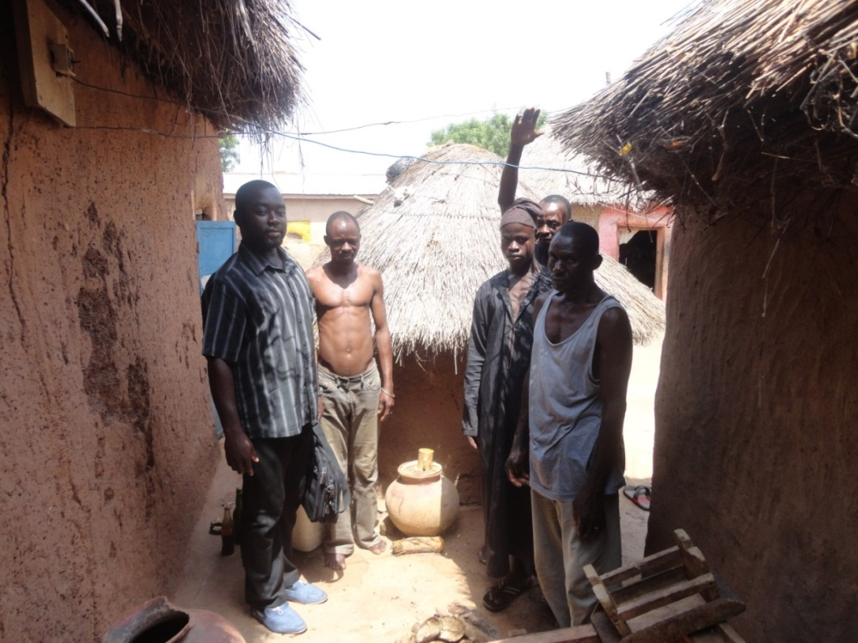
Photo 2: Picture: Stephen Awuni in AbdullaiMuazu herbal home with some apprentices. Location- Kumbungu, Tamale.

An important feature of TM is the registration of the products before putting them out on the market or dispensing them to patients in Ghana or anywhere else. There are Ghanaian traditional medicinal products that also get marketed outside the borders of Ghana especially in the West African countries of Togo, Cote d’Ivoire, Benin and Nigeria. A little over half of the respondents (52%) had at least one of their products registered with the Food and Drugs Authority (FDA) and or the Ghana Standards Authority or have tested the product at the Centre for Scientific Research into Plant Medicine (CSRPM). About 90% of those who registered did so with the FDA. The rest (48%) of those who did not register their products gave reasons including the following:

- the cumbersome nature of the registration procedures;
- registration not seen as very important; and
- the fees charged being too high.
Mandatorily, TM products have to be registered with the FDA otherwise the products are legally not allowed on the market for customers to buy. It is an offence to sell or market food and drug products not approved by the FDA. It puts the FDA in a strong position to determine the fate of food and drug products. The other institutions mentioned such as the GSA and the CSRPM only contribute to the adherence of standards and quality assurance. The respondents mentioned the following as requirements to have a product registered; that you first of all buy a form and when submitting your completed form you add a sample of your product to it and pay the required fee. The product will be tested for verification and then a certificate is issued to the applicant and about 85% of the respondents were able to narrate this procedure.

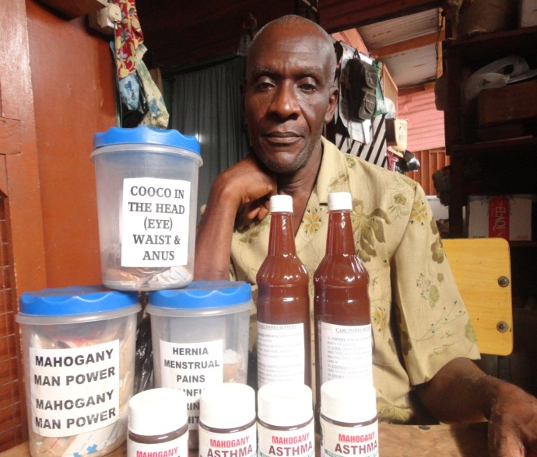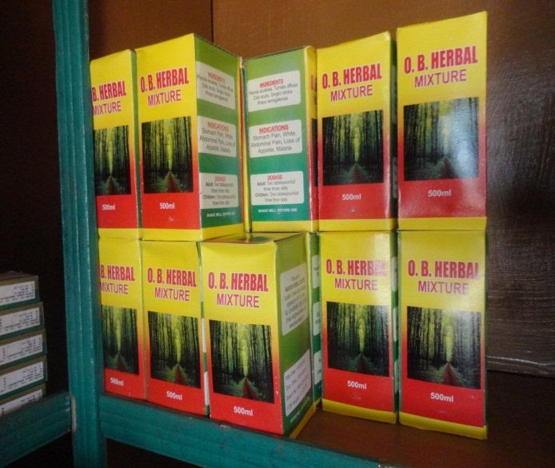
Photo 3 & 4: Some herbal products. The herbalist behind his products is Mr. Praise DotseKlu of Mahogany Herbs based in Madina in Accra.

Various reasons were given for registering a herbal product. The first reason is for certification and authentication of the product by a recognized body like the FDA and thereby avoiding conflict with the law. This is as cited by 42% of the respondents. About 39% of the respondents also indicated that registration of the herbal product allowed for easy marketing both on the local and international market. There are also the other responses indicating that registration is to obey the rules and regulations guiding the practice.

Those who went through the registration gave their assessment of the registration process in Ghana and said it was very cumbersome. Almost all of them (98%) claimed the registration process was very difficult and only one person indicated that it was easy. Even those who have not as at now registered a product alluded to the cumbersome nature of the process. As many as 76% of them claimed they made the attempt but could not pursue it to the end. The issue of registration is important given that it can be a vehicle for maintaining quality and efficacy of TM. However, there has to be some kind of review of the process to facilitate registration especially for the ordinary TMP who operates in the informal sector.

Section II: Innovation (Learning and Knowledge Flows) in the IE

2.1 Key Features of the Innovation System of Traditional Medicine

A fundamental concept which needs to be understood in relation to traditional medicine is innovation. The conceptual framework underscores the systemic principle of innovation for the studies. This is very relevant to traditional medicine where the identifiable stakeholders or critical actors are making contribution to the wide range of innovation in Ghana. Traditional medicine thrives on traditional knowledge and the indigenous heritage of the healthcare value of plants and their derivatives. Thus the source of knowledge for the practice makes the systemic approach to defining innovation very crucial. In high and low-income countries alike, innovation is now well understood as the ‘implementation of a new or significantly improved product (good or service), or a [new] process, a new marketing method (e.g. a novel product design), or a new organizational method in business practices, workplace organization or external relations’ (OECD/ Statistical Office of the European Commission, 2005). This definition includes incremental innovations that are new to the enterprise or new to the country.

Another recent definition, which is more applicable in the context of the informal economy states that ‘inclusive innovation is any innovation that leads to affordable access of quality goods and services creating livelihood opportunities for the excluded population, primarily at the base of the pyramid and on a long term sustainable basis with a significant outreach.’ (Mashelkar, 2012). Introducing the adjective ‘inclusive’ points to the informal efforts at enhancing production processes and their products but again paying due reference to affordability, opportunity and sustainability. For traditional medicine the medicinal nature of innovation is as important as the market value. Understanding what innovation is enables a better appreciation of the innovation products and processes.

In Ghana, one may describe a National Innovation System of Traditional Medicine comprising critical actors such as the traditional herbal medical practitioners, policy makers, researchers, regulators, entrepreneurs and consumers and the relevant institutions. Each of the categories of critical actors performs roles and functions which contribute to innovation in traditional medicine as illustrated in Figure 5.

Figure 5: Ghana’s National Innovation System and Traditional Medicine
EXTERNAL ENVIRONMENT – INTERNATIONAL CONVENTIONS, AGREEMENTS AND INSTITUTIONS GOVERNING TRADE, SOCIO-ECONOMIC AND POLITICAL RELATIONS IN THE HEALTH SECTOR

Source: Authors’ Elaboration

Figure 5 illustrates how the critical actors are connected in the National Innovation System (NIS) of Traditional Medicine. The focus of the illustration however is the generation of innovation in the system through the behaviors and activities of the informal, semi-formal and formal TMPs. The gist of this is that, the activities and influences of the actors in policy, regulatory and knowledge institutions in line with the internal or national socio-cultural and economic conditions enable the TMPs and associated actors such as the TMP associations and consumers to produce traditional medicine innovations. There are also external influences such as the trade and economic arrangements and the scientific and technological advancements, which impact on the TM innovations. Table 8 makes the functions and activities of the identifiable actors more explicit.

Table 8: The Functions of the Actors of the Traditional Medicine Innovation System
Actor | Functions | Assessed Level of Impact of TM Innovation
TMPs | Practices TM; produces and markets traditional medicine products; innovates in process and products. | Indispensable
GHAFTRAM | Serves as focal point for the association of TMPs; facilitates learning and innovation; policy advocacy | Very high
TAMD | Implements the national traditional medicine policy | High
Traditional Medicine Practice Council | Registers TMPs; promotes standards of the practice | Very high
Ministry of Health (MOH) | Oversees the health sector, formulates relevant policies and strategies | Indispensable
Ministry of Trade and Industry (MOTI) | Oversees the industry sector including micro and small entrepreneurs | Limited
CSRPM | Conducts research in plant medicine; produces TM innovations; tests products | Very high
KNUST | Trains under-graduate Herbal Medicine; short-term training to TMPs | High
FDA | Tests and approves or bans TM products | Very high
GSA | Tests and approves TM products as per standards | High
RGD (or RGO) | Registers companies | Limited
GHS Traditional Medicine Clinics | Promotes TM health care in public hospitals for those interested | High
Local industries | Produces drugs and health care products; other relevant products e.g. drinks | High
Chemical Shops/ Pharmacies | Sells TM products | High
Source: Field Data, 2013; Authors’ assessment

Table 8 summarizes the respective roles and functions of the actors in the innovation system. In the qualitative assessment of the impact on TM innovation, the idea is to highlight the differences in the extent of impact by the actors. Those with indispensable or very high impacts are those whose functions have direct impact on the activities of the TMPs. For example the Ministry of Health (MOH) is the oversight establishment for health care services delivery in Ghana. In overseeing the sector, it formulates policies, plans and programs to direct the national effort in health care service delivery. It is a crucial mandate which when exercised decisively drives innovative outcomes. In the particular case of traditional medicine, the ministry spearheaded the formulation and passage of the Traditional Medicine Practice Act 595 in the year 2000. The Act set up a Traditional Medicine Practice Council to regulate traditional medicine practice, register traditional medicine practitioners (TMPs) and license them, among other things. The Ministry has also set up the Traditional and Alternative Medicine Directorate (TAMD) to provide the institutional framework specifically for the development of traditional medicine. TAMD spearheaded the formulation of guidelines for the development of traditional medicine in 2005 through a participatory process which brought together the stakeholders in the practice, research, education, regulation, among others. MOH’s policy initiatives have led to the current establishment of traditional medicine clinics in public hospitals under the auspices of the Ghana Health Service. It is an emphatic statement of the acceptance of TM for health care delivery. The ministry has also included some herbal medicine in its Essential Drug List, which is also an important move to encourage public procurement of local herbal drugs. The ministry is therefore an indispensable actor in fostering innovation in TM.

The traditional herbal medical practitioners (TMPs) as a critical core group also play a crucial role in advancing (or downgrading) the practice in Ghana. In a number of ways, they have improved their practice adopting innovations and creating increasing peer pressure to further enhance performance by forming associations. Since the formation of the Ghana Psychic and Traditional Healers Association in 1961, there have been other associations formed to promote the interests of TMPs. The various associations were brought together under one umbrella called the Ghana Federation of Traditional Medicine Practitioners Associations (GHAFTRAM) in 1999. TMPs have produced a number of innovations in products, packaging, processes of production and health care delivery. It is fairly common to walk into an orthodox pharmacy and find stock of traditional herbal preparations on the shelves with the trained pharmacists recommending purchase. Such products are usually produced along the lines of allopathic medicine complete with labels on dosage and manufacturer’s contact details. Some TMPs have even established health care delivery facilities and operate along the format of allopathic medicine. Whilst these are positive developments in traditional herbal medicine, there are also the rather less positive developments of practitioners stuck in their old ways and showing no innovation. The extreme of the less positive development is where the quacks still operate to the detriment of the genuine practice. It raises the issue of making efforts to professionalize and further advance traditional herbal medicine within the context of the practice.

The traditional medicine practice currently overlaps the informal and formal economy; the micro practitioner is completely an informal entrepreneur practicing mainly in the manner of his or her forebears. In many cases, there are other occupations e.g. farming and trading. Some small and medium scale entrepreneurs have formalized their practice setting up in some cases modern enterprises for the production and supply of the herbal products. Even for these formal traditional medicine enterprises, the challenge of competing in the health care industry, dominated by foreign industries is a huge challenge in Ghana. In continuing to directly bring about innovations in the value chain of traditional medicine, TMPs are indispensable in the innovation system.

There are also industries of small and medium categories which have also zeroed in on traditional medicine. Even Phyto-Ryker, which by the classification of enterprises in Ghana is a large enterprise, invests in developing some herbal products. The role of industry as an identifiable critical actor is also important in the national innovation system. Whether these industries emerge from outside of traditional medicine or from within (e.g. growing from the practice of one innovating TMP), the activities, drives and propensities of these industries are important in promoting innovation. Even the enterprises in the marketing component of the value chain – the pharmacies and chemical shops – are important promoters or inhibitors of innovation.

The role of the Food and Drugs Board (FDB) as a regulatory institution for approval of dispensed or marketed TM products makes the Board highly relevant in the NIS. Regulation is a driver for innovation. Though some TMPs may not comply, those in serious business and with the goal of up scaling, will make every effort to comply. In that effort, innovation is a sine qua non. Some forge linkages with the knowledge centers to enable innovation in products and practice not only to pass the mandatory tests, but to secure larger segments of the market.
The mention of knowledge institutions, points to the role of researchers and or scientists. Researchers are playing important roles to stimulate innovations in traditional medicine and strengthen the scientific base of the traditional medicine industry. The Centre for Scientific Research into Plant Medicine (CSRPM) was established in 1971 and has since developed into a strong knowledge institution for herbal medicine. Besides, the Centre has also become the embodiment of research enterprise in traditional medicine even as other scientific institutions are contributing in some ways to advance traditional herbal medicine on sound scientific basis. Research activities in ethno-botany, plant medicine, biochemistry, pharmaceuticals, among other specializations have been carried out in the public universities and research institutes. Beyond the efforts in scientific research, there is also the contribution in enhancing knowledge, developing the human resource and orienting the new generation of TMPs to scientific methodologies. For example, Kwame Nkrumah University of Science and Technology (KNUST) has introduced a four-year first degree program in herbal medicine which is aimed at producing the scientific human resource for enhancing traditional medicine in line with the policy guidelines the ministry has formulated. Already the graduates are out with some posted to the TM clinics in some of the public hospitals.

The issues of Intellectual Property (IP) are directly in the domain of the Registrar-General’s Department, which is the public establishment overseeing industrial property matters in Ghana. The Department is better known for performing the primary function of registering and certifying all businesses in Ghana before commencement. It has additional functions, which include registering patents and trademarks and enabling industries and entrepreneurs to consolidate and protect their industrial properties. Even though the awareness of IP and its advantages is not very high among the critical actors, there is sufficient consciousness of the need for IP ownership. The role of the Department and other related agencies in raising IP consciousness and promoting the use of Ghana’s IP regime is crucial for the advancement of traditional herbal medicine. However, this has to be done in the context of the national legislative framework for recognizing traditional knowledge and the fundamental rights of local communities to access to benefits of the exploitation of their indigenous knowledge. In this specific area of traditional knowledge, the role of the RGD is not very strong.

Figure 5 illustrates the linkages in the National innovation system leading to the innovations of traditional medicine. It illustrates the influences also of the external environment such as the global market and economic conditions and technological advancements. Locally the policy conditions and the legislative and regulatory framework create the ambience for innovation to be generated in traditional medicine.

2.2 Innovation Profile of the Sector and Learning and Innovation process

The case study has shown how far TM is being transformed in Ghana currently with diverse innovations. The Ghanaian herbalist produces a variety of TM products such as pills, tablets, capsules, creams in tubes and mixtures bottled for longer shelve life. There are also a range of health products e.g. tea bags and beverages, which ordinarily one may not expect of the TMP. Apart from the product innovations, there are also process innovations. For example, instead of boiling their herbs, practitioners extract the active ingredients with alcohol or isolate the active ingredient with some other liquid chemicals. TMPs, especially those operating on fairly enhanced scale have adopted a variety of modern equipment to increase production and improve on quality.

Indeed, the TMP in Ghana had gone through many technological innovations in the value chain of traditional medicine from processing to packaging. The dispensing herbalists are now employing the use of diagnostic equipment like scanners, laboratory machines, mixing machines, blenders, etc. Those in manufacturing are installing tube filling machines, machines for bottling liquid preparations with their seals, the use of semi-automated capsule filling machines as well as labeling machines. Some of the old modes of production such as drying of herbs and pounding in simple wooden mortars or grinding on stones are giving way to modern machinery for these activities. Dryers are being used to dry herbs. And the age-old clay pot used for boiling is giving way to stainless steel boilers. TMPs are also adopting modern ways of preservation for longer shelf life such as the use of sodium benzoate. Table 9 summarizes the innovations observed in the case study with the elaboration of the innovations following.

Table 9: Number of Respondents Using New Technologies – Production Techniques or Innovations
New Innovations | Frequency | Percent
Scientific Equipment – Like PH meters, filters, Diagnostic Machines, scanning equipment’s | 14 | 28.00%
Water storage containers and pumping machines, gas stoves, power generators and plants | 14 | 28.00%
Tube filling machines /bottling machines | 10 | 20.00%
Mixing machines/blenders | 10 | 20.00%
The use of semi-automated capsule filling machines. | 9 | 18.00%
The use of Aluminium boiling containers instead of iron. | 7 | 14.00%
Labeling machines/seals | 2 | 4.00%
Use of preservatives e.g. sodium benzoate | 1 | 2.00%
Use of Homeopathic techniques eg. Reflexology/acupressure | 1 | 2.00%
Source: Field Data, 2013

Boiling and Brewing in Herbal Drugs Processes

There are regulations concerning the types of metals used in boiling or brewing containers for producing foods and drugs generally. These are necessary to ensure there is no interaction between the materials or drug ingredients being processed and the containers. Photo 5 illustrates the modern boiling containers which was recommended by the Food and Drugs Authority (FDA) and is being used by many producers of traditional herbal products who want their products registered.

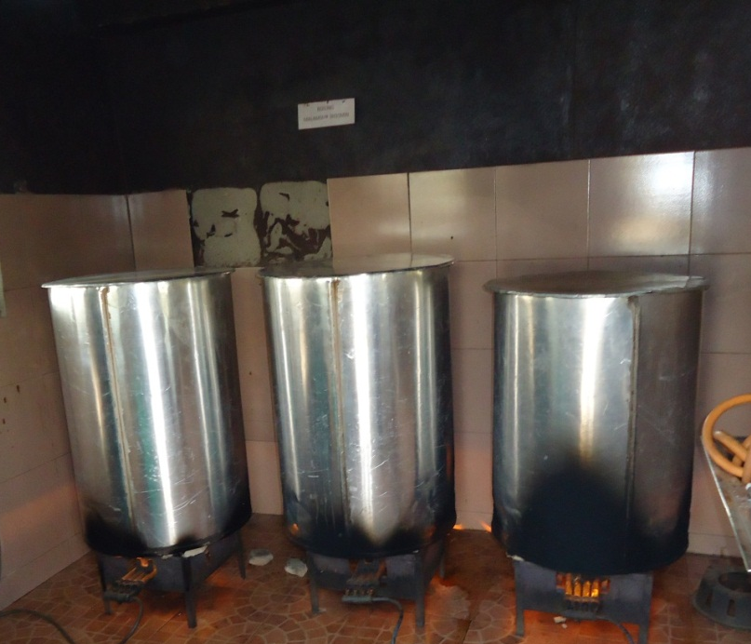

Photo 5: Picture of Improved Aluminum Boilers for Brewing Traditional Herbal Medicine Preparations

The use of the semi-automated capsule filling machines

A recent innovation in the production of herbal medicine was the production of medicine in the form of capsules. The old mode of wrapping herbal medicine in leaves or at best in polythene has changed for the innovators. They produce their herbal medicine in modern capsules like any allopathic medicine. Some have acquired capsule-filling machines to produce their medicines in capsules.

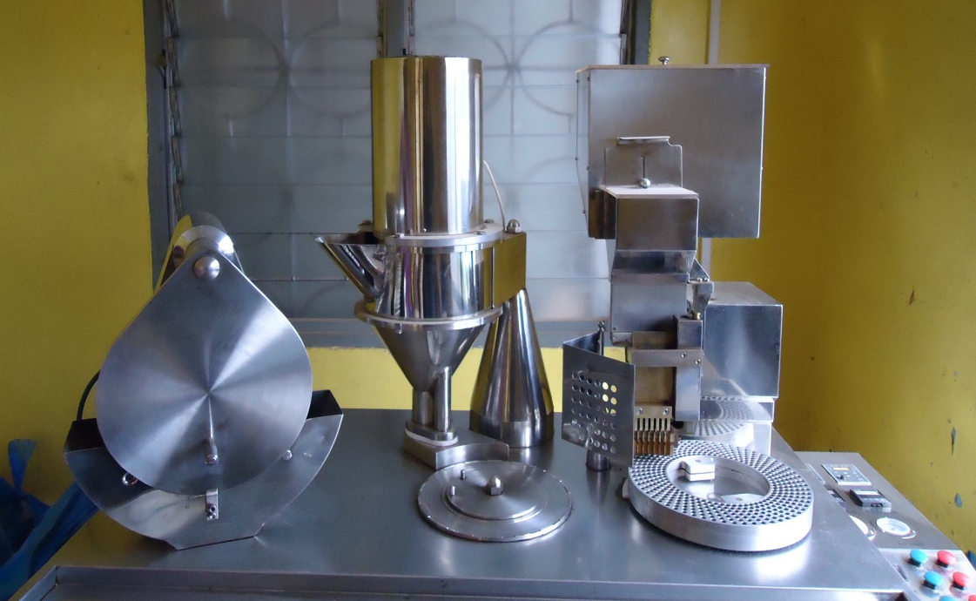
Photo 6: Picture of capsule filling machine, for the production of traditional medicine in capsules

Use of scientific equipment like PH meters, filters, diagnostic machines and scanning equipment

Among the recent innovations in the production of traditional medicine is the use of modern scientific equipment’s like diagnostic machines, pH meters, filters, labs etc. Picture shows a lab of traditional medical practitioner.

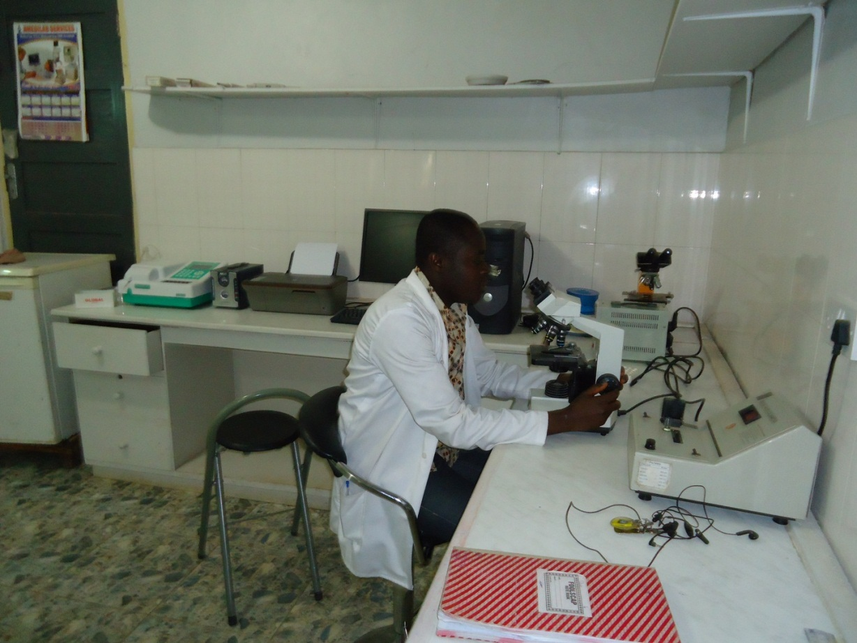

Photo 7: Picture of scientific laboratory of a traditional medical practitioner

Increased sustainability of utilities like water storage containers, pumping machines, power generators and plant

Most respondents stated that, to prevent inconsistencies while promoting effective and efficient services in the production process, they needed stable supply of utilities. Thus to augment these supply systems, they had water storage containers, electric pumps and generators for that purpose. The pictures illustrate these.

Photo 8: Picture of water storage container with an electric pump

Tube filling machines, bottling machines, mixing machines and others

Another product innovation in the traditional herbal medicine has to do with the packaging of creams in tubes. This has made way for the use of a tube filling machine in their manufacturing processes. Picture illustrates a tube filling machine being used to fill tubes.

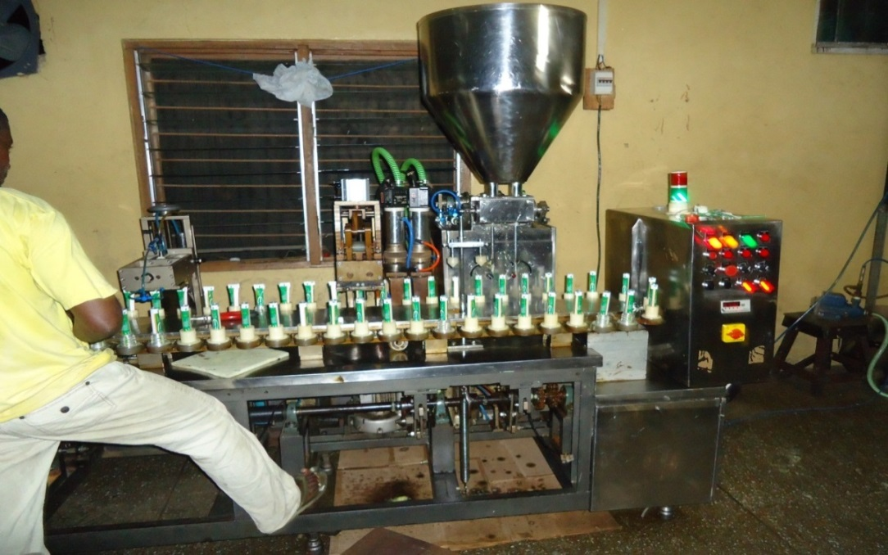

Photo 9: Picture of tube filling machine being used to fill tubes with creams

Apart from having boiling containers, respondents also said they had mixing machines to make it easier as well as help them to produce in bulk. Picture illustrates a mixing machine.

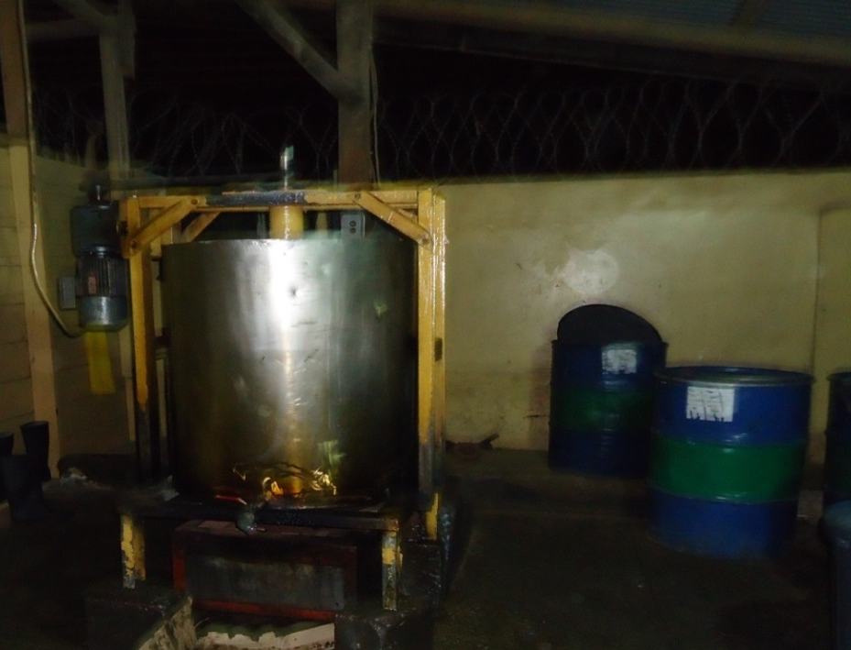

Photo 10: Picture of mixing machine for mixing herbal soap

For new process innovations developed over the last five years, most of them indicated that, instead of packaging the leaves and selling, there was further processing like turning the herbs into powder and packaging as capsules or tea bags. There was also a lot more boiling of actual preparation with the goal of ensuring good extraction of the active ingredients.

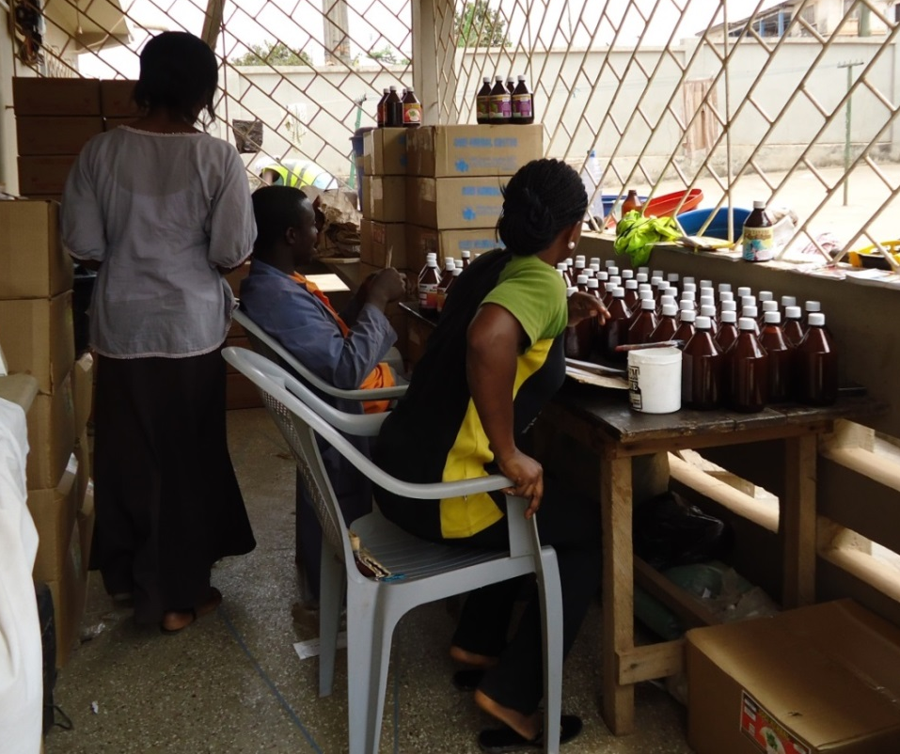

Photo 11: Picture shows bottling of herbal remedies in amber bottles as a recent innovation

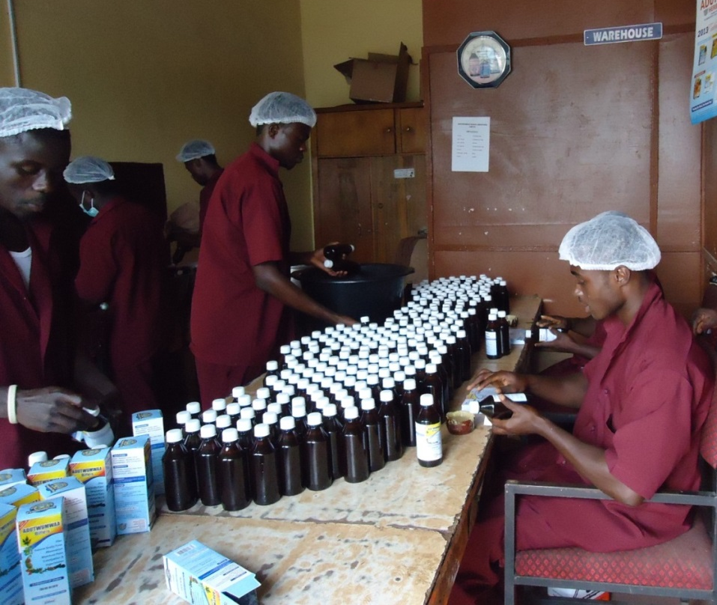

Photo 12: Picture shows bottling under hygienic conditions to improve quality assurance procedures

The finishing of the manufacturing process was important in assuring quality. So there was adoption of quality assurance measures and the use of good packaging materials with good labeling with indications of dosages, batch numbers, expiry dates, etc. The jackets, bottles, tubes and other packaging materials used enhance the advertisement of the products.

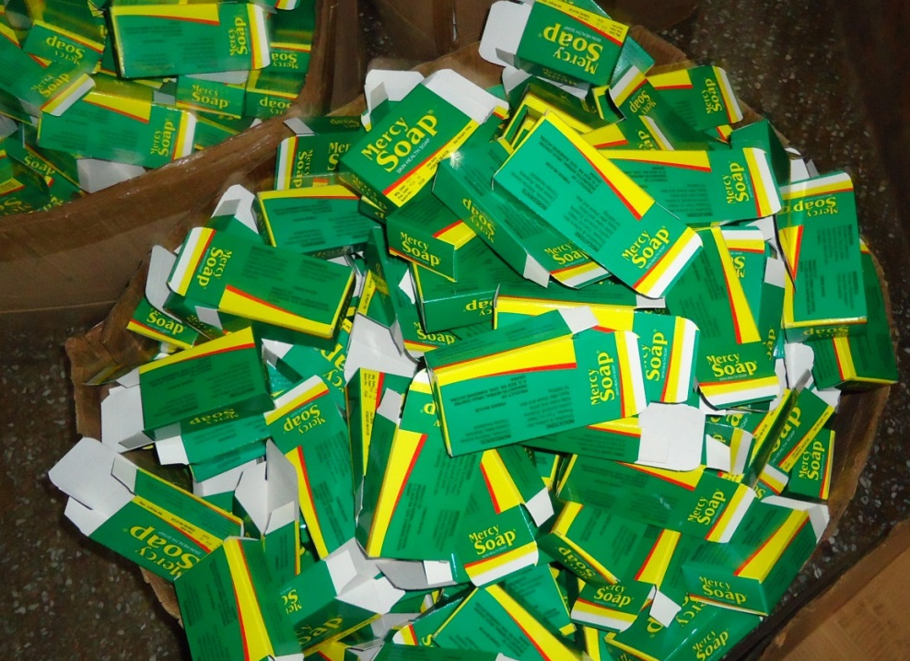

Photo 13: Picture shows jackets for packaging soap to improve quality and promote advertisement

Figure 6: Innovations in the Value Chain

Inputs, packaging materials
Inputs herbs, chemicals, energy

Inputs water, harvested herbs, chemicals, packaging materials, etc.
The Pull Effect
Market demand,
Consumers/ patients

Marketing/ dispensing phase
Pre-production phase
Production phase
Finishing phase

Innovations
* Water supply systems e.g. tanks, water pumps, filters
* generators

Innovations
* Broilers
* Grinders
* Mixers
* dryers

Innovations
* Diagnostic equipment
*Pharmacies/
* Chemical Shops
* Radio/ TV adverts
Innovations
*Encapsulators
* Bottling machines
* Sealing machines
* Wrappers

The Push Effect
Policy, Regulation, Competition, Entrepreneurship, New Knowledge

Source: Authors’ Elaboration

Figure 6 summarizes the observed innovations in the traditional medicine practice from the value chain perspective. In the identifiable components of the value chain, there are key innovations that have upgraded the practice or operations of the TMPs. Even some of the micro and small scale practitioners value these innovations and are able to access them where they do not have their own. In the FGD with the GHAFTRAM members, they made the point that a central processing facility with all the essential machines installed will contribute a great deal to enhance their practice. But the innovations are not only in terms of machinery and equipment but also the techniques and the skills and knowledge for use of these innovations.
The drivers of innovation can be broadly analyzed in terms of the push and pull effects. The policy initiatives have made TM an option for public health care delivery. In the past, TM practice was universal but was not a recognized public health care option. This changed with the policies formulated by the Ministry of Health. The ministry through its relevant agencies such as TAMD, the TMPC and the Ghana Health Service have formulated and implemented policies and programs which have enhanced the practice of TM and with innovations.
Policy formulation and implementation have also moved fairly in tandem with regulations some of which are generic in nature but of effect on TM. For example, the Food and Drugs Act 199, P.N.D.C. L. 3058, Act 1992, sub-section 18 (I) states that “A person shall not manufacture, prepare, sell, supply, export or import a drug, cosmetic, device or chemical substance unless the article has been registered with the Board.” Even the advertisement of drugs is subject to regulation this regulation as stated in sub-section 15, “A person shall not advertise a drug, cosmetic, device or chemical substance to the general public as treatment, preventive or cure for a disease, disorder or abnormal physical state…” The regulations pushed for innovations not simply in the products but in other related areas such as labeling, advertisement and marketing.

As illustrated in Figure 7, there has been a general increase in applications for FDA approvals since 2000 when the TMPs began seriously complying with the regulations for FDA approvals. There is usually a lag between the number of applications received in a year and the number of approvals given. The lag was most pronounced in 2001 when a total of 171 applications were received and 71 were approved. Then in 2011 a total of 376 applications were received and 177 were approved. A number of factors account for the delay in approval including the need for thorough scientific analysis, inadequacy of information on the applications, lack of prompt response to queries. Some TMPs complain about the bureaucracy in the processing of applications. However, some other TMPs also seem to be able to comply effectively and use their approval as a point of marketing. It all goes to improve the quality of herbal medicinal products and enhance the acceptability and efficacy for the consumers. This is what regulation and the quality assurance institutions are achieving for the country.
Competition is another driver for innovation in TM practice. There is the competition that is within the practice itself with TMPs seeing what others have done to come out with more marketable products and deciding to match these or improve further. But there is also the competition that comes from allopathic drugs and imported traditional medicinal products especially from China, India and Korea. Some natural health products also come in from the US and South Africa. Generally the pull effect on the local market with its wide range of options for the consumers to choose from drives TMPs to innovate substantially. The consumer or patient is becoming more sophisticated with the current trend in urbanization. Already over 50% of the population is living in urban areas as against only about 30% in the 1960s. Innovation enables the innovator to compete effectively.

Entrepreneurship is also a driver for innovation. The conventional herbalist is usually one who operates in a hut in the village and expects patients to come with their ailments. The modern herbalist goes out there to create his or her clientele; there is a market of competition. He or she takes the necessary risks to invest and innovate to secure his or her place in the market. In doing this the acquisition of new knowledge either already existing in the context of the practice or coming from outside of the context, is crucial. Knowledge coming in various forms drives innovation in TM.

In the final analysis, it is generally the market that determines the effectiveness of the innovations exerting a pull effect on them. The demand on the market promotes the application of the innovations. The consumers and patients patronizing TM practice are literally the final arbiters. In creating the demand for the TM products and services, the TMPs whether operating at the micro, small or large scale, continue to sustain their enterprises with the innovation.

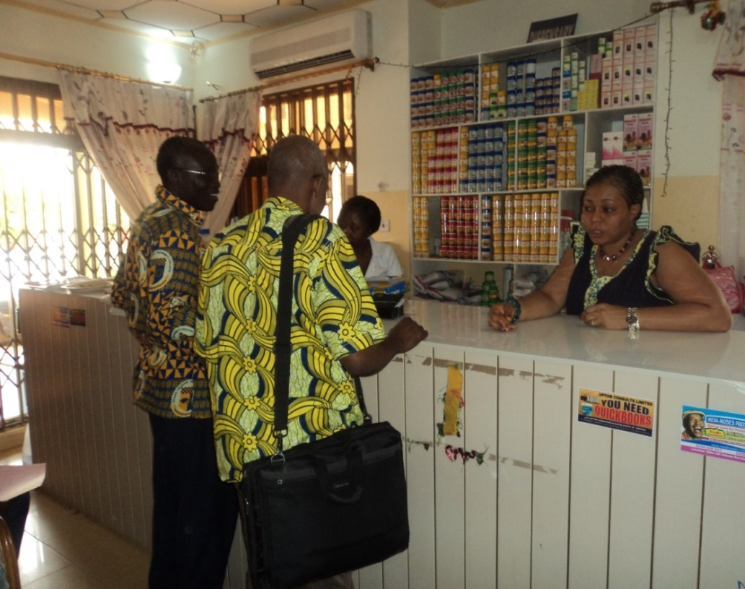
Photo 14: Herbal preparations being purchased at a traditional herbal clinic.

Table 10: Traditional Medical Practitioners Main Customers
Main Customers | Frequency | Percent
All and sundry | 58 | 54.2%
Patients with general diseases | 21 | 19.6%
Drugstores/Pharmacies | 14 | 13.1%
General infertility problems | 11 | 12.2%
Friends/family | 5 | 4.7%
Government hospitals/clinics | 2 | 1.9%
People suffering from specific disease conditions | 15 | 14.1%
Source: Field Data, 2013

Table 10 shows the diversity of the customers for the TMPs. The main customers for the practitioners are all patients with any kind of diseases, notably women and men with infertility problems, people having suffered from stroke, piles, skin and other diseases common in the society. What is important is also that some government hospitals and clinics also provide outlets for the TMPs to market their products. A few of all the respondents (16%) had their products on the Essential Drugs List (EDL) of the Ministry of Health. Majority of those who have their drugs on EDL were of the opinion that it was due to the efficacy and potency of their products that accounted for the selection onto the EDL. They also believed that their drugs were cheaper and had little or no side effect compared to the orthodox.

The interviews of the consumers showed a consistent appreciation of the potency of herbal medicine and preference of herbal medicine compared to orthodox medicine due to their personal experiences. Here are some of the statements made by the consumers in personal communication during the interviews:
A 68-year old man praised the herbal doctors for the good work they are doing. He said “the medication has no side effect like the orthodox one I used to take. I used to have severe headaches when I take the orthodox anti-hypertensive. But thank God now it is a thing of the past since I switched over to herbal medicine”.
Another male – a 48-year patient said “I tried orthodox but I was not responding to the treatment given me. I therefore decided to try the herbal treatment. The result has been positive.”
A female 39-year hypertensive mother said “my doctor recommended herbal treatment to help give me relief. I was diagnosed hypertensive during my second pregnancy and it has been with me ever since. I was assured that it may be gone after delivery but it has been with me for over ten years. I am now taking herbal medicine and think I am responding to treatment. I constantly come to the herbal clinic as soon as my prescriptions get finished”.

The consumers’ preference for herbal medicine often came from personal experience. Some had had previous treatments with orthodox medicine and it had not worked for them. Often, those who benefited positively from herbal treatment recommended it to others thereby increasing the patronage of herbal medicine. Apparently, the policy to institutionalize and promote the use of traditional herbal medicine has been very beneficial to some segments of the Ghanaian population. How the improvements come about according to the respondents in the case study is illustrated in Table 11.

Table 11: The Improvement of Products and Practice
Towards Improvement on Products/ Practice | Frequency | Percent
Research/Monitoring and Evaluation | 48 | 44.9%
Feedback from clients/ consumers/ colleagues | 28 | 26.2%
Maintaining manufacturing standards | 16 | 15.0%
Adhering to divine direction/ beliefs | 8 | 7.5%
Sourcing the best herbs for production | 8 | 7.5%
Preservation of family heritage/mentorship | 6 | 5.6%
Attending Trainings and workshops | 5 | 4.7%
Advertisement/marketing | 5 | 4.7%
Labeling/packaging/sealing | 3 | 2.8%
Feedback from regulatory institutions. | 2 | 1.9%

A high percentage of 44.9% indicated that research, monitoring and evaluation were at the heart of the improvement on products and practice as in Table 11. The use of the term ‘research’ is liberal in this study. It refers to all activities engaged in to obtain knowledge for use in improving the product including desk research, experimentation with plant extracts and new formulations. This is related to ‘feedback from clients, consumers and colleagues’ which had 26.2%. Maintaining manufacturing standards also had 15.0%. What is of importance in the list of the sources for improvement is that, there is less emphasis on the esoteric and ‘adhering to divine direction and beliefs’ which had only 7.5%. However, it is worrying that ‘feedback from regulatory institutions’ should score only 1.9% given that, there is a statutory regulation for assessing and approving the products and feedback should not be difficult to give into to TMPs to improve the products.

2.3 Obstacles to Innovation and Scalability

Despite the good trend in innovation, there are obvious obstacles which have to be addressed to facilitate the growth of TM and stimulate greater innovation. Firstly, the relative small scale nature of the operations does not allow for greater innovation given that innovation needs investment and acquisition of new skills and expansion of markets. It is almost a chicken and egg situation. Should practitioners upscale operations and then be able to invest and innovate or they invest and innovate and then upscale? The case study shows that the TM enterprises which have the most innovations are those of the relatively larger size and qualify as small or medium enterprises.

Table 12: Selected Enterprises and Drugs on EDL

Name of Enterprise | No. of employees | Scale of Enterprises | Drugs on Essential drug list?
Medi Moses Medical Centre | 20 | Small | Yes
Nana BoakyeHerbal Clinic | 8 | Micro | No
Crown Pharmacy | 4 | Micro | Yes
Adam Nana Herbal Center | 5 | Micro | No
Semenhyia Herbal Clinic | 2 | Micro | No
Kascala Herbal Centre | 61 | Medium | No
Angel Herbal Centre | 16 | Small | No
Frelena Health Centre | 63 | Medium | Yes
Nyame Ye OdoEnterprise | 6 | Micro | Yes
NyameAma Health Clinic | 3 | Micro | No
Osei Herbal Clinic | 24 | Small | No
Tawheed Naturopathic clinic | 43 | Medium | Yes
Insaanyia Drug Centre | 24 | Small | No
Adutwumwaa Herbal Centre | 35 | Medium | Yes
Source: Field Data, 2013

Table 12 illustrates the point that there is generally an opportunity for TMPs to get their drugs accepted on the Essential Drug List (EDL) whether micro, small or medium. Two of the six listed micro TMPs had their drugs on the list and one of the four small TMPs also had drug listed. However, three out of the four listed medium TMP enterprises had their drugs listed. It suggests that the bigger enterprises, the more likely their drugs would be on the Essential Drug List (EDL), which is ultimately the aim of almost all TMPs. The challenge of upscaling is that as the TMP upscales and adds value to the products through innovation, its prices may rise above the affordable levels of some of the customers. This is where it is necessary to begin formulating strategies that will facilitate scalability and yet ensure that the issues of affordability for which most people fall on TM products will adequately be addressed. The issues were highlighted in an interview with one of the Herbal Doctors in one of the Herbal Medicine Clinics. This is what he said about his experience in practice since 2010:

“I was the first to begin this herbal medicine clinic in this hospital. Attendance was very slow when we started. The daily attendance was between two and three. Even some days we don’t see any patient. Attendance improved over time though not as fast as expected. So we conducted a small research among our clients. Their responses were that because National Health Insurance Scheme (NHIS) did not cover their drugs, they could not afford to come all the time, even though the medicine given them here was good.”

So in promoting traditional herbal medicine, an important challenge has to do with the exclusion of even the approved TM drugs from the list of those paid for by the NHIS. In the process, the allopathic treatment often becomes more affordable – the NHIS picks the bills for the conventional treatments but not for the herbal treatment in the trial herbal clinics. Apparently, the implementation of the traditional medicine policy needs to go further than the setting up of trial clinics.

On the question of how research was conducted on the herbal products to assess efficacy, the Herbal Doctor explained:

“We used their contact numbers to check on them especially those with chronic cases who needed to come for review. I don’t encourage my clients to use their own herbal preparations, e.g.pluck neem tree leaves, boil and prepare their own concoctions. The neem can be phytotoxic at high doses. It is why neem extracts must be administered professionally. However, it is very good for hot steaming, I also advise them to use garlic or ginger because of their anti-oxidant effect. Herbs are good but one needs a lot of guidance in its application”.

The use of traditional medicine has seen innovation in terms of products and production processes and this has enhanced the safety in the patronage of traditional medicine. But there is more to be done to ensure that the system improves and becomes better integrated into Ghana’s health care delivery system. In the survey the suggestions coming up with regard to ameliorating the situation generally are presented in Table 13.

Table 13: Suggestion to Improve Traditional Herbal Practice in Ghana
Measures to improve Traditional Herbal Practice | Frequency | Percent
Massive government assistance (e.g. financial and ministerial support) | 58 | 54.2%
Education, training and workshops on herbal practice | 37 | 34.6%
Collaboration between orthodox and traditional medicine practitioners | 12 | 11.2%
Sensitization of people to patronize herbal products/ adverts | 11 | 10.3%
Remove bureaucracy in the registration process | 5 | 4.7%
Legal frameworks and proper law enforcement | 4 | 3.7%
Registration should be affordable and accessible | 4 | 3.7%
Policy formulation to enhance herbal practice | 3 | 2.8%
More lands to develop herbal plantations | 3 | 2.8%
Establish and invest in research centers/ herbal clinics | 3 | 2.8%
Establish herbariums to preserve knowledge | 2 | 1.9%
Removal of quack practitioners from the system | 2 | 1.9%
Good leadership for herbal practitioners | 2 | 1.9%
Promotion of herbal studies in the universities | 2 | 1.9%
Establish TMP Associations | 1 | 0.9%
Clinical data collection and analysis to convince skeptics | 1 | 0.9%
Provide incentives for herbal science | 1 | 0.9%
Establishment of manufacturing plants for herbal practitioners | 1 | 0.9%
Establishment of ethno-medical foundations for research | 1 | 0.9%
Health insurance should be extended to cover herbal practice | 1 | 0.9%

Source: Field Data, 2013

The suggestions presented in Table 13 highlight the fact that, there are three broad categories of actions needed to promote innovation and scalability. Firstly, there are the policy actions (government schemes for direct assistance and more facilitative legislation and regulation). For example, the issue of the National Health Insurance Scheme (NHIS) not covering herbal products is incongruous to the current national policy and program promoting TM. If nothing at all, those on the EDL should be covered. Secondly, there are the knowledge and technology support systems comprising research and development, manufacturing plants, herbarium and medicinal herb plantations, which are necessary for consolidating the advancement of TM. Thirdly, there are the organizational actions that have to be taken, either by the TMPs themselves or relevant actors, such as the Ministry of Health. In all this, there is need for a holistic or systemic approach to undertake the envisaged actions.

Traditional Medical Practitioners have in modern times made effort to belong to associations. It is a way of fostering networking and facilitating flow of knowledge. Table 14 shows the distribution of membership among the case study respondents with many belonging to more than one association.

Table 14: Names of Associations
Association Names | Frequency | Percent
Ghanaian Associations
Ghana Federation of Traditional and Alternative Medicine (GHAFTRAM) | 57 | 65.5%
Ghana Association of Traditional Healers | 52 | 59.8%
Northern Traditional Healers Association | 3 | 3.4%
National Traditional Healers Association | 2 | 2.3%
Ghana Psychic and Traditional Healers Association | 2 | 2.3%
Ghana Naturopathic and Physician Organization | 1 | 1.1%
Ghana Association of Medical Healers | 1 | 1.1%
Foreign Associations
Ontario Herbalist Association Canada | 1 | 1.1%
Zimbabwe National Traditional Healers Association | 1 | 1.1%
International Organization of Medical Traditional Practitioners Research | 1 | 1.1%
Source: Field Data, 2013

Four out of five practitioners interviewed belonged to at least one or more associations both locally and internationally. As shown in Table 14 the local traditional medicine associations to which respondents indicated membership were Ghana Federation of Traditional and Alternative Medicine (66%) and Ghana Association of Traditional Healers (60%). The rest were National Traditional Healers Association, Ghana Psychic and Traditional Healers Association, Ghana Naturopathic and Physician Organization and Northern Traditional Healers Association. Table 14 shows that GHAFTRAM is establishing as the umbrella association of the TMPs but it is yet to achieve dominance. The international ones were Ontario Herbalist Association of Canada, International Organization of Medical Traditional Practitioners Research and Zimbabwe National Traditional Healers Association. It is good for networking and knowledge flows to go beyond the local context.

Table 15: Benefits of Membership of Association(s)
Benefits of Membership | Frequency | Percent
1- Sharing ideas on the practice | 22 | 25.3%
2- Attending training and workshop | 34 | 39.1%
3- Advocacy/ promotion of products ( Exhibitions) | 14 | 16.1%
4- A feeling of belonging/ solidarity | 6 | 6.9%
Source: Field Data, 2013

As shown in Table 15 about 40% of the herbalists were of the opinion that the main benefits of being a member of the association were to attend workshop to acquire more knowledge as well as sharing ideas. For those who belonged to any association, some of the trainings received in their association covered basic science in herbalism (23%), proper documentation (20%) and quality assurance (13%). See Figure 7 below.

Source: Based on Field Data, 2013

It is interesting that the training over the years has placed emphasis on the scientific knowledge of the TMPs and the largest percentages indicated were the related subjects or courses – basic science in herbalism (23.)%), herbal medicine production and administration (17.2%), quality assurance (12.6% and good manufacturing practices (9.2%). The other courses are also very useful for enhancing the practice and management of TM.

The networking has not been exclusive to the membership of the associations. Direct networking with the local knowledge institutions has been going on. Some of the respondents (48%) had worked with recognized institution in Ghana, notably the CSIR at Mampong-Akwapim, KNUST, University of Ghana and the Noguchi Memorial Institute of Medical Research. The research institutions and universities are the conventional knowledge institutions. However there are other institutions where useful knowledge resides for the TMPs to tap into. Thus the other institutions they worked with were the Food and Drugs Authority, Ghana Standard Authority, Register General Department, Traditional Medical Practice Council, the Ministry of Health and the West African Health Organisation (WAHO).

Source: Based on Field Data, 2013

Figure 8 illustrates the rationale for the linkage with the knowledge institutions including the regulatory bodies. Many who worked with these institutions mentioned that their association with them exposed them to various forms of improving their practice. Most importantly at training workshops, they were introduced to new production or processing techniques such as for the preservation of the products and extension of shelf life. In Figure 8, some 37.9% indicated that their linkage with the knowledge institutions was for them to obtain new formula to preserve products. The knowledge institutions or knowledgeable scientists are involved in the upgrading of the knowledge of the TMPs and in stimulating innovation.

When asked if they would want to team up with somebody to commercialize their enterprise on a large scale, about 80% of the sample answered in the affirmative. The 20% who would not want to team up were afraid of someone hijacking their trade and taking their livelihood for life. A good number of those who wanted to team up for commercialization (78%) were equally concerned of the possible commercialization of their innovation or innovative ideas which would deprive them of regular income. For the few (20%) who were not concerned about the commercialization concept, it came out that majority (61%) of them practiced secrecy as a means of protecting their innovations. Other protective measures put in place to protect their innovations or innovative ideas included trademark or combination of both secrecy and trademark.

What came up strongly in the field study was the apparent recourse to social norms for the protection of innovation or intellectual property. This is in accord with the Conceptual Study defining the framework for the case studies (de Beer et al, 2013). The other case studies have also found similar trends in appropriation by the social norms in South Africa and Kenya (Kraemer-Mbula, 2013; Bull, 2013). Many of the modern TMPs who were the respondents in the field study did not shroud their traditional medicine practice in mystic rituals as often is the case with the spiritualist herbal healer. For example, about 73% of the sample indicated they ascribed to Christianity and so may not be indulging in the traditionalist religious practices associated with the traditional spiritual healer. The rituals are the high points of secrecy as mechanism in protecting their medicinal intellectual property. Still, the simple act of non-disclosure of how the TMPs produce their medicines is in line with the known customary practices of ensuring sole ownership of innovations in traditional medicine.

The concept of open transfer or exchange of innovation/innovative ideas was seen to be useful in traditional medicine by majority (92%) of the practitioners. Similarly, many (93%) of those concerned with the possibility of commercialization of their innovation or innovative ideas that may deprive them of their livelihood were all for the introduction of the open transfer or exchange of innovation and innovative ideas. About 89% of those who registered their enterprise and 85% of those contributing to social security were all in support of the open transfer or exchange of innovation/innovative ideas. However, the view of subscribing to open access is in conflict with the position on appropriation of intellectual property to check unwarranted commercialization. It may seem that respondents might not have thought through carefully the implication of open access.

Overall, there is need for awareness creation and good education on the issues of IP. For the TMPs, while the social norms and traditional mechanisms of secrecy may serve the purpose, there is still the need to enhance the IP appropriation mechanisms to facilitate their operations in the modern economy. The fundamental question however is what mechanism is appropriate and how may this be fashioned? What are the policy measures needed to bring about these mechanisms and get them implemented?

Section III: Mechanisms to Protect and Appropriate Innovation to Generate Returns from Innovation in the IE

3.1 Appropriation Mechanisms in the Informal Economy

Ghana like most African countries has established the institutional framework for intellectual property catering for both copyright and industrial property with the specific public offices assigned responsibilities for administration. The Copyright Office administers copyright in line with the Copyright Act, 2005 (Act 690) and the Copyright Regulations of 2010 (L.I. 1962). The Registrar-General’s Department (RGD) is responsible for the administration of the industrial property with due regards to Trade Marks Act, 2004 (Act 664), Industrial Designs Act, 2003 (Act 660), the Patents Act, 2003 (Act 657) and the Legislative Instrument 1616. The RGD performs the functions of receiving applications for obtaining the respective industrial property, processing and granting the industrial property where deserving.

In principle, intellectual property laws are designed for the reward and benefit of all actors involved in any kind of creativity, inventiveness and entrepreneurship. However, in practice and in the Ghanaian context these intellectual property laws appear to be much more relevant to enterprises and businesses in the formal sector and less to the informal. Most of the informal entrepreneurs are not even registered with the RGD as is legally required of them and whatever innovations they come out with are protected intellectually by secrecy. In the case study, there are enterprises in traditional medicine or TMPs who have registered with the RGD as is generally required of all businesses in Ghana. Some 118 registered local enterprises, whose objects include traditional medicine (as at December, 2011) are in the database of the RGD. The number covers both local and foreign companies registered with the RGD with almost all of them operating in the formal sector of the economy. The point needs to be made that the 118 enterprises in the database are those specifying traditional medicine as an object of their business. The figure could be higher.

The types of intellectual property mechanism registered with RGD in the traditional medicine business sector are only trademarks. Intellectual Property (IP) covers 45 Classes of products. Class 5 includes pharmaceuticals and herbal medicines fall into this class. The total number of registered trademarks under Class 5 is 3,396 for the period 1994 to 2012. This is a significant number for a developing country like Ghana but again the number covers primarily operators in the formal sector and more importantly comprises foreign applications.

The total number of patent applications is 275 for the period 1996 to 2012 excluding ARIPO applications. The IP for Industrial Design does not fall under the scope of the herbal medicine study. Some patents are granted on behalf of RGD by Africa Regional Intellectual Property Organisation (ARIPO) based in Zimbabwe. Before the regional office grants the patents, they seek the approval of RGD in Ghana. The total number of patent applications through ARIPO is 1, 567 as of 2010. These are patents that cover all sectors of the economy in Ghana and for all the years up to 2010 indicating that the innovative capacity of the country is rather low; this comprises patents of both foreign and local sources. Comparing the numbers of trademarks and patents applied for over the years, it appears that patenting is the less exploited option for appropriation of intellectual property in Ghana generally. This must be due to the more stringent requirements for successful application for patent – one has to prove novelty, an inventive step and meet other criteria.

In the particular case of the informal TMPs, the cost of application and maintenance of the intellectual property can also be beyond the TMPs. Incidentally the cost is higher for trademarks than for patents. Table 16 highlights some of the costs of industrial property in Ghana.

Table 16: Fees charged for patents and trademarks by ARIPO and RGD (US$)
Trademarks |  |  |  | Patents
ARIPO |  | RGD |  | ARIPO |  | RGD
Item | Fees | Item | Fees | Item | Fees | Item | Fees
Application of series of marks | 100 | Application | 75 | Application | 250 | Application form | 0.5
Application for one mark | 50 | Examination | 30 | Designation per country | 75 | Application (individuals) | 2.5
Application in one class per D/S | 10 | Certificate | 50 | Examination report | 250 | Application (companies) | 5
Application in every additional class per D/S | 10 | 1st Renewal in 10 years | 170 | Search report | 250
Sources: Legislative Instruments on Patents and Trademarks, ARIPO website and interviews

The cost of appropriation or protection through trademarks or patents is spelt out in the Legislative Instruments going with the respective Acts. The Legislative Instrument 1616 of 1996 which specifies how much individuals or corporate bodies pay for patent applications at the RGD is outdated and therefore the fees are ridiculously low compared to what usually obtains in other countries. For an individual, it takes only the equivalent of 3USD to file the application and for an enterprise it is less than 6USD. There are other costs such as for attorneys should their services be used. But on the whole, the costs coming with securing a patent at the RGD should normally be affordable to most entrepreneurs including some informal TMPs. The fact that there are no patents therefore suggests that the cost may not be the factor inhibiting patenting of traditional medicine. It may well be that the patent system is not appropriate for the TMPs. The cost of trademarking is however relatively high and it may be beyond what most informal TMPs can afford.

The cost of patent appropriation through the regional body ARIPO is much higher. The Protocol entered into force in 1984 and now has 17 member states as contracting parties including Ghana, Botswana, Kenya, Lesotho, Tanzania, Uganda, Zambia and Zimbabwe. Table 16 shows that just to file an application with one country designated, one needs 325USD. Then there is the examination and search reports totaling 500USD to pay for. The ARIPO fees for trademarks are comparatively lower. However there are other fees which are not listed. When it comes to extending industrial property into the informal sector, the member states of ARIPO may have to institute measures to ensure affordability. There may be subsidizing schemes and through their respective associations, there can be programs formulated to create awareness and appreciation of the appropriation mechanisms such as the trademarks.
The case study showed that almost half of the respondents (48%) were of the view that the main intellectual property mechanism for the practice should be trademarks. See Figure 9. It was believed that trade mark would be the most appropriate for traditional medical products mainly because of the ease of appropriation.

Figure 9 also shows that a significantly high number of 38% of the respondents also suggest that secrecy is a good option for traditional medical practice while only 14% indicated that patents could also be appropriate. Most respondents used secrecy to protect their innovative ideas and naturally would suggest the use of secrecy. However, secrecy alone cannot be an option in the modernized environment in which TM has advanced into in Ghana. There has to be a more rigorous mechanism that protects the interests of the innovator and still allows for knowledge flows for collective gain.

3.2 Scenarios Building – Costs and Benefits of Intellectual Property Protection in TM

Everything begins with the IP policy of Ghana. Clearly the IP regime appears to be mainly relevant to the formal economic actors and in particular, those operating above the micro and small scales. Where the cost of IP protection is very affordable as is the case of patenting at the RGD, the very technical nature of the process of granting patent is a barrier for the micro entrepreneurs. Trademarks may be more appropriate in their circumstances but then the cost for many of them is quite high. But then trademarks do not protect the content of the intellectual creation itself the way patents do. Sometimes, the real barrier is the awareness and familiarity with the IP system in Ghana. It emphasizes the need for awareness creation and public education on IP issues. The case study surveyed awareness of the IP policy regime in Ghana among the TMPs. See the Figure 10 below.

Source: Based on Field Data, 2013

What the survey did was to find out from the TMPs how they assessed their awareness and knowledge of the Ghana IP policy regime; whether they are aware of the IP laws and the processes by which they could obtain intellectual property protection. As Figure 10 shows, about a third of all the respondents (33.6%) mentioned that there was no IP Policy in Ghana for traditional medical practitioners as at now with another 23.4% indicating that the IP policy was very low. Some of them had different views. Still only a total of 29.4% assessed the IP policy to be average, high or very high. Thus many were of the view that the IP regime in Ghana even if there was one in existence then its impact on their activities was very weak or on the low side. The respondents suggested the following as relevant measures to improve the IP regime in Ghana.

- Public education;
- Reduction of bureaucratic processes;
- Enforcement of laws;
- Collaboration of traditional healers with others in the relevant sectors of the economy especially the health sector;
- Training and workshops on TMPs and industry workers;
- Governmental financial assistance;
- Assistance in advertisement;
- Improving the legal framework and enforcing the law.
Clearly to improve the intellectual property regime in Ghana and make it more responsive to the needs of economic actors such as the TMPs, there is the need for improving on the legal and institutional framework. It all begins with the nature of the appropriation mechanisms instituted for the TMP. The kind of appropriation or protection mechanism, which may be useful for herbal medicinal products in Ghana can be various with each having strengths and weaknesses. For example, trademarks can only work to some extent. It only distinguishes the goods of one business from the other; the anti-malarial medicine of one TMP under trademark is branded and made unique to that TMP. Should another TMP imitate the medicine and use the same trademark without authorization, it infringes on the IP of the owner of the trademark. However, what if the trademark is not copied but the content of the medicine is used and another trademark placed on? The culprit may get away with it. Industrial designs may also not be appropriate since they are solely for mechanical devices. Patent is a good option for traditional medicine. It lasts for 20 years after which it goes back to the public domain. But there are stringent requirements for granting and the TMPs are rarely able to meet the requirements. The product to be patented should be novel and not exist in the prior art. It should be industrially applicable and all information about the product must be disclosed. It should also not be excluded from patentability, among other things according to Ghana’s applicable law on patenting – the Ghana Patent Act of 2003 (Act 657).

Indigenous knowledge or traditional knowledge (TK) plays a key role in traditional medicine. Identifiable communities and or particular herbalists overtime have accumulated knowledge in the efficacy and potency of various herbs and natural substances. Some of this knowledge has been documented. International conventions such as the Convention on Biological Diversity (CBD) and specifically in respect of Access and Benefit Sharing protect the rights of local communities to their natural resources and the traditional knowledge that comes with it. The Convention also enshrines the rights of the communities to shares in the gains of the exploitation of these resources. Ghana has signed Swakopmund Protocol which enforces the rights of the individuals to gains in the exploitation of their traditional knowledge. The country thus recognizes the importance of a sui generis system for granting rights to owners of traditional knowledge. Whether the Swakopmund Protocol adequately meets the needs of intellectual property rights in traditional medicine is an issue for discussion given the general facilitative role of IP in innovation. But it is suggested the Swakopmund Protocol on the protection of Traditional Knowledge and Expressions of Folklore (2010) within the Framework of ARIPO will take care of the IP situation of the Traditional Medicines. When it is ratified it may address some of the shortfalls on the protection of Traditional Medicines. However, the procedures and advantages may have to be well explained to the TMPs through their associations to be able to successfully implement it. There has to be a proactive approach to institutionalizing the provisions of the Swakopmund Protocol and the TMPs, especially the majority operating at the micro level and in the informal sector will need to be engaged so that the system will co-evolve with them.

There is need for specific awareness creation programs on the IP systems and what benefits they offer to the different categories of TMPs especially those in the informal sector. There is a fundamental need to shape attitudes towards IP in light of the working of the innovation ecosystem and current technology diffusion. It is not simply about the gains accruing to the individual producing the innovation. It is also about the gains accruing to the larger collective where others may be able to have access to the knowledge embodied in the innovation. It means that policy makers will have to review the IP policy regime substantially.

IV. Supporting Innovation in the IE – The Policy Approach

The crux of Recommendation 34 of WIPO’s development agenda is to conduct case studies to assist member countries to develop national programs for promoting innovation in the informal economy and to maximize impacts, notably on employment. The review of past and current policy approaches shows that existing IE policy approaches are mostly not designed with a view to fostering innovation and/or IP in the informal economy. Besides, in many countries innovation policies do not extend to the informal economy as a potential source of innovation (de Beer et al, 2013). However, what has emerged in the study of traditional medicine in Ghana is that, innovation can occur in the informal economy. Thus national policies, including IP policies, must be shaped and implemented to enhance innovation and its benefits in the informal economy. In this regard, this section discusses the policy options in line with the findings for further promoting innovations in traditional medicine. Furthermore, it discusses the options for enhancing impacts especially on employment generation.

4.1 Review of the existing IE policy framework

The recognition of the important role of the informal sector in Ghana’s economy spans the history of modern Ghana. There have been various policy initiatives intended to address the challenges of the micro and small scale entrepreneurs whose operations in diverse sectors e.g. food processing, metal fabrication, handicrafts, textiles and garments, carpentry and furniture works, automobile repairs and commerce, contribute significantly to the GDP of Ghana. There have been government’s financial support schemes such the Microfinance and Small Loans Centre (MASLOC) which enables the government to support micro and small entrepreneurs in starting or rejuvenating their businesses. The schemes have not been as successful as expected. For example, the MASLOC scheme is facing challenges with indebtedness, which has the potential of collapsing the scheme. The private sector ventures in microfinance have come to offer good options for financing micro and small businesses. Over 170 microfinance institutions and money lenders are currently registered with the Bank of Ghana and are providing various services to beneficiaries.

Nevertheless, some government initiatives are thriving. A good example is the Rural Enterprise Program (REP) which began in the 1990s and has become so successful that it has upscaled to cover all the regions in Ghana. Currently, preparations are underway to enter 46 municipalities and districts further deepening their penetration into the rural areas. The services they provide to mainly micro and small scale entrepreneurs are in the areas of agro-processing, services and non-farm-based economic activities. There is training and skill development for the REP clients, notably on support for access to credits and finance, as well as innovation and market development. The REP works in collaboration with the National Board for Small Scale Industries (NBSSI), which operates Business Advisory Centres (BACs) in the municipalities and districts covered by the Program. The REP also involves Municipal and District Assemblies (which are the highest governance authorities of the respective localities).

It appears that the model of creating hubs in the districts for attending to the needs of the informal micro and small scale entrepreneurs is appropriate for enhancing their activities. The hubs such as the REP offices can be used for promoting innovation in their respective entrepreneurial activities. In the case of traditional medicine, forging the linkage between their associations and the envisaged hubs can promote innovation and raise the practice to advanced levels.

However, beyond the specific project-type approach to assisting informal economic actors, there should be an explicit national informal economy policy that provides a holistic approach to the development of the informal sector. There is need to formulate a particular IE policy statement for the country outlining among other things, the principles of developing IE, the goals and objectives and the mechanisms for development. The policy should evolve from the premise that informal enterprises cannot all be “formalized” and that the economic context will continue to have informal enterprises in a continuum of formality and informality. More importantly, appropriate policies can optimize the contribution to the GDP of informal enterprises no matter how small. Such a policy document can provide further impetus for the advancement of traditional medicine practice in Ghana and the operations of the informal TMPs.

4.2 Policies aimed at IP and Innovation in the Informal Economy

In the context of the Ghana study, the question arises whether IE policy approaches in the past have aimed to foster innovation in the IE. Another question is whether conventional innovation policies play a role in the IE or whether new approaches are needed to promote innovation in IE.

The findings of the Ghana case study, conforms substantially with the viewpoints of the conceptual study. As de Beer et al (2013) have noted, based on the review of past and current approaches, existing IE policy approaches largely are not designed with a view to fostering innovation and/or IP in the IE. In fact, in many countries innovation policies do not consider the IE a potential source of innovation; the IE is almost never perceived as an explicit innovation policy target. This ought to be addressed to enhance the innovations currently observed in the traditional herbal medicine sector.

Furthermore, the IE policies do not explicitly refer to innovation. National innovation policies continue to be dominated by science and technology perspectives or institutionalized and formalized Research and Development (R&D). IE innovation is largely overlooked. In the development of traditional medicine in Ghana, some efforts have gone into creating bridges between the modern science and technology system and the traditional medicine system. The collaboration between the TMPs and the knowledge institutions illustrate the point. There are some positive results such as traditional herbal preparations being prescribed in public healthcare institutions. Nevertheless, there is significant marginalization of the informal traditional medicine practitioners, which is not conducive to IE innovation. The situation calls for inclusive strategies to ensure cogent connections between the modern science and technology system and the traditional medicine system.

On the basis of the Ghana case study, the following framework is applied in Table 17 to highlight the key findings and issues for fostering innovation in the IE including IP-related policies.

Table 17: Innovation Policies for the Informal Economy
1) Providing a functioning property rights system and functioning economic institutions
Ensuring that clear rights to property exist (e.g., protection of formal ownership) | The Copyright Office administers copyright in line with the Copyright Act, 2005 (Act 690) and the Copyright Regulations of 2010 (L.I. 1962). The Registrar-General’s Department (RGD) is responsible for the administration of the industrial property with due regards to Trade Marks Act, 2004 (Act 664), Industrial Designs Act, 2003 (Act 660), the Patents Act, 2003 (Act 657) and the Legislative Instrument 1616.
2) Improving the infrastructure and providing urban spaces
Ensuring access to basic infrastructure e.g. electricity, water and waste disposal. | Access to basic infrastructure services is guaranteed in Ghana to all citizens or enterprises. All TMPs are given access provided they can afford. There are utility companies providing services. However, municipal and urban authorities have bye laws concerning use of premises and TMPs have to conform.
3) Facilitating access to markets and participation in the formal economy
Are there institutions and programs facilitating access to markets and participation in the formal economy? | The NBSSI set up in 1985 with representation in all the 10 administrative regions facilitate some access. REP also does. This includes participation in Trade Fairs and Exhibitions. However, the TMPs’ main access is selling in the open markets and shops. The setting up of the herbal clinics in the government hospitals is also enhancing participation in the formal health care delivery system.
4) Providing access to finance
Facilitating the necessary investment and increasing efficiency and productivity. Microfinance, financial services aimed at the rural economy and the IE, financial inclusion to assist households | The predominant access to the informal TMPs is outside of the formal banking system. Generally, they rely on their own or family financial resources. There are medium scale financial institutions offering loans to some of them. But the main source of finance is their savings or family/ friend benevolence.
5) Improving education and skills, including entrepreneurship capacity
Ensuring basic literacy and numeracy  Developing skills of informal workers through education, training, including basic skills as well as more advanced business and financial skills, and language skills | Ghana has literacy rate of 71.5% which is one of the highest rates in Africa (according to Ghana’s 2010 population census). Currently there is the Free Compulsory Universal Basic Education (FCUBE). The associations of TMPs and relevant public and non-governmental organizations implement program to upgrade knowledge and skills of TMPs especially in safety and quality assurance of their products.
6) Fostering the innovation system and improving the capacity to innovate
M&E mechanisms to assess or quantify the contribution of IE innovations?  Identification of innovative and creative potential (who innovates where and how?)  Facilitating start-ups  Adaptation of SME and entrepreneurship policies for the IE  Stimulating linkages between formal and informal actors, and the integration of the IE in formal sector value chains?  Creating local knowledge-sharing networks to connect innovators, adopters and intermediaries?  Making public research and other innovation actors more relevant to the IE? Etc.* | Ghana is included in the African Science, Technology and Innovation Indicators (ASTII) survey conducted every two years currently under NEPAD. But scope is mainly formal enterprises. The Ghana Statistical Service is supposed to conduct industrial census which includes the micro enterprises. The last one done however was 2003. The Public Procurement Act of 2003, Act 663 does not give incentives for transaction with informal enterprises. Act 663 is typically formal-sector oriented.  Registration of enterprises by the Registrar General’s Department (RGD) these days is quite open and friendly to the informal and their trade associations.  For the traditional medicine sector, linkages exist with public research institutions e.g. KNUST and Centre for Scientific Research Into Plant Medicine. The following policies and programs have contributed in addressing some of the relevant issues here:  - Strategic Plan Document for the Development of Traditional Medicine (2002 – 2004)  - Policy on Traditional Medicine Development (2003)  - Training Manual for Traditional Medicine Practitioners (2003 and 2005)  - Strategic Plan Document for the Development of Traditional Medicine (2005 – 2009)  - Preparation of List of Recommended Herbal Medicines Essential for Primary Healthcare Services (2008)  - Policy and Administrative Guidelines for Complementary Alternative Medicine (2008)
7) Intellectual property policies
Needs assessment  Overcoming the hurdles in accessing the IP system  Awareness-raising and training on IP  Technological information and advisory services  Financial assistance  Assistance in IP exploitation and technology transfer  Redesigning certain features of the IP system, such as conceptualizing a set of “informal” IP norms to offer IP protection that is cheaper and better suited to the IE milieu | As mentioned earlier, there are the general IP laws. For traditional medicine in particular, there are views to have a sui generis IP. The RGD and the Ministry of Health have produced the report:  - Guidelines for Intellectual Property Rights Protection Framework for Indigenous Knowledge Related to Health and Medicinal Plant Resources (2008).  To improve practice according to standards the following was produced:  - Code of Ethics and Standards of Practice Document (translated into three local languages – 2006)

* Etc. - Setting up public-private bodies to serve as a bridge between national and global research centers and IE firms? Establishing technology commons that allow the sharing of innovations between IE actors (“horizontal learning”); Improving the design of IE innovations?; Using public procurement or procurement of non-governmental organizations (NGOs; Establishing prizes, grants, etc., to foster IE innovation?; Improving IE actor organization; Providing help to cooperatives, self-help groups, business and workers associations in creating organizational capacity, cooperation, clustering and political representation; Strengthening the intermediary parties (e.g., informal sector associations, cooperatives, NGOs) to address the needs of the IE for skill development and technology transfer.

The Ghana study has shown the extent and diversity of innovation in traditional medicine. The TMPs have innovated on products, processes of production and business practices. Promoting these innovations further will require some policy directions. In some cases, it may only require the streamlining of the implementation of prevailing policies on traditional medicine. An example is the incorporation of traditional medicine practice in the public hospitals through the establishment of herbal medicine centers in these hospitals. Extending coverage of the NHIS to patients patronizing these centers will increase patronage and encourage greater innovation.
There is also the need to strengthen existing institutions to deliver on their mandates. For example, the Centre for Scientific Research into Plant Medicine (CSRPM) will need to continue its support for traditional medicine practice through research and development. This is at the heart of improving on the products of the TMPs and making them able to meet the safety and quality requirements for approval by the FDA or use in the herbal medicine centers in the hospitals. Training through the associations of TMPs and with the support of knowledge institutions such as KNUST will also promote innovation. All these efforts may be articulated in a national program focusing on innovation in traditional medicine in Ghana.

Nevertheless, the question of whether IP facilitates innovation in the informal economy is fundamental to the study. From the perspective of the individual innovator, a system that enables efficient reaping of the rewards of the innovation as found in the IP system, is beneficial and stimulates more innovations. At the national level, the system which allows for an assemblage of information and knowledge on innovations as in the IP system is also of collective interest to the nation. However, there are constraints in the existing construct of the IP system with reference to the innovators in the informal economy. The case study of the traditional medicine in Ghana has highlighted key areas of concern even as it has shown that the IP system in Ghana is well-established and vibrant through the operations of the Registrar-General’s Department.

Firstly, TMPs will generally use trade secrecy to appropriate their innovations because it comes with little financial cost and it is a cultural practice already widely used. The cost is more at the collective level where knowledge is not codified for access to others and where the knowledge is not passed on through apprenticeship or training to others, the knowledge is permanently lost with the death of the innovator. The modern appropriation mechanisms of trademarks may be promoted. But the trade marks have their limitations and in terms of the financial costs, not many TMPs can afford. Similarly with the patent system, it can also be very costly and even too complex for the informal and micro TMP to be able to use. There is therefore the need to review the existing policy regime to address the limitations and to evolve the kind of IP system which is more suitable to the needs of the informal TMPs.

Secondly, the current initiatives in the health sector to promote the advancement of traditional medicine appear to aim at upscaling the practice beyond the informal and micro level to the formal and medium and large scale. It is as if the point being made is that the informal traditional medicine operator cannot innovate sufficiently and therefore has to be made to upscale. Arguably, some of the upscaling is to be expected. Going through the ranges of innovations some of the TMPs have adopted, one has to operate at higher production levels to achieve the economies of scales that are vital for realizing the commensurate economic gains. But really, the informal TMPs can still operate at their micro levels and through their associations, they can be assisted to innovate.

Thirdly, there is a strong tradition of networking in associations in traditional medicine which can be capitalized on. With the related structures such as the TMPC, the GHAFTRAM can be used to reach out to the regional centers and provide central facilities to enable them produce in more innovative ways. It calls for serious investment in the informal traditional medicine. The scale of investment may require innovative approaches such as the use of public-private partnerships.
Fourthly, the whole sector of traditional medicine offer good opportunities for employment and job creation. The Ghana case study has shown that the TM industry comes in a continuum of informality to formality; there is a pyramid of micro TMPs at the base of the pyramid and very few medium and large TMPs at the top of the pyramid. But all these kinds of TMPs offer opportunities for all kinds of workers – herbalists, plant collectors, factory hands, drivers, artists, secretaries and a host of workers finding their niches in the value chain. What needs to be done is to identify the traditional medicine sector as a priority sector for industrialization. The strategy is to infuse greater value and efficiency across the value chain. This must necessarily be done within the appropriate policy regime.

Fifthly, policy review is an important ministerial function to streamline policy impacts. Currently, Ghana has formed a 10-member Committee on Herbal Medicine Research and Intellectual Property Rights Protection following a review of operations of the pilot centers for herbal medicine services in the selected government hospitals. The Terms of Reference are:

1. To facilitate achieving the highest possible scientific, safety, efficacy and quality requirements for herbal medicines selected for primary healthcare to pass Clinical Trials and become FDA Registered.

2. In view of activity 1; to negotiate placing the selected products under the Pharmaceutical Research Material or Orphan Drugs Category and request from the FDA for a moratorium period to supply the results for activity 1 as part of the requirements that need time and resources to complete;

3. To facilitate engagement with the Ministry of Trade and Industry and the Patents Office of the Registrar General, to update the National Patents Act in line with new WTO-TRIPs Provisions and ensure the inclusion of public health innovations and the related Indigenous Knowledge.
The work of the Committee and the subsequent implementation of their report and recommendations will widen the scope of impacts of national policies on traditional medicine and the resultant benefits to the general populace.

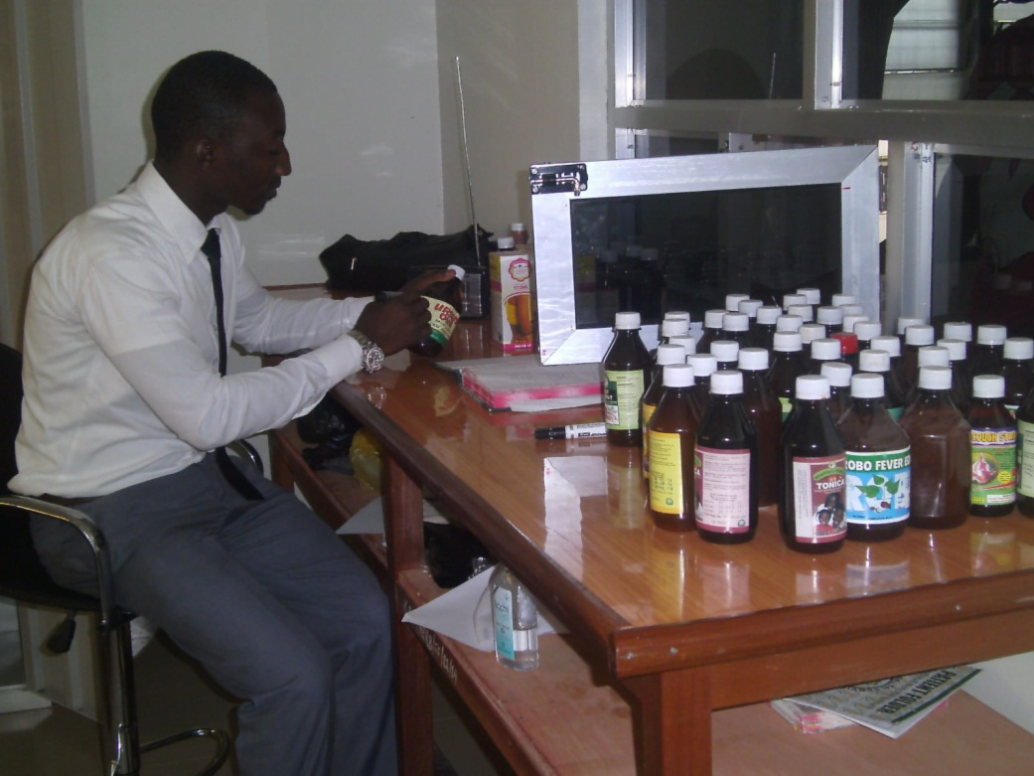
Photo 15: Picture of trained healthcare service provider in a hospital of the Ghana Health Service of MOH dispensing herbal medicine
The challenge of enhancing impacts especially on employment is an onerous one. It is a challenge which has generally become a national anxiety as youth unemployment is increasing with the graduation of tens of thousands from all kinds of second-cycle and tertiary educational institutions and apprenticeship programs. Traditional medicine practice offer job creation opportunities along the value chain – in the production and supply of the raw materials, the processing, packaging and marketing of traditional medicinal products. However, the exploitation of the job creation opportunities needs the formulation of a focused national strategy. Broadly, such a national strategy will highlight the specific steps to expanding on employment in the identifiable components of the value chain. For example, the establishment of large plantations of medicinal herbs will engage labor in the rural communities. The upscaling of herbal industries especially those producing the approved herbal products for use in the public hospitals will absorb some of the skilled graduates. Beyond local consumption of herbal products, the national strategy should aim at taking advantage of global consumption.

Indeed, countries such as China and India have evolved national export strategies for traditional herbal products. Ghana can have a strategy designed to have traditional herbal products as a key component of the non-traditional exports. The export orientation will demand more stringent quality assurance measures and IP. The use of trademarks for example, will facilitate marketing and development of niche markets globally for the Ghanaian traditional medicine products. It is therefore vital that the overall policy regime for the development and promotion of traditional medicine incorporates strategies for IP.

4.3 Policy Recommendations and Conclusion

At the outset of the case study, a number of questions were posed in order to address WIPO’s Development Agenda Recommendation 34, which requests that this study ‘assesses the tangible costs and benefits of IP protection [in the IE] in particular in relation to generation of employment’. The questions include whether there is potential use for IP and whether uptake is realistic, given the current nature of innovation; which IP forms are particularly relevant and for which sectors or innovation activities in particular; what are the related drivers and barriers to the uptake of IP? What are the potential impacts of the formal IP use on the broader innovation ecosystem in the IE, its innovation outputs and related impacts? Most of these questions have been addressed in the preceding sections. However, the concluding answers to these questions begin with stepping back and examining again the sector-specific policies that Ghana has pursued over the last two decades. One may then be better able to analyze the data from the field work; the TMPs have provided sufficient communication of their perspectives on existing policies especially how these policies are being implemented. Stepping back to appraise some of the key policy initiatives and their outcomes can set the stage to generating the needed policy options for the future of the TM sector.

On the whole, Ghana’s policy formulation and implementation in traditional medicine have been positive. Policy has enhanced the recognition of traditional medicine. It has over the years positioned the MOH as a lead agency in institutionally innovating for the TM sector to advance.

The following are some of the key policies or programs spearheaded by MOH:

- Strategic Plan Document for the Development of Traditional Medicine (2002 – 2004)
- Policy on Traditional Medicine Development (2003)
- Training Manual for Traditional Medicine Practitioners (2003 and 2005)
- Strategic Plan Document for the Development of Traditional Medicine (2005 – 2009)
- Code of Ethics and Standards of Practice Document (translated into three local languages – 2006)
- Preparation of List of Recommended Herbal Medicines Essential for Primary Healthcare Services (2008)
- Policy and Administrative Guidelines for Complementary Alternative Medicine (2008)
- Guidelines for Intellectual Property Rights Protection Framework for Indigenous Knowledge Related to Health and Medicinal Plant Resources (2008).
The policies and programs enumerated here and others have created conditions for the growth of TM and pushed for innovations in production and practice. The setting up of the TAMD and the TMPC has gone a long way to mainstream and elevate TM into the public health care delivery system. There is however a seeming contradiction in the driving philosophy of the policy makers and the fundamental conviction of the practitioners regarding the mainstreaming of TM. On one hand, policy makers aim at modernizing the practice along the lines of allopathic medicine. The goal is to establish a “herbal medicine service delivery system and Industry that is self-motivated for excellence and responds positively to the health needs of the population with unique products, services and approaches that are accessible, safe, efficacious, affordable and compatible with modern science, technology and healthcare practices” (MOH, 2012; p.4)

The implementation of the policy has gone as far as the collaboration with the KNUST to train Medical Herbalists graduating in four years with a B.Sc. in Herbal Medicine. These graduates are then posted to the Herbal Medicine Centres set up in the government hospitals and to interested private clinics or industries. There is an apparent interest in modernizing to fit the framework of allopathic medicine. This however is not acceptable to most of the informal traditional medicine practitioners who see TM as patently distinct from allopathic medicine.

The views of the TMPs are that, by virtue of their many years of learning and practice, TM incorporation into the public health care delivery system should not be to merge them with orthodox medicine. As a general principle, TMPs have emphasized the need to acknowledge the parallelism of traditional medicine vis-à-vis orthodox medicine. In their view, policy should aim not at converting traditional medical practice to orthodox medical practice. Rather, the thrust of policy should be to reinforce traditional medical practice as an alternative to the orthodox. So far the tension in the perspectives of the policy makers and the TMPs has not degenerated into open conflict. Both actors have cooperated very well to bring TM practice onto a higher pedestal than it was some two decades ago.

Obviously, there is a fundamental dilemma in the argument that TM should advance parallel to allopathic medicine. Traditional medicine developing along the lines of allopathic medicine enables it to attract customers who want to see the same efficacy and quality standards observed in traditional medicine as pertains to allopathic medicine. The scientific approach to diagnosis through tests and the application of diagnostic kits carry conviction for the patients. Perhaps the main argument here is the fact that the progression along the path of allopathic medicine eventually transforms from the TMP into a formal medium or large scale operator. Very few of the TMPs can go along that path.

Nevertheless, in moving onto policy recommendations the point which needs reiteration is the fact that the formal IP system comprising trademarks and patents present challenges to the TMPs. They resort to secrecy to protect their intellectual property because that is the time-tested mechanism for appropriating knowledge and innovation. Apparently the recourse to secrecy is in contradiction with the acceptance of openness and unimpeded sharing of intellectual property. At the heart of this conflict is the limited awareness and knowledge about the IP system. Generally, there seems to be a limited awareness of the processes for institutionalized appropriation mechanisms (e.g. trademarks and patents) and the benefits thereof. Even if they know, the cost of appropriation (e.g. of trademarks) is in itself a challenge for most of the informal TMPs and should the cost be waived, it is doubtful whether their products can meet the criteria for obtaining IPRs such as patents.

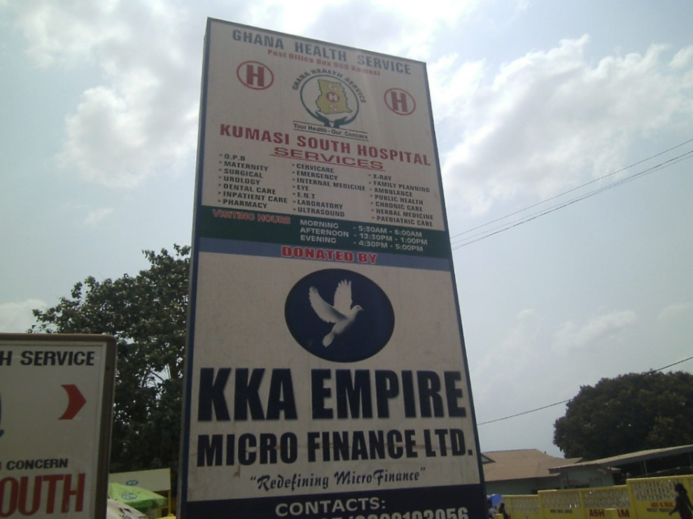
Photo 16: Picture of a signboard of a hospital of the Ghana Health Service of MOH in Kumasi with herbal medicine services indicated. It illustrates the full adoption of traditional medicine as a key strategy of healthcare delivery in Ghana’s Health Policy.

It appears public policy implementation is fairly strong in regulation and formalizing the traditional medicine sector through the registration of traditional medicine practice. There are some good reasons why regulation should be strong in traditional medicine generally. In the public interest, there is need to assure efficacy and quality products. In a practice which is more easily open to quacks than the alternative orthodox practice, regulation is essential to minimize quackery to the barest level and safeguard the integrity of the practice. Simply put, it is in the interest of traditional medicine to strengthen regulation to enhance the image of the practice. Yet, regulation should at the same time stimulate the growth of the practice and its sustainability and not stifle industry individually and collectively as well as entrepreneurship.

Going back to the rationale of the CDIP Project and Recommendation 34 of WIPO’s Development Agenda, which is to conduct case studies to assist member countries to develop national programs for promoting innovation in the informal economy and to maximize impacts, notably on employment generation, there are key points to reiterate. There is significant innovation in traditional medicine practice in Ghana and it is a factor in the opportunities emerging for job creation and employment. It is time for a holistic policy approach to enhance innovation and exploit the employment opportunities. Ghana can develop traditional medicine as a non-traditional export industry to her advantage. In doing this, IP has an important role to play.

Conclusion

The demographics of traditional herbal practitioners illustrate the socio-cultural context in which the practitioners operate. The interesting finding in the case study is the relatively widespread formal education background of TMPs. It is an important characteristic which policy makers can capitalize on to engage the TMPs and co-evolve more appropriate policies for TM generally and IP and innovation strategies for the TMPs.

The case study confirms the view that TMPs normally operate in the informal sector and are predominantly micro entrepreneurs. There are some small, medium and large scale TM enterprises but these are few compared to the large numbers of micro TMPs. The important characteristic about the informality of traditional medicine practice is that, there is a continuum of informal-formal within which the micro, small, medium and large entrepreneurs are operating much in accord with the elaboration in the conceptual framework of the study (de Beer et al, 2013). It suggests that in principle, there can be broad policy measures to enhance competitiveness among the TMP entrepreneurs. Still, there is need to tailor the policy measures to suit the respective scales of operation.

In totality, there are significant innovations in processes and products. There are improved production systems with innovations to address contextual challenges such as the unstable supply of utilities, specifically water and electricity. There are innovations for better quality assurance and packaging. Traditional medicine in Ghana today shows innovativeness even in the organizational systems and marketing strategies. These are opportunities for policy interventions to enhance the innovations for the further advancement of traditional medicine.

An important finding from the case study is the strong linkages among the TMPs with the formation of associations and the emergence of the umbrella association of GHAFTRAM. The associations are facilitating knowledge flows and learning. Linkages are also built with the knowledge institutions, which provide resource persons and expertise for training sessions and assistance in developing products. The impact of knowledge is positive in the TM sector.

The current appropriation mechanism system for the TM is a challenge. If the traditional mode of secrecy would have to give way to trademarks and patents, then a lot more have to be done to create awareness about the IP system and promote their usage. Even then there are inherent challenges as to meeting the technical criteria for granting patents. In this regard the sui generis system for appropriation needs to be developed for TM.

Overall, policy, legislation and regulation are important drivers for innovation. Ghana has shown how policy initiatives have impacted positively on traditional medicine to the extent that it is an integral component of the health care delivery system. Regulations have also pushed for innovations to improve on quality and acceptability of the products by consumers. Innovations have also contributed to the competitiveness of traditional medicine products. It is perhaps time to raise traditional medicine onto an even more industrial level. The challenge however is to do this while still creating space for the informal practitioner to gainfully operate.

List of Abbreviations and Acronyms

AGI - Association of Ghana Industries
ARIPO - African Regional Intellectual Property Organization
BAC - Business Advisory Centres
CDIP - Committee on Development and Intellectual Property
CSRPM - Centre for Scientific Research into Plant Medicine
EDL - Essential Drug List
FDA - Food and Drugs Authority
FGD - Focus Group Discussion
GHAFTRAM Ghana Federation of Traditional Medicine Practitioners Association
GDP - Gross Domestic Product
GSA - Ghana Standards Authority
GSGDA - Ghana Shared Growth and Development Agenda
GVA - Gross Value Added
HAI - Health Action International
ISSER Institute of Statistical, Social and Economic Research
KNUST - Kwame Nkrumah University of Science and Technology
MOH - Ministry of Health
MTEF Medium Term Expenditure Framework
NBSSI National Board for Small Scale Industries
NHIS - National Health Insurance Scheme
NIS - National Innovation System
RGD - Registrar-General’s Department (or Registrar-General’s Office)
STEPRI - Science and Technology Policy Research Institute
TAMD Traditional and Alternative Medicine Directorate
TK - Traditional Knowledge
TMP - Traditional Medical Practitioner
TMPC Traditional Medicine Practice Council
TRIPS Trade Related Intellectual Property System
WAHO - West Africa Health Organisation
WHO World Health Organization
WIPO World Intellectual Property Organization

APPENDIX 1: LIST OF PERSONS AND ENTERPRISES INTERVIEWED FOR THE STUDY
- TRADITIONAL MEDICINE LOCATIONS VISITED FOR THE STUDY
CODE | NAME OF ENTERPRISE | LOCATION | DISTRICT |  | REGION
101 | Omouye Agan DJA Herbal Centre | Abeka | Okaikoi Central |  | Greater Accra
102 | Ark Clinic | Lapaz |  |  | Greater Accra
103 | Gud Life Herbal Clinic | Awoshie |  |  | Greater Accra
104 | Alive Clinic | Awoshie-WW |  |  | Greater Accra
105 | Capital 02 Natural Health Clinic | Dansoman | Accra Metro |  | Greater Accra
106 | Kascala Herbal Company | New Adenta |  |  | Greater Accra
107 | Medi-moses Herbal Clinic | Adenta |  |  | Greater Accra
108 | Isaaniyya Herbal Drug Centre | Kasoa | Awutu Senya |  | Greater Accra
109 | Semenhyia Herbal Clinic | Kasoa | Awutu Senya |  | Greater Accra
110 | Crown Pharmacy Limited | Laterbiokoshie |  |  | Greater Accra
111 | Nana Boakye Herbal Clinic | Okaishie |  |  | Greater Accra
112 | Adam Nana Herbal Clinic | Kasoa |  |  | Greater Accra
113 | Adom Bi Nti | Teshie | Ledzokuku-Krowor |  | Greater Accra
114 | JAD Gold Fingers | Lashibi | Tema West |  | Greater Accra
115 | SomanaKunfayakun Herbal Centre | Ashaiman-Zeenu | Ashaiman |  | Greater Accra
116 | Tinaett Herbal Manufacturing Co. Ltd. | Spintex | Ledzokuku-Krowor |  | Greater Accra
117 | Edu Herbal Research Centre | Ashaiman | Ashaiman |  | Greater Accra
118 | Agbenyo Ventures | Ashaiman | Ashaiman |  | Greater Accra
119 | Hosanna Christian Herbal Centre | Ashaiman | Ashaiman |  | Greater Accra
120 | Sasem Herbal Clinic | Atico Last Stop | Ablekuma South |  | Greater Accra
121 | Elizabeth Amoako Herbal Centre | Omandzor |  |  | Greater Accra
122 | Amen Scientific Herbal Clinic | Dome |  |  | Greater Accra
123 | Patshaphat Herbal center | La | Dadekotopon |  | Greater Accra
124 | Al Qudus Herbal Products Ltd. | Fise | Amasaman |  | Greater Accra
125 | Gods Plan Mission Medica/Clinic | Labone | Dadekotopon |  | Greater Accra
126 | Alalao Herbal Solutions | Dome | Ga East |  | Greater Accra
127 | Akora Herbal Center | Taifa | Accra East |  | Greater Accra
128 | A.G.S Enterprise | GICEL - SCC | New Weija |  | Greater Accra
129 | Oboako herbal Center | Taifa | Ga East |  | Greater Accra
130 | Omanye Aba Herbal Center | Palmwine Junction | Dadekotopon |  | Greater Accra
131 | Apaak Traditional Medicine & clinic Co. | Agape | Ablekuma |  | Greater Accra
132 | Krobea Traditional Medicine Research Centre | Darkuman | Ablekuma North |  | Greater Accra
133 | I Am Spiritual And Herbal Center | Odorkor | Ablekuma |  | Greater Accra
134 | Sadona Herbal Center | Taifa | Ga |  | Greater Accra
135 | AlhassanAkwae | Ofankor |  |  | Greater Accra
136 | Individaul | Sakora - Medina | Medina Municipality |  | Greater Accra
137 | Hawe Enterprise | Atomic Junction | Accra |  | Greater Accra
138 | Mahogany herbs | Medina | Medina-Municipality |  | Greater Accra
139 | Lifecare Herbal Clinic | Caprice(Abease) |  |  | Greater Accra
140 | NyameAhyira So Herbal | Nungua | Ledzokuku |  | Greater Accra
141 | Givers Scientific Herbal Clinic | Teshie | Ledzokuku |  | Greater Accra
142 | KIS Health Industries Ltd. | Dansoman Estate | Ablekuma West |  | Greater Accra
143 | Natural Scientific Pharmaceuticals | Old Ashongman | Ga East |  | Greater Accra
144 | Obiri Herbal Research Center | GICEL-SCC | New Weija |  | Greater Accra
145 | Adidome Herbal | Darkuma | Darkuma |  | Greater Accra
146 | Salvation herbal Center | Dansoman |  |  | Greater Accra
201 | OgyefoYena Herbal Center | Pedu Estate | Cape Coast |  | Central
202 | Manna Herbal Center | Afutu | Cape Coast |  | Central
203 | Nsanka Herbal Center | Brofobeba | Elimina |  | Central
204 | Anuanom Herbal Center | Tantre | Cape Coast |  | Central
205 | EnoBrago | Tantre | Cape Coast |  | Central
206 | AbibifoAsupiti | Kuwait | Moree |  | Central
207 | Sahara herbal Center | Adisadel | Cape Coast |  | Central
208 | Kwasammy Herbal Center | Adisadel | Cape Coast |  | Central
209 | Eden Plants Research Centre And Clinic | AgonaSwedru | Agona |  | Central
210 | AdomWoWim | Brabedze | Afutu |  | Central
211 | Dua Ma Yeresa | Kasoa Post Office | Awutu Senya |  | Central
301 | Glorious Natural Health Centre | Koforidua | New - Juaben |  | Eastern
302 | Natures Way Herbal Centre | Koforidua | New - Juaben |  | Eastern
303 | Powerful Herbal Centre | Koforidua | New - Juaben |  | Eastern
304 | Awuradde Na Aye Herbal Centre | Asokore | New - Juaben |  | Eastern
305 | 0tu yare ase | Oyoko | New - Juaben |  | Eastern
306 | Green Garden Industries Ltd. | Asokore | New - Juaben |  | Eastern
307 | Akoa Herbal Centre | Koforidua | New - Juaben |  | Eastern
308 | Obese Nyarko Herbal Centre | Anum-Boso | Asuogyaman |  | Eastern
309 | AgyeiAkyiaa Herbal Centre | Anum-Boso | Asuogyaman |  | Eastern
310 | Ayeh Herbal Centre | Anum-Boso | Asuogyaman |  | Eastern
311 | Hodinya Herbal Centre | Anum-Boso | Asuogyaman |  | Eastern
312 | Som-Pa Herbal Centre | Koforidua | New-Duaben |  | Eastern
401 | Tawheed laboratory and naturopaticclini | Boadi |  |  | Ashanti
402 | Adutwumwaa Industries Ltd. | Abuakwa | Abuakwa-Mahyia |  | Ashanti
403 | Frelena Health Centre | AhenemangKokobeng |  |  | Ashanti
404 | Nyame ye odo enterprise | Aboahia |  |  | Ashanti
405 | Osei Herbal |  |  |  | Ashanti
406 | Angel Herbal Company | Aboahyia |  |  | Ashanti
407 | Nyameama herbal centre | Bantema |  |  | Ashanti
501 | Individual | Tamale | Sagnarigu |  | Northern
502 | Dr. Adams Herbal | Tamale | Sagnarigu |  | Northern
503 | Individual | Kumbungu | Kumbungu |  | Northern
504 | Individual | Kumbungu | Kumbungu |  | Northern
505 | Individual | Kumbungu | Kumbungu |  | Northern
506 | Individual | Kumbungu | Kumbungu |  | Northern
507 | Individual | Kumbungu | Kumbungu |  | Northern
508 | Individual | Kumbungu | Kumbungu |  | Northern
509 | Individual | Tamale | Tamale Metropolitan |  | Northern
510 | Taimako Plant Research Centre | Tamale | Tamale Metropolitan |  | Northern
511 | Rakson Herbal Centre | Tamale | Sagnarigu |  | Northern
512 | Sinda herbal centre | Saboba | Saboba |  | Northern
513 | Individual | Tamale | Tamale Metropolitan |  | Northern
514 | Adam herbal centre | Tamale | Tamale Metropolitan |  | Northern
515 | Trado Eye Specialist Centre | Tamale | Tamale Metropolitan |  | Northern
516 | Individual | Tamale | Tamale Metropolitan |  | Northern
601 | Golden Pharmaceuticals Co. Ltd | Ho | Ho |  | Volta
602 | Clidem herbal clinic | Kpedze | Ho West |  | Volta
603 | Dr.Amaglo herbal centre | Ho |  |  | Volta
604 | Makavo enterprise | Sokode-lokoe |  |  | Volta
605 | Omega herbal centre | Dodze | Ketu North |  | Volta
606 | Amenuveve herbal centre | Bitty 9 | Ho |  | Volta
607 | Agbeyeye spiritual and herbal centre | Ho Housing | Ho Municipal |  | Volta
608 | Mawulikplem herbal centre | Tokor | Ketu South |  | Volta
609 | Liberty herbal centre | Liberty | Ho |  | Volta
610 | Ya Fattah herbal centre | Gbedekofe |  |  | Volta
611 | Felibram enterprise | Avoemesakani |  |  | Volta
612 | Enyonam herbal centre | Dodze |  |  | Volta
701 | Abdee Scientific Herbal Clinic | Effiekuma | Ahanta |  | Western
702 | Individual | Effiekuma | Ahanta |  | Western
703 | Karafi Ltd | Liberation Road | Ahantan |  | Western

LIST OF KEY INFORMANTS* AND THEIR ORGANISATIONS
NAME | DESIGNATION/ ORGANISATION | LOCATION
1. TorgbuigaYaka IV (Mr.Hlortsi Akakpo) | Registrar, TMPC, MOH | Accra
2. Mr. Peter Arhin | Director, TAMD, MOH | Accra
3.Mrs. Sarah Anku | Registrar-General’s Department | Accra
4. Dr. Kofi Annan | Head, Herbal Medicine Dept, KNUST | Kumasi
5. Godfred Amofa | Health Officer, Kumasi South Hospitals Herbal Clinic Unit | Kumasi
6. Mr. Abu Sumaila | Head, Herbal Dept., Food and Drugs Authority | Accra
Note: Some key informants preferred being anonymous and are not listed.

MEMBERS OF FOCUS GROUP DISCUSSIONS FROM GHAFTRAM
NO. | NAME | INSTITUTION | CONTACT
1.  2.  3.  4.  5.  6.  7.  8.  9.  10.  11. | T.Dr. Amoh-Addae Emmanuel  Oscar AsamoahDonkor  KojoOdumEduful  George Atta Sasu  Monica Sedalor  Nana K. Obiri  Priscilla Mercy Nketia  Japhet Kofi Seglah  Osofo Kwasi Dankama Quarm  G. D. Koranteng  Florence Attipoe | GHAFTRAM  GHAFTRAM  GHAFTRAM  GHAFTRAM  GHAFTRAM  GHAFTRAM  GHAFTRAM  GHAFTRAM  GHAFTRAM  GHAFTRAM  GHAFTRAM | 0244622897 (amohddae13@gmail.com)  0207285079  0244158407 (eduful10@yahoo.com)  0208828172  0249420962  0277587387  0208436048/0243765082  0244786962  0242106137  0244139284  floobaby@yahoo.com

APPENDIX 2: QUESTIONNAIRE FOR THE STUDY OF THE TRADITIONAL HERBAL MEDICINE IN GHANA

Introductions:
Introduction of case study
Informed consent (START recording to get voice consent)

Section I: General information:

- Name of Respondent……………………………………………. Gender: Male [ ] Female [ ]

- Age: [____] Marital Status: Single [ ] Married [ ] Divorced [ ] Widow [ ] Separated [ ]

- Educational level: Primary [ ] JHS/MSLC [ ] Secondary [ ] Tertiary [ ] No formal education [ ]

- What religion do you practice? Christian [ ] Muslim [ ] Traditional [ ] Other…………………………..

- Location of practice ……..………………….………… District …………..………...……… Region:………….……..…………

- Section I: Traditional Medical Practice (TMP)

- Name of Enterprise (if your traditional medical practice is done under the name of a company) ………………………………………………………………………………………

- Specialty of respondent………………………………………………………………………..
…………..…………………………………………………………………………………………..

- Is your enterprise/ practice registered? Yes [ ] No [ ].

- How many other employees? [____]

- Do you contribute to social security? Yes [ ] No [ ]

- Were you able to get some loan from bank for your practice? Yes [ ] No [ ].

- If yes which bank? …………………………………………………………………………….………

- Have you ever received financial any assistance from government? Yes [ ] No [ ].

- Give the name of any agency which helped you in your practice?.............................................

- For how long have you been in the traditional medical practice? [ ] years

- Which year did you actually start practicing? .................

- How did you become a Traditional Medical Practitioner? (e.g. apprenticeship, family business, divine call, hobby)…………………......................................................................... …………………………………………………………………………………………………

- If you trained to be a TMP, how long was your training? [ ] (number of years)

- Explain the nature of your training……….………………………………………………......
………………………………………………….………………………………………………….

- What are your main herbal procucts?.........................................................................................
………………………………………………………………………………………………………

- Which one(s) did you start with?...............................................................................................

- Are all your herbal products registered? Yes [ ] No [ ].

- State the institution you registered the products with………….……………………………..
……………………………………………………………………………………………………....

- What are the requirements to have your products registered by these organisations?
……………………………………………………………………………………………………..
……………………………………………………………………………………………………..

- Why did you register your product(s)?
……………………………………………………………………………………………………..
……………………………………………………………………………………………………..

- How do you assess the registration process in Ghana?
- Very difficult [ ] Difficult [ ] Easy [ ] Very Easy [ ]

- How profitable do you find the TMP? Very profitable [ ] Quite Profitable [ ] Not profitable [ ]

- Explain your answer above to question 22……….………………..…………………………..
……………………………………………………………………………….……………………..

Section II: Innovation

- Describe new technologies, machines, production techniques or innovations you adopted in the last five years……………..…………...…………………………………………………
………………………………………………………………………………………………………………………………………………………………………………………………………………
- Describe new products and processes you developed in the last five years……………….….
………………………………………………………………………………………………………………………………………………………………………………………………………………………………………………………………………………………………………………………………………………………………………………………………………………………………

- Have you patented or formally appropriated any of your products? Yes [ ] No [ ]

- Do you know the process you go through to patent or formally appropriated a product? Yes/No

- Where do you sell your products?..............................................................................................
……………………………………………………………………………………………………..

- Who are your main customers?..................................................................................................
……………………………………………………………………………………………………..

- The products you adopted, where do they come from?.............................................................

- What exactly do you do to improve on your products or practice?...........................................
………………………………………………………………………………………………………………………………………………………………………………..……………………………..

- Do you produce on large scale for people to collect and retail for you? Yes [ ] No [ ]

- Do you have some of your products in the chemical/pharmacy shops? Yes [ ] No [ ]

- Which of your products (if any) is on the Essential Drugs List (EDL) of the Ministry of Health?
………………………………………………………………………………………………………………………………………………………………………………..…………………………..

- What do you think accounted for that (your medicine sold in pharmacy or on the EDL)? .................……………………………………………………………………………………………………………………….. …………………………………………………………………………………………………………..……….…………………….

Section III: Networking and Knowledge Flows

- Do you belong to any traditional medicine association? Yes [ ] No [ ]

- Give the name of the association(s)…………………………………………………………...
………………………………………………………………………………………………………

- State the benefits of your membership of the association(s)……….………………………….
- ……………………………………………………………………………………………………………………………………………………………………………………………….……………..
- State any training you have received in your association……………………….…………….
……………………………………………………………………………………………………..
- Have you worked with any recognised institution in Ghana (CSIR-Mampong, Noguchi, KNUST, KCCR, Legon) before? Yes [ ] No [ ]

- Explain how you worked – or are still working – with these institutions?
………………………………………………………………………………………………………………………………………………………………………………………………………………………………………………………………………………………………………..
- What are the other institutions you worked with?
……………………………………………………………………………………………………………………………………………………………………………………………………………………………………………..………………………………………………………..
- How do you work with these other institutions?
……………………………………………………………………………………………………………………………………………………………………………………………………………………………………………………………………………………………………….

- Would you want to team up with somebody to commercialise on a large scale? Yes [ ] No [ ]

Section IV: Intellectual Property Protection

- Are you concerned of possible commercialization of your innovations/innovative ideas without your knowledge or consent?
- Yes [ ] No [ ]

- If yes, what mechanisms do you use to protect your innovation or innovative ideas?
…………………………………………………………………………………………………………………………………..……………………………………………………………………………………………………………..………………………………………………………..

- What is the cost of appropriation? ……………………………………………………………

- Is open transfer or exchange of innovation/innovative ideas useful in traditional medicine?
Yes [ ] No [ ]

- What main intellectual property mechanism (e.g. patent, trade mark, secrecy) do you think is most appropriate for traditional medical products?............................................................... …………………………………………..……………………………………………...…………………………………………………

- How do you assess the IP policy regime in Ghana among traditional medical practitioners?
Very high [ ] High [ ] Average [ ] Low [ ] Very low [ ] Non-existent [ ]

- What do you suggest to improve the IP situation in the country?........................................ ………………………………………..…………………………………………………………………………………………………..……………………………………………………………………………………………………………………………………………………..

- What do you suggest to improve traditional herbal practice in Ghana?............................... ……………………………...……………………………………………………………………………………………..……………………………………………………………………
- At end of interview, switch off recorder and thank the participant.

APPENDIX 3: THE STUDY TEAM

Name |  | Position |  | Qualification
Researchers
George Owusu Essegbey | Director, STEPRI |  | Ph.D. Development Studies; M.A. International Affairs; Post-Graduate Diploma in Communication Studies; B.Sc. Zoology; Diploma in Education
Stephen Awuni | Research Scientist, STEPRI |  | M.Phil. Zoology; B.Sc. Biological Sciences
Mavis Akuffobea | Research Scientist |  | M.Phil. Sociology; B.A. Sociology
Elizabeth Baaba Micah | Research Scientist, STEPRI |  | M.Phil, Nutrition; B.Sc. Biological Sciences
Ivan Tetteh Essegbey | Information Scientist, Christian Health Associations of Ghana |  | M.Sc. Management Information Systems; B.Sc. Computer Science
Others
Pamela Lamisi Atanga | Intern, STEPRI |  | B.A. Economics/ Sociology
Johnny Owusu | Intern, STEPRI |  | B.Sc. Biological Sciences
Ida Kwadzode | National Service Officer |  | B.A. Psychology/ Sociology

References

Adusei, P. (2013) Patenting of Pharmaceuticals & Development in Sub-Saharan Africa: Laws, Institutions, Practices, and Politics, Springer-Verlag, Berlin, Heidelberg.

Apoya, P. (2012) “Political Economy Analysis of the Health Sector (Rural Health Services) in Ghana”, STAR-Ghana, Accra, 38p.

Bulls, C., Daniels, S. & Kinyanjui, M. “A Study of the Metalworking Sector in Nairobi, WIPO, Geneva.

Cameron, A. Ewen, M. Ross-Degnan, D. Ball, D. Laing, R. (2008). Medicine Prices, Availability, and Affordability in 36 Developing and Middle-Income Countries: A Secondary Analysis. Geneva: The World Health.

Charmes, J. (2012). The Informal Economy Worldwide: Trends and Characteristics. Margin: The Journal of Applied Economic Research, 6(2), 103–132.

de Beer, J., Fu, K. &Wunsch-Vincent, S. (2013) "The Informal Economy, Innovation and Intellectual Property - Concepts, Metrics and Policy Considerations," WIPO Economics Working Paper No. 10, 2013, (http://www.wipo.int/export/sites/www/econ_stat/en/economics/pdf/wp10.pdf).

Ebomoyi, E. W. (2009). ‘Genomics in Traditional African Healing and Strategies to Integrate Traditional Healers into Western-Type Health Care Services- A Retrospective Study’. Researcher, 1(6): 69-79.

Elhanan Helpman: Innovation, Imitation and Intellectual Property Rights. Econometrica, Vol. 61, No. 6 (November 1993), 1247-1280

Essegbey, G.O. (2003) “Ghana’s National Innovation System: Options for Developing a Biopharmaceutical Capacity”, Paper presented at the International Workshop at UNU-INTECH on Pathways to Building (Bio)pharmaceutical Innovation Systems in Developing Countries, 26th – 27th Feb. 2003, UNU-INTECH, Maastricht, The Netherlands.

Kraemer-Mbula, E. (2013) Country study on innovation, intellectual property and the informal economy: Informal Chemical Manufacturers in South Africa, presented to CDIP/13, WIPO, Geneva.

Kiringe, J.W (2005) Ecological and Anthropological Threats to Ethno-Medicinal Plants Resources and their Utilization in Maasai Communal Ranches in the Amboseli Region of Kenya’. Ethnobotany Research and Applications, 3: 231 -241 (2005)

Kiringe, J.W. 2005.”Ecological and Anthropological Threats to Ethno-Medicinal Plants” Resources and Knowledge System, 2:75-87.

Lawal, O. A. and Banjo, A. D. (2007).‘Survey for the Usage of Arthropods in Traditional Medicine in Southwest Nigeria’. Journal of Entomology, 4(2): 104-112.

Mashelkar, R. (2012) “Inclusive Innovation: the New Global Agenda”, Presentation by Ramesh Mashelka, accessed January 2014 at: http://www.knowledge-economy.net/uploads/documents/2012/presentations/R.%20A.%20Mashelkar%20-%20Inclusive%20Innovation.pdf )

Mander, M., Ntuli, L., Diederichs, N., and Mavundla, K., (2007).”Economics of the Traditional Medicine Trade in South Africa” in Harrison S., Bhana, R. &Ntuli, A. (Eds.) South Africa Health Review 2007, Health Systems Trust, Durban. pp. 189-200

Ministry of Health (2012) Operational Guidelines for Integrating Herbal Medicine Practice into Health Care Institutions, Ghana Health Service, Accra.

Ministry of Health (2005) Policy Guidelines on Traditional Medicine Development, MOH, Accra.

Patwardhan, B. 2005. ‘Traditional Medicine: Modern Approach for affordable Global health’. WHO-CIPIH Study Nine on TM, Draft Report.

Payyappallimana, U. (2005).’ Role of Traditional Medicine in Primary Health Care: An Overview of Perspectives and Challenges’. Yokohama Journal of Social Sciences, Vol. 14 No. 6.

Peltzer, K. &Mngqundaniso, N. (2008). Traditional Healers and Nurses: A Qualitative Study on Their Role on STIs including HIV and AIDS in KwaZulu-Natal, South Africa. Afr. J. Trad. CAM, 5 (4), 380-386. http://dx.doi.org/10.1186/1471-2458-8-255

Sophia Twarog and Promila Kapoor (2004): Protecting and Promoting Traditional Knowledge: Systems, National Experiences and International Dimensions: United Nations Conference on Trade and Development

STEPRI (2007) Ghana Herbal Pharmacopoeia, Science and Technology Policy Research Institute (STEPRI), Accra.

Teshome-Bahiru, W. (2005).‘Impacts of Urbanisation on the Traditional Medicine of Ethiopia. Anthropologist, 8(1):43-52 (2005)

Traditional Medicine Practice Act, 595, 2000

UNCTAD (2011) Science, Technology & Innovation Policy Review, UNCTAD, Geneva.

Van Andel, T, Britt Myren & Sabine van Onselen (2012) “Ghana’s Herbal Market”, Journal of Ethnopharmacology, doi: 10.1016/ j.jep.2012.01.028

WHO Traditional Medicine strategy 2000-2005, WHO Geneva, 2002.

WHO.(1996). Traditional Medicine-WHO Information fact sheets. Fact sheet N134, September 1996

WHO. (2002). World Health Organization Traditional Medicine Strategy 2002–2005.

WHO/EDM/TRM/2002.1Original: English Distribution: General. WHO, Geneva.

World Health Organization (2008): Traditional Medicine. Fact sheet No. 134

[End of Annex and of document]

The views expressed in this Study are those of the authors and do not necessarily reflect those of the WIPO Secretariat or any of the Organization’s Member States.
Information on this workshop is available at : http://www.wipo.int/meetings/en/details.jsp?meeting_id=28084
Conceptual Study on Innovation, Intellectual Property and the Informal Economy (CDIP/11/INF/5) presented to the eleventh session of the CDIP and available at: http://www.wipo.int/export/sites/www/econ_stat/en/economics/pdf/wp10.pdf
Information on this workshop is available at : http://www.wipo.int/meetings/en/details.jsp?meeting_id=28084
See http://www.who.int/countries/gha/en/ (accessed 24th June 2013)
ILO, 1993
See the Conceptual Paper by de Beer, et al, 2013 or See Resolution concerning statistics of employment in the informal sector, adopted by the Fifteenth International Conference of Labour Statisticians (ILO, 1993); The 17th International Conference of Labour Statisticians: Guidelines concerning a statistical definition of informal employment (ILO, 2003) and (ILO, 2011)
See http://ghaftram.com/ The history of the Federation can be traced to the involvement of President Kwame Nkrumah in 1961. It moved through various phases to the present where the Federation brings together eight (8) different associations of members practicing traditional medicine.
The share of tertiary education of the sample is high only because it is defined broadly as any formal certificated education beyond high school. It includes education obtained from nursing training colleges, teacher training colleges, agricultural training colleges, polytechnics and universities.
The Herbal Doctor who granted the interview is best kept anonymous. But he graduated from KNUST in 2007 and did national service in one of the private clinics from September 2007 to June 2008. Thereafter he did an internship in the CSRPM for about a year before going back to write the TMPC professional licensure exams. After that, he was posted to one of the pilot Herbal Medicine Clinics.
Due to the nature or structure of the database, it cannot be confirmed whether the goods registered in Class 5 of the Nice Classification includes traditional medicine.
As per the exchange rate of November 2013
http://www.aripo.org/index.php/2013-04-09-09-05-22/fees/viewcategory/4-fees
The Minister of Interior Hon. Kwesi Ahwoi was reported to have called on MASLOC beneficiaries to refund loans given to them to “avoid the collapse of the scheme”. See http://www.ghanabusinessnews.com/2013/05/06/refund-masloc-loans-or-scheme-will-collapse-minister/
See http://www.bog.gov.gh/index.php?option=com_content&view=article&id=1126&Itemid=296
The 10-member Committee made up of experts was inaugurated by the Minister for Health on 27th November 2013.
This is a point that came out strongly in the FGD of the TMPs and the interviews with them. Many of the participants were at pains to stress the originality of their practice and therefore rejecting the notion that they have to practice in the mode of allopathic medicine to gain legitimacy.
In the focus group discussion, the practitioners have expressed frustration with the services of some of the regulatory institutions. They are bureaucratic in handling their samples for testing and approvals and there appears to be a lack of business attitude in their officers.

