E
CDIP/14/8 Rev. 2
ORIGINAL: English
DATE: November 14, 2014

Committee on Development and Intellectual Property (CDIP)

Fourteenth Session
Geneva, November 10 to 14, 2014

CONCEPT PAPER FOR THE PROJECT ON INTELLECTUAL PROPERTY AND TECHNOLOGY TRANSFER: COMMON CHALLENGES - BUILDING SOLUTIONS
(RECOMMENDATIONS 19, 25, 26 AND 28)

prepared by the Secretariat

- The Project on Intellectual Property and Technology Transfer: “Common Challenges - Building Solutions”, approved by the Committee on Development and Intellectual Property (CDIP) at its sixth session, held in November 2010, envisaged the elaboration of a Concept Paper on building solutions as the basis for discussion at the High-Level Expert Forum on International Technology Transfer, envisaged to be held at the end of the Project (tentatively scheduled to take place in January 2015).
- Accordingly, the Annex to this document contains the above-mentioned Concept Paper.
- The present document sets out a revised version of the Concept Paper as originally set out in document CDIP/14/8. This revised version incorporates comments made by representatives from Member States’ Permanent Missions during informal briefing sessions on the original version of the Concept Paper that took place on September 1, 2014, and October 21, 2014; comments made by participants who attended a meeting organized for NGOs, IGOs, professional associations and selected experts that took place on October 28, 2014, and feedback received from Regional Coordinators during an informal briefing session held on October 24, 2014. The revised document also includes comments made by Member States during the fourteenth session of the CDIP.

- The CDIP is invited to consider and approve the Concept Paper set out in the Annex to this document.

[Annex follows]

I. BACKGROUND OF THE PROJECT
- The present Concept Paper analyzes the source of the challenge for international technology transfer, summarizes the main achievements for the Project on Intellectual Property and Technology Transfer: “Common Challenges – Building Solutions” (Recs. 19, 25, 26 & 28) approved by the Committee on Development and Intellectual Property (CDIP) at its sixth session, held in November 2010 (the “Project”), and proposes to build solutions together to respond to the common challenges faced globally, based on fair and equitable international technology transfer.
- In addition, the Concept Paper is meant to provide the basis for discussion at the High Level International Expert Forum, tentatively scheduled to take place in Geneva, at the end of the project, in January 2015.

DEFINITION of “technology Transfer”
- One of the first achievements of this Project was to define, for the purposes of the Project, the term “transfer of technology”. The agreed wording of the definition was finalized during CDIP/9 as follows:
  - “For the purposes of this paper, transfer of technology refers broadly to a series of processes enabling and facilitating flows of skills, knowledge, ideas, know-how and technology among different stakeholders such as university and research institutions, international organizations, IGOs, NGOs, private sector entities and individuals, as well as international technology transfer among countries.”
  - “Transfer of technology, which is often considered to include the absorption of new technologies, is sometimes also considered to involve the transfer of concrete knowledge for the manufacture of products, the application of a process or for the rendering of a service granting the improvement of domestic as well as the international competitiveness in the economic market.”
- Under the agreed definition of “transfer of technology” set out above, finding solutions to the challenges for international technology transfer is inherently linked with enabling the right dynamics for knowledge flow, incorporating the important concept of “concrete knowledge”.
- Much research has been done to analyze the challenges to innovation and the dissemination of technology, particularly in the area of environmental innovation. According to that research, transactions in technology are characterized by three principal problems: a) asymmetric information: the difficulty for ex-ante buyers in assessing the value of information; b) market power: time to market, awareness of IPRs, access to capital; and c) externalities: uncompensated spillovers and lack of institutional framework.
- Keith Maskus, University of Colorado, provides three options that can be pursued to promote international technology transfer: a) safeguarding national “policy space” to address market failures; b) identifying actions by source countries to encourage international technology transfer; and c) multilateral initiatives to address externalities associated with technology markets and/or national policies.
- To address the challenges mentioned above, one should start by identifying the formal channels for international technology transfer. There are three main channels: a) trade in goods and services; b) foreign direct investment; and c) intellectual property licensing, including the licensing of trade secrets.
- Intellectual Property (IP) captures the economic value of development and facilitates the reduction of the knowledge gap.
- In the corporate world, as enterprises increasingly rely on intangible or knowledge-based assets rather than tangible or physical ones for creating and maintaining their competitiveness in the marketplace, their ability to create, deploy and strategically manage such proprietary assets is becoming a crucial factor in business success.

II. PROJECT PAPER APPROVED BY THE CDIP
- The Project Paper for this Project (document CDIP/9/INF/4) was approved by the CDIP at its ninth session, held in May 2012. The Project Paper provides the vision, strategy and ultimate objectives for the Project, and a holistic and comprehensive picture of the Project.
- In addition, the Project Paper contains information and a detailed description of the stages as well as all activities proposed for the Project. It also provides an overview of the different existing approaches to technology transfer by different entities.

III. SUMMARY OF PROJECT DELIVERABLES
- According to the Project Paper as approved by the CDIP, the project deliverables for this Project are the following:
  - the organization of five regional technology transfer consultation meetings (see paragraphs 13 to 16, below);
  - the elaboration of six peer-reviewed analytic studies (see paragraphs 17 and 18, below);
  - the drafting of a concept paper (the present document) on building solutions as the basis for discussion at the High Level International Expert Forum, submitted to the CDIP for approval (see paragraphs 29 to 31, below);
  - the organization of a High-Level International Expert Forum in the form of an international conference (see paragraphs 19 to 25, below);
  - the preparation and provision of materials, modules, teaching tools and other instruments resulting from recommendations adopted at the High-Level International Expert Forum(see paragraph 26, below);
  - the creation of a Web Forum (see paragraph 27, below); and
  - the incorporation of any outcome resulting from the above activities into the WIPO programs, after consideration by the CDIP and any possible recommendation by the Committee to the General Assembly (see paragraph 28, below).

IV. REGIONAL CONSULTATION MEETINGS
- Under the Project, a total of five regional consultation meetings on intellectual property and technology transfer were organized, with Member States’ prior consultation, who approved, at the eighth session of the CDIP, the terms of reference (TORs) and composition criteria in respect of the regional consultation meetings and the experts tasked to elaborate the various studies.

(A) ORGANIZATION OF FIVE MEETINGS
- The five regional consultation meetings were organized in the following regions:
  - Asian Region (“Singapore”): Regional Consultation Meeting on Intellectual Property and Technology Transfer, Singapore, Singapore, July 16-17, 2012,
  - African and Arab Regions (“Algiers”): Regional Consultation Meeting on Intellectual Property and Technology Transfer, Algiers, Algeria, January 29-30, 2013,
  - Transition Region (“Istanbul”): Regional Consultation Meeting on Intellectual Property and Technology Transfer, Istanbul, Turkey, October 24-25, 2013,
  - Developed Region (“Geneva”): Regional Consultation Meeting on Intellectual Property and Technology Transfer, Geneva, Switzerland, November 25-26, 2013, and
  - Latin American and Caribbean Region (“Monterrey”): Regional Consultation Meeting on Intellectual Property and Technology Transfer, Monterrey, Mexico, December 5-6, 2013.

(B) ANALYSIS OF THE MEETINGS
- Appendix I provides a series of info-graphics on the total number of participating country representatives (Fig. 1), the total number of participants for each event (Fig. 2), the total number of thoughts formulated at each event (Fig. 3), the number of thoughts in areas such as capacity building (Fig. 4), support in institutional framework (Fig. 5), support in innovation infrastructure (Fig. 6), support in funding mechanisms (Fig. 7), support in evaluation mechanisms (Fig. 8), global collaboration (Fig. 9), the geographical origin of international experts at each event (Figs. 10, 11, 12, 13 and 14), and the affiliation of international experts at each event (Fig. 15).

(C) SUMMARY OF THE MEETING RESULTS
- At the end of each of the regional consultation meetings, open-ended feedback was sought from all the participants from the region in the form of “thoughts” as to how to foster international technology transfer. Appendix II provides lists of those “thoughts” from each of the five regional meetings.

V. PEER-REVIEWED ANALYTIC StUDIES

(A) COMMISSIONED ANALYTIC STUDIES
- Under the Project, a total of 6 reviewed analytic studies in different areas work were commissioned, covering the following issues: (i) economic studies on obstacles to international technology transfer; (ii) IPR-related policies in developed countries; (iii) cooperation between R&D institutions; (iv) favorable incentives for business partnership; (v) technology transfer issues from the perspective of developing countries; and (vi) alternatives to R&D efforts to support innovation besides patents.

(B) STUDY EXPERTS, TERMS OF REFERENCE AND STUDY COMPLETION
- Figure 16 in Appendix I provides the geographical origin and affiliation of the experts tasked to develop the studies. A brief overview of the studies in set out in Appendix III. These studies have been peer-reviewed. The final text of the studies as well as the peer-reviews will be made available on the CDIP website. The titles, authors and completion dates of the studies are as follows:
  - Study (a): Economics of IP and International Technology Transfer, by Prof. A. Damodaran, Bangalore, India (final text, incorporating the comments by the peer-reviewer, Prof. Francesco Lissoni, Bocconi University, Italy, was received on July 30, 2014);
  - Study (b): Intellectual Property-Related Policies and Initiatives in Developed Countries to Promote Technology Transfer, by Mr. Sisule Musungu, Nairobi, Kenya (final text, incorporating the comments by the peer-reviewer, Prof. Walter Park, American University, USA, was received on September 5, 2014);
  - Study (c): Case Studies on Cooperation and Exchange between R&D Institutions in Developed and Developing Countries, by Prof. Bowman Heiden, Gothenburg, Sweden (final text, incorporating the comments by the peer-reviewer, Dr. Nikolaus Thumm, European Commission Joint Research Centre, Spain, was received on September 11, 2014);
  - Study (d): Policies Fostering the Participation of Businesses in Technology Transfer, by Mr. Philip Mendes, Brisbane, Australia (final text, incorporating the comments by the peer-reviewer, Dr. Nikolaus Thumm, European Commission Joint Research Centre, Spain, was received on September 5, 2014);
  - Study (e): International Technology Transfer: An Analysis from the Perspective of Developing Countries, by Prof. Keith Maskus, Boulder, Colorado, USA, and Prof. Kamal Saggi, Nashville, Tennessee, USA (final text, incorporating the comments by the peer-reviewer, Prof. Walter Park, American University, USA, was received on July 31, 2014); and
  - Study (f): Alternatives to the Patent System that are Used to Support R&D Efforts, including both Push and Pull Mechanisms, with a Special Focus on Innovation Inducement Prizes and Open Source Development Models, by Mr. James Packard Love, Washington, DC, USA (final text, incorporating the comments by the peer-reviewer, Prof. Dominique Foray, EPFL, Switzerland, was received on September 9, 2014).

VI. HIGH-LEVEL INTERNATIONAL EXPERT FORUM
- The High-Level International Expert Forum envisaged to be organized under the Project is tentatively scheduled to take place at the WIPO’s headquarters in Geneva in January 2015. As set out in document CDIP/9/INF/4, the High-Level International Expert Forum will take the form of an international conference, aimed at initiating discussions on how, within WIPO’s mandate, to further facilitate access to knowledge and technology for developing countries and LDCs, including in emerging areas, as well as other areas of special interest for developing countries, taking into account recommendations 19, 25, 26 and 28 (food, agriculture, climate change). Drawing, inter alia, on the outcomes of the five regional technology transfer consultation meetings, the six peer-reviewed studies and the experience of global experts in the area of transfer of intellectual property rights in academia and industry, the Forum will provide a framework for an open dialogue among experts from both developed and developing countries knowledgeable in public and private sector technology transfer and for debates on technology transfer supportive IP-related policies by developed countries.
- With regard to the selection of experts to be invited to the Forum as well as the terms of reference for those experts, document CDIP/9/INF/4 (paragraph 59, at the end) states the following:
“The High-Level Expert Forum should also benefit from consultations with Member States. Concerning the composition of the High-Level Experts Forum, the top experts worldwide on the different aspects of the subject would need to be selected by WIPO according to fair selection criteria approved by Member States to ensure the project’s progress. For the experts meeting, experts from both the public and private sector would be invited. The terms of reference (TORs) for the experts would be decided in consultation with Member States.”
- So as to seek guidance on a possible mechanism for obtaining approval by Member States of a set of fair criteria for the selection of the experts to be invited to the Forum and for consulting with Member States on the terms of reference for those experts, the Secretariat invited the Coordinators of all Regional Groups to an informal meeting, which was held in Geneva on October 24, 2014.
- At the meeting, there was agreement among all Regional Coordinators to seek Member States’ approval of the following proposed criteria for the selection of experts to be invited to the Forum (based on the criteria which had been approved by Member States in the context of selecting consultants for the regional consultation meetings carried out under the project; see document CDIP/9/INF/4, Appendix I, paragraph 12):
“The Secretariat was requested, when selecting experts to be invited to the High-Level Expert Forum, to seek a balance in terms of their geographical representation (developed as well as developing countries), their affiliation (public and private sector), and their position with respect to the role of IP in technology transfer.”
- At the meeting, there was further agreement among all Regional Coordinators to consult with Member States on the following proposed terms of reference for the experts to be invited to the High-Level Expert Forum:
“Experts should make themselves familiar with the project deliverables. When identifying thoughts for inclusion in a list of suggestions and possible measures for promoting technology transfer, to be submitted to the CDIP for its consideration, experts should start with the least common denominators between all perspectives and base such thoughts on realistic and mutually acceptable and beneficial elements as a starting point for building joint solutions.”
- Finally, as had been originally envisaged, the High Level Expert Forum will be held as a three-day event.
- Member States’ approval is thus sought on the proposed criteria for the selection of experts to be invited to the High-Level Expert Forum set out in paragraph 22, above. Furthermore, Member States’ feedback is sought on the proposed terms of reference for those experts set out in paragraph 23, above.

VII. MATERIALS, MODULES, TEACHING TOOLS
- Following any recommendations from the High-Level International Expert Forum, as envisaged under the Project Paper approved by the CDIP, materials, modules, teaching tools and other instruments will be prepared and incorporated into the global WIPO capacity building framework.

VIII. WEB FORUM
- The Web Forum, envisaged under the Project Paper approved by the CDIP, will be incorporated within the framework of the portal on Innovation and Technology Transfer Support Structure for National Institutions, established in the context of the project for Recommendation 10.

IX. INCORPORATION OF OUTCOMES INTO WIPO PROGRAMS
- Following any recommendations from the High-Level International Expert Forum, as envisaged under the Project Paper approved by the CDIP, any outcome resulting from the above activities will be incorporated into the work of the Organization, after consideration and adoption by the CDIP and any possible recommendation by the Committee to the General Assembly.

X. SUBMISSION OF CONCEPT PAPER FOR COMMENTS BY INTERNATIONAL EXPERTS
- As set out in the implementation timeline contained in CDIP/6/4 Rev, a draft of the present Concept Paper was submitted on March 27, 2014, to the following international experts: Mr. Pedro Roffe, Senior Associate, and Mr. Ahmed Abdel Latif, Senior Programme Manager, Innovation, Technology and Intellectual Property Programme, International Centre for Trade and Sustainable Development (ICTSD). They provided feedback on the content of the info-graphics, the thoughts from the regional consultation meetings and on the analytic studies, and on their presentation in the present Concept Paper. This Concept Paper incorporates those comments.

XI. PRESENTATION OF CONCEPT PAPER TO PERMANENT MISSIONS IN GENEVA
- As set out in the implementation timeline contained in CDIP/6/4 Rev, the present Concept Paper was presented to Permanent Missions in Geneva in informal briefing sessions that took place at WIPO’s headquarters on September 1, 2014 and October 21, 2014. The comments from Member States expressed during those briefing sessions have been incorporated in this final version of the Concept Paper.

XII. ONE-DAY MEETING WITH IGOs, NGOs, PROFESSIONAL ASSOCIATIONS and SELECTED EXPERTS
- As set out in the implementation timeline contained in CDIP/6/4 Rev, the present Concept Paper was presented to NGOs, IGOs, professional associations and selected experts, in a meeting that took place at WIPO’s headquarters on October 28, 2014. Speakers gave examples of the benefits from being engaged in technology transfer in developing countries. Representatives of industry and intergovernmental as well as non-governmental organizations agreed on the timeliness and importance of this WIPO project, noting that it could help achieve the potential of technology transfer for the benefit of all, particularly in terms of future market opportunities. Questions raised during the meeting included queries regarding the procedural aspects of the project, aimed at ensuring that meaningful results will be ‘built’ through this project (as its name indicates: “Common Challenges – Building Solutions”). Speakers and participants at the meeting suggested the following thoughts aimed at supporting local initiatives through technology transfer:
  - build human capital;
  - expand national innovation systems; and
  - develop a balanced IP system.

XIII. CONCLUSION
- The WIPO Development Agenda Project on Intellectual Property and Technology Transfer: “Common Challenges – Building Solutions” (Recs. 19, 25, 26 & 28) used a step-by-step dichotomic approach to explore new ways of establishing international IP collaboration, to enhance understanding and to reach consensus on possible IP initiatives or policies to promote technology transfer. The Project was split into different phases, including the organization of 5 regional consultations, the commissioning of 6 analytic studies, the holding of a High Level International Expert Forum and the development of a web forum.
- The High Level Expert Forum, which will be in the form of an international conference, is tentatively scheduled to take place at WIPO’s headquarters in Geneva on January 19 and 20, 2015. Drawing on the outcomes of the five regional technology transfer consultation meetings, the six peer-reviewed studies and the experience of global experts in the area of transfer of intellectual property rights in academia and industry, the Forum will provide a framework for an open dialogue among experts from both developed and developing countries knowledgeable in public and private sector technology transfer and for debates on technology transfer supportive IP-related policies by developed countries.
- The exploratory and step-by-step approach adopted in this WIPO Development Agenda Technology Transfer Project has some promise. It offers an opportunity to rethink and test assumptions and consider new areas that have received little attention in earlier works. From the project’s inception in the fourth session of the CDIP, this project had been conceived as a Stage I project, with a potential second phase including a more practical project involving pilot countries.
- At the conclusion of the High Level International Expert Forum, the aim of the project is to incorporate any outcome into the WIPO programs, after consideration by the CDIP and any possible recommendation by the Committee to the General Assembly.

[Appendix I follows]

APPENDIX I

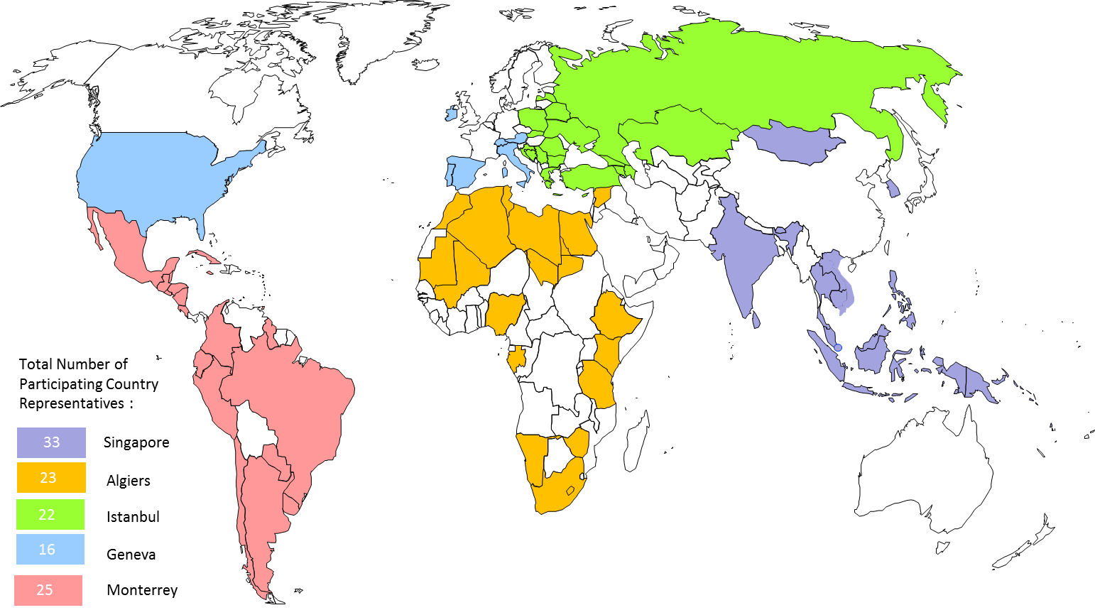

Figure 1. Participating Country Representatives to Regional Consultation Meetings.

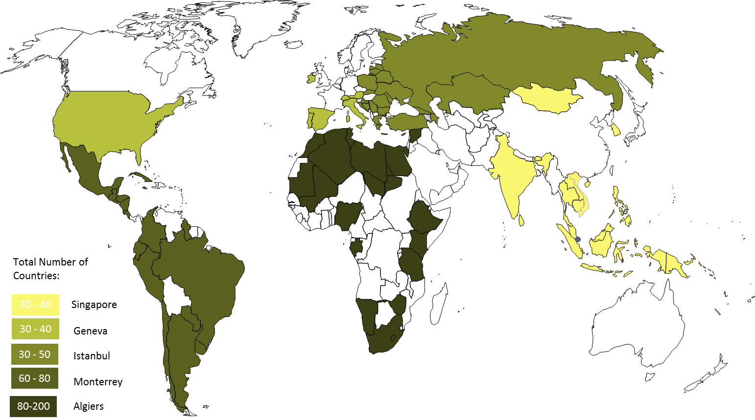

Figure 2. Number of Participants to Regional Consultation Meetings.

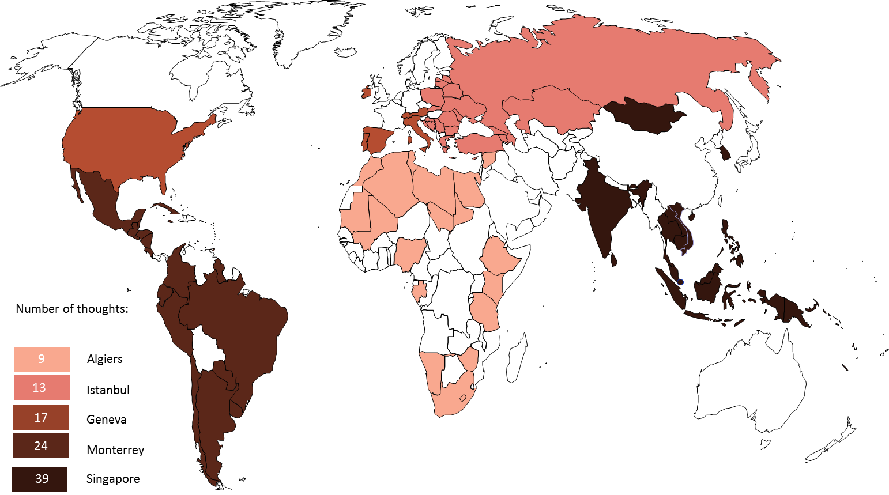

Figure 3. Total Number of Thoughts at Regional Consultation Meetings.

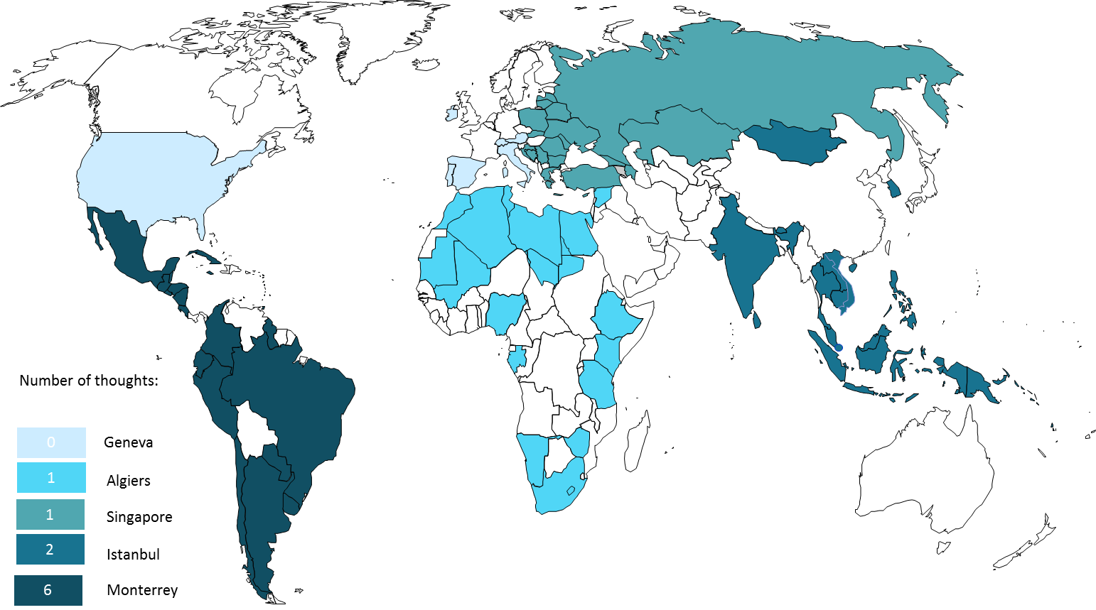

Figure 4. Number of Thoughts in Capacity Building at Regional Consultation Meetings.

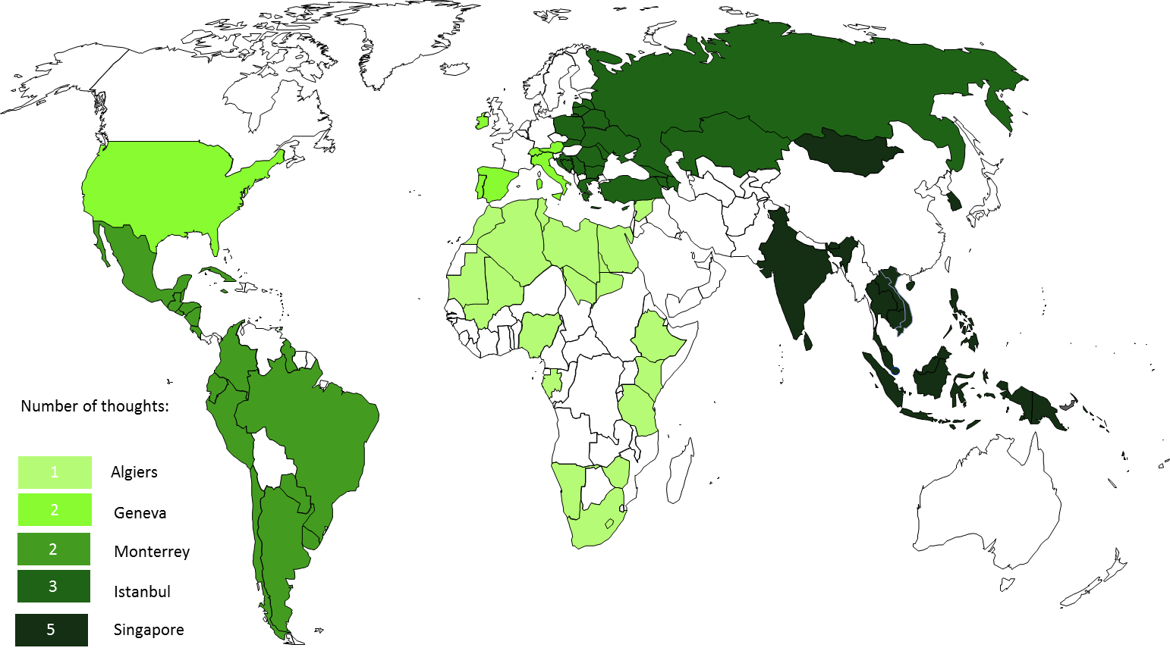

Figure 5. Number of Thoughts for Support in Institutional Framework at Regional Consultation Meetings.

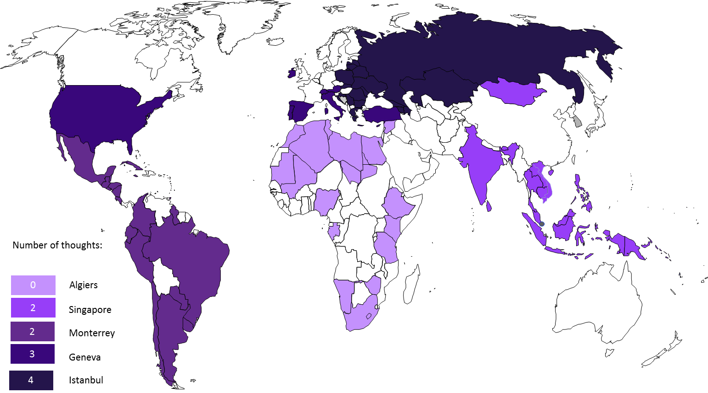

Figure 6. Number of Thoughts for Support in Innovation Infrastructure at Regional Consultation Meetings.

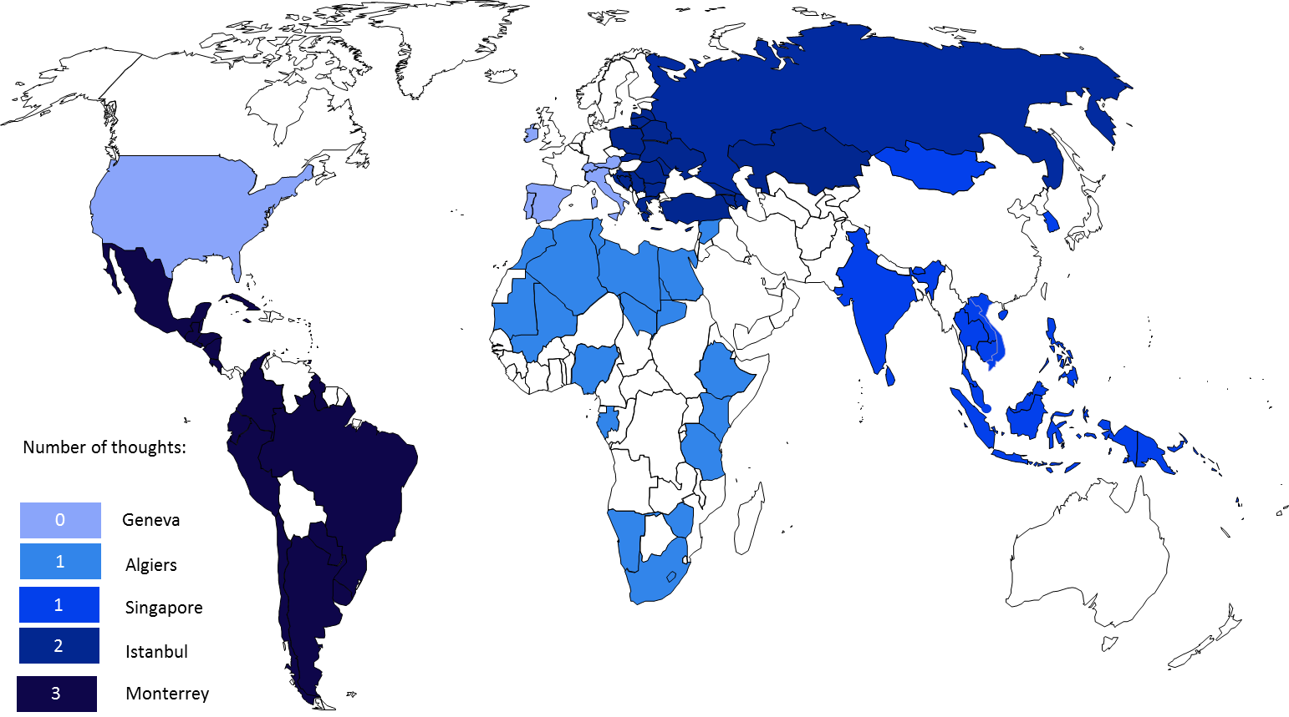

Figure 7. Number of Thoughts for Support in Funding Mechanisms at Regional Consultation Meetings.

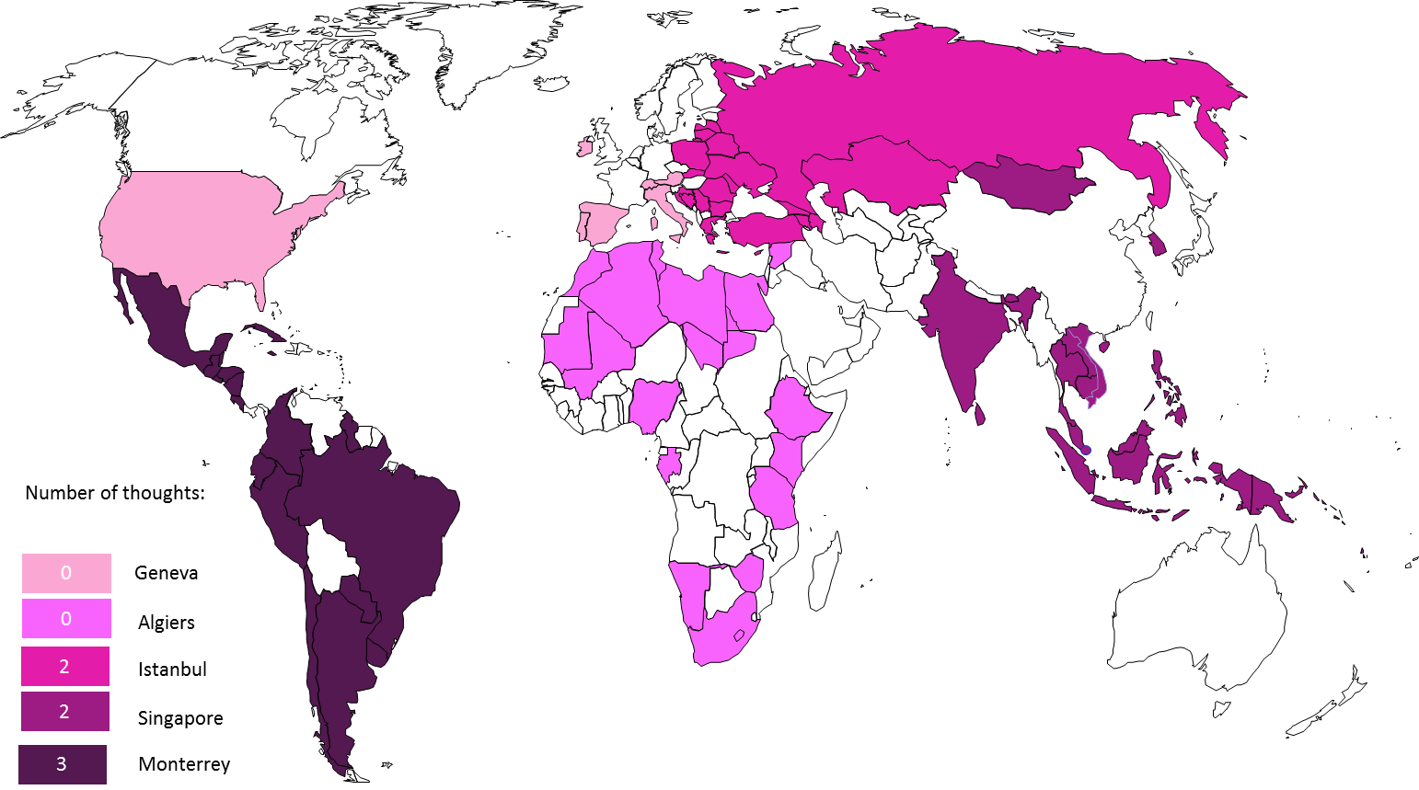

Figure 8. Number of Thoughts for Support in Evaluation Mechanisms at Regional Consultation Meetings.

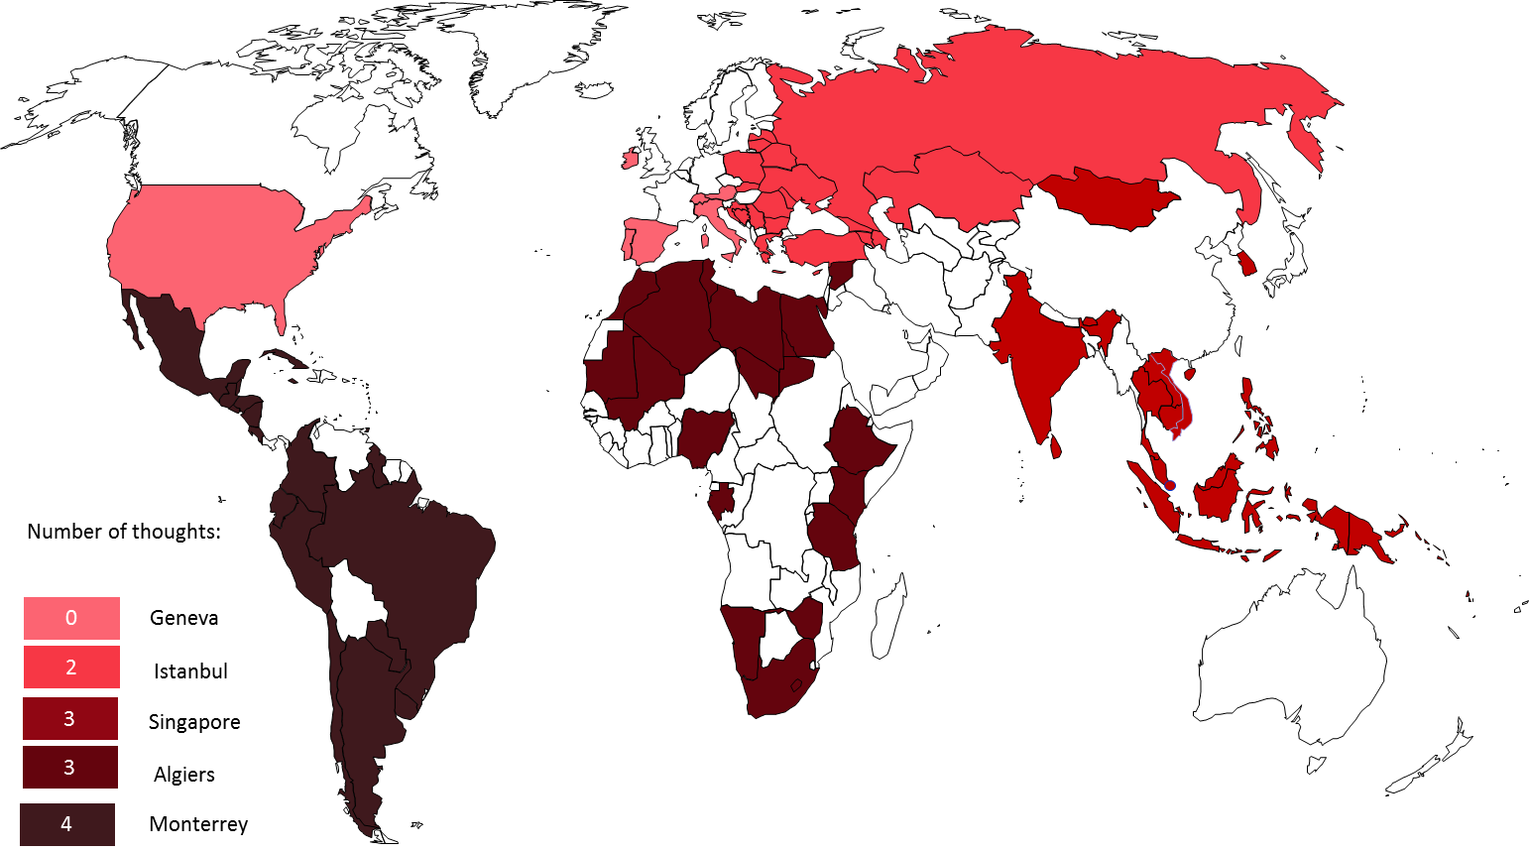

Figure 9. Number of Thoughts for Global Collaboration Incentives at Regional Consultation Meetings.

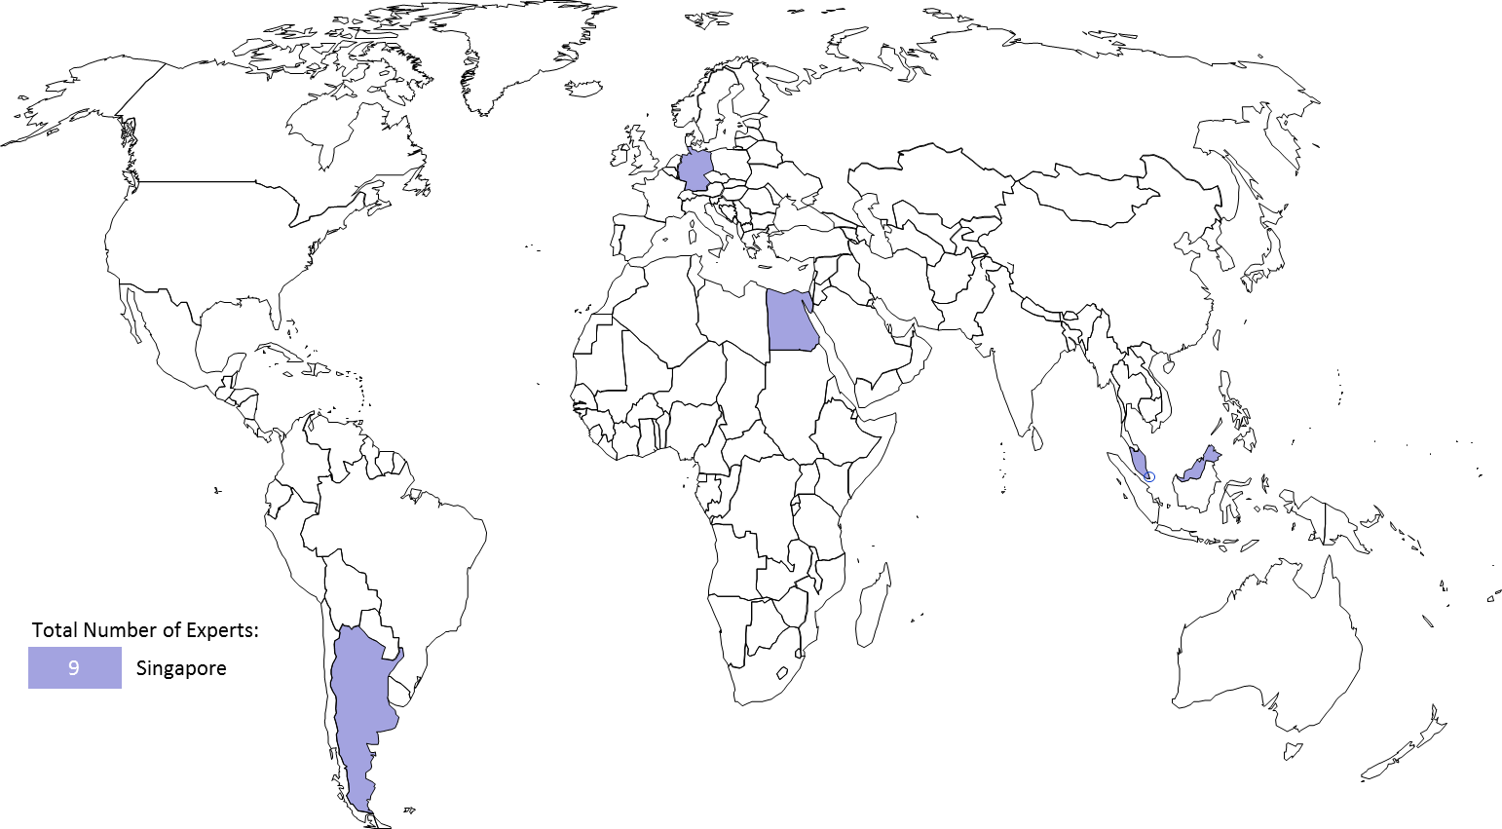

Figure 10. Geographical Origin for International Experts at the Regional Consultation Meeting in Singapore.
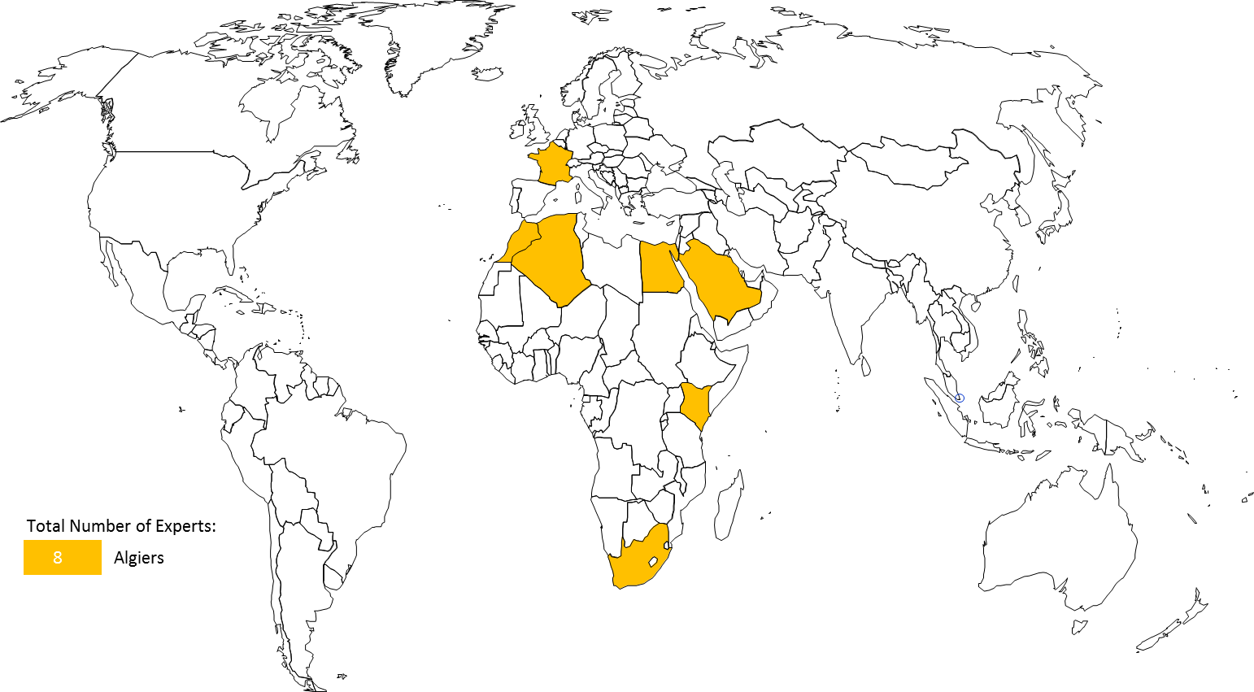

Figure 11. Geographical Origin for International Experts at the Regional Consultation Meeting in Algiers.

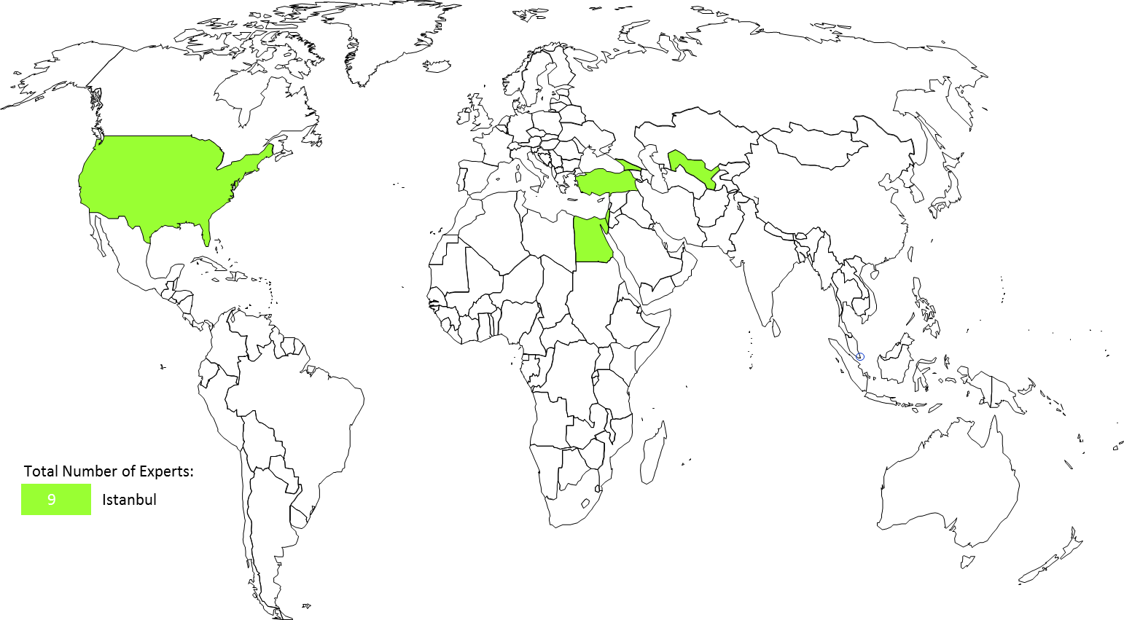

Figure 12. Geographical Origin for International Experts at the Regional Consultation Meeting in Istanbul.
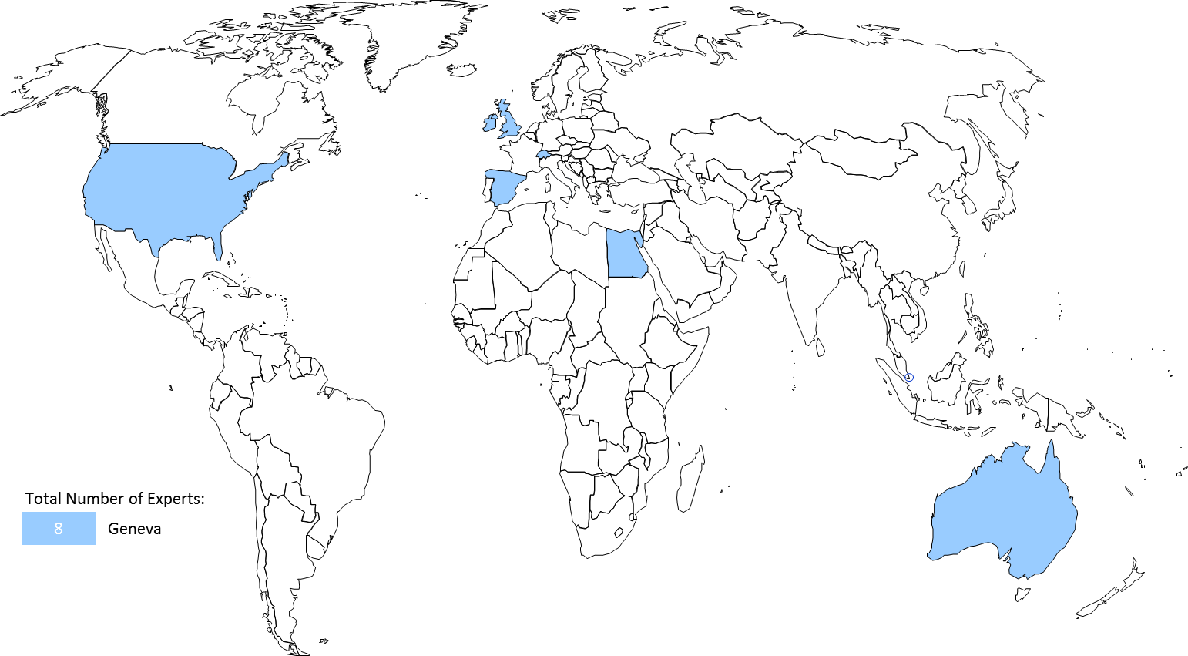

Figure 13. Geographical Origin for International Experts at the Regional Consultation Meeting in Geneva.

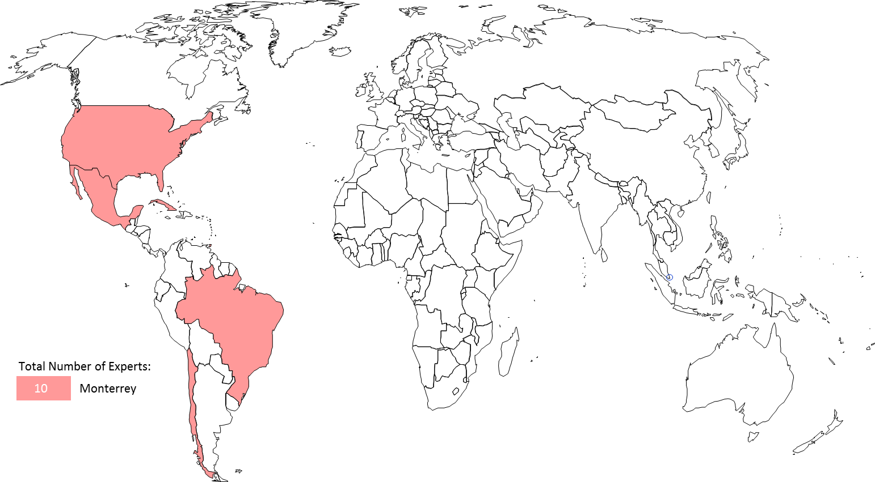

Figure 14. Geographical Origin for International Experts at the Regional Consultation Meeting in Monterrey.

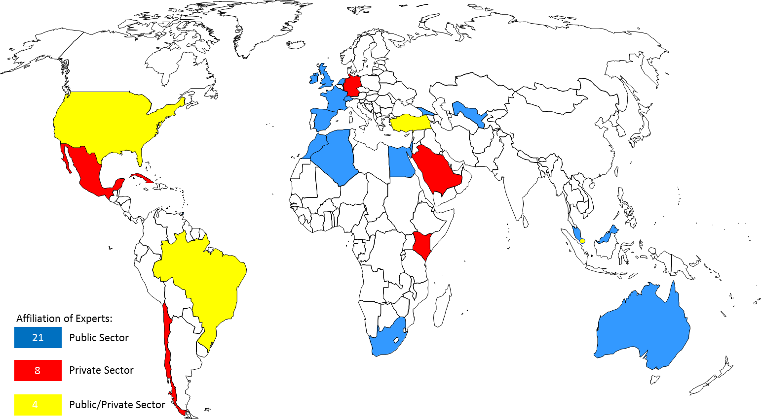

Figure 15. Affiliation for International Experts at the 5 Regional Consultation Meetings.

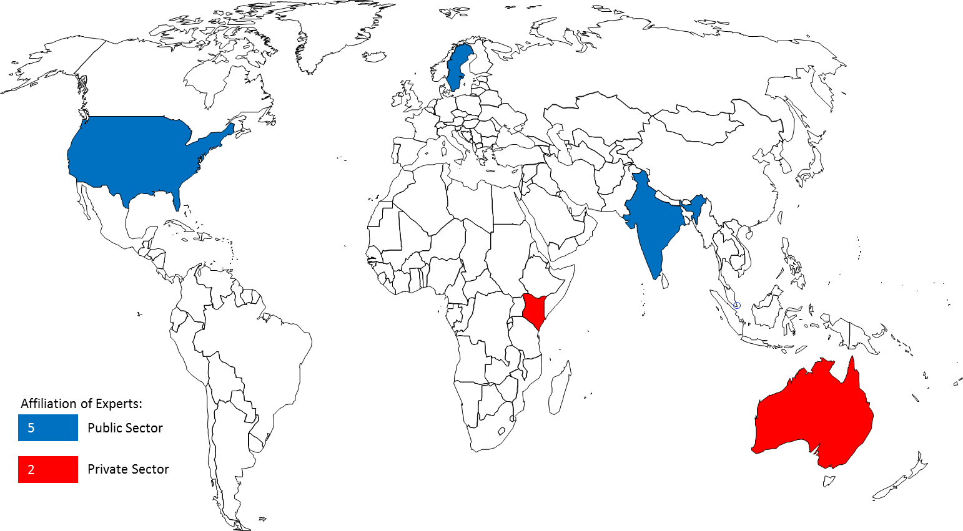

Figure 16. Affiliation of Experts for 6 Technology Transfer Studies.

[Appendix II follows]
APPENDIX II

(A) THE FIRST REGIONAL CONSULTATION
- The first Regional Consultation Meeting on Intellectual Property and Technology Transfer which took place in Singapore, Singapore, July 16-17, 2012, achieved some important milestones for the project. It obtained important information about the current status of technology transfer in this rapidly emerging Asian region and shared valuable experts’ opinions. The outcome of this Regional Consultation helped shape the next regional consultation in the African and Arab regions. 33 representatives attended from the following 19 Asian countries (2 from each country except Maldives, which was represented by only one representative): Bhutan, Brunei Darussalam, Cambodia, China, Fiji, Indonesia, Lao People’s Democratic Republic, Malaysia, Maldives, Mongolia, Myanmar, Papua New Guinea, Philippines, Republic of Korea, Singapore, Sri Lanka, Thailand and Vietnam.
- Some of the main actionable thoughts from this first Regional Consultation in the Asian region, which focused mainly on capacity building, included the following:
- provide IP awareness building and especially on economic benefits of IP;
- encourage governments for national innovation and in updating IP protection laws;
- provide more training on IP and technology evaluation through patent information search, as well as, more assistance in capacity building on technology transfer and innovation;
- assist in the establishment of national technology transfer mechanisms;
- assist in developing a national IP policy and innovation infrastructure, technology transfer infrastructure in universities and R&D institutions, and innovation-based human resources development;
- assist in the creation of collective technology transfer offices and in the creation of links between developing countries and centers of excellence in developed countries;
- provide institutions with capacity building including in R&D planning, technology evaluation, industrial design, patents, valuation, and patent information search, encouragement of know-how and trade secret;
- assist governments to provide concrete encouragement and incentive programs to commercialize IP;
- create regional IP open forums for the exploitation of IP valuation models in different industry sectors;
- foster university-industry collaboration, through government partial financing (50%) of research projects when industry collaborates with universities and IP donation/low royalty licensing of IP in developed countries to developing countries; and
- encourage increased membership to the PCT system.

(B) THE SECOND REGIONAL CONSULTATION
- The second Regional Consultation Meeting on Intellectual Property and Technology Transfer, Algiers, Algeria, January 29-30, 2013, built on the achievements of the first regional consultation and discussed a list of thoughts for the African and Arab regions, which focused on capacity building, innovation infrastructure, institutional infrastructure, university-industry collaboration, funding, regional and South-South cooperation, recognition for young inventors, and the markets. 23 representatives attended from the following 23 African and Arab countries (1 representative from each country): Algeria, South Africa, Saudi Arabia, Djibouti, Egypt, Ethiopia, Gabon, Ghana, Jordan, Kenya, Lebanon, Mali, Mauritania, Morocco, Namibia, Nigeria, Palestine, Sudan, Syria, Tanzania, Tunisia, Zambia and Zimbabwe.
- Some of the main actionable thoughts from this second Regional Consultation in the African and Arab region included the following:
- provide additional capacity building for the development of human resources and skills in innovation commercialization with tailored workshops (particularly in the areas of patent search, examination, IP and entrepreneurship, and IP awareness), Academy trainings, training of trainers programs, as well as to participate in the elaboration of IP curricula at school, undergraduate and graduate-level programs (while taking into account the local language requirements and promoting a mixture of North-South participation);
- organize regional workshops to share best practices for the development of efficient innovation infrastructures and the promotion of regional-based networking of TISCs;
- assist universities and R&D institutions in elaborating their institutional infrastructures and help them to adopt intellectual property policies that encourage, through a system of recognition, the filing of patents and other intellectual property rights, as well as to launch a regional training center for the commercialization of intellectual property and the transfer of technology;
- design and develop workshops for improving the communication between universities and enterprises, including adopting the cluster models that have gained widespread success in some countries, as well as to develop regional competitions and awards for best collaborations among universities, enterprises and individual inventors;
- develop mechanisms for providing funding to innovation projects, through the potential creation of a Global Fund or an Angel Investor Program for intellectual property commercialization and technology transfer, which could be used by SMEs as well as individuals;
- promote regional and South-South cooperation for the promotion of intellectual property commercialization and technology transfer;
- design programs for the encouragement of publications and recognition to young inventors; and
- provide a better understanding of the market for technology, such as identifying needs in particular technology areas and conducting patent landscapes in emerging areas of technology;
- call for the launch of a “United Nations Decade for Innovation and Youth Employment” from 2014-2023, similar to other international decades such as the United Nations Decade for the Eradication of Poverty.

(C) THE THIRD REGIONAL CONSULTATION
- The Third WIPO Regional Consultation Meeting on Intellectual Property and Technology Transfer, Istanbul, Turkey, October 24-25, 2013. 22 representatives attended from the following 22 countries in transition: Azerbaijan, Belarus, Bosnia and Herzegovina, Bulgaria, Croatia, Georgia, Greece, Israel, Kazakhstan, Kyrgyzstan, Republic of Latvia, Republic of Macedonia, Malta, Moldova, Montenegro, Poland, Romania, Republic of Tajikistan, Turkey, Ukraine and Republic of Uzbekistan.
- Some of the main actionable thoughts from this third Regional Consultation in the Transition region included the following:

In the area of institutional framework:
  - provide IP Offices with guidelines on data mining and the visualization of statistical intellectual property data and evidence;
  - assist Member States in the development, monitoring and evaluation of national intellectual property, innovation and technology transfer strategies; and
  - revitalize the WIPO University Initiative.

In the area of Innovation infrastructure:
- assist in the setup of benchmarking platforms for best practices in technology transfer;
- develop a Guide on success stories for successful business environments to promote technology transfer;
- develop a platform for enhancing the regional collaboration and the sharing of experiences of TTOs; and
- identify the role and lessons learned from national innovation funds.

In the area of capacity building and the development of human resources with innovation commercialization skills:
  - develop and fund a Mentors Program to connect leaders in a particular field to TTOs around the world; and
  - design and develop a practical Workshop and Guide for the licensing of trade secrets.

In the area of private funding facilitation and evaluation mechanisms:
  - commission a Survey of available Venture Capitalists, angel investors and philanthropist donors, for funding technology transfer; and
  - provide a matchmaking platform.

In the area of repatriation incentives and global collaboration:
  - commission a Study on the incentives for the repatriation of international professionals; and
  - promote the exchange of expertise in the area of TTOs.

(D) THE FOURTH REGIONAL CONSULTATION
- The Fourth WIPO Regional Consultation Meeting on Intellectual Property and Technology Transfer, Geneva, Switzerland, November 25-26, 2013. 16 representatives attended from the following 8 Permanent Missions: Ireland, Austria, Holy See, Italy, Portugal, Spain, Switzerland, and the United States of America.
- Some of the main actionable thoughts from this fourth Regional Consultation in the Developed Country region included the following:

The first area of work concerned the people exchange:
  - create a program for people exchange to share experience and knowledge for long-term sustainability;
  - analyze existing programs such as those of the Licensing Executives Society International (LESI) and the Association of University Technology Managers (AUTM) for the networking of technology transfer officials;
  - scope out what an effective Technology Transfer Office looks like;
  - create a subgroup of technology transfer officials from developed countries;
  - enable a network of technology centers around the world;
  - create a database of technology transfer opportunities;
  - increase awareness for the potential of technology transfer;
  - identify effective technology transfer activities and apply lessons from those to future WIPO programs;
  - advertise effective technology transfer activities through the media so they become models to follow;
  - map of incentives for technology transfer and landscape certain initiatives such as the EU twinning practices between different institutions for the exchange of know-how;
  - expand on the EU twinning scheme and apply it between developed and developing countries; and
  - benchmark experiences and best practice relevant to the transfer of technology to inform the future and ensure that experience permeates everything;

Regarding the enabling infrastructure:
  - build networks of innovation infrastructures and encourage the twinning of technology transfer agents; and
  - create a Global Observatory providing technical assistance in technology transfer to ensure a regional strategy rather than a piecemeal approach;

Finally, with reference to the innovation policy:
- evaluate the impact of investment in technology transfer on economic and social development;
- commission a Study on incentives for technology transfer; and
- commission a landscaping Report on successful technology transfer between developed and developing countries.

(E) THE FIFTH REGIONAL CONSULTATION
- The Fifth WIPO Regional Consultation Meeting on Intellectual Property and Technology Transfer, Monterrey, Mexico, December 5-6, 2013. 25 representatives attended from the following 21 Latin American and Caribbean countries: Argentina, Bahamas, Barbados, Brazil, Chile, Colombia, Costa Rica, Cuba, Ecuador, El Salvador, Guatemala, Guyana, Honduras, Jamaica, Mexico, Nicaragua, Paraguay, Peru, Saint Kitts and Nevis, Saint Vincent and the Grenadines, Uruguay, and Trinidad and Tobago.
- Some of the main actionable thoughts from this fifth Regional Consultation in the Latin American and Caribbean region included the following:

In the area of capacity-building and the development of human resources with innovation commercialization skills:
  - develop a workshop for the training of TTO staff and the exchange of experiences between TTOs at a regional level;
  - conduct workshops on IP awareness for SMEs in the LAC region;
  - incorporate IP awareness and initiatives for schoolchildren/teachers and IP curricula at all education levels;
  - design and develop a workshop on the licensing of trade secrets and knowhow;
  - enable the dissemination of existing capacity-building tools through one-stop shops; and
  - provide patent examiners with access to proprietary databases.

Concerning institutional framework:
  - promote among the Member States of the PCT system its better use in the LAC region; and
  - support the development of university and research institute’s appropriate IP policies.

As to innovation infrastructure:
  - assist in the development of innovation networks; and
  - share best practices and business models from innovation infrastructures in the LAC region.

Regarding the regulatory framework:
  - assist in the development of guidelines and rules for institutions to promote technology transfer;
  - establish a forum to debate on trade and innovation and use the expertise of the WTO;
  - explore multilateral frameworks to improve access to technology that meets public needs including the promotion of WIPO platforms such as WIPO Re: Search and WIPO Green; and
  - promote the use of flexibilities of the TRIPs Agreement in order to increase access to technology.

On the subject of funding mechanisms:
  - commission a Study on the impact of funding mechanisms and best practices for innovation and technology transfer;
  - assist in the design of cost-effective projects on technology transfer; and
  - commission a Study on the impact of funding mechanisms such as proof-of-concept centers which provide seed funding and the tailoring of this model to countries in the LAC region;

As regards to the evaluation mechanisms:
  - assist in the development of national score cards with respect to the performance in IP management and technology transfer;
  - evaluate the extension of the Global Innovation Index parameters to include the patent applications in offices such as USPTO and EPO and look at the impact of specifying the multiple citizenships for inventors; and
  - improve awareness of the use of the WIPO databases and on the feedback from the users;

Finally, in the area of global collaboration:
  - develop and strengthen networks of TISCs at the regional level;
  - examine mechanisms for the repatriation of international talents and exchange experiences in this area;
  - design and launch a Web Forum to exchange experiences and best practices in international technology transfer; and
  - develop a global compendium of incentives for international technology transfer.

[Appendix III follows]
APPENDIX III

(A) THE FIRST STUDY

- The first of the six peer-reviewed analytical studies to be carried out under the project was to be (see document CDIP/9/INF/4, Annex, page 12): “(a) a series of economic studies on IP and international technology transfer. These studies would focus on areas that have received less attention in the available economic literature and on identifying possible obstacles and suggesting possible ways in which technology transfer could be enhanced. These studies should not be redundant with existing internal (in other WIPO committees such as the Standing Committee on the Law of Patents) or external (from other organizations) studies on technology transfer”.
- This first study entitled “Economics of IP and International Technology Transfer” was conducted by Prof. A. Damodaran, Indian Institute of Management, Bangalore, India. The study focuses on key compartments of international macroeconomic policy. It was peer-reviewed by Prof. Francesco Lissoni, Bocconi University, Italy.

(B) THE SECOND STUDY
- The second of the six peer-reviewed analytical studies to be carried out under the project was to be (see document CDIP/9/INF/4, Annex, page 12): “(b): a study that will provide information on existing intellectual property right (IPR) related policies and initiatives found in the public and private sector of developed countries to promote technology transfer and R&D capacity in developing countries, including international IP standards pertaining to technology transfer, such as the use of flexibilities in international IP agreements. This new study should avoid duplication of work and constitute an addition to work already undertaken in WIPO”.
- This second study, entitled “Intellectual Property-Related Policies and Initiatives in Developed Countries to Promote Technology Transfer”, was conducted by Mr. Sisule Musungu, Partner, Sisule Munyi Kilonzo & Associates, Nairobi, Kenya. This study analyses and reviews the potential and performance of identified policies and initiatives in developed countries to determine which are most favorable to promoting technology transfer. It was peer-reviewed by Prof. Walter Park, American University, USA.

(C) THE THIRD STUDY
- The third of the six peer-reviewed analytical studies to be carried out under the project was to be (see document CDIP/9/INF/4, Annex, page 12): “(c): a series of case studies of cooperation and exchange between R&D institutions in developed countries and R&D institutions in developing countries as well as a database of links to national institutions that already offer technology transfer opportunities or may offer such possibilities”.
- This third study, entitled “Case Studies on Cooperation and Exchange between R&D Institutions in Developed and Developing Countries”, was conducted by Mr. Bowman Heiden, Professor, University of Gothenburg, Gothenburg, Sweden. This work generates eight case studies gathering different insights on international cooperation from the viewpoint of the different investigators on the nature of technology transfer in the different developing country contexts. It was peer-reviewed by Dr. Nikolaus Thumm, European Commission Joint Research Centre, Spain.

(D) THE FOURTH STUDY
- The fourth of the six peer-reviewed analytical studies to be carried out under the project was to be (see document CDIP/9/INF/4, Annex, page 12): “(d): a study on Favorable Incentive Policies for businesses to become partners in technology transfer processes at the national and international level”.
- This fourth study, entitled “Policies Fostering the Participation of Businesses in Technology Transfer”, was conducted by Mr. Philip Mendes, Principal, Opteon, Inc., Brisbane, Australia. The study focuses on the many factors influencing the underutilization of technology transfer processes. It was peer-reviewed by Dr. Nikolaus Thumm, European Commission Joint Research Centre, Spain.

(E) THE FIFTH STUDY
- The fifth of the six peer-reviewed analytical studies to be carried out under the project was to be (see document CDIP/9/INF/4, Annex, page 12): “(e): an analysis of transfer of technologies issues relating to existing and emerging issues of concern to DCs and LDCs in order to identify their needs in certain specific regions or sub-regions”.
- This fifth study, entitled “International Technology Transfer: An Analysis from the Perspective of Developing Countries”, was conducted by Mr. Keith Maskus, Professor, University of Colorado, Boulder, Colorado, USA and Mr. Kamal Saggi, Professor, Vanderbilt University, Nashville, Tennessee, USA. The study focuses on international technology transfer, with a particular emphasis on the concerns of developing countries in gaining greater access to global technology. It was peer-reviewed by Prof. Walter Park, American University, USA.

(F) THE SIXTH STUDY
- The sixth of the six peer-reviewed analytical studies to be carried out under the project was to be (see document CDIP/9/INF/4, Annex, page 12): “(f): a series of studies looking at alternatives for R&D efforts and support to innovation aside from the currently existing patent system”.
- This sixth study, entitled “Alternatives to the Patent System that are Used to Support R&D Efforts, including both Push and Pull Mechanisms, with a Special Focus on Innovation Inducement Prizes and Open Source Development Models”, was conducted by Mr. James Packard Love, Director, KEI, Washington, DC, USA. The study focuses on several alternatives to the patent system including direct government funding of research, tax policy, mandates to fund research-based upon a percentage of product sales, and innovation inducement prizes. It was peer-reviewed by Prof. Dominique Foray, EPFL, Switzerland.

[End of Annex and of document]

Recommendation No. 19 (Cluster B): “To initiate discussions on how, within WIPO’s mandate, to further facilitate access to knowledge and technology for developing countries and LDCs to foster creativity and innovation and to strengthen such existing activities within WIPO.” Recommendation No. 25 (Cluster C): “To explore IP related policies and initiatives necessary to promote the transfer and dissemination of technology, to the benefit of developing countries and to take appropriate measures to enable developing countries to fully understand and benefit from different provisions, pertaining to flexibilities provided for in international agreements, as appropriate.” Recommendation No. 26 (Cluster C): “To encourage Member States, especially developed countries, to urge their research and scientific institutions to enhance cooperation and exchange with research and development (R&D) institutions in developing countries, especially LDCs.” Recommendation No. 28 (Cluster C): “To explore supportive IP related policies and measures Member States, especially developed countries, could adopt for promoting transfer and dissemination of technology to developing countries.”
See CDIP/9/INF/4, paragraphs 9 and 10
Under recommendation 36, an “Atlas of Global Knowledge Flows” was developed by Community Systems Foundation (CSF), New York, and delivered in its final form on July 22, 2014.
Kamal Saggi, Keith E. Maskus and Bernard Hoekman, “Transfer of Technology to Developing Countries: Unilateral and Multilateral Policy Options”, World Bank Policy Research Working Paper 3332, June 2004.
Literature suggests a number of informal channels such as access to patent information and international fairs.
See CDIP/9/INF/4, http://www.wipo.int/meetings/en/doc_details.jsp?doc_id=202624
See CDIP/8/7, http://www.wipo.int/meetings/en/doc_details.jsp?doc_id=188786
http://www.wipo.int/meetings/en/details.jsp?meeting_id=28643
http://www.wipo.int/meetings/en/details.jsp?meeting_id=31263
http://www.wipo.int/meetings/en/details.jsp?meeting_id=30703
http://www.wipo.int/meetings/en/details.jsp?meeting_id=31242
http://www.wipo.int/meetings/en/details.jsp?meeting_id=31243
The final versions of the analytic studies will be uploaded on the “Project Status” page of the CDIP (http://www.wipo.int/ip-development/en/agenda/projects.html) under the Project on IP and Technology Transfer.
http://www-ocmstest.wipo.int/innovation
http://www.wipo.int/meetings/en/details.jsp?meeting_id=34205

