E
CDIP/21/10
ORIGINAL: English
DATE: march 26, 2018

Committee on Development and Intellectual Property (CDIP)

Twenty-First Session
Geneva, May 14 to 18, 2018

REPORT on WIPO’s contribution to the implementation of THE Sustainable Development Goals and its associated targets

prepared by the Secretariat

At its eighteenth session, the Committee on Development and Intellectual Property (CDIP) requested the Secretariat to present an annual report to the Committee, at its first session of the year, containing information on World Intellectual Property Organization (WIPO)’s contribution to the implementation of the Sustainable Development Goals (SDGs) and its associated targets on:

(a) the activities and initiatives undertaken individually by the Organization;

(b) the activities undertaken by the Organization as part of the UN System; and

(c ) the assistance provided by WIPO to Member States upon their request.

The present report is submitted pursuant to that request. It is also a contribution to the discussions initiated at the fifteenth session of the Committee on how WIPO would support Member States to fulfill the objectives of the 2030 Agenda for Sustainable Development.

3. It is recalled that the Committee considered at its sixteenth, seventeenth and eighteenth sessions, a series of documents on “WIPO and the Post-2015 Development Agenda” (document CDIP/16/8), “Mapping of WIPO Activities Related to the SDGs Implementation” (document CDIP/17/8), and the “Compilation of Member State Inputs on SDGs relevant to WIPO’s Work” (document CDIP/18/4), respectively. The first annual report on WIPO’s contribution to the implementation of the SDGs and its associated targets was submitted to the Committee at its nineteenth session (document CDIP/19/6).

WIPO and the 2030 Agenda for Sustainable Development

4. “Transforming our world: the 2030 Agenda for Sustainable Development” (2030 Agenda) is a comprehensive set of goals and targets adopted unanimously by the United Nations General Assembly (UNGA) in September 2015 for full implementation by 2030. These goals and targets are integrated, indivisible, and balance the three dimensions of sustainable development: the economic, social and environmental. The 2030 Agenda is a universal plan which involves all countries, developed and developing alike, taking into account different national realities, capacities, policies and priorities. It builds on the outcomes of all major United Nations (UN) Conferences and Summits as well as on the achievements of the Millennium Development Goals and seeks to identify integrated solutions to the remaining important challenges to sustainable development.

5. For the implementation of the 2030 Agenda, Member States recognized that each country has primary responsibility for its own economic and social development, and acknowledged that the scale and ambition of the new agenda requires a revitalized Global Partnership, bringing together Governments, the private sector, civil society, the United Nations system and other actors, and mobilizing all available resources. As a specialized Agency of the UN, WIPO has participated as an observer in the negotiation and the adoption of Agenda 2030.

6. It is to be noted that there is no direct reference to intellectual property (IP) in the goals and targets composing the 2030 Agenda, with the exception of paragraph 3.b of Goal 3 that mentions IP rights regarding flexibilities to protect public health, in accordance with the Doha Declaration on the Trade-related Aspects of Intellectual Property Rights (TRIPS) Agreement and Public Health. Also, there are no indicators related to IP in the current Global indicator framework, adopted in 2017 respectively by the UN Statistical Commission, the UN Economic and Social Council, and the UN General Assembly.

7. It is also to be noted that science, technology and innovation are recognized throughout the 2030 Agenda, particularly in SDG 9, as a major driver to achieve the SDGs. Innovation is at the heart of WIPO’s mission. SDG 9 is the most central to WIPO’s mandate.

8. Yet, many of the SDGs are dependent upon the development and diffusion of innovative technologies. Innovation and creativity are not goals in themselves; they are means and tools for creative solutions to development challenges and, being at the heart of the system, have an impact on many of the SDGs. As such, innovation has a direct impact on SDG 2 (zero hunger), SDG 3 (good health and wellbeing), SDG 6 (clean water and sanitation), SDG 7 (affordable and clean energy), SDG 8 (decent work and economic growth), SDG 11 (sustainable cities and communities) and SDG 13 (climate change). As a policy setting, innovation can assist in achieving SDG 1 (no poverty, SDG 8 (decent work and economic growth), SDG 14 (life below water), and SDG 15 (life on land). Moreover, certain SDGs are relevant to the settings of an innovation policy framework, notably SDG 5 (gender equality, SDG 8 (decent work and economic growth), SDG 10 (reduced inequalities), and SDG 12 (responsible consumption and production).

9. In a recent resolution on the Impact of rapid technological change on the achievement of the Sustainable Development Goals, the UNGA stressed “the vital role that science, technology and innovation, including environmentally sound technologies, can play in development and in facilitating efforts to address global challenges, such as efforts to eradicate poverty, achieve food security and nutrition, improve agriculture, enhance access to energy and increase energy efficiency, fight diseases, improve education, protect the environment, accelerate the pace of economic diversification and transformation, improve productivity and competitiveness and ultimately support sustainable development”.

A. The activities and initiatives undertaken individually by the Organization

10. The WIPO Development Agenda is at the heart of WIPO’s contribution to the implementation of Agenda 2030. Since its adoption in 2007, development considerations became an integral part of WIPO’s work and the development dimension of the Organization’s activities and deliberations have drastically increased. The effective implementation of the Development Agenda is a key priority and a major component of the assistance WIPO can provide to its Member States, within its mandate, to help achieve the SDGs. A detailed report on the implementation of the Development Agenda is presented at the current session of the Committee.

11. IP can help achieve the SDGs by facilitating the uptake and diffusion of new ideas and technologies. A balanced and effective IP system enables domestic innovation and creativity, and its sharing and diffusion across borders for the benefit of all. The IP system can also help support the flow of knowledge and technical know-how within and between countries, by making available information on innovative processes, and by providing the legal basis upon which partnerships and collaborations can occur among stakeholders in the innovation ecosystem.

12. In this context, WIPO offers a wide-range of programs, platforms, projects and activities which help Member States create or strengthen a positive environment for innovation and creativity that could be crucial to achieve the SDGs.

13. WIPO assists its Member States, particularly developing and least developed countries, upon their request, to produce national IP strategies that encourage and facilitate the effective creation, development, management, and protection of IP at the national level. The legal framework of the IP System, which includes the twenty-six international treaties administered by WIPO and national IP laws, is of outmost importance to the innovation ecosystem in the global economy. It promotes a positive enabling environment to support the innovation in technological development, and diversity in creativity, that will be important for achieving the SDGs.

14. WIPO’s legislative and policy assistance is based on the multilateral legal framework and aims to support domestic technology development, research and innovation in developing countries, including by ensuring a conducive policy environment. Member States’ legislative activity has grown, particularly due to their increasing participation in regional economic integration processes and preferential trade agreements. Additionally, a number of Member States are revising their current patent laws to accommodate local public policies, or due to their accession to multilateral treaties on patents, namely the Patent Cooperation Treaty (PCT), Budapest Treaty, and Patent Law Treaty (PLT), and implementing them for the first time through the adoption of regulations. Moreover, countries joining the World Trade Organization (WTO) systematically revise their legal frameworks. Therefore, requests for legislative advice follow the same trend. During the period covered by this report, Legislative Assistance was provided to nine Member States, upon their request, via the elaboration of comments or the preparation of draft laws.

15. Various WIPO world-leading databases also contribute to foster innovation: Patentscope aims to raise public awareness of the wealth of technological information in the context of facilitating transfer of knowledge and fostering development. It offers free online dissemination of patent data with over 60 million technology disclosures. The Global Brands Database provides access to over 20 million records relating to internationally protected trademarks, appellations of origin and armorial bearings, flags and other state emblems as well as the names, abbreviations and emblems of IGOs; the Global Design Database enables free and simultaneous searches of more than 1,770,000 industrial designs registered under the WIPO-administered Hague System and/or in participating national collections; WIPO Lex, the leading reference on IP laws worldwide, is a global database that provides free of charge access to legal information on intellectual property (IP) such as treaties administered by WIPO, other IP-related treaties, and laws and regulations of the Members States of WIPO, the UN and WTO; the IP Statistics Data Center is a world leading reference for IP activities and is intended to be a tool for IP professionals, researchers and policymakers worldwide.

16. A number of WIPO’s Platforms promote innovation by helping Member States and various users strengthen their ability to understand and leverage trends in policy, business, and innovative technologies:

(a) More than 600 WIPO Technology and Innovation Support Centers (TISCs) provide innovators in over 40 countries with access to locally based, high quality technology information and related services, helping them to exploit their innovative potential and to create, protect, and manage their intellectual property (IP) rights. Services offered by TISCs include access to online patent and non-patent resources and IP-related publications, assistance in searching and retrieving technology information, training in database search, on-demand searches, monitoring technology and competitors, basic information on industrial property laws, management and strategy, and technology commercialization and marketing. In 2017, WIPO received twelve new requests from Member States for setting up TISC networks following the signing of a Service Level Agreement. Additionally, TISC training to establish and/or reinforce services and their sustainability were carried out, at their request, in thirty-one Member States;

(b) The Industrial Property Automation System (IPAS) is a modular automation administrative system used in over 80 developing countries throughout the world to automate their IP business and administrative processes. IPAS is one of the key components of the global IP infrastructure provided by WIPO, along with a set of modernization services, to offer a comprehensive sustainable automation solution to requesting IP offices from developing countries with diverse levels of development, resources, capacity, skills and infrastructure;

(c ) The WIPO Centralized Access to Search and Examination (CASE) system enables participating patent offices to securely share search and examination documentation related to patent applications with the objective to improve the quality and efficiency of the patent search and examination process done at local and regional patent offices; and

(d) Finally, the WIPO Digital Access Service (DAS) allows secured electronic exchange of priority documents between participating intellectual property offices. The system enables applicants and offices to meet the requirements of the Paris Convention for certification in an electronic environment.

17. WIPO contributes also to the innovation ecosystem through a number of analytical reports: The World IP Reports, the World IP Indicators and the Global Innovation Index; as well as through a number of partnerships, as recommended by SDG 17. The following programs could be mentioned among those partnerships:

(a) Access to Research for Development and Innovation (ARDI) aims to increase the availability of scientific and technical information in developing countries. By improving access to scholarly literature from diverse fields of science and technology, ARDI seeks to reinforce the capacity of developing countries to participate in the global knowledge economy and supports researchers in those countries in creating and developing new solutions to technical challenges faced on a local and global level. Currently, over 100 publishers provide access to around 30,000 journals, books, and reference works for 121 developing countries and territories through ARDI.

(b) Access to Specialized Patent Information (ASPI) program is a public-private partnership administered by WIPO and made possible through cooperation with leading patent information providers. Through ASPI, eligible patent offices and academic and research institutions in developing countries can receive free or low-cost access to sophisticated tools and services for retrieving and analyzing patent data.

(c ) The Accessible Books Consortium (ABC) is a private/public partnership aiming to increase the number of books worldwide in accessible formats – such as braille, audio, e-text, large print – to people who are blind, have low vision or are otherwise print disabled. It includes organizations that represent people with print disabilities such as the World Blind Union (WBU); libraries for the blind; standards bodies, and organizations representing authors, publishers and collective management organizations. ABC provides training and technical assistance in developing countries for governmental, non-governmental and private sector actors who wish to promote the production of books in accessible formats. The Consortium provides also a Global Book Service that enables libraries serving the print disabled to share items in their collections.

(d) WIPO Re:Search is a Consortium established in collaboration with BIO Ventures for Global Health (BVGH) and the technical advice of the World Health Organization (WHO), which catalyzes the development of medical products for neglected tropical diseases (NTDs), malaria, and tuberculosis through innovative research partnerships and knowledge sharing among the leading pharmaceutical companies and other private and public sector research institutions. It provides access to intellectual property, including pharmaceutical compounds, technologies, know-how and data available for research and development for NTDs, tuberculosis, and malaria, with the aim to accelerate the discovery and product development of medicines, vaccines, and diagnostics, and to create new solutions for people affected by those diseases, as stipulated in SDG 3.

(e ) WIPO Green promotes innovation and diffusion of green technologies by connecting technology and service providers with those seeking innovative solutions. It brings together a wide range of players in the green technology innovation value chain, and connects owners of new technologies with individuals or companies who might be looking to commercialize, license or otherwise distribute a green technology. Through this program, WIPO helps to accelerate innovation and diffusion of environmentally sustainable technologies and contribute to the efforts in addressing climate change.

(f) The Inventor Assistance Program (IAP) is an innovative program aimed at making the IP system more accessible to developing country inventors and small businesses, by matching financially under-resourced inventors of promising new technologies and ideas with qualified IP counsel, who provide free of charge legal assistance on how to file a patent to protect their inventions.

18. Technical assistance and capacity building programs are set to promote IP as a tool for development and to spur innovation and creativity. The WIPO Academy is the core entity in WIPO for enhancing training and human capacity-building activities, particularly for developing countries, least-developed countries (LDCs) and countries in transition. The Academy acts as a catalyst for a virtual network of partners, experts and teachers in development-oriented IP training. It provides professional and open-access online learning and training designed to expand the range and impact of training opportunities at the national, regional and international levels. In addition to the activities of the Academy, various sectors of WIPO organize throughout the year regional, sub regional, and national seminars and workshops both on public policy matters and to develop local capacities.

19. In a resolution adopted without a vote on December 20, 2017 entitled Science, technology and innovation for development, the UNGA recognized “the importance (…) of an efficient, adequate, balanced and effective intellectual property framework” and encouraged “the World Intellectual Property Organization to continue to undertake technical support activities, including helping countries to design, develop and implement national intellectual property and innovation strategies aligned with their development strategies. In the same resolution, the UNGA notes “the ongoing efforts by the World Intellectual Property Organization, under its existing mandate, to establish technology and innovation support centers in over 60 countries, providing access to technological information through patent databases and access to scientific literature through the access to Research for Development and Innovation Programme, the access to Specialized Patent Information programme and the development of national intellectual property and innovation strategies”.

Program and Budget 2018 - 2019

20. The 2018 - 2019 Program and Budget adopted at WIPO’s 57th Assemblies in October 2017, establishes for the first time, under the Result Framework, a link between WIPO’s Strategic Goals and the SDGs.

21. Under each of the concerned Strategic Goals, a wide range of programs and activities involving all the Sectors of the Organization, contribute to the SDGs. The total number of Programs linked to SDGs amount to twenty out of a total of thirty-one Programs. The mapping Charts reflecting the 20 programs under WIPO Strategic Goals I, II, III, IV, V, and VII which contribute to the SDGs are contained in the Annex to this document. Each chart shows the link between the Programs and the relevant Sustainable Development Goals to which they contribute directly or indirectly, through the Performance Indicators and Expected Results set for the achievement of WIPO’s Strategic Goals.

22. The Program mapping shows that WIPO’s Strategic Goals and Programs are aligned with the priorities set in the 2030 Agenda. WIPO’s development cooperation, technical assistance and capacity building activities are strategically placed to deliver support to its Member States as they integrate the SDGs in their national sustainable development plans. WIPO will work upon request of its Member States to ensure that national IP and innovation strategies are integrated appropriately in those national development plans taking into account their development needs, capacities and resources. Throughout the term of the 2030 Agenda, WIPO will continue to work closely with its Member States to adapt to their changing development priorities, capacities and resources, so as to optimize WIPO’s support in governments’ use of the IP and innovation system as a tool for the achievement of the SDGs.

Specific activities in 2017

23. Other activities have been undertaken individually by the Organization since the presentation in May 2017 of the first report on WIPO’s contribution to the implementation of the SDGs and its associated targets. These activities aim to promote the role and impact of innovation (SDG 9) with regard to various challenges related to clean water and sanitation (SDG 6), to health (SDG 3), to education and economic growth (SDGs 4 and 8), to food security and to gender equality (SDG 2 and 5).

24. With respect to SDG 6 – water and sanitation, and SDG 17 – Partnerships for the Goals WIPO, WIPO GREEN organized the first Innovate 4 Water matchmaking forum in collaboration with Waterpreneurs and WaterVent from June 7 to 9, 2017 at WIPO Headquarters in Geneva, Switzerland. The forum sought to harness the insight and expertise of key sector actors to accelerate innovation and investment. It provided an opportunity to create connections between entrepreneurs and impact investors, promote the transfer of innovative water technologies and innovative business models in emerging markets and developing countries, raise awareness about water issues, and strengthen and promote the WIPO GREEN Network. Over 350 high-level participants including entrepreneurs, investors, companies, public sector organizations, UN agencies, incubators and others took part in the event. Forty entrepreneurs presented their green business activities to experts and investors. Around 60 organizations with water-related projects and programs pitched their current challenges and needs. The forum led to more than 240 connections, two of which already matured into deals. To promote safe water, WIPO GREEN and Partner InvenTrust also jointly launched two Open Challenges related to energy efficient water desalination and leakage elimination in water distribution.
25. With respect to SDG 3 – Global Health and Well-being and SDG 17 – Partnerships for the Goals:
(a) WIPO in collaboration with Access to Medicine Foundation and WHO organized on November 8, 2017, a Global Challenges seminar during which the Global Challenges Report “Vaccines: Accelerating Innovation and Access” was launched. During the seminar, the challenges of reaching global immunization coverage through increasing access to current and future vaccines were discussed. The report describes the innovation process for vaccines; limitations to vaccine access at various stages, including those related to intellectual property; as well as approaches for addressing these impediments;
(b) WIPO continues to contribute to the global health policy debate through its trilateral cooperation with WHO and WTO. The organizations held their 7th trilateral symposium on Sustainable Development Goals: Innovative technologies to promote healthy lives and well-being, on February 26, 2018 at the WHO headquarters. The symposium was an opportunity to discuss challenges and opportunities to ensure that innovative technologies are developed and reach patients in order to realize the right to health and the health-related SDGs; and
(c ) WIPO and the research-based pharmaceutical industry launched on October 3, 2017 a new partnership to promote the accessibility of patent information for health agencies tasked with procurement of medicines. An agreement was signed between WIPO and the International Federation of Pharmaceutical Manufacturers and Associations (IFPMA), establishing the Patent Information Initiative for Medicines, or “Pat-INFORMED”. This initiative will link public patent information to registered medicines in a new online global gateway, helping health professionals to navigate the medicine-procurement process for the benefit of their citizens. Pat-INFORMED will act as a global gateway to medicine patent information. It will offer new tools and resources to determine the existence of patents relevant to products sought by procurement bodies’ disease-management strategies or other work addressing public health needs. Twenty leading global research-based biopharmaceutical companies have already committed to make information available via a database to be established by Pat-INFORMED, with more organizations expected to join.
26. As a contribution to SDG 4 (Quality Education) implementation, WIPO organized on November 22 and 23, 2017, in Yaoundé, Cameroun, a High-level Regional Conference on the Publishing Industry in Africa and its Role in Education and Development. The objective was to prepare an action plan to promote the African publishing industry, with a focus on the education sector. The action plan focuses on the role of copyright in developing a sustainable national publishing industry which will provide access to culturally relevant, affordable and high quality educational material across Africa.

27. Innovation and Intellectual Property as Engines for Competitive Agribusiness:
Empowering Women Researchers and Entrepreneurs in Africa, was the theme of a Regional Forum organized by WIPO in Casablanca, Morocco, from 15 to 17 November, 2017. The Forum was an opportunity for African women researchers, scientists, entrepreneurs and IP experts to share their experiences on how African women can use the IP system as a tool for fostering innovation in the field of agriculture and agribusiness. It provided also a platform to discuss how science, technology and innovation can foster the implementation of the SDGs, particularly those related to hunger, poverty, gender equality, economic growth, and innovation and how they can crucially contribute to food and nutritional security in Africa by increasing agricultural productivity, competitiveness, wealth creation, resilience and sustainability. The Forum brought together over two hundred women researchers and entrepreneurs actively engaged in the agricultural and agribusiness sector from diverse national regional institutions and the private sector representing over 50 African countries, including the African Regional Intellectual Property Organization (ARIPO) and l’Organisation africaine de la propriété intellectuelle (OAPI).

b. The activities undertaken by the Organization as part of the UN System
28. As a specialized agency of the United Nations, WIPO participated in the key UN processes supporting the preparation of the 2030 Agenda and the SDGs. Subsequently, WIPO engaged in the framework for follow-up and review of the 2030 Agenda, including through the annual High-level Political Forum on Sustainable Development and the development of the Global Indicator Framework.

29. WIPO participated in the Executive Committee on Economic and Social Affairs (ECESA) Plus Mechanism, which serves as the coordinating mechanism among UN system and related organizations for implementation of the 2030 Agenda, and the Small Island Developing States (SIDS) SAMOA Pathway outcome document. WIPO is also an active member and contributes to meetings and reports of the Inter-Agency Task Team on Financing for Development, and participates as an observer in the Inter-Agency and Expert Group on the SDG Indicators. WIPO is also a longstanding member of the Inter-Agency Task Team on Science, Technology and Innovation for SDGs, established by the member States in 2015, as one of three core components of the Technology Facilitation Mechanism. WIPO has also contributed to inter-agency strategic thinking on SDG issues within the UN Chief Executives Board (CEB), and the High-Level Committee on Management and High-Level Committee on Programmes.

30. In each of these key processes, the role of the WIPO Secretariat included:

- monitoring the negotiations and discussions in these processes as they related to WIPO’s mandate;

- providing factual information on the role of the intellectual property system in relation to broader policy areas, as required by Member States and UN Secretariat; and

- raising awareness of the various WIPO programs, projects and initiatives which may support Member States in implementing the Sustainable Development Goals (SDGs).

31. Previous reports on WIPO’s contribution to the implementation of the SDGs and engagement with the preparatory processes for the 2030 Agenda were presented by the Secretariat at the nineteenth and sixteenth sessions of the CDIP respectively (documents CDIP/19/6 and CDIP/16/8).

The Technology Facilitation Mechanism

32. The Technology Facilitation Mechanism (TFM) was established by the Outcome Document of the Third International Financing for Development Conference: the “Addis Ababa Action Agenda” (AAAA) and adopted in the 2030 Agenda. Its purpose is to support the achievement of SDGs through use of science, technology and innovation.

33. The TFM is composed of a UN Interagency Task Team on Science, Technology and Innovation for the SDGs (IATT), an annual Multi-stakeholder Forum on Science, Technology and Innovation for the SDGs, and an on-line platform to provide a cohesive overview of UN initiatives on science, technology and innovation, and facilitate access to and use of such technology-related initiatives. The aim of the IATT is to promote coordination, coherence, and cooperation within the UN system on STI-related matters with the aim of enhancing synergy and efficiency, in particular to enhance capacity-building initiatives.

34. WIPO is a founding member of the IATT, which now numbers some 38 UN entities, and meets regularly at the UN in New York. WIPO, through its New York Coordination Office, is closely involved in this process and has, together with UN Women and United Nations Educational, Scientific and Cultural Organization (UNESCO), initiated a sub-group within the IATT on gender and science, technology and innovation for SDGs. The objective of the sub-group is to promote cohesiveness among UN system on gender-related initiatives in this field. WIPO also assisted United Nations Department of Economic and Social Affairs (UNDESA) and the 10-member advisory group appointed by the UN Secretary General with the organization of the second annual Multi-stakeholder Forums on Science, Technology and Innovation (STI) for the SDGs, convened by the President of ECOSOC, at UN Headquarters New York (May 15 and 16, 2017). The Forum addressed the theme Science, Technology and Innovation for a Changing World – Focus on SDGs 1, 2, 3, 5, 9, and 14. In addition, WIPO, in cooperation with the United Nations Conference on Trade and Development (UNCTAD), ITU and the World Bank and the Permanent Missions of Japan and Mexico, organized in the margins of the Second STI Forum, on May 16, 2017, a side event on Innovation strategies: Designing national policies that use innovation to meet the SDGs.

35. WIPO, together with UN Women and UNESCO, developed a joint initiative to explore policy and strategic approaches to issues of gender and science, technology and innovation in the context of achieving progress under the SDGs. As part of this initiative WIPO, through its New York Coordination Office, hosted an expert meeting on future foresight methodologies for policymaking on gender and STI (March 30, 2017).

UN High Level Political Forum (HLPF) on Sustainable Development

36. The HLPF was part of the agreement reached in 2012 at the UN Conference on Sustainable Development (RIO+20) with the aim to strengthen Sustainable Development governance at the global level. Its main role is to promote and review progress in implementing the 2030 Agenda and to provide political leadership, guidance and recommendations for sustainable development.

37. WIPO was represented at the HLPF session held in New York (July 10 to 19, 2017). The theme of the session was “Eradicating poverty and promoting prosperity in a changing world”. During this session the HLPF addressed SDGs 1, 2, 3, 5, 9 and 14 and conducted 43 Voluntary National Reviews, presented by developing and developed countries.

38. WIPO has participated by attending and engaging in the discussions of each session of the HLPF. It has contributed to the policy/background briefs for the HLPF, in particular focusing on the subject of innovation, science and technology, and has suggested speakers and participated in ECESA-Plus coordinated efforts to contribute to the preparation of specific sections of the HLPF program.

39. WIPO also co-organized SDG-specific side events during the HLPF 2017 and during the preparatory process. As part of the joint initiative with UN Women and UNESCO on gender and science, technology and innovation (mentioned in paragraph 8), WIPO co-organized, with the Permanent Mission of Rwanda, a side event at the High-level Political Forum on Sustainable Development on STI for SDGs on the theme of Closing the Gender Gap on STI for SDGs (July 12, 2017).

40. During the preparatory process for the HLPF 2017, and to coincide with World IP Day, WIPO co-organized an event with the Permanent Mission of China, UNESCO and UN Women, on Women as Innovators and Beneficiaries of Innovation for Sustainable Development (April 26, 2017). As part of the abovementioned joint initiative, WIPO also co-organized with UN Women and UNESCO an expert meeting on future foresight methodologies for policymaking on gender and STI (March 30, 2017).

Interagency and Expert Group on the SDG Indicator Framework

41. The Inter-Agency and Expert Group on Sustainable Development Goal Indicators (IAEG-SDGs) was established at the forty-sixth session of the Statistical Commission with the task of developing and implementing the global indicator framework to measure progress in implementing the SDGs. Between June 2015 and February 2016, the IAEG-SDGs developed the initial set of global indicators through a process of intergovernmental negotiations informed by experts and UN system observers who provided inputs as required.

42. WIPO participates as an observer in the IAEG-SDGs and the Statistical Commission meetings and teleconferences. WIPO has regularly attended the IAEG-SDG meetings held in 2015 through 2017, including the sixth session held in Manama, Kingdom of Bahrain (November 11 to 14, 2017). WIPO made its data sets and data methodologies available, upon request by members, for the measurement of the contribution of innovation systems to achieve SDGs 9 and 17. The IAEG members were informed about WIPO statistical products which may support and inform their work, such as the World Intellectual Property Indicators Report and the Global Innovation Index. Currently no specific indicator is related to intellectual property. The global indicator framework is subject to ongoing periodic review throughout the 2030 Agenda period.

43. In parallel to its contribution to the official global indicator framework, WIPO has contributed to the work led by the UNESCO Institute of Statistics on development of thematic indicators on science, technology and innovation for the SDGs.

United Nations Office in Geneva (UNOG)

44. WIPO attended the briefings organized by the UNOG on the SDGs to be informed on the implementation of the Agenda 2030 at the global level.

45. WIPO is also a member of the United Nations Informal SDG Group and is participating in the SDG Lab which includes representatives from UN agencies, Non-Governmental Organizations, academia, the private sector and Member States. The SDG Lab groups together this wide range of stakeholders to exchange information and identify measures to support and accelerate the achievement of the SDGs.

46. Along with the International Telecommunication Union and the United Nation Industrial Development Organization, WIPO gave a presentation, on May 8, 2017, to the UN agencies based in Geneva on SDG 9 which was part of the SDGs to be reviewed by the second session of the HLPF. Following this meeting, WIPO and UNOG organized an event on June 1, 2017, on Gender Equality (SDG 5) and Innovation (SDG 9).

47. WIPO cooperated with UNCTAD in the organization of the UN Joint Event on Entrepreneurship and Migration. The event was held in the framework of the Geneva Entrepreneurship Week 2016 (GEW), in cooperation with the International Organization for Migration (IOM), the United Nations Development Program (UNDP), UNOG, the Permanent Mission of the United States of America to the UN in Geneva, the Geneva Peacebuilding Platform, the University of Geneva (UNIGE) and the Service de la promotion économique du canton de Genève (SPEG). WIPO specifically contributed to a Panel on how to create an enabling ecosystem to maximize the impact of diaspora investment for the SDGs. A presentation was given on “Patent data for migration and innovation research: Diasporas and knowledge diffusion”.

48. WIPO will continue in 2018 to monitor, follow and provide, as required, input to the different processes and discussions on the implementation of 2030 Agenda.

C. THE ASSISTANCE PROVIDED BY WIPO TO MEMBER STATES UPON THEIR REQUEST

49. At the time of the preparation of this report, the Secretariat has not received any request from Member States seeking assistance related the attainment of the SDGs.

50. The CDIP is invited to consider the information contained in this document.

[Annex follows]
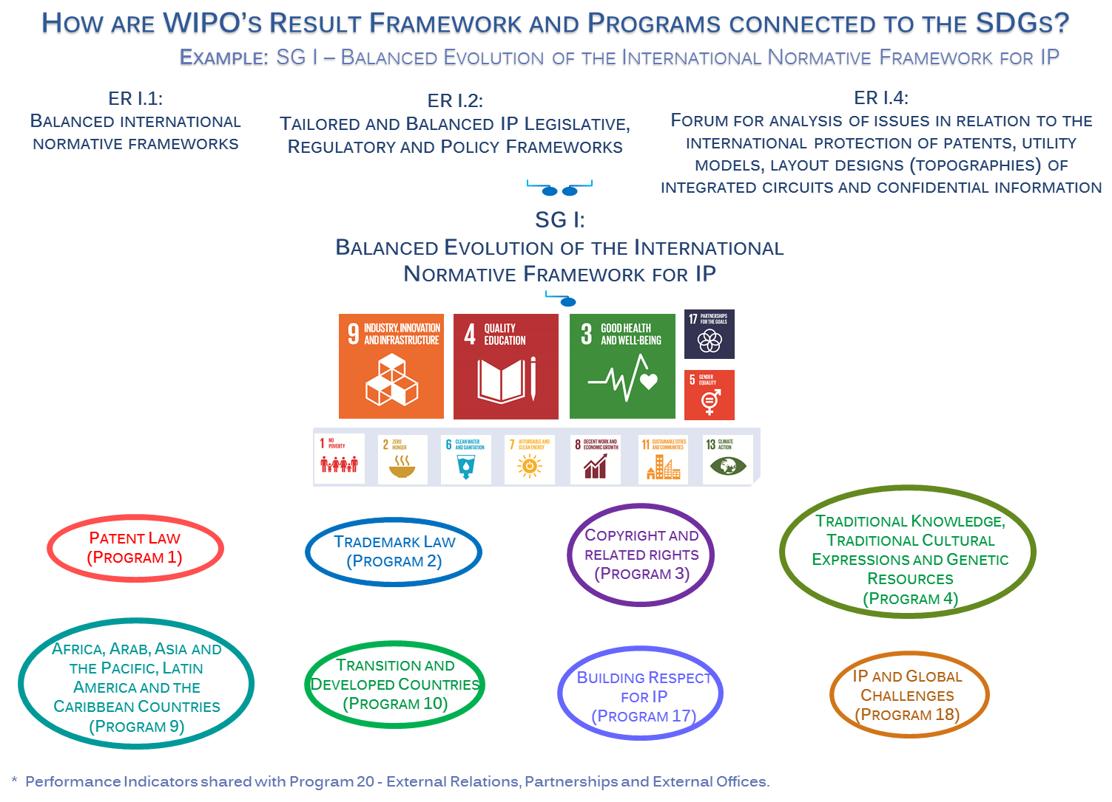
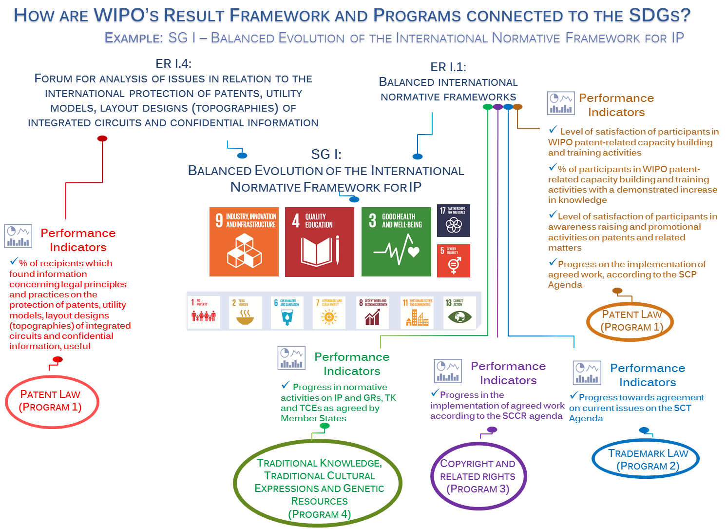

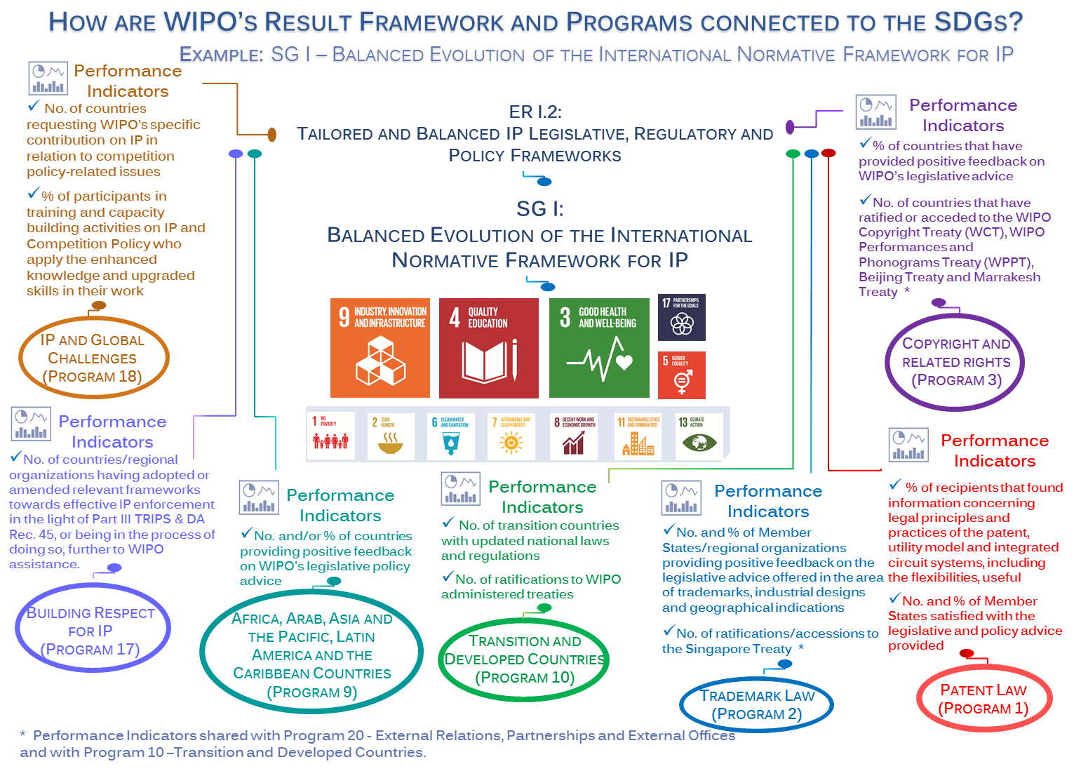
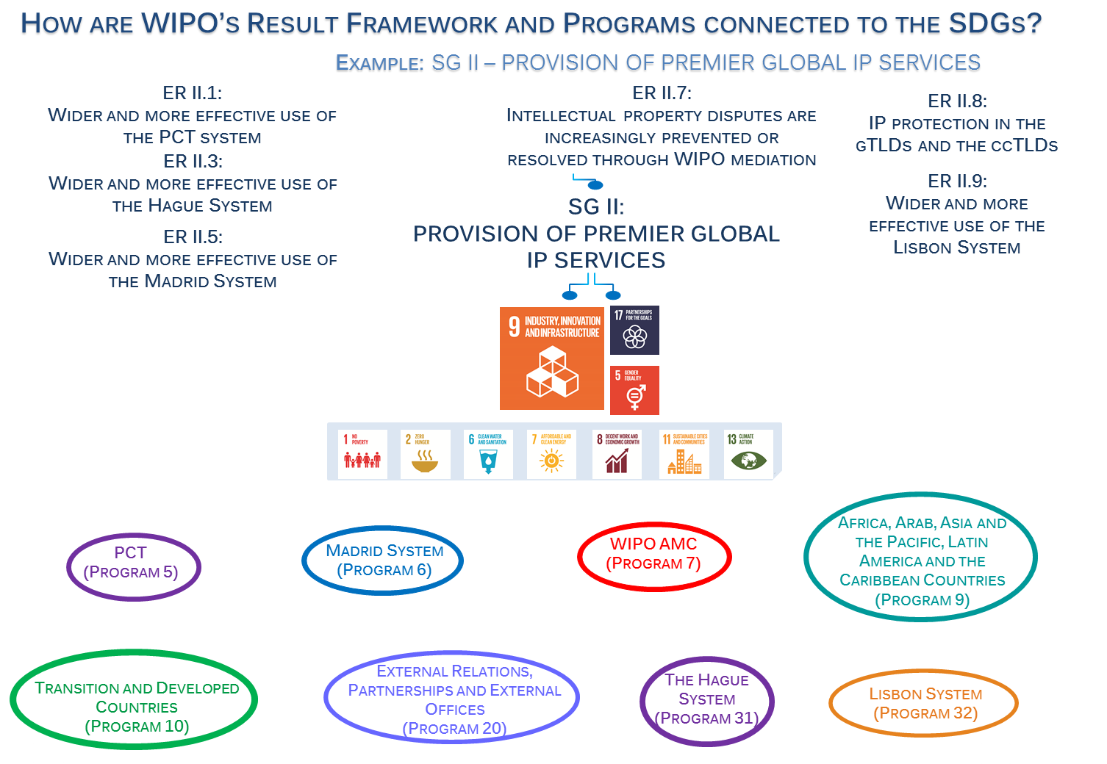

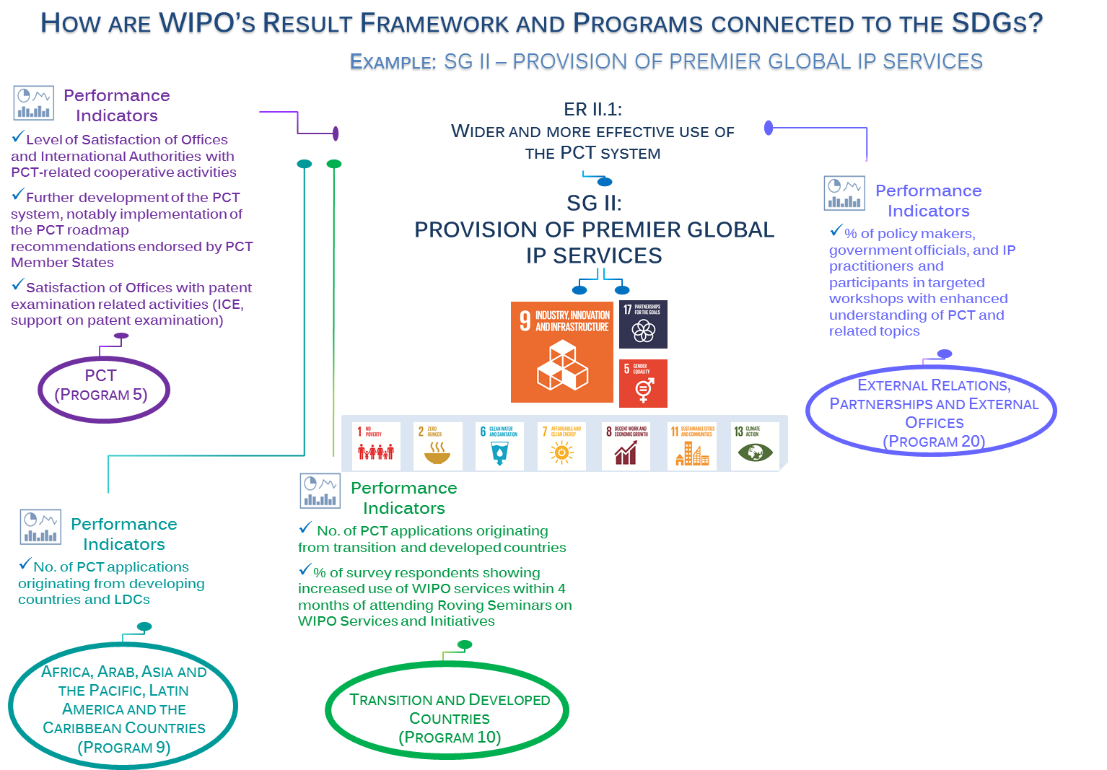

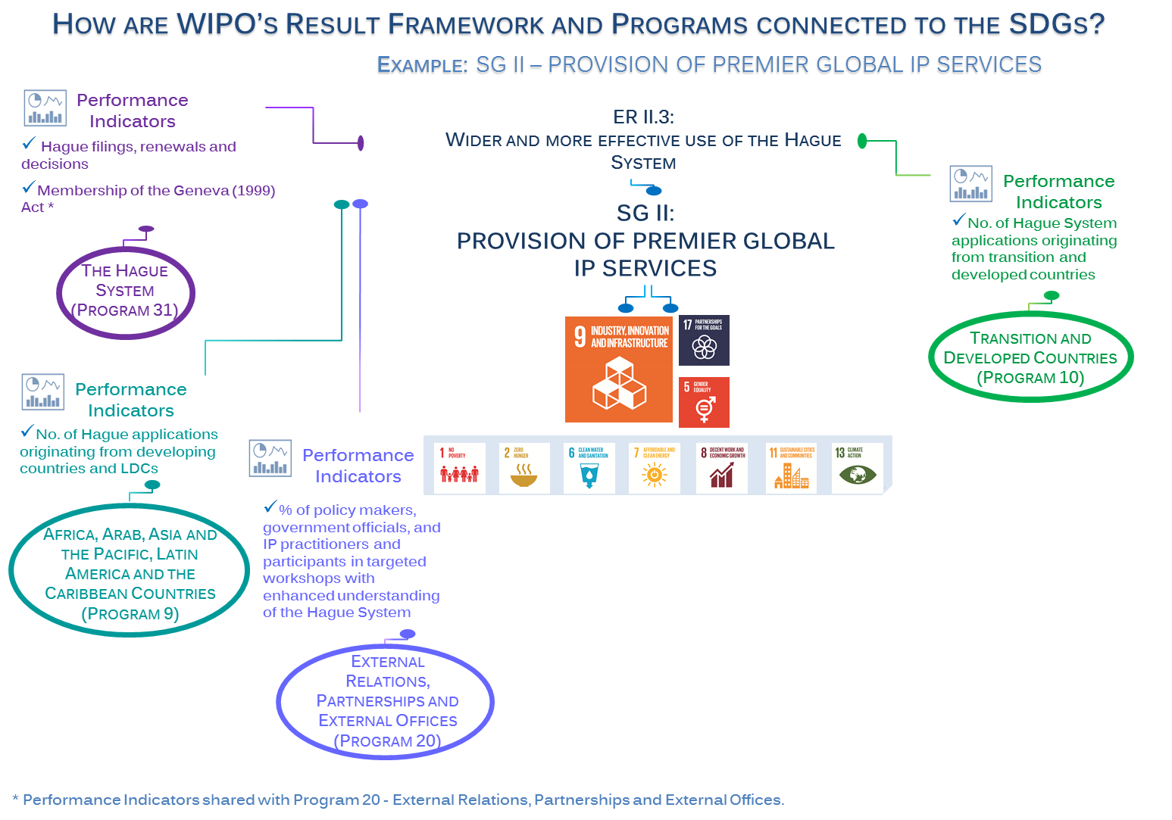
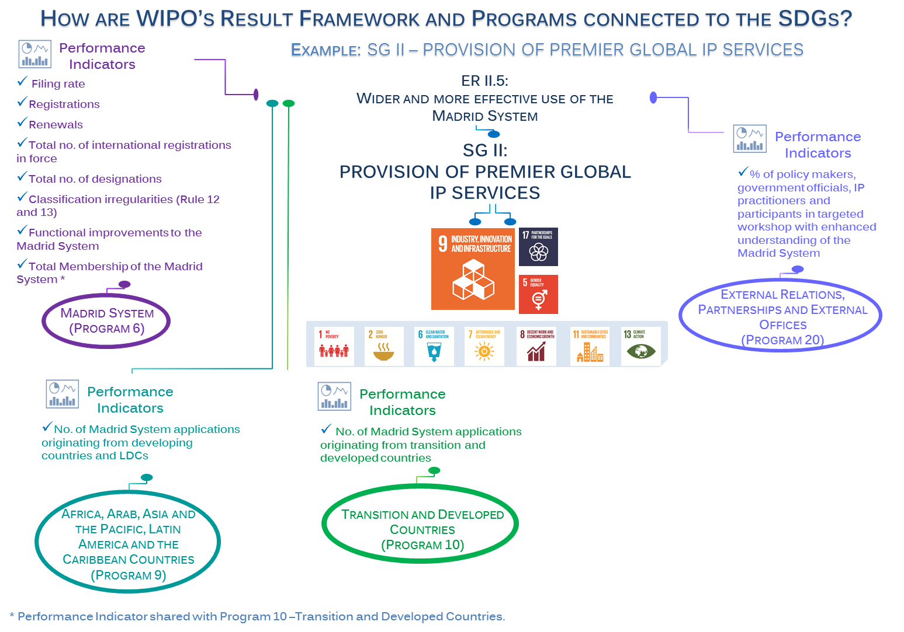

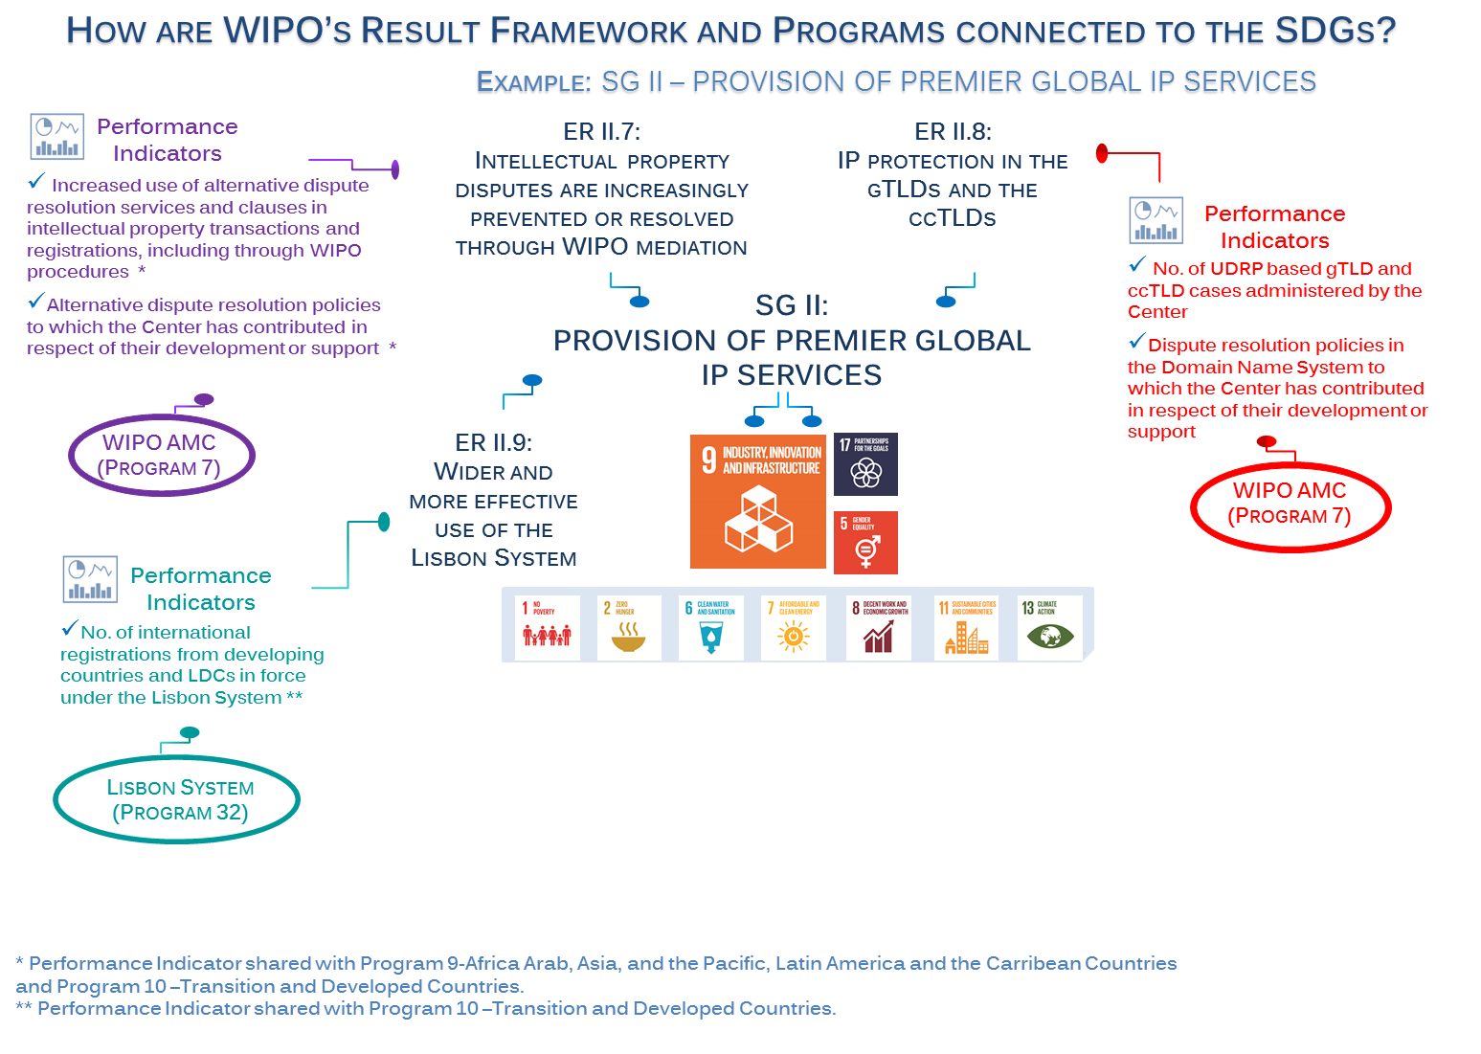
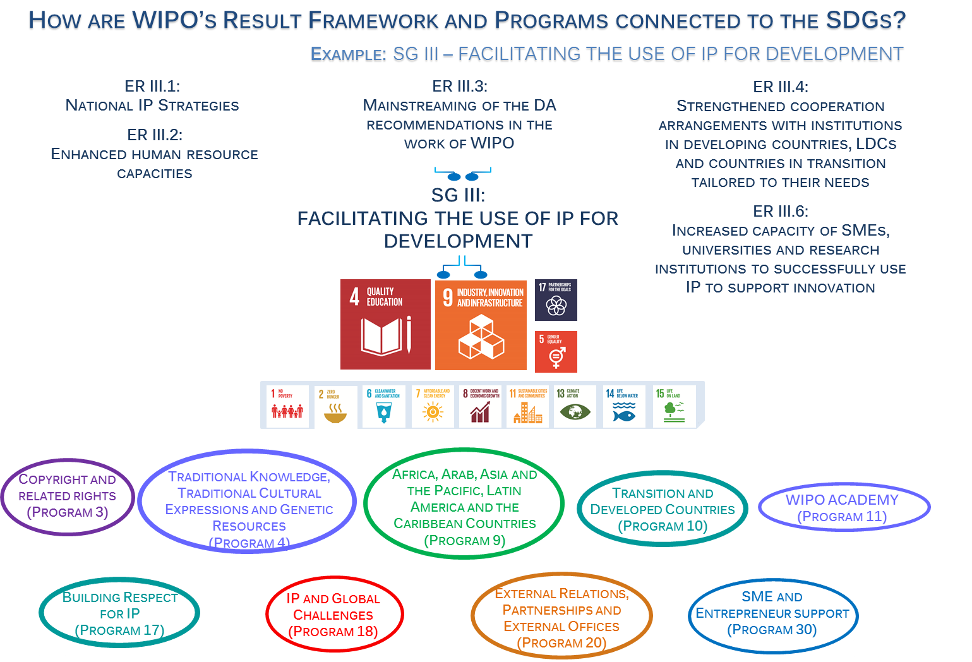

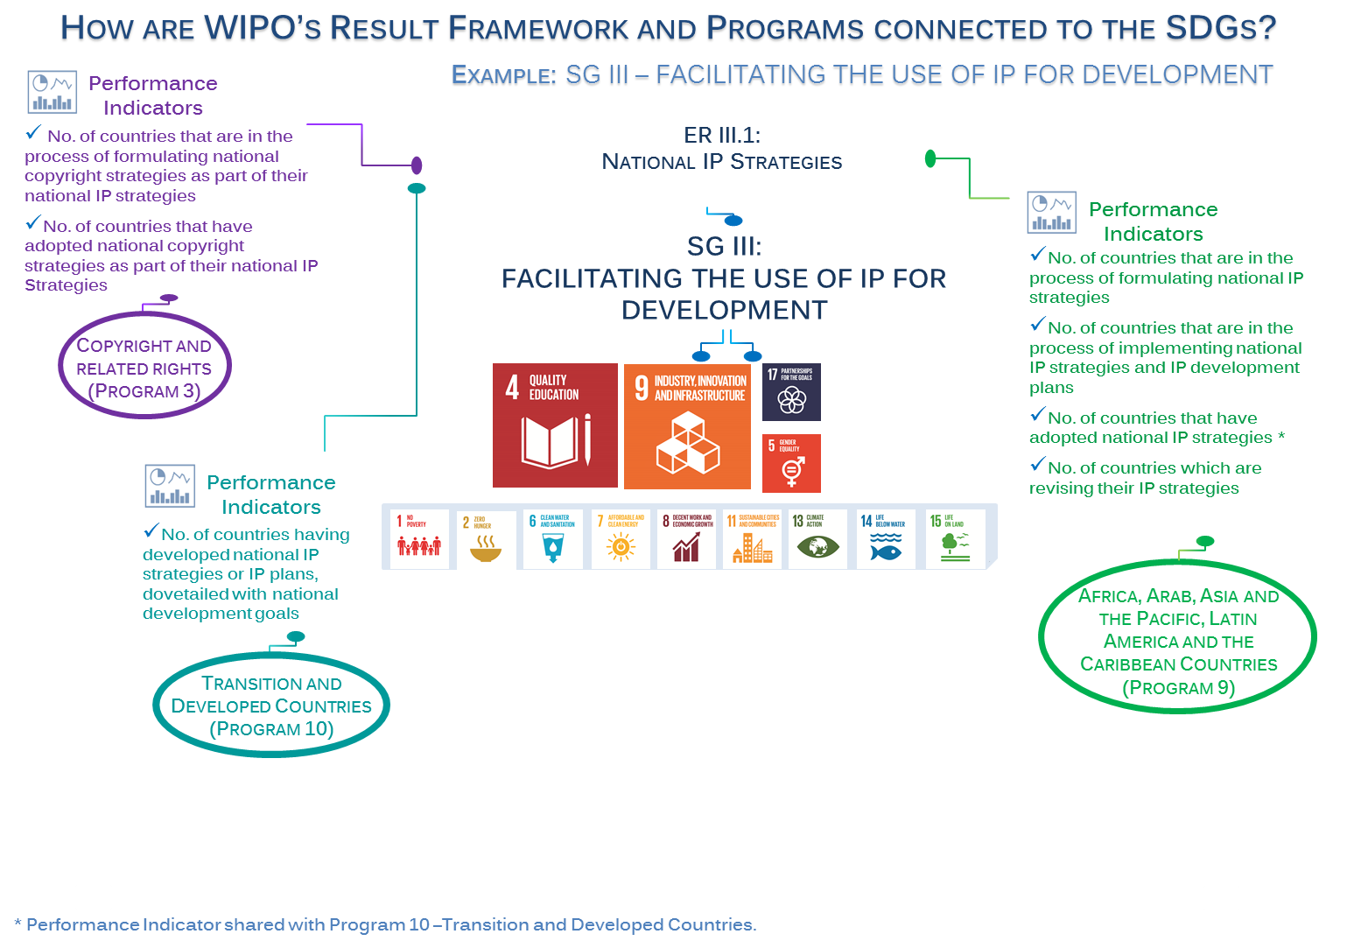
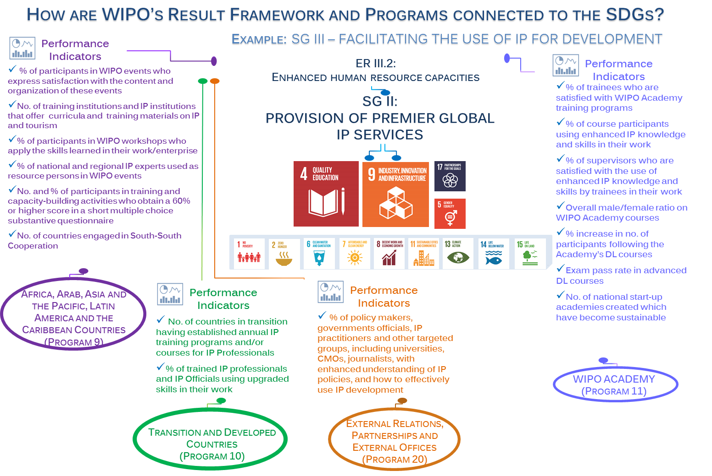

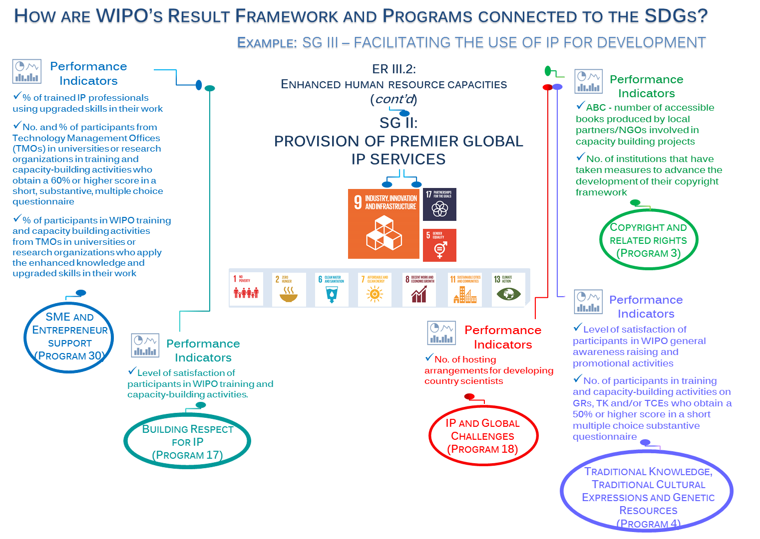
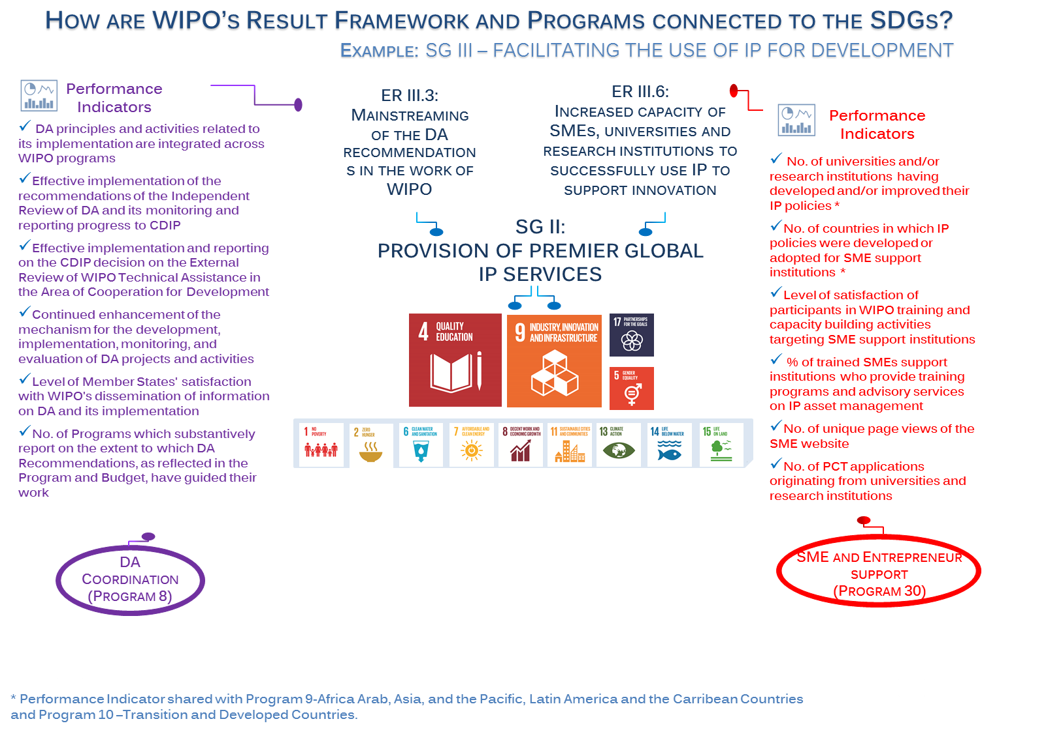
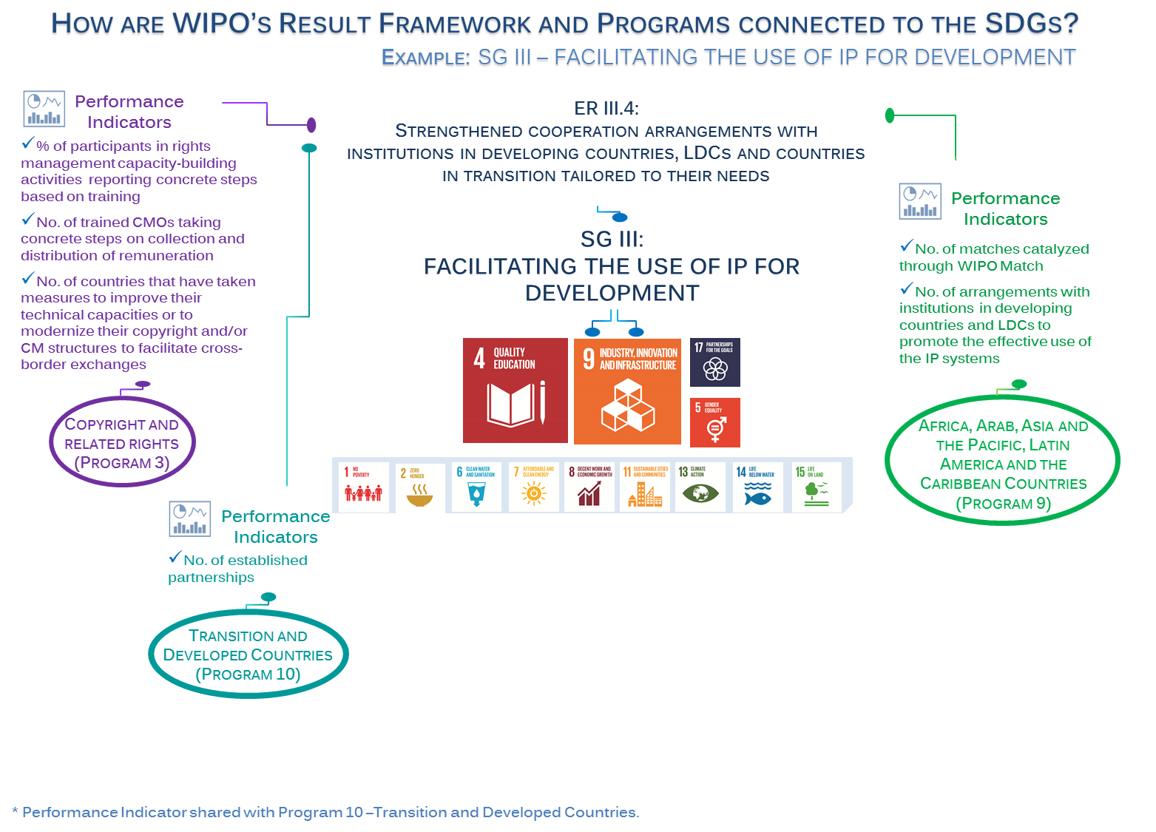
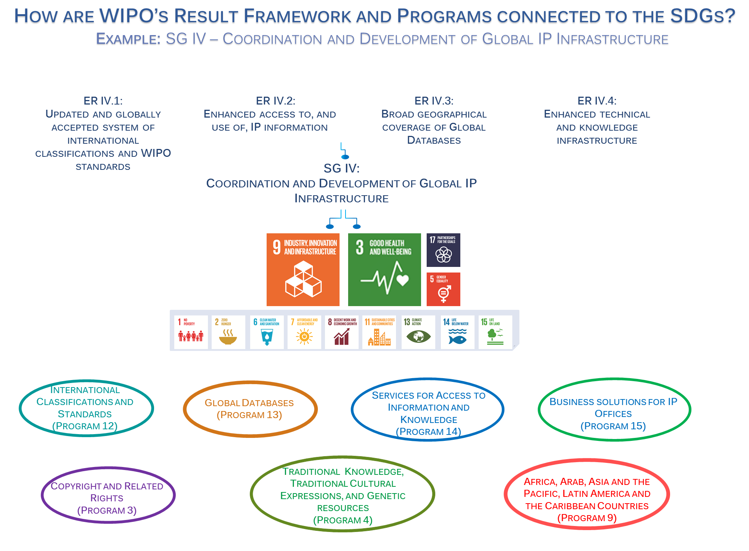
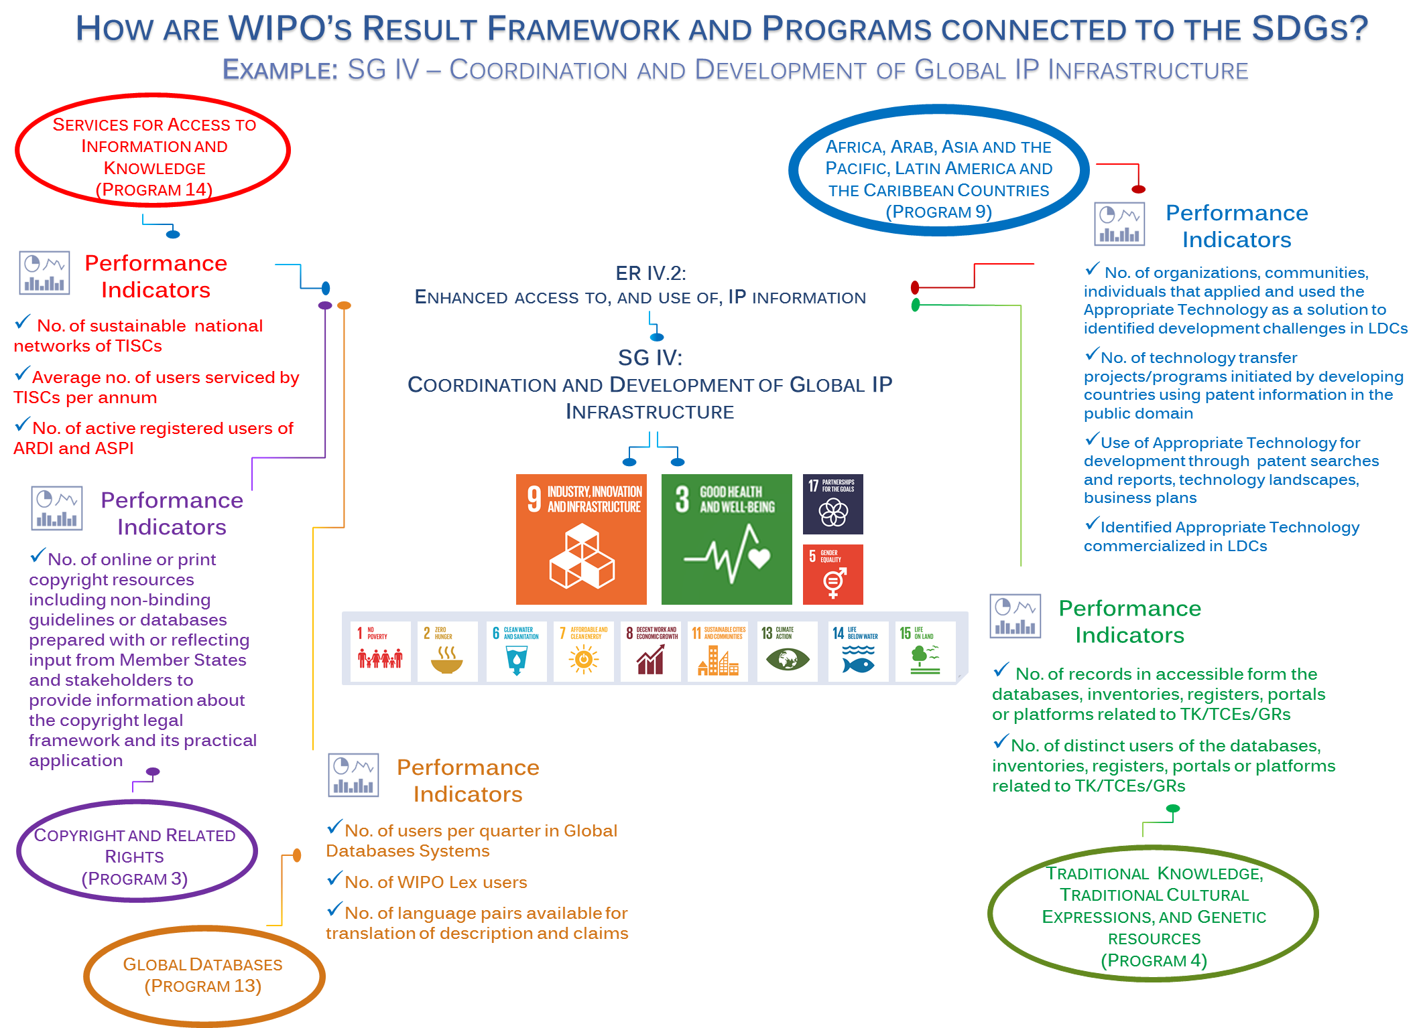
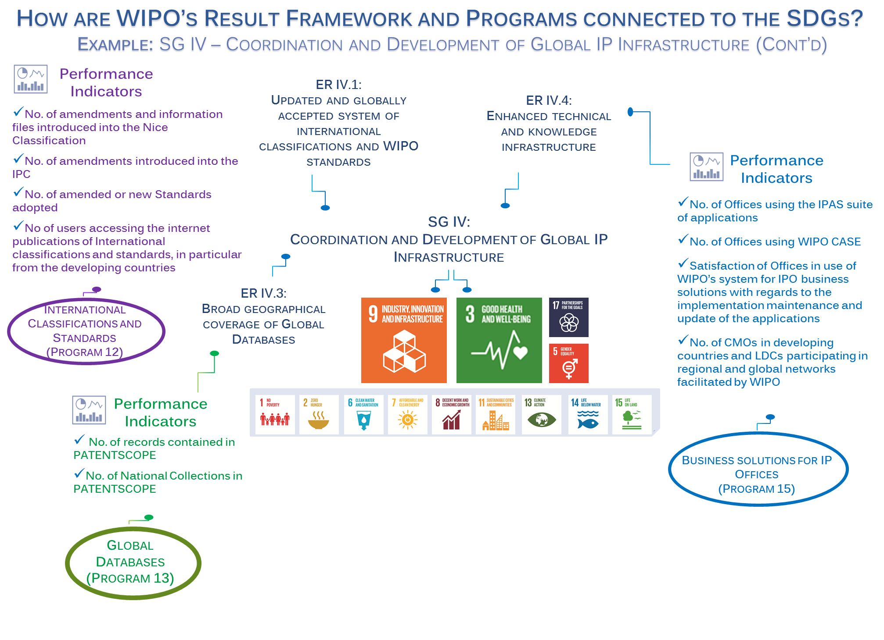
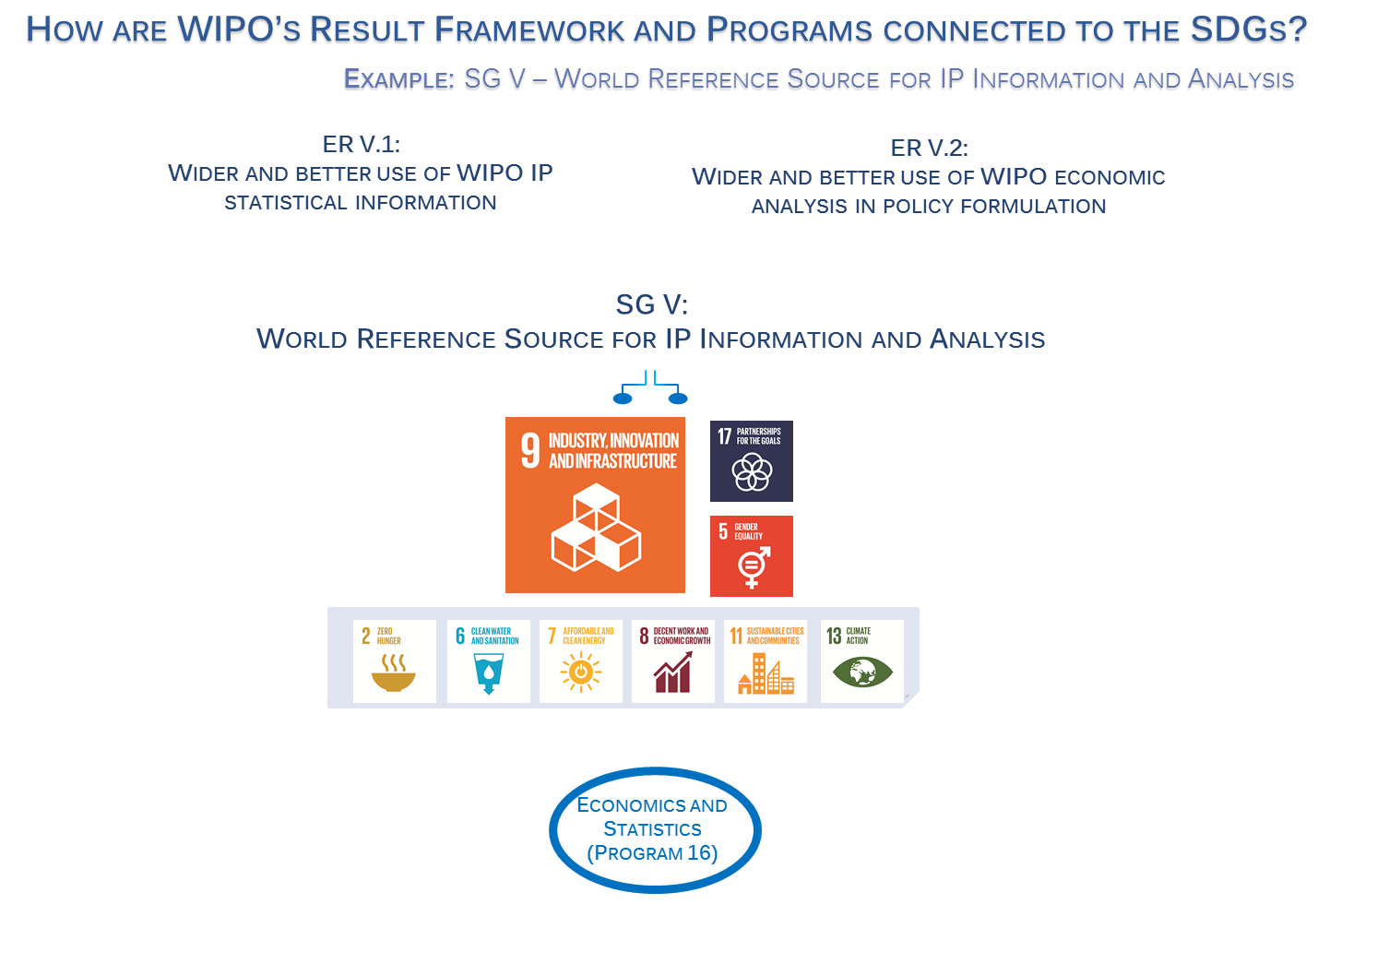
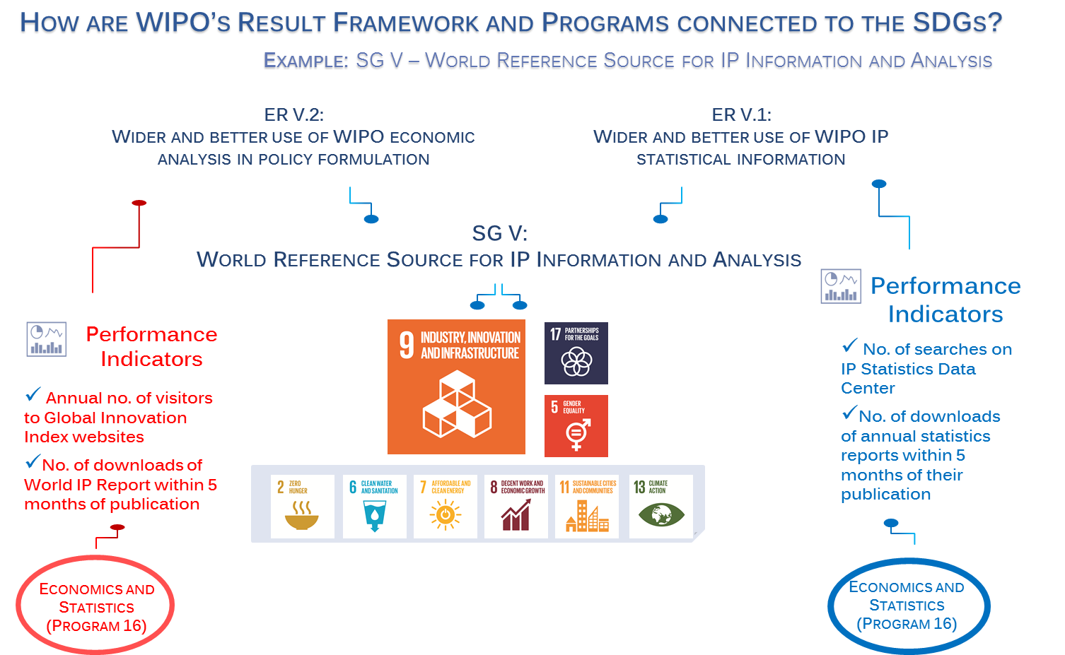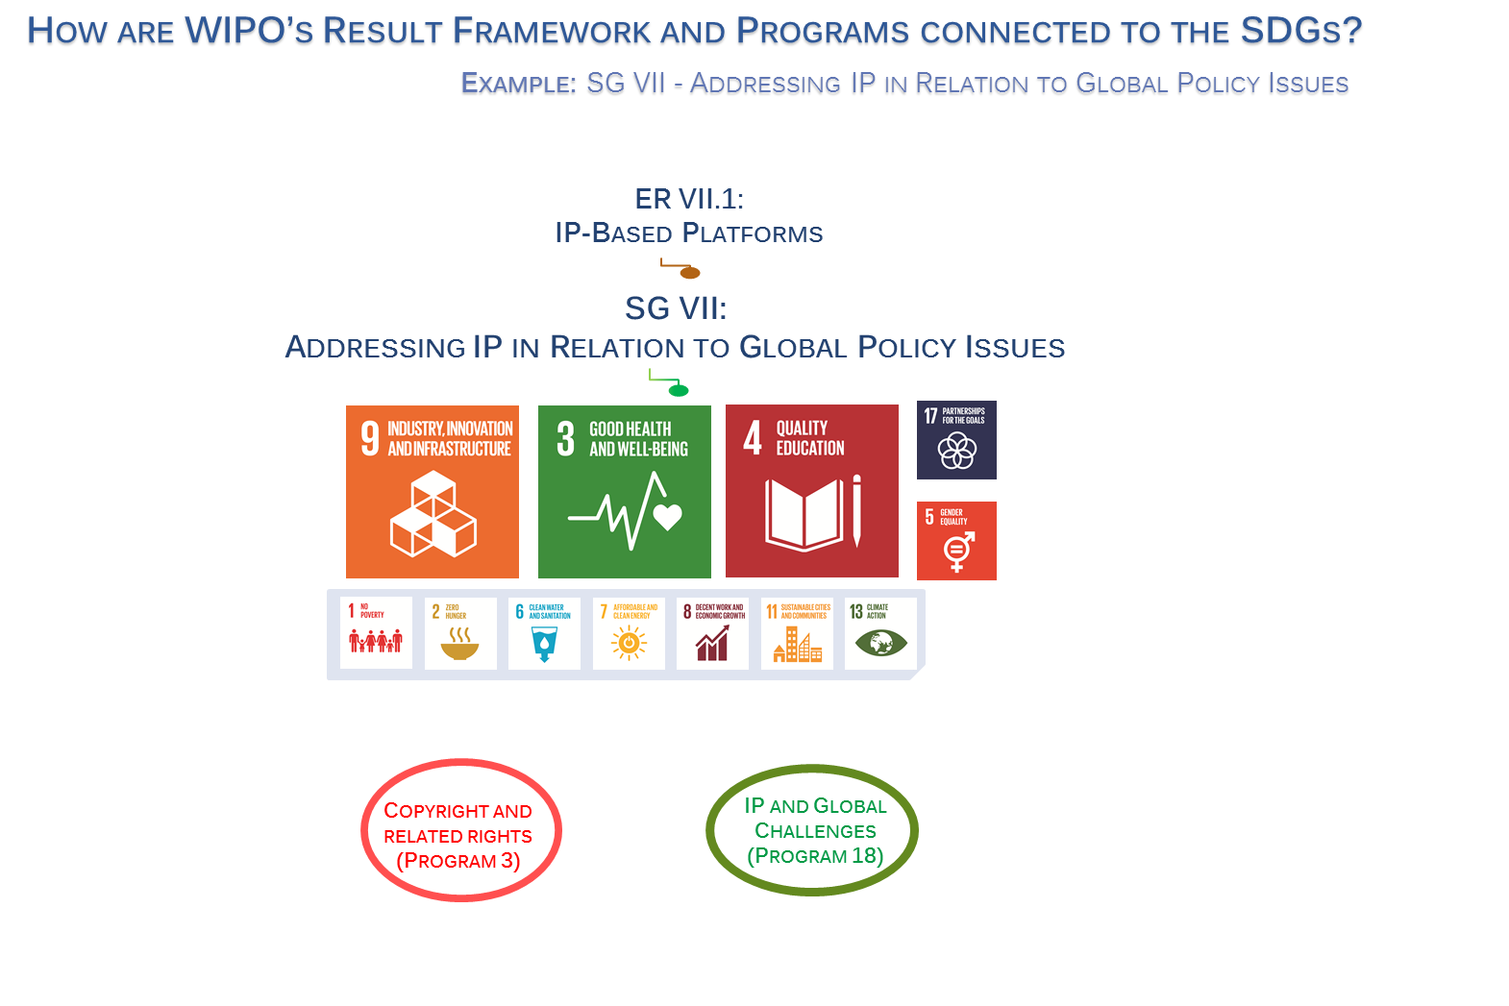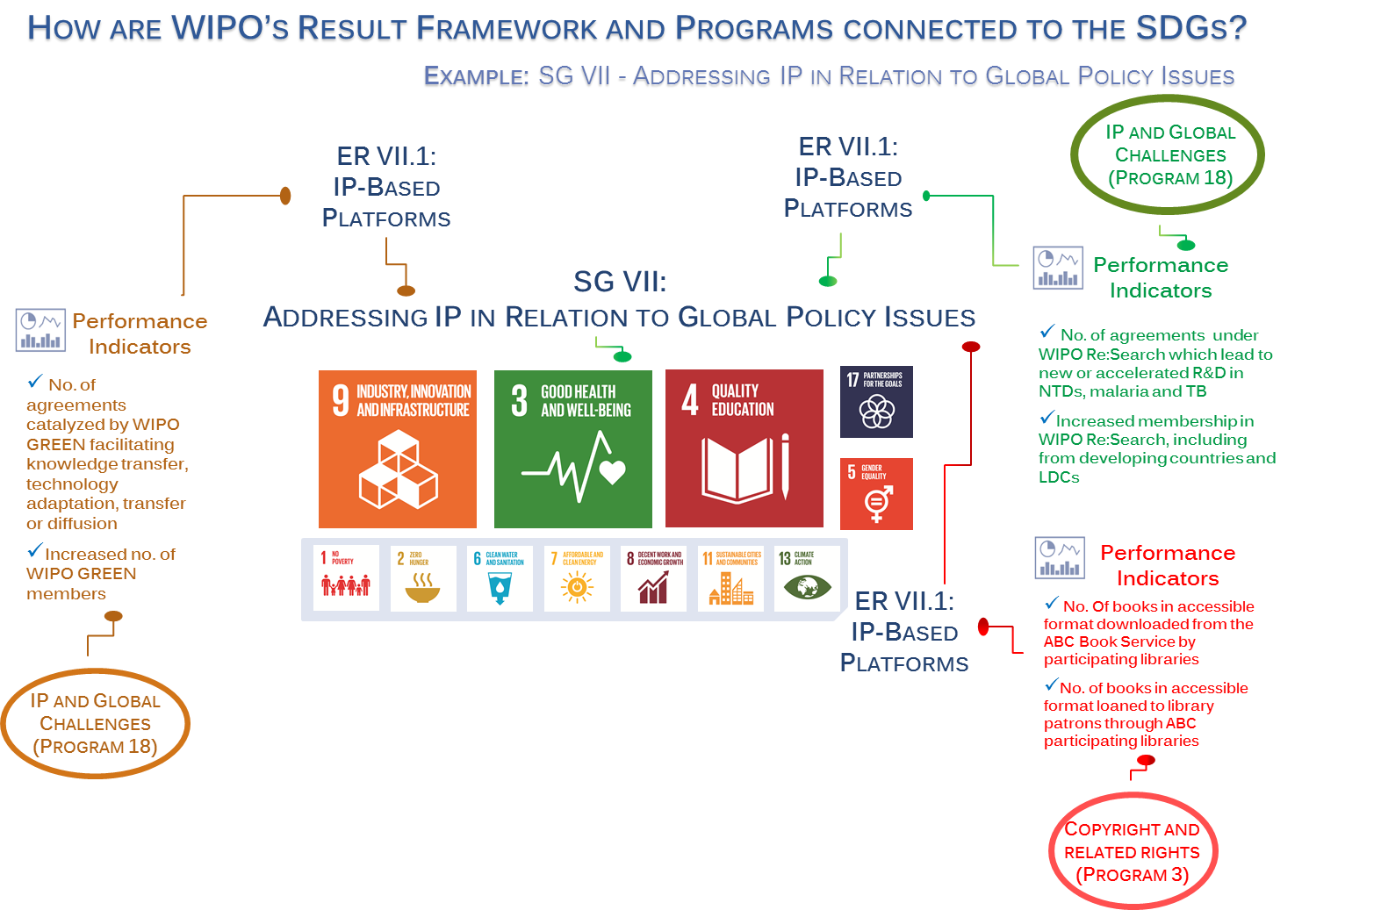

[End of Annex and of document]

A detailed report on WIPO’s engagement on the preparatory processes for 2030 Sustainable Development Agenda was presented by the Secretariat at the sixteenth and nineteenth sessions of the CDIP (document CDIP/16/8 and CDIP/19/6).
A/RES/72/242, adopted without a vote on December 22, 2017.
World IP reports successively addressed the following themes: The impact of breakthrough innovations, the role that brands play in a global marketplace, the changing face of innovation, and the Intangible Capital in Global Value Chains.
Document A/RES/72/228.
It should be noted that the eight Programs under Strategic Goal VIII and IX are related to support functions.

