|  |  |  |
| --- | --- | --- |
|  | WIPO-E | **E** |
| CDIP/25/INF/2 | | |
| ORIGINAL: English | | |
| DATE: march 18, 2020 | | |

**Committee on Development and Intellectual Property (CDIP)**

**Twenty-Fifth Session**

**Geneva, May 18 to 22, 2020**

PROOF OF CONCEPT OF A SEARCHABLE ONLINE CATALOGUE FOR DEVELOPMENT AGENDA PROJECTS AND OUTPUTS

*prepared by the Secretariat*

1. The Committee on Development and Intellectual Property (CDIP) at its twenty-fourth session, approved a project submitted by the Delegations of Brazil, Canada, Indonesia, Poland and the United Kingdom on Tools for Successful Development Agenda Project Proposals, contained in document [CDIP/24/14 Rev..](https://www.wipo.int/meetings/en/doc_details.jsp?doc_id=461561)
2. One of the project outputs is the creation of an online searchable Catalogue, containing all past and ongoing DA projects together with additional information on each project, including a reference to the beneficiary countries (where applicable), main project activities and outputs, implementation start and end dates, outcomes and achievements, and progress and evaluation reports and recommendations. This document describes the proof of concept of the online searchable Catalogue, currently under development in the context of the above-mentioned project.
3. The metadata that will be used for developing the final product will consist of the information contained in all DA project documents, progress reports, evaluation reports, completion reports, and outputs of DA projects (studies, guidelines, databases).
4. The proof of concept was created on the basis of the information collected from eight project documents. The visual design of the Catalogue will be finalized once the final product will be developed, and made available on the WIPO website.
5. When developing the proof of concept of the Catalogue, the following expected user groups were identified: (i) Member States wishing to present project proposal(s) to the CDIP (this is the main user group identified); (ii) Member States interested in benefiting from activities emanating from DA projects; (iii) project managers (WIPO staff); and (iv) information seekers.
6. Hence, the Catalogue will be developed around the information model presented in Annex I to this document, structuring the information flow in two main clusters: selectable information (grey boxes), and additional information (white boxes). Below is the list of information clusters by which the users will be able to refine the search in the Catalogue:

* DA Recommendation cluster;
* DA Recommendations;
* DA projects (this will include the completed and ongoing projects);
* Activities undertaken in the context of the implementation of DA projects;
* Implementing WIPO Program;
* Beneficiary countries;
* Project document code;
* IP fields;
* Project outputs.

1. The Catalogue will also provide additional results that will be easily accessible, once the information has been already refined or at the start of the user’s search. The additional results will include information on the following:

* WIPO Strategic Goals;
* Link to the CDIP session when the document was approved or discussed;
* Reports (this will include progress reports, completion reports, and evaluation reports);
* Total expenditure;
* Project budget;
* Project outcomes;
* Related documents;
* Project mainstreaming.

1. In addition to refining by selecting the categories mentioned in para. 6, the Catalogue will also permit full text searching in six official UN languages, based on the availability of the documents used for developing the metadata of the Catalogue.
2. The Catalogue will be designed in a way that any new relevant material (projects, outputs, reports) could be easily updated to the platform. This will ensure that the information contained in the Catalogue will be always accurate and up to date.
3. The online searchable Catalogues will have the name of “DA Projects’ Catalogue”, and will replace the currently available online summary table on the WIPO DA website at: <https://www.wipo.int/ip-development/en/agenda/projects.html>.
4. Annex II contains screenshots of a prototype developed by WIPO.
5. *The CDIP is invited to take note of the information contained in this document.*

[Annexes follow]

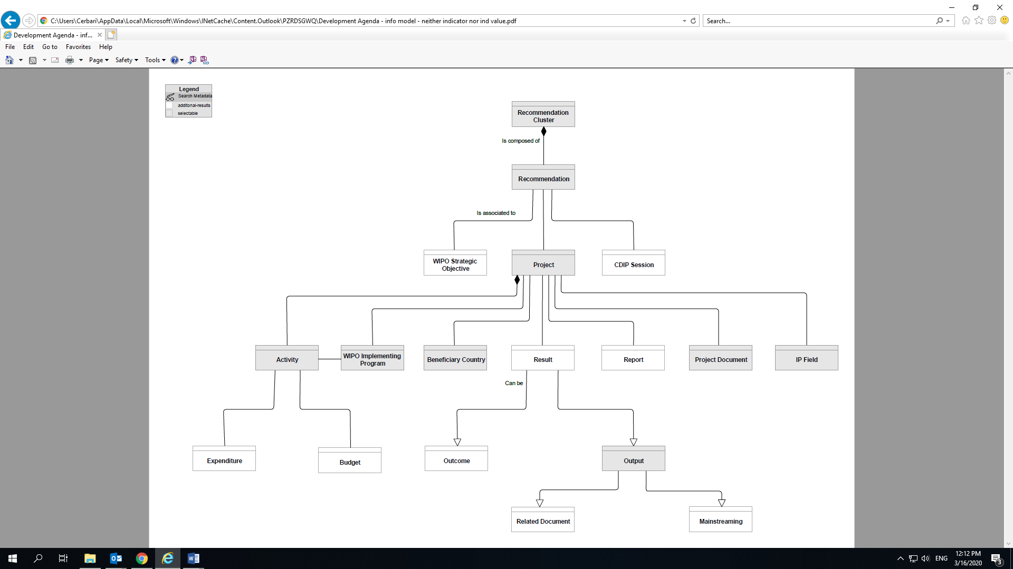

[Annex II follows]

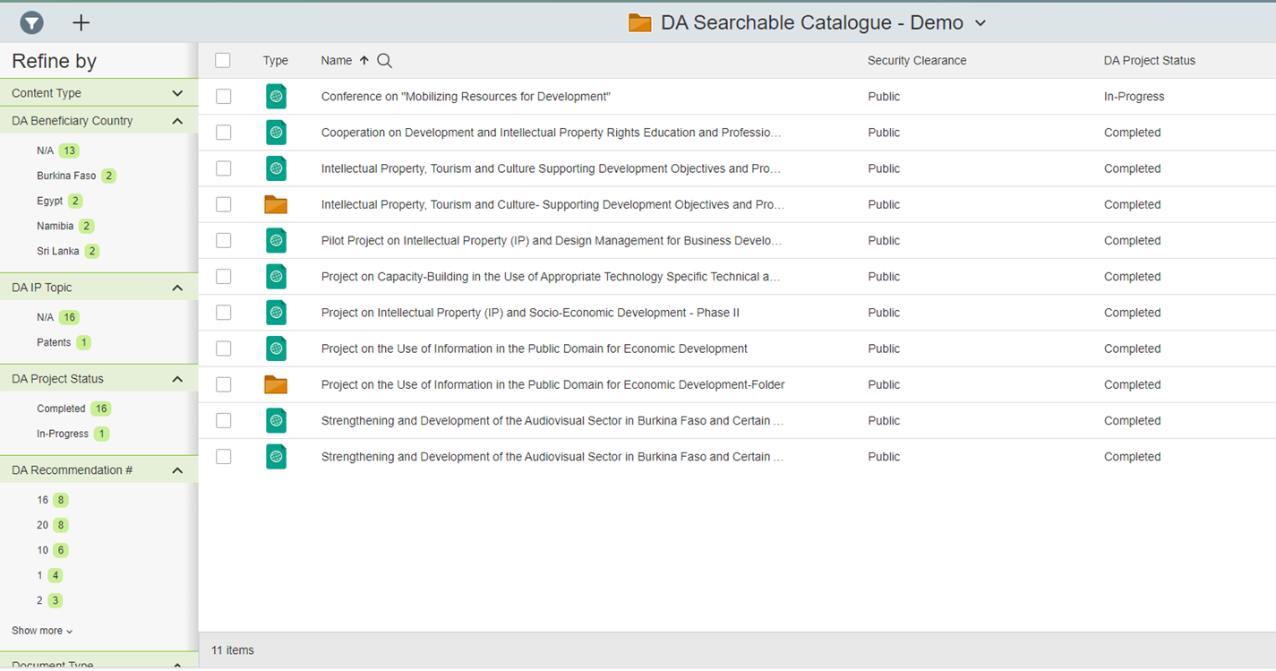

Refining content by selecting the DA Recommendations / Beneficiary Countries

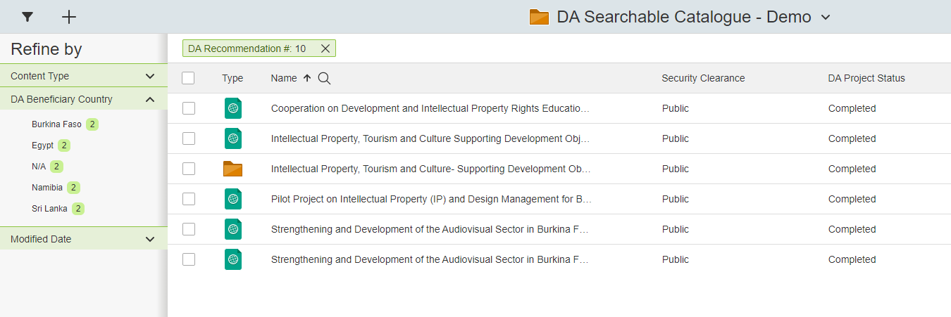

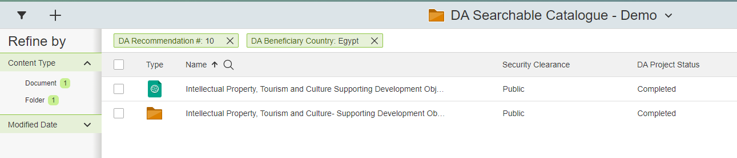

Full text search in Chinese

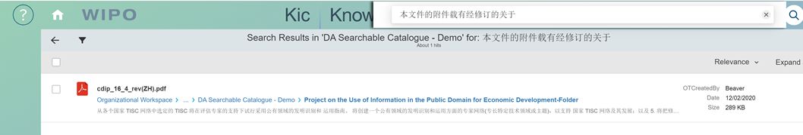

[Annex III follows]

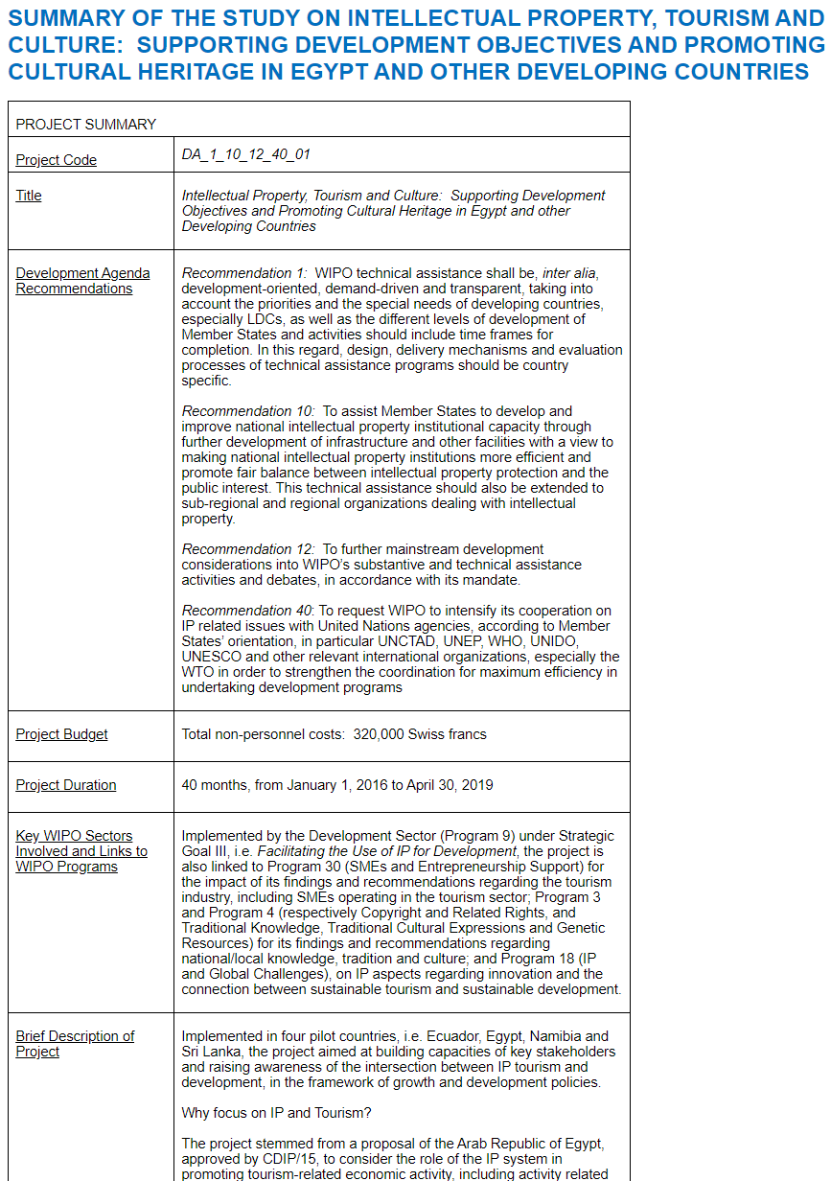

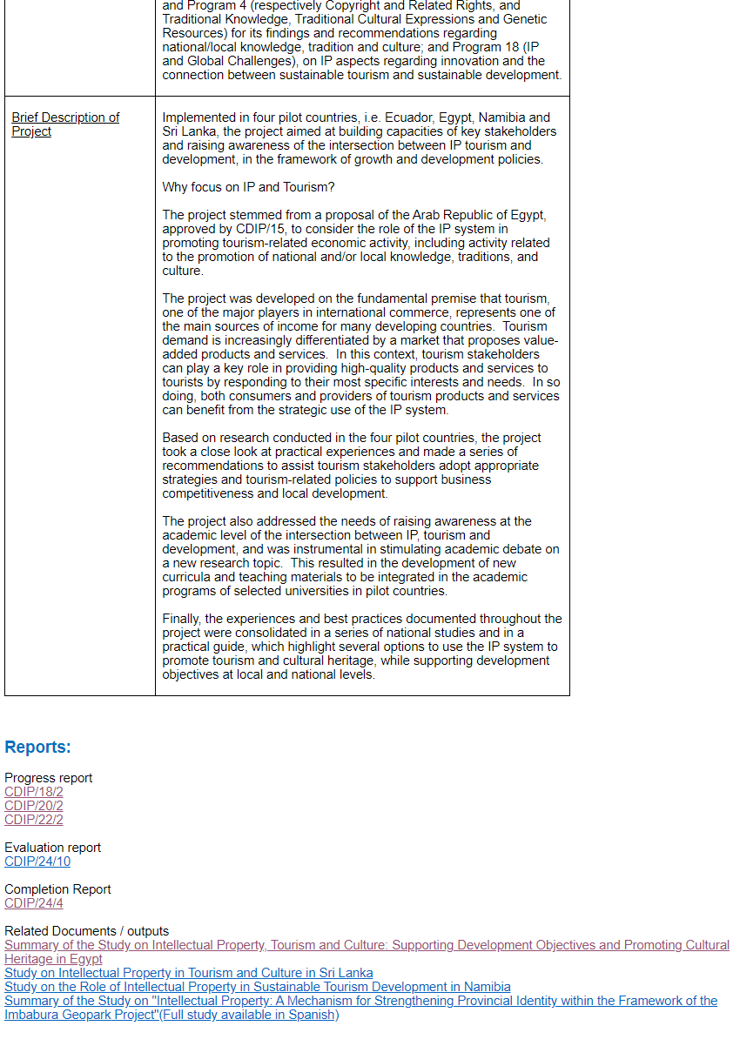

[End of Annex and of document]