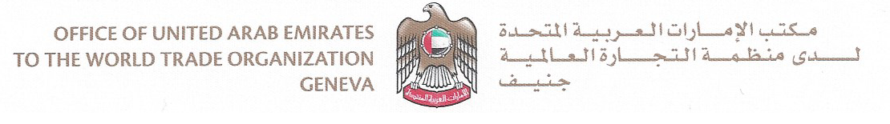

UAE Statement at CDIP
10 November 2020

Item 6:

Report on WIPO's Contribution to the Implementation of the Sustainable Development Goals and its Associated Targets

Document CDIP/25/6

Madam Chair,

Please allow me at the outset to congratulate your Excellency and Vice-Chairs on your election to preside over this important committee and express our confidence in your abilities to guide us to successful outcomes for the benefit of all.

I also wish to take this opportunity to express our sincere thanks and appreciation to the WIPO Secretariat for its diligent and tireless efforts in the preparation for this session convened under exceptional circumstances. I would also like to convey our special thanks to Mr. Mario Matus for his valuable inputs throughout his career as part of WIPO’s Senior Management Team.

Madam Chair,

The Sustainable Development Goals are considered important milestones in the global development process. Indeed, they reflect a rare consensus on a common global vision, aimed at creating a bright future for all. Not only do they help us make a difference as individuals, societies and states, but they also encourage us to work together in order to ensure that all voices are heard and all desires for a life full of satisfaction and hope are fulfilled.

We would like to express our appreciation for WIPO's continuous work in cooperation with Member States to contribute to the achievement of the Sustainable Development Goals. We also took note of document CDIP/25/6 which highlighted, in a holistic manner, recent developments regarding the SDGs as an integral part of the implementation of the Development Agenda through various activities and initiatives such as analytical reports prepared by the Organization to reach a better understanding of how an effective innovation and creativity ecosystem works as well as identify the solutions that WIPO provides to IP offices to improve access to technological and commercial information.

We also encourage WIPO to strengthen partnerships within the framework of the Sustainable Development Goals as part of the United Nations system. As reports and studies have revealed that the COVID-19 pandemic weighs heavily on development, we reiterate our commitment to all efforts aimed at health, development and economic recovery, by improving public-private partnerships in various areas such as health, innovation, small and medium-sized enterprises and green technologies.

Madam Chair,

As part of the UAE Centennial 2071, the UAE has launched a platform last year which covers the main initiatives undertaken by the UAE to achieve the 17 SDGs and highlight the tireless efforts made to achieve these goals, which included 1,400 initiatives implemented by the public, academic and private sector as well as public welfare associations and other institutions to encourage investments and harness the creative and entrepreneurial potential to create a brighter future.

We would also like to commend WIPO’s role as a strategic partner in the field of cooperation, in the context of several activities implemented under the WIPO UAE Funds-In-Trust to promote sustainable development goals in the UAE and the region.

Thank you, Madam Chair

