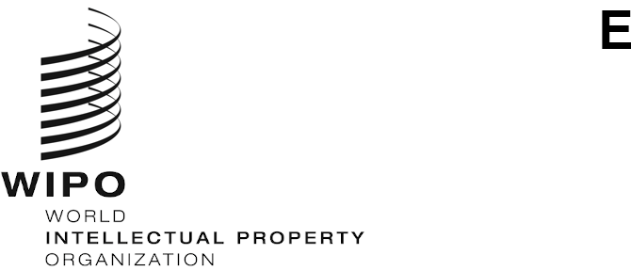
CDIP/29/3
ORIGINAL: ENGLISH
DATE: july 26, 2022

Committee on Development and Intellectual Property (CDIP)

Twenty-Ninth Session
Geneva, October 17 to 21, 2022

PROPOSAL BY THE AFRICAN GROUP CONCERNING THE BIENNIAL ORGANIZATION OF AN INTERNATIONAL CONFERENCE ON INTELLECTUAL PROPERTY AND DEVELOPMENT
prepared by the Secretariat
- By means of a communication dated June 20, 2022, the Secretariat has received a proposal by the Delegation of Algeria, on behalf of the African Group, concerning the biennial organization of an International Conference on Intellectual Property and Development, for consideration of the 29th session of the CDIP.

- The mentioned proposal is contained in the Annex to this document.

- The CDIP is invited to consider the information contained in the Annex to this document.

[Annex follows]

PROPOSAL of THE AFRICAN GROUP concerning the BIENNIAL organization of an INTERNATIONAL CONFERENCE ON INTELLECTUAL PROPERTY AND DEVELOPMENT
INTRODUCTION
At the nineteenth session of the Committee on Development and Intellectual Property (CDIP), held on May 15 to 19, 2017, the African Group submitted a proposal for the biennial organization of an International Conference on Intellectual Property and Development (CDIP/19/7).
At its twenty-second session, the CDIP agreed to organize three one-day international conferences on Intellectual Property and Development, to be held consecutively every two years, on the first day of the week of the CDIP meetings, from the twenty-third session of the CDIP.
The first international conference on Intellectual Property and Development was held on May 20, 2019, on the topic “How to Benefit from the IP System”. The second conference held on November 22 to 23, 2021, concerned “Innovation in Green Technologies for Sustainable Development”. The third conference, due to be held in 2023, will focus on “Intellectual Property and Innovation for Sustainable Agriculture”.
Given (1) the success of the two international conferences on Intellectual Property and Development, held in 2019 and 2021, as reflected in the meeting reports contained in documents CDIP/24/5 and CDIP/28/3, respectively; and (2) the great interest shown and positive comments made by Member States regarding the relevance of the conference and its contribution to achieving the objectives of the Development Agenda; the African Group proposes that the CDIP officialize the organization of the international conference on Intellectual Property and Development from 2023 onwards, as follows:
GENERAL TITLE
International Conference on Intellectual Property and Development
SECONDARY TITLE
The secondary title of the conference will be based on the topic related to Intellectual Property and Development and the associated practical issues. It will need to be approved at the first session of the Committee, which meets during the first year of the WIPO budget cycle.
CORE OBJECTIVES
- Discuss urgent and emerging issues in the areas of intellectual property and development;
- Highlight the role of intellectual property in promoting creativity and innovation for economic, social and cultural development;
- Share national experiences and best practices on the use of intellectual property with a view to addressing global challenges.

FREQUENCY
Biennial
PLACE
WIPO headquarters, Geneva, or another country proposed by the Member States
DURATION
One or two days
DATES
First half of the second year of the WIPO budget cycle
PARTICIPATION
Participation in the Conference will be open to representatives of the Member States, intergovernmental organizations and NGOs, universities, political decision-makers and civil society. Participants may register in advance online or in person at the venue.
TOPICS
The International Conference will focus on the topic of the secondary title agreed by the Member States at the first session of the Committee, which meets during the first year of the WIPO budget cycle.
The Secretariat will be invited to arrange the program of the International Conference and to draft the content of each topic, consulting informally with the coordinators of the regional groups.
FORMAT
The Conference will meet during the first half of the second year of the WIPO budget cycle. All meetings will be held in plenary session. Each session will need to allow for an open and dynamic discussion; and include a question and answer session. The working languages will be the six official languages of the UN, with simultaneous interpretation provided in all six languages.
SPEAKERS
Speakers should be selected with due regard for the principles of geographic balance, gender equality, appropriate expertise and balanced representation of viewpoints.

OUTCOMES AND COMMUNICATIONS
A factual report summarizing the main discussions held at the International Conference will be prepared by the Secretariat and presented to the CDIP.
A web page with detailed information on the International Conference will be created on the WIPO website. It will provide free access to all conference documents – including the program, written versions of presentations, audio and video files of the conference proceedings and the meeting report. It will also provide access to a live webcast of the proceedings.

[End of Annex and of document]

