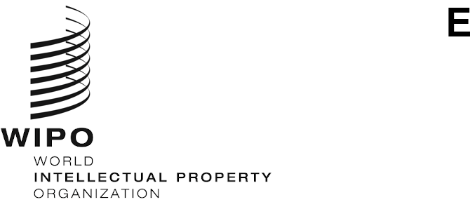

WIPO/IP/AI/3/GE/20/INF/3

ORIGINAL: English

DATE: October 27, 2020

# WIPO Conversation on Intellectual Property (IP) and Artificial Intelligence (AI)

**Third Session  
Geneva, November 4, 2020**

Speaker Profiles

*prepared by the WIPO Secretariat*

# KEYNOTE Speaker

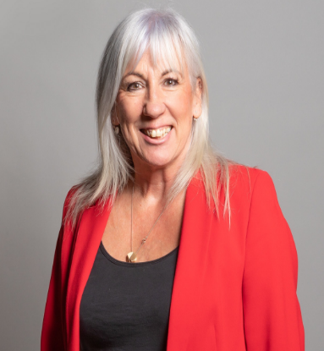**H.E. Ms. Amanda Solloway MP**Parliamentary Under Secretary of State (Minister for Science, Research and Innovation), United Kingdom of Great Britain and Northern Ireland

Amanda Solloway is the current Member of Parliament for Derby North, and was appointed as Parliamentary Under Secretary of State at the Department for Business, Energy and Industrial Strategy, serving as the Minister for Science, Research and Innovation.

Amanda was originally born in Nottingham and has two younger siblings. She was educated at Bramcote Hills Grammar School at Bramcote, Broxtowe, Nottinghamshire, which became a comprehensive in 1978, and is now is part of Bramcote Hills Sport and Community College.

Mrs Solloway spent 15 years in retail management with J Sainsbury and a further 15 years within HR across the Not for Profit (Help the Aged and Save the Children) and Private Sector (Baird Clothing Group) supporting Manufacturing, Warehousing and Retail.

Mrs Solloway was first elected in 2015 and held the seat until the 2017 General Election. She later reclaimed the seat in the 2019 General Election. During her previous tenure, she was a PPS at DFID.

Mrs Solloway is a passionate campaigner for mental health, and following the 2017 General Election started a mental health CIC called Head High, which offered mental health services in Derby, including a crisis café open at night called the Nightbus.

Mrs Solloway is married and has two children and one grandchild.

# Session 1: Definitions

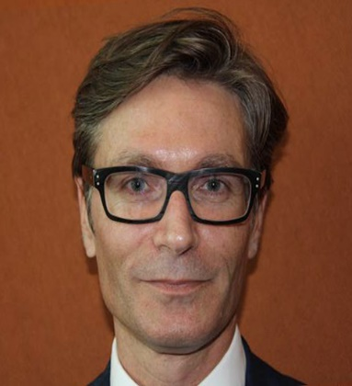**Mr. Jean-Marc Deltorn**Senior Researcher at Center for International Intellectual Property Studies, University of Strasbourg, Strasbourg, France

Jean-Marc is Senior research at the International Centre for the Study of Intellectual Property (CEIPI, University of Strasbourg).

At CEIPI, Jean-Marc studies the interplay between the legal norms (with an emphasis on IP) and emerging digital technologies (such as AI, quantum computing and blockchain). He is co-founder and director of CEIPI's "AI & IP" university diploma.

Prior to joining CEIPI in 2020, Jean-Marc spent more than 15 years at the European Patent Office (EPO) where he was responsible for the prosecution of AI applications (including image, speech and text processing). At the EPO, Jean-Marc was a member of the AI core expert group and of the Guidelines working group on computer-implemented inventions.

Jean-Marc holds a MSc fundamental physics and a PhD in astrophysics from Paris University, a Master of Laws from the University of Strasbourg and is now in the final stages of completing a PhD in law.

# Session 2: Trademarks

**Ms. Tiki Dare**President-Elect International Trademark Association (INTA), Assistant General Counsel at Oracle, Burlington, United States of America

Tiki Dare is Assistant General Counsel at Oracle, where she specializes in trademark and copyright law. Her areas of practice also include anticounterfeiting, advertising, intellectual property, and competition.

Ms. Dare previously led the trademark group at Sun Microsystems, Inc. Before joining Sun, Ms. Dare specialized in trademark law at Fenwick & West in Palo Alto, California. She started her legal career in the Federal Practice group at Arent Fox in Washington, D.C., where she litigated issues including trademark and patent infringement and false advertising.

Ms. Dare is a graduate of Dartmouth College (cum laude) and the Duke University School of Law.

Ms. Dare currently serves on the Executive Committee of the Board of Directors of the International Trademark Association.

# Session 3: Capacity Building

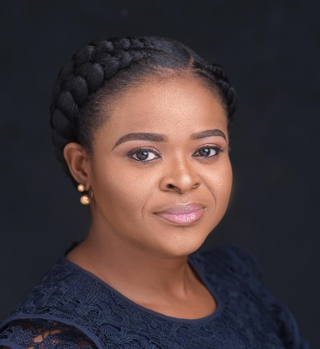**Ms. Nta Ekpiken**Partner and Head of IP Practice, The New Practice (TNP), Lagos, Nigeria

Nta is a partner and heads TNP’s Intellectual Property practice group, drawing from a wealth of experience in the protection of intellectual property rights, brand protection, anti-counterfeiting, copyrights, image rights, licensing & franchising. Nta’s legal expertise cuts across IP, Tech/Media and Sports Law.

She manages a notable portfolio of companies in the tech & media space and has an in-depth understanding of the regulatory landscape and needs within the Nigerian eCommerce and financial technology ecosystem.

Nta is passionate about innovation and startups in the tech space and offers pro-bono advisory services regularly. She holds a Masters degree from Swansea University, Wales United Kingdom, is a Chartered Secretary with the Institute of Chartered Secretaries and Administrators (ICSA) United Kingdom and has a certificate on Copyright from the Berkman Klein Center of Harvard Law School.

She has a bi-monthly publication on IP & tech news in Nigeria and manages the legal portfolio of one of the leading sports academies (Barca Academy) in Nigeria.

# Session 3: Accountability for Decisions in IP Administration

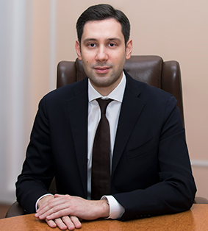**Mr. Yuriy Zubov**Deputy Head, Federal Service for Intellectual Property (Rospatent), Moscow, Russian Federation

Before he was appointed as Deputy Head of Rospatent, Mr. Zubov held several senior positions in Russian governmental entities, including Division for IT Services for the Diplomatic Corps (Ministry of Foreign Affairs), Division for Science, Innovations and Information Technologies (Ministry of Culture) and Federal Institute of Industrial Property (FIPS).

Born in Moscow, Mr. Zubov previously served as Director of the FIPS, which he joined in 2016. In November 2018, Yuri was appointed as Deputy Head of Rospatent.

He leads the Office’s digital transformation and supervises the implementation of the National Digital Economy Program, which projects focus on the development of new digital platforms and services, as well as the electronic communication with all the stakeholders.

In January 2019, Mr. Zubov introduced the Modernization of Rospatent within the Digital Economy at the World Economic Forum held in Davos. The same year he moderated the discussion on AI technologies within the Moscow Open Innovations Forum. In July 2020, Yuri participated as a speaker within the WIPO Conversation on IP and AI Second Session.

[End of document]