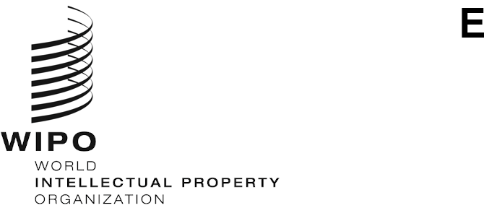
WIPO/IP/CONV/GE/21/INF/3/PROV.5
ORIGINAL: English
DATE: September 23, 2021

WIPO CONVERSATION ON INTELLECTUAL PROPERTY (IP) AND Frontier Technologies

Fourth Session
Geneva, 22 to 23 September 2021, 12.00 to 14.30 CET

List of Interventions
prepared by the WIPO Secretariat

Thursday, September 23, 2021

Panel 4: Data in the current IP system

Russian Federation / Fédération Russe
Mr. Alexander GORBUNOV, Advisor to the Director, Federal Institute of Industrial Property, Moscow
Ms. Daria SHIPITSYNA, Advisor, Center for International Cooperation, Federal Service for Intellectual Property (ROSPATENT), Moscow

Japan / Japon
Ms. Yuka ONIZUKA, Deputy Director, Intellectual Property Policy Office, Ministry of Economy, Trade and Industry, Tokyo

Republic of Korea / République de Corée
Mr. Dae Soon JUNG, Director of Industrial Property Trade & Cooperation Division, Korean Intellectual Property Office, Daejeon

United Kingdom / Royaume-Uni
Mr. Robin STOUT, Deputy Director, Copyright Legal Framework, United Kingdom Intellectual Property Office, Newport

European Union Intellectual Property Office (EUIPO) / Office de l'Union européenne pour la propriété intellectuelle
Mr. Thierry GRANET, IT Specialist, Alicante, Spain / Espagne

International Chamber of Commerce (ICC) / Chambre de commerce internationale
Mr. Danny GRAJALES PEREZ-Y-SOTO, Knowledge Manager, Paris, France / France

International Confederation of Societies of Authors and Composers / Confédération Internationale des Sociétés d’Auteurs et Compositeurs (CISAC)
Mr. Barry SCANNELL, Chair, CISAC AI and Copyright working-group, Paris, France / France

Japan Intellectual Property Association (JIPA)
Mr. Takeshi UENO, JIPA Councilor, Tokyo, Japan / Japon

International Federation of the Phonographic Industry (IFPI)
Mr. Abbas LIGHTWALLA, Acting Director of Legal Policy, London, United Kingdom / Royaume-Uni

South Centre (SC) / Centre Sud (CS)
Mr. Vitor IDO, Programme Officer, Health, Intellectual Property and Biodiversity Programme (HIPB), Geneva, Switzerland / Suisse

Robert Bosch Engineering and Business Solutions Private Limited
Mr. Aman SINHA, Intellectual Property Counsel, Bengaluru, India / Inde

Ericsson
Mr. Piotr MACH, Patent Attorney, Ericsson, Reading, United Kingdom / Royaume-Uni

Individuals
Mr. Christian CZYCHOWSKI, Prof. Dr., Attorney at Law, Nordemann Czychowski & Partner Rechtsanwältinnen und Rechtsanwälte mbB, Berlin, Germany / Allemagne
Ms. Rita MATULIONYTE, Senior Lecturer, Macquarie Law School, Australia / Australie
Ms. Kimani GODDARD, PhD Fellow, Maastricht University, Netherlands / Pays-Bas
Mr. Jin Keun JEONG, Professor, Kangwon National University Law School, Chuncheon, Republic of Korea / République de Corée
Mr. Dae-Hee LEE, Professor, Korea University School of Law, Seoul, Republic of Korea / République de Corée
Ms. Luo LI, Assistant Professor in Law, Coventry Law School, Coventry University, United Kingdom / Royaume-Uni
Ms. Daniela SIMONE, Honorary Lecturer, University College London, United Kingdom / Royaume-Uni
[End of Document]

